- Appendix

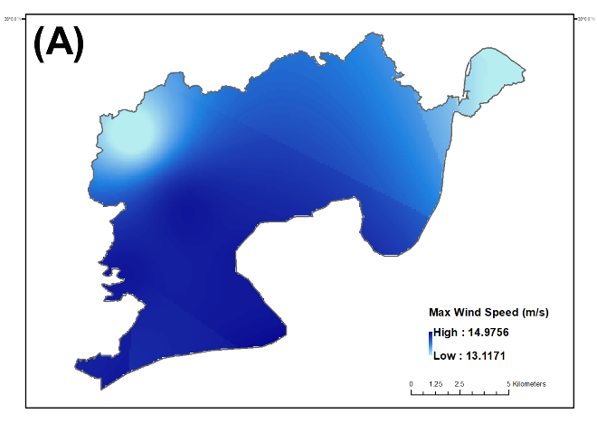 | 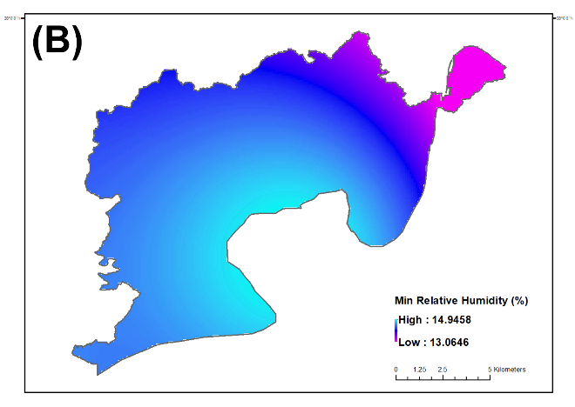
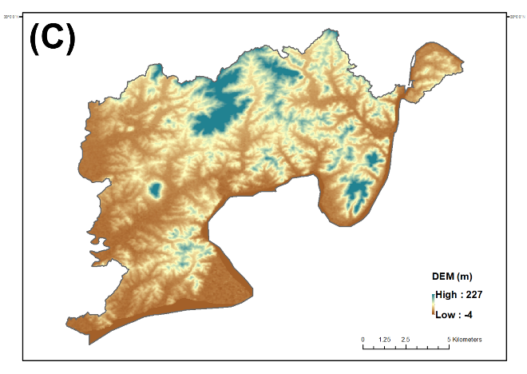 | 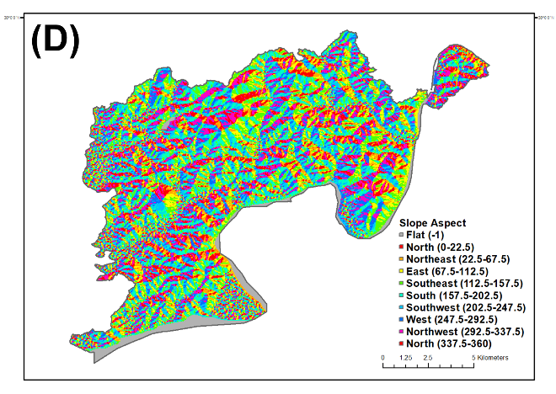
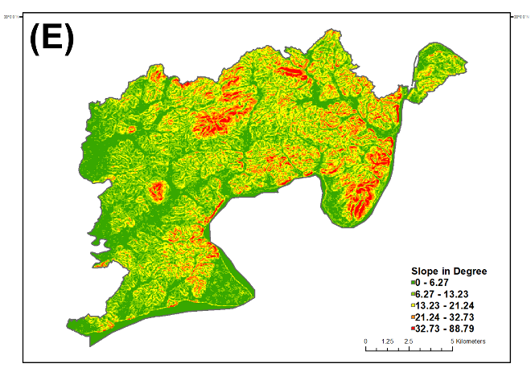 | 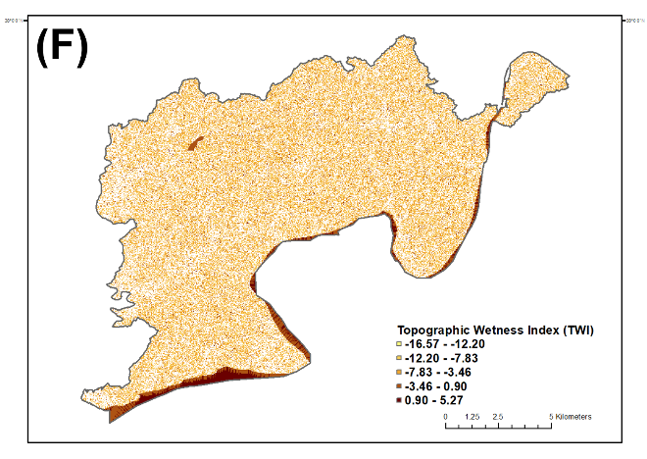
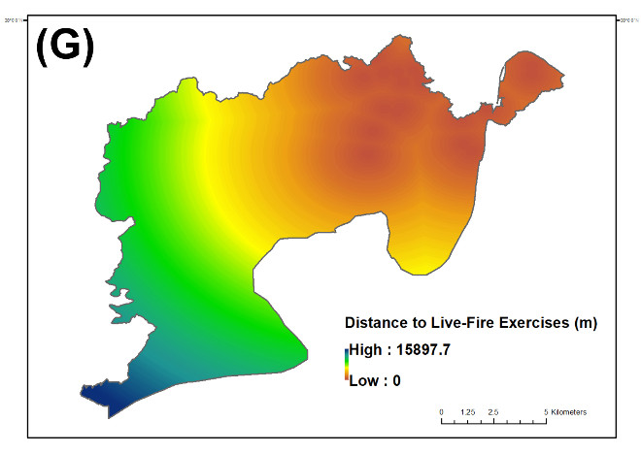 | 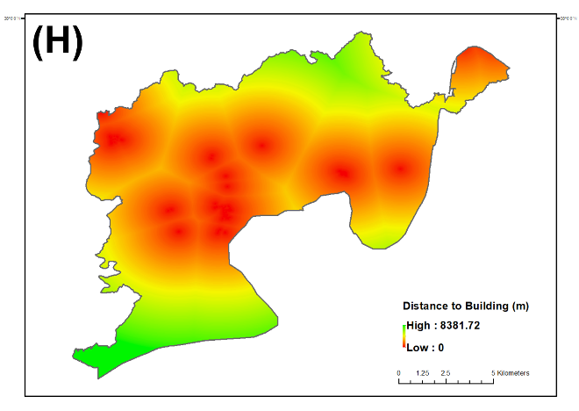
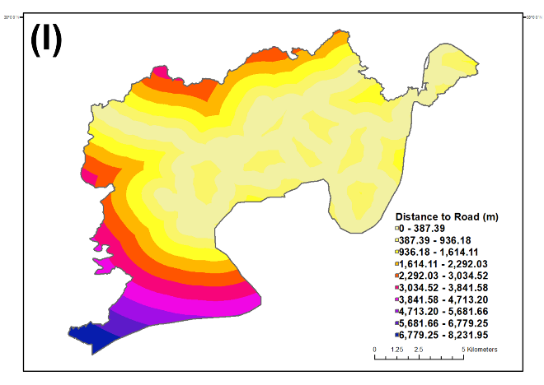 | 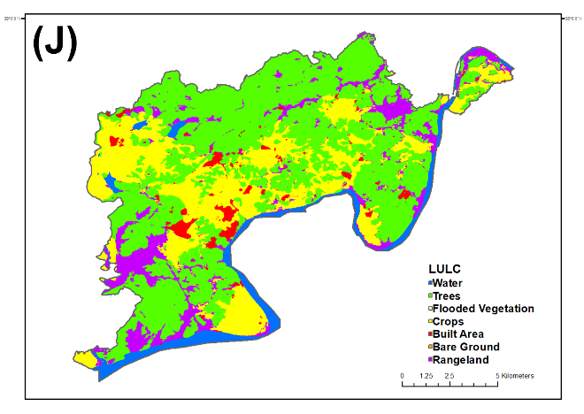
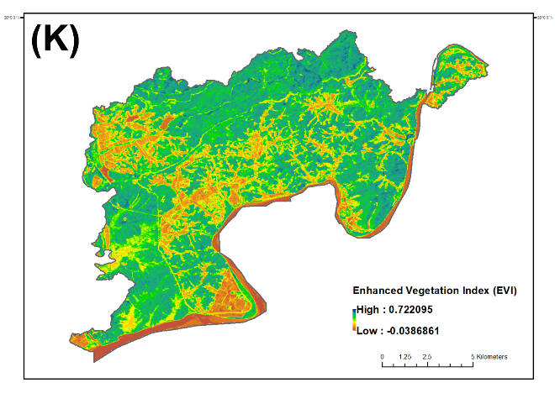

Fig. A1. Selected environmental drivers map

Table A1. Area statistics by wildfire risk level based on Natural Jenks classification of RF-predicted probability.
Risk Level | Value | Area (m2) | Area (%)
Very low | 0-0.05 | 132,909,453.64 | 88.88
Low | 0.05-0.17 | 7,907,428.93 | 5.29
Moderate | 0.17-0.32 | 5,225,976.86 | 3.49
High | 0.32-0.51 | 2,403,108.08 | 1.61
Very high | 0.51-1 | 1,088,488.99 | 0.73

