Supplementary Material

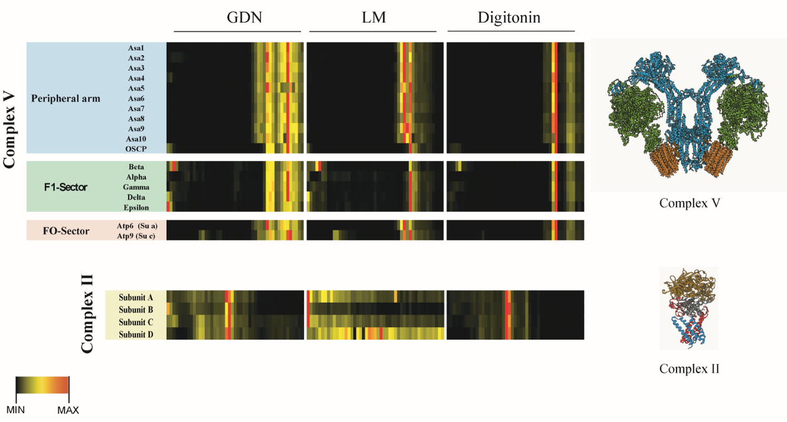

Figure S1. Comparison between the complexome profile of mitochondria isolated from P. parva with three different detergents.
Mitochondria isolated from P. parva were solubilized with detergents at a ratio of 2:1 mg of detergent per mg of protein. The samples were separated by BN-PAGE followed by quantitative mass spectrometry analysis. The amount (iBAQ) of each of the subunits that form the different complexes was represented by a heat map. For complexes V and II, all its known constituent subunits were identified, 18 and 4, respectively.

Figure S2. Isoforms of some subunits of the OXPHOS complexes. Sequence alignment of the isoforms found in complex I (NUPO4, ND4 and CA3), complex II (subunit D), complex IV (Cox6b), and complex V (Asa9).

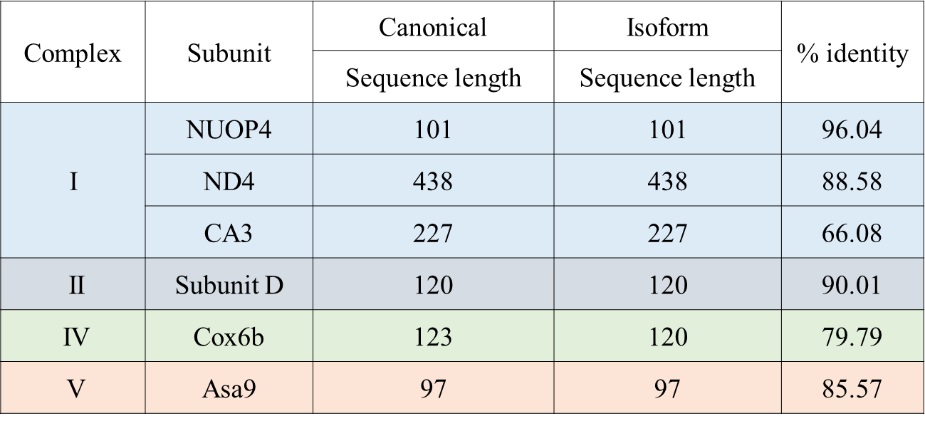

Table S1. Subunit isoforms present in the algal OXPHOS complexes. Analysis of the clusters where the subunits belonging to the OXPHOS complexes were found allowed us to identify the presence of six subunits with small variations in amino acid composition that are also present in the mature complexes.

Table S2. Subunits of mitochondrial complexes I, III, and IV identified by MS. Comparison of subunits belonging to the green alga C. reinhardtii complexes, with its corresponding counterparts in the colorless P. parva complexes. a) complex I.

Table S2 (continued). Subunits of mitochondrial complexes I, III, and IV identified by MS. Comparison of subunits belonging to the green alga C. reinhardtii complexes, with its corresponding counterparts in the colorless P. parva complexes. b) complexes III, and IV.

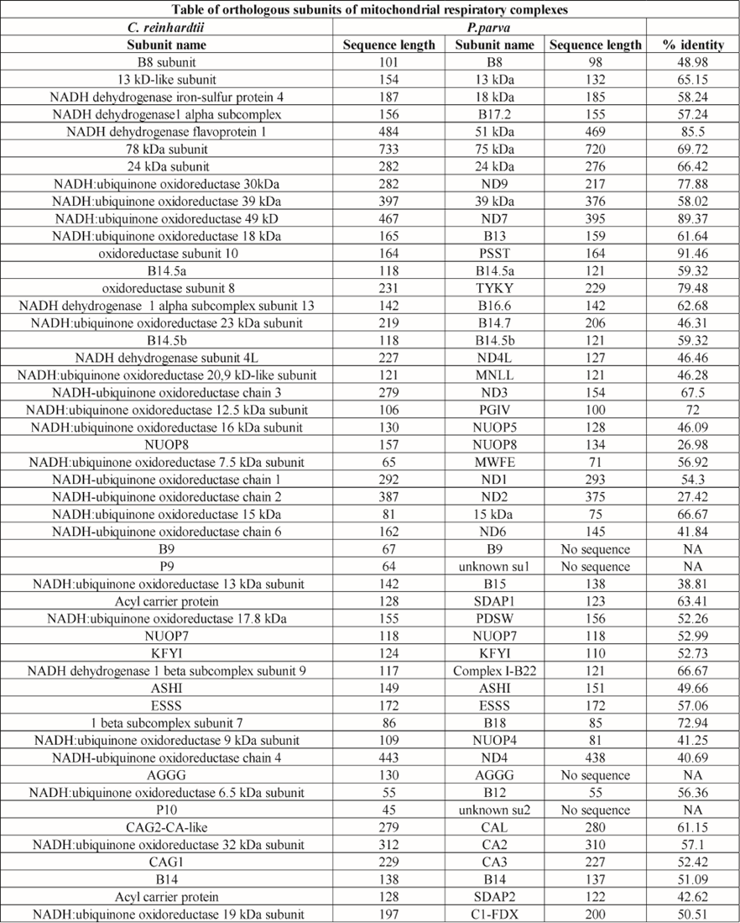
Table S3 (continued). List of subunits of complexes I, III, and IV from C. reinhardtii and their putative orthologs in P. parva. The name, length of the amino acid chain and the percentage identity for each sequence is listed.

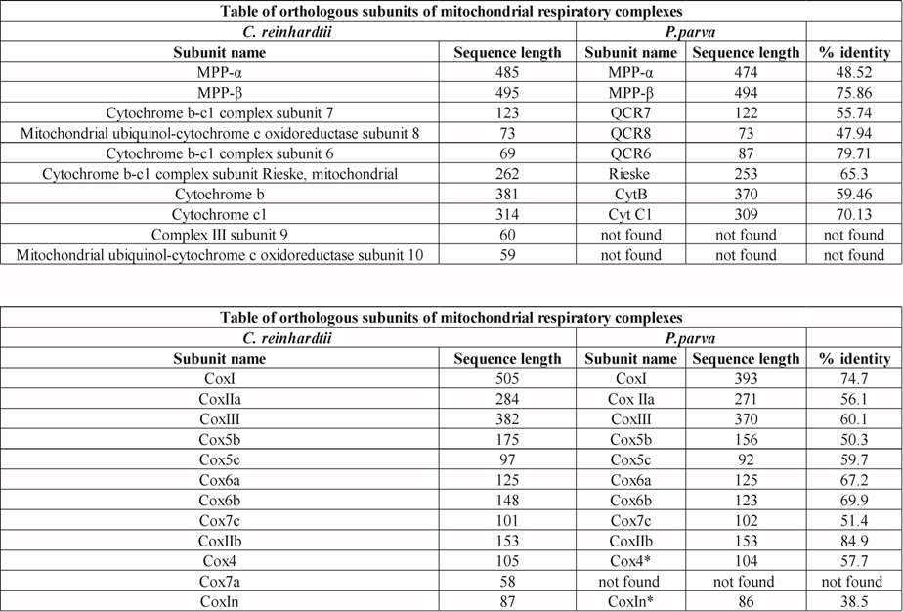

Table S3 (continued). List of subunits of complexes I, III, and IV from C. reinhardtii and their putative orthologs in P. parva. The name, length of the amino acid chain and the percentage identity for each sequence is listed.

