Supplementary Figures and Legends
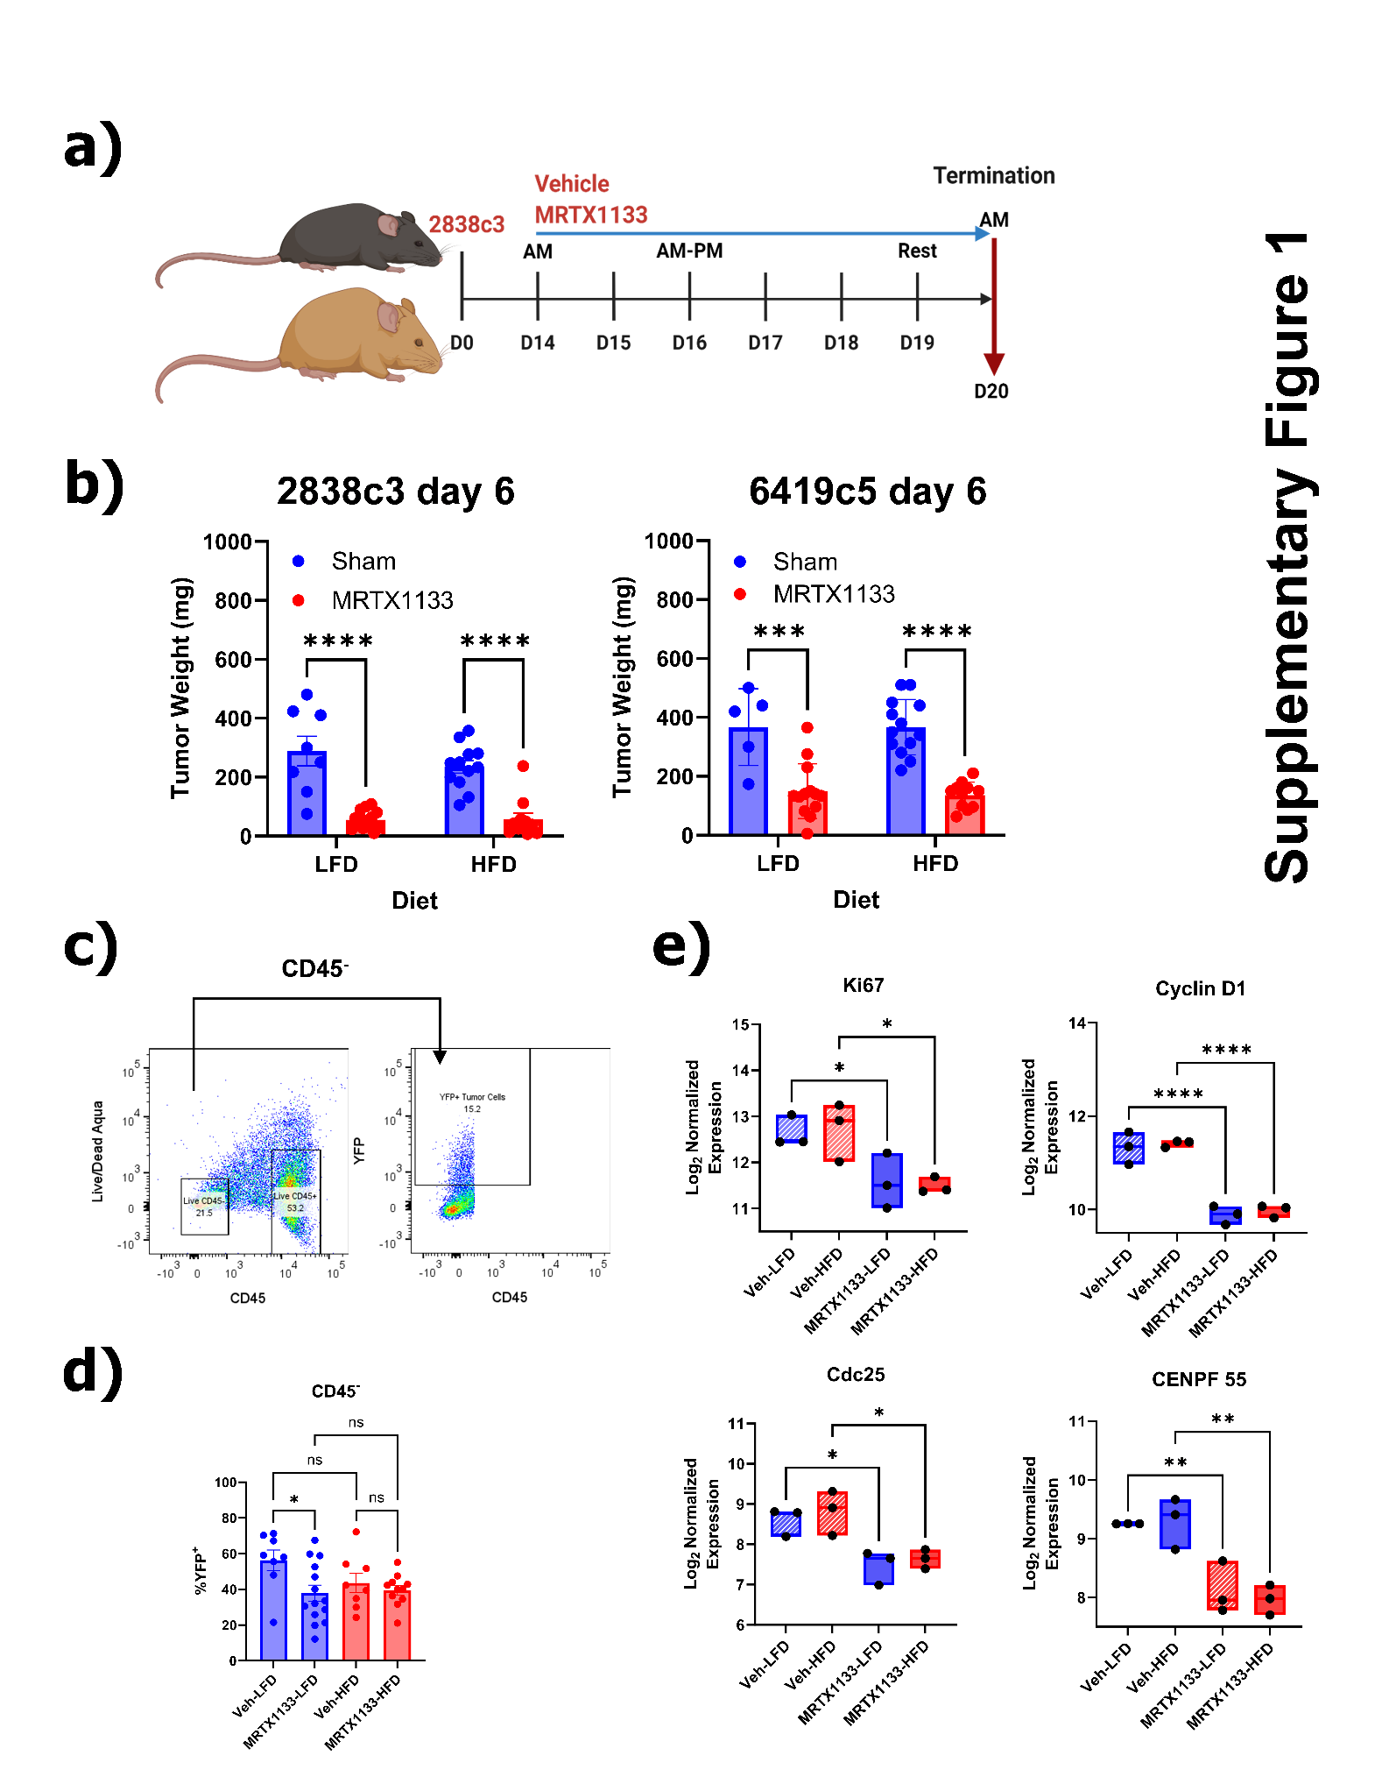

Supplementary Figure 1. MRTX1133 alters cell cycle mRNA expression in vivo after 6 days of treatment. a) Schema representing generation of diet-induced obese and low-fat diet induced lean murine models modelling obesity. b) Tumor weights of LFD and DIO vehicle and MRTX1133 treated cohorts. Data is representative of an aggregate of 2 independent experiments with n = 10 – 15 mice/group, ANOVA with Šídák's multiple comparisons test (***P<0.001 and ****P<0.0001) c) Volcano plot of differential gene expression in vehicle-LFD and MRTX1133-LFD cohorts with genes exhibiting statistically significant down regulation (purple) and upregulation (green) listed. NanoString data is derived from n = 3 mice/group, ANOVA with Šídák's multiple comparisons test (*P<0.05). d) mRNA gene expression for proliferation (Ki67), S phase (Cyclin D1), and M phase (Cdc25 and Cenpf) LFD and DIO vehicle and MRTX1133 treated cohorts (n = 3/ group; +/- SD). Statistical significance was calculated using one-way ANOVA with Tukey’s multiple comparison test to correct for type 1 error. *P<0.05 and ****P<0.0001.

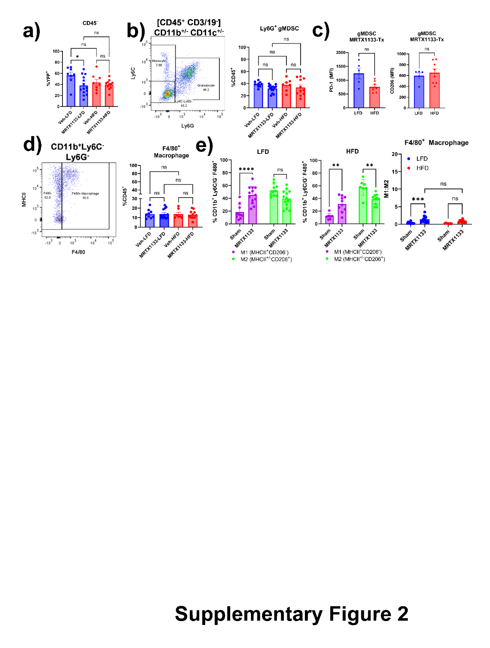

Supplementary Figure 2. MRTX1133 has minimal impact of myeloid cell infiltration in 6419c5 PDAC TiME. a) Frequency of CD45⁻ YFP⁺ tumor cells in LFD and DIO vehicle and MRTX1133 treated cohorts. b) Frequency of CD45⁺ that are CD11b⁺ Ly6G⁺ gMDSC within TME at the end of the scheduled treatment regimen in LFD and DIO vehicle and MRTX1133 treated cohorts. c) Expression of PD-L1 and CD206 in gMDSC within the TME at the end of scheduled treatment regimen in LFD and DIO vehicle and MRTX1133 treated cohorts. d) Frequency of CD45⁺ that are CD11b⁺ Ly6C/G⁻ F4/80⁺ macrophage within TME at the end of the scheduled treatment regimen in LFD and DIO vehicle and MRTX1133 treated cohorts. e) Frequencies and ratio of M1 (MHCII⁺CD206⁻) and M2 (MHCII⁻CD206⁺) macrophage within the TME at the end of scheduled treatment regimen in LFD and DIO vehicle and MRTX1133 treated cohorts. For All FACS data (with exception of MFI data-which is representative of 2 independent experiments) in panels a-e) is represented as an aggregate of two independent experiments with n = 8 – 14 mice/group, +/- SEM. Statistical significance across groups was calculated using 2-way ANOVA with Tukey’s multiple comparison test to correct for type 1 error. *P<0.05, **P<0.01, ***P<0.001, and ****P<0.0001.

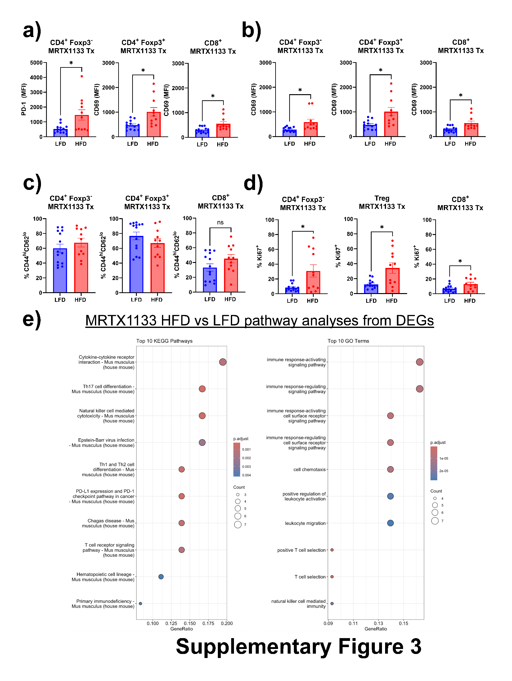
Supplementary Figure 3. MRTX1133 induces increased activation and proliferation of T cells in DIO 2838c3 TiME. a) Expression of PD-1, b) CD69, c) CD44 and CD62L, and d) Ki67 in 2838c3 LFD and DIO vehicle and MRTX1133 treated cohorts (n = 8-14 mice/ group +/- SEM, Student’s t test. *P<0.05 and **P<0.01. e) KEGG and Gene Ontology analysis of differential gene expression in MRT1133 LFD vs MRTX1133 HFD reveals changes in lymphocyte activation, migration, and NK cell cytotoxicity.

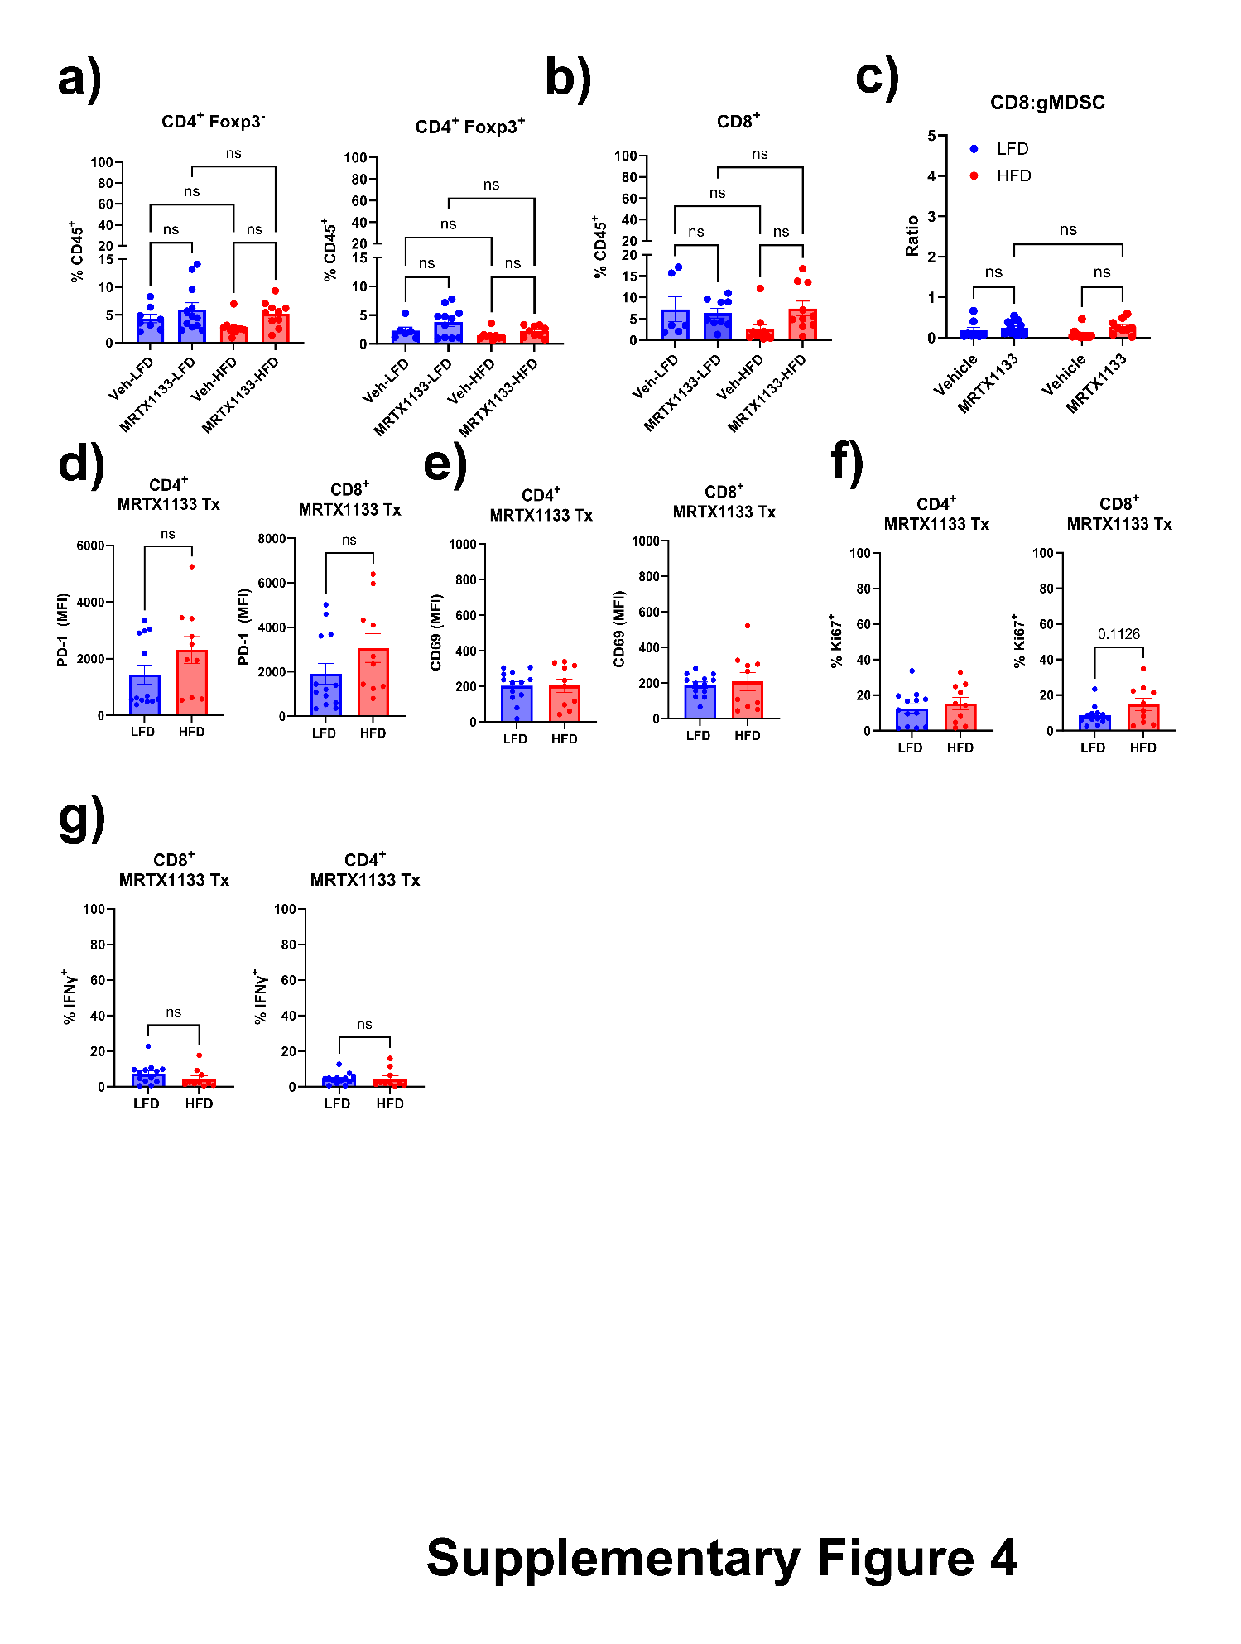

Supplementary Figure 4. MRTX1133 has minimal impact of T cell infiltration and function in 6419c5 PDAC TiME. a-b) Frequency of a) CD45⁺ that are CD3⁺ CD4⁺ Foxp3⁻, CD3⁺ CD4⁺ Foxp3⁺, and b) CD3⁺ CD8⁺ T cells within the TME at the end of scheduled treatment regimen in LFD and DIO sham and MRTX1133 treated 6419c5 tumor bearing cohorts. c) Quantification of ratio of frequency of CD8⁺ T cells to gMDSCs in vehicle and MRTX1133 treated cohort of LFD and HFD 6419c5 tumor bearing mice. d) Expression of PD-1, e) CD69, f) Ki67, and g) IFNγ in 6419c5 LFD and DIO sham and MRTX1133 treated cohorts (n = 8-13/ group; +/- SEM). Statistical significance was calculated using Student’s t test.

Supplementary Figure 5. Representative whole western blots for pERK1/2, total ERK, and βactin. Representative blots for 2838c3 at 3 including pERK1/2, total ERK, and βactin with 2 technical replicates.

Supplementary Figure 6. Representative whole western blots for pERK1/2, total ERK, and βactin. Representative blots for 6419c5 at 3 including pERK1/2, total ERK, and βactin with 2 technical replicates.

Supplementary Tables
Supplementary Table 1. Western Blot Primary Antibodies
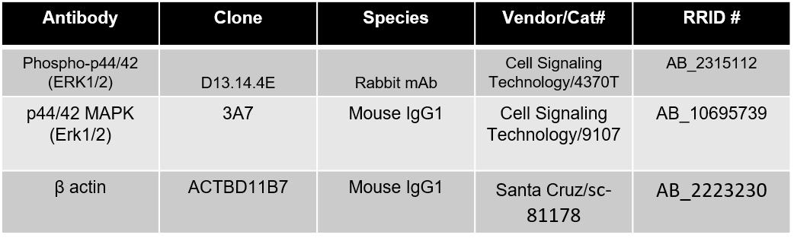

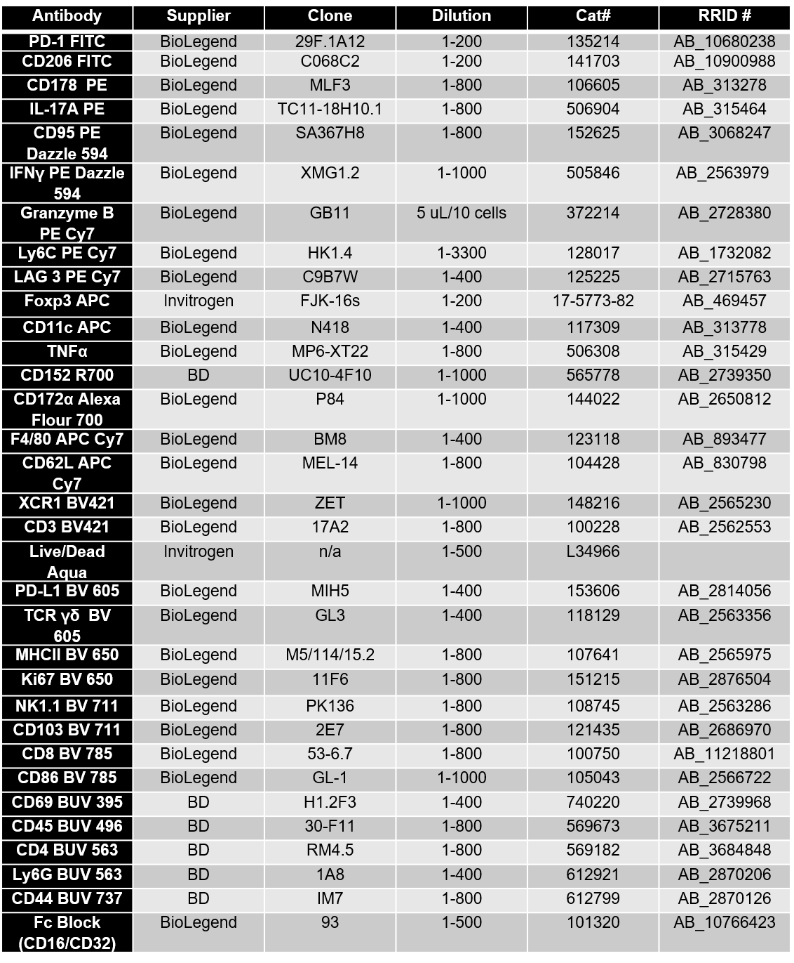
Supplementary Table 2. FACS Antibody List

