Supplementary information:
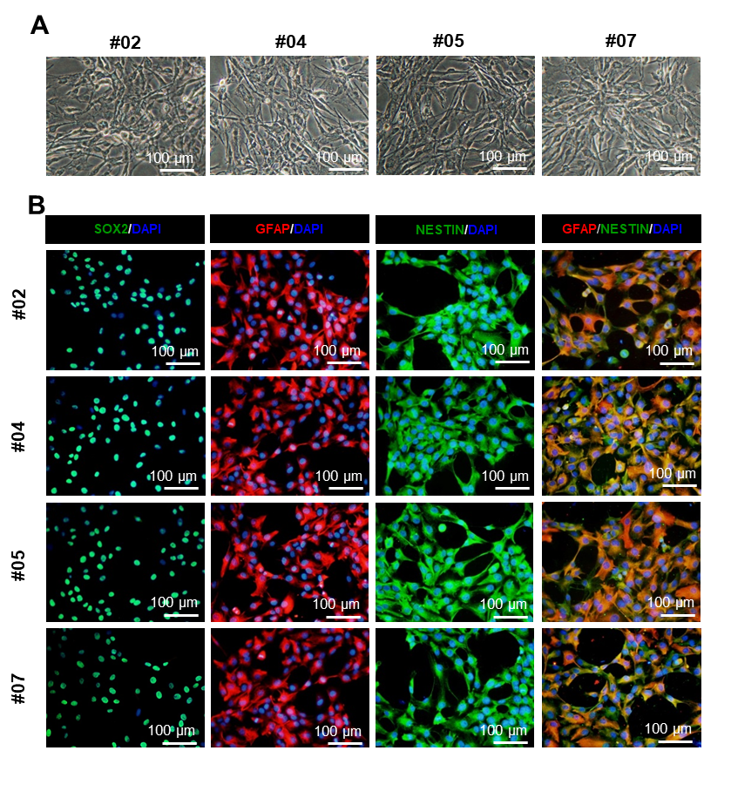
S.1. Cell characterization for 4 animals. A) Phase-contrast imaging of the SVZ-NSC in each subject in transplanted groups at passage four. B) Expression of NSC Markers (SOX2, NESTIN, and GFAP and co-expression of GFAP/NESTIN) for all animals in transplantation groups.

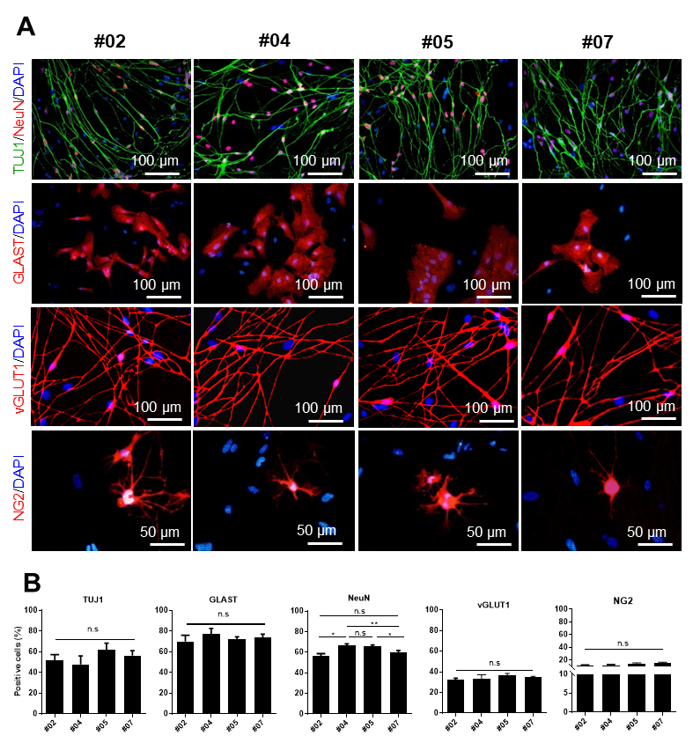
S. 2. SVZ-NSCs multipotency in Vitro evaluation. A) Spontaneous differentiation of SVZ-NSCs has been assessed by immunolabeling for TUJ1, NeuN (co-expression), GLAST (as a glial marker), vGLUT1 (glutamatergic neuron’s marker) and NG2 (oligodendrocyte’s marker) for each animal. B) Quantification of all markers in part A did not show any difference in all animals except in NeuN (p < 0.05, one-way ANOVA, Tukey posttest).

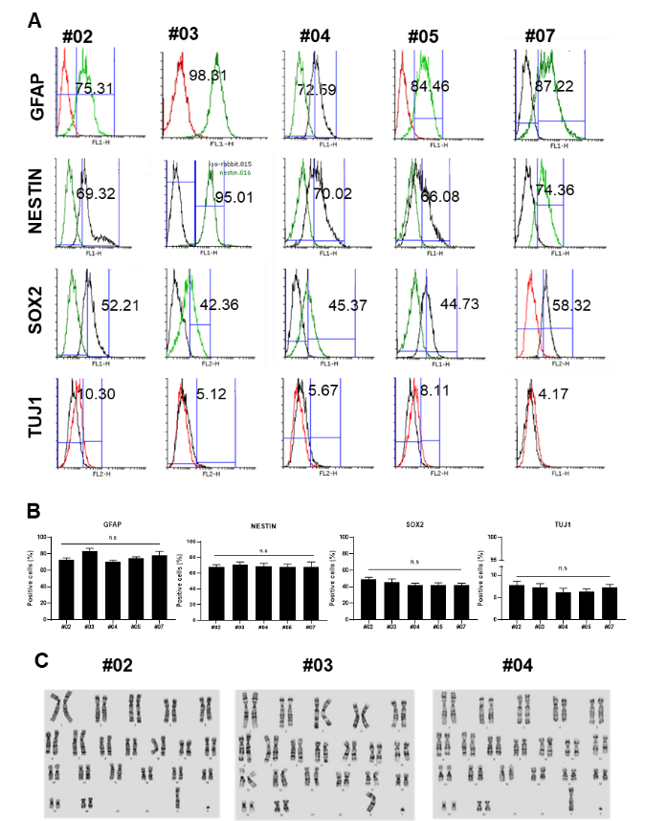
S. 3. Flow cytometry and Karyotype assessment. A, B) Flow cytometry has demonstrated NSC properties for all 4 subjects. The individual histogram has been represented for NESTIN, GFAP, SOX2, and TUJ1. C) Karyotype analysis did not show any chromosomal abnormality in number and structure after four passages In Vitro.

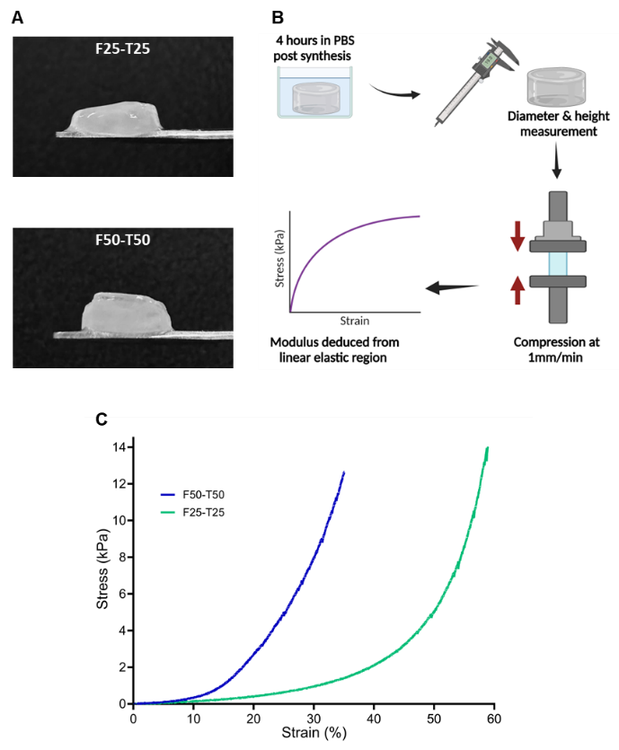
S. 4. Macrographs of fibrin hydrogels and compression testing workflow. A) Side-view of F25-T25 and F50-T50 fibrin hydrogels equilibrated in PBS for 4 hours post-synthesis. (B) Schematic illustration of the compression testing process. Hydrogels were equilibrated, measured for diameter and height, and subjected to uniaxial compression at a rate of 1 mm/min. The elastic modulus was extracted from the linear elastic region of the stress-strain curve. (C) Stress-strain profiles of F50-T50 and F25-T25 fibrin hydrogels, capturing their mechanical behavior under increasing compressive strain.

