Supplementary Figures
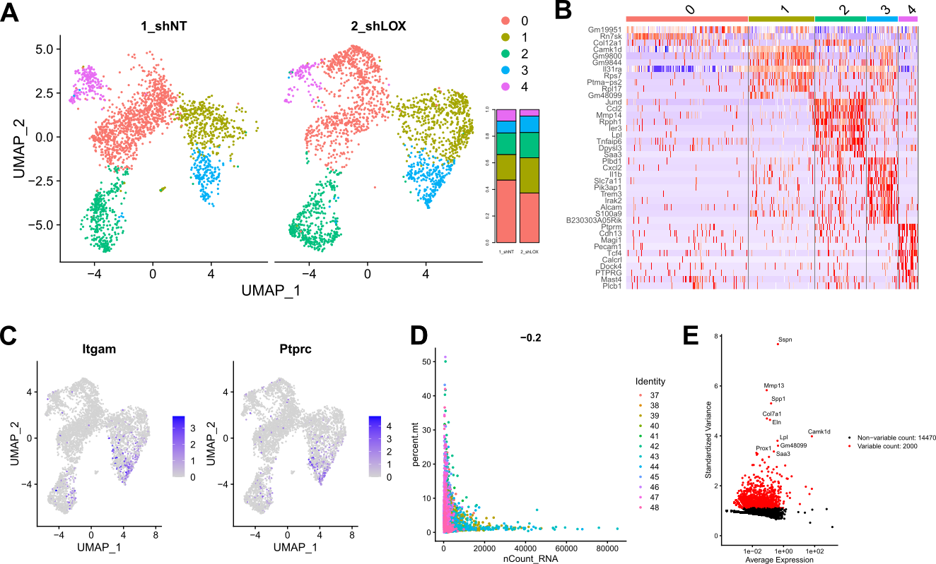
Figure S1: Immune cell group scRNA-seq data. (A) Immune cell group UMAP and bar chart depicting the ratio between the clusters in shNT and shLOX groups. (B) Immune cell group heat map with marker genes. (C) Immune cell group feature plot of Itgam and Ptprc. (D) Immune cell group feature scatter plot and (E) Variable feature scatter plot.

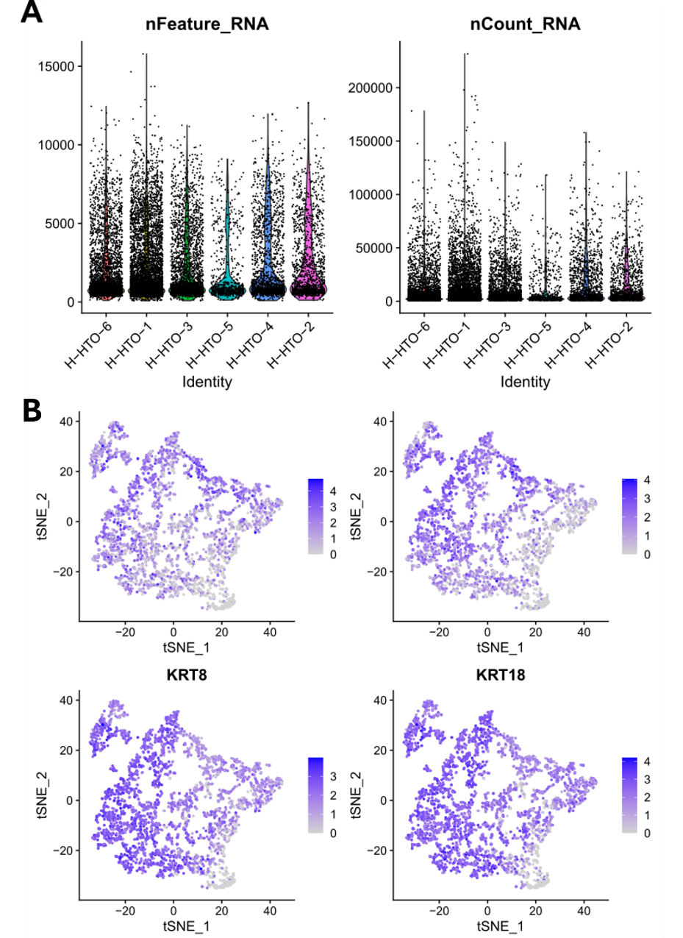
Fig S2: HTO-Breakdown and Keratin Feature Plots of Aged vs. Young ECM Tumors. (A) RNA-Feature Chart. (B) RNA Count Chart.

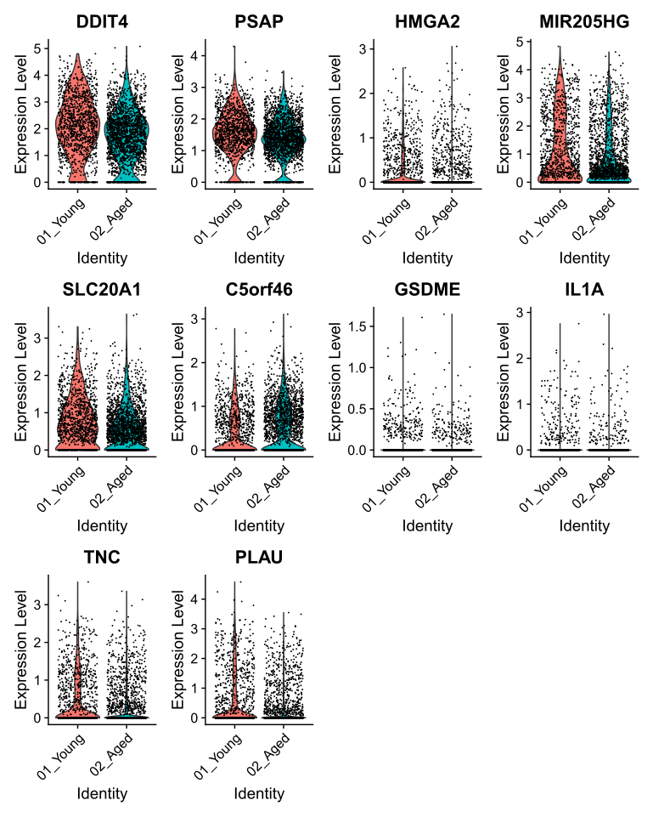
Fig S3: Violin Plots with Significantly Upregulated Genes on the Aged ECM.

