Supplementary material

Supplementary Figure 1. Schematic diagram of experimental flow. First, we transplanted Atractylodes lancea plantlets with short roots grown on a rooting medium for four weeks to sterile nutrient soil. Second, 9 days later, new roots were observed from the bottom of the bottle. Subsequently, a 5 mL soil suspension was inoculated around the roots of the plantlets. Thirdly, 15 bottles of plantlets inoculated with soil suspension (N+B) and 15 bottles of plantlets inoculated with sterilized soil suspension (N) were placed in a greenhouse (23 ± 2 ℃ all day, with a light intensity of 1500–2000 lx and 12 h of daylight). Another 15 bottles of plantlets inoculated with soil suspension (H+B) and 15 bottles of plantlets inoculated with sterilized soil suspension (H) were placed in an artificial climatic incubator (30 ± 2 ℃ all day, with a light intensity of 1500–2000 lx and 12 h of daylight).

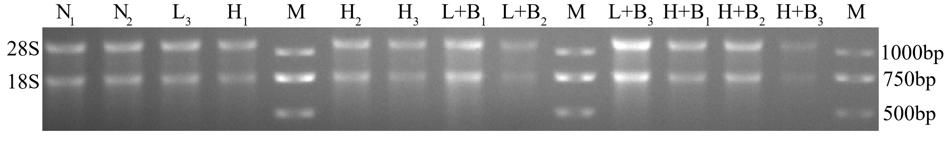
Supplementary Figure 2. Agarose gel electrophoresis of total RNA of roots of Atractylodes lancea plantlets. N₁₋₃ indicates the normal temperature (23 ℃) and free-microbes treatment group. N+B₁₋₃ indicates inoculated microorganisms at normal temperatures (23 ℃). H₁₋₃ indicates high temperature (30 ℃) and free-microbes treatment group. H+B₁₋₃ indicates inoculated microorganisms at high temperatures (30 ℃). M indicates DNA mark.

Supplementary Figure 3. Differential abundance levels of bacterial genera in the root tissues of the N+B group and H+B group, and the NH and NH+B groups. a Differential abundance analysis of bacterial genera diversity between the N+B group and H+B group. b Difference abundance analysis of bacterial genera diversity between the NH group and the NH+B group. Only the top 15 abundant genera are shown. N+B indicates inoculated microorganisms at normal temperature. H+B indicates inoculated microorganisms at high temperatures. NH indicates the N group and H group were treated as a non-inoculation group. NH+B indicates the N+B group and H+B group as an inoculation group. Student’s t-tests followed by Bonferroni (P < 0.05) corrections were performed at the genus level. * indicates a significant difference (Student’s t-test, P < 0.05). ** indicates an extremely significant difference (Student’s t-test, P < 0.01). *** indicates an extremely significant difference (Student’s t-test, P < 0.001).

Supplementary Figure 4. Differential abundance of bacterial genera in control soil and rhizosphere soil of the inoculated groups at normal temperature or high temperature. a The differences in bacterial abundance in the control soil were compared at different temperatures. b The differences in bacterial abundance in the rhizosphere soil were compared at different temperatures. Only the top 15 genera are shown. Student’s t-tests followed by Bonferroni (P < 0.05) corrections were performed at the genus level. * indicates a significant difference (Student’s t-test, P < 0.05). ** indicates an extremely significant difference (Student’s t-test, P < 0.01). *** indicates an extremely significant difference (Student’s t-test, P < 0.001).

Supplementary Table 1. Standard curves of four essential oils
Volatile oils | Standard curve | R²
Hinesol | Y = -185861+999564*X | 0.9999
β-Eudesmol | Y = -560335+1057374*X | 0.9986
Atractylon | Y = -413450+1458182*X | 0.9997
Atractylodin | Y = -2948594+769420*X | 0.9998

Supplementary Table 2. Primers of three selected key enzyme genes related to the volatile oil synthesis pathway in Atractylodes lancea.
Gene | Forward | Reverse
HMGR | AAACAACATAAATCCGGCGAACT | AGGCGTCGATGGCTTTTG
FPPS | CTGCCCTTGGTTGGTGCGTT | TTCTTGGGACATGGTTGCGA
DXS | TGCCTGTGAGATTTGCGT | CCTATCCCATTTCCTCGTG
18S | GTAGTTGGGCTTTGGGTTG | AGCGTAGGCTTGCTTTGAG
Abbreviations: 3-hydroxy-3-methylglutaryl coenzyme A (HMGR), farnesyl pyrophosphate synthase (FPPS), 1-deoxylated xylose-5-phosphate synthase (DXS), Ribosomal protein 18 (18S) was used as an internal reference.

