Appenix
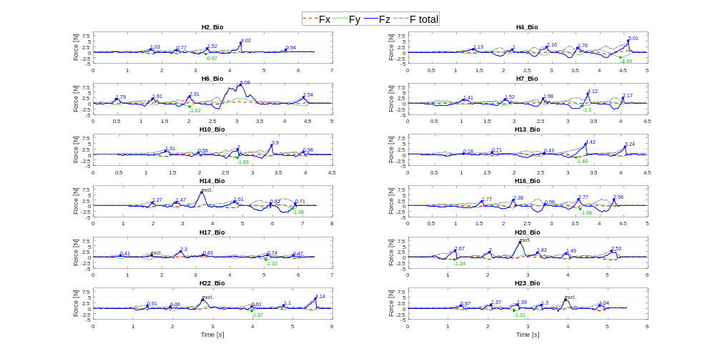
A
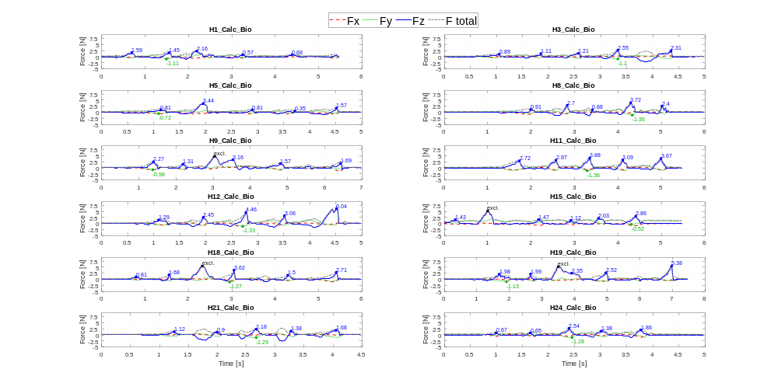
B
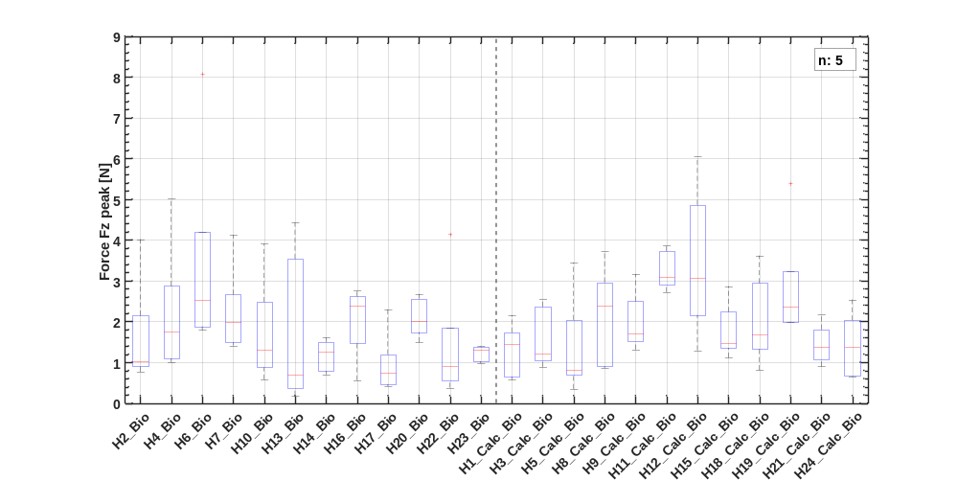
C
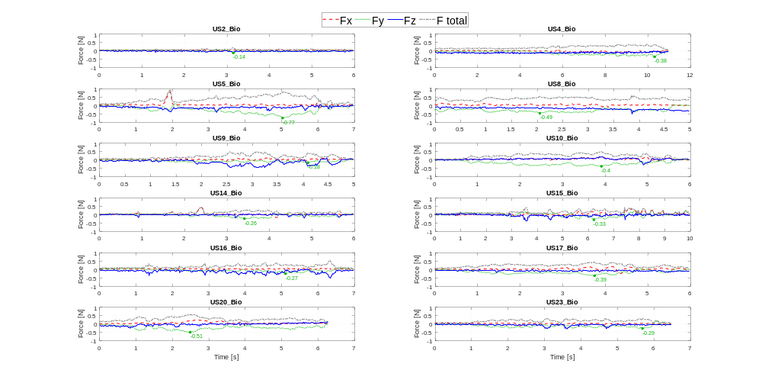
D
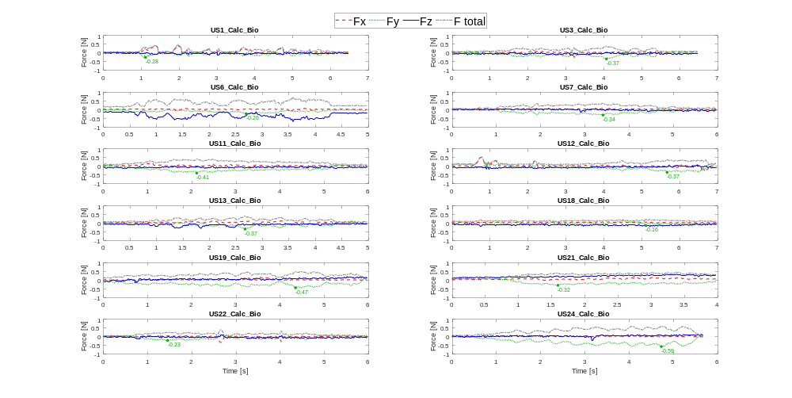
E
Fig. 6 Force measurement in X, Y, Z direction, peak indication and exclusions, and calculated total force for: (A) hand instrumentation of biofilm; (B) hand instrumentation of combined biofilm and calculus; (C) comparison of the five valid Fz peak values of all hand instrumentation; (D) ultrasonic instrumentation of biofilm; (E) ultrasonic instrumentation of combined biofilm and calculus.

