Supporting Information

Disentangling the Janus-faced effects of cations in electrocatalysis
Xinwei Zhu, ^{a,b,*} Tobias Binninger, ª Marc T.M. Koper, ^{c} Michael Eikerling ^{a,b,*}
ª Theory and Computation of Energy Materials (IET-3), Institute of Energy Technologies, Forschungszentrum Jülich GmbH, 52425 Jülich, Germany
^{b} Chair of Theory and Computation of Energy Materials, Faculty of Georesources and Materials Engineering, RWTH Aachen University, 52062 Aachen, Germany
^{c} Leiden Institute of Chemistry, Leiden University, 2333CC Leiden, The Netherlands
* Corresponding authors:
Xinwei Zhu: x.zhu.electrochem@gmail.com
Michael Eikerling: m.eikerling@fz-juelich.de

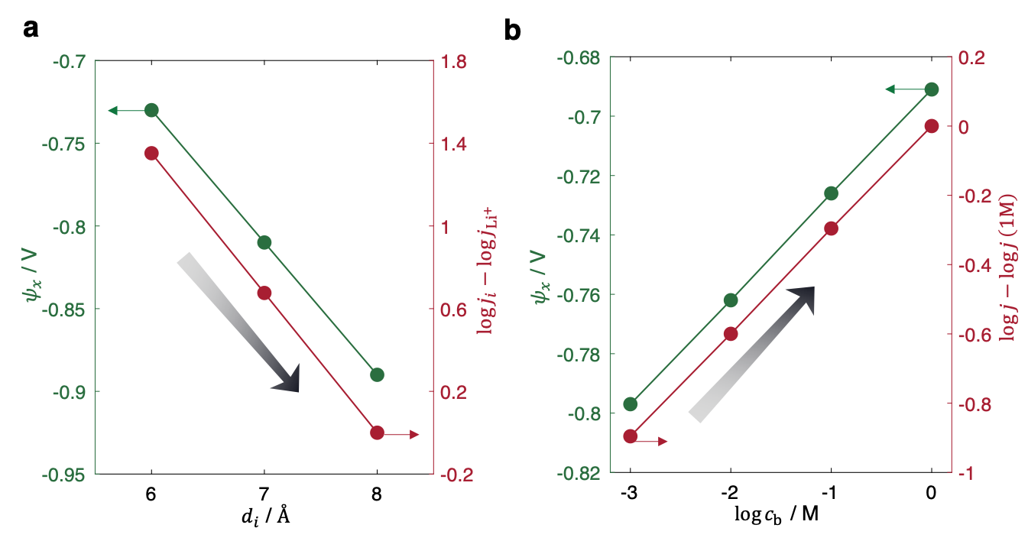
Figure S1: (a) Dependence of $ψ_{x}$ (assumed $ψ_{x}=ψ_{IHP})$ and HER rate on effective cation size, using $c_{b}=0.1 M$. (b) Dependence of $ψ_{x}$ and HER rate on supporting cation concentration, using $d_{i}=6 Å$. The results are calculated using Eqs. 1 and 2. $α$ is set to the typical value of 0.5. $E_{M}=-0.6 V$ versus the reversible hydrogen electrode (RHE) and pH = 13. Other parameters are given in Table 1.

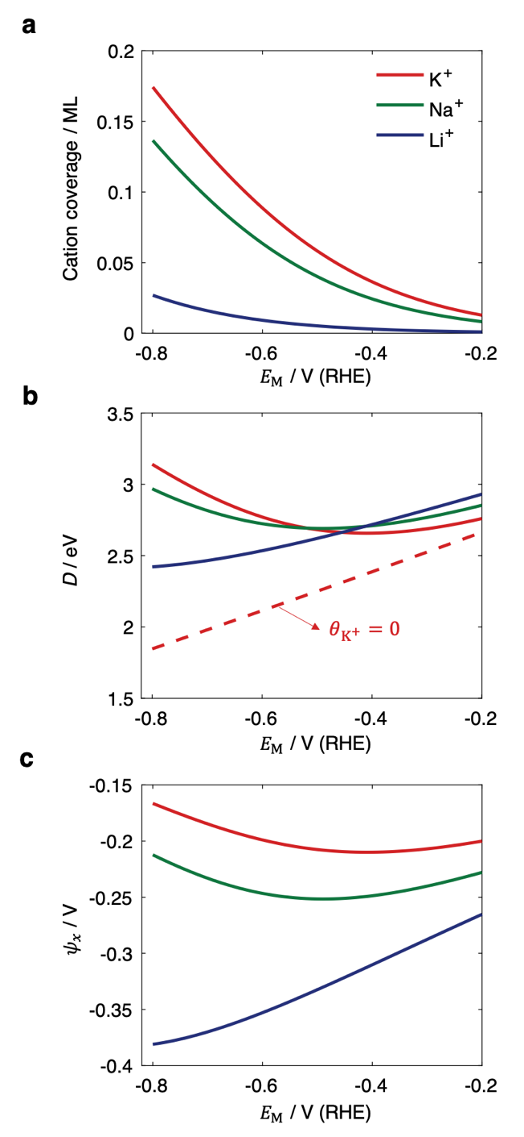
Figure S2: (a) Simulated cation coverages on Au in 0.1 M KOH, NaOH, and LiOH. (b) Simulated H-OH bond strength as the function of applied potential. The result for K⁺ without considering cation adsorption is shown for comparison. (c) Simulated $ψ_{x}$ (assumed $ψ_{x}=ψ_{OHP}$) as the function of applied potential. Parameters used are given in Table 1.

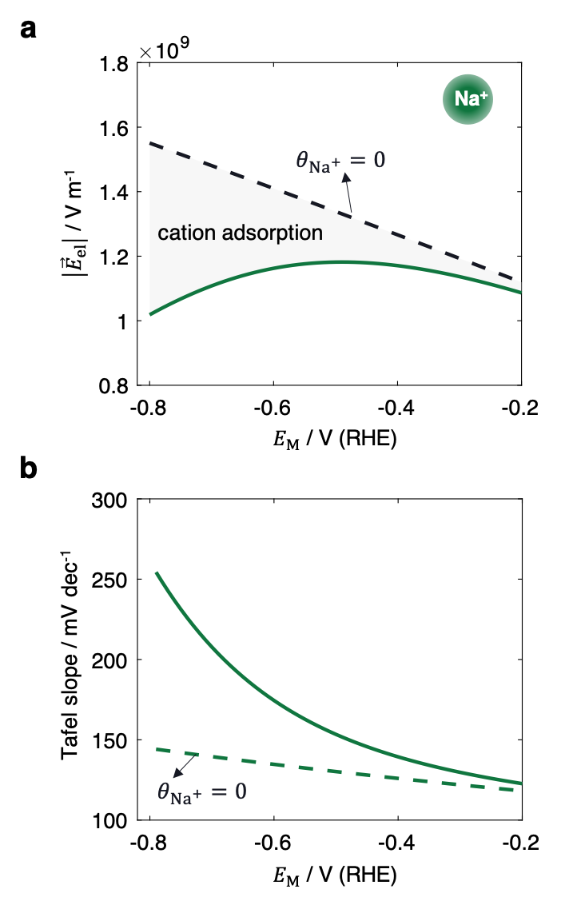
Figure S3: (a) Calculated electric field strength within the OHL for Na⁺. (b) Influence of Na⁺ adsorption on the Tafel slope. Parameters used are given in Table 1.

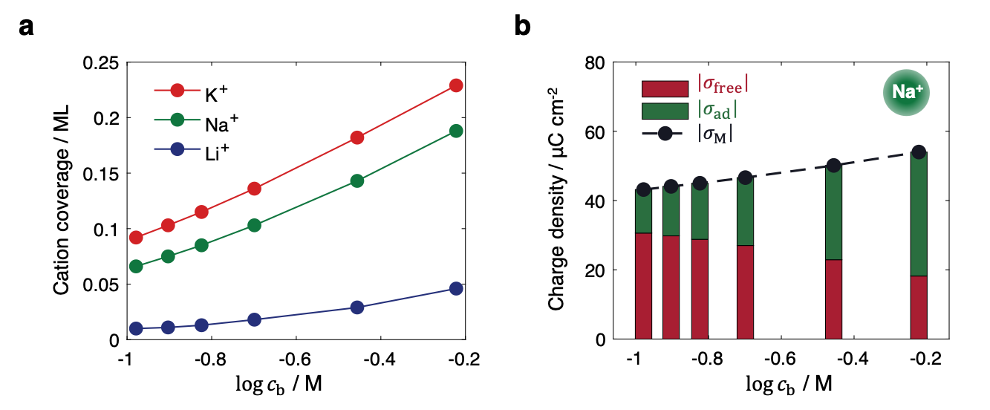
Figure S4: (a) Influence of cation concentration on cation adsorption coverages. (b) Influence of cation concentration on surface charge densities for Na⁺. $E_{M}=-0.6 V$ versus RHE and pH = 13. The results are simulated using Eqs. 3-8 and parameters given in Table 1.

