2D/2D Heterojunction Interfaces of 1T-MoS₂ and Ti₃C₂ MXene: Designing High-Performance Catalyst for the Hydrogen Evolution Reaction

Sana Akir^{1*}, Bastian Schmiedecke¹, Debabrata Bagchi², Jan Plutnar³, Prashanth W. Menezes^{2,4}, Yael Rodriguez-Ayllon^{5,6}, Yan Lu^{5,6}, Zdenek Sofer³, and Michelle P. Browne¹
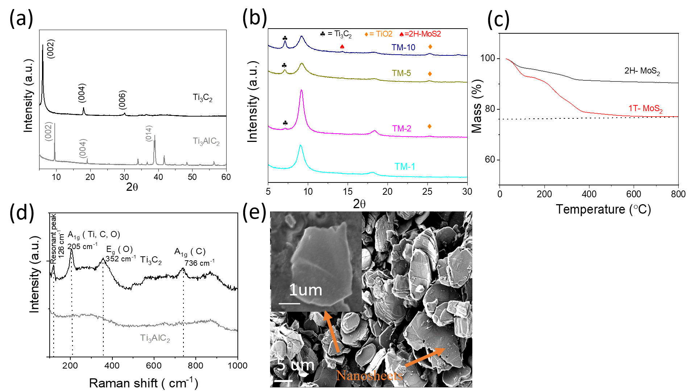

Figure S1. (a) XRD of Ti₃C₂ and Ti₃AlC₂, (b) zoomed-in XRD of composites from 5 to 30°, (c) TGA curves of 2H-MoS₂ and 1T-MoS₂, (d) XRD of Ti₃C₂ and Ti₃AlC₂, and (e) SEM of delaminated Ti₃C₂ MXene.
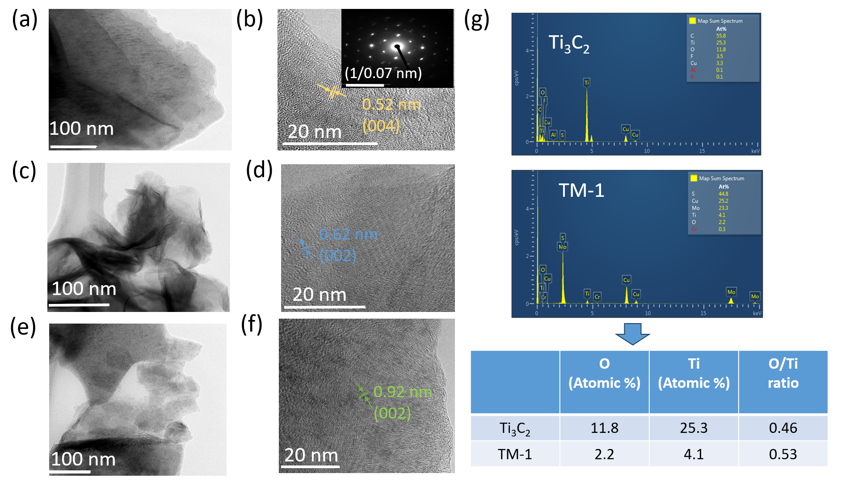

Figure S2. (a) TEM of Ti₃C₂, (b) HRTEM of Ti₃C₂ (Inset: SAED of Ti₃C₂), (c, d) TEM and HRTEM of 2H-MoS₂, (e, f) TEM and HRTEM of 1T-MoS₂, (g) EDS spectra of Ti₃C₂ and TM-1 and their corresponding O/Ti atomic % ratio
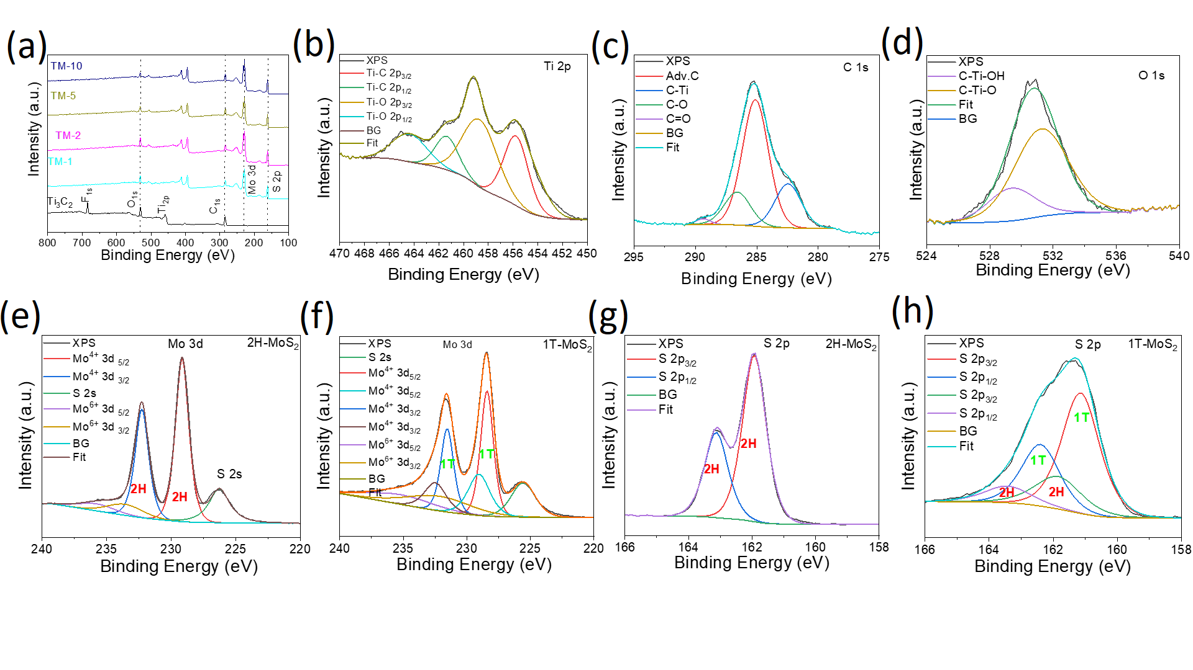
Figure S3. (a) XPS survey spectra of Ti₃C₂ and composites, high-resolution XPS spectra of Ti₃C₂: (b) Ti 2p, (c) C 1s, and (d) O1s, High-resolution XPS spectra of Mo 3d in: (e) 2H-MoS₂, and (f) 1T-MoS₂, High-resolution XPS spectra of S 2p in: (g) 2H-MoS₂, and (h) 1T-MoS₂

Table S1a. Report the full-width-half-maximum (FWHM) values for the XPS deconvoluted peaks of Mo 3d
Sample | 1T 3d₅/₂ | 1T 3d₃/₂ | 2H 3d₅/₂ | 2H 3d₃/₂ | Mo (VI) 3d₅/₂ | Mo (VI) 3d₃/₂ | S 2s
TM-1 | 1.28 | 1.28 | 1.83 | 1.83 | 5.35 | 5.35 | 2.68
TM-2 | 1.24 | 1.24 | 2.00 | 2.00 | 3.60 | 3.60 | 2.52
TM-5 | 1.24 | 1.24 | 1.91 | 1.91 | 4.42 | 4.42 | 2.50
TM-10 | 1.22 | 1.22 | 2.18 | 2.18 | 3.80 | 3.80 | 2.51

The 5/2 and 3/2 components of the same type of electrons are constrained, meaning their FWHMs are forced to be equal. The lower FWHMs of the 1T phase correspond to its conducting, metallic behavior, confirming the assignment of the 1T/2H phase.
These values fall within expected ranges for chemically distinct Mo species in MoS₂-based materials. The narrower FWHMs of the 1T-MoS₂ components (~1.22-1.28 eV) relative to those of the 2H-MoS2 peaks (~1.83-2.18 eV) are consistent with the more delocalized electronic structure of the 1T phase, which arises from its metallic, octahedrally coordinated Mo environment. In contrast, the broader 2H peaks reflect its semiconducting character and the increased chemical disorder associated with 2H domains in the mixed-phase composite. Furthermore, the significantly broader FWHMs for the Mo (VI) peaks (3.6-5.35 eV) likely reflect the contribution from multiple surface oxidation species.

Table S1b. Deconvoluted peak areas of the S 2p region from XPS analysis and calculated 1T phase content of MoS₂.
Sample | 1T S2p₃/₂ | 1T S2p₁/₂ | 2H S2p₃/₂ | 2H S2p₁/₂ | % 1T-MoS₂
TM-1 | 31495.5 | 16094.2 | 4132.1 | 2111.5 | 89
TM-2 | 25484.5 | 13022.6 | 3701.8 | 1891.6 | 87
TM-5 | 16942.8 | 8657.8 | 3191.0 | 1630.6 | 84
TM-10 | 26902.2 | 13747.0 | 5163.4 | 2638.5 | 83

The percentage of 1T-MoS₂ was determined by integrating the areas of the deconvoluted S 2p₃/₂ and S 2p₁/₂ peaks corresponding to both the 1T and 2H phases of MoS₂. The 1T phase content was calculated using the following formula:
1T-MoS₂​ (%) = (A_{1T}​ /(A_{2H}​+A_{1T}​​)) ×100
where A_{1T}​ and A_{2H}​ represent the total integrated areas of the S 2p peaks attributed to the 1T and 2H phases, respectively.

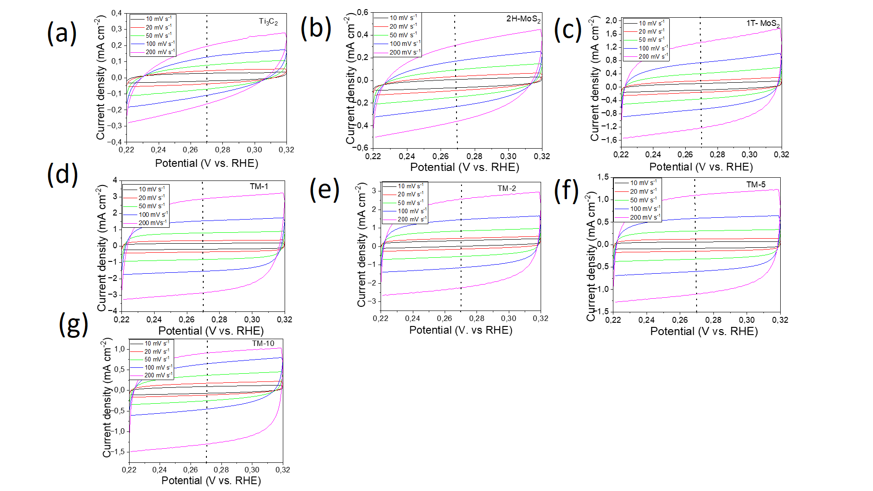
Figure S4. Cyclic voltammograms obtained from the non-Faradic Region of (a) Ti₃C₂, (b) 2H-MoS₂, (c) 1T-MoS₂, (d) TM-1, (e) TM-2, (f) TM-5, and (g) TM-10 at different scan rates in 0.5M H₂SO₄.

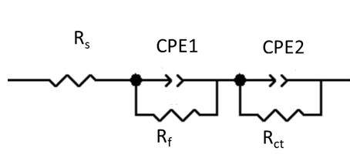

Figure S5. Equivalent circuit used to stimulate the Nyquist plot where L: inductance, R_{s}: solution resistance, R_{f} and CPE₁ are related to the porosity of the electrode; R_{ct}: charge transfer resistance, CPE₂ is related to the interface between catalyst and electrolyte; CPE represents constant phase element.
(EIS data fitted by ZView software)
Table S2. Comparison of the electrocatalytic performance of Ti₃C₂/1T-MoS₂ with other MoS₂-MXene-based materials for the hydrogen evolution reaction (HER).
Catalysts | Overpotential  η₁₀ [mV] | Tafel Slope  [mV·dec⁻¹] | Mass loading | Synthesis method | Electrolyte | References
Ti₃C₂/ 1T-MoS₂ | 248 | 55 | 0.32 mg cm⁻² | Hydrothermal | 0.5 M H₂SO₄ | This work
Ti₃C₂/ MoS₂ (1T-2H) | 280 | 83.8 | 0.44 mg cm⁻² | Hydrothermal+ Interfacial Assembly | 0.5 M H₂SO₄ | ¹
MoS₂/Ti₃C₂ | 400 | 68 | 0.35 | hydrothermal method | 0.5 M H₂SO₄ | ²
TCO/MoS₂ | 269 | 82 | 3.8 | One-pot solvothermal synthesis | 0.5 M H₂SO₄ | ³
MoS₂ QDs/Ti₃C₂T_{x} | 220 | 72 | 0.354 | Electrostatic self-assembly | 0.5 M H₂SO₄ | ⁴
MoS2-MXene | 307 | 68.5 | - | hydrothermal method | 0.5 M H₂SO₄ | ⁵
Ti₃CN(OH)_{x}@MoS₂ h | 120 | 64 | 0.408 | Hydrothermal method | 0.5 M H₂SO₄ | ⁶
Mo₂Ti₂C₃Tx/MoS2 | 298 | 112 | 0.2 | microwave-assisted hydrothermal method | 1 M KOH | ⁷
MoS₂/Ti₃C₂ MXene | 421 | 217 | - | Hydrothermal method | 1 M NaOH | ⁸
MoS₂/Nb₂CT_{x} | 127 | 56.3 | - | hydrothermal method | 0.5 M H₂SO₄ | ⁹
MoS2-Ti3C2Tx | 152 | 70 | 0.28 | combining liquid nitrogen-freezing and subsequent annealing. | 0.5 M H₂SO₄ | ¹⁰
MoS2-Nb2CTx | 141 | 93.4 | - | hydrothermal method | 1 M KOH | ⁹
Fe₂O₃/MoS₂/Ti₃C₂T_{x} MXene | 123 | 71 |  | hydrothermal synthesis | 0.5 M H2SO4 | ¹¹

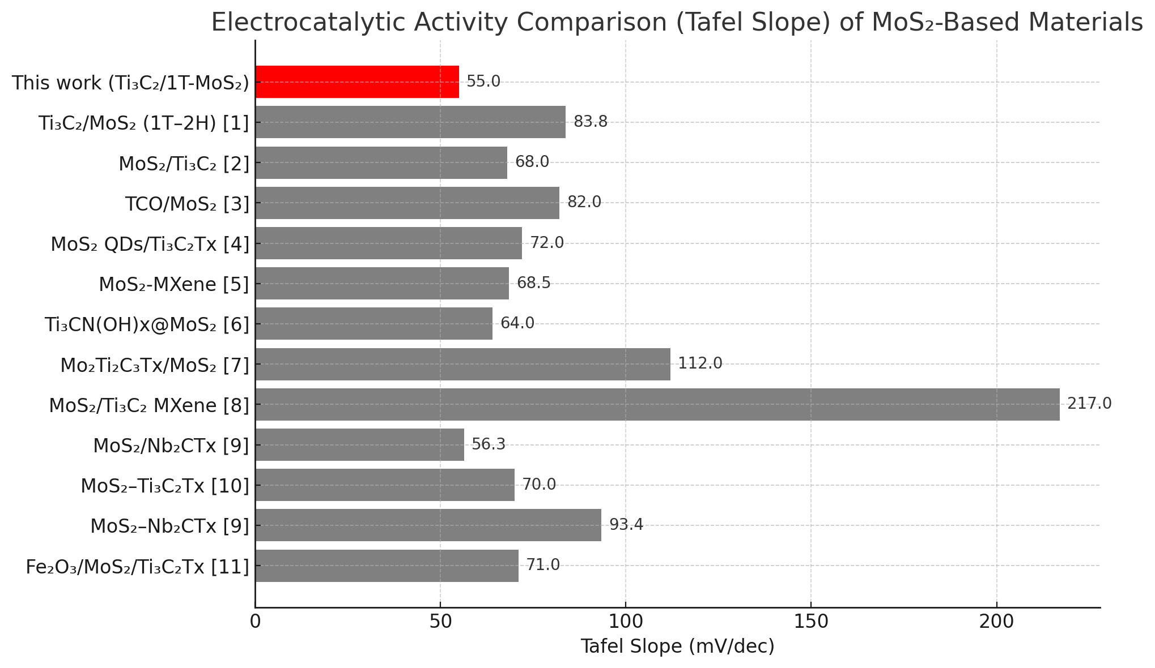
Figure S6. Bar chart comparing the Tafel slopes of MoS₂-MXene-based HER catalysts. The Ti₃C₂/1T-MoS₂ catalyst from this work is highlighted in red. Reference numbers correspond to those listed in Table S2.

Table S 3. The estimated Cdl and the corresponding ECSA of different samples
Catalysts | Cdl (mF cm⁻²) | ECSA (cm²)
TM-1 | 14 | 350
TM-2 | 11.8 | 295
TM-5 | 5.45 | 136.25
TM-10 | 4.5 | 112.5
1T-MoS₂ | 6.16 | 154
2H-MoS₂ | 1.82 | 45.5
Ti₃C₂ | 0.8 | 20

References

1 Loh, J. Y., Yap, F. M. & Ong, W.-J. 2D/2D heterojunction interface: Engineering of 1T/2H MoS2 coupled with Ti3C2Tx heterostructured electrocatalysts for pH-universal hydrogen evolution. Journal of Materials Science & Technology 179, 86-97 (2024). https://doi.org/https://doi.org/10.1016/j.jmst.2023.10.002
2 Huang, L., Ai, L., Wang, M., Jiang, J. & Wang, S. Hierarchical MoS2 nanosheets integrated Ti3C2 MXenes for electrocatalytic hydrogen evolution. International Journal of Hydrogen Energy 44, 965-976 (2019). https://doi.org/https://doi.org/10.1016/j.ijhydene.2018.11.084
3 Lontio Fomekong, R. et al. Enhancing the Electrocatalytic Properties of a One-Pot Synthesis of Defect-Rich 2D/2D Nanoheterointerface of Titanium Carbo-Oxide and Molybdenum Disulfide for Hydrogen Evolution Reaction in Acidic Medium. ACS Sustainable Chemistry & Engineering 11, 14528-14537 (2023). https://doi.org/10.1021/acssuschemeng.3c03621
4 Chen, L. et al. Quasi zero-dimensional MoS2 quantum dots decorated 2D Ti3C2Tx MXene as advanced electrocatalysts for hydrogen evolution reaction. International Journal of Hydrogen Energy 47, 10583-10593 (2022). https://doi.org/https://doi.org/10.1016/j.ijhydene.2021.12.185
5 Raj, S. K., Sharma, V., Mishra, S. & Kulshrestha, V. MoS 2 quantum dot-modified MXene nanoflowers for efficient electrocatalytic hydrogen evolution reaction. RSC Applied Interfaces 1, 1057-1068 (2024).
6 Jiang, J. et al. Carbonitride MXene Ti3CN(OH)x@MoS2 hybrids as efficient electrocatalyst for enhanced hydrogen evolution. Nano Research 16, 4656-4663 (2023). https://doi.org/10.1007/s12274-022-5112-x
7 Hanan, A., Numan, A., Norhaffis Mustafa, M., Walvekar, R. & Khalid, M. High-performance Mo2Ti2C3Tx/MoS2 hybrid electrocatalyst for sustainable hydrogen production. International Journal of Hydrogen Energy 161, 150533 (2025). https://doi.org/https://doi.org/10.1016/j.ijhydene.2025.150533
8 Hasanah, R. et al. Two-dimension MoS2/Ti3C2 MXene nanocomposite for an efficient hydrogen evolution reaction in alkaline media. Materials Research Bulletin 190, 113514 (2025). https://doi.org/https://doi.org/10.1016/j.materresbull.2025.113514
9 Hu, L. et al. Experimental and theoretical investigation on MoS2/MXene heterostructure as an efficient electrocatalyst for hydrogen evolution in both acidic and alkaline media. New Journal of Chemistry 44, 7902-7911 (2020). https://doi.org/10.1039/D0NJ00956C
10 Liu, J. et al. Hierarchical “nanoroll” like MoS2/Ti3C2Tx hybrid with high electrocatalytic hydrogen evolution activity. Applied Catalysis B: Environmental 241, 89-94 (2019). https://doi.org/https://doi.org/10.1016/j.apcatb.2018.08.083
11 Dongre S, S. et al. Synergistic Catalyst Design for Enhanced Electrochemical Hydrogen Evolution: Fe2O3/MoS2/Ti3C2Tx MXene Ternary Composite. ACS Applied Engineering Materials 2, 943-954 (2024). https://doi.org/10.1021/acsaenm.4c00027

