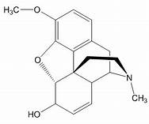Codeine
Graphical illustration of the impact and associated mechanism of codeine on human spermatozoa
Reduced motility
Plasma membrane damage
DNA damage

ROS generation
Human spermatozoa

