Statistical comparison between the Multimodal Transformer Model and baseline models using DeLong test on combined datasets (Test1 + Test2). Color intensity represents -log₁₀(p-value). All comparisons showed significant differences (** p<0.01,***p<0.001).

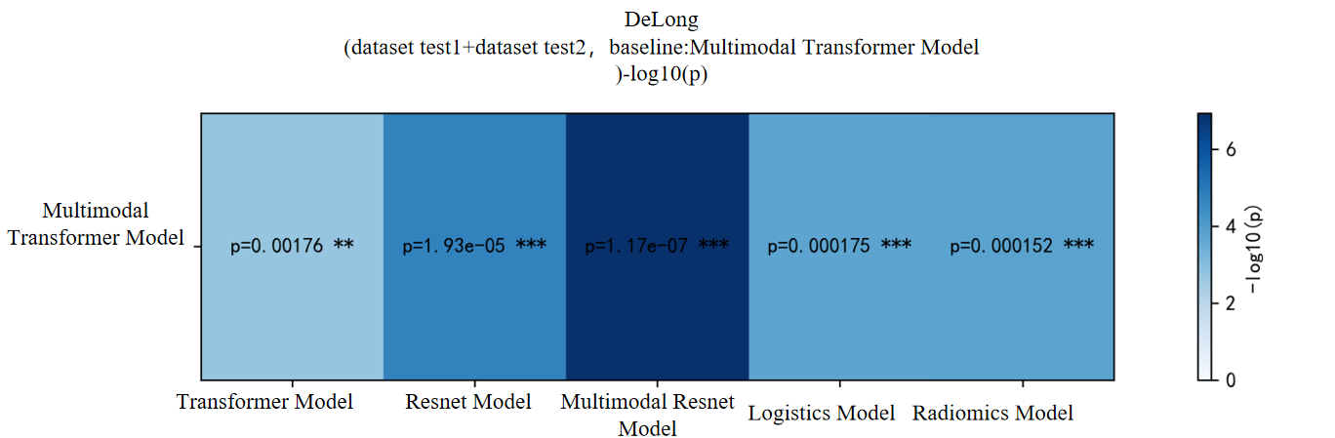

Performance comparison of six models across training set (green), test set (blue), and independent external test set (orange).

