Supplementary Information

On-chip 2D beam-steering with a liquid-crystal-tunable optical phased array

Kazuki Nakamura¹, Akira Hashiya¹, Takaiki Nomura¹, Yoshikazu Yamaoka¹, Masahiko Tsukuda¹, Hiroyuki Takagi¹, Yoshiki Sasaki¹, Atsushi Ishikawa¹, Daivid Fowler², Stephane Malhouitre², Viviane Muffato², Wilfried Rabaud², Kazuya Hisada¹, Taku Hirasawa¹ and Yasuhisa Inada¹

1 Technology Division, Panasonic Corporation, 1006 Kadoma, Kadoma City, Osaka 571-8508, Japan.
2 University Grenoble Alpes and CEA, LETI, Minatec Campus, F-38054 Grenoble Cedex, France.

*inada.yasuhisa@jp.panasonic.com

1. Device Fabrication
Figure S1 illustrates the overall flow of fabrication process. The samples were fabricated using a modified CMOS-compatible silicon photonics process. The DBRs of SiO₂/TiO₂ were deposited onto the top and bottom substrates by a vapor deposition method. The liquid crystal (LC) process was carried out after preparing the top and bottom substrates. Firstly, photo-spacers were formed on the bottom substrate (Fig. S2) to define the gap in which the LC was introduced after bonding the substrates. The alignment films were applied to both substrates. For the aligning process, the photo-aligning method was applied for the bottom substrate, while the rubbing method was applied for the top substrate to generate the pretilt angle. Such a pretilt alignment was needed to avoid disclinations in the LC core. These substrates were bonded in a vacuum laminator with a UV curing resin, forming a C-shaped pattern (Fig. 3a). Finally, the LC (5CB: nematic liquid crystal with n=1.52 (ordinary), n=1.68 (extraordinary)) was injected by putting the LC at the opening of the C-shaped pattern and then releasing the vacuum. The opening was sealed with the same UV curing resin.
The thickness distribution of the sample with the single LC-tunable Bragg reflector waveguide outcouplers was determined by a retardation measurement (Fig. S3). A homogeneous thickness was obtained owing to the vacuum bonding process with the photo spacers. The thickness of the LC core was ~2470 nm for the beam steering experiments shown in Fig. 3.

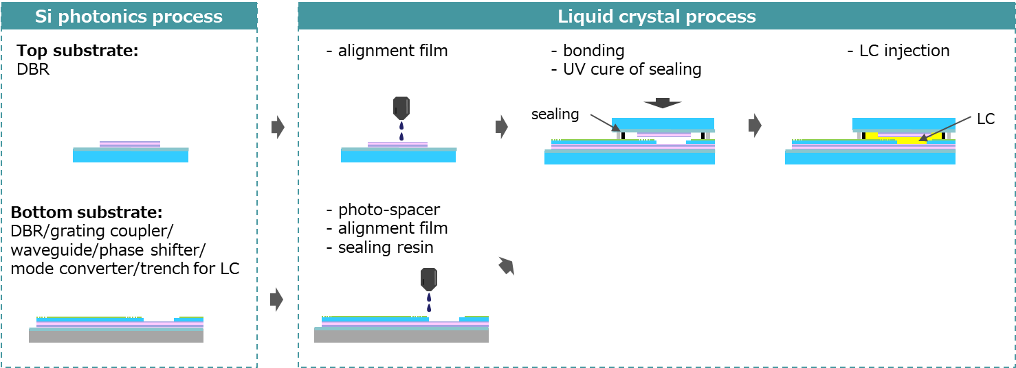

Fig. S1| Schematic of the fabrication process. The top and bottom substrates were fabricated using a modified Si photonics process. For the bottom substrate, photo-spacers were formed, followed by applying the alignment film. Another alignment film process was also conducted for the top substrate. These substrates were bonded with UV curable resin. The LC was introduced using the vacuum injection method.

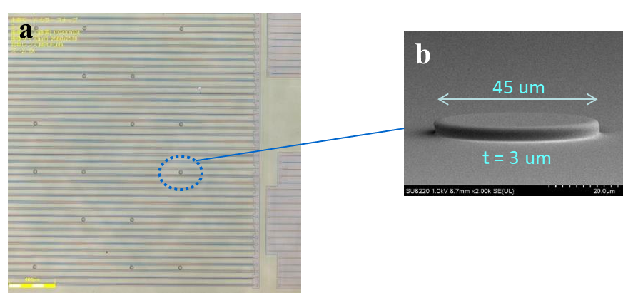
Fig. S2| Photo spacers. a, A microscope image of the photo spacers formed on the bottom substrate. b, A close-up SEM image of the photo spacer. Photo spacer material was spin-coated onto the substrate and patterned by photolithography to uniformly distribute the photo spacers over the waveguides. The height of the spacer was carefully controlled by the rotation speed of the spin coating.

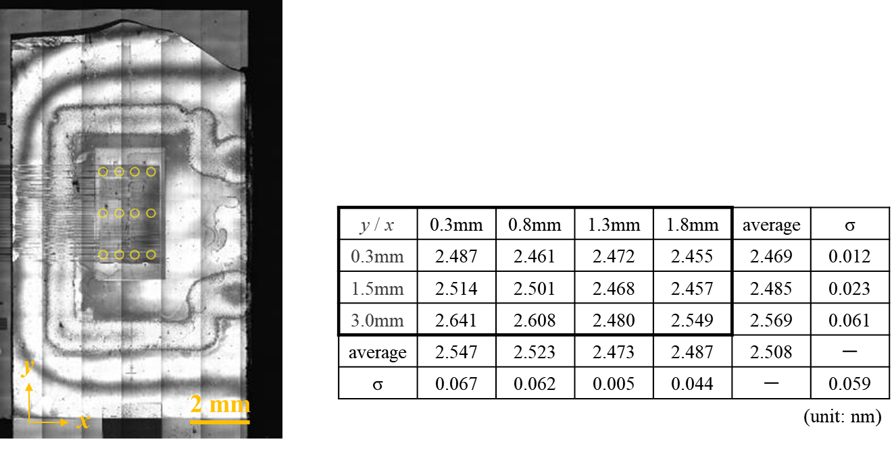
Fig. S3| Measurement of the LC thickness distribution. The LC thickness of single LC-tunable Bragg reflector waveguide outcouplers was determined by a retardation measurement. The thickness distribution is summarized in the table.

2. DBR Design
The reflectivity of the bottom DBR must be higher than that of the top DBR to extract the guided mode to the air through the top DBR. The top DBR is designed to exhibit the reflectivity of ~99.6%, while a reflectivity of more than 99.96% was targeted for the bottom DBR. The parameters of the stack are listed in the Table S1, and the calculated reflectivity is shown in Fig. S4.

Table. S1| DBR stack design. The material, refractive index, and thickness of each layer is listed.
Bottom DBR |  |  |  | Top DBR
Layer # | Material | Index | Thickness (nm) | Layer # | Material | Index | Thickness (nm)
1 | TiO2 | 2.36 | 107 | 1 | TiO2 | 2.36 | 107
2 | SiO2 | 1.47 | 172 | 2 | SiO2 | 1.47 | 171
3 | TiO2 | 2.36 | 107 | 3 | TiO2 | 2.36 | 107
4 | SiO2 | 1.47 | 172 | 4 | SiO2 | 1.47 | 171
5 | TiO2 | 2.36 | 107 | 5 | TiO2 | 2.36 | 107
6 | SiO2 | 1.47 | 172 | 6 | SiO2 | 1.47 | 171
7 | TiO2 | 2.36 | 107 | 7 | TiO2 | 2.36 | 107
8 | SiO2 | 1.47 | 172 | 8 | SiO2 | 1.47 | 171
9 | TiO2 | 2.36 | 107 | 9 | TiO2 | 2.36 | 107
10 | SiO2 | 1.47 | 172 | 10 | SiO2 | 1.47 | 171
11 | TiO2 | 2.36 | 107 | 11 | TiO2 | 2.36 | 107
12 | SiO2 | 1.47 | 172 | 12 | SiO2 | 1.47 | 171
13 | TiO2 | 2.36 | 107 | 13 | TiO2 | 2.36 | 107
14 | SiO2 | 1.47 | 172 | 14 | SiO2 | 1.47 | 171
15 | TiO2 | 2.36 | 107 | 15 | TiO2 | 2.36 | 107
16 | SiO2 | 1.47 | 172
17 | TiO2 | 2.36 | 107
18 | SiO2 | 1.47 | 172
19 | TiO2 | 2.36 | 107
20 | SiO2 | 1.47 | 172
21 | TiO2 | 2.36 | 107

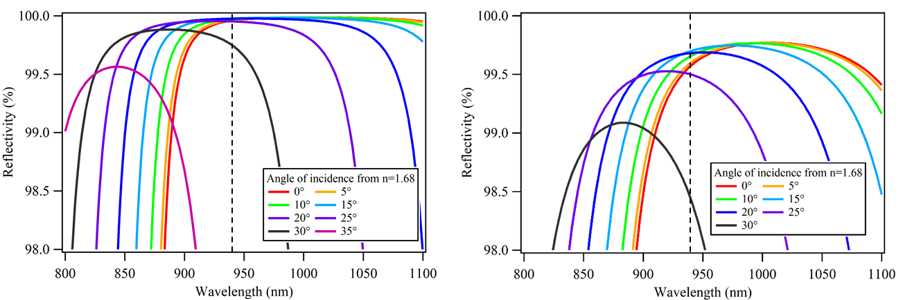
Fig. S4| Simulated reflectivity of the bottom (left) and top (right) DBRs. The reflectivity is calculated for a light incident from n=1.68, assuming a guided mode in LC core.
3. LC-tunable OPA Sample
Figure S5 shows the LC tunable OPA sample. As shown in Fig. S5b, laser light was introduced from an optical fiber to an input grating coupler of the sample. The voltages were applied to the phase shifters and the LC with multi contact probes. Near-field and far-field images were taken by an image sensor. Fig. S5e shows a close-up SEM image of trenches for the LC cores, revealing defects on the bottom trenches due to a process error. The scattered light in the horizontal direction shown in Fig.4b is considered to be due to these defects.

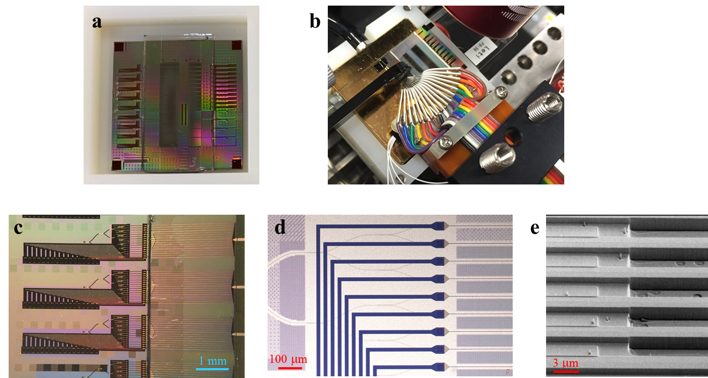
Fig. S5| LC tunable OPA sample. a, A photograph of the sample. b, The sample with a fiber input and voltage application setup. The near and far field emission were collected with an objective lens, and their images were taken with an image sensor. c, A microscopic image of the LC tunable OPAs, and d, the OPA (waveguides and phase shifters). e, A close-up SEM image of trenches for the LC cores. Some defects caused by a process error are seen on the bottom of the trenches.

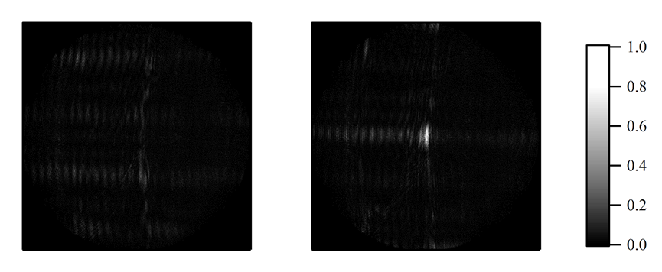
Fig. S6| Initial OPA phase calibration. The far-field images before (left) and after (right) phase calibration. The individual phase of the waveguides was carefully tuned to make an output beam converged. The phase calibration is carried out for each beam-steering angle.

4. Response Time Measurement
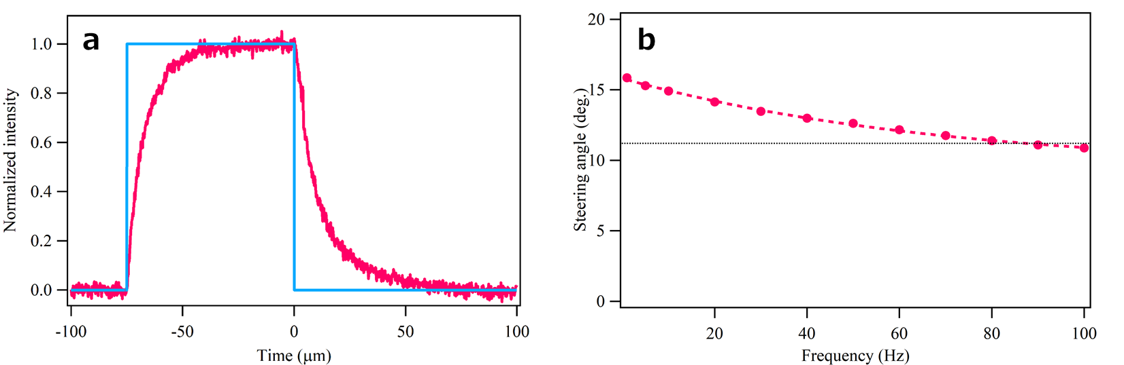
Fig. S7| Measurements of time response. a, The temporal response of the Mach–Zehnder interferometer (MZI) with the thermo-optic phase shifter. The thermal constant is obtained by fitting the signal with an exponential function. The 1/e response time is 14 μs. b, The frequency response of the LC-tuning, demonstrating the steering angle decreases as the frequency increases. The dashed line represents the fitting by an exponential function. The 3-dB bandwidth is ~85 Hz (~12 ms).

5. LC Simulations
The LC simulations was performed using a simulation tool (Expert LCD provided by LinkGlobal21). The LC is mostly oriented along the alignment film on the top and bottom DBRs, but the LC near the SiO₂ cladding is fixed against the film. When the external field is applied in the y-direction, most of the LC is aligned with the field, but the LC near the alignment film is fixed. These effects result in the smaller index tuning range for the TE mode than the birefringence amplitude of the LC material.
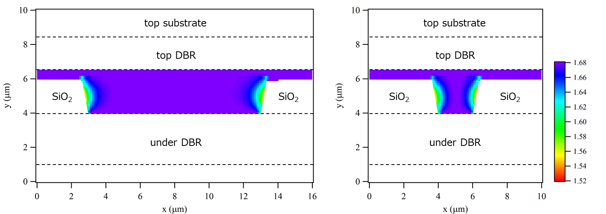
Fig. S8| LC simulations. The refractive index distribution of the LC for the TE mode. The LC orientation is defined by the alignment film on top and bottom DBRs, but the LC near the SiO₂ cladding is fixed against the alignment film.

6. Slab Waveguide Design
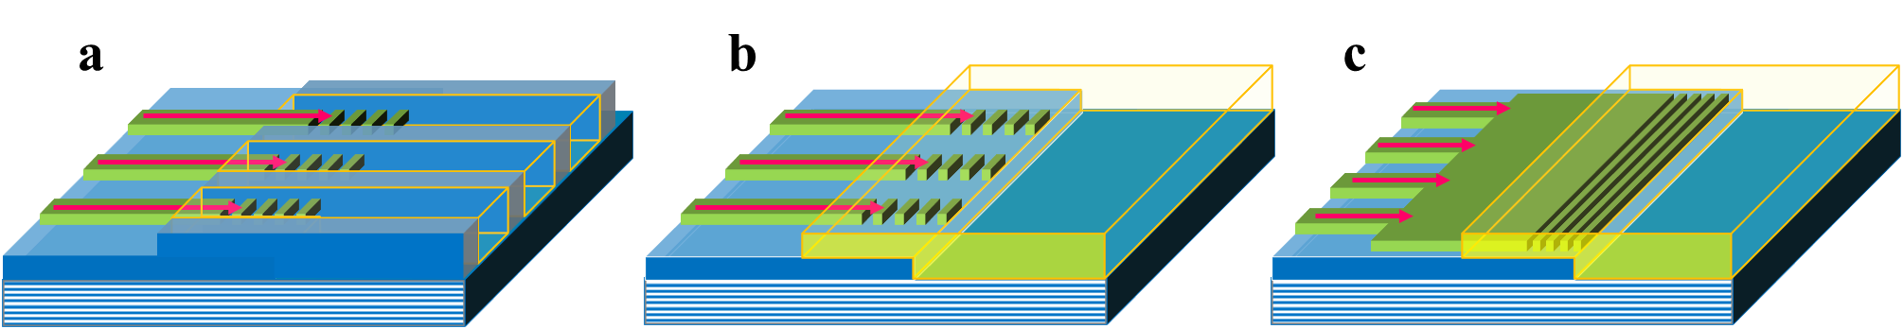

Fig. S9| LC tunable OPA designs. a, Array of Bragg reflector LC waveguides in this work. Each LC waveguide is separated by SiO₂ claddings. Light from single mode waveguides is individually transferred to the LC waveguides. b, An array of single mode waveguides is connected to a LC slab waveguide. c, An array of single mode waveguides are combined to a slab waveguide. Light is then transferred to a LC slab waveguide. In b and c, the space for the LC is large so that the reorientation of the LC is unimpeded, whereas the LC near the SiO₂ cladding is fixed in a.

