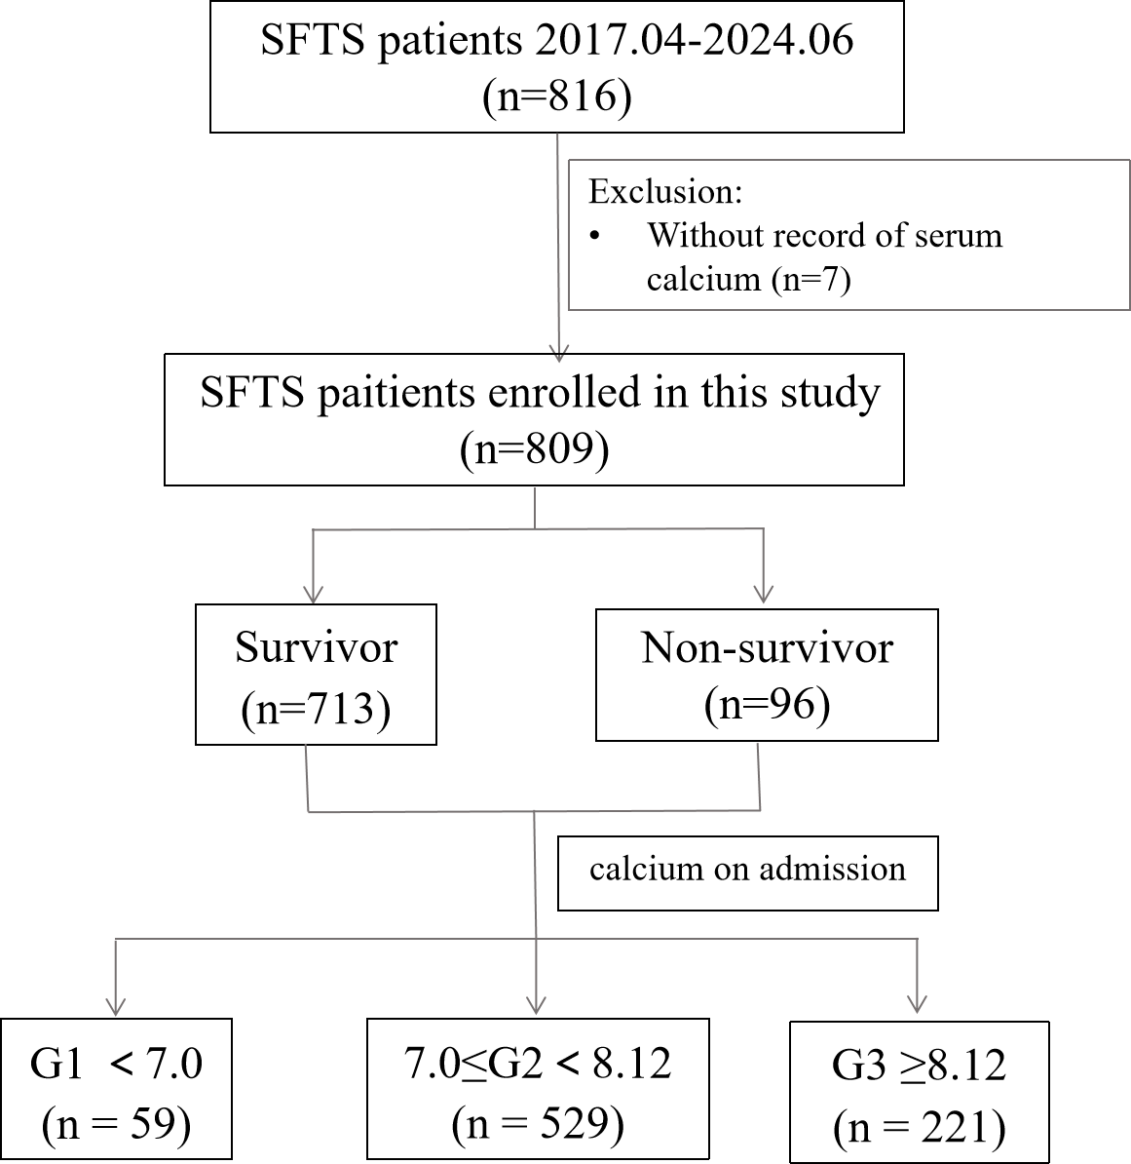
S1 Fig Flowchart of participants enrollment in the study

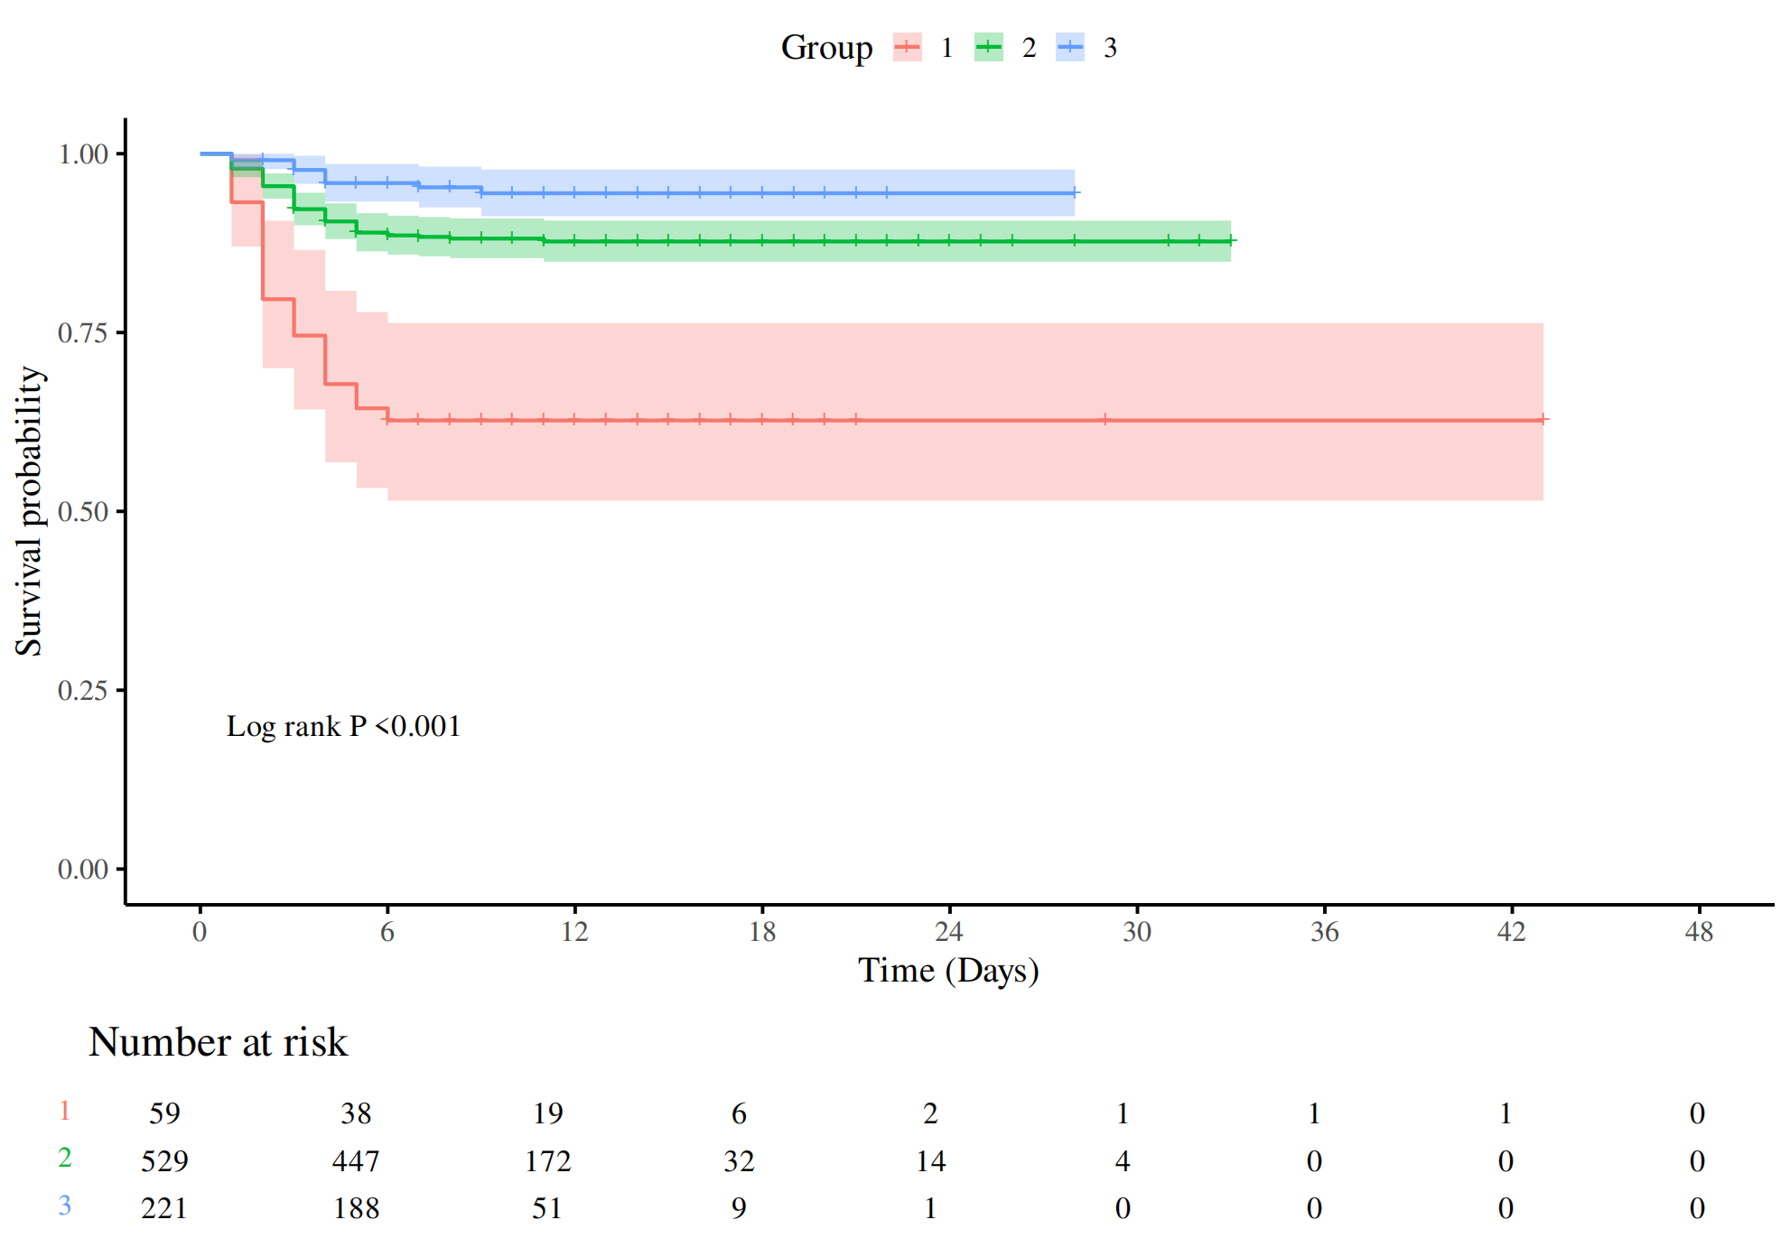
S2 Fig Kaplan-Meier survival analysis curves according to the serum calcium levels between the three groups

