Table S1: Characteristics of external study cohorts used in our study

Study | Reference | Dataset | Total participants | CRC patients in our study | Age, median | BMI, median
Cong, J., et al. (2018) | [1] | PRJNA422482 | 22 | 10 | 59 (IQR = 29) | 25.5 ± 1.2
Hernández‐González, P. I., et al. (2023) | [2] | PRJNA871042 | 111 | 65 | 73.2 ± 10.8 | 24.8 ± 6.5
Png, C.-W., et al. (2022) | [3] | PRJNA662014 | 37 | 12 | 63.8 ± 9.3 | 25.8 ± 4.0
Lee, S. Y., et al. (2023). | [4] | PRJNA948146 | 20 | 10 | 63.1 ± 9.5 | 23.7 ± 3.6

Supplementary Figure

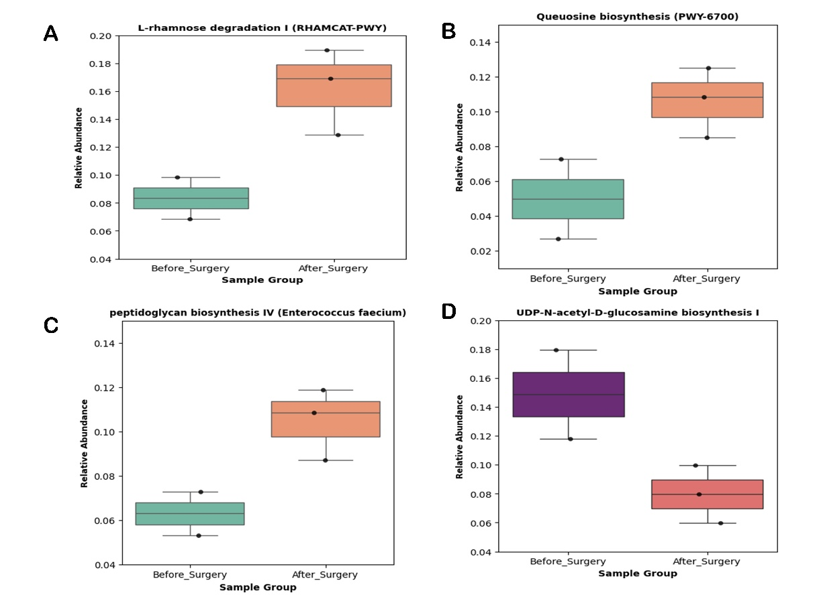
Fig. S1: Top-ranked PICRUSt-predicted gut microbial pathways enriched between pre- and post-surgery colorectal cancer (CRC) patients.

References

Cong J, Zhu H, Liu D, Li T, Zhang C, Zhu J, Lv H, Liu K, Hao C, Tian Z (2018) A pilot study: changes of gut microbiota in post-surgery colorectal cancer patients. Frontiers in microbiology 9:2777
Hernández‐González PI, Barquín J, Ortega‐Ferrete A, Patón V, Ponce‐Alonso M, Romero‐Hernández B, Ocaña J, Caminoa A, Conde‐Moreno E, Galeano J (2023) Anastomotic leak in colorectal cancer surgery: Contribution of gut microbiota and prediction approaches. Colorectal Disease 25(11):2187-2197
Png C-W, Chua Y-K, Law J-H, Zhang Y, Tan K-K (2022) Alterations in co-abundant bacteriome in colorectal cancer and its persistence after surgery: a pilot study. Scientific Reports 12(1):9829
Lee SY, Park H-M, Kim CH, Kim HR (2023) Dysbiosis of gut microbiota during fecal stream diversion in patients with colorectal cancer. Gut Pathogens 15(1):40

