Supplementary material:

Amino acids as molecular linchpins in fundamental prebiotic processes

Udita Bandyopadhyay^{1#}, Souradeep Das^{1#}, Sahil Sunil Mulewar¹, R Tejashwini¹, Sudha Rajamani^{1*}
Additional information on methods:
S1. Buffer Preparation
200 mM buffer of pH 9.6 or pH 8.5 was prepared in the following manner: 200 mM solutions of respective amino acids were made in CHES (N-cyclohexyl-2-aminoethanesulfonic acid) pH 9.6 buffer and control reactions involved use of Bicine (N,N-Bis(2-hydroxyethyl) glycine) pH 8.5 buffer; they were made by adding an appropriate amount of the solute in filtered Nanopure water (18 MΩ) water. The pH of the Bicine and CHES buffer solutions was brought to pH 8.5 and 9.6, respectively, by adding the required amount of NaOH and mixing the buffer solutions thoroughly. The pH of the buffer was also checked after adding oleic acid to it, which remained unchanged. This confirmed the buffering ability of amino acid solutions under our experimental conditions.
S2. Pyrene- and Laurdan-based solvatochromic probe assays
Pyrene excimer formation was used to estimate bilayer content in each sample using the protocol previously standardised in our lab (Sarkar et al., 2021). Intensity ratio of pyrene excimer peak (I_{ex}) at 470 nm and the I₁ intensity of the first vibronic peak at 372 nm indicates the extent of excimerization of pyrene molecules when excited with a light of 335 nm wavelength (Liu et al., 2020). The excimerization, i.e. pi-pi interaction between P and P* states of pyrene, increases with an increase in bilayer formation. This results in a decrease in I_{ex}/ I₁ ratio, which we have calculated and plotted. Oleic acid vesicles as a positive control was made in pH 8.5 bicine buffer which is the optimum condition for this process, and data of these control samples were compared with the data of different vesicle samples prepared in all the amino acid buffered solutions (Method section 5).
Laurdan is a non-polar fluorescent solvatochromic probe that shows a red shift with increasing polarity in its environment. It has a hydrocarbon chain, which makes it preferably partition into the bilayer, with its ring structure present closer to the head group of the amphiphile. All these properties make laurdan a preferable choice for studying membrane properties. Appropriate volume of 200 μM laurdan stock was added to the lipid suspensions, so as to keep its concentration at 3 μM in the final solution. The samples were then incubated at RT for a minimum of 15 minutes before subjecting to fluorescence spectroscopy using a Fluoromax-4 spectrophotometer. Each sample was subjected to a steady-state fluorescence measurement detailed in Method section 5.
S3. Dynamic Light Scattering
Vesicle sizes were estimated using dynamic light scattering (DLS). Vesicle suspensions for DLS were prepared using the same method of dry lipid film rehydration using appropriate buffer or amino acid stock solution. The samples were equilibrated in the DLS instrument cuvette holder for at least three minutes. Disposable polycarbonate cuvettes were used for the measurements and 800 µL of sample was used in the cuvette (4-sided, 12.5 X 12.5 X 45 mm) for each measurement. The DLS Instrument Malvern Panalytical Zetasizer Nano ZS90 (Malvern, UK), has a theoretical limit of measuring 10 µm as a result of which particle sizes larger than 10 µm were not detected in the experiment.

Supplemental figures (S1-S5, Table T1-T3):
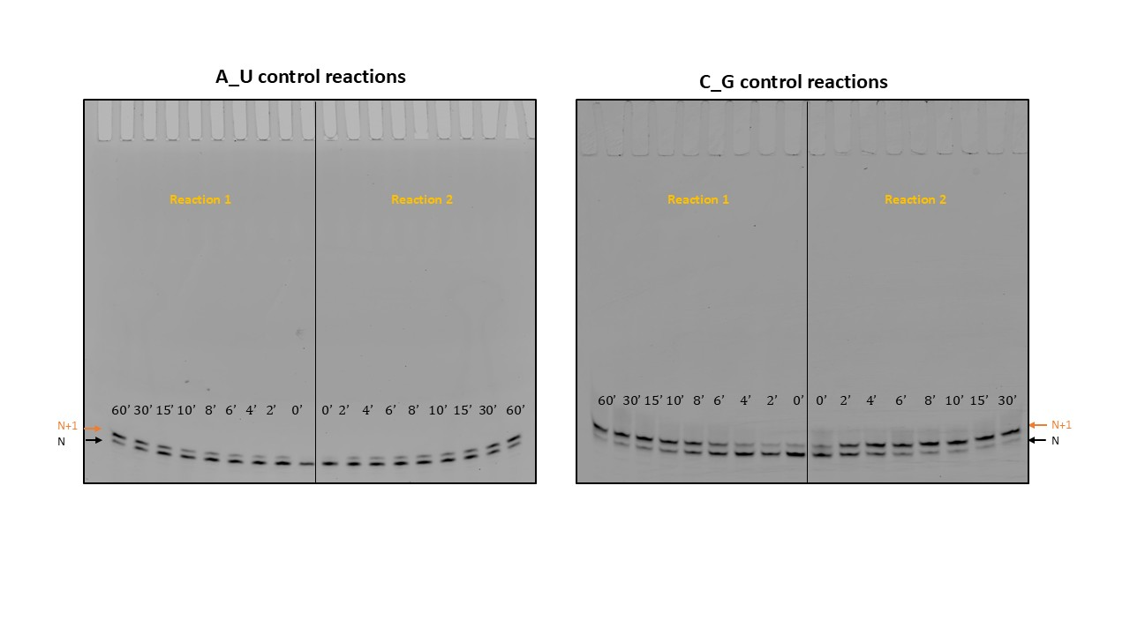
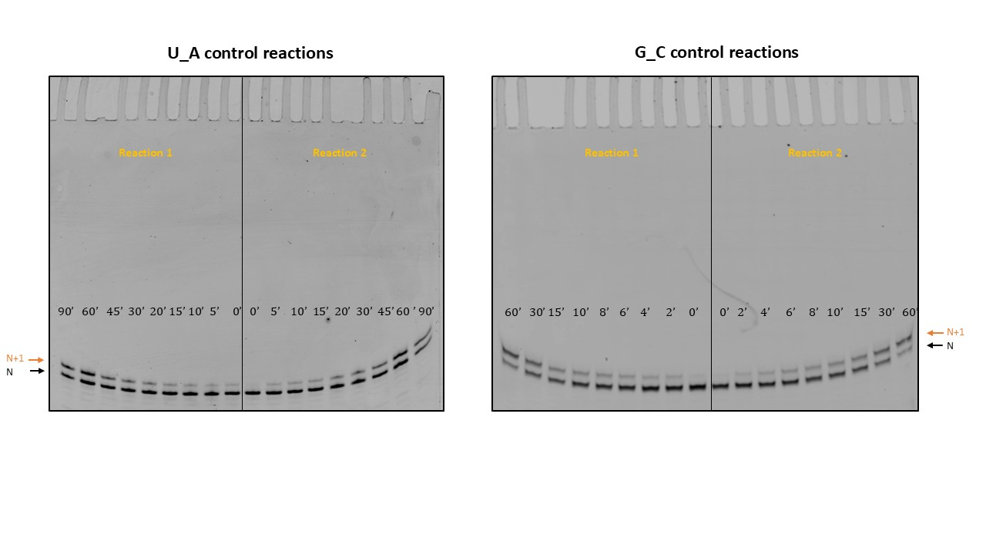
A)

B)

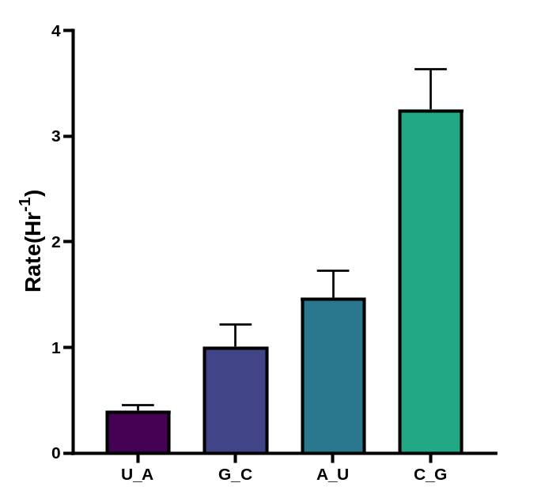
Figure S1: A) Uncropped gel images for all the control reactions (in presence of 10 mM Mg²⁺), which were run on 20% Urea gels (20 X 20 cm) having 20 wells. Reaction replicates were run simultaneously in a single urea gel. The upper band represents N+1 and the lower band represents the N primer. The images shown here were contrast adjusted using Fiji ImageJ software for effective viewing. B) Bar graph showing the difference in the rate of the control reactions obtained for the four different primer-template complexes when facilitated only in presence of Mg²⁺. The highest rate was seen in the case of C_G and the lowest rate for U_A, N=3; The error bars represent standard deviations among individual replicates.

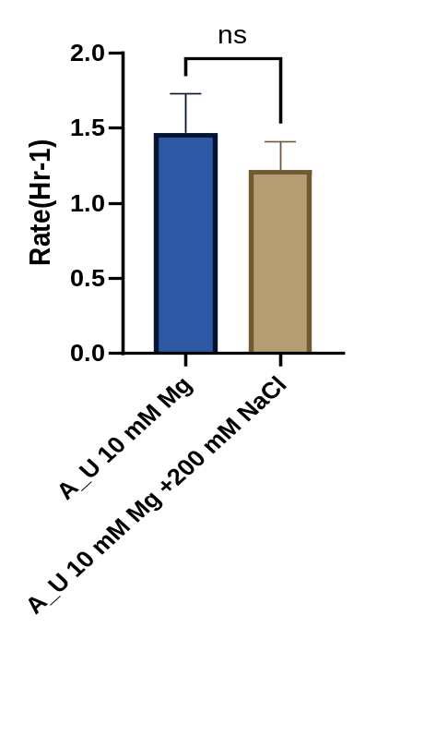
Figure S2: Bar graph showing the difference in the rates obtained for control A_U reaction having 10 mM Mg²⁺ versus the rate obtained for A_U reaction having 10 mM Mg²⁺ in presence of 200 mM NaCl. The presence of Mg²⁺ along with NaCl did not result in any significant change in the reaction rate. For statistical analysis unpaired student’s t-test was performed. N=3 for A_U control reactions and N=2 for the A_U 10mM Mg²⁺ + 200 mM NaCl containing reactions. Error bars represent standard deviations.

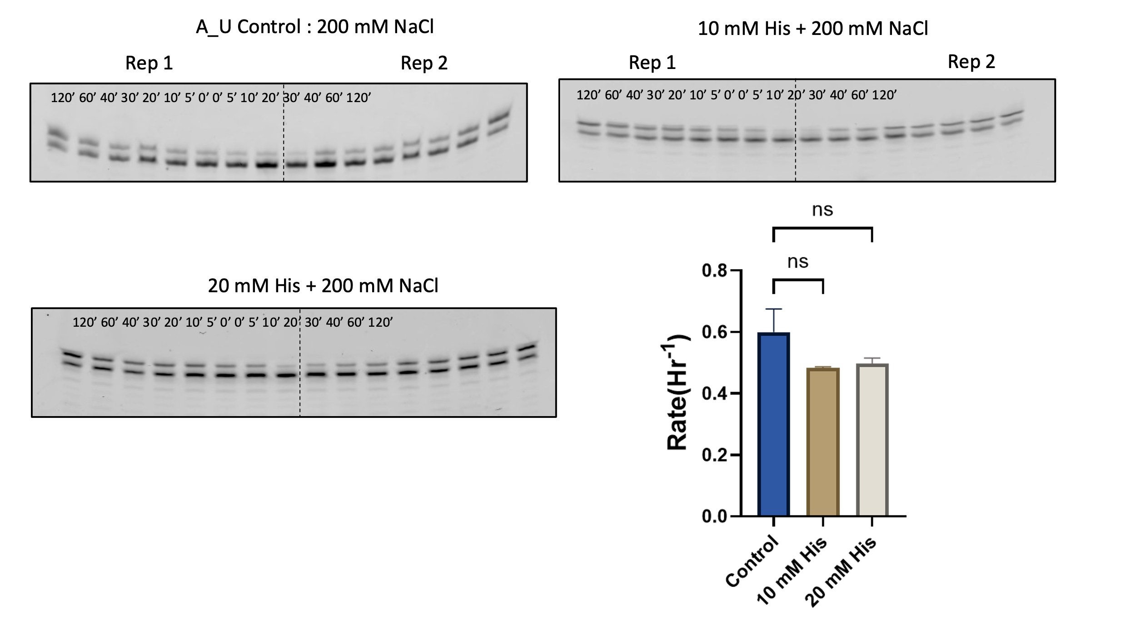
Figure S3: The effect of 10 mM Histidine on templated RNA replication in the presence of 200 mM Na⁺ for A_U reactions: Histidine did not show any significant effect on the control reaction rate that was carried out in mix having 200 mM NaCl. When the concentration of histidine was doubled in the 200 mM NaCl reaction, there was still no significant change. Error bars represent the standard deviation, N=3 for A_U control. N=2 for the other two amino acid reactions. Two representative gels have been used the control reactions.

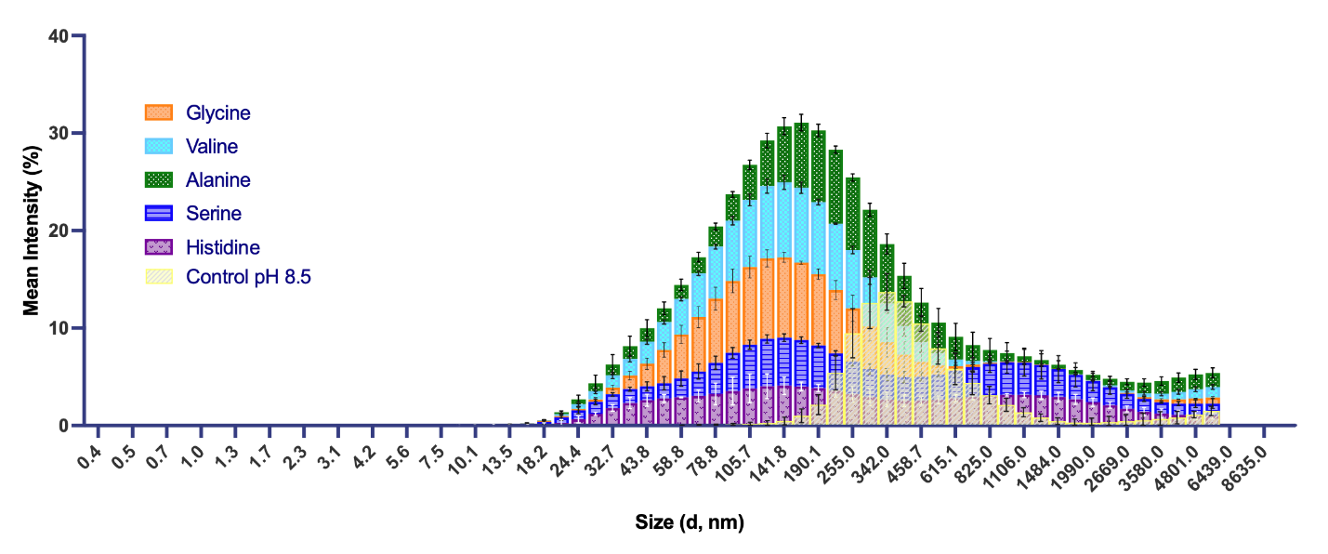
Figure S4. Comparison of size distribution of the vesicles that result in the different amino acid solutions versus the ones that form in the control optimum condition of pH 8.5 using synthetic bicine buffer (light yellow overlay). The data was obtained using DLS and plotted as a stacked Gaussian distribution graph wherein the total area under the curve for each sample (plot) amounts to 100%. Each bar represents the amount/percentage of vesicles of a certain size that were detected in a specific size range or of a specific hydrodynamic radius (diameter in nanometers), as mentioned on the X axis.

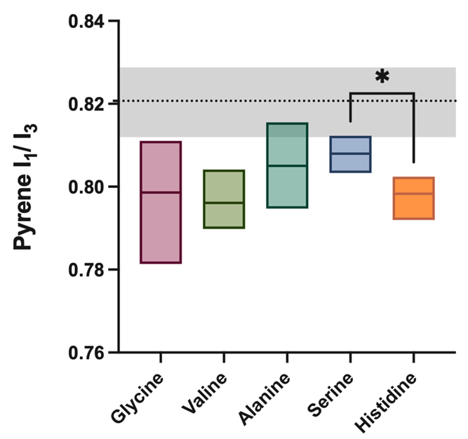
Figure S5. Pyrene I1/I3 ratio plots for fatty acid vesicles that formed in different amino acid solutions. Mean of the data is marked as a midline in each box while the upper and lower limits are defined by the edges of each box. The data is averaged over three experimental replicates. Data for control vesicles in pH 8.5 bicine buffer is plotted as a baseline (black dashed line whose value range has been indicated in grey).

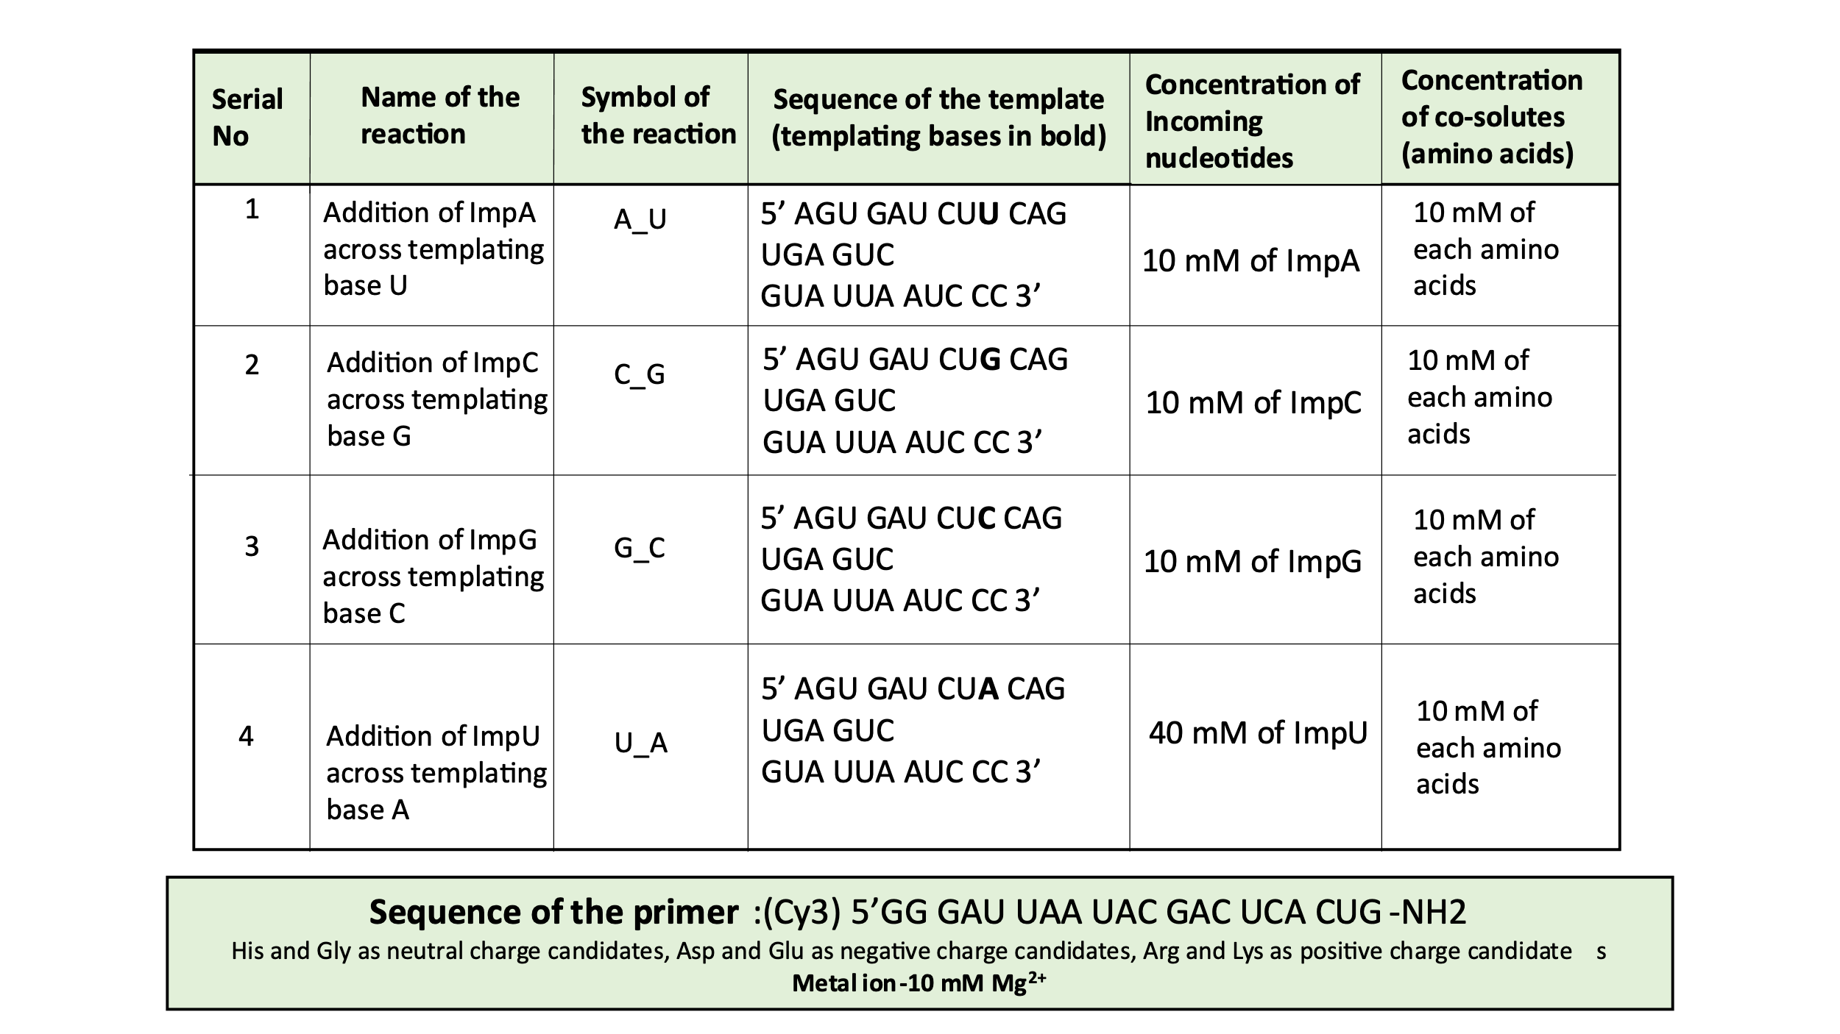

Supplementary Table 1: Reaction conditions and the sequences of primer and templates used in the study.

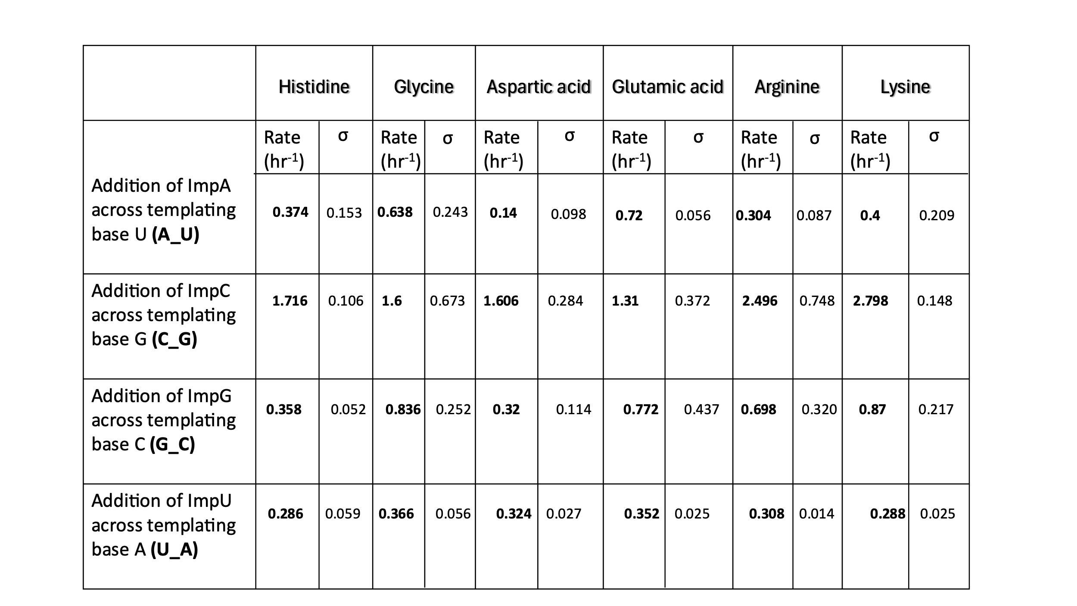
Supplementary Table T2: Rates (hour⁻¹) obtained for all the templated-replication reactions that were carried out in the presense of amino acid (10 mM) and 10 mM Mg²⁺. σ denotes the standard deviation among the experimental replicates. For all the sets, N=3 reactions have been considered. The rates have been analyzed by using ImageQuant TL D v8.2.0 and Excel 2016 software.

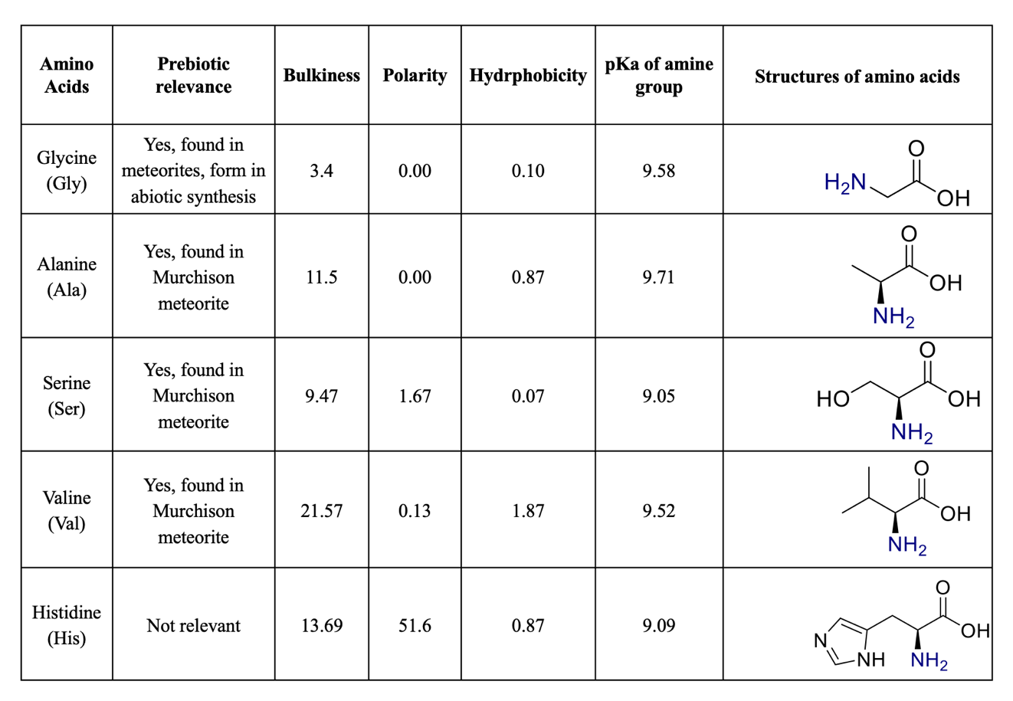

Supplementary Table T3. Different parameters of L-amino acids that were considered in this study as they could impinge on the amino acids’ potential for interaction with the fatty acid vesicles. Our results show that these amino acids were demonstrating buffering capacity of in the 9.6 range; the pKa of ɑ-amine group in the backbone (marked in blue) is potentially responsible for the buffering seen in the amino acid solutions. Data in the table is compiled and adapted from (Jones, 1975).

References:
Jones DD. Amino Acid Properties and Side-Chain Orientation in Proteins: A Cross Correlation Approach. J Theor Biol 1975;50(1):167–183; doi: 10.1016/0022-5193(75)90031-4.
Liu T, Huang Z, Feng R, et al. An Intermolecular Pyrene Excimer-Based Ratiometric Fluorescent Probes for Extremely Acidic pH and Its Applications. Dyes Pigments 2020;174:108102; doi: 10.1016/j.dyepig.2019.108102.
Sarkar S, Dagar S and Rajamani S. Front Cover: Influence of Wet–Dry Cycling on the Self‐Assembly and Physicochemical Properties of Model Protocellular Membrane Systems (ChemSystemsChem 5/2021). ChemSystemsChem 2021;3(5); doi: 10.1002/syst.202100033.

