Supplementary Materials

The five cities in this analysis includes Bridgeport, CT, Middletown Township, NJ, Norfolk VA, Wilmington SC, and Jacksonville FL. The entire boundary of each city is included. For Middletown, the adjacent areas of Atlantic Highlands and Highlands are also included. For Jacksonville, the towns along the barrier island next to Jacksonville are also included from Atlantic Beach to Palm Valley.

Elevation

The spatial analysis begins by measuring the elevations within each city to identify what locations were less than 15 feet in elevation and therefore vulnerable to flooding. The white areas are above 15 feet and not vulnerable to coastal flooding. The map for Jacksonville is in the paper. The maps for the other cities are below. Except for Norfolk which is almost entirely vulnerable to flooding, the flood vulnerable parts of most of the cities lie very close to the coast. Note that the “coast” includes stretches that run deep into the interior along rivers. The actual coastline is much longer than a straight line from one end of the map to the other.

Figure S.1 Elevations of Bridgeport CT

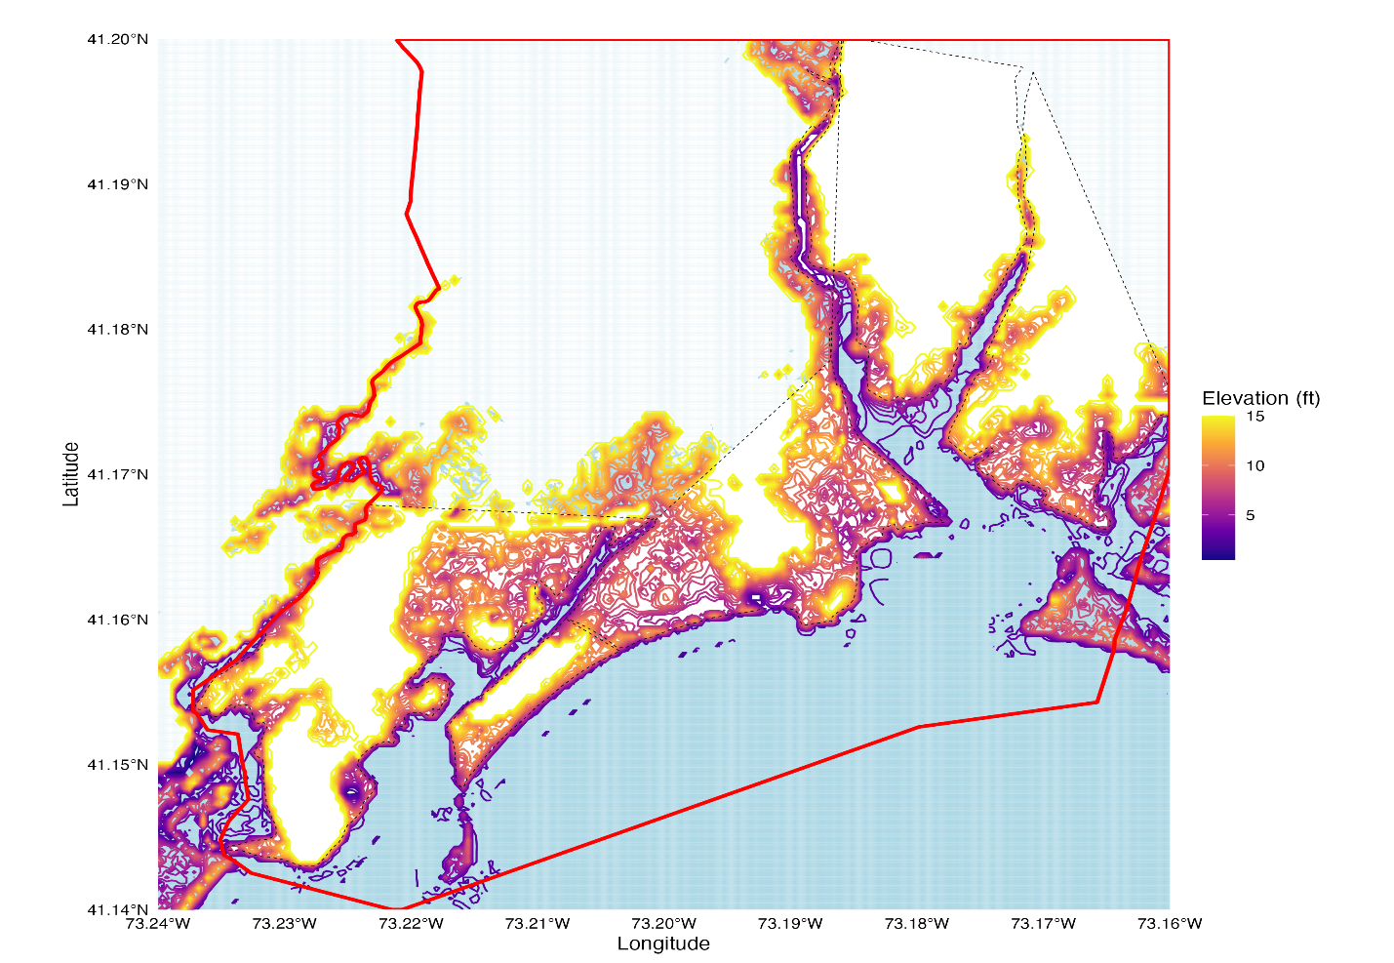

Figure S.2 Elevations of Middletown Township

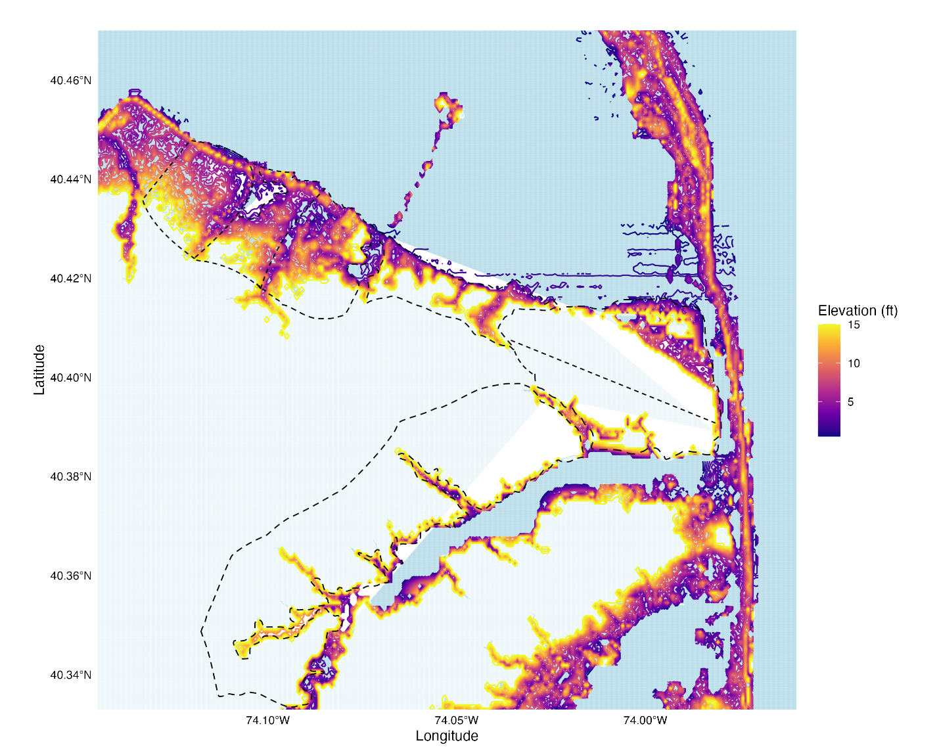
Figure S.3 Elevations of Norfolk VA
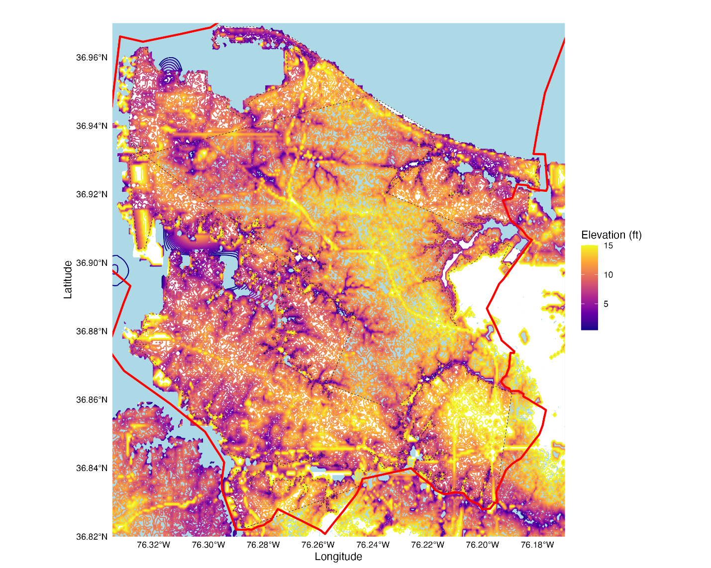

Figure S.4 Elevations of Wilmington SC

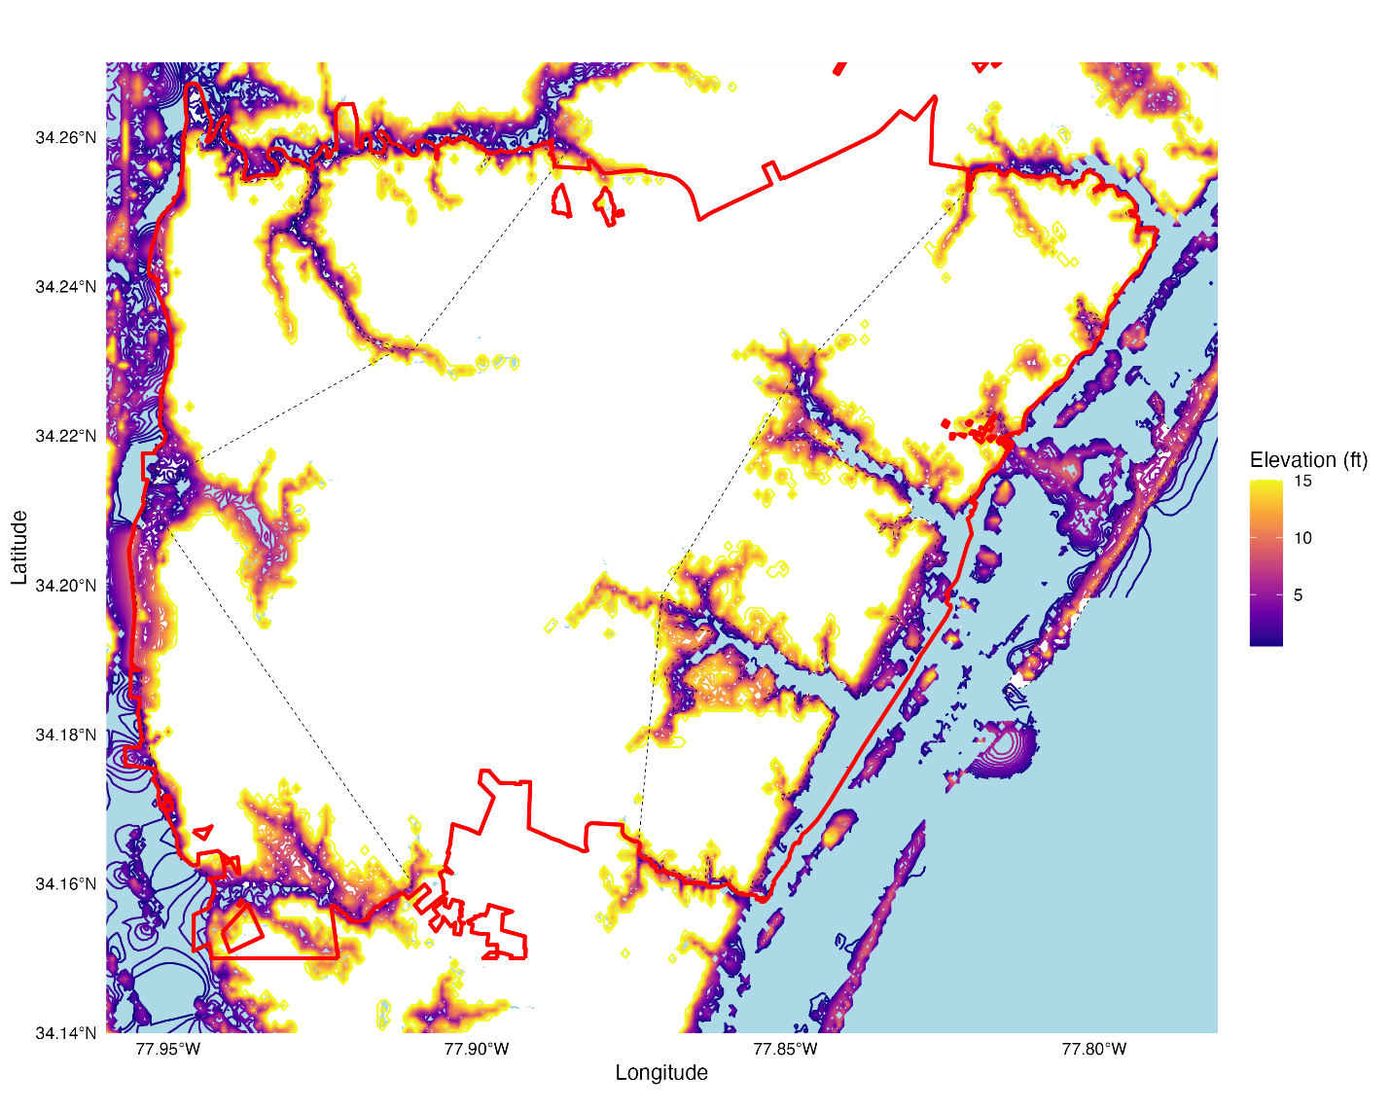

Segments

The elevation maps reveal there are a number of independent section of land along the coast that are independent from their neighbor. Quite often the edge is an inland river. Each of these segments has been numbered in the figure below and had been studied separately by the model. The segments of Norfolk VA are in the paper.

Figure S.5 Segments of Bridgeport CT

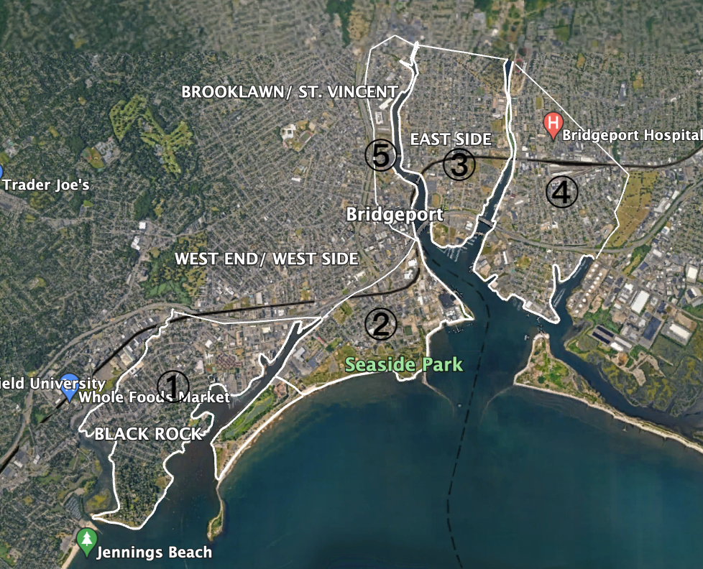

Figure S.6 Segments of Middletown Township

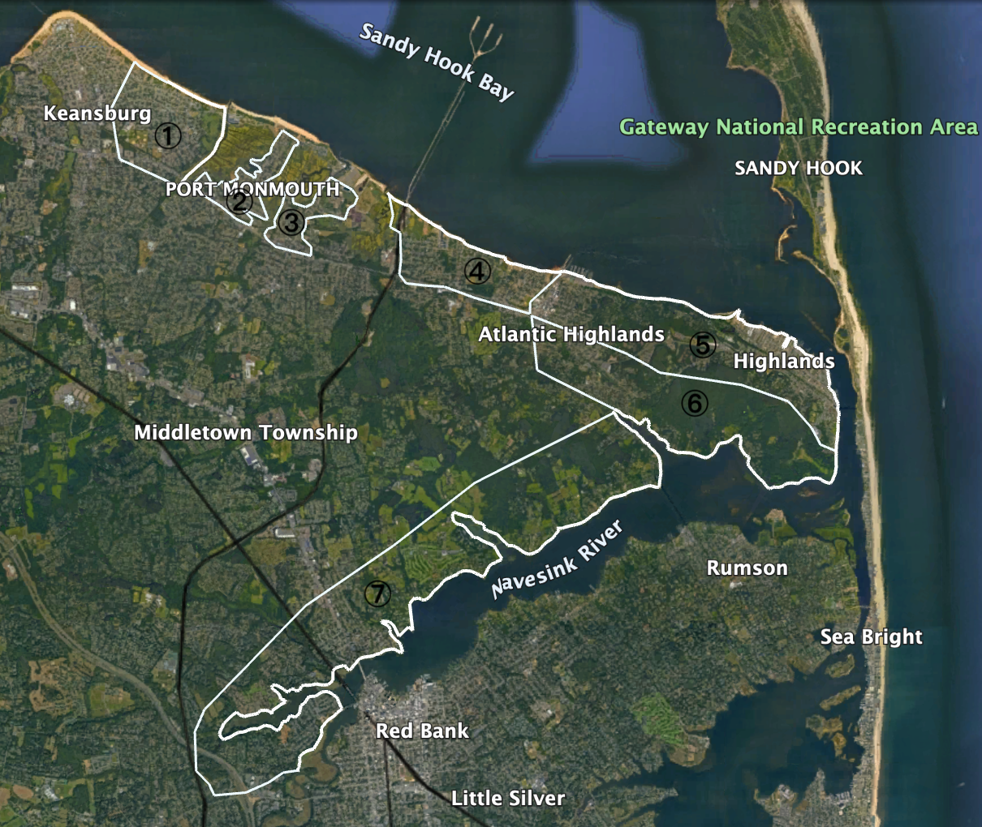

Figure S.7 Segments of Wilmington SC

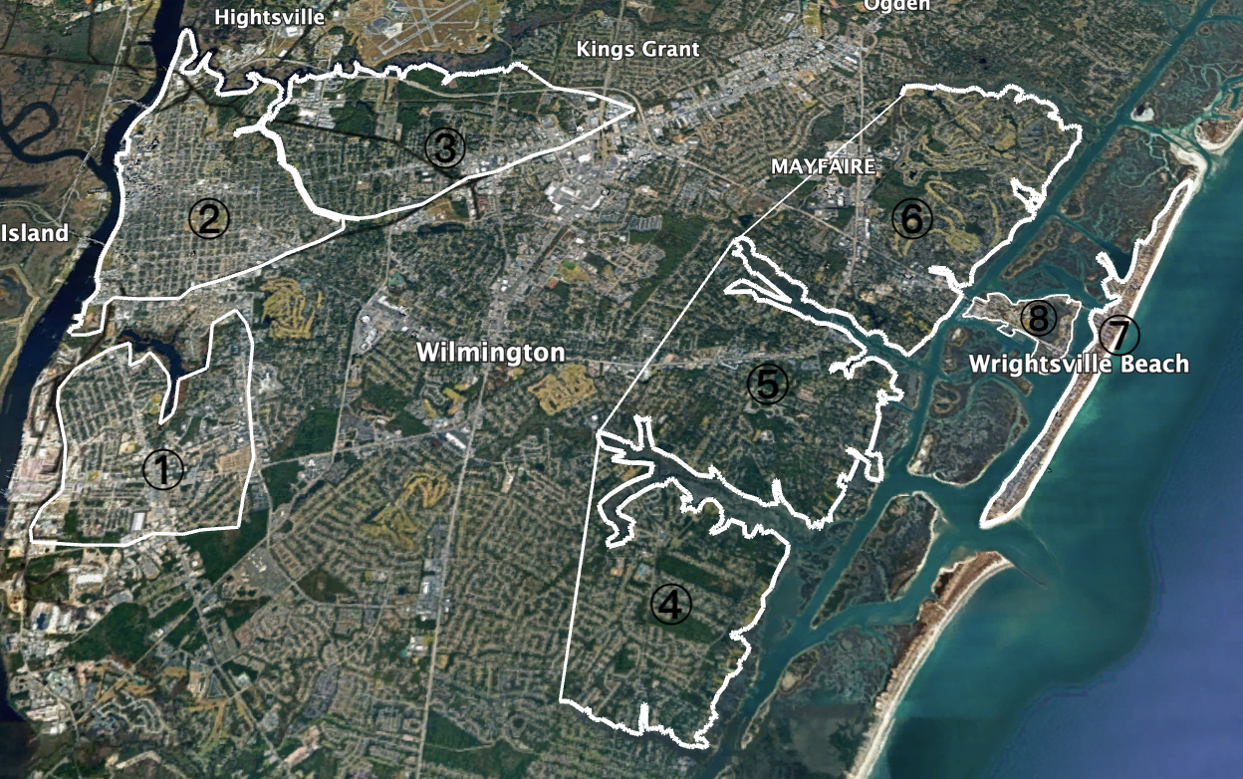

Figure S.8 Segments of Jacksonville FL

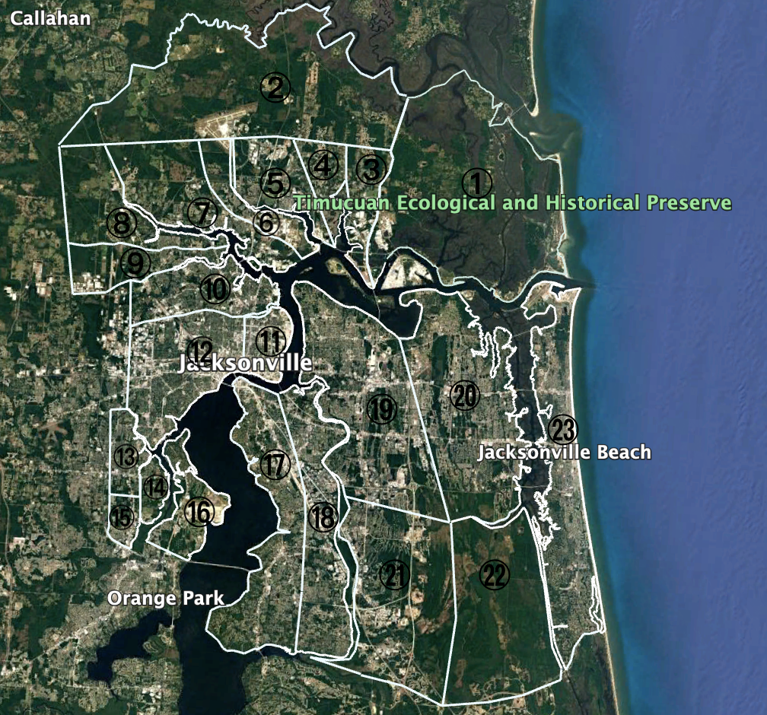

Storm Surge Probability Function

The probability distribution of surge heights was estimated for each station using a GEV regression on the maximum annual tide observed each year at that station. The location parameter, which shifts the distribution from left to right accounts for the most conspicuous differences between the distributions in each city.

Table 1 — GEV Parameters and SLR rate distributions for each city
 | $μ_{0}$  (Location Parameter) | $σ$  (Scale Parameter) | $k$  (Shape Parameter) | Land elevation change (mm/year)
Bridgeport, CT | 1.85 | 0.15 | 0.08 | +0.4
Middletown, NJ | 1.57 | 0.18 | -0.11 | -0.5
Norfolk, VA | 1.59 | 0.18 | -0.10 | -1.1
Wilmington, NC | 1.11 | 0.15 | 0.02 | +1.0
Jacksonville, FL | 1.46 | 0.14 | -0.07 | +0.8
Notes: The GEV parameters estimated by the authors based on NOAA (2024a) data. The SLR rate distributions are derived from NOAA's (2024b) estimates of regional sea level rise rates.

