Supporting Information
Beyond One-Size-Fits-All:
Cancer Biology Shapes Nanoparticle Behavior
Maria Bravo ^{a,b}, Guillermo Solís-Fernandez ª*, Sandra Krzyzowska ª, Steven Huysecom ª, Ana Montero-Calle ^{c}, Indra Van Zundert ª, Boris Louis ª, James Hutchison ^{b}, Rodrigo Barderas ^{c,d}, Beatrice Fortuni ª*, Susana Rocha ª*
ª Molecular Imaging and Photonics, Chemistry Department, KU Leuven, Celestijnenlaan 200F, 3001 Heverlee, Belgium;
^{b} ARC Centre of Excellence in Exciton Science, School of Chemistry, University of Melbourne, Parkville, VIC 3010, Australia;
^{c} Functional Proteomics Unit, Chronic Disease Programme (UFIEC), Instituto de Salud Carlos III, Majadahonda, E-28220, Madrid, Spain;
^{d} CIBER of Frailty and Healthy Aging, Instituto de Salud Carlos III, E-28029, Madrid, Spain;
* Correspondence: susana.rocha@kuleuven.be, beatrice.fortuni@kuleuven.be, guillermo.solisfernandez@kuleuven.be

This file includes:
Supplementary Figures S1 to S13
Supplementary Table S1
Captions Tables S2 to S5
References (1 to 6)

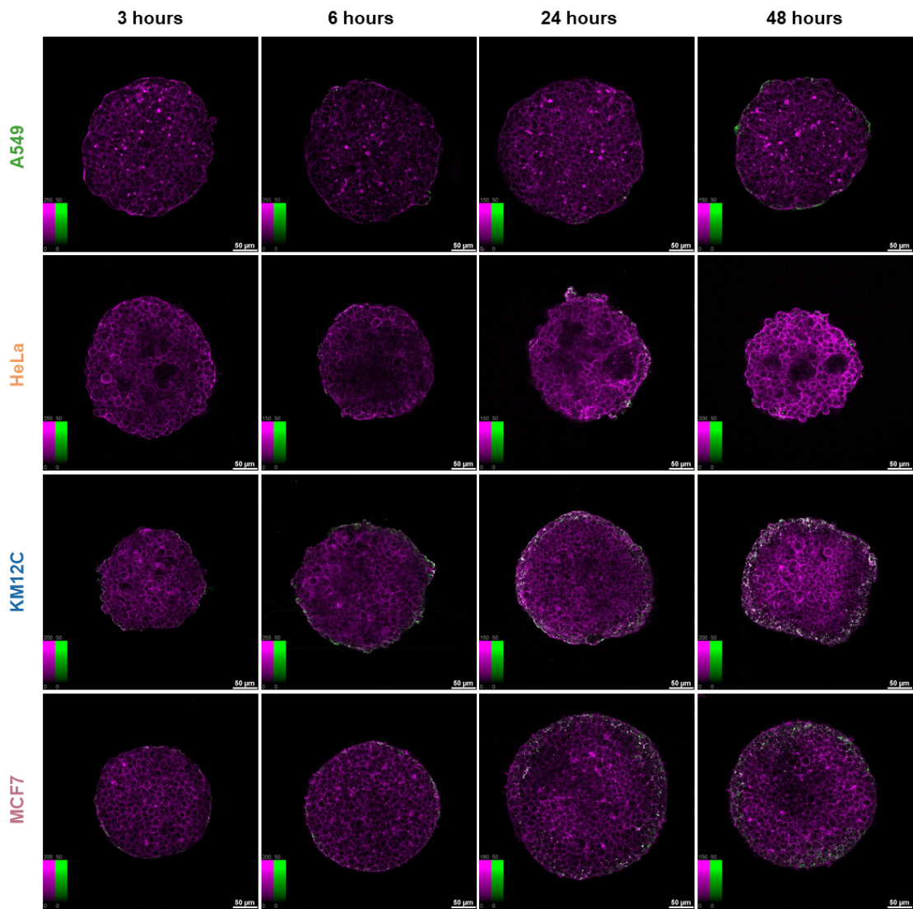
Figure S1| Confocal fluorescence microscopy images of NP distribution in 3D tumor spheroids from A549 (lung), HeLa (cervical), KM12C (colorectal), and MCF7 (breast) cancer cell lines, at the mid-plane of the spheroids. AuNP@mSi-PEI uptake was assessed at 3, 6, 24, and 48 hours, with columns showing the different time points and rows representing cell lines. Nanoparticles (green) were detected via photoluminescence following multi-photon laser excitation, and actin filaments (magenta) were stained with Phalloidin CruzFluor647. Scale bar = 50 µm. Color bars show contrast values, fixed for the NP channel (0–50).
Figure S2| Average total NP accumulation per spheroid, based on total NP signal intensity within the spheroid volume at the different time points, showing an increasing amount of NPs inside the spheroids over time for all the samples, except HeLa spheroids after 48 hours of NP incubation, where a slight intensity decrease was observed. A549, HeLa, KM12C, and MCF7 are represented in green, orange, blue, and pink, respectively. Error bars indicate ± SD, with ns meaning not significant; * (p < 0.05), ** (p < 0.01), *** (p < 0.001), and **** (p < 0.00010) (n ≥ 20).

Figure S3| NP penetration profiles displayed as cumulative NP distribution (Intensity% %) relative to the distance from the spheroid outer rim at each time point. A549, HeLa, KM12C, and MCF7 are represented in green, orange, blue, and pink, respectively. (n ≥ 20).
Figure S4| Spheroid size over time (fixed samples). A549, HeLa, KM12C, and MCF7 are represented in green, orange, blue, and pink, respectively. (n ≥ 20). Error bars indicate ± SD, with ns meaning not significant; * (p < 0.05), ** (p < 0.01), *** (p < 0.001), and **** (p < 0.00010) (n ≥ 20).

Figure S5| Brightfield images of spheroid formation over time (6 days) in agarose molds. When spheroids are not manipulated, HeLa spheroid size does not decrease, corroborating the loss of the proliferative layer upon spheroid collection. Scale bar = 200 µm.
Figure S6| Spheroid size over time as monitored via live brightfield imaging (samples were not manipulated). A549, HeLa, KM12C, and MCF7 are represented in green, orange, blue, and pink, respectively. (n ≥ 10). Error bars indicate ± SD, with ns meaning not significant.

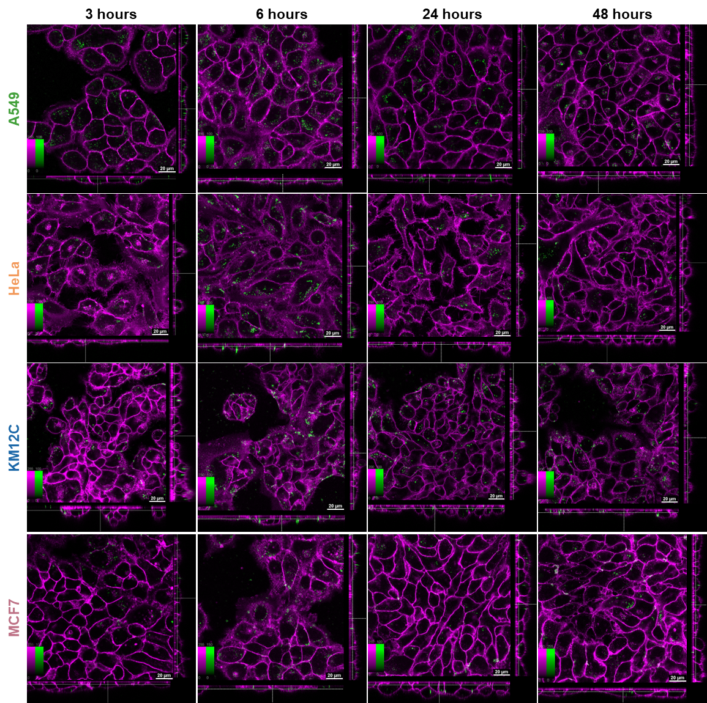
Figure S7| Confocal fluorescence microscopy images of NP internalization in 2D cell monolayers from A549 (lung), HeLa (cervical), KM12C (colorectal), and MCF7 (breast) cancer cell lines. AuNP@mSi-PEI uptake was assessed at 3, 6, 24, and 48 hours, with columns showing the different time points and rows representing cell lines. Nanoparticles (green) were detected via photoluminescence following multi-photon laser excitation, and the cell membrane (magenta) was stained with CellMask DeepRed. Scale bar = 20 µm. Color bars show contrast values, fixed for the NP channel (0–100). The central square represents a single xy plane, while the bottom and left panels are the xz and yz cross-sections.
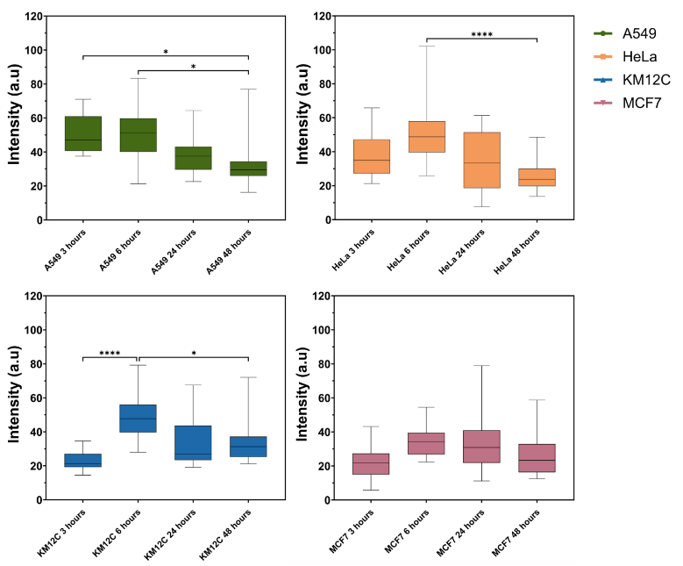
Figure S8| Average NP intensity inside the cells per cell line over time, normalized to the cell area. A549, HeLa, KM12C, and MCF7 are represented in green, orange, blue, and pink, respectively. Error bars indicate ± SD, with ns meaning not significant; * (p < 0.05), ** (p < 0.01), *** (p < 0.001), and **** (p < 0.00010 (n ≥ 20).

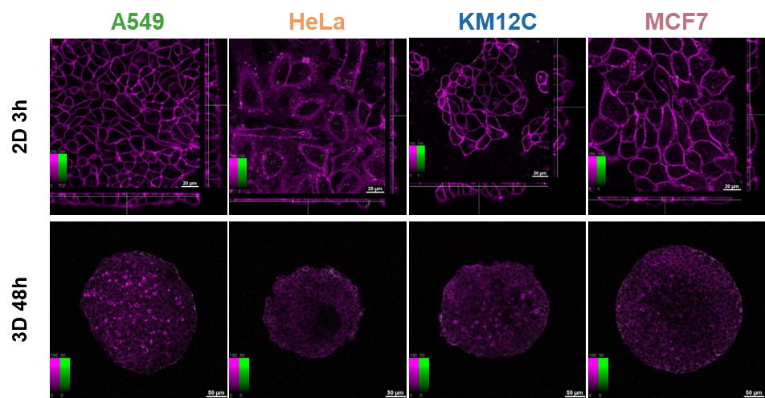
Figure S9| Confocal fluorescence microscopy images of Au@mSi internalization in 2D cell monolayers and 3D spheroids from A549 (lung), MCF7 (breast), HeLa (cervical), and KM12C (colorectal) cancer cell lines. AuNP@mSi uptake was assessed at 3 hours in 2D and 48 hours in 3D models, with columns showing the different cell lines. Nanoparticles (green) were detected via photoluminescence following multi-photon laser excitation, and cell membrane (2D, magenta) or cytoskeleton (3D, magenta) were stained with CellMask DeepRed and Phalloidin CruzFluor647, respectively. Scale bar: 20 µm in cell monolayers and 50 µm in tumor spheroids. Color bars show contrast values, fixed for the NP channel (0–100 in 2D, and 0-50 in 3d). The central square in 2D monolayers represents a single xy plane, while the bottom and left panels are the xz and yz cross-sections.
Figure S10| NP penetration profiles displayed as cumulative NP distribution (Intensity%) relative to the distance from the spheroid outer rim, comparing NP distribution of Au@mSi NPs for each cell line at 48 hours. A549, HeLa, KM12C, and MCF7 are represented in green, orange, blue, and pink, respectively. (n ≥ 20).

Figure S11| (a) Protein expression levels of three of the most relevant endocytic (CAV1, PTRF, and SNAP23) and ECM proteins (VTN, FN1, and LAMB1). Proteomics analysis was performed on four biological replicates. A549, HeLa, KM12C, and MCF7 are represented in green, orange, blue, and pink, respectively. Error bars indicate ± SD. (b) A total of 12.5 μg of the indicated total extracts or subcellular fractions of the four different cell lines (three replicates) of the study were subjected to WB analysis with specific antibodies. Protein bands were quantified by densitometry.
Table S1| List of primary and secondary antibodies used for Western Blotting in proteomics validation step.
Primary antibodies
Protein | Supplier | Catalog Number | Dilution | Secondary antibody (dilution)
SNAP23 | Atlas Antibodies | HPA001214 | 1/500 | MAR-HRP (1/500)
CAV1 | ProteinTech | 66067-1-Ig | 1/1000 | GAM-488 (1/1000)
PTRF | ProteinTech | 18892-1-AP | 1/500 | MAR-HRP (1/1000)
VTN | ProteinTech | 66398-1-Ig | 1/500 | GAM-488 (1/500)
FN1 | ProteinTech | 66042-1-Ig | 1/1000 | GAM-488 (1/1000)
LAMB1 | ProteinTech | 23498-1-AP | 1/1000 | MAR-HRP (1/1000)
GAPDH | ProteinTech | 60004-1-Ig | 1/1000 | GAM-488 (1/1000)
Secondary antibodies
Protein | Supplier | Catalog Number
MAR IgG-HRP | SCBT | sc-2357
GAM-Alexa Fluor 488 | ThermoFisher | A11001
Figure S12| Overview of the software for NP behavior analysis in 3D spheroids. (a) Spheroid detection by the software for each xy plane of the z stack, and resulting orthogonal view of the 3D structure. (b) Preprocessing steps to determine the spheroid edge, including median filtering, noise removal, and edge detection via the Sobel algorithm. The x,y coordinates of the spheroid centre are determined by averaging the centroid positions of the segmented areas in 20 adjacent stacks around the plane where the spheroid appears widest. The z coordinate of the centre is taken as the z coordinate of this plane. (c) Transformation of data into ellipsoidal coordinates, storing azimuth, elevation, and distance for each point. The azimuth angle is not shown in this 2D side view. (d) NP detection on channel 2. (e) Assignment of ellipsoidal coordinates to every pixel in the nanoparticle channel, and (f) calculation of the distance of each pixel from the spheroid edge to determine penetration depth. (g) Penetration profile from the integration of nanoparticle intensity over distance.

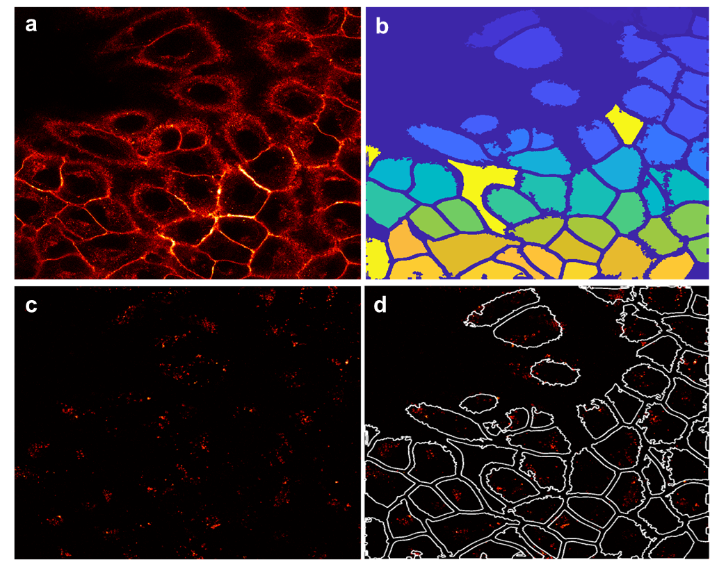
Figure S13| Overview of the software for NP behavior analysis in 2D cell monolayers. (a) Preprocessing of cell membrane data with median filtering. (b) Segmentation of individual cells using the Cellpose deep learning algorithm, performed on the most representative plane of the z-stack. Parameters such as cell threshold, cell diameter, and flow error tolerance are optimized for accurate segmentation. Postprocessing steps include erosion to refine segmentation boundaries. (c) NP identification in channel 2 (d) Nanoparticle intensity integration: labelled masks were used to compute nanoparticle intensity in each cell.

Table Captions
Table S2| List of all proteins identified by mass spectrometry-based proteomics in the four cell lines (A549, HeLa, KM12C, and MCF7).
Table S3| Subset of proteins from Supplementary Table S2 annotated with the Gene Ontology term “Endocytic Transport”(GO: 0030139) and “Extracellular Matrix” (GO: 0031012)
Table S4| Expression levels of proteins annotated with the GO term “Endocytic Transport” after data imputation. Includes expression values for all samples and relative expression ratios compared to MCF7.
Table S5| Expression levels of proteins annotated with the GO term “Extracellular Matrix” after data imputation. Includes expression values for all samples and relative expression ratios compared to MCF7.

References
1. Chen, J., Zhang, R., Han, L., Tu, B. & Zhao, D. One-pot synthesis of thermally stable gold@mesoporous silica core-shell nanospheres with catalytic activity. Nano Res. 6, 871–879 (2013).
2. Van Zundert, I. et al. Fluorescence Imaging of 3D Cell Models with Subcellular Resolution. BIO-PROTOCOL 12, (2022).
3. Berg, S. et al. ilastik: interactive machine learning for (bio)image analysis. Nat Methods 16, 1226–1232 (2019).
4. Stringer, C., Wang, T., Michaelos, M. & Pachitariu, M. Cellpose: a generalist algorithm for cellular segmentation. Nat Methods 18, 100–106 (2021).
5. Wiśniewski, J. R. & Gaugaz, F. Z. Fast and Sensitive Total Protein and Peptide Assays for Proteomic Analysis. Anal. Chem. 87, 4110–4116 (2015).
6. Solís-Fernández, G. et al. Aryl-hydrocarbon receptor-interacting protein regulates tumorigenic and metastatic properties of colorectal cancer cells driving liver metastasis. Br J Cancer 126, 1604–1615 (2022).

