Supplementary Information for

Global supply chain relocation reshaped PM_{2.5} pollution and human health risks

Author list:
Kaijie Chen^{1,2}, Tingting Fang^{1,2}, Qi Ran^{1,2}, Steve Hung-Lam Yim^{1,2,3,4,*}

Affiliations:
¹ Centre for Climate Change and Environmental Health, Nanyang Technological University, Singapore
² Earth Observatory of Singapore, Nanyang Technological University, Singapore 639798, Singapore
³ Asian School of the Environment, Nanyang Technological University, Singapore 639798, Singapore
⁴ Lee Kong Chian School of Medicine, Nanyang Technological University, Singapore

Corresponding author: Steve Hung-Lam Yim
Email: yimsteve@gmail.com

Supplementary Text 1 Scenarios setup
To quantify the impact of global supply chain (GSC) relocation on air pollutant emissions, PM_{2.5} pollution and related health burdens, we set up following scenarios:
(1) 'trade' scenario ('Baseline' scenario): reflects the actual air pollutant emissions of each country r ($E_{Baseline}^{r}$).
(2) 'no trade' scenario: assumes no international trade. The calculation of emissions under the 'no trade' scenario is presented in the main text (Eq. 4)
(3) 'no NS trade' scenario: assumes no trade between the Global North and Global South. For each Global South (North) country r, emissions are adjusted by subtracting those embodied in exports to the Global North (South) and adding those embodied in imports from them.
$E_{No NS trade}^{r}=E_{Baseline}^{r}-E_{export_NS}^{r}+E_{import_NS}^{r}$ (1)
where $E_{export_NS}^{r}=\sum_{s∈Opp(r)}{E_{Baseline}^{rs}}$ and $E_{import_NS}^{r}=\sum_{s∈Opp(r)}{E_{Baseline}^{sr}}$,
and $Opp(r)$ refers to countries in the opposite group (i.e., if $r∈Global North$, then $Opp(r)∈Global South$, and vice versa).
(4) 'no SS trade' scenario: assumes no trade within the Global South. For each country r in the Global South, emissions under this scenario ($E_{No SS trade}^{r}$) are recalculated by subtracting emissions embodied in exports to other Global South countries and adding back emissions embodied in imports from them. Emissions of countries in the Global North remain unchanged.
$E_{No SS trade}^{r}=\left\{\begin{aligned}E_{Baseline}^{r}-E_{export_SS}^{r}+E_{import_SS}^{r}, if r∈Global South \\ E_{Baseline}^{r} , if r∈Global North\end{aligned}\right.$ (2)
where $E_{export_SS}^{r}=\sum_{r≠s,s∈Global South}{E_{Baseline}^{rs}}$ and $E_{import_SS}^{r}=\sum_{r≠s,s∈Global South}{E_{Baseline}^{sr}}$.
(5) 'no NN trade' scenario: assumes no trade within the Global North. For each country r in the Global North, emissions under this scenario ($E_{No NN trade}^{r}$) are recalculated by removing emissions embodied in exports to other Global North countries and adding back emissions embodied in imports from them. Emissions of countries in the Global South remain unchanged.
$E_{No NN trade}^{r}=\left\{\begin{aligned}E_{Baseline}^{r}-E_{export_NN}^{r}+E_{import_NN}^{r}, if r∈Global North \\ E_{Baseline}^{r} , if r∈Global South\end{aligned}\right.$ (3)
where $E_{export_NN}^{r}=\sum_{r≠s,s∈Global North}{E_{Baseline}^{rs}}$ and $E_{import_NN}^{r}=\sum_{r≠s,s∈Global North}{E_{Baseline}^{sr}}$.

Supplementary Text 2 CESM configuration/simulation and validation
CESM configuration. We employed the Community Earth System Model version 2.2.2 (CESM2.2.2), developed by the National Center for Atmospheric Research^{1,2}, to simulate the fractional contribution of the GSC relocation to PM_{2.5} concentration. The atmospheric component is the Community Atmosphere Model version 6 with interactive chemistry (CAM6-chem) coupled with the four-mode version of the Modal Aerosol Module (MAM4) and the Model for Simulating Aerosol Interactions and Chemistry (MOSAIC)³.
The simulations were conducted using the 'FCnudged' component set, where meteorological fields were nudged to the Modern-Era Retrospective analysis for Research and Applications, Version 2 (MERRA-2) reanalysis data. All simulations were run at a horizontal resolution of 0.9° latitude × 1.25° longitude with 32 vertical levels. The model also includes the Community Land Model version 5.0 (CLM5.0), and sea-surface temperatures and sea-ice extent are prescribed. All scenario simulations were conducted from January 2021 to December 2022, with the first year as the spin-up period.
For the baseline emissions inputs, the gridded global anthropogenic emissions inventory is obtained from the EDGAR database (https://edgar.jrc.ec.europa.eu/index.php/dataset_ap81) and re-gridded to the model resolution at 0.9° × 1.25°. The biomass burning emission inventories used in the simulations are obtained from the CESM database developed for Coupled Model Intercomparison Project Phase 6 (CMIP6, https://svn-ccsm-inputdata.cgd.ucar.edu/trunk/inputdata/atm/cam/chem/emis/).
To obtain gridded emissions under each counterfactual scenario (i.e., scenarios (2)-(5)), we assume that trade-related emissions from each sector exhibit the same spatial distributions as total emissions in baseline scenario. The emissions for each grid cell i in country r ($E_{i, scenario}^{r}$) under each counterfactual scenario can be calculated by:
$E_{scenario}^{r, i}=E_{Baseline}^{r, i}×\frac{E_{scenario}^{r}}{E_{Baseline}^{r}}$ (4)
where $E_{Baseline}^{r}$ and $E_{scenario}^{r}$ represent emissions in country r under the 'Baseline' scenario and each counterfactual scenario, respectively.
Model evaluation. We carried out model validation by comparing simulated PM2.5 concentration under baseline scenario with observations from Environmental Protection Agency (EPA, https://www.epa.gov/outdoor-air-quality-data), National Air Pollution Surveillance Program (NAPS, https://data-donnees.az.ec.gc.ca/data/air/monitor/national-air-pollution-surveillance-naps-program/), European Evaluation and Monitoring Program (EMAP, https://www.emep.int/), and the China National Environmental Monitoring Center (CNEMC, http://www.cnemc.cn/en/). As shown in Supplementary Figure 6, our modeled PM_{2.5} concentrations agree reasonably well with observations, with correlation coefficient (R) of 0.8 and normalized mean bias (NMB) of 5.3%.
Supplementary Text 3 Uncertainty analysis
Due to the complex framework and the use of multiple datasets in this study, our calculations are subject to some uncertainties and limitations. First, for the emissions inventory from EDGAR, the uncertainty is mainly attributable to emission factors, activity data, and spatial allocation, with uncertainty varying by species and region^{4,5}. Second, uncertainties in the MRIO model are related to inaccurate national economic statistics and sectoral mapping. However, previous studies have shown that uncertainties related to the MRIO model were smaller than the uncertainty of production-based emissions inventory^{5,6}. Third, the PM_{2.5} concentrations simulated by CESM inevitably involves uncertainties in emission inputs as well as parameterizations of chemical and physical processes. However, we applied change ratios of simulated PM_{2.5} concentration between scenarios rather than absolute simulated PM_{2.5} concentration, which might help reduce the importance of CESM simulation uncertainties. Fourth, the uncertainties of PM_{2.5}-related premature deaths estimation arise mainly from the MR-BRT model. Following methods from previous studies⁷, we assessed the uncertainties of PM_{2.5}-related premature deaths and emphasize that the 95% confidence intervals of PM_{2.5}-related premature deaths in this study reflect only the statistical uncertainty of the relative risk (RR) from the MR-BRT model.

Supplementary Table 1. Sectors in the Eora26.
Code | Sector
1 | Agriculture
2 | Fishing
3 | Mining and Quarrying
4 | Food & Beverages
5 | Textiles and Wearing Apparel
6 | Wood and Paper
7 | Petroleum, Chemical and Non-Metallic Mineral Products
8 | Metal Products
9 | Electrical and Machinery
10 | Transport Equipment
11 | Other Manufacturing
12 | Recycling
13 | Electricity, Gas and Water
14 | Construction
15 | Maintenance and Repair
16 | Wholesale Trade
17 | Retail Trade
18 | Hotels and Restaurants
19 | Transport
20 | Post and Telecommunications
21 | Financial Intermediation and Business Activities
22 | Public Administration
23 | Education, Health and Other Services
24 | Private Households
25 | Others
26 | Re-export & Re-import

Supplementary Table 2. Sectors mapping from EDGAR emission inventory to Eora sectors.
Sector in EDGAR | Sector code in Eora
Main Activity Electricity and Heat Production | 13
Petroleum Refining - Manufacture of Solid Fuels and Other Energy Industries | 7
Manufacturing Industries and Construction | 4-12, 14
Road Transportation no resuspension | 19
Road Transportation resuspension | 19
Railways | 19
Water-borne Navigation | 19
Other Transportation | 19
Residential and other sectors | Not mapped
Solid Fuels | 3
Oil and Natural Gas | 3
Cement production | 7
Lime production | 7
Glass Production | 7
Other Process Uses of Carbonates | 7
Chemical Industry | 7
Metal Industry | 8
Non-Energy Products from Fuels and Solvent Use | 7
Other Product Manufacture and Use | 9
Other | 4, 6
Manure Management | 1
Emissions from biomass burning | 1
Direct N2O Emissions from managed soils | 1
Solid Waste Disposal | 23
Biological Treatment of Solid Waste | 23
Incineration and Open Burning of Waste | 23
Wastewater Treatment and Discharge | 23
Fossil fuel fires | 3
Note: The Residential sector is treated as domestic direct consumption and therefore not mapped to any Eora sector.
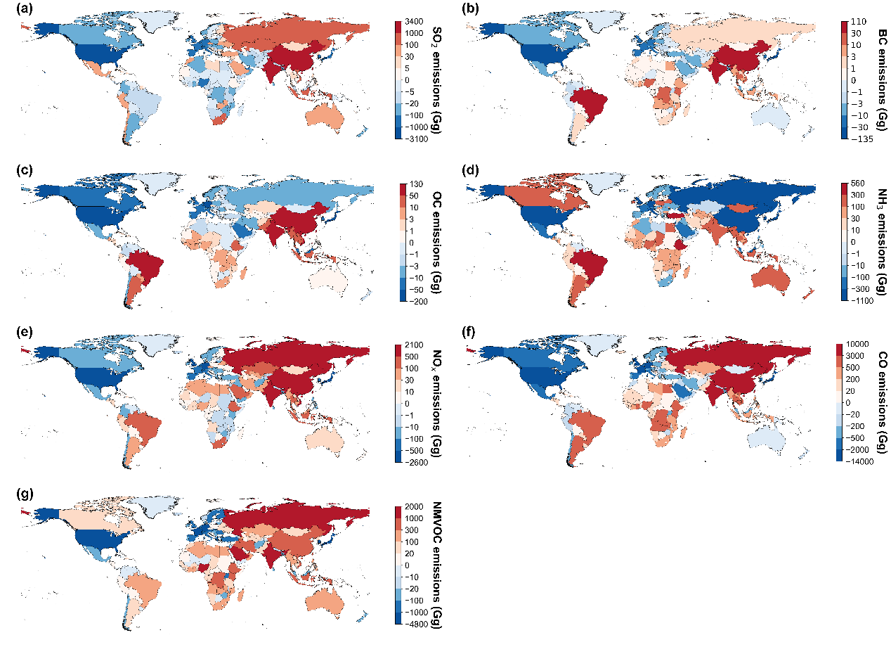
Supplementary Figure 1. The differences in (a) SO₂, (b) BC, (c) OC, (d) NH₃, (e) NO_{x}, (f) CO, (g) NMVOC emission between 'trade' and 'no trade' scenarios in 2022.

Supplementary Figure 2. The impact of North-South (blue bars), South-South (red bars), and North-North trade (green bars), on (a) SO₂, (b) BC, (c) OC, (d) NH₃, (e) NO_{x}, (f) CO, (g) NMVOC emission changes across countries in 2022.
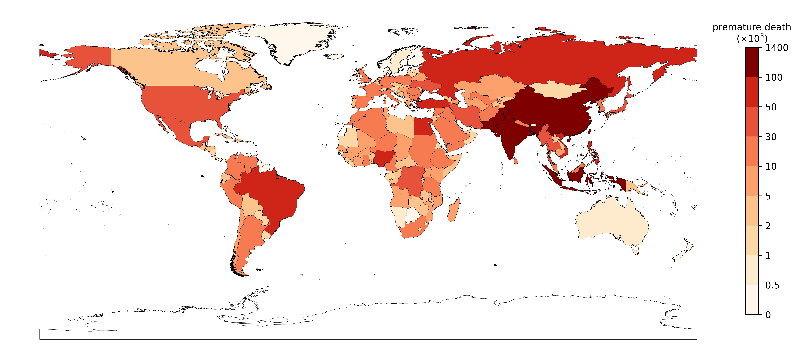
Supplementary Figure 3. The total ambient PM_{2.5}-related premature deaths across countries under the 'trade' scenario in 2022.

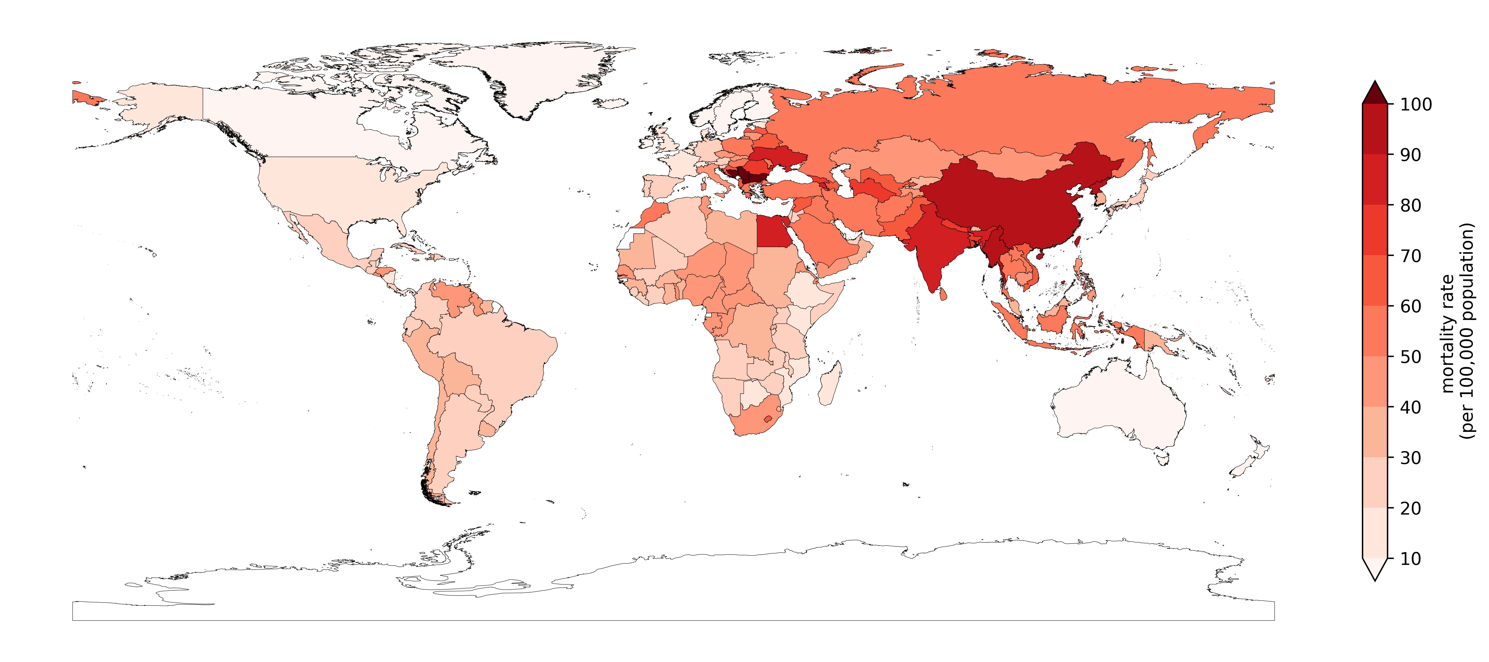
Supplementary Figure 4. The PM_{2.5}-related mortality rate (premature deaths per 100,000 population) across countries under the 'trade' scenario in 2022.

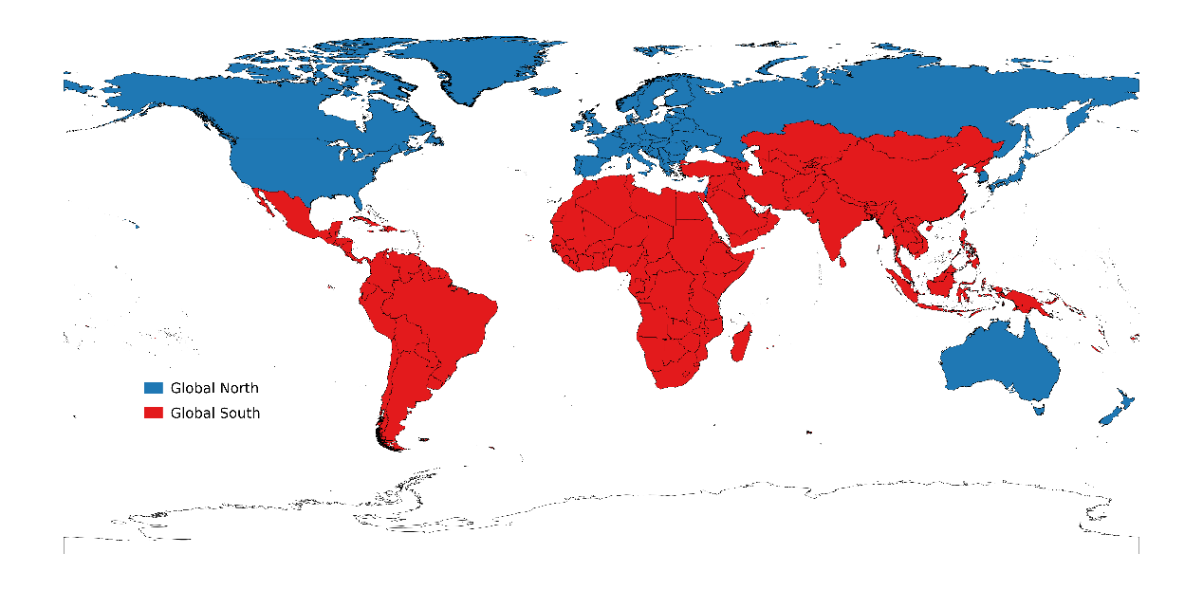
Supplementary Figure 5. Definition of the Global North and Global South.

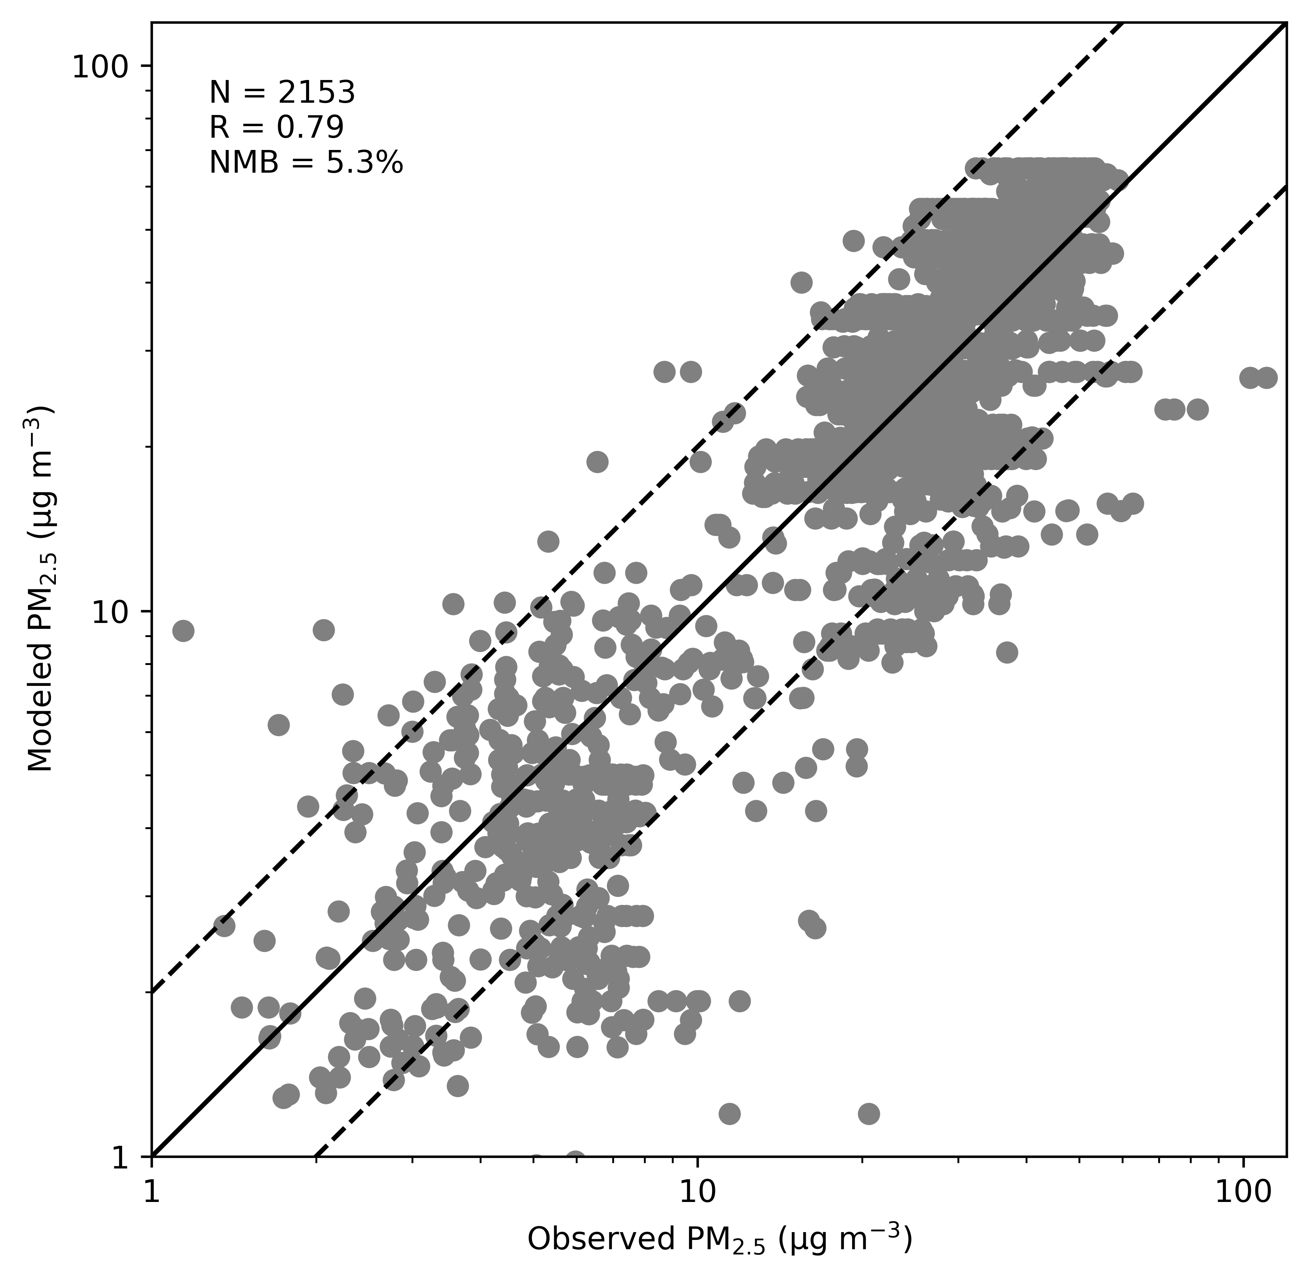
Supplementary Figure 6. Comparison between observed and modeled PM_{2.5} concentrations. The solid line represents the 1:1 line, the dashed lines represent the 1:2 and 2:1 line. R and NMB stand for the correlation coefficient, and normalized mean bias, respectively.

Reference
1 Danabasoglu, G. et al. The Community Earth System Model Version 2 (CESM2). J. Adv. Model. Earth Syst. 12, e2019MS001916 (2020).
2 Emmons, L. K. et al. The Chemistry Mechanism in the Community Earth System Model Version 2 (CESM2). J. Adv. Model. Earth Syst. 12, e2019MS001882 (2020).
3 Lu, Z. et al. Radiative Forcing of Nitrate Aerosols From 1975 to 2010 as Simulated by MOSAIC Module in CESM2-MAM4. J. Geophys. Res.-Atmos. 126, e2021JD034809 (2021).
4 Crippa, M. et al. Gridded emissions of air pollutants for the period 1970–2012 within EDGAR v4.3.2. Earth Syst. Sci. Data 10, 1987–2013 (2018).
5 Ma, R. et al. Mitigation potential of global ammonia emissions and related health impacts in the trade network. Nat. Commun. 12, 6308 (2021).
6 Zhang, Q. et al. Transboundary health impacts of transported global air pollution and international trade. Nature 543, 705–709 (2017).
7 Wang, H. et al. Trade-driven relocation of air pollution and health impacts in China. Nat. Commun. 8, 738 (2017).

