SUPPLEMENTAL MATERIAL
Materials and Methods
Behavior Apparatus
Across experiments, operant behavioral testing was conducted in identical experimental chambers (24 [length] x 30 [width] x 21cm [height]; Med Associates Inc., VT, USA). Each chamber was enclosed in sound- and light-attenuating cabinets (40 × 56 × 56 cm) and fitted with fans for ventilation and background noise. Chambers were made of Perspex rear-wall, ceiling and hinged front-wall, and stainless-steel sidewalls. Chamber floors were made of stainless-steel rods (4mm in diameter) spaced 15mm apart. A recessed magazine (3cm in diameter) within a 4cm x 4cm hollow in the right-side chamber wall received grain pellets (45mg; Bio-Serv) from an external automatic hopper. Infrared photocells detected entries into the magazine. Infrared digital cameras, attached to the ceiling of the cabinets, recorded all activity within the chamber from above. For fiber photometry experiments, a patch cable was threaded into the chamber through a ceiling hole and supported by a counterweighted gimbal holder.
Locomotor tests were conducted in open field chambers (43.2 × 43.2 × 30.5 cm; Med Associates) that tracked movement via 16-beam infrared arrays located along X- and Y-axes.

Fiber photometry apparatus
Two Doric LEDs, controlled via dual channel LED drivers, provided 465 nm (experimental signal) and 405 nm (isosbestic control signal) excitation light. Resulting fluorescence (~525nm) was measured using femtowatt photoreceivers (Newport 2151). Doric Dual Fluorescence Mini Cube (FMC2, Doric Lenses) relayed excitation/fluorescence wavelengths to/from pre-bleached patch cable and fiber optic implant. A real-time processor (RZ5P, Tucker Davis Technologies) controlled and modulated excitation lights (465 nm: 209 Hz; 405 nm: 331 Hz), as well as demodulated and low-pass filtered (3 Hz) fluorescence signals. The RZ5P also received Med-PC signals to record behavioral events in real-time. Light intensity at the tip of the patch cable was maintained at 10-40 µW across sessions.
Multimode fiber optic cannulae implants and patch cables (0.39 NA, 400μm core) were constructed using materials from Thor Labs (Newton, NJ, USA).

Surgery
For neural manipulation experiments, rats were anaesthetized using 1.3 ml/kg ketamine (100 mg/ml; Ketapex; Apex Laboratories, Sydney, Australia) and 0.2 ml/kg muscle relaxant, xylazine (20 mg/ml; Rompun; Bayer, Sydney, Australia) (i.p.). For fiber photometry experiments, rats were anesthetized with isoflurane (5% induction; 2% maintenance).
Following anesthetic induction, rats were placed in a stereotaxic frame (Model 900, Kopf, Tujunga, CA, USA), with the incisor bar maintained at approximately 3.3 mm below horizontal to achieve a flat skull position.
Immediately following surgery, animals were given i.p. injections of antibiotics. For neural manipulation experiments, 0.3ml procaine penicillin solution (300mg/ml Benicillin; Illium) and 0.3ml cefazolin (100mg/ml) was given. For fibre photometry experiments, Duoplicin (0.15ml/kg) was given instead.

Perfusions and immunohistochemistry
For Experiments 1 and 3, rats were anesthetized with i.p. injections of sodium pentobarbital (100mg/kg) and perfused with 0.9% saline solution containing 1% sodium nitrate and heparin (5000 IU/ml), followed by 4% paraformaldehyde in phosphate buffer solution (PB; 0.1M). Brains were extracted, incubated in 20% sucrose solution for cryoprotection, sliced coronally (40μm) through VTA using a cryostat and stored in PB solution with 0.1% sodium azide at 4°C.
Brain tissue was washed in PB, incubated in PBT-X solution (10% horse serum [NHS], 0.5% Triton X-100 in PB) for 2 hours, and then incubated in PBT-X solution (2% NHS, 0.2% TritonX-100 in PB) with primary antibody (Experiment 1: 1:1000 rabbit anti-GFP [ThermoFisher Scientific, #A11122], 1:1000 sheep anti-TH [Sigma Aldrich, #AB1542]; Experiment 3: 1:1000 rabbit anti-mCherry [Abcam, #ab167453], 1:2000 sheep anti-TH [Sigma Aldrich, #AB1542]) and at room temperature for 24hr. Tissue was then washed with PB and incubated overnight in PBT-X (2% NHS, 0.2% TritonX-100 in PB) with secondary antibody (Experiment 1: 1:1000 AlexaFluor 488 anti-rabbit [ThermoFisher Scientific, #A21206], 1:1000 Cy3 donkey anti-sheep [Jackson ImmunoResearch, #713-095-147]; Experiment 3: 1:500 AlexaFluor 488 donkey anti-rabbit [Invitrogen, #A21206], 1:1000 AlexaFluor 555 donkey anti-sheep [Invitrogen, #A21436]; 1:1000 AlexaFluor 594 donkey anti-goat [Invitrogen, #A11058]). Tissue was washed with PB and mounted onto gelatinized slides. Slides were left to dry and then cover-slipped. Biosensor expression and cannula placements were verified using fluorescent microscopy. Animals were excluded from analyses if fiber tip and biosensor expression could not be confirmed as co-localized in VTA.
For pharmacology (Experiment 2), rats were anesthetized with i.p. injections of sodium pentobarbital (100mg/kg). Unfixed brains were extracted, frozen and sliced coronally (40 µm) through VTA using a cryostat. Each section was collected and subsequently stained with cresyl violet for histological examination. Animals were excluded from analyses if guide cannulae were not bilaterally located within VTA.

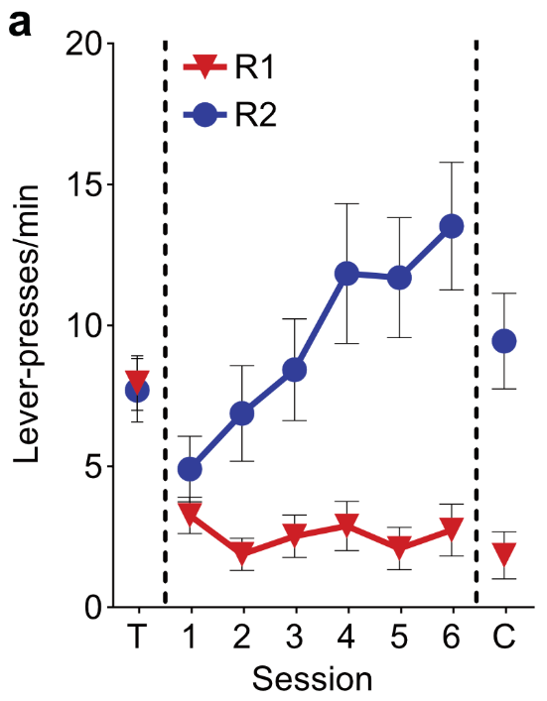
Figure S1. Supplementary results for Experiment 1 (fiber photometry) behavior. [A] Mean ± SEM lever-press rates for R1 and R2 across the last day of training (T), punishment and choice sessions (N = 14). All subjects exhibited a strong preference for the unpunished lever R2 during punishment and choice tests.

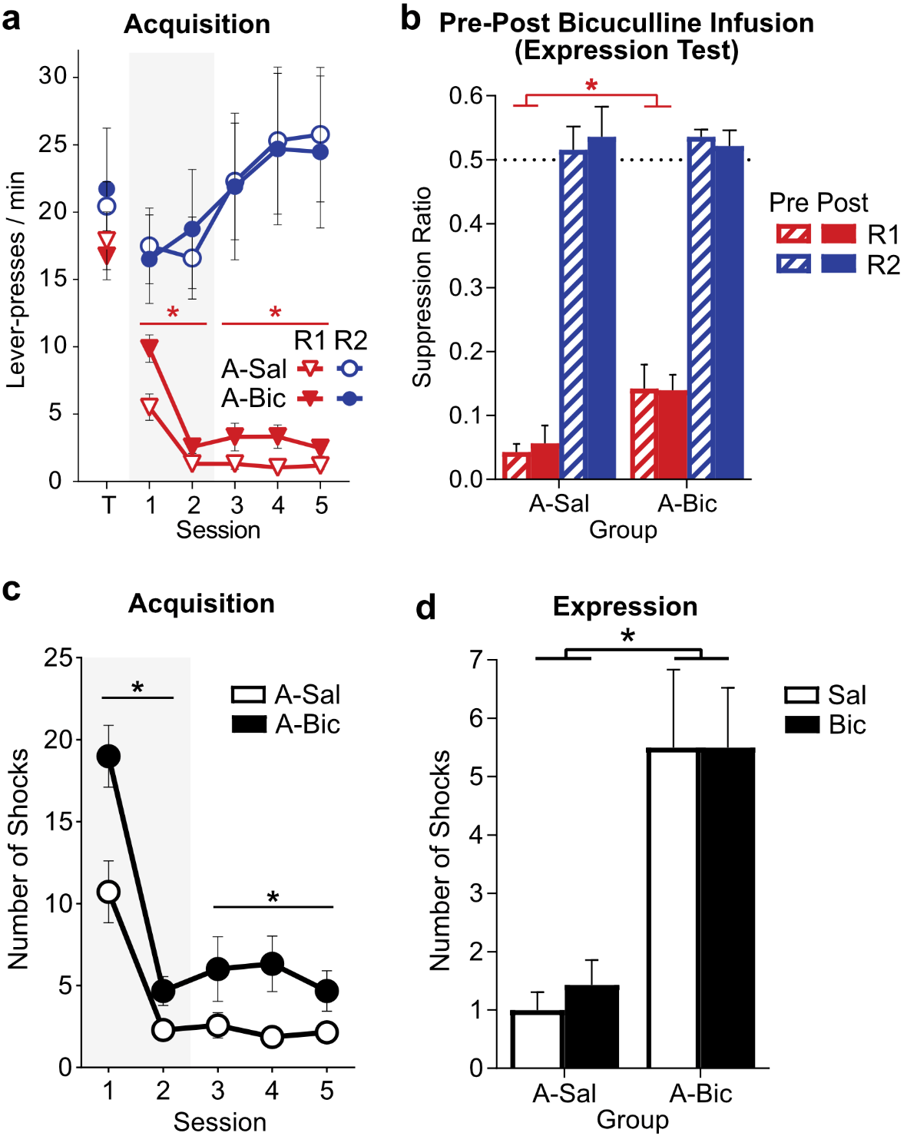
Figure S2. Supplementary results for Experiment 2 (VTA GABA_{A} blockade) behavior. [A] Mean ± SEM lever-press rates for R1 and R2 during last day of training (T) and punishment acquisition sessions. A-Bic vs. A-Sal groups received bicuculline (Bic) vs. saline (Sal) (respectively) before the first 2 sessions of punishment (shaded region). A-Bic rats exhibited a persistent deficit in punishment avoidance. [B] Mean ± SEM suppression ratios for R1 and R2 lever-presses during the punishment session before (Pre) and after (Post) Bic expression test. Bic during expression had no effect on subsequent punishment avoidance in either A-Sal or A-Bic group. *p<.05. [C] Mean ± SEM number of shocks delivered across punishment acquisition sessions. A-Bic rats were shocked, on average, significantly more than A-Sal rats both during infusion (group: F_{(1,11)}=10.60, p=.008) and post-infusion (group: F_{(1,11)}=6.14, p=.031) sessions. [D] Mean ± SEM number of shocks delivered during punishment expression tests by acquisition group. A-Bic subjects received significantly more shocks than A-Sal subjects (group: F_{(1,11)}=16.15, p=.002). Acute bicuculline infusions during expression had no effect on this (drug: F_{(1,11)}=0.206, p=.659; drug*group: F_{(1,11)}=0.206, p=.659).
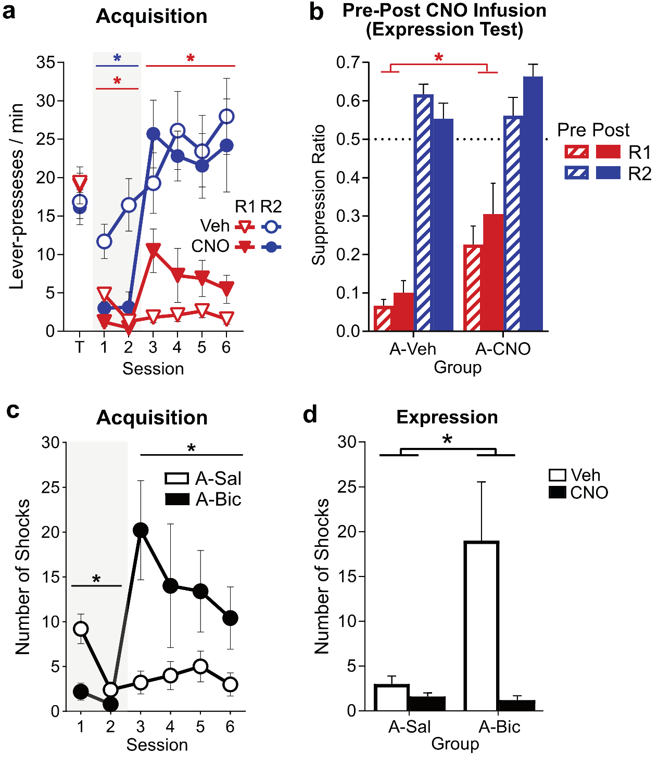
Figure S3. Supplementary results for chemogenetic activation of VTA_{DA} neurons during punishment. [A] Mean ± SEM lever-press rates for R1 and R2 during last day of training (T) and punishment acquisition sessions. A-CNO vs. A-Veh groups received CNO vs. vehicle (respectively) before the first 2 sessions of punishment (shaded region). [B] Mean ± SEM suppression ratios for R1 and R2 lever-presses during the punishment session before (Pre) and after (Post) CNO expression test. *p<.05. [C] Mean ± SEM number of shocks delivered across punishment acquisition sessions. A-Veh rats incurred significantly more shocks than A-CNO rats during infusion days (group: F_{(1,8)}=10.33, p=.012). Across post-infusion days, A-CNO rats receiving more shocks compared to their A-Veh counterparts (group: F_{(1,8)}=5.49, p=.047). [D] Mean ± SEM number of shocks delivered during punishment expression tests by acquisition group. A-Bic rats incurred substantially more shocks than A-Sal rats, particularly following vehicle injections (group: F_{(1,8)}=5.31, p=.050; drug*group: F_{(1,8)}=6.37, p=.036). In correspondence with general decreases in responding, CNO administration reduced numbers of shocks received during Expression CNO tests (drug: F_{(1,8)}=8.74, p=.018).

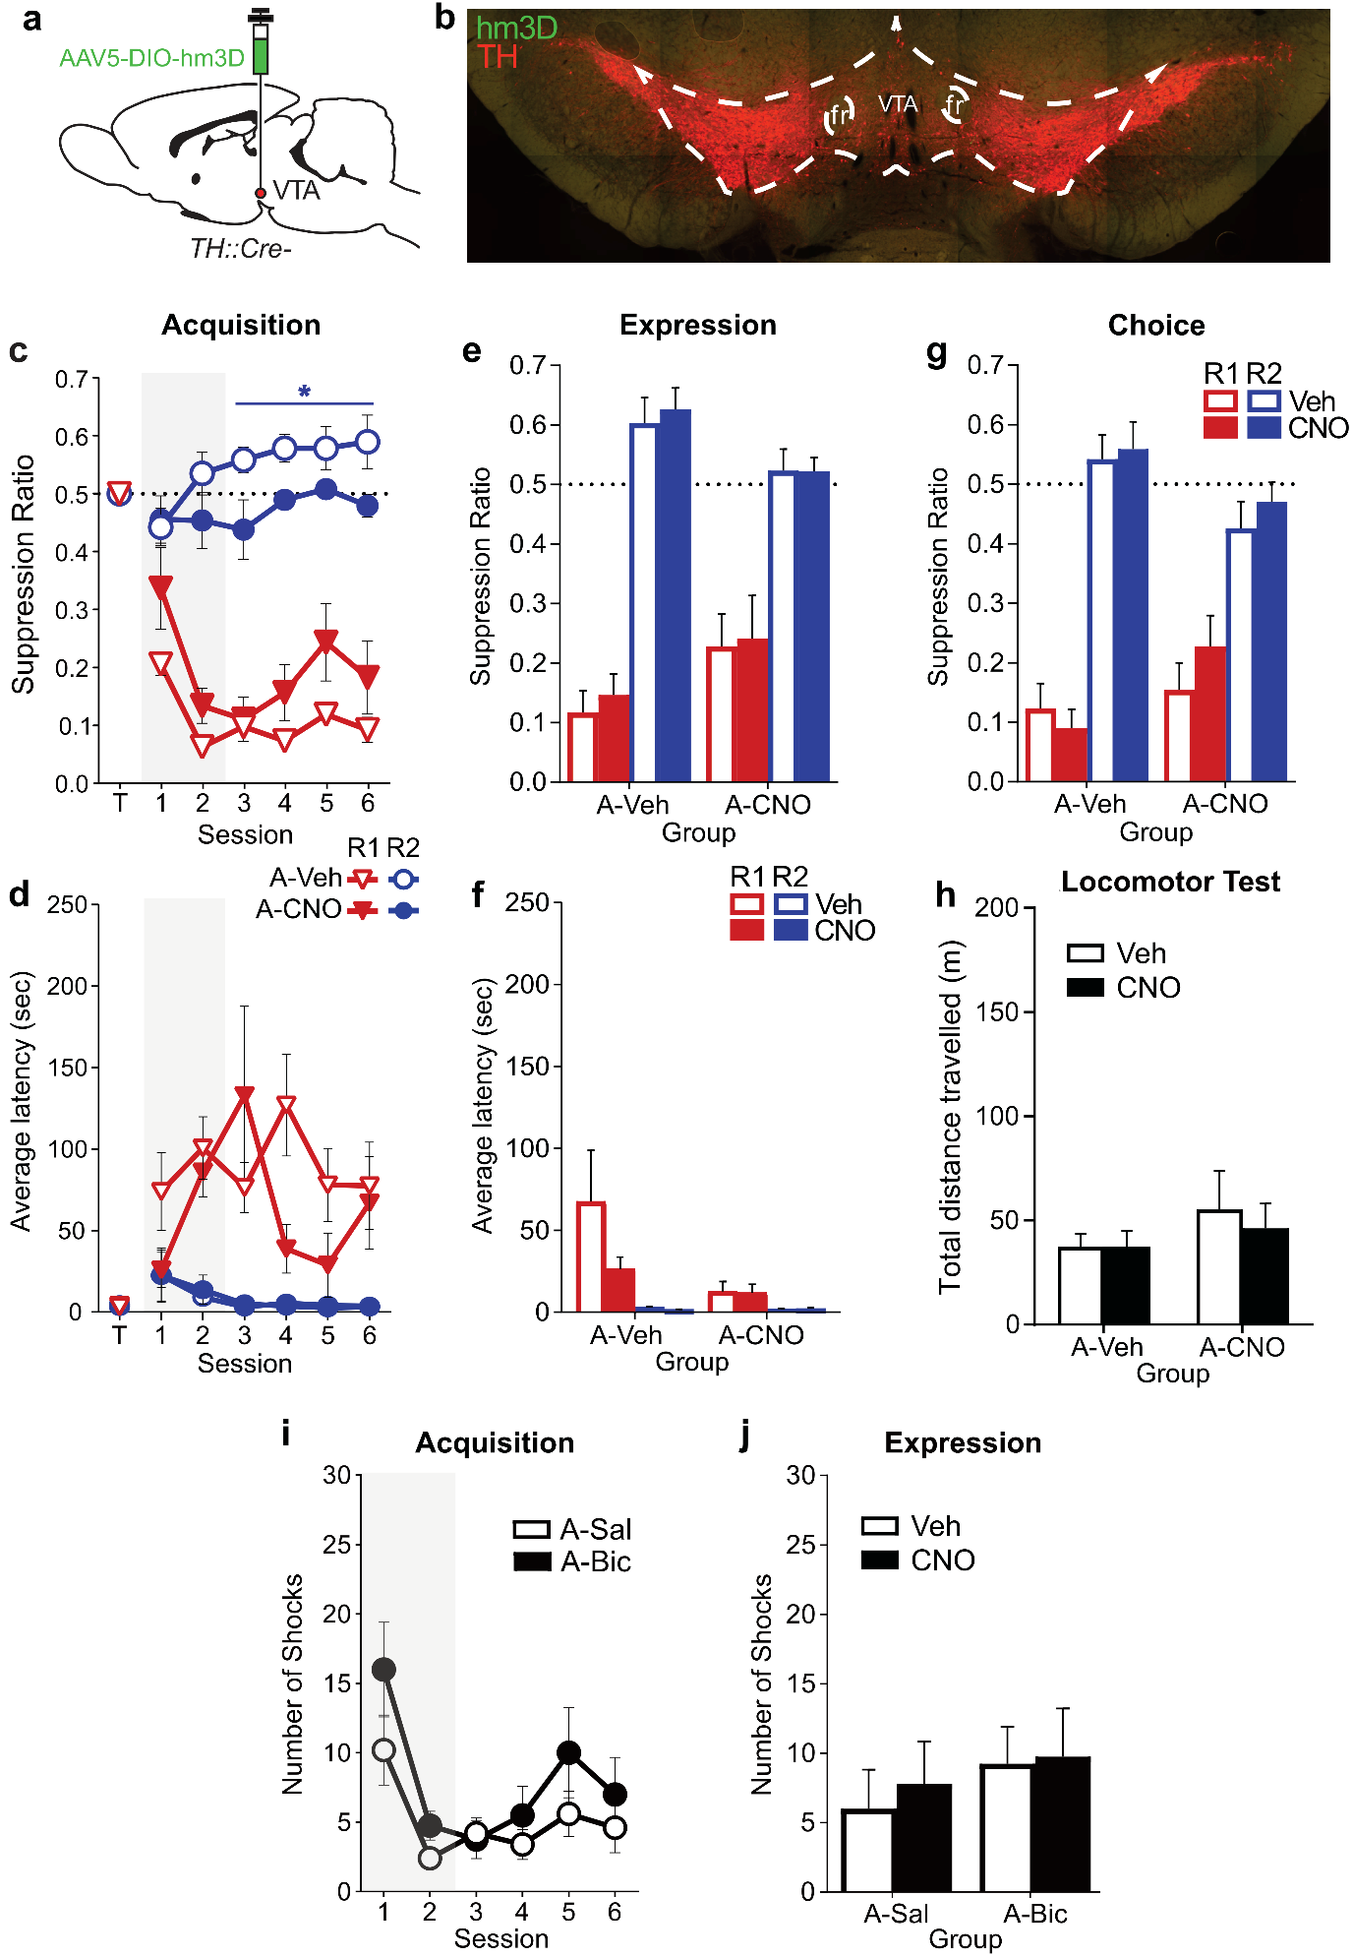
Figure S4. Effects seen in TH::Cre- animals during punishment. [A] TH::Cre- rats received virus encoding Cre-dependent excitatory DREADD hm3D bilaterally into the VTA. Given these animals do not express Cre in any cells, no hm3D expression was expected; these animals serve as control comparisons for the TH::Cre+ experiment reported in main text/figures. [B] Example hm3D and TH expression in TH::Cre- animal. No hm3D expression was observed. [C] Mean ± SEM lever suppression ratios by acquisition group (A-Veh [n=5], A-CNO [n=4]) across last day of training (T) and punishment acquisition sessions. Grey shaded area indicates injection sessions. In contrast to the effects of CNO in TH::Cre+ rats, CNO did not significantly affect behavior during injection sessions (group: F_{(1,7)}=0.54, p=.486) or during subsequent post-injection sessions (group: F_{(1,7)}=0.07, p=.799). There was a significant but uninteresting difference between groups in unpunished responding during these post-infusion sessions (F_{(1,7)}=6.57, p=.037). [D] Mean ± SEM lever-press latencies by acquisition group across the last day of training (T) and punishment acquisition sessions. Unlike CNO effects in TH::Cre+ animals, CNO did not significantly affect responding in TH::Cre- animals across punishment acquisition (group[infusion days]: F_{(1,7)}=0.84, p=.390; group[post-infusion days]: F_{(1,7)}=0.51, p=.498). [E] Mean ± SEM lever suppression ratios during punishment expression tests. No significant effect of acquisition group was observed (F_{(1,7)}= 0.01, p=.916). [F] Mean ± SEM lever-press latencies during punishment expression tests. No significant effects were observed (infusion: F_{(1,7)}=2.05, p=.195; group F_{(1,7)}=2.57, p=.153). [G] Mean ± SEM suppression ratios during choice tests. No significant effects were observed (drug: F_{(1,7)}=1.66, p=.239; group F_{(1,7)}=0.05, p=.825). [H] Mean ± SEM distance travelled during locomotor tests. Unlike TH::Cre+ subjects, no significant effects were observed (drug: F_{(1,6)}=0.78, p=.411, group: F_{(1,7)}=0.94, p=.370). [I] Mean ± SEM number of shocks delivered across punishment acquisition sessions. No significant effect of acquisition group was observed during infusion (group: F_{(1,7)}=2.48, p=.159) or post-infusion sessions (group: F_{(1,7)}=0.69, p=.435). [J] Mean ± SEM number of shocks delivered during punishment expression tests by acquisition group. No effect of acquisition group (group: F_{(1,7)}=0.37, p=.561) or acute CNO (session: F_{(1,7)}= 3.775, p=.093; session*group: F_{(1,7)}= 1.206, p=.308) was observed.

