Supplementary Materials for
Early warning signals to anticipate critical transitions in high-dimensional systems

Table S1. Bioreactor chemical dataset. We analyzed two chemical datasets: the 'Expertise' dataset, containing eight meaningful chemical and performance indicators, and the 'Naive' dataset, including a broader set of environmental variables. This comparison aims to evaluate the robustness of MM-DEV when applied to data that may contain uninformative and/or redundant variables, reflecting limited knowledge of the studied system.
Dataset | Variables
Expertise | Formate (mg/L), Acetate (mg/L), Propionate (mg/L), Isobutyrate (mg/L), Butyrate (mg/L), Isovalerate (mg/L), measured COD, and methane yield.
Naive | pH, ORP, Alkalinity (mg CaCO₃/L), Formate (mg/L), Acetate (mg/L), Propionate (mg/L), Isobutyrate (mg/L), Butyrate (mg/L), Isovalerate (mg/L), Calculated COD (mg/L), Measured COD (mg/L), Calculated COD/Measured COD (mg/L), Calculated COD removal (%), Measured COD removal (%), Gas production in NTP (L/day), H₂(%), N₂(%), CH₄ (%), CO₂ (%), DNA concentration (ng/uL), HRT (day), COD loading (g-COD/L/day), CH₄ production in NTP (L/day), and Methane yield normalized by carbon input in NTP (L-CH₄/g-COD).

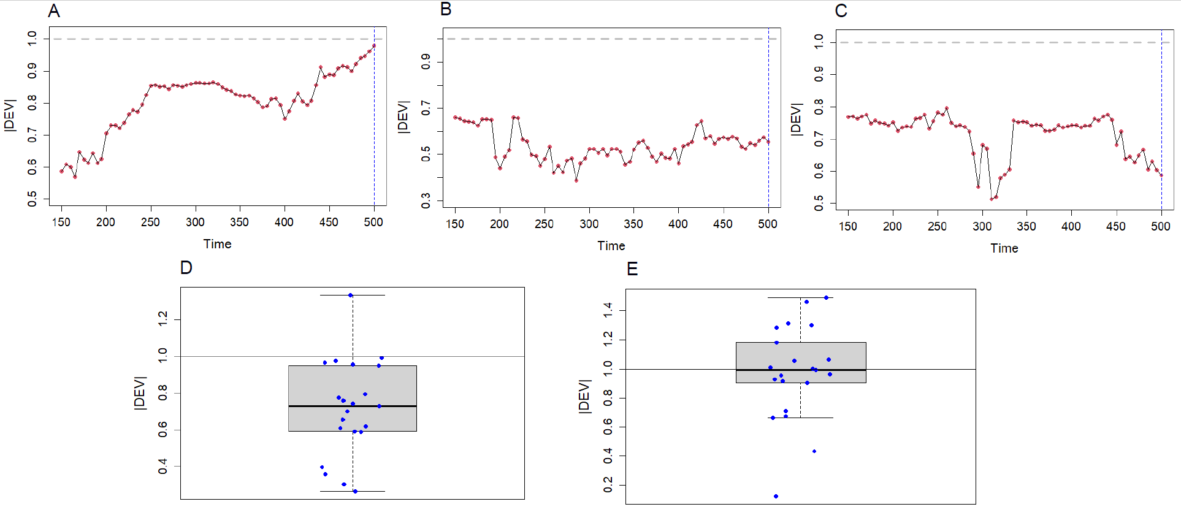
Fig. S1: Demonstration of the performance of univariate DEV using the Ricker model.
(A-C) Univariate |DEV| of the top three dominant variables of the Ricker model. (D) Box plot summarizing the results of univariate |DEV| at the tipping point of 21 original variables, indicating that the univariate |DEV| is not performing well. (E) Box plot summarizing the results of univariate |DEV| at the tipping point of the 21 ISOMAP factors, indicating that using ISOMAP to extract the principal factors improves the performance of univariate DEV, although the variation remains substantial. The vertical dashed blue line indicates the timing of the true critical transition based on mathematical analysis of the model.
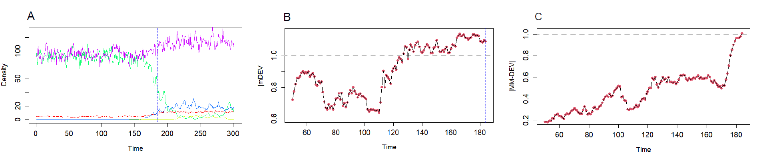
Fig. S2: Comparison between MM-DEV and multivariate DEV without manifold projection (mDEV). The |MM-DEV| and the |mDEV| are estimated for a 5-species model. Time series of the model (A) indicates that one species (green) experienced a clear transition around the time point 184. The |mDEV| (B) reached 1 near data point 130, far before the true critical transition. In comparison, |MM-DEV| (C) reached 1 exactly at point 184; moreover, it exhibits a steadily increasing trend prior to the transition. The vertical dashed blue line indicates the timing of the critical transition based on mathematical analysis of the model.

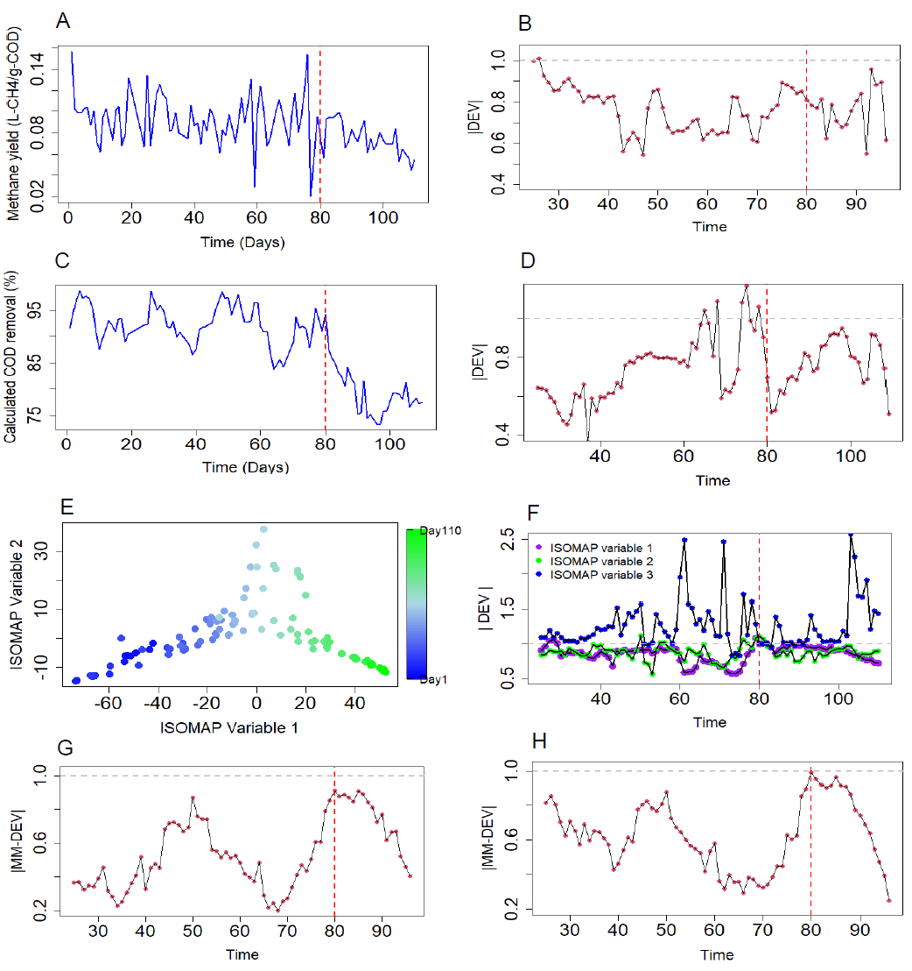
Fig. S3: The differences between univariate DEV and MM-DEV in the Bioreactor dataset. Time series of the methane yield (A) and its univariate |DEV| (B). Time series of the calculated COD removal (C) and its univariate |DEV| (D). In both performance indicators, the univariate |DEV| fails to predict an upcoming transition at day 80. Biplot of the first two ISOMAP variables (E) from 153 KTU variables indicates the change of taxonomic composition of the microbial community. The univariate |DEV| (F) of each of the first three ISOMAP variables does not serve as a correct EWS. The comparison of these results with Figure 3G in the main text indicates that the |MM-DEV| estimated from the ISOMAP variables warns of a transition; in contrast, each of the univariate |DEV|s of the first three ISOMAP variables fails to predict it when applying microbial data. In addition, the |MM-DEV|s of the two chemical datasets: 'Expertise' (G) and 'Naive' (H) (Table S1) show a similar temporal pattern. This comparison suggests the robustness of our framework when applied to data that may contain uninformative and/or redundant variables, reflecting limited knowledge of the studied system. The |MM-DEV| based on the Naive dataset gives a better indication and reaches 1 at the tipping point (H). This finding is unexpected; perhaps, this is due to the enhanced signal-to-noise ratio through manifold projection resulting from gathering much redundant information of various performance indicators. The vertical dashed red line indicates the timing of the critical transition.

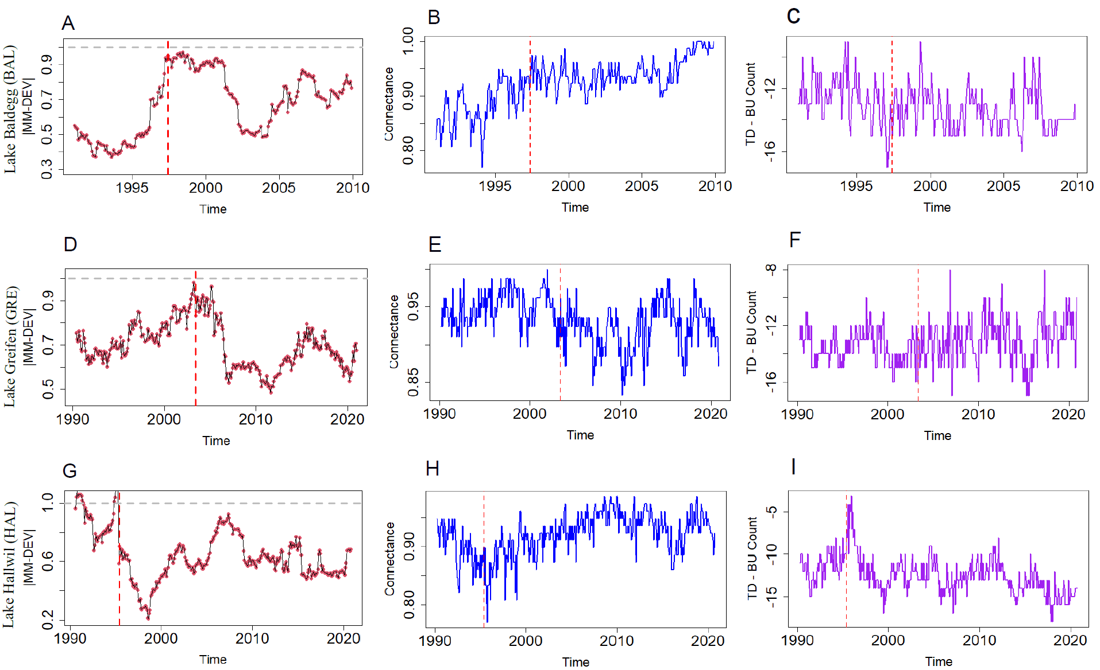
Fig. S4: Demonstration of efficacy of MM-DEV with the plankton abundances of three nearby lakes of Lake Zurich: Lake Baldegg, Lake Greifen, and Lake Hallwil. (A-C) |MM-DEV| suggests a transition in Lake Baldegg around the year 1997. (D-F) Lake Greifen is going through a transition around the year 2003. (G-I) Lake Hallwil is going through a transition around the year 1995. The time series of network connectance and TD-BU count also support the results of MM-DEV. The vertical dashed red line indicates the timing of the critical transition.

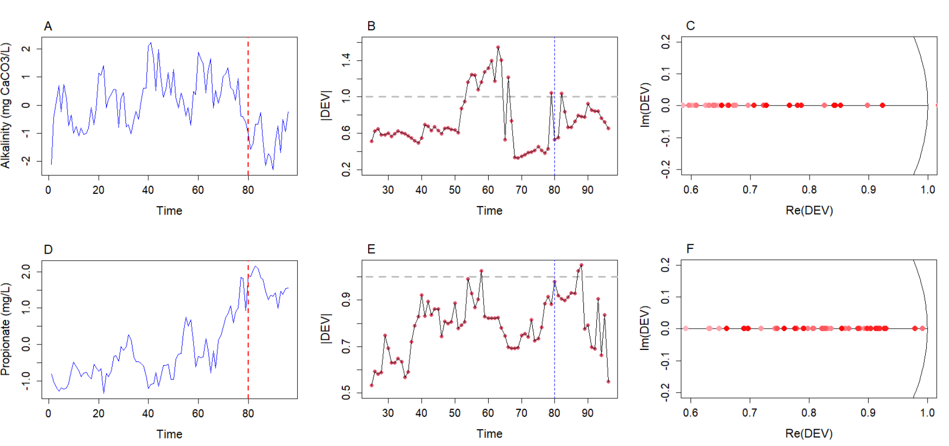
Fig. S5: Univariate DEV of two important chemicals from the Bioreactor dataset. Panels A–C show the time series data, univariate |DEV|, and its associated complex plane for alkalinity from the ‘Naïve’ dataset; panels D–F present the same analyses for propionate from the ‘Expertise’ dataset. These chemicals are the most dominant in their respective datasets. In both cases, the complex plane indicated a fold bifurcation, which is consistent with the bifurcation type observed in the bioreactor’s MM-DEV: chemical variables (Fig. 3F) and microbial variables (Fig. 3H).

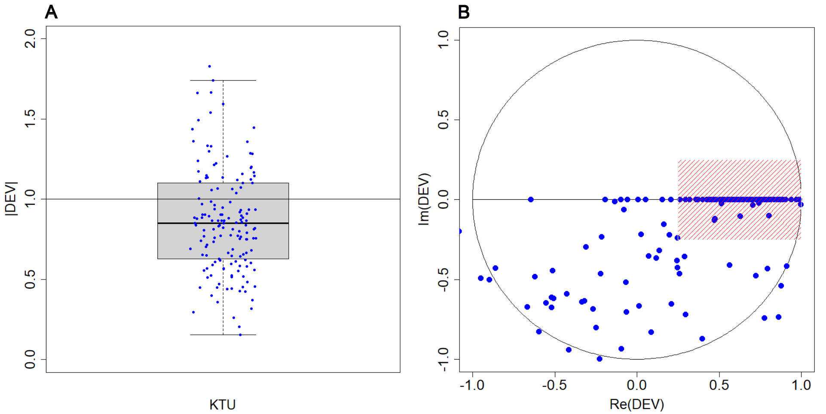
Fig. S6: Univariate DEV of 153 KTUs from the Bioreactor dataset at the tipping point. We analyzed the univariate DEV of all 153 KTUs at the tipping point (i.e., time point 80) to check the bifurcation type. (A) The average of univariate |DEV|s of KTUs at the tipping point does not reach 1 and exhibits substantial variation. (B) Most DEVs (over 55% of the points within the shaded region) in the complex plane for the 153 KTUs clustered near (1, 0) (i.e., Re=1, Im=0), indicating a fold bifurcation, consistent with the MM-DEV result (Fig. 3H).
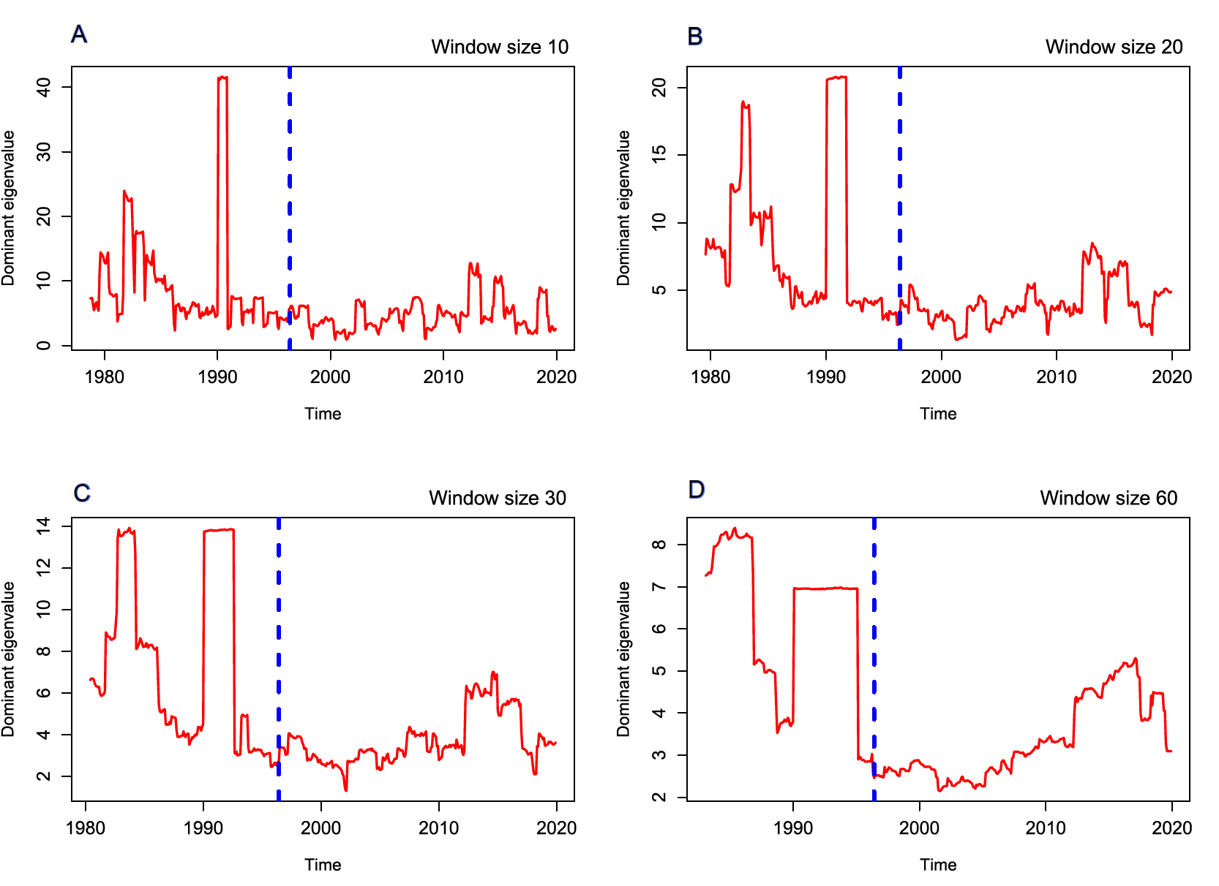
Fig. S7: Dominant eigenvalue of the covariance matrix for the plankton dynamics model of Lake Zurich. (A-D) For the Lake Zurich multivariate plankton data, the dominant eigenvalue of the covariance matrix is estimated with a moving window of 4 different window sizes (as no clear criterion has been proposed to decide the window size). The dominant eigenvalue of the covariance matrix failed to detect the bifurcation with any choice of window size. In contrast, |MM-DVE| of Lake Zurich showed a clear indication of a major transition around 1996 (Fig. 4); for |MM-DEV|, the window size was 60.

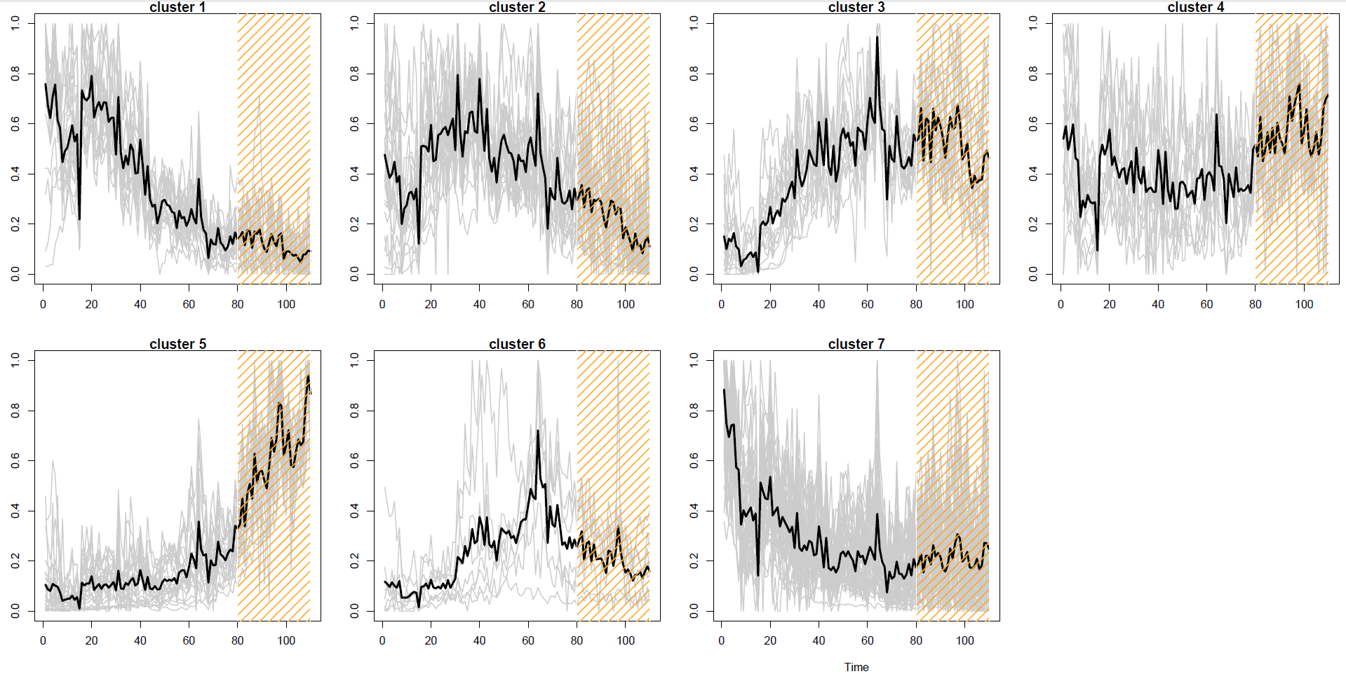
Fig. S8: KTU time series clustered into seven groups. The clusters of microbial KTUs based on temporal correlation reveal groups of taxa with similar abundance patterns over time. This clustering highlights synchronized temporal dynamics and potential functional associations among taxa. The 153 KTUs were clustered into 7 different groups. Clusters 1, 2, 3, and 6 exhibit some time series patterns that have changed near the time point 40, prior to the critical transition. MM-DEV also reflected this change (Fig. 3G).

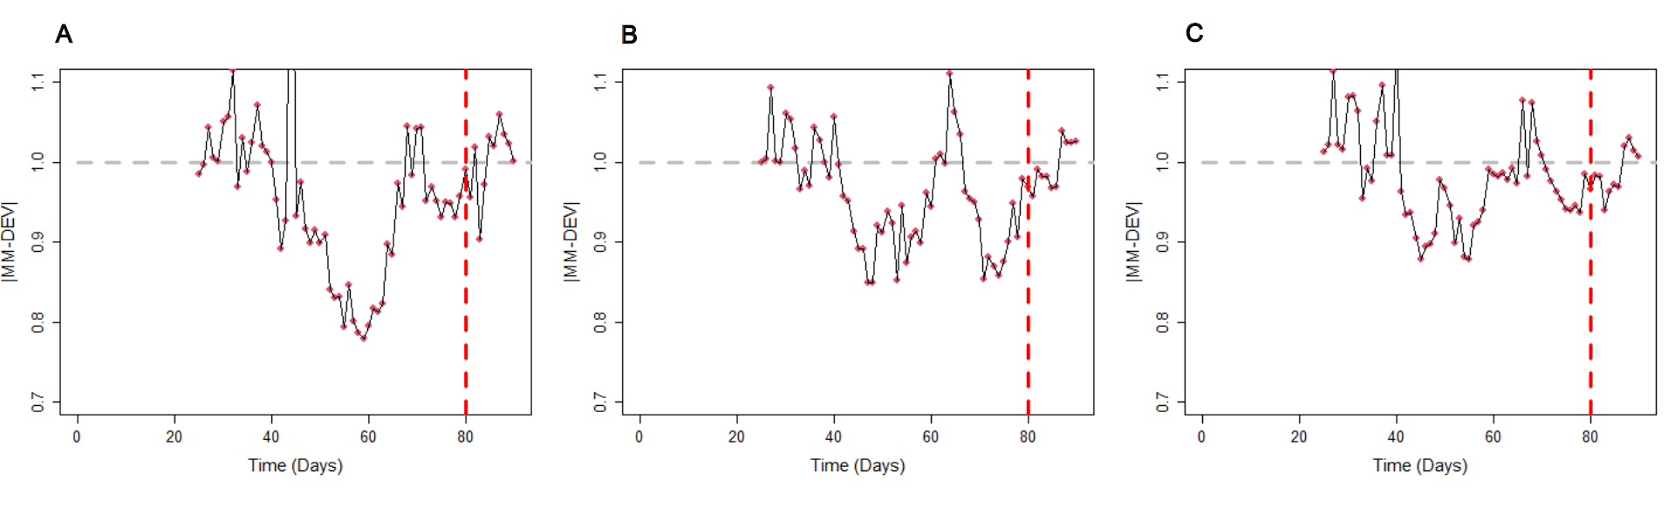
Fig. S9: Sensitivity analysis of MM-DEV with different numbers of KTUs. The accuracy of MM-DEV deteriorates when the system includes many sparse variables: (A) 191 KTUs (more than 80% non-zero in a KTU), (B) 257 KTUs (more than 70% non-zero in a KTU), (C) 345 KTUs (more than 50% non-zero in a KTU). The accuracy declines when the system includes many sparse variables.

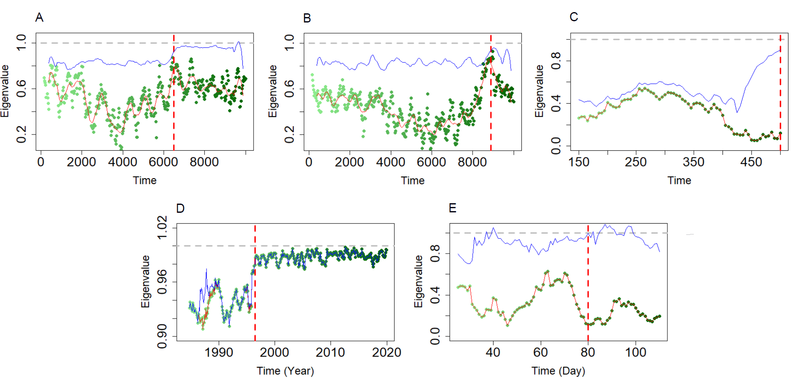
Fig. S10: Comparison between MM-DEV versus the second largest eigenvalue of the time-dependent Jacobian matrix. Time series of the |MM-DEV| and the second largest eigenvalue of the multivariate Jacobian are estimated for the three model datasets and two empirical datasets: the Lotka-Volterra model with a transcritical bifurcation (A), the Lotka-Volterra model with a saddle-node bifurcation (B), the Ricker model with a period-doubling bifurcation (C), the Lake Zurich plankton abundances (D), and the bioreactor KTU abundances dataset (E). The dotted vertical line represents the transition point; the color gradient from light to dark green presents time progression from initial to final time for the second largest eigenvalue; the solid red curve is the smoothing curve for the second largest eigenvalue; the solid blue curve represents the |MM-DEV|. The temporal patterns of the |MM-DEV| and the second largest eigenvalue were more consistent in the Lotka–Volterra models (A, B), although the second largest eigenvalue did not reach 1 at the tipping point. In contrast, the second largest eigenvalue failed to predict the transition in the Ricker model (C). Whereas, the results were mixed across different empirical datasets (D, E).

Fig. S11: Residual variance analysis of the ISOMAP. Residual variance is estimated for all the datasets: the Lotka-Volterra model with a transcritical bifurcation (A), the Ricker model (B), the Lake Zurich plankton abundances (C), and the bioreactor Expertise chemical dataset (D). The residual variance shows that including 2 or 3 ISOMAP variables is sufficient for the reduced spaces.

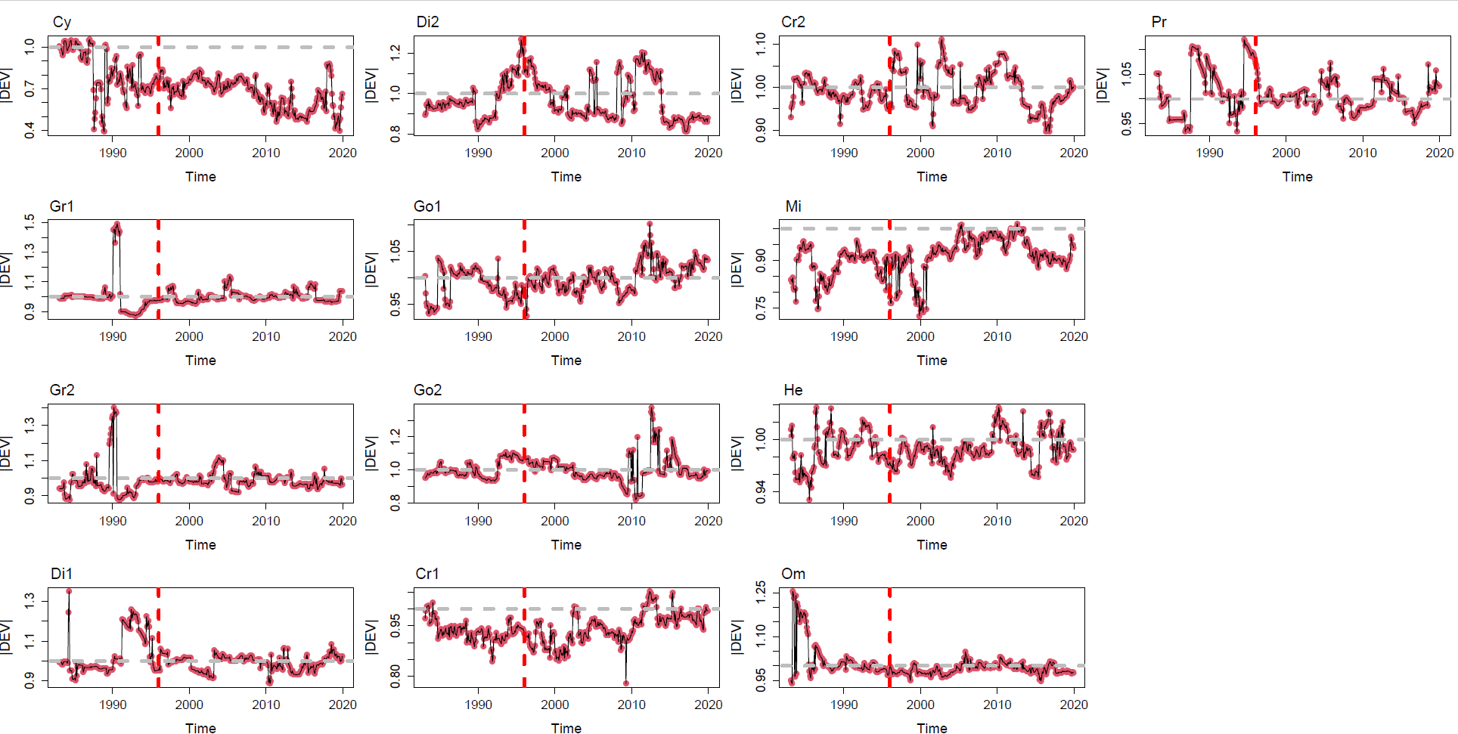
Fig. S12: Univariate DEV of each of the 13 plankton groups. The vertical dashed line indicates 1996, the supposed year of critical transition. None of the univariate |DEV|s correctly warns of the critical transition.

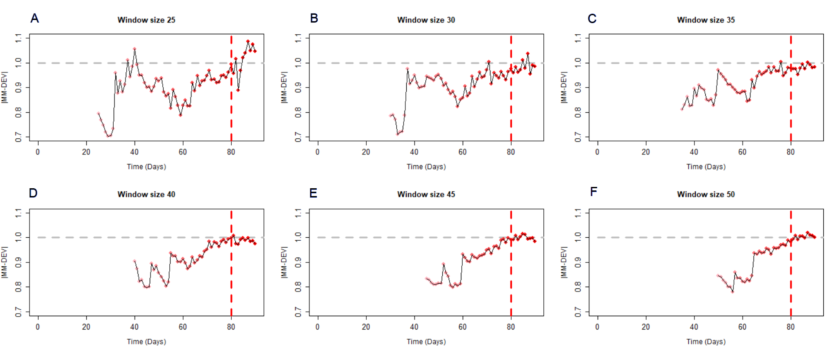

Fig. S13: Robustness of the MM-DEV indicator against different window sizes for the KTU dataset of the bioreactor experiment. For the MM-DEV analysis of the KTU dataset, we fixed the window size at 25 (Fig. 3G) due to the limited number of data points. Here, we examined the |MM-DEV| for different window sizes ranging from 25 to 50, in steps of 5 (A–F). With smaller window sizes (A–C), |MM-DEV| successfully captured the initial (around day 40) dynamics of the KTU dataset. With larger window sizes (D–F), |MM-DEV| failed to capture the early dynamics; however, it successfully predicted the transition around day 80. Overall, for datasets with limited data points, MM-DEV performs adequately, but smaller window sizes can provide richer insights into the system’s overall dynamics.
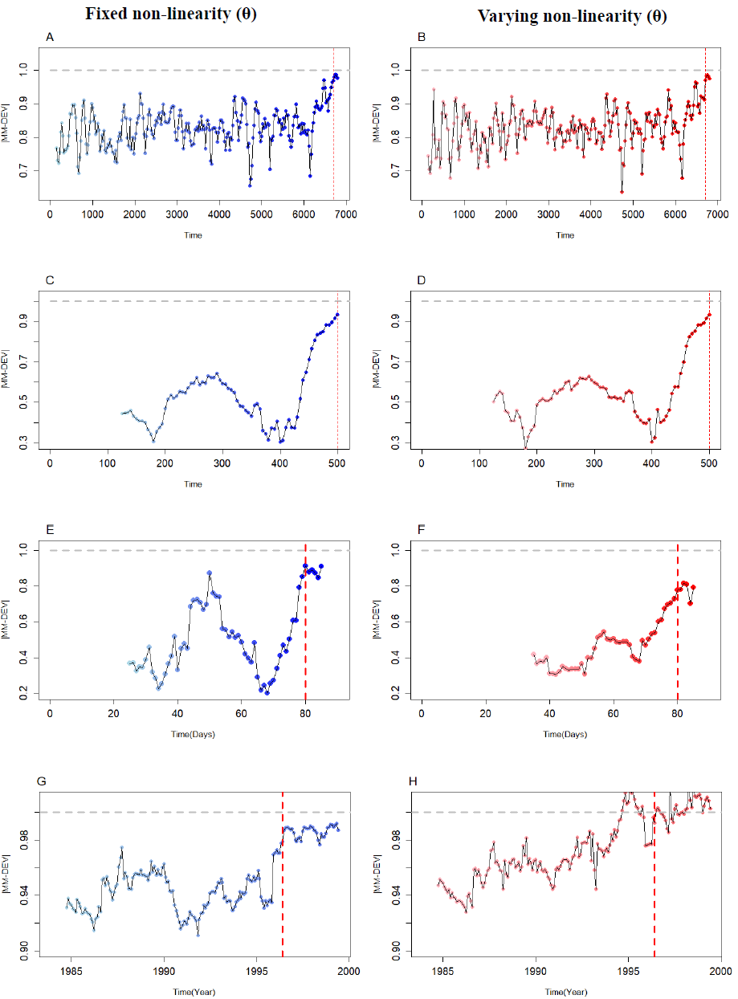
Fig. S14: Comparison between fixed versus varying non-linearity parameter (θ) for the MM-DEV analysis. In all MM-DEV analyses, we fixed the non-linearity parameter (θ) at 1 (left panels) to reduce computational time. We also tested θ values ranging from 0 to 2 in steps of 0.25 (right panels); that is, selecting the best θ based on the S-map predictability criterion. This assessment was performed for all datasets: (A–B) Lotka–Volterra model, (C–D) Ricker model, (E–F) Bioreactor Expertise chemical dataset, and (G–H) Lake Zurich plankton dataset. Across all datasets, |MM-DEV| patterns were largely consistent between fixed and varying θ, with most cases, optimal θ values falling between 0.5 and 1.5, indicating that fixing θ at 1 has minimal impact on |MM-DEV| behaviour. The only exception appears in the Lake Zurich plankton dataset, in which the critical transition appeared earlier than 1996.

