Supplementary Materials
Table S1
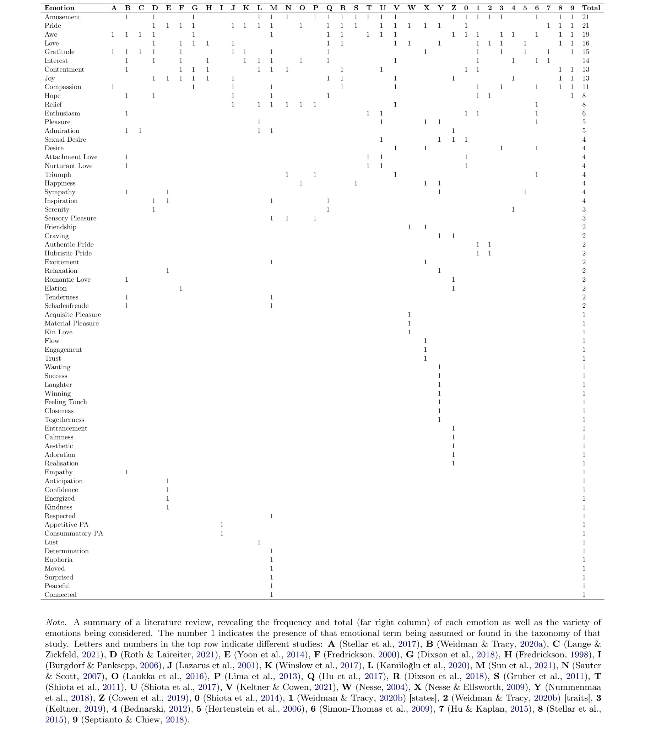
Literature Review on the Number of Emotions

Two-Factor Solution
Below are the results for the additional EFA with a two-factor solution. The first factor was strongly loaded by ‘Positivity’, ‘Pleasantness’, ‘Flow’, ‘Reward’, ‘Inner Marker’, ‘Approach Tendency’, and ‘Meaning’ (see Table S2), suggesting that the first factor is best characterised by positive valence. In the second EFA, the second factor was strongly loaded by ‘Power’, and moderately loaded by ‘Subject Evaluation’, ‘Self-Congruence’, and ‘Ethical’ (see Table S2). These loadings suggest that the first factor is best characterised as positive valence, while the second factor is capturing aspects of emotion related to empowerment or self-concept. See Figure S1 for an additional visualisation.
Table S2
Factor Loadings and Communalities of Candidate Valence Dimensions in the Two-Factor Solution
Dimension | F1 Loading | F2 Loading | Communality
Positivity | 0.95 | -0.05 | 0.91
Inner Marker | 0.98 | -0.15 | 0.99
Reward | 0.84 | 0.09 | 0.71
Flow | 0.96 | -0.12 | 0.94
Approach Tendency | 0.95 | -0.11 | 0.91
Goal Conducive | 0.75 | 0.24 | 0.63
Pleasant | 0.96 | -0.13 | 0.94
Meaning | 0.92 | -0.06 | 0.84
Object Evaluation | 0.90 | -0.14 | 0.83
Ethical | 0.64 | 0.32 | 0.51
Aesthetic | 0.70 | 0.14 | 0.51
Self-Congruence | 0.63 | 0.43 | 0.58
Subject Evaluation | 0.43 | 0.44 | 0.38
Power | 0.15 | 0.75 | 0.58
Novelty | -0.11 | 0.23 | 0.07
Note. F1 (Factor 1) = Positive Valence, F2 (Factor 2) = Power.
Figure S1
Factor Loading Heatmap for the Two-Factor Solution, Ordered by Hierarchical Clustering from the Dendrogram
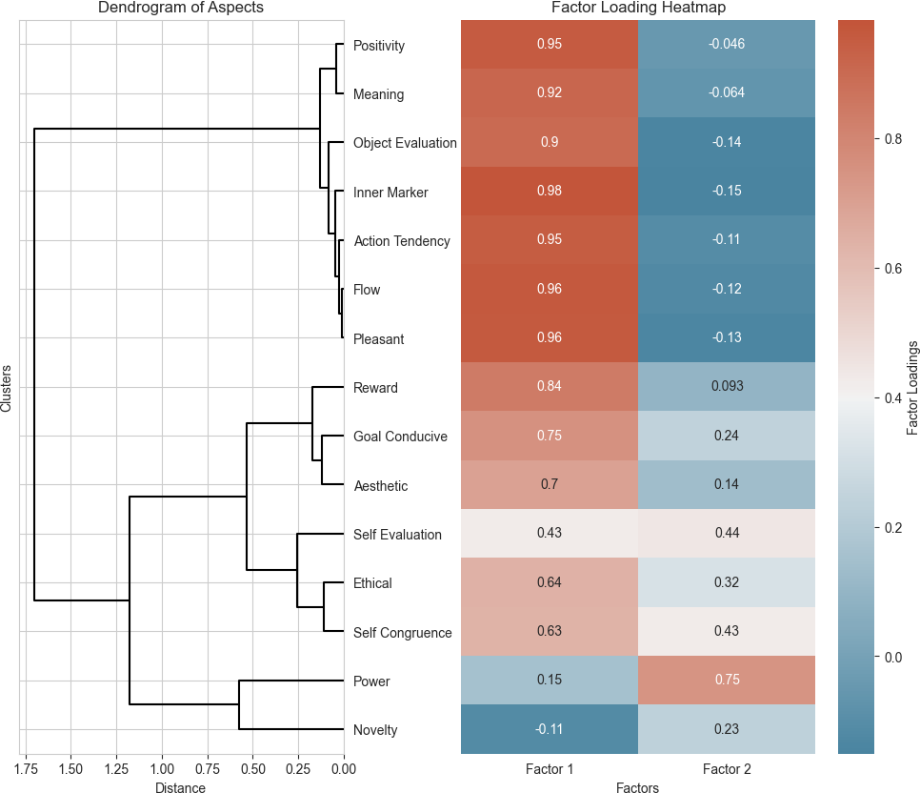

Power as a Third Dimension of Emotion
The weak factor loadings cast doubt on the validity of the second (non-valence) factor as a distinct dimension of emotion. Nevertheless, for the sake of theoretical exploration, this factor may hypothetically align with the emotional dimension of ‘Dominance’ (Mehrabian, 1996), or ‘Potency-Control’ (Fontaine et al., 2007; Gehm & Scherer, 2013; Herrmann & Raybeck, 1981), or ‘Power’ appraisal (Scherer, 2013) argued for by other affective researchers. If this were the case, the notion of power in emotional experiences may extend beyond the mere physical ability to influence outcomes, to include an individual’s psychological ability to shape their emotional responses in line with their personal values and self-concept. In other words, power may not be limited to the control one has over the situation and the external factors which give rise to emotional experiences, but may also encompass the control one has over one’s reactions, evaluations, and the internal factors that characterise and influence one’s emotional experiences. However, even if this factor were a distinct dimension of emotion, this would not necessarily mean it qualifies as an additional dimension of valence. Just as ‘arousal’ is typically considered a fundamental dimension of emotion, but is not inherently tied to valence (Russell, 1980). Importantly, although several items loaded moderately on this second factor, ‘Power’ was the only aspect which had notably stronger loadings on the second factor than on the first. All other items showed equivalent or weaker loadings on the second factor. This suggests that while power may constitute a unique component of emotion, the other positive aspects are largely accounted for by the first positive valence factor.

Interrelationships of Positive Aspects
Figure S2
Pairplot Indicating the Relationships and Distributions Among All Candidate Valence Dimensions

Note. Kernel Density Estimates on the diagonal reflect the distributions of each dimension. Scatterplots, everywhere else, reflect the type of relationships between dimensions.

Figure S3
Correlation Matrix Heatmap Showing the Correlations Between All Candidate Dimensions
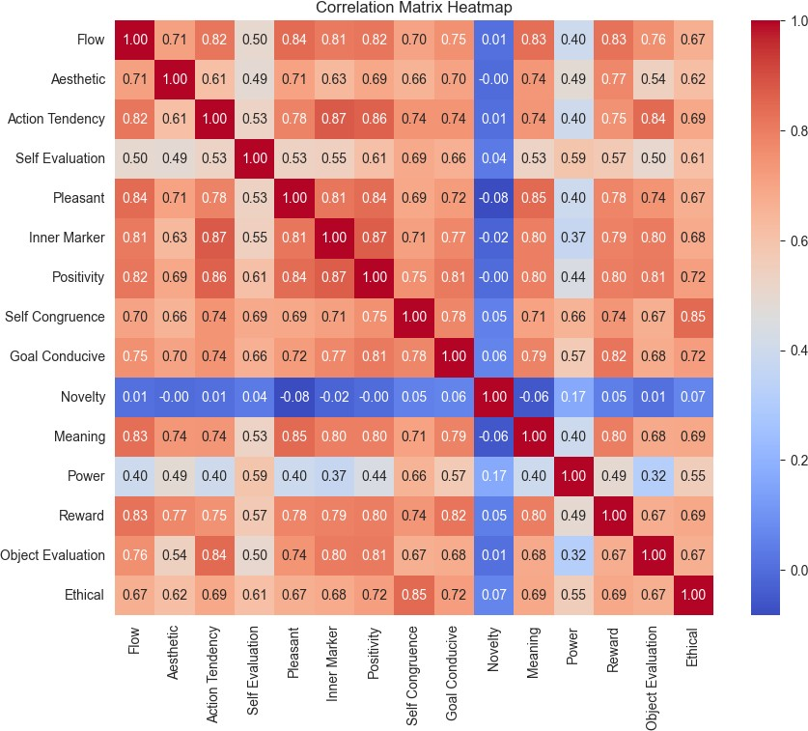

Robustness Check Across Extraction and Rotation Methods
Figure S4
Heatmap of Factor Loadings for Two-Factor Solutions Across every Method-Rotation
Combination
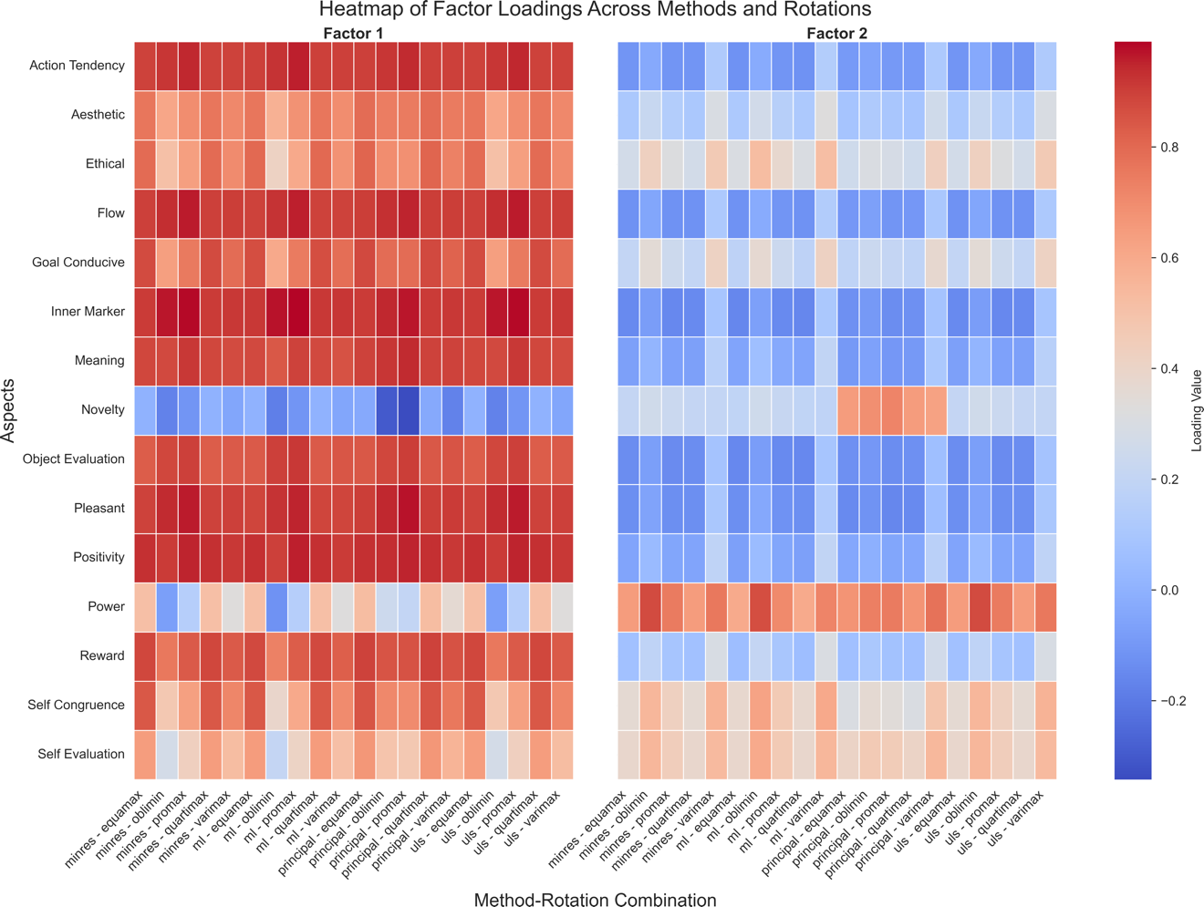
Note. Extraction methods include ‘minres’ (Minimum Residual), ‘ml’ (Maximum Likelihood), ‘uls’ (Unweighted Least Squares), and ‘principal’ (Principal Components Analysis). Rotation techniques are as named.

Intermediary Analyses
Figure S5
Average Coefficients for Each Emotion on Two Factors
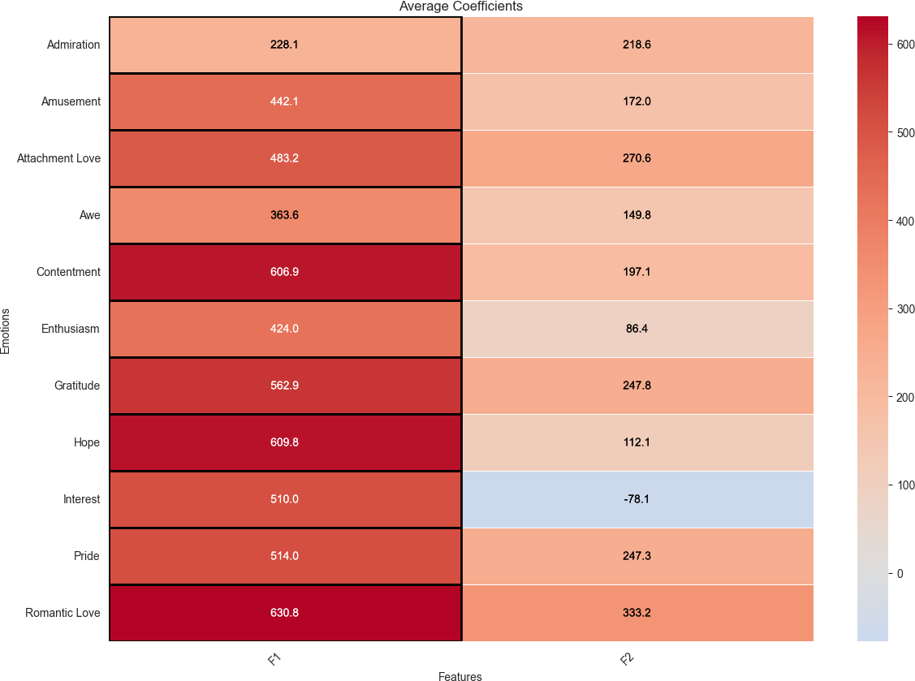
Figure S6
Average Coefficients for Each Emotion on Three Factors
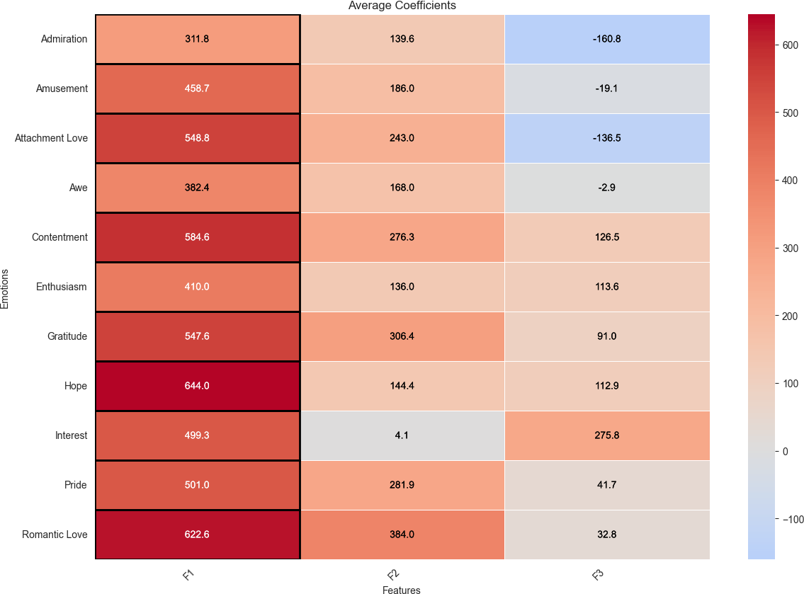
Figure S7
Average Coefficients for Each Emotion on Four Factors
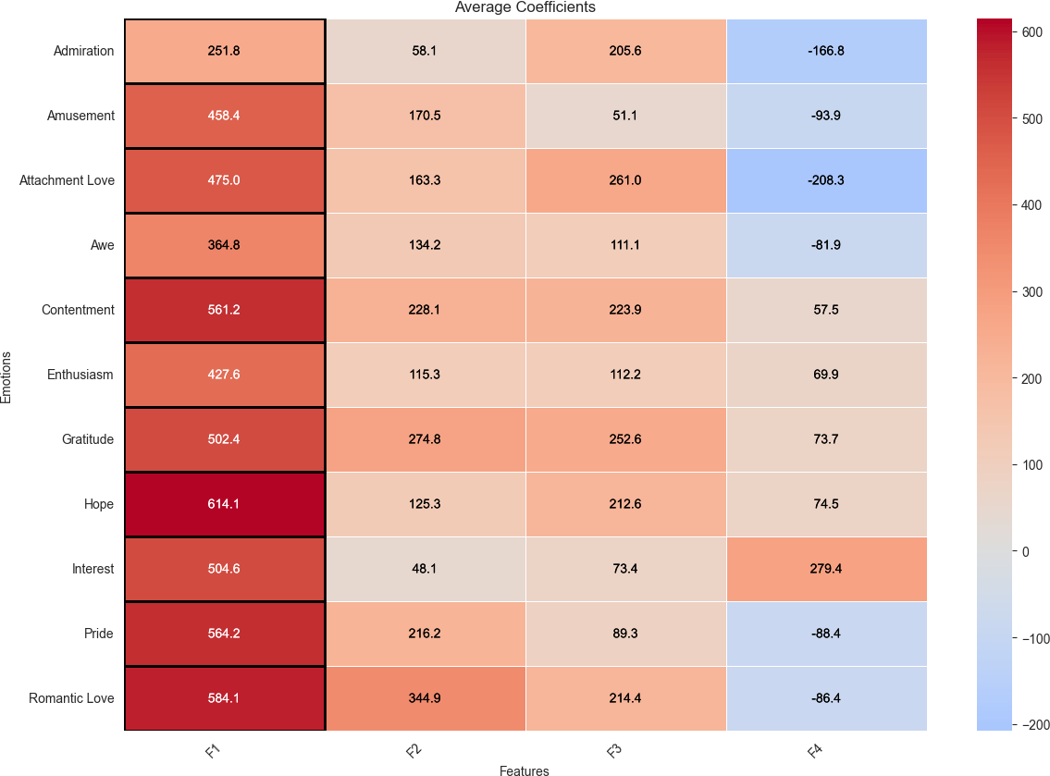

Figure S8
Average Coefficients for Each Emotion on Five Factors
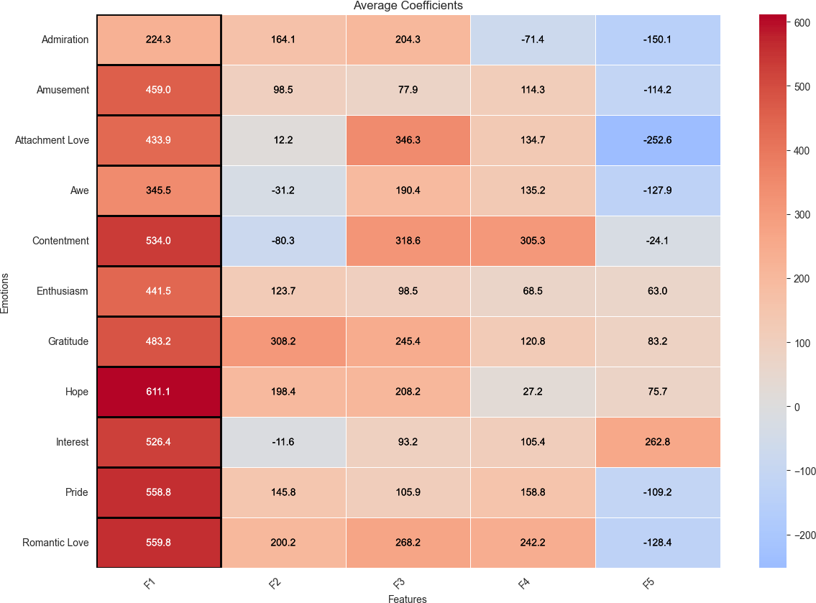
Table S3
Factor Loadings (One Emotion Per Participant)
Aspect | Factor 1 | Factor 2
Aesthetic | 0.76 | -0.04
Power | -0.20 | 0.79
Meaning | 0.72 | 0.06
Ethical | 0.42 | 0.40
Reward | 0.84 | -0.03
Approach Tendency | 0.79 | 0.06
Positivity | 0.76 | 0.17
Object Evaluation | 0.76 | 0.10
Subject Evaluation | 0.30 | 0.47
Inner Marker | 0.81 | 0.07
Pleasant | 0.94 | -0.15
Novelty | -0.01 | 0.06
Flow | 0.90 | -0.22
Goal Conducive | 0.41 | 0.37
Self-Congruence | 0.40 | 0.51

Figure S8
Scree Plot and Factor Retention Criteria (One Emotion Per Participant) 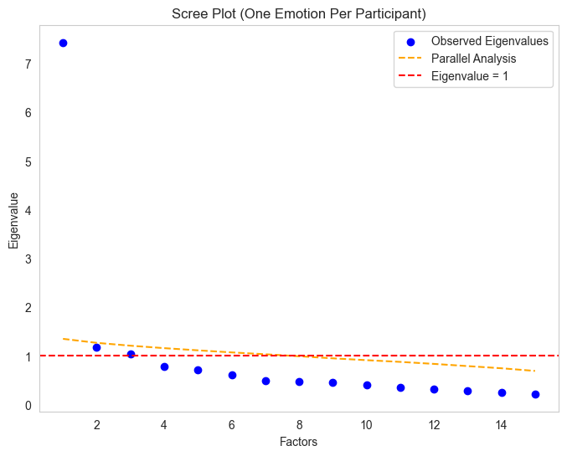
Figure S9
Tucker’s Phi: Factor Congruence Across Datasets