Additional File 1

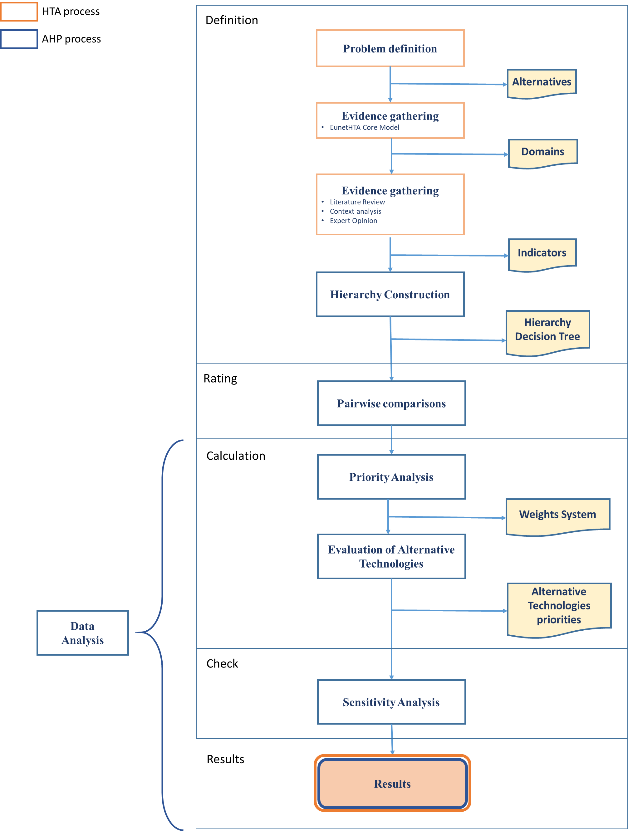
Figure S1: Shows the integration of the analytical approach (AHP) within the qualitative assessment tool (EunetHTA), allows quantifying opinions and transforming them into a coherent decision model assessing all factors and their interactions in a decision domain, leading to define a final rank of several health interventions. The idea is that a decision problem can be decomposed into a hierarchy of more sub-problems each of which can be measured and analyzed independently. AHP mathematical process using pairwise comparisons, eigenvector method for deriving weights, and a method to verify the “consistency” of judgments, is able to integrate all KPIs evaluation in a final numerical result, which represents the alternatives' relative ability to achieve the decision goal.

