Supporting information
Digital light processing 3D printing of surface-oxidized Si₃N₄ coated by silane coupling agent
Ping Yang^{1,*}, Zhenfei Sun¹, Shengwu Huang, Jun Ou, Shanghua Wu*
School of Electromechanical Engineering, Guangdong University of Technology, Guangzhou 510006, People’s Republic of China
*Corresponding authors.
Electronic mail: ping_yang@foxmail.com (P. Yang); swu@gdut.edu.cn (S. Wu)
¹ Both authors contributed equally to this work.

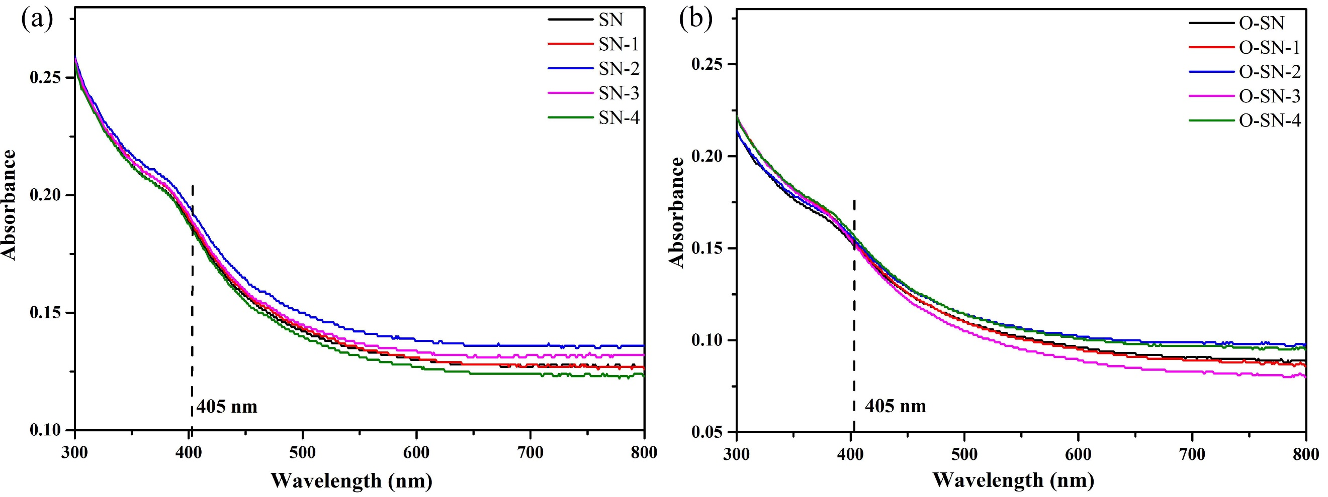
Fig. S1 The light absorbance of Si₃N₄ under a wavelength from 300 to 800 nm. (a) the pristine Si₃N₄ with different content of KH560, (b) the oxidized Si₃N₄ with different content of KH560.

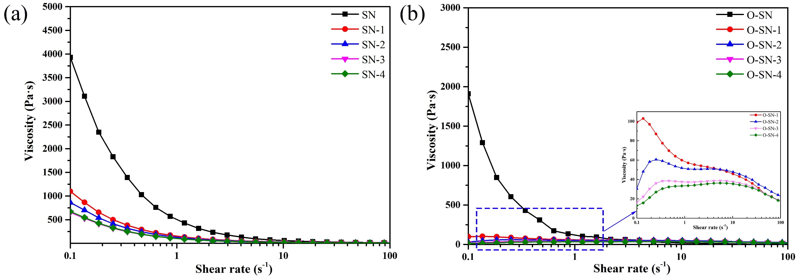
Fig. S2 The rheological properties of Si3N4 slurry (30 vol.%). (a) the pristine Si₃N₄ with different content of KH560, (b) the oxidized Si₃N₄ with different content of KH560.

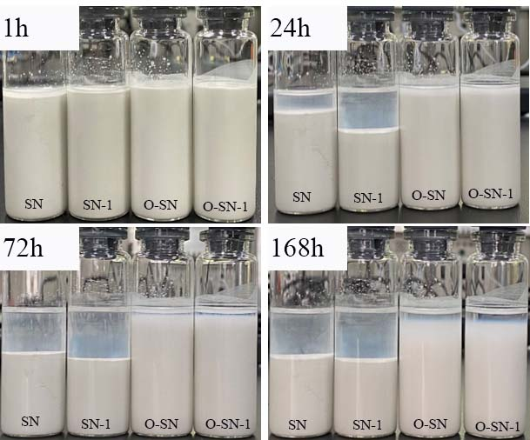
Fig. S3 Sedimentation phenomena of Si₃N₄ slurry under different time.

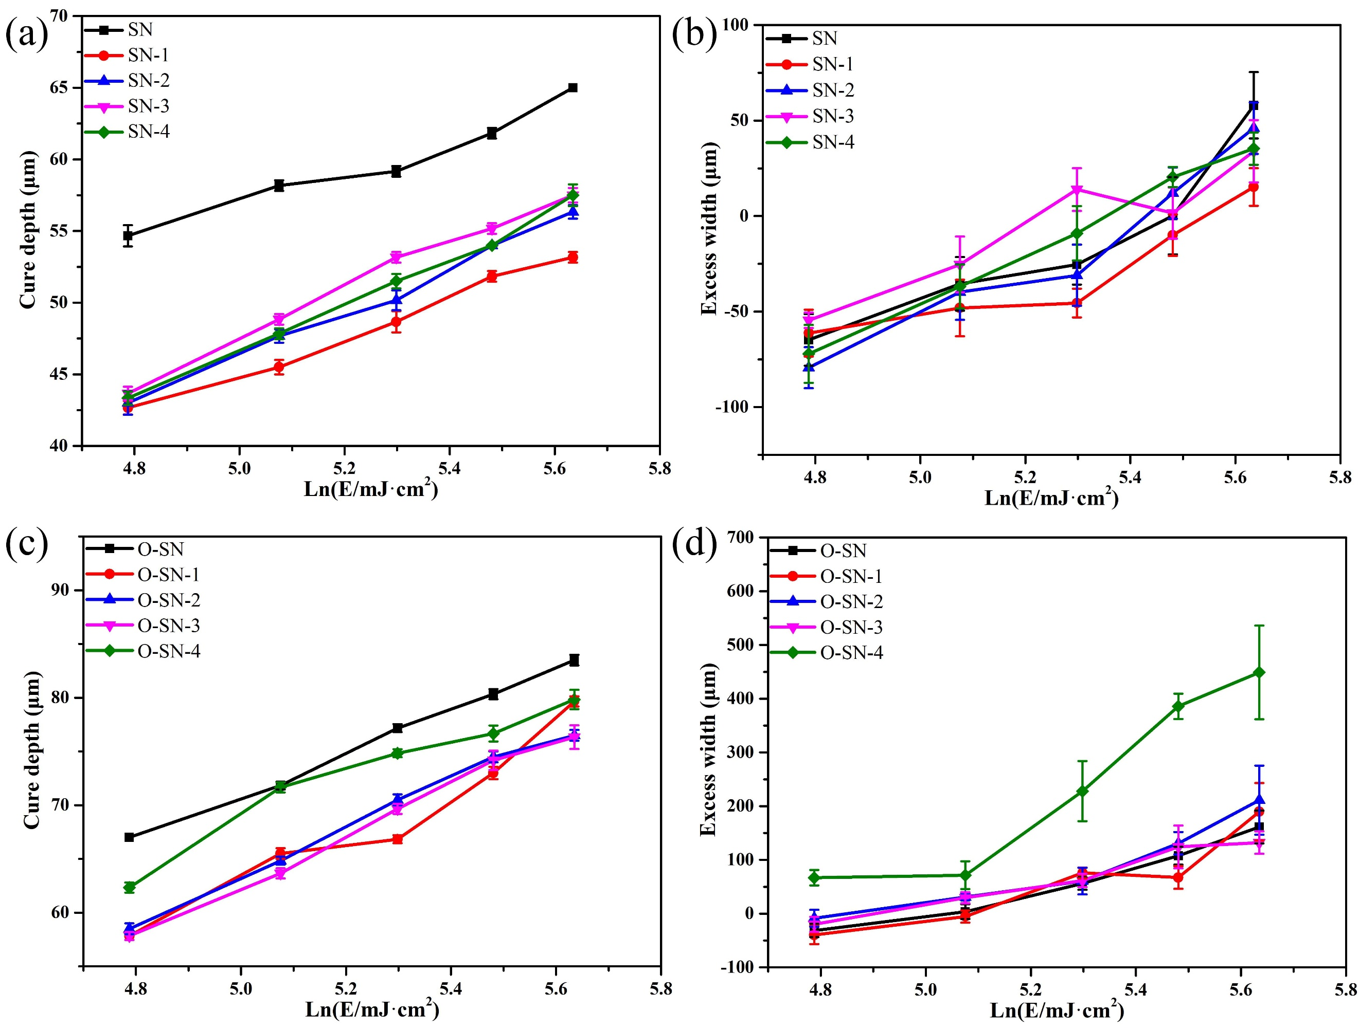
Fig. S4 The influence of KH560 modification on the cure depth and excess width of Si₃N₄ slurry (15 vol.%). (a-b) the pristine Si₃N₄ with different content of KH560, (c-d) the oxidized Si₃N₄ with different content of KH560.

