Supplemental Figures and Tables
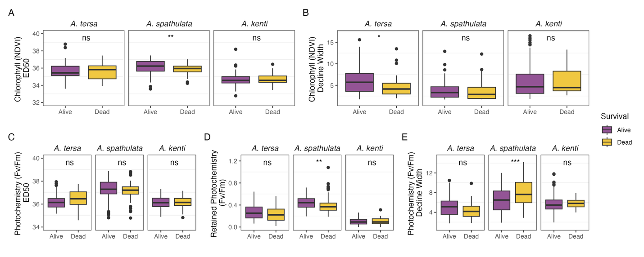

Figure S1. Survival in three Acropora species after a marine heatwave in 2024 as they relate to acute experimental metrics measured in 2021-2023 including A.) NDVI ED50, B.) NDVI decline width, C.) F_{v}/F_{m} ED50, D.) retained F_{v}/F_{m}, and E.) F_{v}/F_{m} decline width. Survival was grouped into two levels: alive (≥95% of colony surface area), or dead (<95%). T-tests were run to compare survival proportions within each species using Benjamini-Hochberg corrected p-values, with asterisks representing statistically significant p-values, where ns represents p > 0.05, * represents p < 0.05, ** represents p < 0.01, *** represents p < 0.001, and **** represents p < 0.0001. NDVI is the normalized difference vegetation index, ED50 is the effective dose 50, and F_{v}/F_{m} is a metric of photochemical efficiency of the algal symbionts.

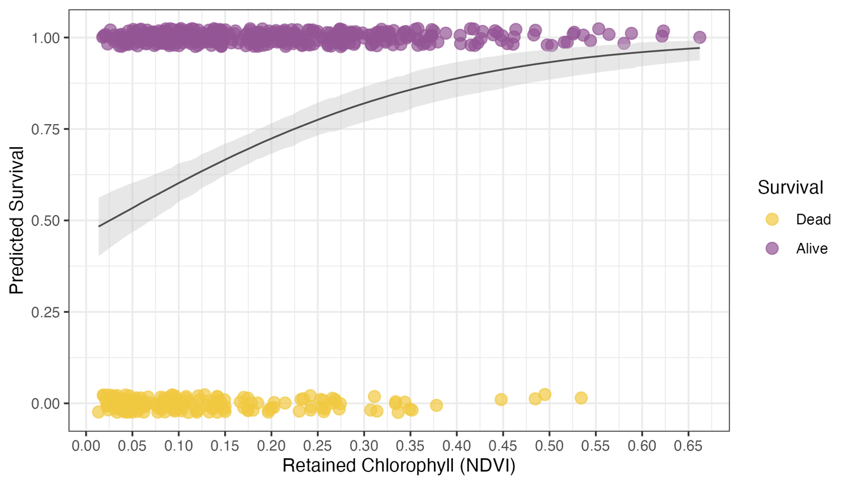
Figure S2. A multi-species Bayesian model showing strong evidence (slope > 1 in >97.5% of posterior samples) that an increased chlorophyll retention (i.e., NDVI) can be used to predict a higher likelihood of survivorship after a marine heatwave. This model was fitted using data pooled from Acropora tersa, Acropora kenti, and Acropora spathulata on the Great Barrier Reef. Survival was grouped into two levels: alive (≥95% of colony surface area), or dead (<95%), designated as 1 and 0, respectively.

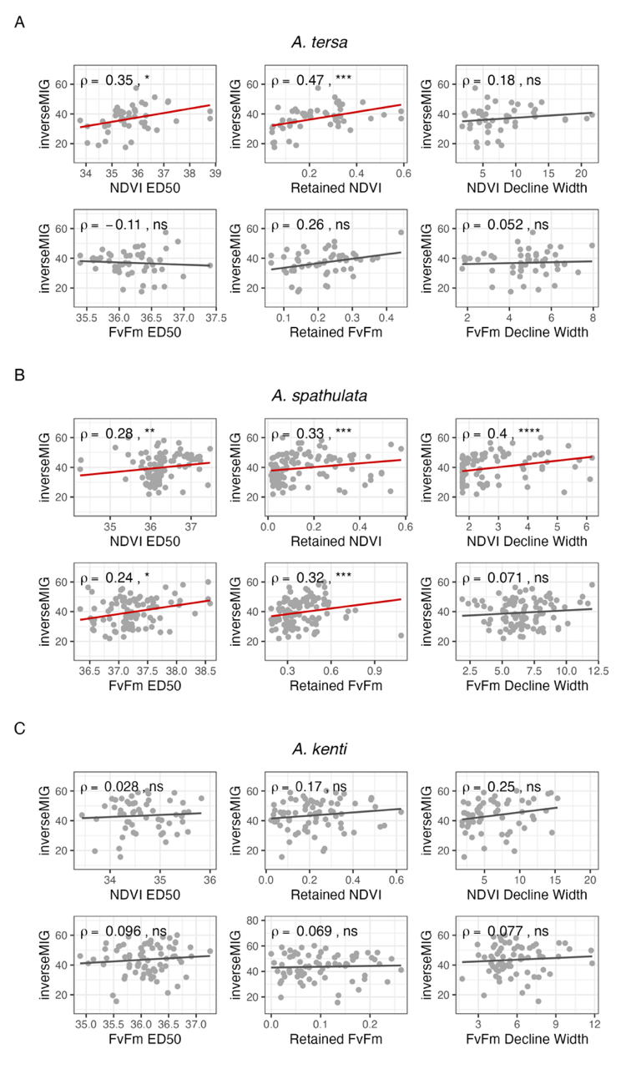
Figure S3. Relationship of the six heat tolerance metrics measured in an acute heat stress assay in 2021-2023 compared to the inverse MIG (mean intensity of grey) measured during a marine heatwave in 2024 for the three coral species A.) Acropora tersa, B.) Acropora spathulata, and C.) Acropora kenti. A higher inverse MIG value indicates less bleaching. Analyses were restricted to colonies from reefs of the Great Barrier Reef that had variable bleaching during the heatwave. One outlier was removed from the analysis for retained F_{v}/F_{m} in A. spathulata as its Mahalanobis distance exceeded a 0.999 quantile threshold. Significant positive associations are denoted with a red line. Spearman’s ρ and p values are shown with asterisks representing statistically significant p-values, where ns represents p > 0.05, * represents p < 0.05, ** represents p < 0.01, *** represents p < 0.001, and **** represents p < 0.0001. One outlier was excluded as its Mahalanobis distance exceeded the chi-square critical value at p < 0.001.
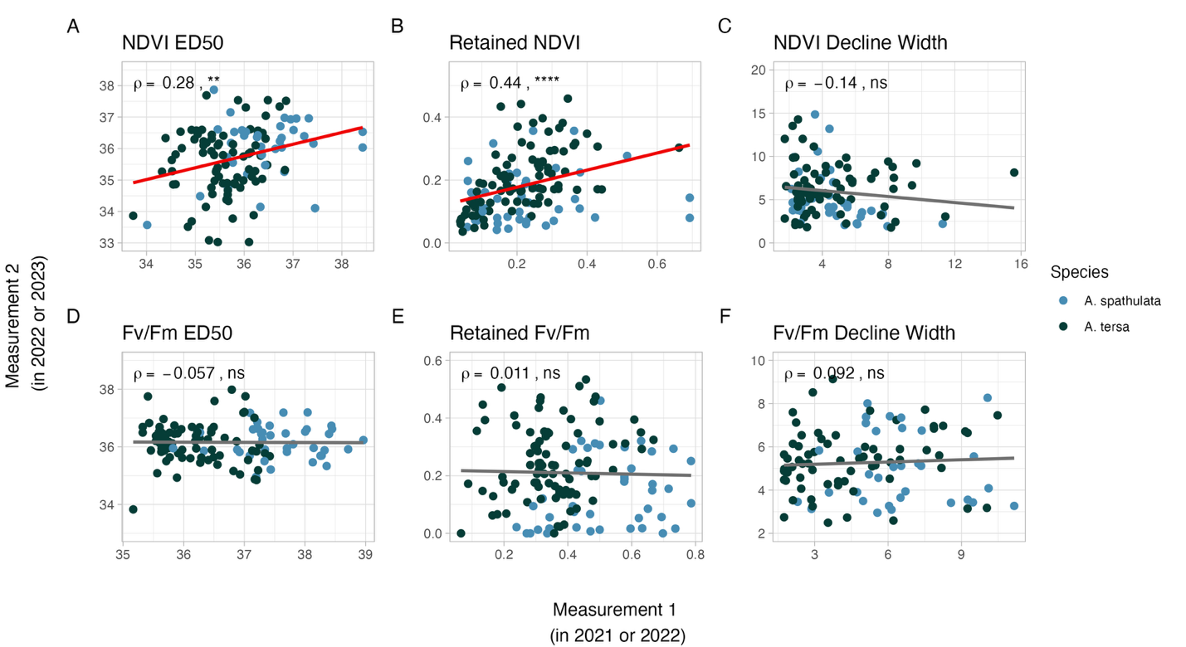

Figure S4. NDVI ED50 and retained NDVI in pooled colonies of two Acropora species are reproducible across acute heat stress assays performed in different years on the Great Barrier Reef, regardless of prior sustained heat stress (no filter on degree heating weeks; DHW). There was a significant positive association for the same individuals assessed in an acute heat stress assay between two measurements taken during sampling years 2021, 2022, and 2023 for A.) NDVI ED50, B.) retained NDVI, and F) F_{v}/F_{m} decline width. There was no association between measurements in different sampling years for C) NDVI decline width, D) F_{v}/F_{m} ED50, and E) Retained F_{v}/F_{m}. Significant positive associations are denoted with a red line. Spearman’s ρ and p values are shown with asterisks representing statistically significant p-values, where ns represents p > 0.05, * represents p < 0.05, ** represents p < 0.01, *** represents p < 0.001, and **** represents p < 0.0001.

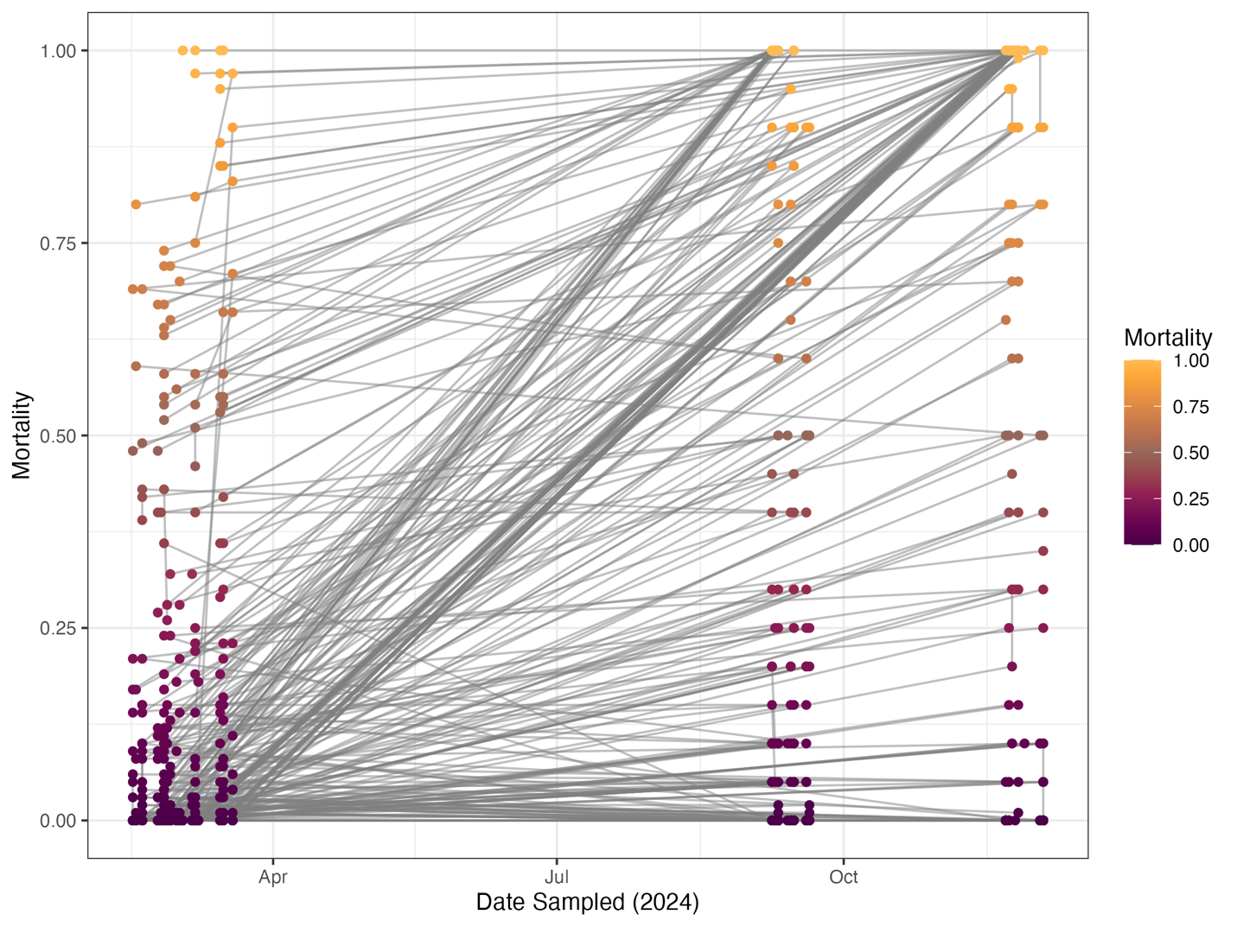

Figure S5. The percent mortality of coral colonies across sampling dates in 2024 of three Acropora species on the Great Barrier Reef. Grey lines connecting points indicate mortality measurements across time for the same unique coral colony, showing many colonies measured as 0% mortality in March up to 100% mortality by November.

Table S1. Numbers of surviving and mortality individuals measured after the 2024 marine heatwave on the Great Barrier Reef in Acropora tersa, A. spathulata, and A. kenti. Survival was classified into two levels based on the percentage of living tissue of the total colony surface area: alive (≥95%), or mortality (<95%).

Species | Number of surviving colonies | Number of mortality colonies
A. tersa | 65 | 36
A. spathulata | 137 | 112
A. kenti | 184 | 31

Table S2. Details of A. tersa and A. spathulata coral colonies resampled on the Great Barrier Reef that underwent a reassessment of heat tolerance in an acute stress assay. Recent accumulated heat stress is noted as Degree Heating Weeks (DHW). Temperature profile changes are denoted for T3 A. spathulata as all other acute assays for A. tersa and A. spathulata used the temperatures of MMM + 3˚C, + 6˚C and + 9˚C.

Species time point | Date sampled | Sites | n | Notes
A. tersa T1 | March 2021 | All sites
A. tersa T2 | March 2022 | Chicken, Davies | 32 | DHW (4.1-4.7) before sampling
A. tersa T3 | March 2023 | Chicken, Martin, No Name | 47
A. spathulata T1 | March 2022 | All sites |  | DHW (0-4.6) before sampling
A. spathulata T2 | December 2022 | Moore, Davies | 16
A. spathulata T3 | March 2023 | Moore, Kelso | 35 | Temp. profile = +4, +7, +10

