Supplementary Legend
Supplemental Figure 1: CVD Burden in Colon Cancer-Related Reporting Odds Ratio Stratified by Age Group in the United States, 1999-2020
Supplemental Figure 2: CVD Burden in Colon Cancer-Related Reporting Odds Ratio Stratified by Sex and Age Group in the United States, 1999-2020
Supplemental Figure 3: CVD Burden in Colon Cancer-Related Reporting Odds Ratio Stratified by Region and Age Group in the United States, 1999-2020
Supplemental Figure 4: CVD Burden in Colon Cancer-Related Reporting Odds Ratio Stratified by Race and Age Group in the United States, 1999-2020
Supplemental Figure 5: CVD Burden in Colon Cancer-Related Reporting Odds Ratio Stratified by Urbanization and Age Group in the United States, 1999-2020

Supplementary Table 1: Total Deaths and Reporting Odds Ratio of CVD Burden in Colon Cancer in Individuals aged 15-85+ in United States from 1999-2020
Supplementary Table 2: Average Annual Percent Change (AAPC) of CVD Burden in Colon Cancer, related Reporting Odds Ratio in the United States, 1999 to 2020
Supplemental Table 3: CVD Burden in Colon Cancer and All Cause Deaths-Related Proportions across Age Groups 15-85+ in the United States, 1999-2020
Supplemental Table 4: CVD Burden in Colon Cancer-Related Reporting Odds Ratio Stratified by Sex and Urbanization in the United States, 1999-2020
Supplemental Table 5: CVD Burden in Colon Cancer-Related Reporting Odds Ratio Stratified by Census Regions in the United States, 1999-2020
Supplemental Table 6: CVD Burden in Colon Cancer-Related Reporting Odds Ratio Stratified by Race in the United States, 1999-2020
Supplemental Table 7: CVD Burden in Colon Cancer-Related Deaths Reporting Odds Ratio Stratified by Census Place of Death in the United States, 1999-2020

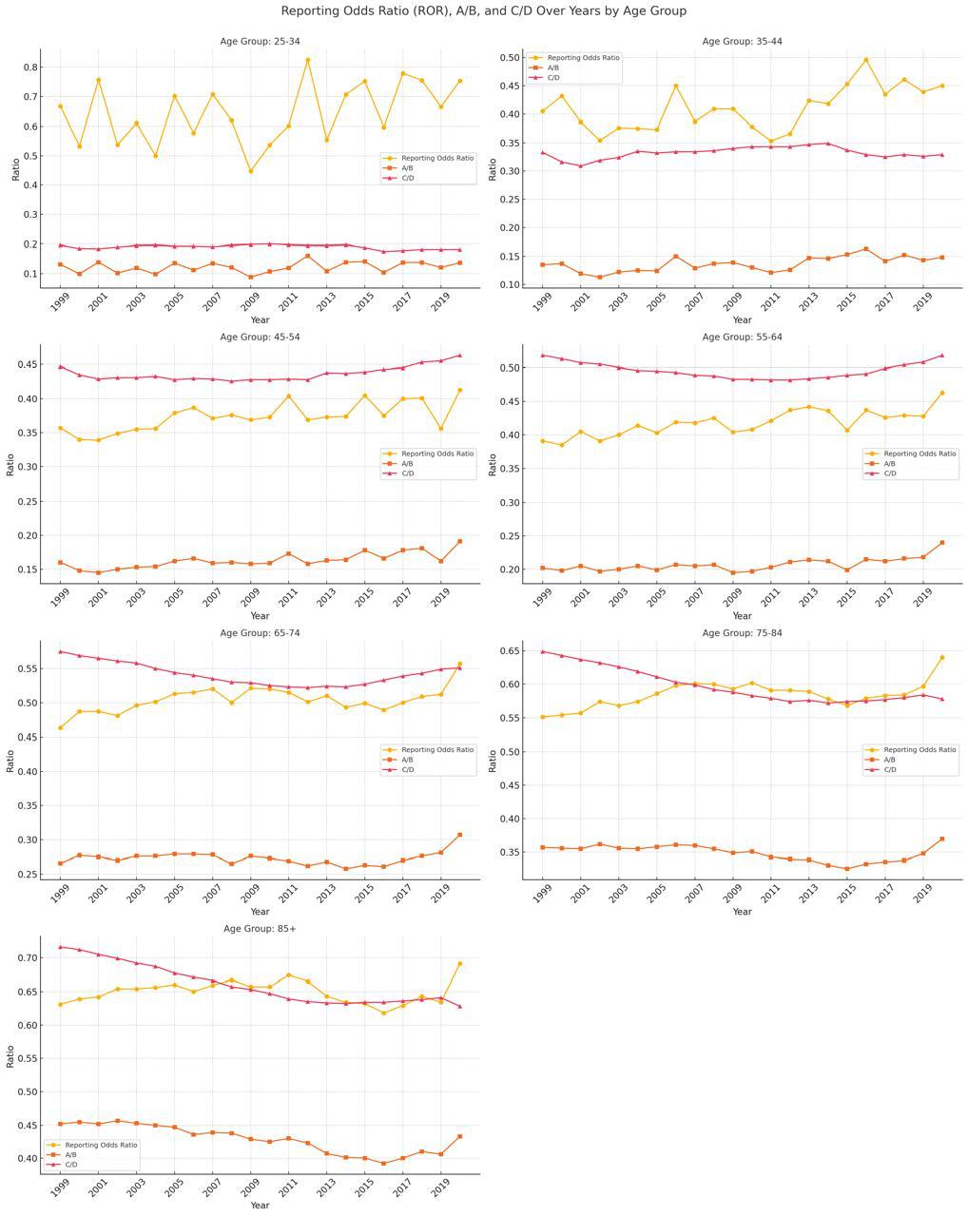
Supplemental Figure 1: CVD Burden in Colon Cancer-Related Reporting Odds Ratio Stratified by Age Group in the United States, 1999-2020

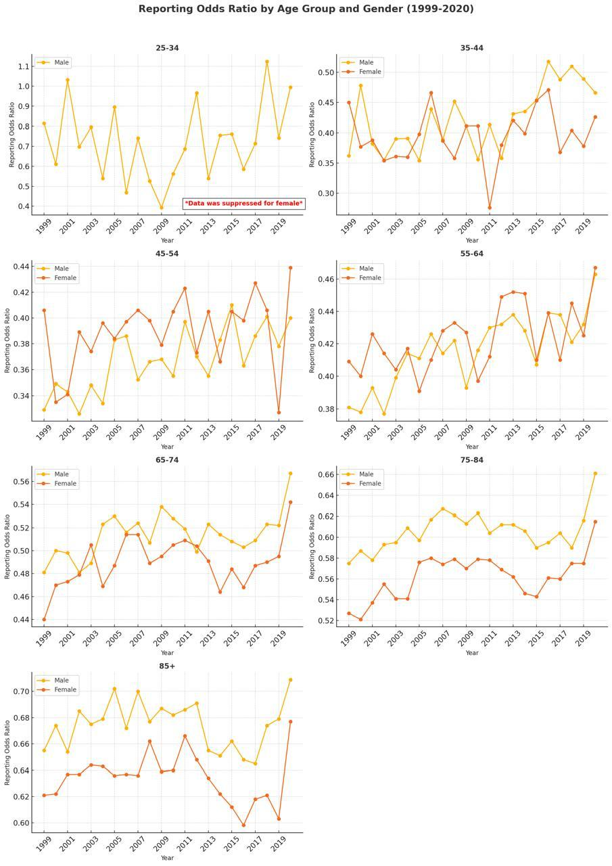
Supplemental Figure 2: CVD Burden in Colon Cancer-Related Reporting Odds Ratio Stratified by Sex and Age Group in the United States, 1999-2020

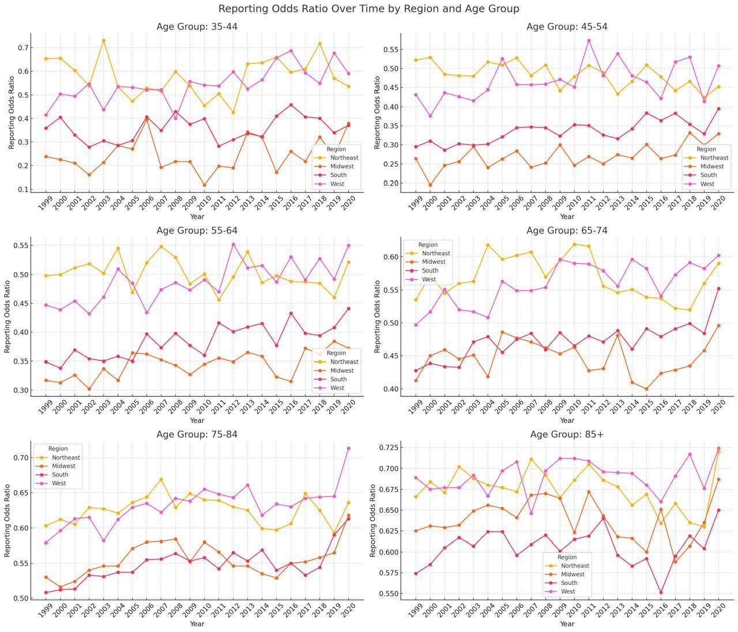
Supplemental Figure 3: CVD Burden in Colon Cancer-Related Reporting Odds Ratio Stratified by Region and Age Group in the United States, 1999-2020

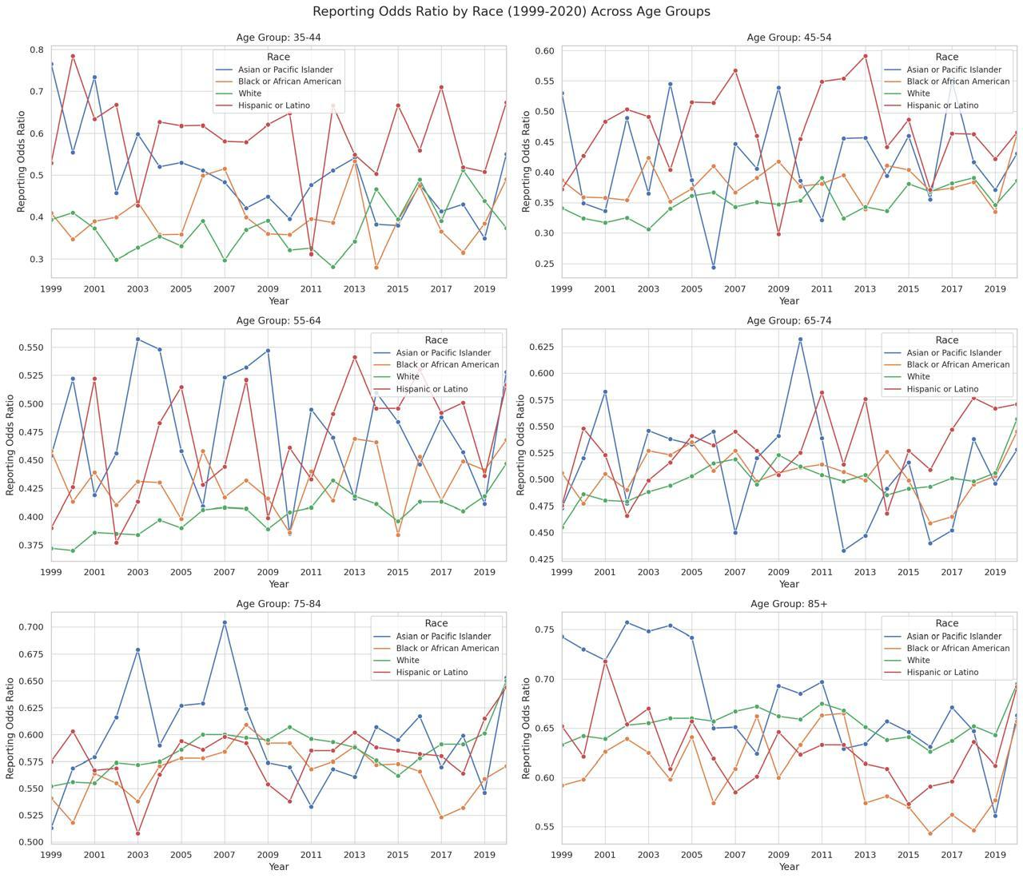
Supplemental Figure 4: CVD Burden in Colon Cancer-Related Reporting Odds Ratio Stratified by Race and Age Group in the United States, 1999-2020

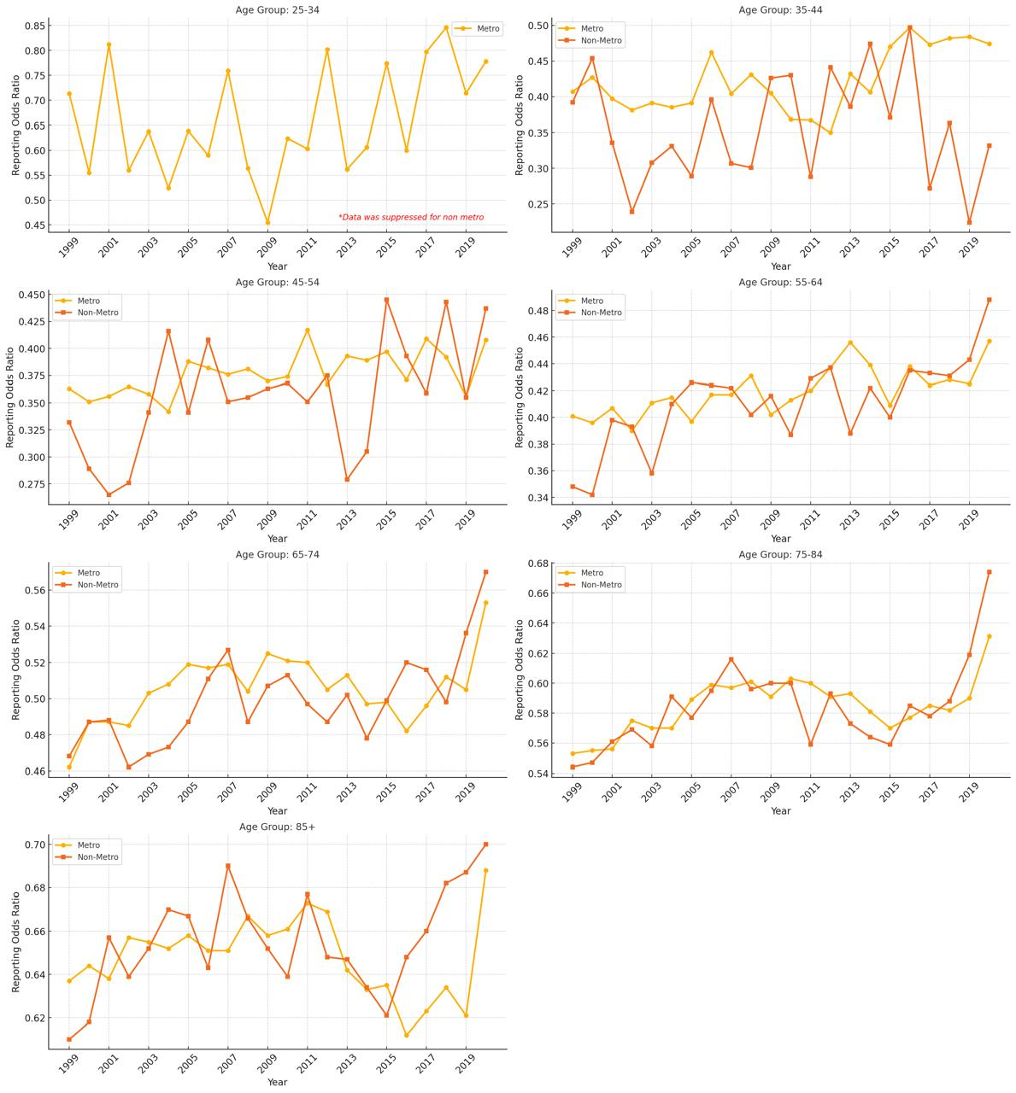
Supplemental Figure 5: CVD Burden in Colon Cancer-Related Reporting Odds Ratio Stratified by Urbanization and Age Group in the United States, 1999-2020

Supplementary Table 1: Total Deaths and Returning Odds Ratio of CVD Burden in Colon Cancers in Individuals aged 15-85+ in United States from 1999-2020
Returning Odds Ratio (95% CI)
Cohort | Colon Cancer and CVD Deaths (A) | Total Colon Cancer Deaths (B) | Total CVD Deaths (C) | All-Cause Deaths (D) | A/B | C/D | ROR (95% CI)
15-24 Age Group
Overall | 98 | 809 | 71932 | 696479 | 0.121 | 0.103 | 1.173 (0.951-1.447)
Female | 37 | 328 | 25714 | 182871 | 0.113 | 0.141 | 0.802 (0.571-1.127)
Male | 61 | 481 | 46218 | 513608 | 0.127 | 0.090 | 1.409 (1.08-1.84)
NH American Indian | 44 | 321 | 891 | 11460 | 0.137 | 0.078 | 1.763 (1.277-2.434)
NH Asian Pacific | 7 | 52 | 2440 | 18442 | 0.135 | 0.132 | 1.017 (0.462-2.242)
NH Black | 20 | 174 | 18505 | 156196 | 0.115 | 0.118 | 0.97 (0.611-1.542)
NH White | 34 | 433 | 38523 | 389760 | 0.079 | 0.099 | 0.794 (0.56-1.127)
Hispanic | 35 | 138 | 11448 | 118666 | 0.254 | 0.096 | 2.629 (1.813-3.812)
Northeast | 29 | 148 | 11330 | 99222 | 0.196 | 0.114 | 1.716 (1.152-2.556)
Midwest | 8 | 165 | 14325 | 151729 | 0.048 | 0.094 | 0.514 (0.253-1.044)
South | 31 | 320 | 30401 | 292574 | 0.097 | 0.104 | 0.932 (0.645-1.348)
West | 30 | 176 | 15876 | 152954 | 0.170 | 0.104 | 1.642 (1.115-2.419)
Metro | 89 | 665 | 58871 | 571297 | 0.134 | 0.103 | 1.299 (1.041-1.621)
Non metro | 9 | 144 | 13061 | 125182 | 0.063 | 0.104 | 0.599 (0.305-1.175)
25-34 Age Group
Overall | 658 | 5334 | 197669 | 1043043 | 0.123 | 0.190 | 0.651 (0.6-0.706)
Female | 295 | 2451 | 73210 | 317873 | 0.120 | 0.230 | 0.523 (0.463-0.59)
Male | 363 | 2883 | 124459 | 725170 | 0.126 | 0.172 | 0.734 (0.658-0.818)
NH American Indian | 113 | 704 | 3134 | 18095 | 0.161 | 0.173 | 0.927 (0.757-1.134)
NH Asian Pacific | 47 | 299 | 5837 | 25727 | 0.157 | 0.227 | 0.693 (0.509-0.944)
NH Black | 146 | 991 | 54190 | 228840 | 0.147 | 0.237 | 0.622 (0.523-0.74)
NH White | 317 | 3154 | 106559 | 613934 | 0.101 | 0.174 | 0.579 (0.516-0.65)
Hispanic | 141 | 825 | 27267 | 152348 | 0.171 | 0.179 | 0.955 (0.798-1.142)
Northeast | 160 | 853 | 30308 | 162275 | 0.188 | 0.187 | 1.004 (0.848-1.19)
Midwest | 73 | 1057 | 39020 | 218478 | 0.069 | 0.179 | 0.387 (0.305-0.49)
South | 225 | 2206 | 86053 | 442618 | 0.102 | 0.194 | 0.525 (0.457-0.602)
West | 200 | 1218 | 42288 | 219672 | 0.164 | 0.193 | 0.853 (0.734-0.991)
Metro | 558 | 4460 | 163401 | 870520 | 0.125 | 0.188 | 0.667 (0.61-0.728)
Non metro | 100 | 874 | 34268 | 172523 | 0.114 | 0.199 | 0.576 (0.468-0.709)
35-44 Age Group
Overall | 3135 | 22965 | 591314 | 1783349 | 0.137 | 0.332 | 0.412 (0.397-0.427)
Female | 1391 | 10677 | 216042 | 657934 | 0.130 | 0.328 | 0.397 (0.375-0.42)
Male | 1744 | 12288 | 375272 | 1125415 | 0.142 | 0.333 | 0.426 (0.405-0.448)
NH American Indian | 22 | 185 | 8131 | 27471 | 0.119 | 0.296 | 0.402(0.258-0.626)
NH Asian Pacific | 167 | 975 | 16065 | 42385 | 0.171 | 0.379 | 0.452 (0.383-0.533)
NH Black | 757 | 4528 | 153115 | 370955 | 0.167 | 0.413 | 0.405 (0.375-0.438)
NH White | 1669 | 14526 | 345816 | 1128801 | 0.115 | 0.306 | 0.375 (0.356-0.395)
Hispanic | 512 | 2707 | 66081 | 207045 | 0.189 | 0.319 | 0.593 (0.539-0.652)
Northeast | 736 | 3860 | 94303 | 285852 | 0.191 | 0.330 | 0.578 (0.534-0.626)
Midwest | 369 | 4747 | 118991 | 372149 | 0.078 | 0.320 | 0.243 (0.219-0.27)
South | 1183 | 9691 | 258328 | 760726 | 0.122 | 0.340 | 0.359 (0.338-0.382)
West | 847 | 4667 | 119692 | 364622 | 0.181 | 0.328 | 0.553 (0.514-0.595)
Metro | 2650 | 19021 | 485353 | 1475982 | 0.139 | 0.329 | 0.424 (0.407-0.441)
Non metro | 485 | 3944 | 105961 | 307367 | 0.123 | 0.345 | 0.357 (0.325-0.392)
45-54 Age Group
Overall | 13217 | 80935 | 1688707 | 3869682 | 0.163 | 0.436 | 0.374 (0.367-0.381)
Female | 5590 | 35842 | 592787 | 1483779 | 0.156 | 0.400 | 0.39 (0.379-0.402)
Male | 7627 | 45093 | 1095920 | 2385903 | 0.169 | 0.459 | 0.368 (0.359-0.377)
NH American Indian | 118 | 661 | 17999 | 44101 | 0.179 | 0.408 | 0.437(0.359-0.532)
NH Asian Pacific | 553 | 2816 | 39904 | 85699 | 0.196 | 0.466 | 0.422 (0.385-0.462)
NH Black | 3210 | 16049 | 388127 | 744429 | 0.200 | 0.521 | 0.384 (0.369-0.399)
NH White | 7791 | 54001 | 1085268 | 2640418 | 0.144 | 0.411 | 0.351 (0.343-0.359)
Hispanic | 1502 | 7227 | 150497 | 339146 | 0.208 | 0.444 | 0.468 (0.443-0.495)
Northeast | 2918 | 13599 | 282998 | 638744 | 0.215 | 0.443 | 0.484 (0.465-0.504)
Midwest | 1960 | 17373 | 349657 | 837077 | 0.113 | 0.418 | 0.27 (0.258-0.283)
South | 5127 | 34343 | 719654 | 1623761 | 0.149 | 0.443 | 0.337 (0.327-0.347)
West | 3212 | 15620 | 336398 | 770100 | 0.206 | 0.437 | 0.471 (0.453-0.489)
Metro | 10941 | 66619 | 1379063 | 3175567 | 0.164 | 0.434 | 0.378 (0.371-0.386)
Non metro | 2276 | 14316 | 309644 | 694115 | 0.159 | 0.446 | 0.356 (0.341-0.373)
55-64 Age Group
Overall | 34714 | 167298 | 3413956 | 6885039 | 0.207 | 0.496 | 0.418 (0.414-0.423)
Female | 13495 | 69829 | 1239376 | 2718374 | 0.193 | 0.456 | 0.424 (0.416-0.432)
Male | 21219 | 97469 | 2174580 | 4166665 | 0.218 | 0.522 | 0.417 (0.411-0.423)
NH American Indian | 280 | 1182 | 29288 | 58938 | 0.237 | 0.497 | 0.477(0.418-0.543)
NH Asian Pacific | 1159 | 4668 | 76338 | 146387 | 0.248 | 0.521 | 0.476 (0.446-0.508)
NH Black | 7483 | 30134 | 666271 | 1157831 | 0.248 | 0.575 | 0.432 (0.421-0.443)
NH White | 22670 | 118888 | 2376345 | 5021170 | 0.191 | 0.473 | 0.403 (0.397-0.409)
Hispanic | 3027 | 12026 | 250791 | 473412 | 0.252 | 0.530 | 0.475 (0.456-0.495)
Northeast | 7355 | 28558 | 586151 | 1148457 | 0.258 | 0.510 | 0.505 (0.492-0.518)
Midwest | 5944 | 36802 | 718988 | 1529325 | 0.162 | 0.470 | 0.344 (0.334-0.353)
South | 13536 | 70128 | 1430197 | 2867979 | 0.193 | 0.499 | 0.387 (0.38-0.394)
West | 7879 | 31810 | 678620 | 1339278 | 0.248 | 0.507 | 0.489 (0.477-0.501)
Metro | 27990 | 134615 | 2749327 | 5556283 | 0.208 | 0.495 | 0.42 (0.415-0.426)
Non metro | 6724 | 32683 | 664629 | 1328756 | 0.206 | 0.500 | 0.411 (0.401-0.422)
65-74 Age Group
Overall | 68523 | 250989 | 5436761 | 10034288 | 0.273 | 0.542 | 0.504 (0.5-0.508)
Female | 27281 | 107833 | 2244594 | 4348898 | 0.253 | 0.516 | 0.49 (0.484-0.497)
Male | 41242 | 143156 | 3192167 | 5685390 | 0.288 | 0.561 | 0.513 (0.507-0.519)
NH American Indian | 394 | 1377 | 36239 | 64742 | 0.286 | 0.560 | 0.511(0.457-0.572)
NH Asian Pacific | 1793 | 6004 | 123773 | 211916 | 0.299 | 0.584 | 0.511 (0.485-0.539)
NH Black | 11089 | 35640 | 804351 | 1309819 | 0.311 | 0.614 | 0.507 (0.496-0.518)
NH White | 50399 | 192630 | 4109156 | 7835707 | 0.262 | 0.524 | 0.499 (0.494-0.504)
Hispanic | 4655 | 14751 | 344198 | 580953 | 0.316 | 0.592 | 0.533 (0.515-0.551)
Northeast | 15195 | 46925 | 991172 | 1754344 | 0.324 | 0.565 | 0.573 (0.563-0.584)
Midwest | 13508 | 58433 | 1176110 | 2280440 | 0.231 | 0.516 | 0.448 (0.44-0.457)
South | 24953 | 98158 | 2196329 | 4086490 | 0.254 | 0.537 | 0.473 (0.466-0.48)
West | 14867 | 47473 | 1073150 | 1913014 | 0.313 | 0.561 | 0.558 (0.548-0.569)
Metro | 54509 | 199305 | 4325213 | 7988242 | 0.273 | 0.541 | 0.505 (0.5-0.51)
Non metro | 14014 | 51684 | 1111548 | 2046046 | 0.271 | 0.543 | 0.499 (0.49-0.509)
75-84 Age Group
Overall | 115427 | 329385 | 8811638 | 14723222 | 0.350 | 0.598 | 0.586 (0.582-0.59)
Female | 54383 | 162868 | 4374987 | 7382049 | 0.334 | 0.593 | 0.563 (0.558-0.569)
Male | 61044 | 166517 | 4436651 | 7341173 | 0.367 | 0.604 | 0.607 (0.601-0.612)
NH American Indian | 428 | 1261 | 36771 | 61070 | 0.339 | 0.602 | 0.564(0.505-0.630)
NH Asian Pacific | 2665 | 6895 | 191772 | 297725 | 0.387 | 0.644 | 0.6 (0.574-0.628)
NH Black | 12692 | 34570 | 884453 | 1367405 | 0.367 | 0.647 | 0.568 (0.556-0.579)
NH White | 93604 | 270533 | 7215497 | 12244092 | 0.346 | 0.589 | 0.587 (0.583-0.592)
Hispanic | 5795 | 15476 | 462615 | 721210 | 0.374 | 0.641 | 0.584 (0.566-0.602)
Northeast | 27777 | 70312 | 1775939 | 2839920 | 0.395 | 0.625 | 0.632 (0.623-0.641)
Midwest | 26190 | 81358 | 2007048 | 3472785 | 0.322 | 0.578 | 0.557 (0.549-0.565)
South | 37149 | 115630 | 3277507 | 5592404 | 0.321 | 0.586 | 0.548 (0.542-0.555)
West | 24311 | 62085 | 1751144 | 2818113 | 0.392 | 0.621 | 0.63 (0.621-0.64)
Metro | 92216 | 263466 | 7063713 | 11821779 | 0.350 | 0.598 | 0.586 (0.581-0.59)
Non metro | 23211 | 65919 | 1747925 | 2901443 | 0.352 | 0.602 | 0.584 (0.576-0.593)
85+ Age Group
Overall | 116752 | 271534 | 11162674 | 16979000 | 0.430 | 0.657 | 0.654 (0.65-0.659)
Female | 70945 | 168043 | 7182135 | 10883756 | 0.422 | 0.660 | 0.64 (0.634-0.645)
Male | 45807 | 103491 | 3980539 | 6095244 | 0.443 | 0.653 | 0.678 (0.67-0.685)
NH American Indian | 268 | 658 | 26972 | 42672 | 0.407 | 0.632 | 0.644(0.559-0.743)
NH Asian Pacific | 2454 | 5285 | 226433 | 328516 | 0.464 | 0.689 | 0.674 (0.642-0.707)
NH Black | 8742 | 21263 | 785500 | 1169730 | 0.411 | 0.672 | 0.612 (0.597-0.628)
NH White | 100667 | 233597 | 9633475 | 14718613 | 0.431 | 0.655 | 0.658 (0.654-0.663)
Hispanic | 4404 | 10265 | 470114 | 689855 | 0.429 | 0.681 | 0.63 (0.608-0.652)
Northeast | 29583 | 63148 | 2484855 | 3627082 | 0.468 | 0.685 | 0.684 (0.674-0.693)
Midwest | 29274 | 70749 | 2696400 | 4199415 | 0.414 | 0.642 | 0.644 (0.636-0.653)
South | 33013 | 84994 | 3699313 | 5807840 | 0.388 | 0.637 | 0.61 (0.602-0.618)
West | 24882 | 52643 | 2282106 | 3344663 | 0.473 | 0.682 | 0.693 (0.682-0.703)
Metro | 93816 | 218902 | 9037541 | 13772027 | 0.429 | 0.656 | 0.653 (0.648-0.658)
Non metro | 22936 | 52632 | 2125133 | 3206973 | 0.436 | 0.663 | 0.658 (0.647-0.668)

Supplementary Table 2: Average Annual Percent Change (AAPC) of CVD Burden in Colon Cancer, related Reporting Odds Ratio in the United States, 1999 to 2020
Reporting Odds Ratio AAPC (1999-2020)
Age Group | AAPC (95% CI) | p-value | Age Group | AAPC (95% CI) | p-value
Overall
15-24 |  |  | 55-64 | 0.58* (0.34-0.86) | < 0.000001
25-34 | 0.81 (-0.31-2.3) | 0.117576 | 65-74 | 0.77* (0.53-0.99) | < 0.000001
35-44 | 0.81* (0.28-1.43) | 0.004799 | 75-84 | 0.72* (0.57-0.83) | < 0.000001
45-54 | 0.63* (0.31-0.99) | 0.0012 | 85+ | 0.26* (0.1-0.4) | 0.003199
CVD Burden in Leukemia Deaths (A/B)
15-24 | - | - | 55-64 | 0.8528* (0.5593-1.0497) | < 0.000001
25-34 | 0.5482 (-0.5707-1.9917) | 0.256349 | 65-74 | 0.5032* (0.3566-0.6585) | < 0.000001
35-44 | 0.9255* (0.3373-1.666) | 0.003599 | 75-84 | 0.1582* (0.0316-0.2401) | 0.027994
45-54 | 0.8829* (0.5336-1.3021) | < 0.000001 | 85+ | -0.3422* (-0.4687--0.228) | < 0.000001
CVD Burden All Cause Deaths (C/D)
15-24 | -0.21 (-0.52-0.14) | 0.137173 | 55-64 | -0.01 (-0.03-0.02) | 0.713457
25-34 | -0.17 (-0.47-0.09) | 0.153169 | 65-74 | -0.18* (-0.21--0.16) | < 0.000001
35-44 | -0.03 (-0.12-0.09) | 0.492701 | 75-84 | -0.53* (-0.56--0.5) | < 0.000001
45-54 | 0.16* (0.09-0.25) | < 0.000001 | 85+ | -0.58* (-0.62--0.55) | < 0.000001
Female
15-24 |  |  | 55-64 | 0.44* (0.13-0.82) | 0.011198
25-34 |  |  | 65-74 | 0.80* (0.46-1.1) | < 0.000001
35-44 | 0.25 (-0.49-1.06) | 0.473505 | 75-84 | 0.67* (0.46-0.87) | < 0.000001
45-54 | 0.41 (-0.05-0.94) | 0.080384 | 85+ | 0.21* (0.01-0.4) | 0.044391
Male
15-24 |  |  | 55-64 | 0.67* (0.42-0.98) | < 0.000001
25-34 | 0.79 (-0.53-2.66) | 0.20156 | 65-74 | 0.66* (0.44-0.88) | < 0.000001
35-44 | 1.14* (0.55-1.89) | 0.0012 | 75-84 | 0.65* (0.49-0.77) | < 0.000001
45-54 | 0.74* (0.4-1.16) | < 0.000001 | 85+ | 0.32* (0.1-0.54) | 0.006799
NH Asian or Pacific Islander
15-24 | - | - | 55-64 | -0.24 (-1.09-0.82) | 0.744251
25-34 | - | - | 65-74 | -0.33 (-1-0.44) | 0.405119
35-44 | -1.97* (-3.25--0.83) | 0.0016 | 75-84 | 0.52 (-0.05-1.57) | 0.057588
45-54 | -0.22 (-1.4-1.38) | 0.895021 | 85+ | -0.86* (-1.28--0.37) | 0.0008
NH Black or African American
15-24 |  |  | 55-64 | 0.22 (-0.19-0.72) | 0.286743
25-34 |  |  | 65-74 | 0.34 (-0.02-0.68) | 0.055989
35-44 | 0.4 (-0.67-1.55) | 0.429914 | 75-84 | 0.13 (-0.09-0.37) | 0.24795
45-54 | 0.34 (-0.25-0.99) | 0.240352 | 85+ | 0.37 (-0.43-0.86) | 0.159968
NH White
15-24 |  |  | 55-64 | 0.57* (0.35-0.81) | < 0.000001
25-34 |  |  | 65-74 | 0.80* (0.57-0.99) | < 0.000001
35-44 | 1.19* (0.11-2.59) | 0.033593 | 75-84 | 0.65* (0.52-0.78) | < 0.000001
45-54 | 0.72* (0.28-1.24) | 0.003999 | 85+ | 0.29* (0.17-0.41) | < 0.000001
Hispanic or Latino
15-24 |  |  | 55-64 | 0.59 (-0.05-1.56) | 0.066787
25-34 |  |  | 65-74 | 0.50* (0.1-1.02) | 0.018396
35-44 | -0.32 (-1.28-0.91) | 0.681064 | 75-84 | 0.56* (0.07-0.85) | 0.015197
45-54 | -0.21 (-1.19-1.06) | 0.894221 | 85+ | 0.07 (-0.43-0.44) | 0.635473
Northeast region
15-24 |  |  | 55-64 | -0.21 (-0.58-0.15) | 0.24835
25-34 |  |  | 65-74 | 0.29 (-0.18-0.64) | 0.125975
35-44 | -0.09 (-1.19-0.95) | 0.773445 | 75-84 | 0.05 (-0.24-0.3) | 0.745451
45-54 | -0.60* (-1.06--0.18) | 0.009198 | 85+ | 0.19 (-0.26-0.46) | 0.209558
Midwest region
15-24 | - | - | 55-64 | 0.66* (0.3-1.07) | 0.0012
25-34 | - | - | 65-74 | 0.63* (0.16-1.15) | 0.010798
35-44 | 1.37 (-0.13-3.42) | 0.068786 | 75-84 | 0.72* (0.48-0.95) | < 0.000001
45-54 | 1.08* (0.4-1.93) | 0.004399 | 85+ | 0.44* (0.16-0.7) | 0.0008
South region
15-24 |  |  | 55-64 | 0.95* (0.55-1.47) | < 0.000001
25-34 |  |  | 65-74 | 0.94* (0.47-1.28) | < 0.000001
35-44 | 0.62 (-0.52-2.09) | 0.227155 | 75-84 | 0.94* (0.72-1.11) | < 0.000001
45-54 | 1.12* (0.62-1.74) | 0.0004 | 85+ | 0.4 (-0.07-0.8) | 0.073985
West region
15-24 |  |  | 55-64 | 0.82* (0.47-1.25) | < 0.000001
25-34 |  |  | 65-74 | 0.65* (0.36-1) | 0.0004
35-44 | 1.48* (0.88-2.36) | < 0.000001 | 75-84 | 0.86* (0.61-1.07) | < 0.000001
45-54 | 0.72* (0.1-1.46) | 0.020796 | 85+ | 0.13 (-0.08-0.36) | 0.223955
Metropolitan area
15-24 |  |  | 55-64 | 0.49* (0.25-0.79) | 0.0016
25-34 | 0.82 (-0.16-2.18) | 0.088382 | 65-74 | 0.69* (0.43-0.94) | < 0.000001
35-44 | 0.98* (0.27-1.74) | 0.007598 | 75-84 | 0.62* (0.4-0.76) | < 0.000001
45-54 | 0.50* (0.19-0.84) | 0.004399 | 85+ | 0.23* (0.02-0.39) | 0.031994
Nonmetropolitan areas
15-24 | - | - | 55-64 | 0.91* (0.39-1.54) | 0.002799
25-34 |  |  | 65-74 | 0.83* (0.36-1.11) | < 0.000001
35-44 | 0.34 (-1.24-2.16) | 0.647471 | 75-84 | 0.98* (0.7-1.23) | < 0.000001
45-54 | 1.19* (0.31-2.32) | 0.011998 | 85+ | 0.59* (0.39-0.83) | < 0.000001
AAPC = average annual percent change; N.H. = non-Hispanic; * Indicates that the average annual percentage change (AAPC) is significantly different from zero at α = 0.05.

Supplemental Table 3: CVD Burden in Colon Cancer and All Cause Deaths-Related Proportions across Age Groups 15-85+ in the United States, 1999-2020
Year | CVD Burden in Colon Cancer Deaths (A/B) | CVD Burden in All Cuase Deaths (C/D) | Reporting Odds Ratio (95% CI)
25-34 Age Group
1999 | 0.131 | 0.196 | 0.667 (0.456-0.977)
2000 | 0.099 | 0.185 | 0.532 (0.34-0.834)
2001 | 0.139 | 0.184 | 0.757 (0.526-1.091)
2002 | 0.102 | 0.190 | 0.537 (0.346-0.834)
2003 | 0.119 | 0.195 | 0.61 (0.409-0.909)
2004 | 0.098 | 0.196 | 0.5 (0.316-0.792)
2005 | 0.136 | 0.193 | 0.702 (0.488-1.011)
2006 | 0.112 | 0.193 | 0.577 (0.387-0.859)
2007 | 0.135 | 0.191 | 0.707 (0.479-1.042)
2008 | 0.121 | 0.196 | 0.619 (0.415-0.923)
2009 | 0.088 | 0.198 | 0.447 (0.279-0.714)
2010 | 0.107 | 0.200 | 0.536 (0.354-0.81)
2011 | 0.119 | 0.197 | 0.602 (0.401-0.904)
2012 | 0.161 | 0.195 | 0.825 (0.595-1.144)
2013 | 0.108 | 0.195 | 0.554 (0.38-0.809)
2014 | 0.139 | 0.197 | 0.706 (0.495-1.006)
2015 | 0.141 | 0.188 | 0.752 (0.54-1.048)
2016 | 0.104 | 0.175 | 0.596 (0.407-0.875)
2017 | 0.138 | 0.178 | 0.779 (0.547-1.11)
2018 | 0.138 | 0.182 | 0.755 (0.54-1.056)
2019 | 0.121 | 0.182 | 0.665 (0.452-0.979)
2020 | 0.137 | 0.182 | 0.753 (0.541-1.048)
35-44 Age Group
1999 | 0.135 | 0.333 | 0.405 (0.34-0.481)
2000 | 0.137 | 0.316 | 0.432 (0.365-0.513)
2001 | 0.119 | 0.309 | 0.386 (0.322-0.461)
2002 | 0.113 | 0.319 | 0.354 (0.294-0.427)
2003 | 0.122 | 0.324 | 0.376 (0.312-0.453)
2004 | 0.125 | 0.335 | 0.375 (0.31-0.453)
2005 | 0.124 | 0.332 | 0.373 (0.309-0.45)
2006 | 0.150 | 0.334 | 0.45 (0.379-0.535)
2007 | 0.129 | 0.334 | 0.387 (0.321-0.466)
2008 | 0.137 | 0.336 | 0.409 (0.344-0.485)
2009 | 0.139 | 0.340 | 0.409 (0.342-0.488)
2010 | 0.130 | 0.343 | 0.378 (0.314-0.456)
2011 | 0.121 | 0.343 | 0.353 (0.293-0.426)
2012 | 0.126 | 0.343 | 0.366 (0.303-0.442)
2013 | 0.147 | 0.347 | 0.424 (0.357-0.504)
2014 | 0.146 | 0.349 | 0.418 (0.354-0.493)
2015 | 0.153 | 0.337 | 0.453 (0.384-0.534)
2016 | 0.163 | 0.329 | 0.496 (0.422-0.582)
2017 | 0.141 | 0.325 | 0.435 (0.366-0.516)
2018 | 0.152 | 0.329 | 0.461 (0.39-0.544)
2019 | 0.143 | 0.326 | 0.439 (0.37-0.522)
2020 | 0.148 | 0.329 | 0.45 (0.382-0.53)
45-54 Age Group
1999 | 0.160 | 0.447 | 0.357 (0.326-0.391)
2000 | 0.148 | 0.435 | 0.34 (0.31-0.373)
2001 | 0.145 | 0.429 | 0.339 (0.309-0.371)
2002 | 0.150 | 0.431 | 0.349 (0.319-0.381)
2003 | 0.153 | 0.431 | 0.355 (0.324-0.388)
2004 | 0.154 | 0.433 | 0.356 (0.324-0.39)
2005 | 0.162 | 0.428 | 0.379 (0.346-0.415)
2006 | 0.166 | 0.430 | 0.387 (0.354-0.422)
2007 | 0.159 | 0.429 | 0.371 (0.34-0.405)
2008 | 0.160 | 0.426 | 0.376 (0.345-0.41)
2009 | 0.158 | 0.428 | 0.369 (0.338-0.402)
2010 | 0.159 | 0.428 | 0.373 (0.342-0.406)
2011 | 0.173 | 0.429 | 0.404 (0.372-0.439)
2012 | 0.158 | 0.428 | 0.369 (0.338-0.402)
2013 | 0.163 | 0.438 | 0.373 (0.342-0.406)
2014 | 0.164 | 0.437 | 0.374 (0.344-0.407)
2015 | 0.178 | 0.439 | 0.405 (0.373-0.44)
2016 | 0.166 | 0.443 | 0.375 (0.344-0.408)
2017 | 0.178 | 0.445 | 0.4 (0.369-0.435)
2018 | 0.181 | 0.453 | 0.401 (0.369-0.435)
2019 | 0.162 | 0.455 | 0.356 (0.326-0.388)
2020 | 0.191 | 0.463 | 0.413 (0.381-0.448)
55-64 Age Group
1999 | 0.202 | 0.518 | 0.391 (0.369-0.414)
2000 | 0.198 | 0.513 | 0.385 (0.363-0.409)
2001 | 0.205 | 0.507 | 0.405 (0.383-0.429)
2002 | 0.197 | 0.505 | 0.391 (0.369-0.414)
2003 | 0.200 | 0.500 | 0.4 (0.378-0.424)
2004 | 0.205 | 0.496 | 0.414 (0.391-0.438)
2005 | 0.199 | 0.495 | 0.403 (0.38-0.427)
2006 | 0.207 | 0.493 | 0.419 (0.396-0.443)
2007 | 0.205 | 0.489 | 0.418 (0.396-0.442)
2008 | 0.207 | 0.488 | 0.425 (0.403-0.449)
2009 | 0.195 | 0.483 | 0.404 (0.382-0.428)
2010 | 0.197 | 0.483 | 0.408 (0.385-0.431)
2011 | 0.203 | 0.482 | 0.421 (0.399-0.445)
2012 | 0.211 | 0.482 | 0.437 (0.414-0.461)
2013 | 0.214 | 0.484 | 0.442 (0.419-0.466)
2014 | 0.212 | 0.486 | 0.436 (0.413-0.459)
2015 | 0.199 | 0.489 | 0.407 (0.386-0.429)
2016 | 0.215 | 0.491 | 0.437 (0.415-0.46)
2017 | 0.212 | 0.499 | 0.426 (0.404-0.449)
2018 | 0.216 | 0.504 | 0.429 (0.407-0.452)
2019 | 0.218 | 0.508 | 0.428 (0.407-0.451)
2020 | 0.240 | 0.518 | 0.463 (0.441-0.487)
65-74 Age Group
1999 | 0.266 | 0.575 | 0.463 (0.446-0.48)
2000 | 0.277 | 0.569 | 0.487 (0.47-0.505)
2001 | 0.275 | 0.565 | 0.487 (0.47-0.506)
2002 | 0.270 | 0.561 | 0.481 (0.463-0.499)
2003 | 0.276 | 0.558 | 0.496 (0.477-0.515)
2004 | 0.276 | 0.550 | 0.501 (0.481-0.521)
2005 | 0.279 | 0.544 | 0.513 (0.492-0.534)
2006 | 0.279 | 0.540 | 0.515 (0.495-0.537)
2007 | 0.278 | 0.535 | 0.52 (0.5-0.542)
2008 | 0.265 | 0.530 | 0.5 (0.48-0.521)
2009 | 0.276 | 0.529 | 0.521 (0.5-0.544)
2010 | 0.273 | 0.525 | 0.52 (0.498-0.542)
2011 | 0.269 | 0.523 | 0.515 (0.493-0.537)
2012 | 0.262 | 0.522 | 0.501 (0.481-0.523)
2013 | 0.268 | 0.524 | 0.51 (0.49-0.532)
2014 | 0.258 | 0.523 | 0.493 (0.473-0.515)
2015 | 0.263 | 0.527 | 0.499 (0.478-0.519)
2016 | 0.261 | 0.533 | 0.489 (0.47-0.51)
2017 | 0.270 | 0.539 | 0.5 (0.481-0.521)
2018 | 0.276 | 0.543 | 0.509 (0.489-0.53)
2019 | 0.281 | 0.549 | 0.512 (0.492-0.533)
2020 | 0.307 | 0.551 | 0.557 (0.536-0.578)
75-84 Age Group
1999 | 0.357 | 0.649 | 0.551 (0.536-0.567)
2000 | 0.356 | 0.643 | 0.554 (0.539-0.569)
2001 | 0.355 | 0.637 | 0.557 (0.542-0.573)
2002 | 0.362 | 0.632 | 0.574 (0.558-0.59)
2003 | 0.356 | 0.626 | 0.568 (0.552-0.584)
2004 | 0.355 | 0.619 | 0.574 (0.558-0.592)
2005 | 0.358 | 0.611 | 0.586 (0.569-0.604)
2006 | 0.361 | 0.603 | 0.598 (0.581-0.616)
2007 | 0.360 | 0.599 | 0.601 (0.583-0.619)
2008 | 0.355 | 0.592 | 0.6 (0.582-0.619)
2009 | 0.349 | 0.588 | 0.593 (0.574-0.612)
2010 | 0.351 | 0.583 | 0.602 (0.583-0.622)
2011 | 0.343 | 0.579 | 0.591 (0.572-0.612)
2012 | 0.340 | 0.574 | 0.591 (0.571-0.612)
2013 | 0.339 | 0.576 | 0.589 (0.568-0.609)
2014 | 0.331 | 0.572 | 0.578 (0.557-0.599)
2015 | 0.326 | 0.574 | 0.568 (0.548-0.589)
2016 | 0.333 | 0.575 | 0.579 (0.559-0.6)
2017 | 0.336 | 0.577 | 0.583 (0.563-0.605)
2018 | 0.338 | 0.580 | 0.584 (0.563-0.605)
2019 | 0.348 | 0.584 | 0.597 (0.576-0.618)
2020 | 0.370 | 0.578 | 0.64 (0.619-0.663)
85+ Age Group
1999 | 0.452 | 0.716 | 0.631 (0.612-0.651)
2000 | 0.455 | 0.712 | 0.639 (0.62-0.658)
2001 | 0.452 | 0.705 | 0.642 (0.622-0.662)
2002 | 0.457 | 0.699 | 0.654 (0.634-0.674)
2003 | 0.453 | 0.692 | 0.654 (0.635-0.675)
2004 | 0.450 | 0.687 | 0.656 (0.635-0.676)
2005 | 0.447 | 0.677 | 0.66 (0.639-0.681)
2006 | 0.436 | 0.671 | 0.65 (0.63-0.671)
2007 | 0.439 | 0.666 | 0.659 (0.639-0.68)
2008 | 0.438 | 0.657 | 0.667 (0.646-0.689)
2009 | 0.429 | 0.653 | 0.657 (0.636-0.679)
2010 | 0.425 | 0.647 | 0.657 (0.636-0.678)
2011 | 0.430 | 0.639 | 0.674 (0.652-0.696)
2012 | 0.423 | 0.635 | 0.665 (0.643-0.687)
2013 | 0.407 | 0.633 | 0.643 (0.622-0.665)
2014 | 0.401 | 0.632 | 0.634 (0.612-0.655)
2015 | 0.400 | 0.634 | 0.632 (0.611-0.654)
2016 | 0.392 | 0.634 | 0.618 (0.597-0.64)
2017 | 0.400 | 0.636 | 0.629 (0.608-0.651)
2018 | 0.410 | 0.638 | 0.643 (0.621-0.665)
2019 | 0.406 | 0.641 | 0.634 (0.612-0.656)
2020 | 0.433 | 0.628 | 0.691 (0.667-0.715)

Supplemental Table 4: CVD Burden in Colon Cancer-Related Reporting Odds Ratio Stratified by Sex and Urbanization in the United States, 1999-2020
Returning Odds Ratio (95% CI)
Year | Overall | Female | Male | Metropolitan Area | Non-Metropolitan Area
25-34 Age Group
1999 | 0.667 (0.456-0.977) | - | 0.814 (0.49-1.354) | 0.713 (0.472-1.075) | -
2000 | 0.532 (0.34-0.834) | - | 0.611 (0.337-1.107) | 0.555 (0.342-0.903) | -
2001 | 0.757 (0.526-1.091) | - | 1.032 (0.642-1.659) | 0.812 (0.546-1.209) | -
2002 | 0.537 (0.346-0.834) | - | 0.698 (0.401-1.216) | 0.56 (0.344-0.91) | -
2003 | 0.61 (0.409-0.909) | - | 0.795 (0.478-1.321) | 0.638 (0.417-0.975) | -
2004 | 0.5 (0.316-0.792) | - | 0.539 (0.282-1.032) | 0.524 (0.318-0.863) | -
2005 | 0.702 (0.488-1.011) | - | 0.896 (0.559-1.436) | 0.639 (0.421-0.969) | -
2006 | 0.577 (0.387-0.859) | - | 0.469 (0.246-0.895) | 0.59 (0.386-0.901) | -
2007 | 0.707 (0.479-1.042) | - | 0.741 (0.433-1.269) | 0.759 (0.498-1.155) | -
2008 | 0.619 (0.415-0.923) | - | 0.526 (0.275-1.007) | 0.564 (0.355-0.895) | -
2009 | 0.447 (0.279-0.714) | - | 0.393 (0.2-0.774) | 0.455 (0.273-0.76) | -
2010 | 0.536 (0.354-0.81) | - | 0.562 (0.324-0.976) | 0.624 (0.404-0.963) | -
2011 | 0.602 (0.401-0.904) | - | 0.687 (0.394-1.198) | 0.603 (0.387-0.939) | -
2012 | 0.825 (0.595-1.144) | - | 0.966 (0.636-1.467) | 0.802 (0.558-1.152) | -
2013 | 0.554 (0.38-0.809) | - | 0.539 (0.317-0.916) | 0.562 (0.369-0.857) | -
2014 | 0.706 (0.495-1.006) | - | 0.755 (0.473-1.206) | 0.606 (0.397-0.926) | -
2015 | 0.752 (0.54-1.048) | - | 0.762 (0.478-1.216) | 0.774 (0.542-1.103) | -
2016 | 0.596 (0.407-0.875) | - | 0.586 (0.338-1.013) | 0.6 (0.398-0.907) | -
2017 | 0.779 (0.547-1.11) | - | 0.715 (0.411-1.244) | 0.797 (0.55-1.154) | -
2018 | 0.755 (0.54-1.056) | - | 1.124 (0.751-1.684) | 0.846 (0.596-1.202) | -
2019 | 0.665 (0.452-0.979) | - | 0.742 (0.448-1.228) | 0.714 (0.482-1.059) | -
2020 | 0.753 (0.541-1.048) | - | 0.995 (0.662-1.496) | 0.778 (0.543-1.114) | -
35-44 Age Group
1999 | 0.405 (0.34-0.481) | 0.45 (0.355-0.571) | 0.362 (0.281-0.467) | 0.407 (0.336-0.494) | 0.392 (0.266-0.579)
2000 | 0.432 (0.365-0.513) | 0.377 (0.289-0.493) | 0.478 (0.382-0.596) | 0.427 (0.353-0.517) | 0.454 (0.309-0.667)
2001 | 0.386 (0.322-0.461) | 0.388 (0.3-0.503) | 0.382 (0.298-0.491) | 0.397 (0.326-0.484) | 0.336 (0.218-0.517)
2002 | 0.354 (0.294-0.427) | 0.354 (0.268-0.467) | 0.355 (0.276-0.456) | 0.381 (0.312-0.465) | 0.239 (0.144-0.398)
2003 | 0.376 (0.312-0.453) | 0.361 (0.273-0.476) | 0.39 (0.304-0.502) | 0.391 (0.319-0.479) | 0.308 (0.192-0.494)
2004 | 0.375 (0.31-0.453) | 0.36 (0.272-0.477) | 0.391 (0.303-0.506) | 0.385 (0.313-0.473) | 0.331 (0.208-0.526)
2005 | 0.373 (0.309-0.45) | 0.398 (0.304-0.52) | 0.354 (0.272-0.461) | 0.391 (0.319-0.479) | 0.289 (0.175-0.476)
2006 | 0.45 (0.379-0.535) | 0.466 (0.363-0.598) | 0.439 (0.346-0.558) | 0.462 (0.383-0.558) | 0.396 (0.258-0.608)
2007 | 0.387 (0.321-0.466) | 0.387 (0.294-0.511) | 0.389 (0.303-0.501) | 0.404 (0.33-0.494) | 0.307 (0.189-0.5)
2008 | 0.409 (0.344-0.485) | 0.358 (0.272-0.47) | 0.452 (0.362-0.565) | 0.431 (0.358-0.519) | 0.301 (0.187-0.483)
2009 | 0.409 (0.342-0.488) | 0.411 (0.318-0.532) | 0.411 (0.322-0.524) | 0.405 (0.333-0.492) | 0.426 (0.277-0.655)
2010 | 0.378 (0.314-0.456) | 0.411 (0.312-0.542) | 0.356 (0.276-0.459) | 0.368 (0.3-0.453) | 0.43 (0.277-0.668)
2011 | 0.353 (0.293-0.426) | 0.276 (0.2-0.38) | 0.413 (0.328-0.521) | 0.367 (0.299-0.449) | 0.288 (0.175-0.475)
2012 | 0.366 (0.303-0.442) | 0.38 (0.287-0.502) | 0.358 (0.277-0.463) | 0.35 (0.282-0.433) | 0.441 (0.294-0.663)
2013 | 0.424 (0.357-0.504) | 0.42 (0.324-0.544) | 0.431 (0.342-0.542) | 0.432 (0.358-0.521) | 0.386 (0.252-0.593)
2014 | 0.418 (0.354-0.493) | 0.399 (0.309-0.516) | 0.435 (0.35-0.541) | 0.406 (0.337-0.489) | 0.474 (0.327-0.687)
2015 | 0.453 (0.384-0.534) | 0.453 (0.356-0.578) | 0.454 (0.363-0.568) | 0.47 (0.394-0.561) | 0.371 (0.238-0.58)
2016 | 0.496 (0.422-0.582) | 0.471 (0.371-0.596) | 0.518 (0.416-0.645) | 0.497 (0.418-0.592) | 0.497 (0.327-0.755)
2017 | 0.435 (0.366-0.516) | 0.368 (0.279-0.485) | 0.488 (0.392-0.608) | 0.473 (0.394-0.568) | 0.272 (0.168-0.442)
2018 | 0.461 (0.39-0.544) | 0.404 (0.313-0.521) | 0.51 (0.41-0.635) | 0.482 (0.403-0.577) | 0.363 (0.235-0.561)
2019 | 0.439 (0.37-0.522) | 0.378 (0.289-0.495) | 0.489 (0.391-0.612) | 0.484 (0.404-0.58) | 0.224 (0.127-0.394)
2020 | 0.45 (0.382-0.53) | 0.426 (0.335-0.543) | 0.466 (0.373-0.582) | 0.474 (0.398-0.564) | 0.332 (0.209-0.528)
45-54 Age Group
1999 | 0.357 (0.326-0.391) | 0.406 (0.356-0.465) | 0.329 (0.29-0.372) | 0.363 (0.328-0.401) | 0.332 (0.267-0.413)
2000 | 0.34 (0.31-0.373) | 0.335 (0.29-0.388) | 0.349 (0.309-0.394) | 0.351 (0.317-0.388) | 0.289 (0.229-0.365)
2001 | 0.339 (0.309-0.371) | 0.341 (0.296-0.392) | 0.343 (0.304-0.388) | 0.356 (0.322-0.393) | 0.265 (0.209-0.335)
2002 | 0.349 (0.319-0.381) | 0.389 (0.341-0.444) | 0.326 (0.288-0.368) | 0.365 (0.331-0.402) | 0.276 (0.219-0.348)
2003 | 0.355 (0.324-0.388) | 0.374 (0.326-0.43) | 0.348 (0.309-0.392) | 0.358 (0.324-0.396) | 0.341 (0.275-0.422)
2004 | 0.356 (0.324-0.39) | 0.396 (0.344-0.455) | 0.334 (0.295-0.378) | 0.342 (0.309-0.38) | 0.416 (0.34-0.509)
2005 | 0.379 (0.346-0.415) | 0.384 (0.334-0.442) | 0.383 (0.34-0.431) | 0.388 (0.351-0.428) | 0.341 (0.273-0.424)
2006 | 0.387 (0.354-0.422) | 0.397 (0.348-0.454) | 0.386 (0.344-0.434) | 0.382 (0.347-0.421) | 0.408 (0.332-0.501)
2007 | 0.371 (0.34-0.405) | 0.406 (0.357-0.462) | 0.352 (0.313-0.396) | 0.376 (0.341-0.414) | 0.351 (0.286-0.43)
2008 | 0.376 (0.345-0.41) | 0.398 (0.349-0.455) | 0.366 (0.326-0.41) | 0.381 (0.346-0.419) | 0.355 (0.289-0.436)
2009 | 0.369 (0.338-0.402) | 0.379 (0.332-0.433) | 0.368 (0.328-0.412) | 0.37 (0.336-0.407) | 0.363 (0.294-0.448)
2010 | 0.373 (0.342-0.406) | 0.405 (0.356-0.461) | 0.355 (0.316-0.399) | 0.374 (0.34-0.411) | 0.368 (0.301-0.449)
2011 | 0.404 (0.372-0.439) | 0.423 (0.372-0.481) | 0.397 (0.356-0.443) | 0.417 (0.38-0.457) | 0.351 (0.287-0.43)
2012 | 0.369 (0.338-0.402) | 0.373 (0.327-0.427) | 0.37 (0.331-0.413) | 0.367 (0.334-0.404) | 0.375 (0.308-0.457)
2013 | 0.373 (0.342-0.406) | 0.405 (0.356-0.461) | 0.355 (0.317-0.397) | 0.393 (0.359-0.431) | 0.279 (0.222-0.35)
2014 | 0.374 (0.344-0.407) | 0.366 (0.319-0.419) | 0.383 (0.344-0.427) | 0.389 (0.355-0.427) | 0.305 (0.245-0.38)
2015 | 0.405 (0.373-0.44) | 0.405 (0.357-0.46) | 0.41 (0.368-0.457) | 0.397 (0.362-0.435) | 0.445 (0.369-0.536)
2016 | 0.375 (0.344-0.408) | 0.398 (0.349-0.454) | 0.363 (0.325-0.406) | 0.371 (0.337-0.408) | 0.393 (0.323-0.478)
2017 | 0.4 (0.369-0.435) | 0.427 (0.376-0.484) | 0.386 (0.346-0.431) | 0.409 (0.374-0.447) | 0.359 (0.29-0.445)
2018 | 0.401 (0.369-0.435) | 0.406 (0.357-0.462) | 0.401 (0.36-0.446) | 0.392 (0.358-0.429) | 0.443 (0.366-0.538)
2019 | 0.356 (0.326-0.388) | 0.327 (0.283-0.378) | 0.378 (0.339-0.423) | 0.356 (0.324-0.392) | 0.355 (0.286-0.441)
2020 | 0.413 (0.381-0.448) | 0.439 (0.388-0.498) | 0.4 (0.359-0.445) | 0.408 (0.373-0.447) | 0.437 (0.362-0.527)
55-64 Age Group
1999 | 0.391 (0.369-0.414) | 0.409 (0.374-0.447) | 0.381 (0.353-0.41) | 0.401 (0.377-0.428) | 0.348 (0.304-0.398)
2000 | 0.385 (0.363-0.409) | 0.4 (0.365-0.438) | 0.378 (0.35-0.407) | 0.396 (0.371-0.422) | 0.342 (0.298-0.393)
2001 | 0.405 (0.383-0.429) | 0.426 (0.39-0.465) | 0.393 (0.365-0.424) | 0.407 (0.382-0.434) | 0.398 (0.349-0.453)
2002 | 0.391 (0.369-0.414) | 0.414 (0.379-0.453) | 0.377 (0.35-0.406) | 0.39 (0.366-0.416) | 0.393 (0.345-0.447)
2003 | 0.4 (0.378-0.424) | 0.404 (0.369-0.443) | 0.399 (0.371-0.43) | 0.411 (0.386-0.438) | 0.358 (0.313-0.409)
2004 | 0.414 (0.391-0.438) | 0.417 (0.381-0.456) | 0.414 (0.385-0.446) | 0.415 (0.389-0.442) | 0.41 (0.36-0.466)
2005 | 0.403 (0.38-0.427) | 0.391 (0.356-0.43) | 0.411 (0.382-0.442) | 0.397 (0.372-0.424) | 0.426 (0.375-0.486)
2006 | 0.419 (0.396-0.443) | 0.41 (0.375-0.448) | 0.426 (0.397-0.458) | 0.417 (0.392-0.444) | 0.424 (0.374-0.482)
2007 | 0.418 (0.396-0.442) | 0.428 (0.392-0.467) | 0.414 (0.386-0.445) | 0.417 (0.392-0.443) | 0.422 (0.374-0.477)
2008 | 0.425 (0.403-0.449) | 0.433 (0.397-0.473) | 0.422 (0.393-0.453) | 0.431 (0.406-0.459) | 0.402 (0.355-0.455)
2009 | 0.404 (0.382-0.428) | 0.427 (0.391-0.466) | 0.393 (0.365-0.422) | 0.402 (0.377-0.427) | 0.416 (0.367-0.471)
2010 | 0.408 (0.385-0.431) | 0.397 (0.363-0.435) | 0.416 (0.388-0.447) | 0.413 (0.388-0.439) | 0.387 (0.341-0.439)
2011 | 0.421 (0.399-0.445) | 0.412 (0.378-0.45) | 0.43 (0.401-0.46) | 0.42 (0.395-0.446) | 0.429 (0.379-0.486)
2012 | 0.437 (0.414-0.461) | 0.449 (0.412-0.489) | 0.432 (0.403-0.463) | 0.437 (0.412-0.465) | 0.437 (0.387-0.492)
2013 | 0.442 (0.419-0.466) | 0.452 (0.416-0.492) | 0.438 (0.409-0.469) | 0.456 (0.43-0.483) | 0.388 (0.343-0.44)
2014 | 0.436 (0.413-0.459) | 0.451 (0.415-0.491) | 0.428 (0.4-0.459) | 0.439 (0.414-0.466) | 0.422 (0.373-0.477)
2015 | 0.407 (0.386-0.429) | 0.41 (0.377-0.447) | 0.407 (0.38-0.436) | 0.409 (0.385-0.434) | 0.4 (0.355-0.451)
2016 | 0.437 (0.415-0.46) | 0.439 (0.404-0.476) | 0.439 (0.411-0.469) | 0.438 (0.413-0.463) | 0.435 (0.386-0.49)
2017 | 0.426 (0.404-0.449) | 0.41 (0.376-0.446) | 0.438 (0.41-0.468) | 0.424 (0.4-0.45) | 0.433 (0.385-0.487)
2018 | 0.429 (0.407-0.452) | 0.445 (0.409-0.483) | 0.421 (0.394-0.45) | 0.428 (0.404-0.454) | 0.431 (0.384-0.484)
2019 | 0.428 (0.407-0.451) | 0.425 (0.39-0.462) | 0.432 (0.405-0.461) | 0.425 (0.401-0.45) | 0.443 (0.395-0.497)
2020 | 0.463 (0.441-0.487) | 0.467 (0.431-0.505) | 0.463 (0.435-0.493) | 0.457 (0.433-0.483) | 0.488 (0.438-0.545)
65-74 Age Group
1999 | 0.463 (0.446-0.48) | 0.44 (0.415-0.465) | 0.481 (0.458-0.505) | 0.462 (0.443-0.481) | 0.468 (0.432-0.508)
2000 | 0.487 (0.47-0.505) | 0.47 (0.444-0.498) | 0.5 (0.476-0.524) | 0.487 (0.468-0.508) | 0.487 (0.449-0.528)
2001 | 0.487 (0.47-0.506) | 0.473 (0.447-0.501) | 0.498 (0.475-0.523) | 0.487 (0.468-0.508) | 0.488 (0.449-0.531)
2002 | 0.481 (0.463-0.499) | 0.479 (0.452-0.508) | 0.481 (0.458-0.506) | 0.485 (0.465-0.506) | 0.462 (0.424-0.503)
2003 | 0.496 (0.477-0.515) | 0.505 (0.476-0.535) | 0.489 (0.465-0.514) | 0.503 (0.482-0.524) | 0.469 (0.43-0.511)
2004 | 0.501 (0.481-0.521) | 0.469 (0.441-0.5) | 0.523 (0.496-0.551) | 0.508 (0.486-0.531) | 0.473 (0.432-0.517)
2005 | 0.513 (0.492-0.534) | 0.487 (0.457-0.519) | 0.53 (0.503-0.558) | 0.519 (0.497-0.543) | 0.487 (0.444-0.533)
2006 | 0.515 (0.495-0.537) | 0.514 (0.483-0.547) | 0.516 (0.489-0.544) | 0.517 (0.494-0.541) | 0.511 (0.467-0.558)
2007 | 0.52 (0.5-0.542) | 0.514 (0.483-0.548) | 0.524 (0.497-0.552) | 0.519 (0.495-0.543) | 0.527 (0.482-0.575)
2008 | 0.5 (0.48-0.521) | 0.489 (0.458-0.522) | 0.507 (0.48-0.535) | 0.504 (0.481-0.527) | 0.487 (0.444-0.533)
2009 | 0.521 (0.5-0.544) | 0.495 (0.463-0.528) | 0.538 (0.511-0.568) | 0.525 (0.501-0.55) | 0.507 (0.462-0.555)
2010 | 0.52 (0.498-0.542) | 0.505 (0.472-0.54) | 0.528 (0.5-0.557) | 0.521 (0.497-0.547) | 0.513 (0.468-0.563)
2011 | 0.515 (0.493-0.537) | 0.509 (0.476-0.544) | 0.519 (0.491-0.548) | 0.52 (0.496-0.545) | 0.497 (0.452-0.545)
2012 | 0.501 (0.481-0.523) | 0.504 (0.471-0.538) | 0.499 (0.472-0.526) | 0.505 (0.482-0.529) | 0.487 (0.444-0.534)
2013 | 0.51 (0.49-0.532) | 0.491 (0.46-0.525) | 0.523 (0.496-0.552) | 0.513 (0.489-0.537) | 0.502 (0.458-0.55)
2014 | 0.493 (0.473-0.515) | 0.464 (0.434-0.496) | 0.514 (0.487-0.543) | 0.497 (0.474-0.521) | 0.478 (0.436-0.526)
2015 | 0.499 (0.478-0.519) | 0.484 (0.453-0.516) | 0.508 (0.482-0.536) | 0.498 (0.476-0.522) | 0.499 (0.456-0.547)
2016 | 0.489 (0.47-0.51) | 0.468 (0.438-0.5) | 0.503 (0.477-0.53) | 0.482 (0.46-0.504) | 0.52 (0.476-0.569)
2017 | 0.5 (0.481-0.521) | 0.487 (0.457-0.519) | 0.509 (0.484-0.537) | 0.496 (0.474-0.519) | 0.516 (0.473-0.563)
2018 | 0.509 (0.489-0.53) | 0.49 (0.46-0.522) | 0.523 (0.497-0.551) | 0.512 (0.489-0.535) | 0.498 (0.456-0.544)
2019 | 0.512 (0.492-0.533) | 0.495 (0.465-0.528) | 0.522 (0.496-0.55) | 0.505 (0.483-0.529) | 0.536 (0.492-0.584)
2020 | 0.557 (0.536-0.578) | 0.542 (0.51-0.575) | 0.567 (0.54-0.595) | 0.553 (0.53-0.577) | 0.57 (0.525-0.619)
75-84 Age Group
1999 | 0.551 (0.536-0.567) | 0.527 (0.507-0.549) | 0.575 (0.553-0.598) | 0.553 (0.536-0.57) | 0.544 (0.511-0.58)
2000 | 0.554 (0.539-0.569) | 0.521 (0.501-0.542) | 0.587 (0.565-0.611) | 0.555 (0.539-0.573) | 0.547 (0.513-0.583)
2001 | 0.557 (0.542-0.573) | 0.537 (0.516-0.559) | 0.578 (0.556-0.602) | 0.556 (0.539-0.574) | 0.561 (0.527-0.599)
2002 | 0.574 (0.558-0.59) | 0.555 (0.533-0.578) | 0.593 (0.57-0.617) | 0.575 (0.557-0.593) | 0.569 (0.534-0.606)
2003 | 0.568 (0.552-0.584) | 0.541 (0.52-0.564) | 0.595 (0.571-0.619) | 0.57 (0.553-0.589) | 0.558 (0.523-0.596)
2004 | 0.574 (0.558-0.592) | 0.541 (0.518-0.564) | 0.609 (0.585-0.634) | 0.57 (0.552-0.589) | 0.591 (0.554-0.631)
2005 | 0.586 (0.569-0.604) | 0.576 (0.552-0.601) | 0.597 (0.572-0.622) | 0.589 (0.569-0.608) | 0.577 (0.54-0.617)
2006 | 0.598 (0.581-0.616) | 0.58 (0.555-0.605) | 0.617 (0.592-0.643) | 0.599 (0.58-0.619) | 0.595 (0.556-0.637)
2007 | 0.601 (0.583-0.619) | 0.574 (0.55-0.6) | 0.627 (0.601-0.654) | 0.597 (0.577-0.618) | 0.616 (0.576-0.66)
2008 | 0.6 (0.582-0.619) | 0.579 (0.554-0.606) | 0.621 (0.595-0.649) | 0.601 (0.581-0.623) | 0.596 (0.556-0.639)
2009 | 0.593 (0.574-0.612) | 0.57 (0.544-0.598) | 0.613 (0.586-0.641) | 0.591 (0.57-0.612) | 0.6 (0.558-0.645)
2010 | 0.602 (0.583-0.622) | 0.579 (0.552-0.607) | 0.623 (0.596-0.652) | 0.603 (0.581-0.625) | 0.6 (0.558-0.645)
2011 | 0.591 (0.572-0.612) | 0.578 (0.55-0.606) | 0.604 (0.577-0.633) | 0.6 (0.578-0.623) | 0.559 (0.518-0.602)
2012 | 0.591 (0.571-0.612) | 0.569 (0.541-0.598) | 0.612 (0.583-0.641) | 0.591 (0.568-0.614) | 0.593 (0.55-0.64)
2013 | 0.589 (0.568-0.609) | 0.562 (0.534-0.592) | 0.612 (0.583-0.641) | 0.593 (0.57-0.616) | 0.573 (0.53-0.618)
2014 | 0.578 (0.557-0.599) | 0.546 (0.518-0.575) | 0.606 (0.577-0.635) | 0.581 (0.558-0.605) | 0.564 (0.522-0.61)
2015 | 0.568 (0.548-0.589) | 0.543 (0.515-0.572) | 0.59 (0.562-0.62) | 0.57 (0.548-0.594) | 0.559 (0.516-0.604)
2016 | 0.579 (0.559-0.6) | 0.561 (0.532-0.592) | 0.595 (0.566-0.624) | 0.577 (0.554-0.601) | 0.585 (0.541-0.633)
2017 | 0.583 (0.563-0.605) | 0.56 (0.531-0.59) | 0.604 (0.575-0.634) | 0.585 (0.561-0.609) | 0.578 (0.534-0.626)
2018 | 0.584 (0.563-0.605) | 0.575 (0.546-0.606) | 0.59 (0.562-0.619) | 0.582 (0.559-0.606) | 0.588 (0.544-0.636)
2019 | 0.597 (0.576-0.618) | 0.575 (0.546-0.606) | 0.616 (0.587-0.646) | 0.59 (0.567-0.615) | 0.619 (0.574-0.667)
2020 | 0.64 (0.619-0.663) | 0.615 (0.584-0.647) | 0.661 (0.631-0.692) | 0.631 (0.607-0.656) | 0.674 (0.626-0.725)
85+ Age Group
1999 | 0.631 (0.612-0.651) | 0.621 (0.598-0.645) | 0.655 (0.622-0.689) | 0.637 (0.615-0.659) | 0.61 (0.569-0.653)
2000 | 0.639 (0.62-0.658) | 0.622 (0.599-0.646) | 0.674 (0.64-0.709) | 0.644 (0.623-0.667) | 0.618 (0.579-0.661)
2001 | 0.642 (0.622-0.662) | 0.637 (0.613-0.662) | 0.654 (0.621-0.688) | 0.638 (0.616-0.66) | 0.657 (0.615-0.703)
2002 | 0.654 (0.634-0.674) | 0.637 (0.613-0.662) | 0.685 (0.652-0.721) | 0.657 (0.635-0.681) | 0.639 (0.598-0.683)
2003 | 0.654 (0.635-0.675) | 0.644 (0.62-0.669) | 0.675 (0.641-0.711) | 0.655 (0.633-0.678) | 0.652 (0.609-0.698)
2004 | 0.656 (0.635-0.676) | 0.643 (0.618-0.669) | 0.679 (0.645-0.715) | 0.652 (0.629-0.675) | 0.67 (0.625-0.718)
2005 | 0.66 (0.639-0.681) | 0.636 (0.611-0.662) | 0.702 (0.667-0.738) | 0.658 (0.635-0.681) | 0.667 (0.622-0.715)
2006 | 0.65 (0.63-0.671) | 0.637 (0.612-0.663) | 0.672 (0.639-0.708) | 0.651 (0.629-0.675) | 0.643 (0.598-0.691)
2007 | 0.659 (0.639-0.68) | 0.636 (0.611-0.662) | 0.7 (0.665-0.737) | 0.651 (0.629-0.675) | 0.69 (0.643-0.739)
2008 | 0.667 (0.646-0.689) | 0.662 (0.635-0.689) | 0.677 (0.643-0.714) | 0.667 (0.644-0.692) | 0.666 (0.62-0.716)
2009 | 0.657 (0.636-0.679) | 0.639 (0.613-0.666) | 0.687 (0.652-0.724) | 0.658 (0.634-0.682) | 0.652 (0.605-0.702)
2010 | 0.657 (0.636-0.678) | 0.64 (0.614-0.668) | 0.682 (0.648-0.718) | 0.661 (0.637-0.685) | 0.639 (0.592-0.688)
2011 | 0.674 (0.652-0.696) | 0.666 (0.639-0.695) | 0.686 (0.652-0.723) | 0.673 (0.65-0.698) | 0.677 (0.627-0.73)
2012 | 0.665 (0.643-0.687) | 0.648 (0.621-0.676) | 0.691 (0.656-0.728) | 0.669 (0.645-0.694) | 0.648 (0.601-0.699)
2013 | 0.643 (0.622-0.665) | 0.634 (0.607-0.663) | 0.655 (0.622-0.691) | 0.642 (0.619-0.666) | 0.647 (0.599-0.7)
2014 | 0.634 (0.612-0.655) | 0.622 (0.595-0.65) | 0.651 (0.618-0.687) | 0.633 (0.61-0.658) | 0.634 (0.586-0.687)
2015 | 0.632 (0.611-0.654) | 0.612 (0.585-0.64) | 0.662 (0.628-0.697) | 0.635 (0.611-0.659) | 0.621 (0.574-0.672)
2016 | 0.618 (0.597-0.64) | 0.598 (0.571-0.626) | 0.648 (0.614-0.684) | 0.612 (0.589-0.636) | 0.648 (0.598-0.701)
2017 | 0.629 (0.608-0.651) | 0.618 (0.591-0.647) | 0.645 (0.612-0.68) | 0.623 (0.599-0.647) | 0.66 (0.61-0.714)
2018 | 0.643 (0.621-0.665) | 0.621 (0.593-0.649) | 0.674 (0.64-0.711) | 0.634 (0.61-0.659) | 0.682 (0.631-0.737)
2019 | 0.634 (0.612-0.656) | 0.603 (0.576-0.631) | 0.679 (0.643-0.716) | 0.621 (0.597-0.646) | 0.687 (0.636-0.743)
2020 | 0.691 (0.667-0.715) | 0.677 (0.647-0.708) | 0.709 (0.672-0.747) | 0.688 (0.663-0.715) | 0.7 (0.646-0.757)

Supplemental Table 5: CVD Burden in Colon Cancer-Related Reporting Odds Ratio Stratified by Census Regions in the United States, 1999-2020
Returning Odds Ratio (95% CI)
Year | Northeast | Midwest | South | West
35-44 Age Group
1999 | 0.653 (0.479-0.889) | 0.238 (0.149-0.379) | 0.359 (0.269-0.479) | 0.415 (0.273-0.63)
2000 | 0.655 (0.472-0.908) | 0.225 (0.137-0.368) | 0.405 (0.307-0.534) | 0.504 (0.349-0.727)
2001 | 0.603 (0.431-0.842) | 0.21 (0.125-0.355) | 0.33 (0.247-0.441) | 0.495 (0.33-0.741)
2002 | 0.537 (0.376-0.766) | 0.16 (0.09-0.286) | 0.278 (0.2-0.386) | 0.546 (0.385-0.774)
2003 | 0.731 (0.515-1.038) | 0.213 (0.13-0.348) | 0.305 (0.222-0.419) | 0.437 (0.292-0.654)
2004 | 0.534 (0.365-0.78) | 0.285 (0.178-0.456) | 0.285 (0.206-0.394) | 0.534 (0.362-0.787)
2005 | 0.474 (0.313-0.719) | 0.27 (0.166-0.437) | 0.306 (0.224-0.42) | 0.531 (0.372-0.757)
2006 | 0.528 (0.362-0.771) | 0.395 (0.256-0.61) | 0.407 (0.311-0.533) | 0.521 (0.361-0.75)
2007 | 0.516 (0.356-0.75) | 0.192 (0.107-0.345) | 0.349 (0.258-0.472) | 0.521 (0.362-0.751)
2008 | 0.598 (0.423-0.847) | 0.217 (0.133-0.355) | 0.429 (0.33-0.557) | 0.401 (0.268-0.6)
2009 | 0.537 (0.365-0.79) | 0.216 (0.126-0.372) | 0.375 (0.284-0.494) | 0.556 (0.392-0.787)
2010 | 0.455 (0.303-0.685) | 0.118 (0.058-0.239) | 0.399 (0.302-0.528) | 0.54 (0.374-0.779)
2011 | 0.505 (0.342-0.746) | 0.197 (0.115-0.338) | 0.282 (0.205-0.388) | 0.537 (0.378-0.764)
2012 | 0.426 (0.274-0.66) | 0.19 (0.106-0.34) | 0.31 (0.227-0.422) | 0.597 (0.428-0.833)
2013 | 0.631 (0.441-0.902) | 0.343 (0.225-0.524) | 0.336 (0.252-0.448) | 0.525 (0.369-0.746)
2014 | 0.636 (0.445-0.908) | 0.32 (0.21-0.488) | 0.323 (0.245-0.426) | 0.563 (0.407-0.778)
2015 | 0.659 (0.452-0.96) | 0.171 (0.096-0.307) | 0.41 (0.317-0.531) | 0.656 (0.486-0.884)
2016 | 0.595 (0.4-0.884) | 0.26 (0.156-0.433) | 0.458 (0.358-0.586) | 0.687 (0.512-0.924)
2017 | 0.609 (0.407-0.911) | 0.217 (0.128-0.365) | 0.407 (0.313-0.529) | 0.593 (0.426-0.823)
2018 | 0.718 (0.496-1.041) | 0.321 (0.207-0.499) | 0.401 (0.308-0.522) | 0.548 (0.395-0.76)
2019 | 0.569 (0.381-0.851) | 0.239 (0.139-0.412) | 0.339 (0.253-0.455) | 0.677 (0.507-0.905)
2020 | 0.535 (0.356-0.805) | 0.38 (0.251-0.575) | 0.371 (0.284-0.486) | 0.59 (0.44-0.791)
45-54 Age Group
1999 | 0.522 (0.439-0.621) | 0.264 (0.213-0.328) | 0.295 (0.252-0.345) | 0.432 (0.352-0.529)
2000 | 0.529 (0.444-0.63) | 0.195 (0.15-0.252) | 0.31 (0.267-0.359) | 0.376 (0.302-0.468)
2001 | 0.485 (0.402-0.585) | 0.246 (0.198-0.307) | 0.286 (0.246-0.333) | 0.437 (0.359-0.532)
2002 | 0.481 (0.403-0.576) | 0.256 (0.206-0.318) | 0.303 (0.261-0.351) | 0.427 (0.351-0.519)
2003 | 0.48 (0.4-0.575) | 0.295 (0.238-0.366) | 0.299 (0.257-0.347) | 0.416 (0.342-0.505)
2004 | 0.517 (0.43-0.623) | 0.24 (0.189-0.305) | 0.302 (0.259-0.352) | 0.445 (0.368-0.539)
2005 | 0.509 (0.42-0.617) | 0.263 (0.209-0.33) | 0.321 (0.276-0.373) | 0.526 (0.438-0.632)
2006 | 0.528 (0.442-0.632) | 0.284 (0.229-0.353) | 0.345 (0.299-0.397) | 0.458 (0.378-0.556)
2007 | 0.481 (0.4-0.578) | 0.241 (0.191-0.304) | 0.347 (0.302-0.398) | 0.457 (0.381-0.547)
2008 | 0.509 (0.424-0.612) | 0.252 (0.2-0.316) | 0.345 (0.301-0.395) | 0.459 (0.382-0.551)
2009 | 0.442 (0.365-0.534) | 0.3 (0.242-0.371) | 0.323 (0.281-0.372) | 0.471 (0.394-0.563)
2010 | 0.478 (0.398-0.573) | 0.246 (0.196-0.309) | 0.353 (0.308-0.404) | 0.451 (0.376-0.542)
2011 | 0.508 (0.422-0.612) | 0.269 (0.216-0.335) | 0.351 (0.307-0.401) | 0.574 (0.487-0.676)
2012 | 0.489 (0.405-0.589) | 0.25 (0.2-0.313) | 0.326 (0.285-0.374) | 0.481 (0.405-0.572)
2013 | 0.434 (0.355-0.53) | 0.274 (0.221-0.339) | 0.316 (0.275-0.364) | 0.539 (0.459-0.632)
2014 | 0.466 (0.384-0.566) | 0.265 (0.213-0.33) | 0.342 (0.3-0.391) | 0.481 (0.405-0.571)
2015 | 0.509 (0.423-0.613) | 0.301 (0.243-0.372) | 0.384 (0.338-0.436) | 0.464 (0.392-0.549)
2016 | 0.478 (0.392-0.583) | 0.264 (0.21-0.332) | 0.364 (0.32-0.414) | 0.422 (0.353-0.504)
2017 | 0.442 (0.361-0.541) | 0.273 (0.219-0.341) | 0.383 (0.338-0.434) | 0.517 (0.44-0.608)
2018 | 0.466 (0.38-0.57) | 0.332 (0.272-0.405) | 0.354 (0.311-0.402) | 0.53 (0.45-0.625)
2019 | 0.425 (0.344-0.525) | 0.299 (0.24-0.372) | 0.329 (0.287-0.376) | 0.414 (0.346-0.495)
2020 | 0.452 (0.364-0.56) | 0.329 (0.27-0.4) | 0.395 (0.349-0.448) | 0.507 (0.431-0.596)
55-64 Age Group
1999 | 0.498 (0.444-0.558) | 0.317 (0.279-0.361) | 0.349 (0.316-0.386) | 0.447 (0.393-0.509)
2000 | 0.5 (0.446-0.561) | 0.313 (0.274-0.358) | 0.338 (0.306-0.373) | 0.439 (0.384-0.501)
2001 | 0.511 (0.456-0.572) | 0.326 (0.286-0.373) | 0.369 (0.335-0.406) | 0.454 (0.399-0.518)
2002 | 0.518 (0.463-0.58) | 0.302 (0.264-0.346) | 0.354 (0.322-0.389) | 0.432 (0.379-0.492)
2003 | 0.502 (0.448-0.563) | 0.337 (0.295-0.385) | 0.35 (0.318-0.386) | 0.461 (0.406-0.523)
2004 | 0.545 (0.485-0.611) | 0.317 (0.276-0.363) | 0.358 (0.325-0.394) | 0.509 (0.45-0.576)
2005 | 0.469 (0.414-0.532) | 0.364 (0.32-0.415) | 0.35 (0.317-0.386) | 0.485 (0.429-0.548)
2006 | 0.52 (0.461-0.587) | 0.362 (0.319-0.411) | 0.397 (0.363-0.433) | 0.434 (0.382-0.492)
2007 | 0.548 (0.487-0.616) | 0.352 (0.31-0.401) | 0.373 (0.341-0.407) | 0.474 (0.419-0.535)
2008 | 0.529 (0.468-0.597) | 0.343 (0.302-0.39) | 0.398 (0.365-0.434) | 0.486 (0.431-0.547)
2009 | 0.484 (0.428-0.548) | 0.327 (0.286-0.374) | 0.377 (0.345-0.412) | 0.473 (0.42-0.533)
2010 | 0.501 (0.444-0.566) | 0.345 (0.303-0.394) | 0.36 (0.329-0.394) | 0.491 (0.437-0.552)
2011 | 0.456 (0.402-0.517) | 0.355 (0.312-0.403) | 0.416 (0.382-0.452) | 0.47 (0.42-0.527)
2012 | 0.496 (0.437-0.563) | 0.349 (0.306-0.398) | 0.401 (0.368-0.437) | 0.552 (0.495-0.615)
2013 | 0.539 (0.477-0.609) | 0.365 (0.321-0.414) | 0.409 (0.376-0.445) | 0.511 (0.457-0.571)
2014 | 0.486 (0.43-0.551) | 0.358 (0.315-0.407) | 0.415 (0.382-0.45) | 0.515 (0.461-0.575)
2015 | 0.498 (0.44-0.565) | 0.323 (0.284-0.367) | 0.377 (0.347-0.41) | 0.487 (0.437-0.544)
2016 | 0.488 (0.43-0.553) | 0.315 (0.277-0.359) | 0.433 (0.401-0.468) | 0.53 (0.477-0.59)
2017 | 0.487 (0.429-0.553) | 0.372 (0.327-0.423) | 0.398 (0.368-0.431) | 0.491 (0.439-0.55)
2018 | 0.485 (0.427-0.551) | 0.362 (0.32-0.41) | 0.394 (0.363-0.427) | 0.527 (0.473-0.586)
2019 | 0.46 (0.402-0.525) | 0.384 (0.341-0.432) | 0.408 (0.377-0.442) | 0.492 (0.442-0.548)
2020 | 0.521 (0.461-0.589) | 0.372 (0.329-0.421) | 0.441 (0.409-0.475) | 0.55 (0.497-0.609)
65-74 Age Group
1999 | 0.535 (0.499-0.575) | 0.413 (0.382-0.446) | 0.428 (0.401-0.457) | 0.497 (0.456-0.543)
2000 | 0.573 (0.534-0.616) | 0.45 (0.417-0.486) | 0.439 (0.412-0.468) | 0.517 (0.475-0.563)
2001 | 0.545 (0.506-0.587) | 0.459 (0.424-0.496) | 0.434 (0.407-0.463) | 0.551 (0.507-0.599)
2002 | 0.56 (0.519-0.604) | 0.445 (0.41-0.483) | 0.433 (0.406-0.462) | 0.52 (0.476-0.567)
2003 | 0.563 (0.521-0.608) | 0.451 (0.415-0.489) | 0.471 (0.441-0.502) | 0.517 (0.475-0.564)
2004 | 0.618 (0.57-0.67) | 0.419 (0.383-0.458) | 0.479 (0.447-0.512) | 0.508 (0.463-0.556)
2005 | 0.596 (0.548-0.648) | 0.486 (0.446-0.53) | 0.455 (0.425-0.488) | 0.563 (0.515-0.615)
2006 | 0.602 (0.552-0.656) | 0.477 (0.437-0.52) | 0.475 (0.443-0.509) | 0.549 (0.501-0.602)
2007 | 0.607 (0.558-0.661) | 0.471 (0.431-0.515) | 0.484 (0.452-0.518) | 0.549 (0.501-0.601)
2008 | 0.57 (0.521-0.623) | 0.462 (0.422-0.505) | 0.459 (0.428-0.492) | 0.554 (0.505-0.607)
2009 | 0.594 (0.542-0.65) | 0.453 (0.412-0.497) | 0.485 (0.453-0.519) | 0.596 (0.546-0.651)
2010 | 0.619 (0.565-0.678) | 0.463 (0.421-0.509) | 0.465 (0.433-0.498) | 0.59 (0.54-0.645)
2011 | 0.616 (0.56-0.676) | 0.428 (0.389-0.471) | 0.48 (0.448-0.515) | 0.589 (0.539-0.645)
2012 | 0.556 (0.507-0.611) | 0.431 (0.392-0.475) | 0.471 (0.44-0.505) | 0.579 (0.53-0.633)
2013 | 0.546 (0.495-0.601) | 0.481 (0.439-0.527) | 0.488 (0.457-0.521) | 0.556 (0.509-0.608)
2014 | 0.551 (0.499-0.608) | 0.41 (0.371-0.453) | 0.46 (0.43-0.492) | 0.596 (0.546-0.65)
2015 | 0.539 (0.49-0.592) | 0.4 (0.363-0.441) | 0.491 (0.46-0.523) | 0.582 (0.534-0.635)
2016 | 0.537 (0.488-0.592) | 0.424 (0.386-0.466) | 0.479 (0.449-0.511) | 0.541 (0.495-0.591)
2017 | 0.522 (0.473-0.576) | 0.429 (0.391-0.471) | 0.491 (0.461-0.523) | 0.573 (0.527-0.623)
2018 | 0.52 (0.47-0.576) | 0.435 (0.397-0.477) | 0.499 (0.469-0.531) | 0.591 (0.545-0.642)
2019 | 0.56 (0.508-0.618) | 0.458 (0.417-0.502) | 0.484 (0.455-0.515) | 0.582 (0.536-0.633)
2020 | 0.59 (0.537-0.647) | 0.496 (0.455-0.54) | 0.552 (0.52-0.585) | 0.602 (0.555-0.653)
75-84 Age Group
1999 | 0.603 (0.571-0.636) | 0.53 (0.501-0.561) | 0.508 (0.483-0.534) | 0.579 (0.542-0.619)
2000 | 0.612 (0.58-0.646) | 0.516 (0.488-0.547) | 0.512 (0.488-0.539) | 0.596 (0.559-0.636)
2001 | 0.605 (0.573-0.64) | 0.524 (0.494-0.555) | 0.513 (0.487-0.54) | 0.613 (0.575-0.654)
2002 | 0.629 (0.595-0.665) | 0.54 (0.509-0.572) | 0.533 (0.507-0.56) | 0.615 (0.577-0.656)
2003 | 0.627 (0.592-0.663) | 0.546 (0.516-0.579) | 0.531 (0.504-0.559) | 0.582 (0.545-0.621)
2004 | 0.621 (0.586-0.659) | 0.546 (0.514-0.579) | 0.537 (0.509-0.565) | 0.612 (0.573-0.654)
2005 | 0.636 (0.599-0.674) | 0.571 (0.538-0.607) | 0.537 (0.51-0.566) | 0.629 (0.588-0.673)
2006 | 0.644 (0.607-0.685) | 0.58 (0.546-0.616) | 0.555 (0.527-0.585) | 0.635 (0.594-0.679)
2007 | 0.669 (0.629-0.711) | 0.581 (0.546-0.618) | 0.556 (0.527-0.587) | 0.622 (0.58-0.667)
2008 | 0.629 (0.59-0.67) | 0.584 (0.548-0.622) | 0.564 (0.534-0.596) | 0.642 (0.598-0.688)
2009 | 0.649 (0.608-0.693) | 0.552 (0.515-0.59) | 0.553 (0.522-0.585) | 0.638 (0.594-0.686)
2010 | 0.64 (0.598-0.685) | 0.58 (0.541-0.62) | 0.558 (0.527-0.591) | 0.655 (0.61-0.704)
2011 | 0.639 (0.596-0.686) | 0.566 (0.528-0.607) | 0.542 (0.511-0.575) | 0.648 (0.603-0.697)
2012 | 0.63 (0.586-0.679) | 0.546 (0.507-0.588) | 0.565 (0.532-0.599) | 0.643 (0.597-0.692)
2013 | 0.625 (0.579-0.674) | 0.546 (0.508-0.587) | 0.553 (0.521-0.587) | 0.661 (0.614-0.712)
2014 | 0.599 (0.553-0.648) | 0.535 (0.496-0.577) | 0.569 (0.536-0.604) | 0.618 (0.573-0.667)
2015 | 0.597 (0.551-0.648) | 0.529 (0.489-0.571) | 0.54 (0.508-0.573) | 0.634 (0.587-0.684)
2016 | 0.606 (0.56-0.657) | 0.55 (0.508-0.595) | 0.55 (0.518-0.584) | 0.63 (0.584-0.679)
2017 | 0.649 (0.599-0.704) | 0.552 (0.511-0.596) | 0.533 (0.501-0.566) | 0.642 (0.596-0.692)
2018 | 0.625 (0.576-0.677) | 0.558 (0.517-0.603) | 0.544 (0.513-0.578) | 0.644 (0.597-0.694)
2019 | 0.593 (0.544-0.646) | 0.565 (0.524-0.61) | 0.59 (0.558-0.625) | 0.645 (0.598-0.696)
2020 | 0.636 (0.586-0.69) | 0.618 (0.574-0.666) | 0.613 (0.579-0.648) | 0.713 (0.664-0.767)
85+ Age Group
1999 | 0.666 (0.627-0.707) | 0.625 (0.589-0.663) | 0.574 (0.542-0.608) | 0.689 (0.641-0.74)
2000 | 0.684 (0.645-0.726) | 0.631 (0.595-0.67) | 0.585 (0.554-0.619) | 0.675 (0.628-0.725)
2001 | 0.671 (0.631-0.712) | 0.629 (0.593-0.668) | 0.605 (0.571-0.64) | 0.677 (0.631-0.727)
2002 | 0.702 (0.661-0.746) | 0.632 (0.595-0.671) | 0.617 (0.583-0.653) | 0.677 (0.63-0.727)
2003 | 0.688 (0.647-0.731) | 0.649 (0.611-0.688) | 0.607 (0.573-0.643) | 0.692 (0.645-0.742)
2004 | 0.68 (0.639-0.724) | 0.656 (0.617-0.697) | 0.624 (0.588-0.661) | 0.667 (0.621-0.717)
2005 | 0.677 (0.636-0.721) | 0.652 (0.613-0.693) | 0.624 (0.589-0.662) | 0.697 (0.65-0.748)
2006 | 0.672 (0.63-0.715) | 0.641 (0.602-0.682) | 0.596 (0.561-0.633) | 0.708 (0.66-0.759)
2007 | 0.711 (0.668-0.756) | 0.668 (0.628-0.71) | 0.609 (0.573-0.647) | 0.646 (0.601-0.695)
2008 | 0.692 (0.649-0.738) | 0.67 (0.63-0.713) | 0.62 (0.584-0.658) | 0.697 (0.65-0.749)
2009 | 0.665 (0.623-0.711) | 0.664 (0.623-0.708) | 0.601 (0.565-0.639) | 0.712 (0.664-0.765)
2010 | 0.686 (0.643-0.731) | 0.623 (0.584-0.665) | 0.615 (0.579-0.654) | 0.712 (0.663-0.764)
2011 | 0.705 (0.66-0.752) | 0.672 (0.629-0.717) | 0.619 (0.582-0.658) | 0.709 (0.662-0.759)
2012 | 0.686 (0.642-0.733) | 0.643 (0.602-0.687) | 0.64 (0.602-0.68) | 0.696 (0.648-0.748)
2013 | 0.678 (0.634-0.724) | 0.618 (0.577-0.662) | 0.596 (0.559-0.634) | 0.695 (0.646-0.748)
2014 | 0.656 (0.613-0.701) | 0.616 (0.575-0.66) | 0.583 (0.547-0.621) | 0.694 (0.645-0.745)
2015 | 0.669 (0.624-0.717) | 0.6 (0.56-0.644) | 0.592 (0.557-0.63) | 0.68 (0.633-0.73)
2016 | 0.634 (0.589-0.682) | 0.651 (0.608-0.697) | 0.551 (0.517-0.588) | 0.66 (0.614-0.71)
2017 | 0.658 (0.612-0.707) | 0.588 (0.548-0.633) | 0.595 (0.559-0.633) | 0.691 (0.644-0.742)
2018 | 0.635 (0.589-0.684) | 0.607 (0.566-0.652) | 0.619 (0.582-0.658) | 0.717 (0.669-0.768)
2019 | 0.63 (0.584-0.679) | 0.635 (0.591-0.682) | 0.604 (0.568-0.642) | 0.676 (0.629-0.727)
2020 | 0.72 (0.668-0.775) | 0.687 (0.641-0.737) | 0.65 (0.612-0.69) | 0.724 (0.674-0.777)

Supplemental Table 6: CVD Burden in Colon Cancer-Related Reporting Odds Ratio Stratified by Race in the United States, 1999-2020
Returning Odds Ratio (95% CI)
Year | American Indian or Alaskan Native | Asian or Pacific Islander | Black or African American | White | Hispanic or Latino
25-34 Age Group
1999 | Suppressed | Suppressed | Suppressed | 0.642 (0.388-1.062) | Suppressed
2000 | Suppressed | Suppressed | Suppressed | - | Suppressed
2001 | Suppressed | Suppressed | Suppressed | 0.584 (0.349-0.978) | Suppressed
2002 | Suppressed | Suppressed | Suppressed | 0.442 (0.245-0.796) | Suppressed
2003 | Suppressed | Suppressed | Suppressed | 0.559 (0.328-0.952) | Suppressed
2004 | Suppressed | Suppressed | Suppressed | - | Suppressed
2005 | Suppressed | Suppressed | Suppressed | 0.603 (0.359-1.01) | Suppressed
2006 | Suppressed | Suppressed | Suppressed | 0.473 (0.262-0.854) | Suppressed
2007 | Suppressed | Suppressed | Suppressed | 0.632 (0.364-1.098) | Suppressed
2008 | Suppressed | Suppressed | Suppressed | 0.664 (0.381-1.155) | Suppressed
2009 | Suppressed | Suppressed | Suppressed | 0.427 (0.224-0.812) | Suppressed
2010 | Suppressed | Suppressed | Suppressed | 0.451 (0.244-0.835) | Suppressed
2011 | Suppressed | Suppressed | Suppressed | 0.66 (0.386-1.129) | Suppressed
2012 | Suppressed | Suppressed | Suppressed | 0.72 (0.446-1.161) | Suppressed
2013 | Suppressed | Suppressed | Suppressed | 0.599 (0.363-0.988) | Suppressed
2014 | Suppressed | Suppressed | Suppressed | 0.653 (0.395-1.08) | Suppressed
2015 | Suppressed | Suppressed | Suppressed | 0.506 (0.298-0.858) | Suppressed
2016 | Suppressed | Suppressed | Suppressed | 0.562 (0.331-0.953) | Suppressed
2017 | Suppressed | Suppressed | Suppressed | 0.737 (0.438-1.237) | Suppressed
2018 | Suppressed | Suppressed | Suppressed | 0.886 (0.56-1.402) | Suppressed
2019 | Suppressed | Suppressed | Suppressed | 0.506 (0.265-0.965) | Suppressed
2020 | Suppressed | Suppressed | Suppressed | 0.681 (0.423-1.095) | Suppressed
35-44 Age Group
1999 | Suppressed | 0.765 (0.451-1.3) | 0.409 (0.291-0.574) | 0.393 (0.316-0.488) | 0.529 (0.287-0.976)
2000 | Suppressed | 0.554 (0.326-0.94) | 0.346 (0.237-0.507) | 0.41 (0.329-0.512) | 0.784 (0.492-1.247)
2001 | Suppressed | 0.734 (0.468-1.15) | 0.389 (0.272-0.558) | 0.372 (0.296-0.467) | 0.633 (0.372-1.079)
2002 | Suppressed | 0.457 (0.252-0.829) | 0.399 (0.277-0.576) | 0.298 (0.231-0.384) | 0.667 (0.412-1.079)
2003 | Suppressed | 0.598 (0.364-0.982) | 0.435 (0.31-0.612) | 0.326 (0.253-0.42) | 0.427 (0.228-0.8)
2004 | Suppressed | 0.52 (0.298-0.907) | 0.357 (0.236-0.539) | 0.353 (0.276-0.45) | 0.626 (0.371-1.056)
2005 | Suppressed | 0.53 (0.308-0.911) | 0.358 (0.24-0.532) | 0.33 (0.257-0.425) | 0.617 (0.381-0.999)
2006 | Suppressed | 0.511 (0.28-0.93) | 0.499 (0.362-0.688) | 0.39 (0.307-0.495) | 0.618 (0.387-0.987)
2007 | Suppressed | 0.483 (0.271-0.859) | 0.515 (0.365-0.725) | 0.297 (0.227-0.388) | 0.581 (0.36-0.938)
2008 | Suppressed | 0.421 (0.237-0.746) | 0.399 (0.282-0.563) | 0.369 (0.292-0.467) | 0.579 (0.367-0.915)
2009 | Suppressed | 0.448 (0.247-0.813) | 0.359 (0.247-0.522) | 0.391 (0.308-0.495) | 0.62 (0.399-0.963)
2010 | Suppressed | 0.395 (0.214-0.73) | 0.357 (0.241-0.528) | 0.32 (0.246-0.417) | 0.647 (0.419-0.999)
2011 | Suppressed | 0.476 (0.286-0.792) | 0.395 (0.274-0.57) | 0.325 (0.253-0.417) | 0.311 (0.167-0.579)
2012 | Suppressed | 0.511 (0.31-0.84) | 0.386 (0.26-0.572) | 0.281 (0.213-0.37) | 0.665 (0.434-1.019)
2013 | Suppressed | 0.541 (0.328-0.893) | 0.533 (0.39-0.729) | 0.341 (0.266-0.437) | 0.549 (0.351-0.858)
2014 | Suppressed | 0.382 (0.224-0.65) | 0.28 (0.185-0.425) | 0.466 (0.38-0.571) | 0.503 (0.325-0.777)
2015 | Suppressed | 0.379 (0.223-0.646) | 0.392 (0.275-0.559) | 0.394 (0.31-0.502) | 0.666 (0.461-0.963)
2016 | Suppressed | 0.477 (0.298-0.763) | 0.474 (0.338-0.664) | 0.489 (0.393-0.609) | 0.559 (0.373-0.838)
2017 | Suppressed | 0.413 (0.242-0.705) | 0.365 (0.25-0.533) | 0.39 (0.307-0.496) | 0.71 (0.485-1.038)
2018 | Suppressed | 0.43 (0.26-0.711) | 0.315 (0.206-0.483) | 0.512 (0.413-0.635) | 0.519 (0.356-0.756)
2019 | Suppressed | 0.348 (0.198-0.612) | 0.384 (0.259-0.569) | 0.438 (0.346-0.553) | 0.508 (0.34-0.759)
2020 | Suppressed | 0.55 (0.355-0.852) | 0.49 (0.356-0.673) | 0.373 (0.291-0.477) | 0.673 (0.481-0.941)
45-54 Age Group
1999 | Suppressed | 0.53 (0.33-0.85) | 0.387 (0.319-0.468) | 0.341 (0.305-0.382) | 0.372 (0.261-0.531)
2000 | Suppressed | 0.349 (0.189-0.643) | 0.359 (0.297-0.434) | 0.324 (0.289-0.364) | 0.427 (0.304-0.6)
2001 | Suppressed | 0.336 (0.201-0.561) | 0.358 (0.296-0.432) | 0.317 (0.283-0.356) | 0.483 (0.342-0.683)
2002 | Suppressed | 0.489 (0.307-0.78) | 0.354 (0.294-0.426) | 0.325 (0.29-0.363) | 0.503 (0.369-0.686)
2003 | Suppressed | 0.365 (0.224-0.596) | 0.424 (0.358-0.504) | 0.306 (0.271-0.345) | 0.491 (0.365-0.662)
2004 | Suppressed | 0.545 (0.356-0.835) | 0.352 (0.29-0.427) | 0.34 (0.302-0.381) | 0.404 (0.294-0.556)
2005 | Suppressed | 0.387 (0.227-0.662) | 0.373 (0.311-0.448) | 0.361 (0.322-0.406) | 0.515 (0.386-0.687)
2006 | Suppressed | 0.244 (0.126-0.47) | 0.41 (0.345-0.488) | 0.367 (0.328-0.41) | 0.514 (0.388-0.682)
2007 | Suppressed | 0.447 (0.278-0.717) | 0.367 (0.306-0.439) | 0.343 (0.307-0.383) | 0.567 (0.439-0.732)
2008 | Suppressed | 0.406 (0.259-0.636) | 0.391 (0.329-0.465) | 0.351 (0.314-0.392) | 0.46 (0.347-0.609)
2009 | Suppressed | 0.539 (0.357-0.814) | 0.418 (0.354-0.495) | 0.347 (0.31-0.388) | 0.298 (0.214-0.415)
2010 | Suppressed | 0.386 (0.244-0.609) | 0.377 (0.317-0.448) | 0.353 (0.316-0.394) | 0.455 (0.349-0.593)
2011 | Suppressed | 0.321 (0.2-0.516) | 0.381 (0.32-0.455) | 0.391 (0.351-0.435) | 0.549 (0.431-0.698)
2012 | Suppressed | 0.456 (0.309-0.674) | 0.395 (0.332-0.469) | 0.324 (0.289-0.363) | 0.554 (0.435-0.705)
2013 | Suppressed | 0.457 (0.309-0.676) | 0.339 (0.282-0.409) | 0.343 (0.307-0.384) | 0.591 (0.474-0.737)
2014 | Suppressed | 0.394 (0.262-0.592) | 0.411 (0.349-0.486) | 0.336 (0.3-0.377) | 0.442 (0.347-0.563)
2015 | Suppressed | 0.46 (0.311-0.68) | 0.404 (0.339-0.48) | 0.381 (0.342-0.424) | 0.486 (0.386-0.612)
2016 | Suppressed | 0.355 (0.234-0.539) | 0.369 (0.309-0.441) | 0.368 (0.33-0.411) | 0.371 (0.288-0.48)
2017 | Suppressed | 0.55 (0.398-0.761) | 0.374 (0.312-0.448) | 0.382 (0.342-0.426) | 0.464 (0.372-0.577)
2018 | Suppressed | 0.417 (0.279-0.623) | 0.384 (0.322-0.459) | 0.391 (0.351-0.435) | 0.463 (0.369-0.581)
2019 | Suppressed | 0.371 (0.257-0.536) | 0.335 (0.275-0.407) | 0.346 (0.308-0.388) | 0.422 (0.335-0.531)
2020 | Suppressed | 0.431 (0.3-0.618) | 0.463 (0.391-0.55) | 0.386 (0.346-0.43) | 0.466 (0.376-0.578)
55-64 Age Group
1999 | Suppressed | 0.454 (0.301-0.686) | 0.458 (0.404-0.52) | 0.372 (0.348-0.399) | 0.39 (0.297-0.512)
2000 | Suppressed | 0.522 (0.369-0.738) | 0.413 (0.361-0.472) | 0.37 (0.345-0.396) | 0.426 (0.332-0.547)
2001 | Suppressed | 0.419 (0.286-0.613) | 0.439 (0.387-0.499) | 0.386 (0.361-0.414) | 0.522 (0.419-0.649)
2002 | Suppressed | 0.456 (0.319-0.653) | 0.41 (0.36-0.467) | 0.385 (0.36-0.412) | 0.377 (0.296-0.481)
2003 | Suppressed | 0.557 (0.402-0.772) | 0.431 (0.379-0.489) | 0.384 (0.359-0.412) | 0.413 (0.328-0.519)
2004 | Suppressed | 0.548 (0.386-0.779) | 0.43 (0.378-0.489) | 0.397 (0.37-0.425) | 0.483 (0.387-0.602)
2005 | Suppressed | 0.458 (0.325-0.646) | 0.398 (0.35-0.453) | 0.39 (0.363-0.418) | 0.515 (0.414-0.64)
2006 | Suppressed | 0.409 (0.29-0.578) | 0.458 (0.406-0.517) | 0.406 (0.38-0.434) | 0.428 (0.344-0.532)
2007 | Suppressed | 0.523 (0.384-0.714) | 0.417 (0.37-0.47) | 0.408 (0.381-0.436) | 0.444 (0.362-0.545)
2008 | Suppressed | 0.532 (0.39-0.725) | 0.432 (0.382-0.488) | 0.407 (0.381-0.435) | 0.521 (0.433-0.628)
2009 | Suppressed | 0.547 (0.41-0.729) | 0.416 (0.368-0.47) | 0.389 (0.363-0.416) | 0.399 (0.325-0.491)
2010 | Suppressed | 0.385 (0.278-0.533) | 0.386 (0.341-0.437) | 0.404 (0.378-0.433) | 0.461 (0.38-0.558)
2011 | Suppressed | 0.495 (0.372-0.659) | 0.44 (0.392-0.494) | 0.408 (0.382-0.436) | 0.433 (0.356-0.528)
2012 | Suppressed | 0.47 (0.349-0.634) | 0.414 (0.367-0.467) | 0.432 (0.405-0.462) | 0.491 (0.409-0.59)
2013 | Suppressed | 0.416 (0.312-0.556) | 0.469 (0.418-0.526) | 0.418 (0.391-0.447) | 0.541 (0.457-0.641)
2014 | Suppressed | 0.51 (0.389-0.669) | 0.466 (0.417-0.52) | 0.411 (0.384-0.439) | 0.496 (0.417-0.591)
2015 | Suppressed | 0.484 (0.37-0.632) | 0.384 (0.341-0.432) | 0.396 (0.371-0.423) | 0.496 (0.42-0.587)
2016 | Suppressed | 0.446 (0.334-0.594) | 0.453 (0.406-0.504) | 0.413 (0.387-0.441) | 0.53 (0.453-0.62)
2017 | Suppressed | 0.488 (0.364-0.653) | 0.414 (0.369-0.463) | 0.413 (0.387-0.441) | 0.492 (0.418-0.579)
2018 | Suppressed | 0.457 (0.347-0.602) | 0.449 (0.402-0.503) | 0.405 (0.379-0.433) | 0.501 (0.43-0.584)
2019 | Suppressed | 0.411 (0.311-0.543) | 0.441 (0.394-0.494) | 0.418 (0.391-0.446) | 0.436 (0.372-0.511)
2020 | Suppressed | 0.528 (0.418-0.667) | 0.468 (0.421-0.521) | 0.447 (0.42-0.476) | 0.517 (0.447-0.599)
65-74 Age Group
1999 | Suppressed | 0.473 (0.355-0.629) | 0.506 (0.459-0.557) | 0.455 (0.436-0.474) | 0.475 (0.398-0.567)
2000 | Suppressed | 0.52 (0.394-0.687) | 0.477 (0.432-0.527) | 0.486 (0.467-0.506) | 0.548 (0.461-0.652)
2001 | Suppressed | 0.583 (0.457-0.745) | 0.505 (0.459-0.557) | 0.48 (0.46-0.501) | 0.523 (0.441-0.619)
2002 | Suppressed | 0.477 (0.365-0.623) | 0.49 (0.444-0.542) | 0.479 (0.459-0.5) | 0.466 (0.391-0.555)
2003 | Suppressed | 0.546 (0.42-0.709) | 0.527 (0.479-0.581) | 0.488 (0.467-0.509) | 0.499 (0.422-0.592)
2004 | Suppressed | 0.538 (0.409-0.71) | 0.523 (0.473-0.577) | 0.494 (0.472-0.518) | 0.516 (0.435-0.611)
2005 | Suppressed | 0.533 (0.412-0.691) | 0.535 (0.484-0.592) | 0.503 (0.48-0.527) | 0.541 (0.458-0.639)
2006 | Suppressed | 0.545 (0.418-0.711) | 0.508 (0.458-0.562) | 0.515 (0.491-0.539) | 0.532 (0.45-0.628)
2007 | Suppressed | 0.45 (0.345-0.589) | 0.527 (0.476-0.584) | 0.519 (0.495-0.544) | 0.545 (0.459-0.646)
2008 | Suppressed | 0.52 (0.398-0.678) | 0.498 (0.449-0.553) | 0.495 (0.471-0.519) | 0.527 (0.449-0.62)
2009 | Suppressed | 0.541 (0.423-0.693) | 0.506 (0.455-0.562) | 0.523 (0.498-0.548) | 0.504 (0.428-0.595)
2010 | Suppressed | 0.632 (0.503-0.794) | 0.511 (0.459-0.568) | 0.512 (0.488-0.538) | 0.525 (0.446-0.618)
2011 | Suppressed | 0.539 (0.419-0.693) | 0.514 (0.464-0.57) | 0.504 (0.48-0.53) | 0.582 (0.499-0.679)
2012 | Suppressed | 0.433 (0.332-0.565) | 0.507 (0.457-0.563) | 0.498 (0.474-0.523) | 0.514 (0.438-0.603)
2013 | Suppressed | 0.447 (0.342-0.583) | 0.499 (0.45-0.553) | 0.504 (0.48-0.53) | 0.576 (0.498-0.668)
2014 | Suppressed | 0.491 (0.381-0.635) | 0.526 (0.474-0.582) | 0.485 (0.462-0.51) | 0.468 (0.399-0.549)
2015 | Suppressed | 0.516 (0.41-0.65) | 0.499 (0.45-0.553) | 0.491 (0.467-0.515) | 0.527 (0.454-0.612)
2016 | Suppressed | 0.44 (0.344-0.564) | 0.459 (0.414-0.51) | 0.493 (0.47-0.518) | 0.509 (0.44-0.59)
2017 | Suppressed | 0.452 (0.358-0.57) | 0.465 (0.42-0.514) | 0.501 (0.478-0.526) | 0.547 (0.476-0.629)
2018 | Suppressed | 0.538 (0.434-0.667) | 0.495 (0.448-0.547) | 0.498 (0.475-0.522) | 0.577 (0.506-0.658)
2019 | Suppressed | 0.496 (0.393-0.627) | 0.503 (0.456-0.556) | 0.506 (0.482-0.53) | 0.567 (0.497-0.648)
2020 | Suppressed | 0.528 (0.428-0.651) | 0.545 (0.497-0.597) | 0.557 (0.532-0.583) | 0.571 (0.502-0.65)
75-84 Age Group
1999 | Suppressed | 0.513 (0.389-0.677) | 0.541 (0.495-0.592) | 0.552 (0.536-0.569) | 0.575 (0.487-0.678)
2000 | Suppressed | 0.569 (0.448-0.723) | 0.518 (0.474-0.567) | 0.556 (0.54-0.573) | 0.603 (0.513-0.708)
2001 | Suppressed | 0.579 (0.465-0.721) | 0.564 (0.517-0.615) | 0.555 (0.539-0.573) | 0.567 (0.483-0.664)
2002 | Suppressed | 0.616 (0.493-0.769) | 0.555 (0.508-0.606) | 0.574 (0.557-0.592) | 0.569 (0.488-0.663)
2003 | Suppressed | 0.679 (0.548-0.841) | 0.538 (0.491-0.589) | 0.572 (0.554-0.59) | 0.508 (0.434-0.595)
2004 | Suppressed | 0.59 (0.475-0.733) | 0.571 (0.521-0.626) | 0.575 (0.557-0.594) | 0.563 (0.486-0.652)
2005 | Suppressed | 0.627 (0.507-0.776) | 0.578 (0.529-0.632) | 0.586 (0.567-0.605) | 0.594 (0.516-0.684)
2006 | Suppressed | 0.629 (0.511-0.774) | 0.578 (0.527-0.633) | 0.6 (0.58-0.62) | 0.586 (0.51-0.673)
2007 | Suppressed | 0.704 (0.573-0.865) | 0.584 (0.532-0.64) | 0.6 (0.58-0.62) | 0.598 (0.52-0.689)
2008 | Suppressed | 0.624 (0.508-0.766) | 0.609 (0.555-0.669) | 0.597 (0.577-0.618) | 0.592 (0.513-0.684)
2009 | Suppressed | 0.574 (0.461-0.714) | 0.592 (0.539-0.651) | 0.595 (0.574-0.617) | 0.554 (0.481-0.639)
2010 | Suppressed | 0.57 (0.459-0.708) | 0.592 (0.537-0.652) | 0.607 (0.585-0.63) | 0.538 (0.465-0.623)
2011 | Suppressed | 0.533 (0.431-0.659) | 0.568 (0.513-0.627) | 0.596 (0.574-0.618) | 0.585 (0.508-0.672)
2012 | Suppressed | 0.568 (0.463-0.697) | 0.575 (0.519-0.637) | 0.593 (0.571-0.617) | 0.585 (0.508-0.673)
2013 | Suppressed | 0.561 (0.451-0.698) | 0.589 (0.533-0.652) | 0.588 (0.565-0.611) | 0.602 (0.527-0.689)
2014 | Suppressed | 0.607 (0.492-0.749) | 0.572 (0.515-0.636) | 0.576 (0.553-0.6) | 0.588 (0.511-0.678)
2015 | Suppressed | 0.595 (0.487-0.726) | 0.573 (0.516-0.636) | 0.562 (0.539-0.586) | 0.585 (0.509-0.673)
2016 | Suppressed | 0.617 (0.506-0.752) | 0.566 (0.51-0.627) | 0.578 (0.555-0.602) | 0.582 (0.506-0.67)
2017 | Suppressed | 0.57 (0.467-0.696) | 0.523 (0.47-0.582) | 0.591 (0.568-0.616) | 0.58 (0.505-0.666)
2018 | Suppressed | 0.599 (0.489-0.733) | 0.532 (0.479-0.592) | 0.591 (0.568-0.615) | 0.564 (0.495-0.643)
2019 | Suppressed | 0.546 (0.443-0.674) | 0.559 (0.504-0.62) | 0.601 (0.577-0.626) | 0.615 (0.539-0.701)
2020 | Suppressed | 0.653 (0.543-0.786) | 0.571 (0.514-0.633) | 0.65 (0.625-0.676) | 0.644 (0.568-0.732)
85+ Age Group
1999 | Suppressed | 0.743 (0.547-1.008) | 0.592 (0.53-0.661) | 0.633 (0.613-0.654) | 0.652 (0.531-0.801)
2000 | Suppressed | 0.73 (0.549-0.97) | 0.598 (0.537-0.666) | 0.642 (0.622-0.663) | 0.621 (0.509-0.757)
2001 | Suppressed | 0.719 (0.545-0.947) | 0.626 (0.561-0.699) | 0.639 (0.618-0.66) | 0.718 (0.601-0.857)
2002 | Suppressed | 0.757 (0.58-0.987) | 0.639 (0.574-0.712) | 0.653 (0.632-0.675) | 0.654 (0.54-0.791)
2003 | Suppressed | 0.748 (0.583-0.96) | 0.625 (0.559-0.698) | 0.655 (0.634-0.677) | 0.67 (0.55-0.818)
2004 | Suppressed | 0.754 (0.591-0.961) | 0.598 (0.532-0.671) | 0.66 (0.638-0.682) | 0.609 (0.499-0.743)
2005 | Suppressed | 0.742 (0.581-0.947) | 0.641 (0.573-0.715) | 0.66 (0.639-0.683) | 0.657 (0.549-0.786)
2006 | Suppressed | 0.65 (0.513-0.823) | 0.574 (0.509-0.647) | 0.657 (0.635-0.68) | 0.619 (0.517-0.741)
2007 | Suppressed | 0.651 (0.516-0.822) | 0.609 (0.543-0.684) | 0.667 (0.645-0.69) | 0.585 (0.487-0.702)
2008 | Suppressed | 0.624 (0.491-0.794) | 0.662 (0.59-0.742) | 0.672 (0.649-0.695) | 0.601 (0.502-0.719)
2009 | Suppressed | 0.693 (0.552-0.871) | 0.6 (0.532-0.676) | 0.662 (0.639-0.685) | 0.646 (0.543-0.768)
2010 | Suppressed | 0.685 (0.55-0.853) | 0.633 (0.562-0.713) | 0.659 (0.636-0.682) | 0.623 (0.523-0.742)
2011 | Suppressed | 0.697 (0.561-0.865) | 0.663 (0.591-0.743) | 0.675 (0.652-0.7) | 0.633 (0.541-0.74)
2012 | Suppressed | 0.629 (0.509-0.777) | 0.665 (0.593-0.746) | 0.668 (0.644-0.692) | 0.633 (0.54-0.741)
2013 | Suppressed | 0.634 (0.503-0.798) | 0.574 (0.508-0.649) | 0.651 (0.628-0.675) | 0.614 (0.522-0.722)
2014 | Suppressed | 0.657 (0.534-0.808) | 0.581 (0.512-0.659) | 0.638 (0.615-0.662) | 0.609 (0.522-0.71)
2015 | Suppressed | 0.646 (0.527-0.792) | 0.57 (0.504-0.645) | 0.641 (0.618-0.665) | 0.573 (0.491-0.668)
2016 | Suppressed | 0.631 (0.51-0.779) | 0.543 (0.478-0.618) | 0.626 (0.603-0.65) | 0.591 (0.507-0.688)
2017 | Suppressed | 0.671 (0.55-0.819) | 0.562 (0.494-0.638) | 0.637 (0.613-0.661) | 0.596 (0.515-0.69)
2018 | Suppressed | 0.647 (0.528-0.792) | 0.546 (0.477-0.624) | 0.652 (0.628-0.677) | 0.636 (0.551-0.733)
2019 | Suppressed | 0.561 (0.46-0.685) | 0.577 (0.507-0.655) | 0.643 (0.619-0.668) | 0.612 (0.53-0.708)
2020 | Suppressed | 0.663 (0.549-0.8) | 0.657 (0.581-0.742) | 0.695 (0.669-0.722) | 0.692 (0.605-0.793)

Supplemental Table 7: CVD Burden in Colon Cancer-Related Deaths Reporting Odds Ratio Stratified by Census Place of Death in the United States, 1999-2020
Deaths and Reporting Odds Ratio (95% CI)
Cohort | Colon Cancer and CVD Deaths (A) | Total Colon Cancer Deaths (B) | Total CVD Deaths (C) | All-Cause Deaths (D) | A/B | C/D | ROR
15-24 Age Group
Medical Facility | 61 | 353 | 52016 | 309565 | 0.173 | 0.168 | 1.028 (0.784-1.35)
Decedent's home | 28 | 337 | 13244 | 138939 | 0.083 | 0.095 | 0.872 (0.593-1.282)
Hospice facility | 7 | 59 | 415 | 2866 | 0.119 | 0.145 | 0.819 (0.372-1.806)
Nursing home/long term care | 2 | 21 | 771 | 3460 | 0.095 | 0.223 | 0.427 (0.1-1.827)
Other/Unknown | 0 | 39 | 5486 | 241649 | 0.000 | 0.023 | 0(0-0.023)
25-34 Age Group
Medical Facility | 384 | 2076 | 130131 | 456185 | 0.185 | 0.285 | 0.648 (0.581-0.723)
Decedent's home | 194 | 2259 | 47473 | 289152 | 0.086 | 0.164 | 0.523 (0.452-0.606)
Hospice facility | 35 | 470 | 1782 | 10634 | 0.074 | 0.168 | 0.444 (0.314-0.629)
Nursing home/long term care | 16 | 171 | 3111 | 12316 | 0.094 | 0.253 | 0.37 (0.222-0.619)
Other/Unknown | 29 | 358 | 15172 | 274756 | 0.081 | 0.055 | 1.467 (1.004-2.142)
35-44 Age Group
Medical Facility | 1661 | 8328 | 371184 | 855610 | 0.199 | 0.434 | 0.46 (0.436-0.485)
Decedent's home | 1020 | 10172 | 159644 | 551767 | 0.100 | 0.289 | 0.347 (0.325-0.37)
Hospice facility | 168 | 1974 | 5960 | 34162 | 0.085 | 0.174 | 0.488 (0.416-0.572)
Nursing home/long term care | 134 | 1049 | 13212 | 47770 | 0.128 | 0.277 | 0.462 (0.385-0.553)
Other/Unknown | 152 | 1442 | 41314 | 294040 | 0.105 | 0.141 | 0.75 (0.635-0.887)
45-54 Age Group
Medical Facility | 6571 | 27770 | 992753 | 1899401 | 0.237 | 0.523 | 0.453 (0.441-0.465)
Decedent's home | 4420 | 36477 | 508190 | 1289012 | 0.121 | 0.394 | 0.307 (0.298-0.317)
Hospice facility | 745 | 7091 | 24030 | 121680 | 0.105 | 0.197 | 0.532 (0.493-0.574)
Nursing home/long term care | 889 | 5061 | 60459 | 177409 | 0.176 | 0.341 | 0.515 (0.48-0.554)
Other/Unknown | 592 | 4536 | 103275 | 382180 | 0.131 | 0.270 | 0.483 (0.443-0.526)
55-64 Age Group
Medical Facility | 16272 | 55419 | 1912702 | 3331399 | 0.294 | 0.574 | 0.511 (0.502-0.52)
Decedent's home | 12009 | 75113 | 1054268 | 2333470 | 0.160 | 0.452 | 0.354 (0.347-0.361)
Hospice facility | 1751 | 13860 | 72915 | 298875 | 0.126 | 0.244 | 0.518 (0.492-0.545)
Nursing home/long term care | 3312 | 14163 | 213891 | 497871 | 0.234 | 0.430 | 0.544 (0.524-0.566)
Other/Unknown | 1370 | 8743 | 160180 | 423424 | 0.157 | 0.378 | 0.414 (0.391-0.439)
65-74 Age Group
Medical Facility | 30674 | 82995 | 2954128 | 4757594 | 0.370 | 0.621 | 0.595 (0.587-0.603)
Decedent's home | 23136 | 107344 | 1509220 | 3140309 | 0.216 | 0.481 | 0.448 (0.442-0.455)
Hospice facility | 3072 | 17696 | 156929 | 476610 | 0.174 | 0.329 | 0.527 (0.507-0.548)
Nursing home/long term care | 9027 | 30081 | 627978 | 1216589 | 0.300 | 0.516 | 0.581 (0.568-0.595)
Other/Unknown | 2614 | 12873 | 188506 | 443186 | 0.203 | 0.425 | 0.477 (0.458-0.498)
75-84 Age Group
Medical Facility | 46090 | 101863 | 4132672 | 6182492 | 0.452 | 0.668 | 0.677 (0.669-0.684)
Decedent's home | 35698 | 125537 | 2128451 | 3914642 | 0.284 | 0.544 | 0.523 (0.517-0.529)
Hospice facility | 4465 | 19147 | 295366 | 668453 | 0.233 | 0.442 | 0.528 (0.511-0.545)
Nursing home/long term care | 24371 | 64748 | 1934536 | 3304530 | 0.376 | 0.585 | 0.643 (0.633-0.653)
Other/Unknown | 4803 | 18090 | 320613 | 653105 | 0.266 | 0.491 | 0.541 (0.524-0.558)
85+ Age Group
Medical Facility | 33880 | 64631 | 3542006 | 5072133 | 0.524 | 0.698 | 0.751 (0.741-0.761)
Decedent's home | 32034 | 86477 | 2451142 | 3753780 | 0.370 | 0.653 | 0.567 (0.56-0.575)
Hospice facility | 4397 | 15304 | 432461 | 768095 | 0.287 | 0.563 | 0.51 (0.493-0.528)
Nursing home/long term care | 40528 | 88414 | 4190898 | 6480050 | 0.458 | 0.647 | 0.709 (0.7-0.717)
Other/Unknown | 5913 | 16708 | 546167 | 904942 | 0.354 | 0.604 | 0.586 (0.569-0.604)

