Supporting Information (SI)

Function Led Design of Aerogels: One-pot Self-assembly of 3D Macroscope Poly(vinyl alcohol) Aerogel for Mercury Species Removal in Aqueous Solution with Super-Fast Regeneration
Jian Liu,ª Jing Bai,ª Yashuang Hei,^{a,*} Jingju Liu,^{a,}* Chong-Bo Ma,^{a,}*

ª Key Laboratory of Polyoxometalate and Reticular Material Chemistry of Ministry of Education, National & Local United Engineering Laboratory for Power Batteries, Key Laboratory of Nanobiosensing and Nanobioanalysis at Universities of Jilin Province, Analysis and Testing Center, Department of Chemistry, Northeast Normal University, Changchun, Jilin Province, 130024, China

Email: liujj132@nenu.edu.cn; macb806@nenu.edu.cn; heiys505@nenu.edu.cn

Fig. S1 Water content comparison of the PA/PVA-n (n=5%, 15%, 25%, 35% and 50%)
Fig. S2 (a-d) Cycles of strain-stress curves of PA/PVA-15%, PA/PVA-25%, PA/PVA-35% and PA/PVA-50%. The 1st and 20th cycles are colored as blue and red, respectively. (e) Stress at 50% strain as a function of aerogel density (beneath water). For samples whose n starts from 15% to 50%, the stress value has approximate linear relationship with aerogel density
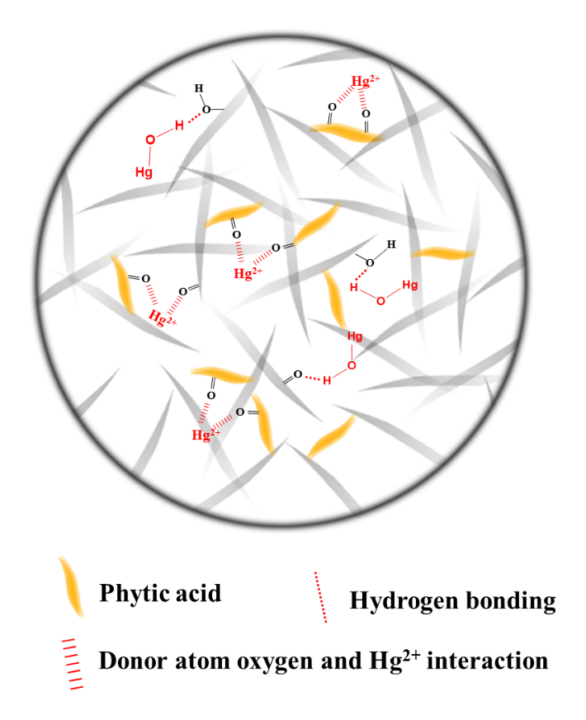
Fig. S3 Schematized interaction between Hg²⁺/Hg(OH)⁺ and aerogel adsorbent
Experimental Section
- Materials and methods
1.1. Chemicals and materials
PVA (Mw ~195,000; 98% purity), HgCl₂ (99.5% purity), phytic acid (50%, in H₂O) were purchased from Aladdin Reagent Company. Multi-wall carbon nanotubes (MWCNTs) aqueous dispersion (2%, weight percent (wt%)) was purchased from Shenzhen nanotech Port Co., Ltd. A standard solution of Hg²⁺ (1000 ppm) was supplied by Guobiao (Beijing) Testing & Certification Co. Ltd. A standard methylmercury (MeHg⁺) solution with a certified concentration of 10 μg mL⁻¹ (with expanded uncertainty of 5%) was purchased from the Institute for Environmental Reference Materials Ministry of Environmental Protection. Deionized (DI) water used for all experiments and was obtained from a Millipore water purification system. All chemicals and reagents were used without further purification. Lake water was obtained from the Chagan Lake in Jilin Province, China. The municipal tap water in Changchun was directly used as the tap water in the experiments.
1.2. Apparatus and characterizations
Freeze-drying process was completed in Alpha 1-2LD plus instrument. SEM was performed on XL-30 ESEM FEG instrument (FEI Company). FT-IR spectra were obtained on VERTEX 70 (Bruker, Germany). SEM and FT-IR samples were prepared by freeze-drying the aerogels after purification. Compressive tests were carried out on Instron 1121 with two flat platforms. The BET specific surface area was acquired via nitrogen absorption on Autosorb iQ Gas Sorption (Quantachrome, USA). The analysis proceeded depending on the nitrogen amount absorbed by the aerogels, ignoring the relative vapor pressure (P/P₀) below 0.35 at -195.8 °C.
1.3. Adsorbent synthesis
In decision for dosage of PA solution, we assumed that one PA molecule can react with six hydroxyl groups in the PVA chain. According to this principle, certain amount of PA solution was added into 11 mL 7% (wt%) PVA solution to synthesize PA/PVA-n (n represents the hydroxyl groups in PVA chain reacting with the phosphate groups in PA molecule theoretically). 1 mL MWCNTs solution was added in the above solution. After the homogeneous mixture was formed, the mixture was transferred to Teflon lined autoclave and was kept in 200 ºC oven for 24 h. The aerogel absorbent was obtained after being immersed in H₂O to removal the residual ions.
  - Density, porosity, water content calculation of the aerogels:
The freeze-dried aerogels were cut into several regular cuboids, the volume of which was calculated by measuring its length, width, and height. Each cuboid was weighed by a balance with 0.1 mg resolution. The density of aerogel (ρ) was calculated by Equation (1)
$ρ=\frac{m}{V}$ (1)
where m and V are the mass and volume of each piece, respectively. We did five parallel measurements to get the mean as the final value.
Porosity of the aerogels was calculated by Equation (2):
$Porosity \left(\%\right)=\left(1-\frac{ρ}{ρ_{p}}\right)×100\%$ (2)
where ρ_{p} is the density of PVA precursor that can be obtained from the product information provided by the manufacturer. Here, the value of ρ_{p} is 1190 kg m⁻³.
The purified aerogel products (under wet state) were cut into some regular cuboids and weighed separately (m_{w}), followed by the freeze-dry process and weighed again (m_{d}). The water content value was calculated by Equation (3):
$water content \left(\%\right)=\frac{m_{w}-m_{d}}{m_{w}}×100\%$ (3)
  - Strain-stress tests:
Aerogels with cylindrical shape (height: 28 mm, diameter: 28 mm) immersed in water. During the tests, the compressing rates for loading and unloading were set to be 10 mm min⁻¹.
  - Hg²⁺ absorption test:
All the solutions to be remediated were made by the dilution of the Hg²⁺ standard solution. All the absorbing process proceeded under 37 ºC. Inductively coupled plasma atomic emission spectroscopy (ICP-AES) was used to determine the Hg²⁺ concentration except the very low concentrations (p.p.b. level or below) were detected by ICP-mass spectrometry (ICP-MS). The distribution coefficient (K_{d}) was calculated via Equation (4):
$K_{d}=\frac{C_{i}-C_{0}}{C_{0}}×\frac{V}{M}$ (4)
where C₀ and C_{i} are Hg²⁺ concentration at equilibrium state and initial phase respectively. V is the volume of the treated solution (mL) and M is the mass of the freeze-dried aerogel (g). In our experiments, all the aerogel adsorbents were stored in H₂O before use and were directly employed to adsorb the pollutant in the wet state. The mass of the dry gel was calculated through Equation (3). The purification process proceeded under shaking (250 rpm) for 24 h. The absorption capacity (q_{e}, mg g⁻¹) was obtained via Equation (5):
$q_{e}=\left(C_{b}-C_{e}\right)×\frac{V}{M}$ (5)
where C_{b} and C_{e} represent the Hg²⁺ concentration at the beginning and at equilibrium (p.p.m.), respectively. V is the volume of the treated solution (L). M is the mass of dry adsorbent (g). The adsorbents were added into a certain volume of aqueous solutions with different concentrations of Hg²⁺ with absorbent to solution ratio (A/S, g L⁻¹) of 2.7 g L⁻¹, and then shaken for 24 h. The final Hg²⁺ concentration was analyzed by ICP.
  - Absorbent regeneration:
The used aerogel absorbent was immersed in 1 M HCl solution, which was then vertically compressed downward for 20 times. The absorbent was taken out by a tweezer and thoroughly washed with H₂O for the subsequent purification process. In order to affirm the high elution rate, the absorbent was freeze-dried, then the absorbed mercury was analyzed with ICP.
  - Hg²⁺ absorption under pH=3 and 10:
The standard Hg²⁺ solution was diluted with HNO₃ and KOH solution to prepare the pH=3 and 10 solutions, whose Hg²⁺ concentration is ~10 p.p.m. (determined by ICP). Certain amount of absorbents was added into the above solutions with the A/S ratio of 3.7 g L⁻¹, afterwards the mixture was shaken for 24 h. The final Hg²⁺ concentration was analyzed by ICP.
  - Hg²⁺ absorption in presence of the competing ions:
Certain amount of CuCl₂·2H₂O, CrCl₃·6H₂O, CdCl₂·H₂O, Pb(NO₃)₂ and MnCl₂·4H₂O was dissolved in the standard Hg²⁺ solution, which was then diluted to make the concentrations are ~10 p.p.m. (determined by ICP). Certain amount of absorbents was added into the above solutions with the A/S ratio of 4.1 g L⁻¹, afterwards the mixture was shaken for 24 h. The final concentrations of the ions were analyzed by ICP.
1.10. Lake and tap water purification test:
Certain amount of HgCl₂ was dissolved in lake and tap water to obtain the Hg²⁺ solution (~10 p.p.m., determined by ICP). Certain amount of absorbents was added into the above solutions with the A/S ratio of 4.3 g L⁻¹, afterwards the mixture was shaken for 24 h. The final Hg²⁺ concentration was analyzed by ICP.
  - . Methylmercury compound removal:
The standard methylmercury solution was firstly diluted by 100-fold. 3 μL of the above solution was added into 300 mL of H₂O, which was then shaken with the absorbent (A/S ratio of 2.7 g L⁻¹) at 37 ºC for 24 h. The final mercury level was analyzed with ICP-MS. Three parallel measurements were performed to obtain the final data.

