Supporting Information

Distinct Transcriptomic and Pharmacogenomic Signatures of Gastric Cancer with Ovarian Metastasis Reveal Immune-Metabolic Vulnerabilities

Tong Wang ¹, Dan Liu ², Haining Liu ¹, Jingyuan Wang ^{1, *}
1. Department of Reproduction, Qingdao Municipal Hospital, Qingdao, 266071, China.
2. Obstetrics Department, Qingdao Municipal Hospital, Qingdao, 266071, China.
3. Department of Reproduction, Qingdao Municipal Hospital, Qingdao, 266071, China.

Corresponding Author:
Jingyuan Wang, M. D. Ph. D, Department of Reproduction, Qingdao Municipal Hospital, Qingdao, 266071, China.
E-mail: hainingliu_sd@163.com

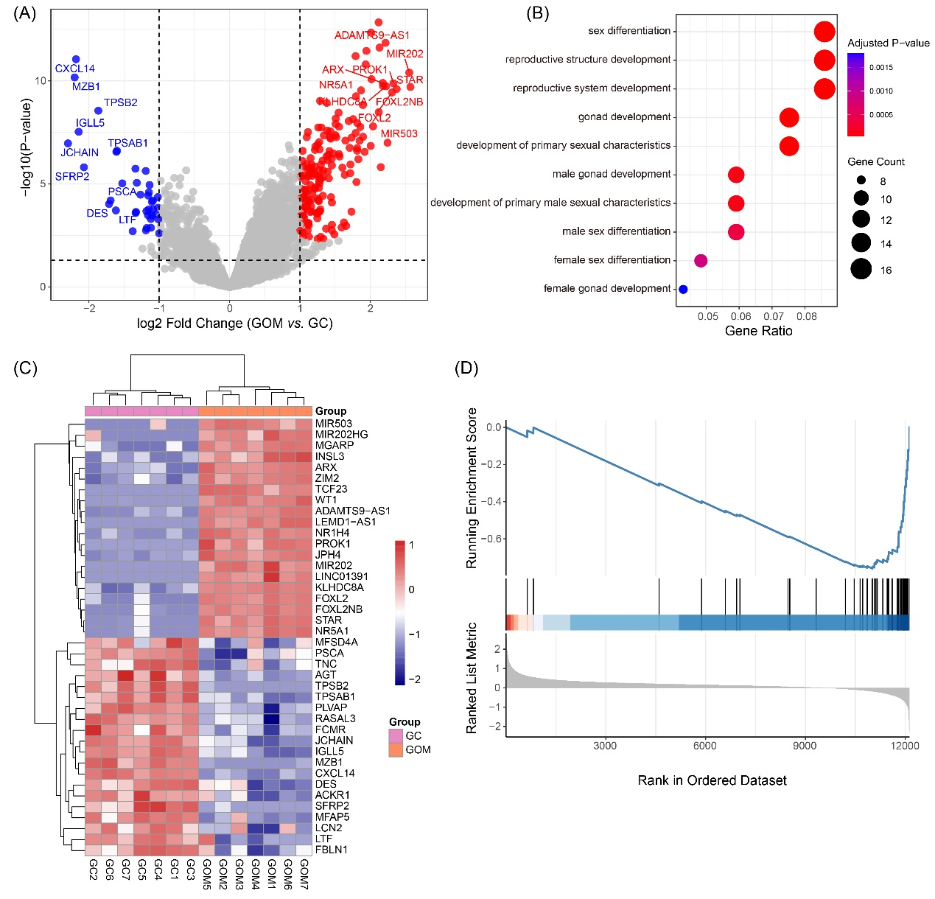
Supplementary Figure S1. Differential expression and pathway enrichment analysis between GOM and GC. (A) Volcano plot showing differentially expressed genes (DEGs) between GOM and GC. Red and blue dots indicate significantly upregulated and downregulated genes in GOM respectively (|log₂FC| ≥ 1, adjusted p < 0.05). (B) Gene Ontology (GO) enrichment analysis for upregulated genes in GOM compared to GC. Key enriched biological processes include immune regulation and cell adhesion. (C) Heatmap of top differentially expressed genes between GOM and GC, revealing a clear separation of sample clusters. (D) GSEA plot showing pathway-level suppression of antigen presentation and adaptive immune responses in GOM compared to GC.

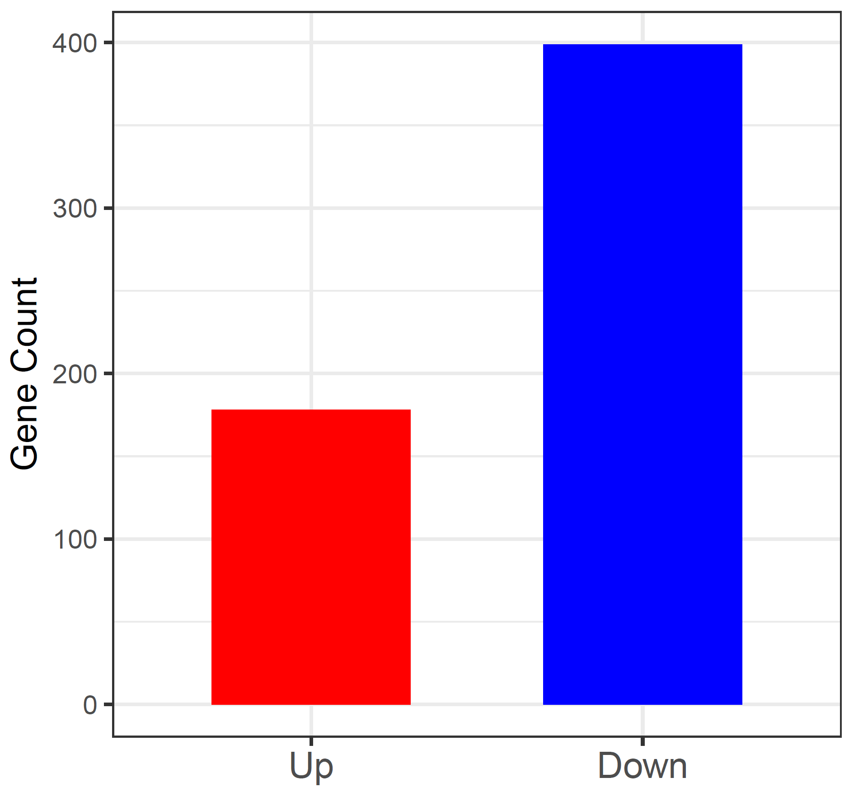
Supplementary Figure 2. Number of differentially expressed genes (DEGs) in GOM vs. OC comparison. Bar plot illustrating the number of upregulated (red) and downregulated (blue) genes identified in gastric cancer with ovarian metastasis (GOM) compared to primary ovarian cancer (OC). A total of approximately 170 genes were upregulated and 400 were downregulated (|log₂ fold change| ≥ 1, adjusted p < 0.05), highlighting a predominantly repressive transcriptomic reprogramming in GOM relative to OC.

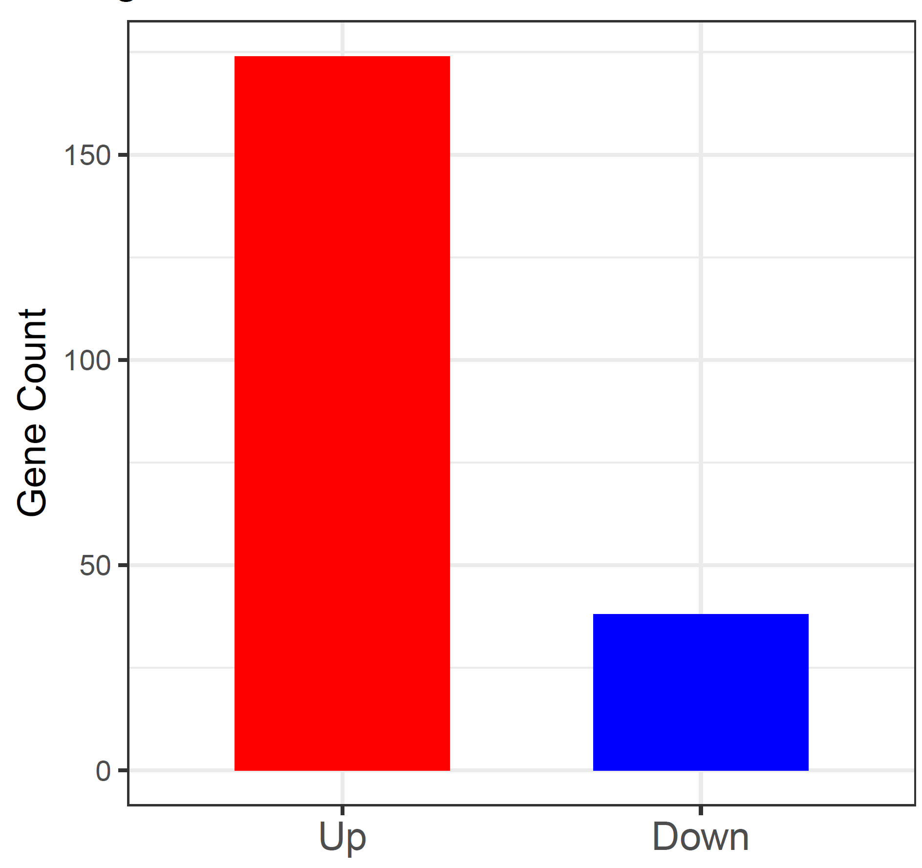
Supplementary Figure 3. Number of differentially expressed genes (DEGs) in GOM vs. GC comparison. Bar plot showing the distribution of DEGs between gastric cancer with ovarian metastasis (GOM) and primary gastric cancer (GC). A total of approximately 175 genes were upregulated (red) and ~35 were downregulated (blue) in GOM (|log₂ fold change| ≥ 1, adjusted p < 0.05), suggesting a transcriptional shift associated with metastatic adaptation.

Table S1. Sample Information Summary
Group | Tissue Type | Sample Size (n) | Dataset
GC | Gastric Cancer | 7 | GSE223426
GOM | Gastric Cancer with Ovarian Metastasis | 7 | GSE223426
OC | Primary Ovarian Cancer | 11 | GSE191139
ON | Normal Ovary | 4 | GSE191139

Table S2. Top 10 Up- and Downregulated DEGs in GOM vs OC
Gene Symbol | log₂FC | adj. p-value | Regulation (↑/↓) | Gene Type Function Summary
SCARNA13 | 2.85 | 1.2e-05 | ↑ | snoRNA RNA modification
HLA-H | -3.10 | 4.6e-07 | ↓ | MHC-I Antigen presentation
SNORD17 | 2.63 | 1.8e-04 | ↑ | snoRNA Ribosomal RNA modification
WFDC2 | -2.94 | 3.1e-06 | ↓ | Secreted protein Tumor marker
MIR3619 | 2.48 | 2.2e-04 | ↑ | lncRNA Immune regulation
VIM-AS1 | -2.50 | 9.9e-05 | ↓ | lncRNA EMT-associated antisense
RMRP | 2.33 | 3.4e-04 | ↑ | lncRNA Mitochondrial RNA processing
CIITA | -2.60 | 1.1e-06 | ↓ | Transactivator MHC class II expression
SNORA73B | 2.12 | 5.7e-04 | ↑ | snoRNA RNA pseudouridylation
HLA-DQB1 | -2.83 | 6.4e-06 | ↓ | MHC-II Antigen presentation

Table 3. Shared DEGs Between GOM vs OC and GOM vs G
Gene Symbol | log₂FC (GOM vs OC) | log₂FC (GOM vs GC) | Regulation Consistency Functional Annotation
NR1H4 | -1.7 | -1.9 | Down in both FXR, bile acid metabolism
ENPP6 | -2.0 | -1.8 | Down in both Lipid metabolism
RHBG | -1.6 | -2.2 | Down in both Ammonium transport
ADAMTS9-AS1 | -1.9 | -1.5 | Down in both Tumor suppressor lncRNA
TCERG1L | -1.4 | -1.6 | Down in both Transcription elongation
FOSB | -2.3 | -2.1 | Down in both AP-1 transcription factor
SLC7A14 | -1.8 | -1.7 | Down in both Solute carrier family
PDZK1IP1 | -1.5 | -2.0 | Down in both Scaffold protein
MSLN | -2.1 | -2.3 | Down in both Cell adhesion
LCN2 | -2.2 | -1.9 | Down in both Iron transport and inflammation

Table S4. Drug Sensitivity Scores for GOM vs OC
Drug Name | Drug Class | ssGSEA Score (GOM) | ssGSEA Score (OC) | p-value (Wilcoxon)
Dinaciclib | CDK1/2 inhibitor | 0.75 ± 0.06 | 0.45 ± 0.04 | <0.001
Romidepsin | HDAC inhibitor | 0.68 ± 0.05 | 0.51 ± 0.03 | <0.01
Sepantronium bromide | Survivin inhibitor | 0.61 ± 0.04 | 0.48 ± 0.04 | <0.01
SN-38 | Topo I inhibitor | 0.72 ± 0.07 | 0.50 ± 0.05 | <0.01

Table S5. Correlation of Hub Genes with Drug Sensitivity Signatures
Hub Gene | Romidepsin | SN-38 | Dinaciclib | Sepantronium bromide
NR1H4 | +0.62 *** | +0.59 ** | -0.55 ** | -0.61 ***
RHBG | +0.49 ** | +0.44 * | -0.53 ** | -0.47 *

