Supplementary materials
  - Pre- and post-tests
To measure students’ learning outcomes, we designed pre- and post-tests based on the lecture content. Since we are using two math topics (Fraction and Perimeter) for the lectures, we prepared two tests for each topic, which were used for the pre- and post-tests, in a counterbalanced order. Each test consisted of 10 questions, with each question one 1 point. To maintain equivalence between both tests, we did not change the questions themselves; instead, we modified the numbers or images used in the questions while retaining their structure. Please see the Appendix A for the four tests we designed for the pre- and post-tests. For the review purpose, the tests were translated and shown in English, but the original versions used in the experiments were in traditional Chinese.
  - Teacher-student verbal interaction
The students were encouraged to ask questions at any time during the lecture and the teacher were instructed to engage students by asking them content-related questions. This approach aimed to simulate a realistic classroom environment. During the lecture/training session, one experimenter sat behind the students and used a structured spreadsheet to code teacher-student interaction. Specifically, we coded the number of questions initiated or topics raised by the teacher/student, and the number of verbal or non-verbal responses from the student/teacher to the question. As shown in Fig. S1, each session had a reasonable number of questions, mostly raised by the teacher, though students in some triads had few responses, indicating a lack of contingent teacher-student interactions. This is not surprising given this being young school-aged children in math lectures. The number of questions initiated by the teacher/student were comparable between the fraction and perimeter sessions (t(106) = 1.88, p = 0.06). Similarly, the number of responses to above questions were also comparable between the two sessions (t(105) = 1.54, p = 0.13), suggesting that teacher-student interactions were comparable between the two sessions.
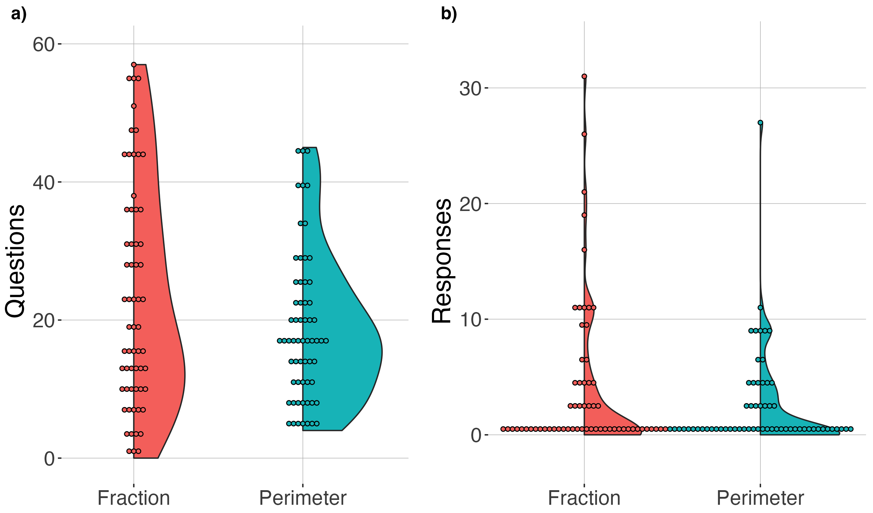
Fig. S1 The number of questions and responses during the lecture sessions.
  - fNIRS data acquisition
The fNIRS data were acquired using two potable NIRSport2 devices. Each device had 16 LED light sources and 16 avalanche photodiode (APD) detectors, with a sampling frequency of 10.16 Hz. Each LED light source emitted near-infrared light with wavelengths of 760 nm and 850 nm. A light source paired with detectors located at about 30-mm distance provided regular fNIRS channels that collected signals. The last APD detectors for each participant in a dyad were connected to a bundle of eight short-channel detectors that were then connected to eight light sources to produce 8-mm short channels. Data recorded in the short channels were involved in further analyses to determine the frequency bands of interest (FOIs).
  - Determining the frequency bands of interest:
To identify the frequency bands of interest (FOI) for further analyses, we compared the IBC across frequencies between regular channels and IBC calculated from the short channels. The regular fNIRS channels measure event-evoked and non-evoked systemic responses and neuronal responses from both the extracerebral and cerebral tissues. IBC with shorter channels, which were specifically designed to penetrate only to the depth to measure cortical responses from extracerebral tissues, from two people could be driven by the shared systemic responses recorded from the extracerebral tissue. Therefore, greater IBC in the regular channels than the shorter channels could indicate synchronization from the neuronal signals, which were only accessible in the former. For detailed description, please see this study (Zhou, Ng, and Wong; under review).

This methodology identified three FOIs, i.e., [0.291 0.489] Hz, [0.137 0.173] Hz, [0.097 0.109] Hz, noted as FOI1, FOI2, and FOI3, respectively. To test how these FOIs were related to the lecture, teacher-student IBC between the lecture and resting conditions were compared. As our interest was in how teachers and students synchronized at the ROI level, IBC values from channels within the same pair of ROI connections were averaged. To eliminate the effect of varying lecture durations across triads on the calculation of IBC, teacher-student IBC values across time per FOI per condition were first ranked in ascending order. Then the comparisons between the lecture and resting conditions were conducted at 5th to 95th percentiles in increments of 5 percentiles. As shown in Fig.S2, teacher-student IBC in the FOI1 and FOI2 were higher during the lecture across all the sixteen ROI pairs, compared to the resting condition. Whereas, the results in the FOI3 were opposite, with greater IBC in the resting condition. These results suggest that increased IBC in the FOI1 and FOI2 but not FOI3 were related to the teacher-student interaction during the lecture.

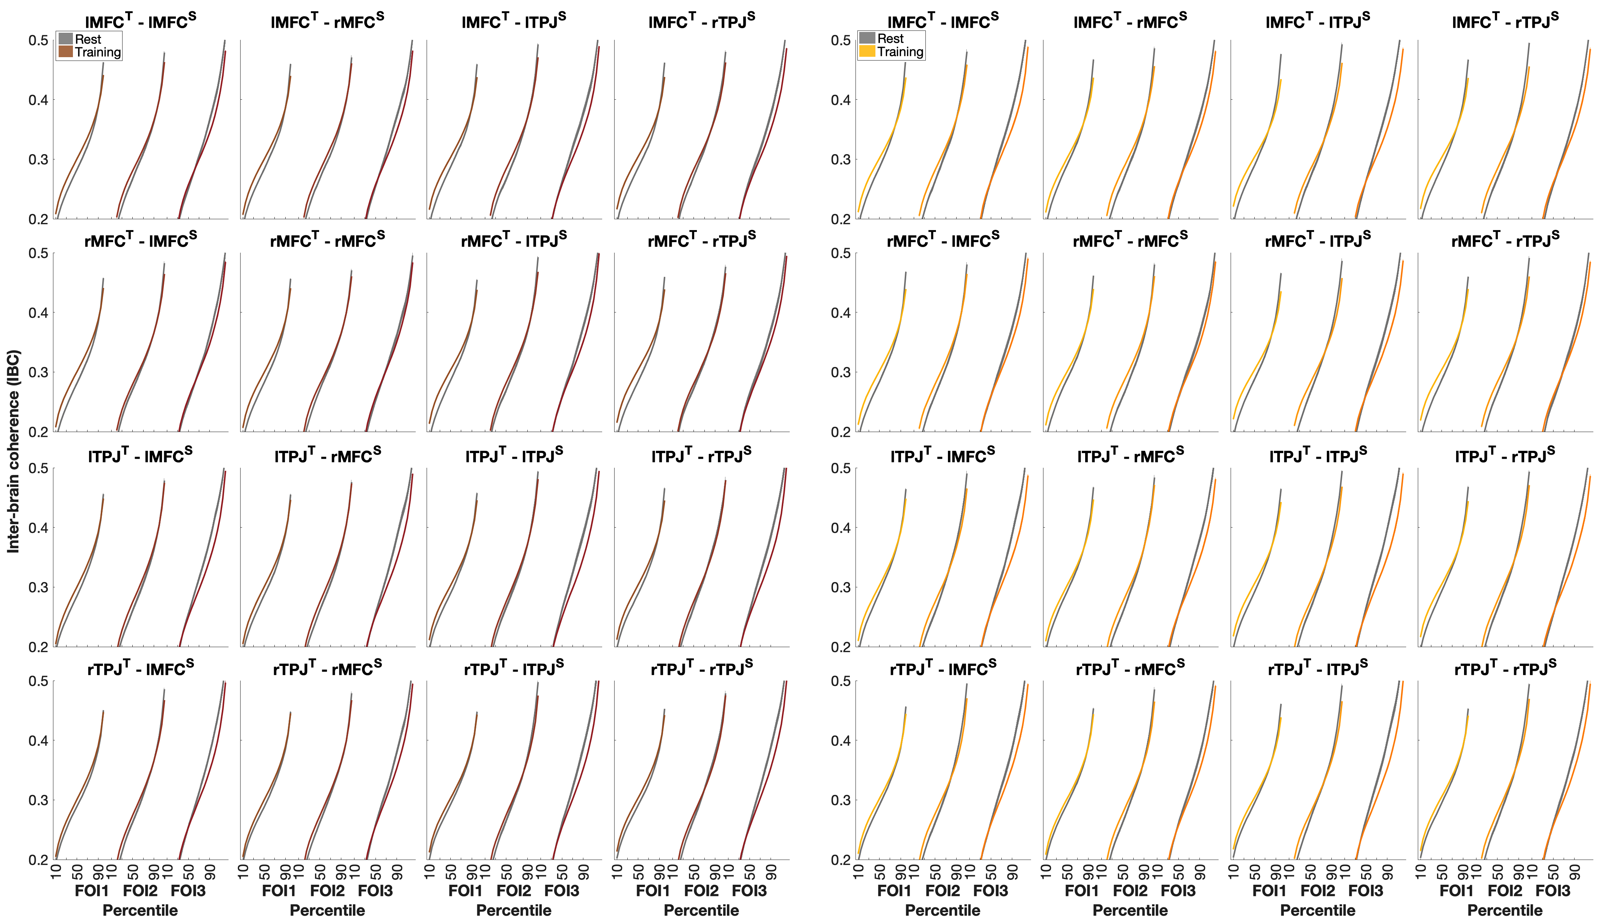
Fig. S2 Teacher-student inter-brain coherence (IBC). Each panel plots the teacher-student IBC for one ROI pairs in three frequency bands of interests (FOIs), i.e., FOI1, FOI2, and FOI3, each from the 5th – 95th percentiles.
Fraction | Pre-test > Rest | Post-test vs. Rest | Lecture > Rest | Lecture vs. Pre-test | Lecture vs. Post-test
lMFC^{T}-lMFC^{S} | t(97) = 2.08, p = 0.053 | t(97) = 1.57, p = 0.16 | t(97) = 5.55, p <.0001 | t(97) = 4.20, p <.0001 | t(97) = 4.17, p <.0001
lMFC^{T}-rMFC^{S} | t(97) = 2.74, p = 0.020 | t(97) = 1.91, p = 0.16 | t(97) = 6.21, p <.0001 | t(97) = 3.91, p <.0001 | t(97) = 4.40, p <.0001
lMFC^{T}-lTPJ^{S} | t(97) = 2.58, p = 0.023 | t(97) = 2.58, p = 0.091 | t(97) = 5.85, p <.0001 | t(97) = 3.93, p <.0001 | t(97) = 3.68, p <.0001
lMFC^{T}-rTPJ^{S} | t(96) = 1.48, p = 0.11 | t(96) = 1.60, p = 0.16 | t(96) = 5.39, p <.0001 | t(96) = 5.07, p <.0001 | t(96) = 3.71, p <.0001
rMFC^{T}-lMFC^{S} | t(97) = 2.19, p = 0.049 | t(97) = 1.01, p = 0.32 | t(97) = 5.51, p <.0001 | t(97) = 3.59, p <.0001 | t(97) = 4.87, p <.0001
rMFC^{T}-rMFC^{S} | t(97) = 2.89, p = 0.020 | t(97) = 1.48, p = 0.16 | t(97) = 5.94, p <.0001 | t(97) = 2.96, p =.002 | t(97) = 5.09, p <.0001
rMFC^{T}-lTPJ^{S} | t(97) = 2.81, p = 0.020 | t(97) = 1.97, p = 0.16 | t(97) = 5.71, p <.0001 | t(97) = 2.61, p =.006 | t(97) = 4.31, p <.0001
rMFC^{T}-rTPJ^{S} | t(96) = 2.02, p = 0.053 | t(96) = 1.51, p = 0.16 | t(96) = 5.08, p <.0001 | t(96) = 3.61, p <.0001 | t(96) = 3.85, p <.0001
lTPJ^{T}-lMFC^{S} | t(97) = 1.28, p = 0.13 | t(97) = -.041, p = 0.67 | t(97) = 4.69, p <.0001 | t(97) = 4.10, p <.0001 | t(97) = 6.07, p <.0001
lTPJ^{T}-rMFC^{S} | t(97) = 1.76, p = 0.082 | t(97) = -.21, p = 0.67 | t(97) = 4.98, p <.0001 | t(97) = 3.95, p <.0001 | t(97) = 6.14, p <.0001
lTPJ^{T}-lTPJ^{S} | t(97) = 1.34, p = 0.13 | t(97) = 0.25, p = 0.65 | t(97) = 3.58, p <.0001 | t(97) = 2.87, p =.003 | t(97) = 4.89, p <.0001
lTPJ^{T}-rTPJ^{S} | t(96) = 0.96, p = 0.17 | t(96) = -.74, p = 0.77 | t(96) = 3.66, p <.0001 | t(96) = 3.69, p <.0001 | t(96) = 6.31, p <.0001
rTPJ^{T}-lMFC^{S} | t(97) = 1.11, p = 0.17 | t(97) = 0.14, p = 0.65 | t(97) = 3.89, p <.0001 | t(97) = 3.43, p <.0001 | t(97) = 5.26, p <.0001
rTPJ^{T}-rMFC^{S} | t(97) = 1.03, p = 0.17 | t(97) = -.20, p = 0.67 | t(97) = 4.04, p <.0001 | t(97) = 3.54, p <.0001 | t(97) = 5.83, p <.0001
rTPJ^{T}-lTPJ^{S} | t(97) = 1.56, p = 0.11 | t(97) = 0.18, p = 0.65 | t(97) = 3.14, p =.001 | t(97) = 1.54, p =.064 | t(97) = 4.31, p <.0001
rTPJ^{T}-rTPJ^{S} | t(96) = 0.96, p = 0.17 | t(96) = -.42, p = 0.70 | t(96) = 3.53, p <.0001 | t(96) = 3.02, p =.002 | t(96) = 5.56, p <.0001
1.5 Differences in IBC between multiple conditions
For each teacher-student ROI pair, we compared the cumulative IBC in each condition against the rest condition, and between the lecture and pre- or post-test condition per topic. P-values were adjusted for multiple comparisons.
Table S1 summarized the results for the session of fraction

Fraction | Pre-test vs. Rest | Post-test vs. Rest | Lecture > Rest | Lecture vs. Pre-test | Lecture vs. Post-test
lMFC^{T}-lMFC^{S} | t(97) = 0.74, p = 0.73 | t(97) = 0.41, p = 0.96 | t(97) = 5.46, p <.0001 | t(97) = 6.89, p <.0001 | t(97) = 6.80, p <.0001
lMFC^{T}-rMFC^{S} | t(96) = 0.60, p = 0.73 | t(96) = 0.29, p = 0.96 | t(96) = 6.21, p <.0001 | t(96) = 6.97, p <.0001 | t(96) = 7.57, p <.0001
lMFC^{T}-lTPJ^{S} | t(97) = 0.21, p = 0.83 | t(97) = 0.74, p = 0.96 | t(97) = 3.75, p <.0001 | t(97) = 5.79, p <.0001 | t(97) = 5.79, p <.0001
lMFC^{T}-rTPJ^{S} | t(97) = 0.81, p = 0.73 | t(97) = 0.83, p = 0.96 | t(97) = 4.85, p <.0001 | t(97) = 6.10, p <.0001 | t(97) = 6.10, p <.0001
rMFC^{T}-lMFC^{S} | t(97) = 1.67, p = 0.73 | t(97) = 1.02, p = 0.96 | t(97) = 6.41, p <.0001 | t(97) = 5.98, p <.0001 | t(97) = 7.65, p <.0001
rMFC^{T}-rMFC^{S} | t(97) = 0.34, p = 0.83 | t(97) = 0.37, p = 0.96 | t(97) = 6.51, p <.0001 | t(97) = 4.49, p <.0001 | t(97) = 8.23, p <.0001
rMFC^{T}-lTPJ^{S} | t(97) = 1.03, p = 0.73 | t(97) = 0.51, p = 0.96 | t(97) = 4.88, p <.0001 | t(97) = 5.57, p <.0001 | t(97) = 7.63, p <.0001
rMFC^{T}-rTPJ^{S} | t(97) = 1.23, p = 0.73 | t(97) = 0.85, p = 0.96 | t(97) = 5.75, p <.0001 | t(97) = 6.10, p <.0001 | t(97) = 7.18, p <.0001
lTPJ^{T}-lMFC^{S} | t(97) = 1.46, p = 0.94 | t(97) = 1.49, p = 0.96 | t(97) = 3.86, p <.0001 | t(97) = 7.68, p <.0001 | t(97) = 7.27, p <.0001
lTPJ^{T}-rMFC^{S} | t(96) = 1.32, p = 0.94 | t(96) = 1.38, p = 0.96 | t(96) = 4.43, p <.0001 | t(96) = 8.38, p <.0001 | t(96) = 7.61, p <.0001
lTPJ^{T}-lTPJ^{S} | t(97) = 1.58, p = 0.94 | t(97) = 0.90, p = 0.96 | t(97) = 3.65, p <.0001 | t(97) = 7.45, p <.0001 | t(97) = 5.44, p <.0001
lTPJ^{T}-rTPJ^{S} | t(97) = 0.63, p = 0.94 | t(97) = 0.53, p = 0.96 | t(97) = 3.86, p <.0001 | t(97) = 7.18, p <.0001 | t(97) = 6.61, p <.0001
rTPJ^{T}-lMFC^{S} | t(97) = 0.41, p = 0.94 | t(97) = 1.42, p = 0.96 | t(97) = 3.86, p <.0001 | t(97) = 5.93, p <.0001 | t(97) = 7.32, p <.0001
rTPJ^{T}-rMFC^{S} | t(96) = 0.94, p = 0.94 | t(96) = 1.80, p = 0.96 | t(96) = 4.17, p <.0001 | t(96) = 6.90, p <.0001 | t(96) = 7.46, p <.0001
rTPJ^{T}-lTPJ^{S} | t(97) = 1.47, p = 0.94 | t(97) = 1.57, p = 0.96 | t(97) = 3.08, p =.001 | t(97) = 5.60, p <.0001 | t(97) = 5.56, p <.0001
rTPJ^{T}-rTPJ^{S} | t(97) = 0.17, p = 0.94 | t(97) = 1.07, p = 0.96 | t(97) = 3.90, p <.0001 | t(97) = 5.27, p <.0001 | t(97) = 6.93, p <.0001
Table S2 summarized the results for the session of perimeter

Reference
Zhou, X., Ng, F. F. Y., and Wong, P. C. M. (2025) Addressing Arbitrary Choices of Frequency Band of Interest in fNIRS Hyperscanning. OSF preprint https://doi.org/10.31234/osf.io/34bmn

Appendix A Pre- and Post-tests
Fractions-a
Subject Code: _________________ Date: ____________________
Instructions:
Circle the correct option and fill in the blanks.
Please leave the question in case you are not sure about the answer.
Question 1: A fraction whose denominator is greater than its numerator is called a ____________ (proper fraction / improper fraction / mixed number).
Question 2: A mixed number is made up of a whole number and a _________ (proper fraction / improper fraction / mixed number).
Question 3: Please use a fraction to represent the coloured part. ______________

Question 4: Please use an improper fraction to represent the coloured part. ____________

Question 5: Please use a mixed number to represent the coloured part. ______________
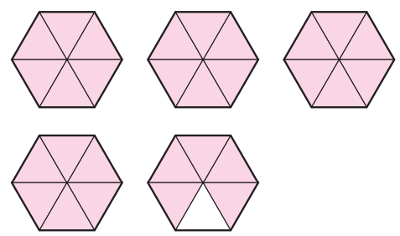
Question 6: Improper fraction $\frac{83}{( )}$ = $4\frac{7}{19}$
Question 7: Improper fraction $\frac{41}{5}$ = $( )\frac{1}{5}$
Question 8: Improper fraction $\frac{19}{8}$ = $( )\frac{3}{8}$
Question 9: Mixed number $4\frac{2}{7}$ = $\frac{( )}{7}$
Question 10: Mixed number $7\frac{3}{8}$ = $\frac{( )}{8}$
Fractions-b
Subject Code: _________________ Date: ____________________
Instructions:
Circle the correct option and fill in the blanks.
Please leave the question in case you are not sure about the answer.
Question 1: A number made up of a whole number and a proper fraction is called a ____________ (proper fraction / improper fraction / mixed number).

Question 2: A fraction whose numerator is equal to or greater than its denominator is called an ____________ (proper fraction / improper fraction / mixed number).
Question 3: Please use a fraction to represent the coloured part. ______________

Question 4: Please use an improper fraction to represent the coloured part. ____________

Question 5: Please use a mixed number to represent the coloured part. ______________
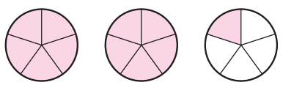
Question 6: Improper fraction $\frac{53}{( )}$ = $6\frac{5}{8}$
Question 7: Improper fraction $\frac{60}{7}$ = $( )\frac{4}{7}$
Question 8: Improper fraction $\frac{17}{4}$ = $( )\frac{1}{4}$
Question 9: Mixed number $3\frac{7}{8}$ = $\frac{( )}{8}$
Question 10: Mixed number $6\frac{5}{6}$ = $\frac{( )}{6}$
Perimeter-a
Subject Code: _________________ Date: ____________________
Instructions:
Circle the correct option and fill in the blanks.
Please leave the question in case you are not sure about the answer.
Question 1: The distance around a shape is called its ______________ (perimeter / area / volume).
Question 2: A shape with opposite sides equal in length and four right angles is called __________ (triangle / square / rectangle / parallelogram).
Question 3: Which shape below does not have perimeter?
- b. c. d.
Question 4: The perimeter of the shape on the right is __________m.
11 m
9 m
12 m
15 m
12 m
18 m
14 m
Question 5: The perimeter of the square on the right is ______________ m.
21 cm
17 cm

Question 6: The perimeter of the rectangle on the right is ____________cm.

Question 7: A square piece of land measuring 209 m on all four sides. _____________ m of chain link fencing is needed to enclose a piece of land this size.
Question 8: Bob has used 64 cm of ribbon to enclose a square picture frame, the length of each edge of the frame is ____________cm.
Question 9: The perimeter of this rectangular flower bed is __________m.
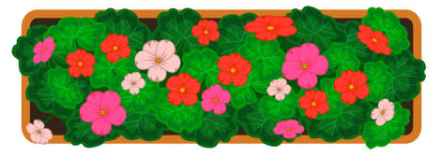
3 m
18 m

Question 10: A rectangular poster is 80 cm long and its width is 15 cm shorter than its length, the perimeter of this poster is __________cm.
Perimeter-b
Subject Code: _________________ Date: ____________________
Instructions:
Circle the correct option and fill in the blanks.
Please leave the question in case you are not sure about the answer.
Question 1: A shape with four equal sides and four right angles is called __________ (triangle / square / rectangle / parallelogram).
Question 2: The formula length × 4 is to measure the perimeter of__________ (triangle / square / rectangle / parallelogram).
Question 3: Which shape below does not have perimeter?
- b. c. d.
12 m
9 m
18 m
17 m
5 m
13 m
Question 4: The perimeter of the shape on the right is __________m.
27 cm
Question 5: The perimeter of the square on the right is ______________ cm.

Question 6: The perimeter of the rectangle on the right is ____________m.
9 m
13 m

Question 7: The perimeter of this square alarm clock is __________cm.
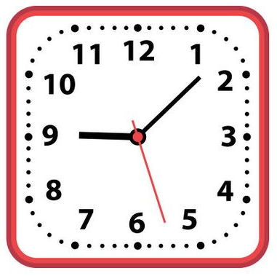
18 cm
Question 8: If the perimeter of a square piece of land is 108 m, the length of each side of this piece of land is ________m.
Question 9: A rectangular sports field is 82 m long and 45 m wide. The perimeter of the field is __________m.
Question 10: A rectangular mirror is 60 cm long and its width is 32 cm shorter than its length. The perimeter of the mirror is __________cm.

