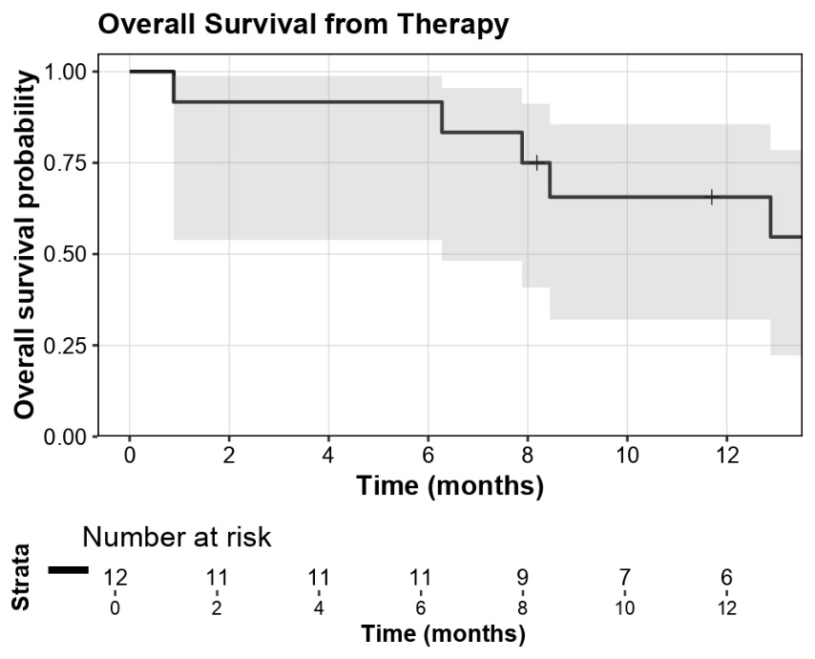
Figure S1. Overall Survival from Diagnosis

Fig S1. Kaplan–Meier curve showing overall survival probability from the date of diagnosis in the study cohort (n = 12). The shaded area represents the 95% confidence interval. Vertical tick marks indicate censored cases.

Figure S2. Overall Survival from Therapy
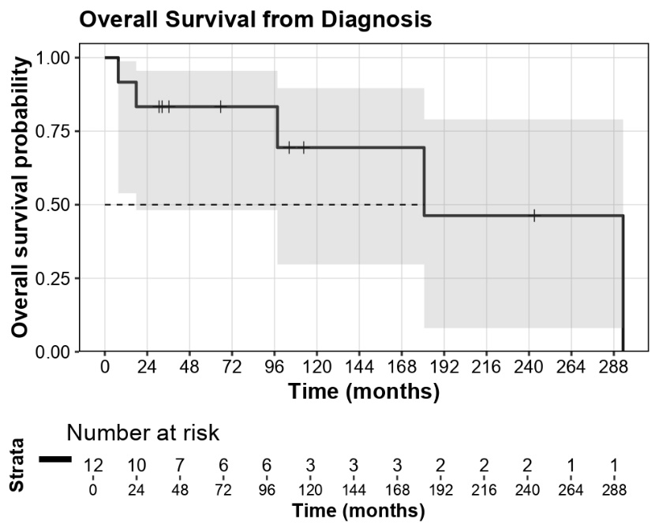
Figure S2. Kaplan–Meier curve showing overall survival probability from the start of systemic therapy (n = 12). The shaded area represents the 95% confidence interval. Vertical tick marks indicate censored cases.

