Supplementary Materials
Title
Genome-wide SNPs reveal adaptation and population structure in Syagrus romanzoffiana (Arecaceae) from southern South America
Authors
- Kauanne Karolline Moreno Martins^{1*}, Matheus Scaketti², Ana Flávia Francisconi², Igor Araújo Santos de Carvalho², Caroline Bertocco Garcia², Thiago Deomar Ludwig², Enéas Ricardo Konzen⁵, Maria Imaculada Zucchi^{1,2,6*}
Affiliations
¹Biology Institute, State University of Campinas – UNICAMP, Campinas, São Paulo, Brazil.
²Department of Genetics, University of São Paulo – ESALQ/USP, Piracicaba, São Paulo, Brazil.
⁵Center for Limnological, Coastal and Marine Studies, Interdisciplinary Department, North Coastal Campus, Federal University of Rio Grande do Sul – UFRGS, Imbé, Rio Grande do Sul, Brazil.
⁶Secretariat of Agriculture and Food Supply of São Paulo State, APTA, UPDR-Piracicaba, São Paulo, Brazil.
* Correspondence:
Kauanne Karolline Moreno Martins (k228341@dac.unicamp.br)
Maria Imaculada Zucchi (mizucchi@sp.gov.br)

Figure S1. Scree plot of the Principal Component Analysis (PCA) with 19 bioclimatic variables from WorldClim v2. The first two principal components together explain approximately 85% of the total variance. This methodological analysis was used to guide variable selection for environmental association tests, justifying the retention of bio06 (minimum temperature of the coldest month) and bio19 (precipitation of the coldest quarter) as predictors in LFMM and RDA.

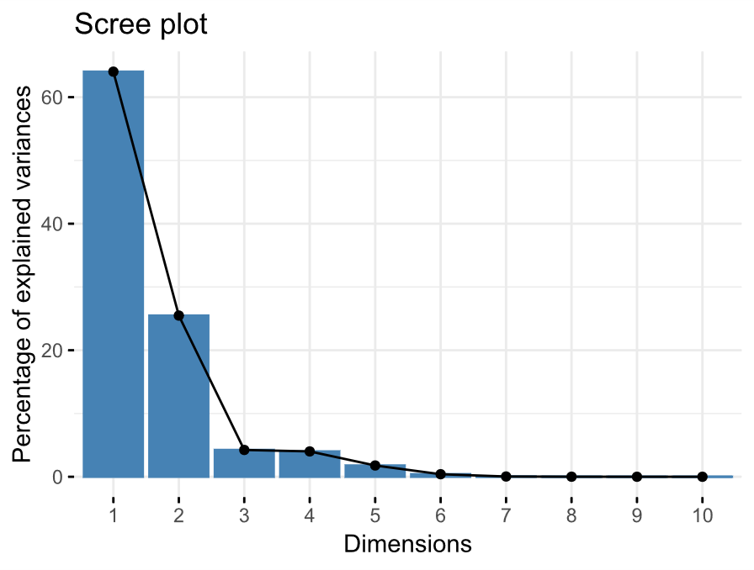

Figure S2. Cross-entropy criterion from preliminary sNMF runs for all SNPs. The model with K = 5 was the most suitable, based on the lowest cross-entropy values. This methodological step was used to define the number of latent factors (K) for LFMM analyses and does not represent the final population structure results, which are presented in the main text.
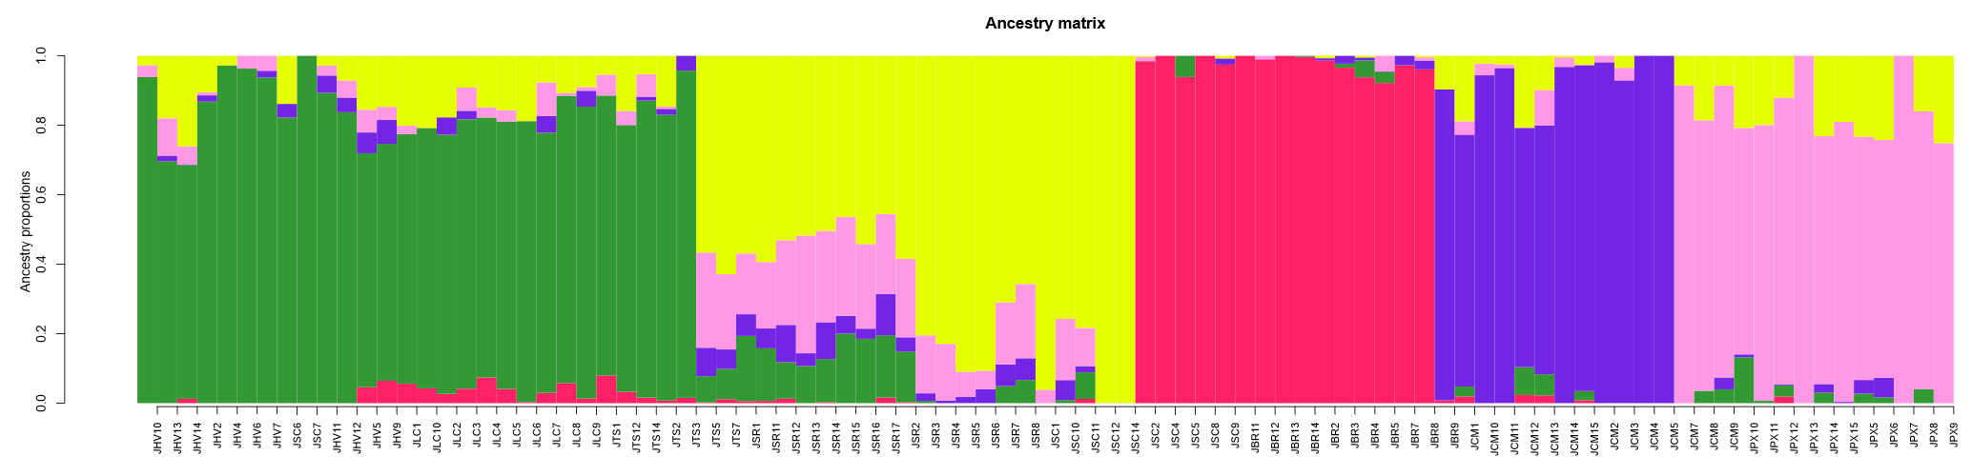

Figure S3. Sequencing quality and filtering of 91 individuals to obtain 24,859 SNPs.
(A) Percentage of missing data per individual. (B) Sequencing depth per individual.

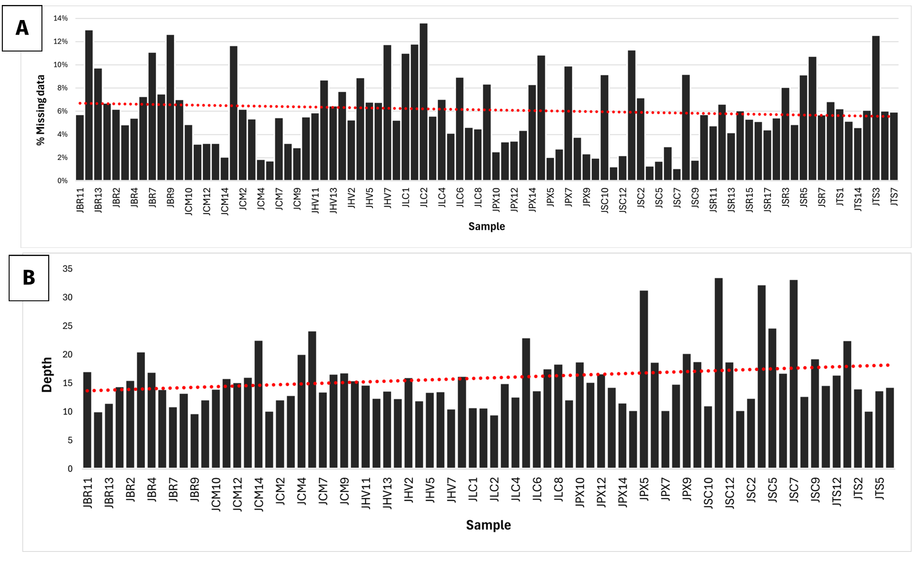

Figure S4. Sequencing quality and filtering of 91 individuals to obtain 24,859 SNPs.
(A) Sequencing depth per locus. (B) Observed transitions and transversions among the obtained SNPs.
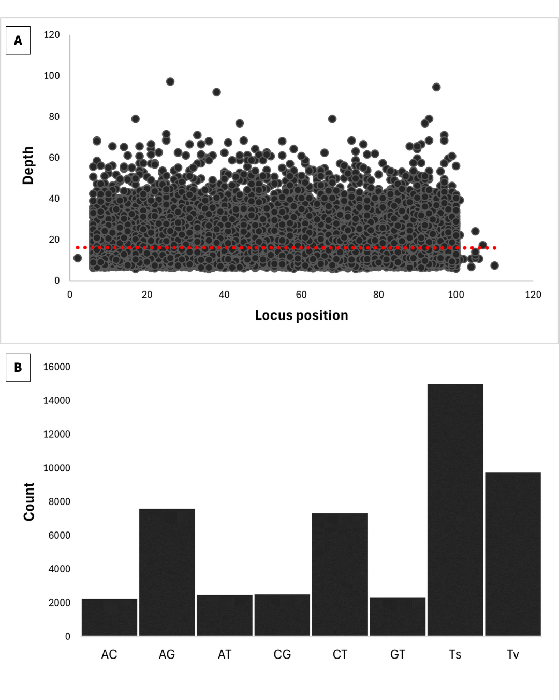

Figure S5. Histogram of adjusted p-values obtained from the LFMM model for the bioclimatic variable bio19 (precipitation of the coldest quarter). The distribution of values indicates a considerable proportion of SNPs with low p-values, suggesting strong genotype–environment association and the presence of candidate loci under local selection.
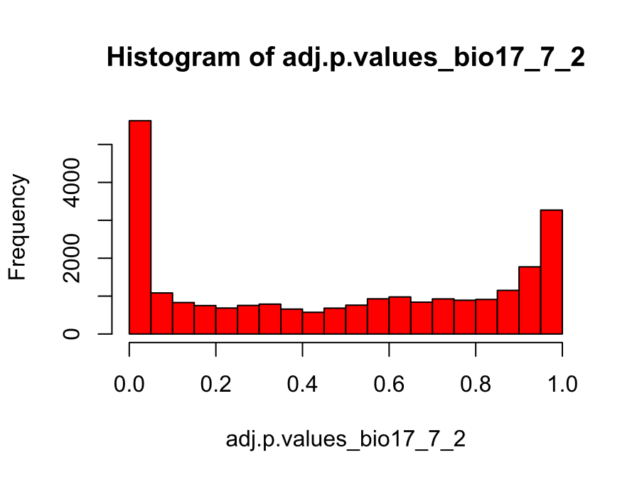
Figure S6. Distribution of adjusted –log₁₀(p) values for the candidate SNPs under selection identified by the LFMM model, associated with the bioclimatic variables bio06 (minimum temperature of the coldest month) and bio19 (precipitation of the coldest quarter). Orange dots represent loci with significant association (q < 0.05), indicating possible regions under adaptive selection.
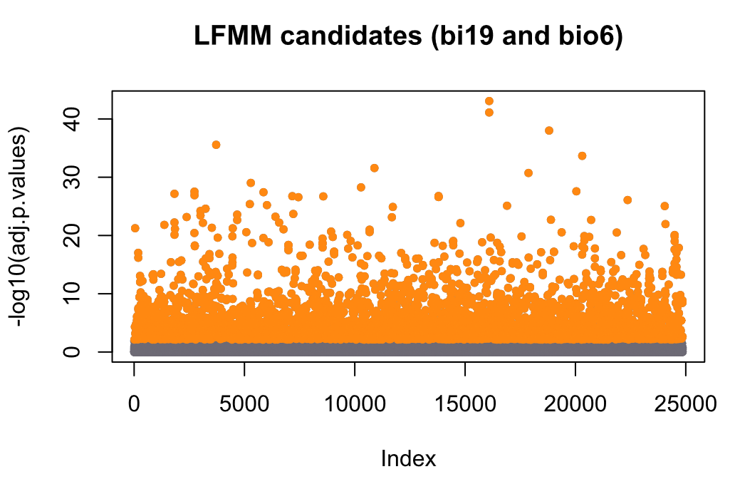Protocols
DNA extraction
DNA extraction from S. romanzoffiana leaf tissues was performed according to Doyle, 1991 protocol with modifications for palms. Specifically, we applied a modified CTAB method; leaf samples were grounded and placed in a 1.5mL microtube containing 700 μL 2% CTAB plus 2 μL β-mercaptoethanol then incubated at 65°C for 40 min. The microtubes were mixed by inversion every 15 min. Next, 700μL chloroform-isoamylalcohol (24:1) were added and the tubes were gently mixed for 1 min, followed by centrifugation for 15 min at 13,000 rpm. Immediately after centrifuging, 500μL of the supernatant of each tube was transferred to a fresh and identified 1.5 mL tube with 600μL cold isopropanol (−20°C) plus 55μL ammonium acetate 7.5M 1:20. Samples were gently mixed by inversion and conditionate at −20°C for at least 2 hours, followed by centrifugation at 13,000 rpm for 15 min. After centrifugation, the supernatants were removed, and the DNA pellets were washed with 400μL of 70% ethanol and mixed by inversion for 30 seconds followed by centrifugation at 13,000 rpm for 5 min. The ethanol was discarded and 400μL 100% ethanol was added and mixed by inversion for 30 seconds plus centrifuged at 13,000 rpm for 5 min, the ethanol discarded, and the tubes were set to dry for at least 40 minutes. The DNA pellets were suspended in 30μL TE buffer (10 mM Tris–HCl pH 7.6, 1 mM EDTA pH 7.6) plus 2μL ribonuclease (RNAse 20 mg/mL), incubated at 37°C for 30 minutes, and stored at −20°C until quantification. The quantification and quality of the samples were evaluated on a 1% agarose gel. Based on the obtained reading, we standardized the DNA to a concentration of 30ng.μl-1. The final quantification was made using Qubit.
Genotyping-by-sequencing (GBS) library preparation
A genomic library was developed to obtain SNPs markers by the GBS double digestion technique (Poland et al. 2012) with modifications. We digested 7 μl of the genomic DNA [30ng.μl-1] from each sample with the enzymes Pst1 and Mse1. The first enzyme was used to fragment the DNA into small sites and the second one to fragment the DNA again, but now into several sites. After that, 25μM of specific adapters (barcodes) from Illumina technology were ligated to these digested fragments. Ligation was performed at the ends of the fragments with T4 DNA ligase. After adapter ligation, we purified the samples using QIAquick PCR Purification Kit (Qiagen). Library enrichment was carried out by PCR using primers matching the adapters. Additionally, eight replicates were performed, each PCR reaction contained 10 μL of the purified and amplified ligation product, 12.5 μL of Phusion1 High-Fidelity PCR Master Mix (NEB, New England Biolabs Inc.), and 2 μL of Illumina forward and reverse primers (10 μM), totaling 25 μL. The amplification conditions were: initial denaturation at 95°C for 30 s, followed by 16 cycles at 95°C for 10 s, 62°C for 20 s, 72°C for 30 s, and a final extension at 72°C for 5 min. Libraries were then purified with the QIAquick PCR Purification Kit (Qiagen). Fragment size distribution was assessed using the DNA 12,000 kit on the 2100 Bioanalyzer (Agilent Technologies). The libraries were quantified using quantitative PCR (qPCR) on a CFX 384 real-time thermocycler (Bio-Rad) to ensure accurate assessment of DNA concentration prior to sequencing. PCR sequencing was performed by Illumina NextSeq 1000/2000 platform at Luiz de Queiroz College of Agriculture – University of São Paulo – (ESALQ-USP).
References
Doyle J (1991) DNA protocols for plants. In: Hewitt GM, Johnston AWB, Young JPW (eds) Molecular Techniques in Taxonomy. Springer, Berlin, pp 283–293. https://doi.org/10.1007/978-3-642-83962-7_18
Poland JA, Brown PJ, Sorrells ME, Jannink JL (2012) Development of high-density genetic maps for barley and wheat using a novel two-enzyme genotyping-by-sequencing approach. PLoS One 7:e32253. https://doi.org/10.1371/journal.pone.0032253

