Table 1: HPLC methods for anticancer drug quantification
S. No | Drug name | Mobile phase ratio | Column details | Flow rate  mL/min | RT | Wavelength (nm) | Analytical/  Bioanalytical | Ref
1 | Abiraterone | Acetonitrile and ammonium acetate buffer (pH 3.5) are 69:31 (% v/v). | LUNA phonomenex  C₁₈ column (50mm  ×2.0 mm, 5.0 μm packing) | 0.75 | 4.57 | 235 | Analytical | (22)
2 | Abiraterone | Acetonitrile and water with a pH of 0.1 v/v orthophosphoric acid (15:85% v/v ratio) adjusted | BDS C₁₈ (250 mm*4 mm, 5um) | 1.0 | 10.00 | 250 | Analytical | (23)
3 | Abiraterone | 50:50 v/v methanol: acetonitrile ratio | Eclipse XDB model C₁₈ Column (4.6) | 1.0 | 7.45 | 255 | Analytical | (24)
4 | Abiraterone | 88.4 mM (pH 9.0) acetonitrile and glycine buffer (60:40, v/v) | C₈ Xterra®MS  (250 mm × 4.6 mm,  5 m; Waters, Milford, USA) | 0.9 | 11.00 | 255 | Bioanalytical | (25)
5 | Doxorubicin | Water: Acetonitrile  (75:25 v/v) | C₁₈ column (Synergi  4u Fusion-RP 80 A,  5mm, 250*4.6mm, Phenomenex, USA) | 1.0 | 8.00 | 254 | Bioanalytical | (26)
6 | Lepatinib | Acetonitrile/20 mM  ammonium acetate in a  proportion 53:47 (v/v) | An UltrabaseC18 column (5 mm; 4.6 · 150 mm) is connected to a guard column filled with the same bonded phase (5 mm; 4.6 · 10 mm) | 1.2 | 12.00 | 260 | Bioanalytical | (27)
7 | Doxorubicin  Arabinoside | Aqueous solution of acetonitrile: ammonium hydrogen phosphate (0.01 M) at pH 6.2 (45:55) | C₁₈ column (5 µm: 250 mm × 4.6 mm) | 0.3 | 8.50 | 252 | Analytical | (28)
8 | Paclitaxel and  Lapatinib | Water and acetonitrile (70/30; V/V) | Analytical Column C18 MZ (5 μm, 150 × 4.6 mm, OSD-3) | 0.5 | 9.00 & 17.00 | 227 | Analytical | (29)
9 | Docetaxel and Paclitaxel | 0.3% orthophosphoric  acid/methanol/  tetrahydrofuran  (40/57.5/2.5, vol/vol) | Supelcosil LC-18 (3mm, 4.6-mm id 15-cm) | 1.0 | 9.20 & 11.30 | 225 & 230 | Bioanalytical | (30)
10 | Vancomycin, Norvancomycin,  Methotrexate, Paclitaxel, and  Imatinib | Water with 0.2%formic  acid (A) and methanol  (B) | Kinetex C₁₈ column  (Phenomenex, 2.1×50mm,1.7μm particle size) | 0.25 | 5.00 | - | Bioanalytical | (31)
11 | Paclitaxel and  Doxorubicin | acetonitrile and octane  sulfonic acid buﬀer  (67: 37) | iChrospher® C₁₈ column  (100,250 mm × 4:6 mm, 5 μm; Merck) | 1.0 | 10.00 | 231 | Analytical | (32)
12 | Paclitaxel | acetonitrile: water  (50: 50) | Zorbax Eclipse XDB-C₁₈  (4.6 × 150 mm, 3.5 µm) | 1.0 | 8.00 | 227 | Analytical & Bioanalytical | (33)
13 | imatinib mesylate and  rifampicin | acetonitrile-TEA/phosphate buffer pH: 7.04 (1:1 v/v) | C18 (150 x 4.6 mm, 3 μm particle size) | 0.8 | 8.254 & 11.473 | 254 | Analytical | (34)
14 | imatinib, Dasatinib and nilotinib | solventA(HPLCgradewater+0.05%  formic acid) and solvent B (HPLC grade acetonitrile+0.05% formic  acid) | Atlantis T3 C18 5 m column 150mm×4.6mm  (Waters; Milan, Italy), protected by a Security Guard with C18  (4.0mm×3.0mm) pre-column | 1.0 | 20 | - | Analytical | (35)
15 | rifampicin | 60% acetate buffer (pH 4.5) and 40% acetonitrile | column: 4.6 x 250 mm inner diameter (ID), 5µm with particle size (Phenomenex Luna) | 1 | 15 | 254 | Analytical | (36)
16 | Dasatinib | methanol and acetonitrile were mixed in the ratio of 50:50% v/v | C18 column (5 µm particle size Χ 4.6 × 250 mm) | 1 | 8 | 323 | Analytical | (37)

Table 2: LCMS methods for anticancer drug quantification
S. No | Drug name | Mobile phase ratio | Column details | Flow rate  mL/min | RT | Pharmaceutical formulation/  biologic al sample | Ref
1 | Abiraterone | 10mM ammonium acetate: acetonitrile,  10:90, v/v) | dC₁₈ column (50 4.6mm, 3mm | 0.7 | 3.50 | Bioanalytical | (31)
2 | Abiraterone, Enzalutamide  and Darolutamide | ACN/water/FA  (70:30:0.1, v/v/v) | Atlantis® dC₁₈; 4.6 × 50mm, 3.0 | 0.4 | 4.00 | Bioanalytical | (35)
3 | Dasatinib, Erlotinib, Gefitinib,  Imatinib, Lapatinib, Nilotinib,  Sorafenib, Sunitinib | The mobile phase consisted of 1 mM ammonium hydroxide in methanol (B) and 10 mM ammonium hydroxide in water at pH 10.5 (A). | 5.0mm particle size, 50 2.0mm i.d., Gemini C18 column | 0.2 | 10.00 | Bioanalytical | (36)
4 | Doxorubicin | Mobile phase A was 10 mM ammonium formate combined with 0.1% v/v formic acid, which was produced every day using a Milli-Q Synthesis A10 System (Millipore, Bellica, MA, USA). Phase B of acetonitrile was mobile. | Gemini C18 column from Phenomenex (150 x 2 mm ID 3) | 0.35 | 8.50 | - | (37)

Table 3: Agree, GAPI, AGREEprep, ESA, and BAGI for assessment of greenness values of several previously published analytical procedures for Anticancer drugs. (HPLC)
S. NO | Agree Tool | MOGAPI Tool | AGREEPREP Tool | AES Tool | BAGI Tool | Ref
1 | 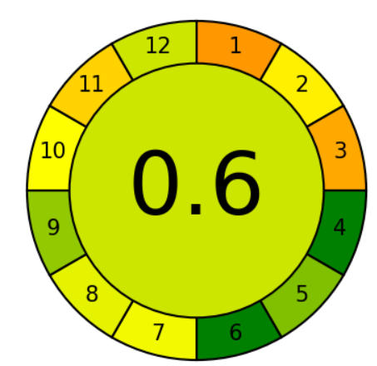 | 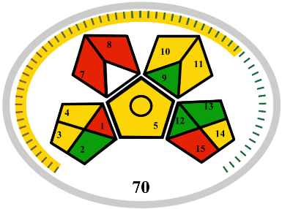 | 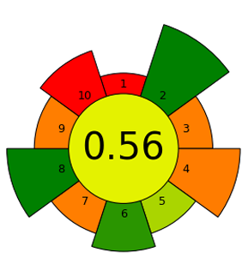 | Acetonitrile : 4  Ammonium Acetate : 0  Amount : 1  Energy Used : 2  Waste : 4  Occupational Hazard : 3  Total penalty points : 14  Analytical eco-scale : 86 | 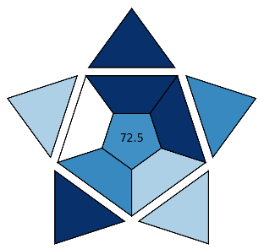 | (22)
2 | 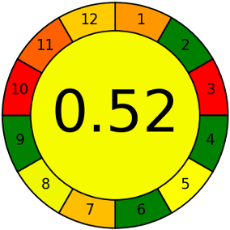 | 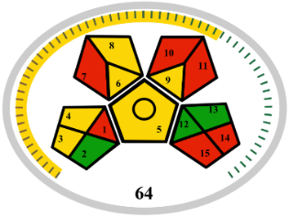 | 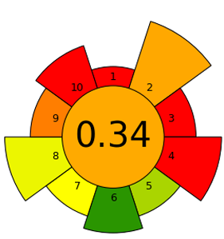 | Acetonitrile : 4  Orthophosphoric acid : 4  Amount : 4  Hazard : 2  Energy : 0  Occupational Hazard : 0  Waste : 8  Total penalty points : 22  Analytical eco-scale : 78 | 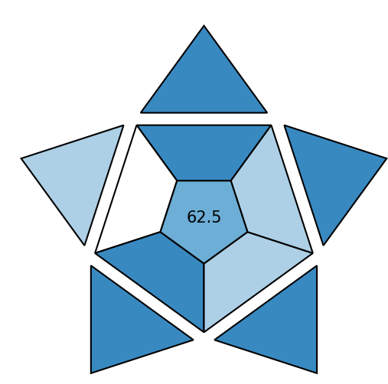 | (23)
3 | 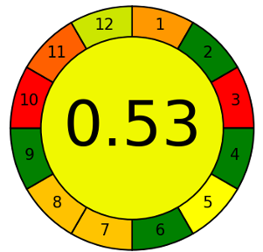 | 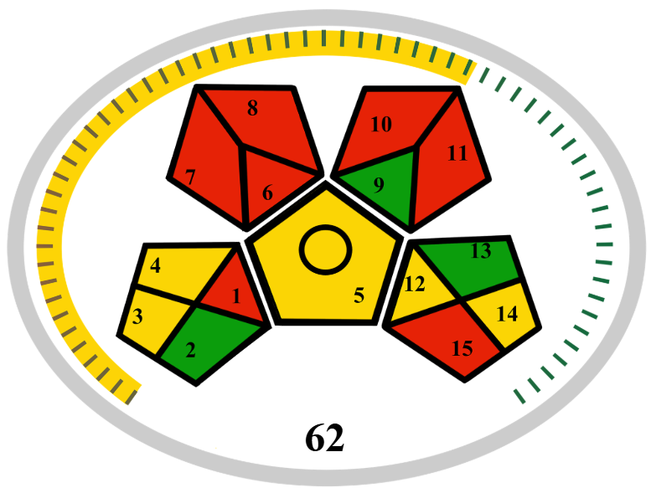 | 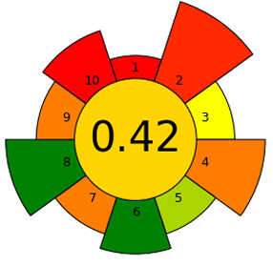 | Acetonitrile : 4  Methanol : 8  Amount : 2  Hazard : 2  Energy : 0  Occupational Hazard : 0  Waste : 8  Total penalty points : 24  Analytical eco-scale : 76 | 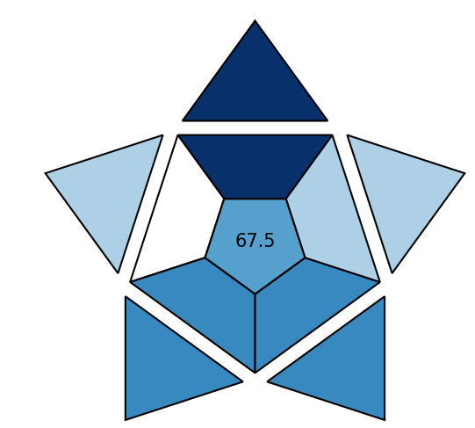 | (24)
4 | 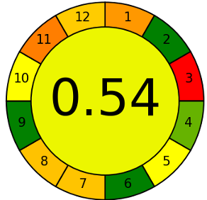 | 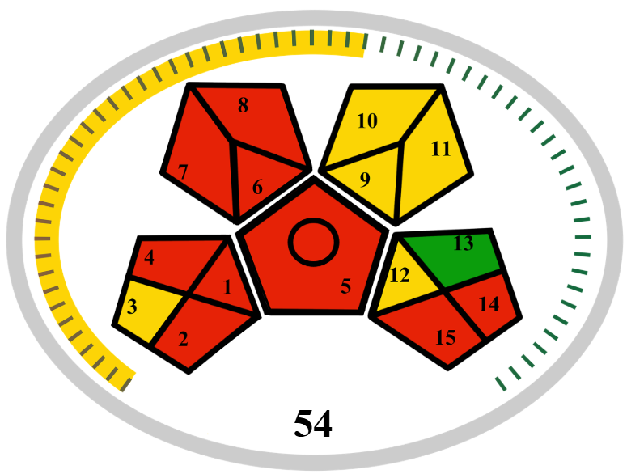 | 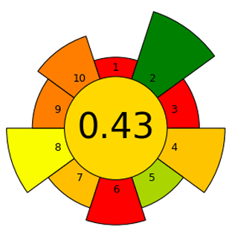 | Acetonitrile : 4  Glycine : 0  Amount : 2  Hazard : 2  Energy : 0  Occupational Hazard : 0  Waste : 8  Total penalty points : 16  Analytical eco-scale : 84 | 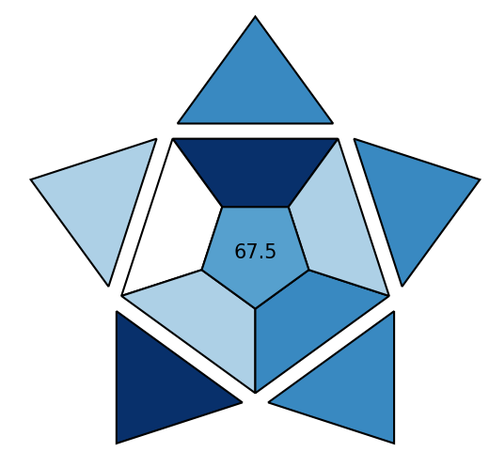 | (25)
5 | 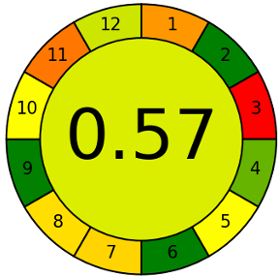 | 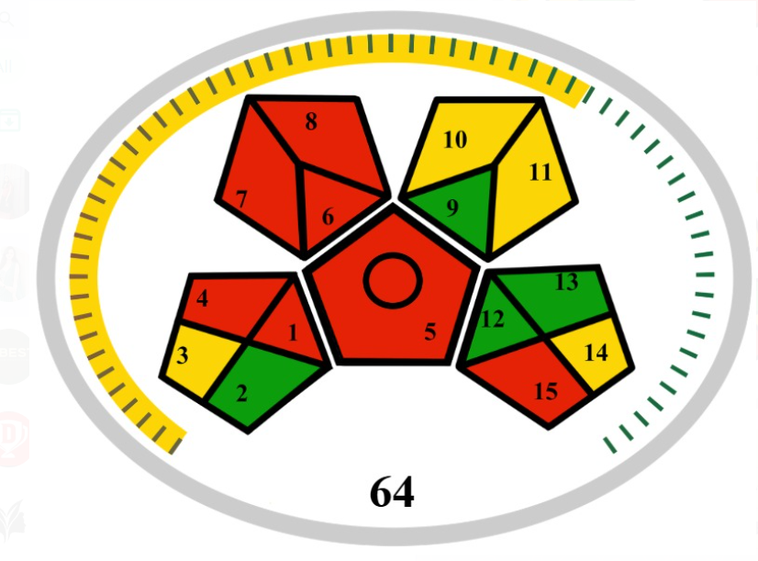 | 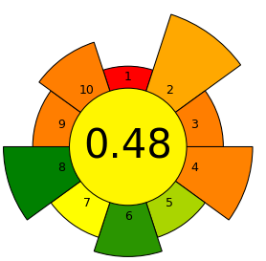 | Acetonitrile : 4  Water : 0  Amount : 2  Hazard : 2  Energy : 0  Occupational Hazard : 0  Waste : 6  Total penalty points : 14  Analytical eco-scale : 86 | 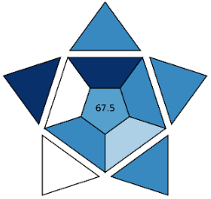 | (26)
6 | 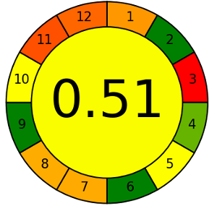 | 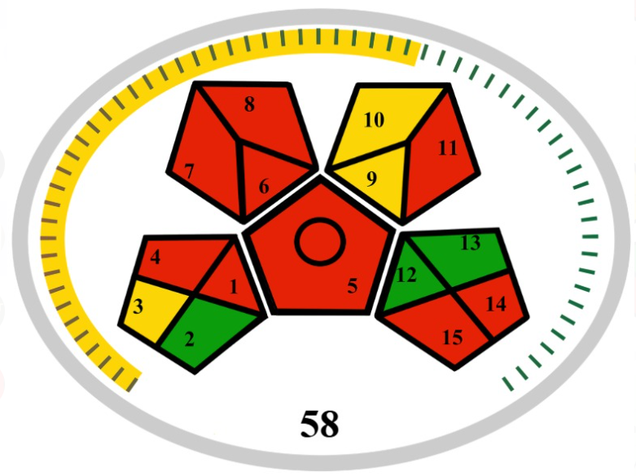 | 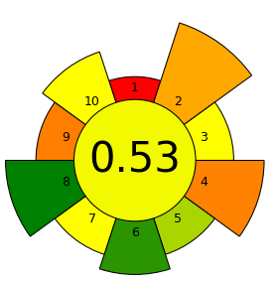 | Acetonitrile : 4  Ammonium Acetate : 1  Amount : 2  Hazard : 2  Energy : 1  Occupational Hazard : 0  Waste : 8  Total penalty points : 18  Analytical eco-scale : 82 | 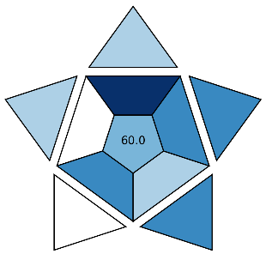 | (27)
7 | 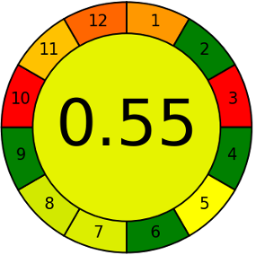 | 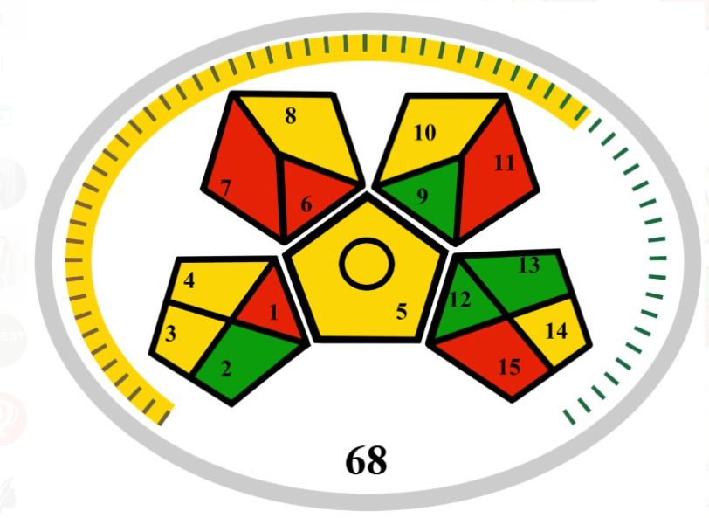 | 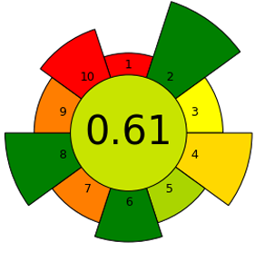 | Acetonitrile : 4  Ammonium hydrogen  Phosphate : 3  Amount : 1  Hazard : 2  Energy : 1  Occupational Hazard : 0  Waste : 6  Total penalty points : 17  Analytical eco-scale : 83 | 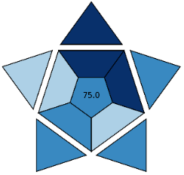 | (28)
8 | 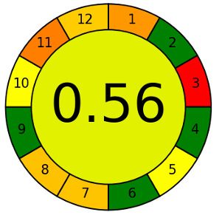 | 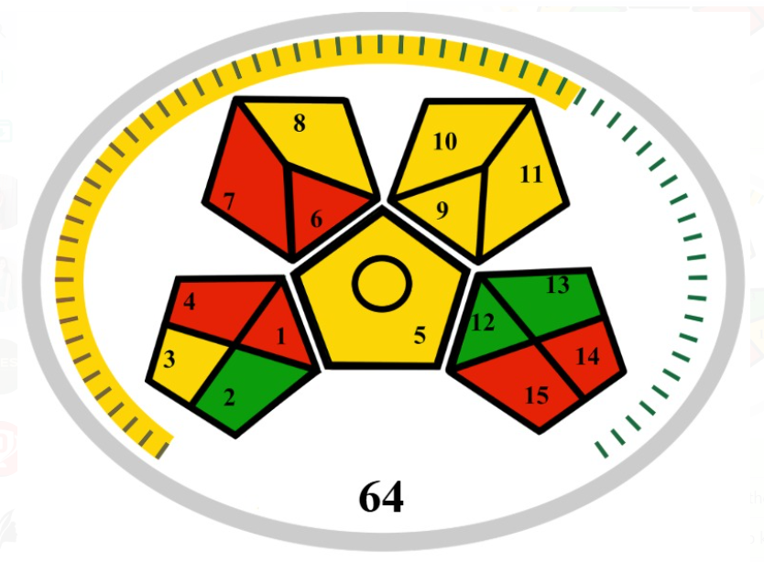 | 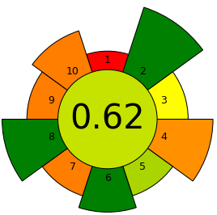 | Acetonitrile : 4  Amount : 2  Hazard : 2  Energy : 1  Occupational Hazard : 0  Waste : 8  Total 9penalty points : 17  Analytical eco-scale : 83 | 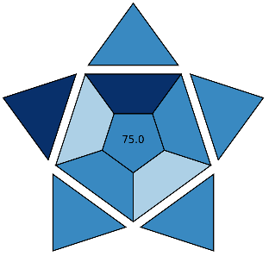 | (29)
9 | 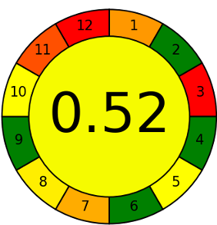 | 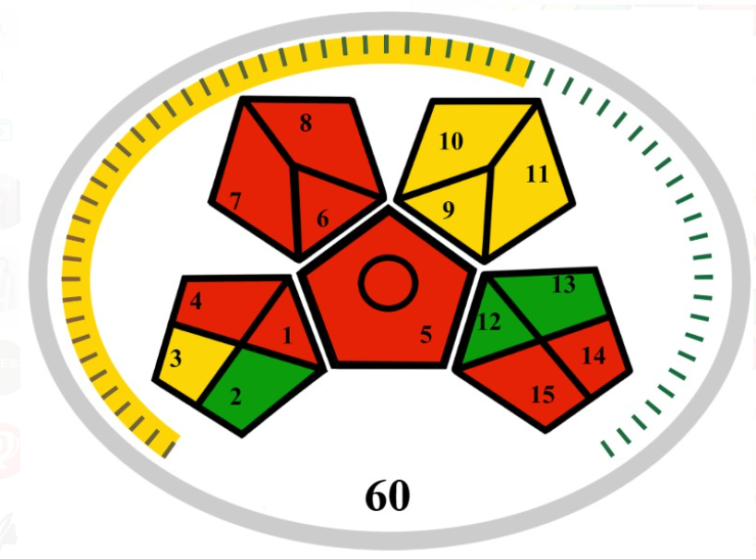 | 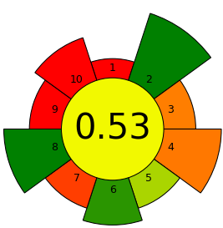 | Orthophosphoric Acid : 2  Tetrahydrofuran : 4  Methanol : 8  Amount : 2  Hazard : 2  Energy : 1  Occupational Hazard : 0  Waste : 8  Total penalty points : 27  Analytical eco-scale : 83 | 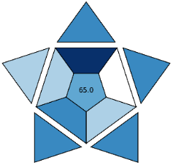 | (30)
10 | 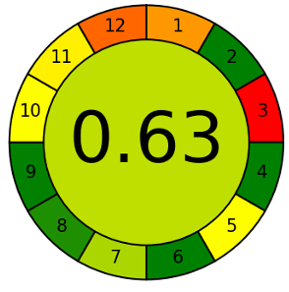 | 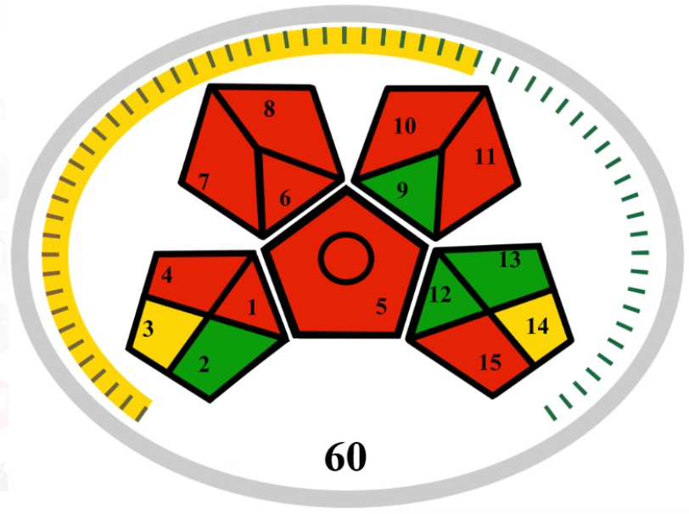 | 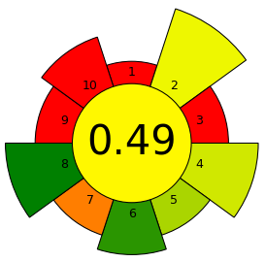 | Acetonitrile : 4  Methanol : 8  Amount : 2  Hazard : 2  Energy : 0  Occupational Hazard : 0  Waste : 8  Total penalty points : 24  Analytical eco-scale : 76 | 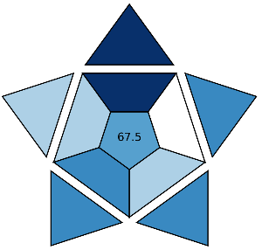 | (31)
11 | 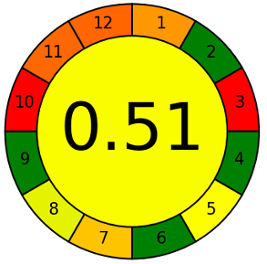 | 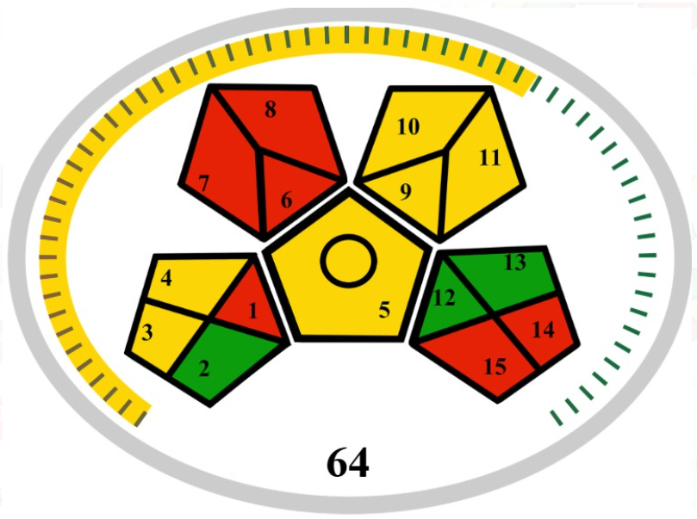 | 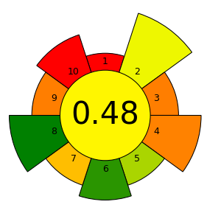 | Acetonitrile : 4  Octane Sulfuric Acid : 1  Amount : 2  Hazard : 2  Energy : 0  Occupational Hazard : 0  Waste : 8  Total penalty points : 17  Analytical eco-scale : 83 | 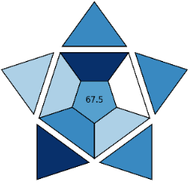 | (32)
12 | 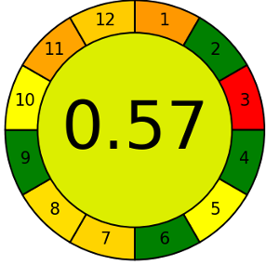 | 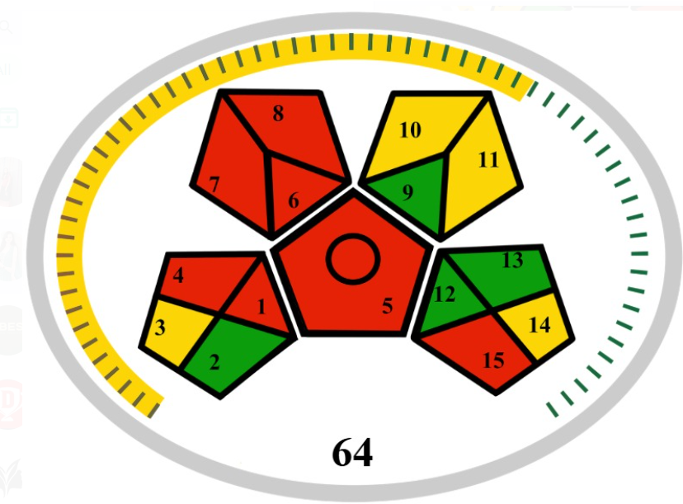 | 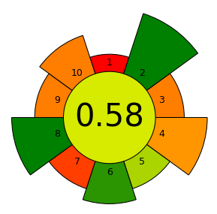 | Acetonitrile : 4  Water : 0  Amount : 2  Hazard : 2  Energy : 0  Occupational Hazard : 0  Waste : 8  Total penalty points : 16  Analytical eco-scale : 84 | 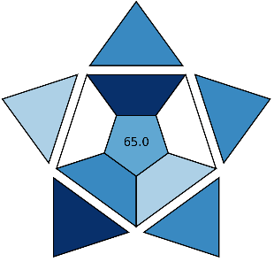 | (33)
13 | 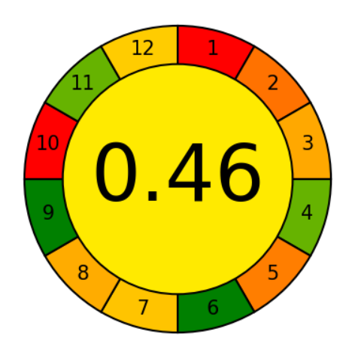 | 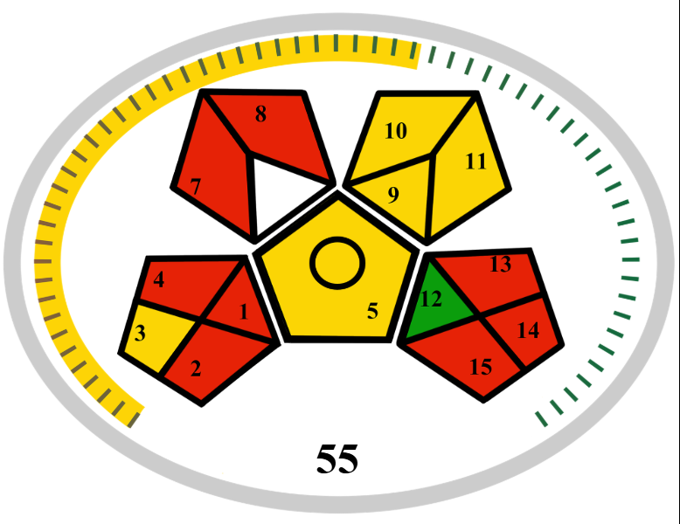 | 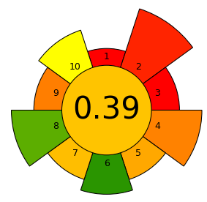 | Acetonitrile : 4  Methanol : 8  o-phosphoric acid : 3  Amount : 2  Hazard : 2  Energy : 0  Occupational Hazard : 0  Waste : 7  Total penalty points : 26  Analytical eco-scale : 74 | 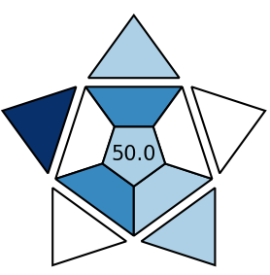 | (34)
14 | 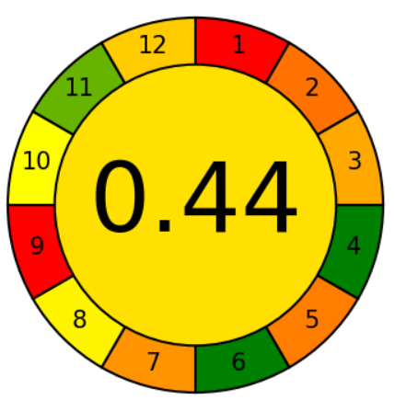 | 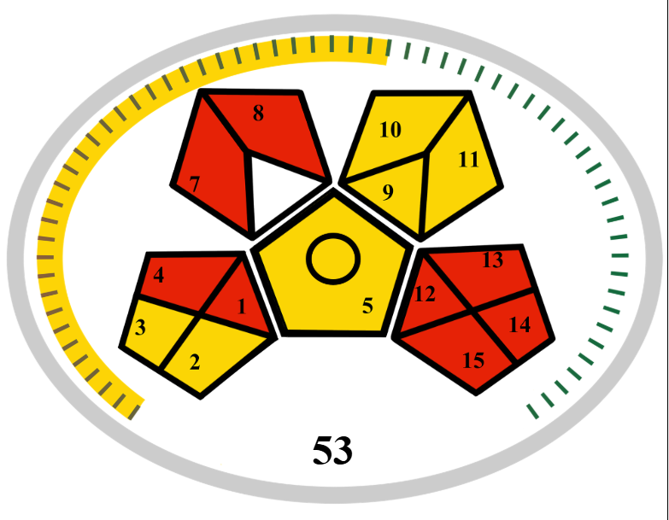 | 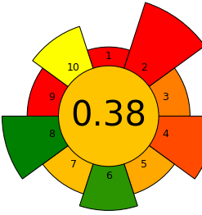 | Acetonitrile : 4  Formic acid : 5  Amount : 1  Hazard : 2  Energy : 1  Occupational Hazard : 0  Waste : 8  Total penalty points : 21  Analytical eco-scale : 79 | 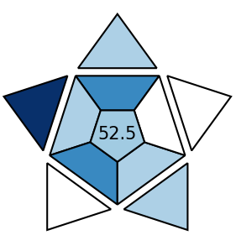 | (35)
15 | 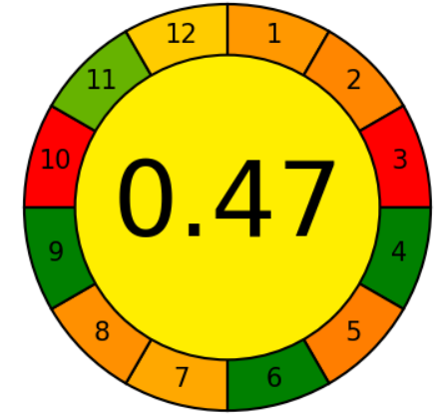 | 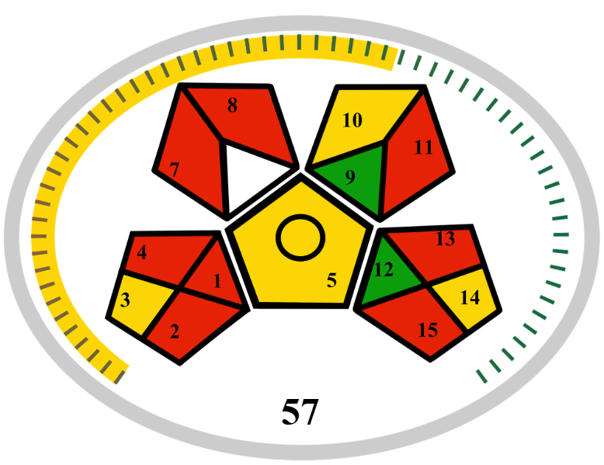 | 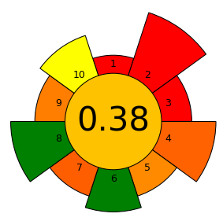 | Acetonitrile : 4  sodium hydroxide : 3  Amount : 2  Hazard : 2  Energy : 1  Occupational Hazard : 0  Waste : 9  Total penalty points : 21  Analytical eco-scale : 79 | 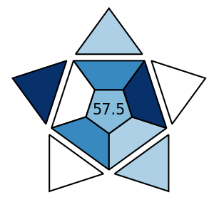 | (36)
16 | 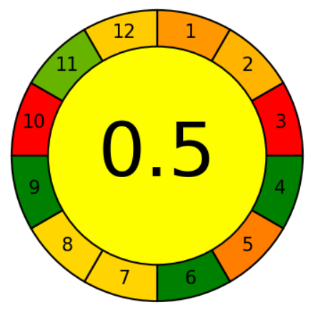 | 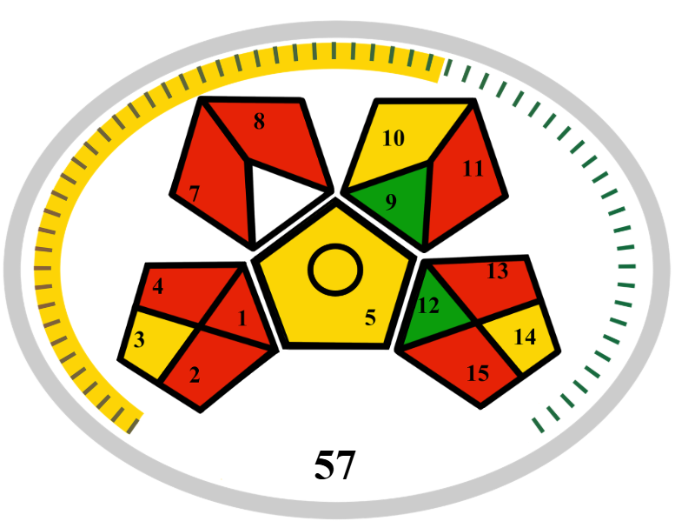 | 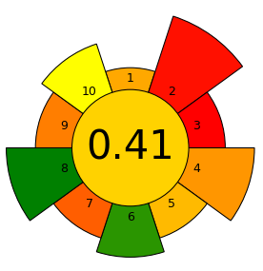 | Acetonitrile : 4  Methanol : 8  Amount : 3  Hazard : 2  Energy : 0  Occupational Hazard : 0  Waste : 7  Total penalty points : 24  Analytical eco-scale : 76 | 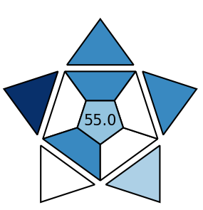 | (37)

Table 4: Agree, GAPI, AGREE prep, ESA and BAGI for assessment of greenness values of several previously published analytical procedures for Anticancer drugs. (LC-MS)
S NO | Agree Tool | MOGAPI Tool | AGREEPREP Tool | AES Tool | BAGI Tool | Ref
1 |  | 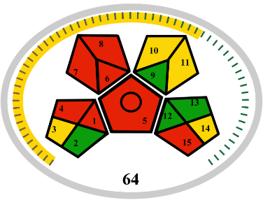 | 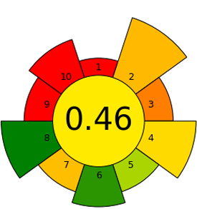 | Acetonitrile : 4  Ammonium Acetate : 1  Amount : 1  Hazard : 2  Energy : 1  Occupational Hazard : 0  Waste : 6  Total penalty points : 15  Analytical eco-scale : 85 | 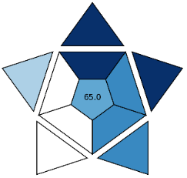 | (38)
2 | 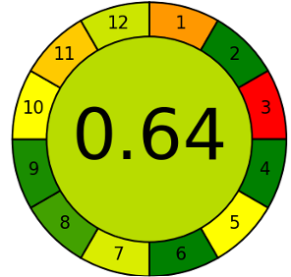 | 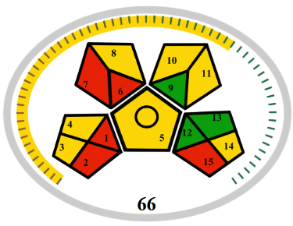 | 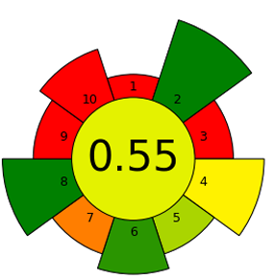 | Acetonitrile : 4  Formic Acid : 5  Amount : 1  Hazard : 2  Energy : 1  Occupational Hazard : 0  Waste : 6  Total penalty points : 19  Analytical eco-scale : 81 | 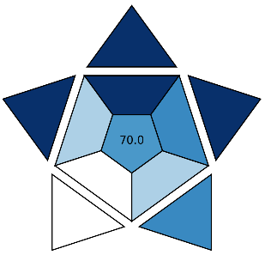 | (39)
3 | 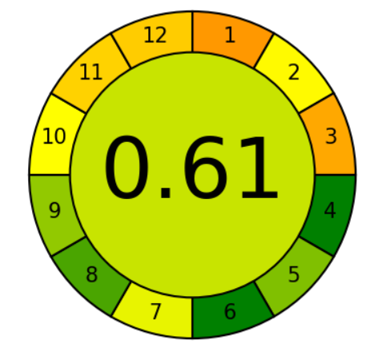 | 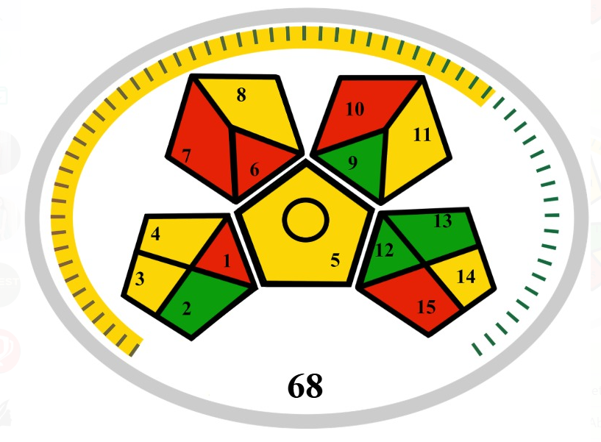 | 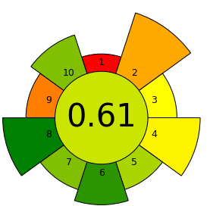 | Ammonium Hydroxide: 6  Methanol : 8  Amount : 1  Hazard : 2  Energy : 1  Occupational Hazard : 0  Waste : 6  Total penalty points : 24  Analytical eco-scale : 76 | 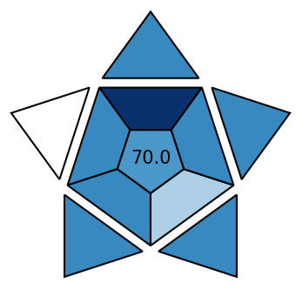 | (40)
4 | 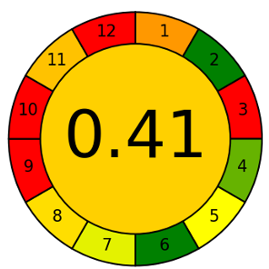 | 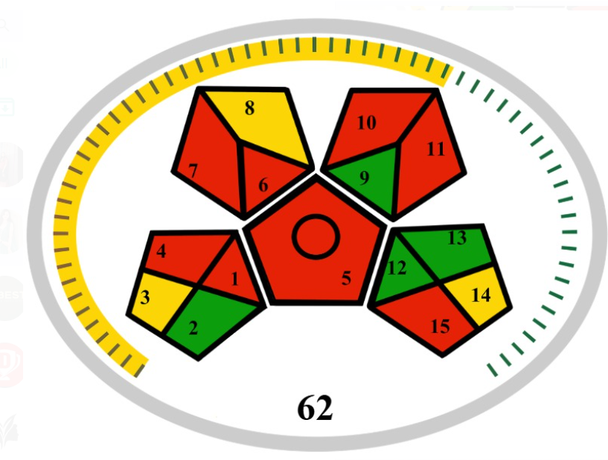 | 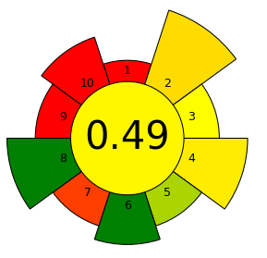 | Acetonitrile : 4  Formic acid : 5  Ammonium Formate : 3  Amount : 1  Hazard : 2  Energy : 1  Occupational Hazard : 0  Waste : 6  Total penalty points : 22  Analytical eco-scale : 78 | 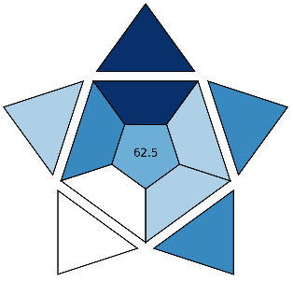 | (41)

