How distinct are sleep sites from active sites across habitat types in lizards?

Nitya Prakash Mohanty^{1,2,*}, Anbazhagan Abinesh¹, Saumitra Dhere¹, Maria Thaker¹

¹Centre for Ecological Sciences, Indian Institute of Science, Bengaluru, India
²Département Adaptations du Vivant, UMR 7179, Mécanismes adaptatifs et Évolution (MECADEV) CNRS/Muséum national d'Histoire naturelle, Paris, France
*Corresponding author e-mail id: nitya.mohanty@gmail.com

Online Resource 1

Table 1 Sampling locations and effort (sample size, n), and mean body size (snout-vent length) for eight Agamid lizard species in peninsular India. The individuals sampled for each phase are unique.

Species | n (active) | n (sleep) | SVL (SD)  active | SVL (SD)  sleep | Type | Site | Habitat description
Salea anamallayana | 24 | 26 | 8.59  (0.76) | 9.21  (0.84) | Arboreal | Kodaikanal | Plantations of Eucalyptus grandis and/or Acasia mearnsii adjoining Southern tropical montane wet evergreen forest (Shola), with invasive plants (Eupatorium glandulosus, Parthenium hysterophorus, and Lantana camara)
Salea horsfieldii | 27 | 42 | 7.2  (0.92) | 6.82  (1.18) | Arboreal | Ooty | Plantations of Eucalyptus grandis adjoining Southern tropical montane wet evergreen forest (Shola), with Shola trees and invasive plants (Cestrum aruntiacum and Eupatorium gladulosum)
Calotes versicolor | 30 | 25 | 11.9  (1.41) | 9.11  (1.61) | Semi-arboreal | Madurai | Scrub jungle and rocky landscape, adjoining inhabited areas
Monilesaurus rouxii | 21 | 27 | 6.9  (0.56) | 6.08  (0.84) | Semi-arboreal | Kudremukh | Tropical semi- evergreen forests
Psammophilus dorsalis | 16 | 21 | 8.98  (2.71) | 10.82  (2) | Rupicolous | Coonoor | Rocky landscape adjoining semi- evergreen vegetation and tea plantation
Sarada superba | 28 | 11 | 6.59  (0.52) | 6.29  (0.35) | Ground-dwelling | Chalkewadi | Grasslands interspersed with rocks
Sitana marudhamneydhal | 30 | 30 | 4.41  (0.7) | 4.8  (0.64) | Ground-dwelling | Tirunelveli | Grasslands, thorny shrubs, rocks
Sitana visiri | 34 | 30 | 4.5  (0.34) | 4.5  (0.33) | Ground-dwelling | Madurai | Shrub jungle, thorny shrubs, rocks

Table 2 Principal Component Analysis (PCA) loadings of variables sorted in descending order of absolute value by PC1.

Salea anamallayana | PC1 | PC2 | PC3
Girth | 0.68 | 0.19 | -0.14
Perch diameter | 0.67 | 0.22 | 0.2
Perch height | -0.2 | 0.69 | 0.58
Distance to main trunk | -0.2 | 0.66 | -0.61
Perch orientation - Horizontal | -0.07 | -0.02 | 0.21
Perch orientation - Vertical | 0.06 | -0.05 | -0.12
Head direction - Inward | -0.05 | 0 | 0.31
Head direction - Perpendicular | 0.03 | -0.02 | -0.04
Head direction - Outward | 0.02 | 0.01 | -0.26
Perch orientation - Angular | 0.01 | 0.08 | -0.09
Substrate - Shrub | 0 | 0 | 0
Substrate - Tree | 0 | 0 | 0
Substrate - Ground | 0 | 0 | 0
Substrate - Rock | 0 | 0 | 0
Substrate - Ground-Under Shrub | 0 | 0 | 0

Salea horsfieldii | PC1 | PC2 | PC3
Girth | 0.7 | 0.03 | 0.17
Perch diameter | 0.69 | -0.15 | 0
Distance to main trunk | 0.14 | 0.64 | -0.71
Perch orientation - Angular | 0.08 | 0.1 | 0.12
Perch orientation - Vertical | -0.08 | -0.17 | -0.04
Perch height | -0.05 | 0.69 | 0.66
Head direction - Outward | -0.01 | -0.17 | 0.06
Head direction - Inward | 0.01 | 0.13 | -0.06
Perch orientation - Horizontal | 0 | 0.07 | -0.08
Head direction - Perpendicular | 0 | 0.04 | 0
Substrate - Shrub | 0 | 0 | 0
Substrate - Ground | 0 | 0 | 0
Substrate - Tree | 0 | 0 | 0
Substrate - Rock | 0 | 0 | 0
Substrate - Ground-Under Shrub | 0 | 0 | 0

Monilesaurus rouxii | PC1 | PC2 | PC3
Perch diameter | 0.5 | 0.4 | 0.2
Distance to main trunk | -0.43 | 0.55 | 0.38
Girth | 0.42 | 0.48 | 0.1
Perch height | -0.41 | 0.39 | -0.67
Perch orientation - Vertical | 0.24 | -0.05 | -0.17
Head direction - Outward | 0.23 | -0.14 | -0.23
Head direction - Inward | -0.21 | 0.12 | 0.25
Substrate - Shrub | -0.15 | -0.24 | 0.31
Substrate - Tree | 0.15 | 0.24 | -0.31
Perch orientation - Horizontal | -0.13 | 0.01 | 0.14
Perch orientation - Angular | -0.11 | 0.05 | 0.02
Head direction - Perpendicular | -0.01 | 0.02 | -0.02
Substrate - Ground | 0 | 0 | 0
Substrate - Rock | 0 | 0 | 0
Substrate - Ground-Under Shrub | 0 | 0 | 0

Calotes versicolor | PC1 | PC2 | PC3
Girth | 0.55 | -0.36 | -0.13
Perch diameter | 0.48 | -0.51 | 0.29
Perch height | 0.47 | 0.48 | -0.49
Distance to main trunk | 0.4 | 0.57 | 0.62
Substrate - Shrub | -0.2 | 0 | 0.17
Substrate - Tree | 0.2 | 0 | -0.17
Head direction - Inward | -0.07 | 0.05 | 0.18
Head direction - Outward | 0.05 | -0.1 | -0.24
Perch orientation - Vertical | -0.02 | -0.14 | 0
Head direction - Perpendicular | 0.02 | 0.05 | 0.06
Perch orientation - Angular | 0.02 | -0.02 | 0.25
Perch orientation - Horizontal | 0.01 | 0.16 | -0.25
Substrate - Ground | 0 | 0 | 0
Substrate - Rock | 0 | 0 | 0
Substrate - Ground-Under Shrub | 0 | 0 | 0

Psammophilus dorsalis | PC1 | PC2 | PC3
Perch Height | 0.98 | -0.1 | -0.14
Perch Orientation - Horizontal | -0.09 | -0.25 | -0.45
Perch orientation - Vertical | 0.09 | 0.25 | 0.45
Substrate - Rock | 0.06 | 0.25 | 0.35
Head direction - Upward | 0.06 | 0.81 | -0.23
Head direction - Angular | 0.06 | -0.32 | 0.54
Substrate - Ground | -0.05 | -0.15 | -0.31
Head direction - Downward | -0.02 | -0.06 | 0.12
Substrate - Shrub | -0.01 | -0.1 | -0.04
Head direction - Perpendicular | 0.01 | -0.08 | 0.06
Substrate - Tree | 0 | 0 | 0
Substrate – Ground-Under Shrub | 0 | 0 | 0
Perch orientation - Angular | 0 | 0 | 0
Head direction - Outward | 0 | 0 | 0
Head direction - Inward | 0 | 0 | 0

Sarada superba | PC1 | PC2 | PC3
Perch Height | 0.96 | 0.29 | 0
Substrate - Ground | -0.21 | 0.68 | 0
Substrate - Rock | 0.21 | -0.68 | 0
Substrate - Shrub | 0 | 0 | 0
Substrate - Tree | 0 | 0 | 0
Substrate - Ground-Under Shrub | 0 | 0 | 0
Perch orientation- Angular | 0 | 0 | 0
Perch orientation - Horizontal | 0 | 0 | 0
Perch orientation - Vertical | 0 | 0 | 0
Head direction - Upward | 0 | 0 | 0

Sitana visiri | PC1 | PC2 | PC3
Perch height | 0.81 | 0.03 | -0.24
Substrate - Shrub | 0.32 | 0.01 | 0.35
Head direction - Outward | 0.32 | 0.01 | 0.35
Perch orientation - Vertical | 0.29 | 0.01 | -0.36
Substrate - Ground-Under Shrub | -0.18 | 0.7 | -0.17
Substrate - Ground | -0.14 | -0.71 | -0.18
Perch orientation - Angular | 0.03 | 0 | 0.71
Substrate - Tree | 0 | 0 | 0
Substrate - Rock | 0 | 0 | 0
Perch orientation - Horizontal | 0 | 0 | 0
Head direction - Inward | 0 | 0 | 0
Head direction –Perpendicular | 0 | 0 | 0

Table 3 Chi-square test of proportions for changes in head direction between diel phases. For semi-arboreal and arboreal lizards on plants head direction was categorized as ‘inwards’, ‘outwards’, ‘perpendicular’, whereas for Psammophilus dorsalis on rocks, it was ‘upward’, ‘angular-upward’, ‘perpendicular’, and ‘downward’. Statistically significant tests (α = 0.05) in bold.

Species | χ² | df | p-value
S. anamallayana | 5.29 | 2 | 0.07
S. horsfieldii | 4.88 | 2 | 0.09
C. versicolor | 13.3 | 2 | <0.001
M. rouxii | 30.57 | 2 | <0.001
P. dorsalis | 4.95 | 3 | 0.174

Fig. 1 Use of substrate types and perch types by arboreal (Salea anamallayana, Salea horsfieldii) and semi-arboreal (Calotes versicolor, Monilesaurus rouxii) Agamid lizards during active (plots on left) and sleep phases (plots on right). Substrate types within each phase sum to 100% and perch types within each substrate type sum to 100%.

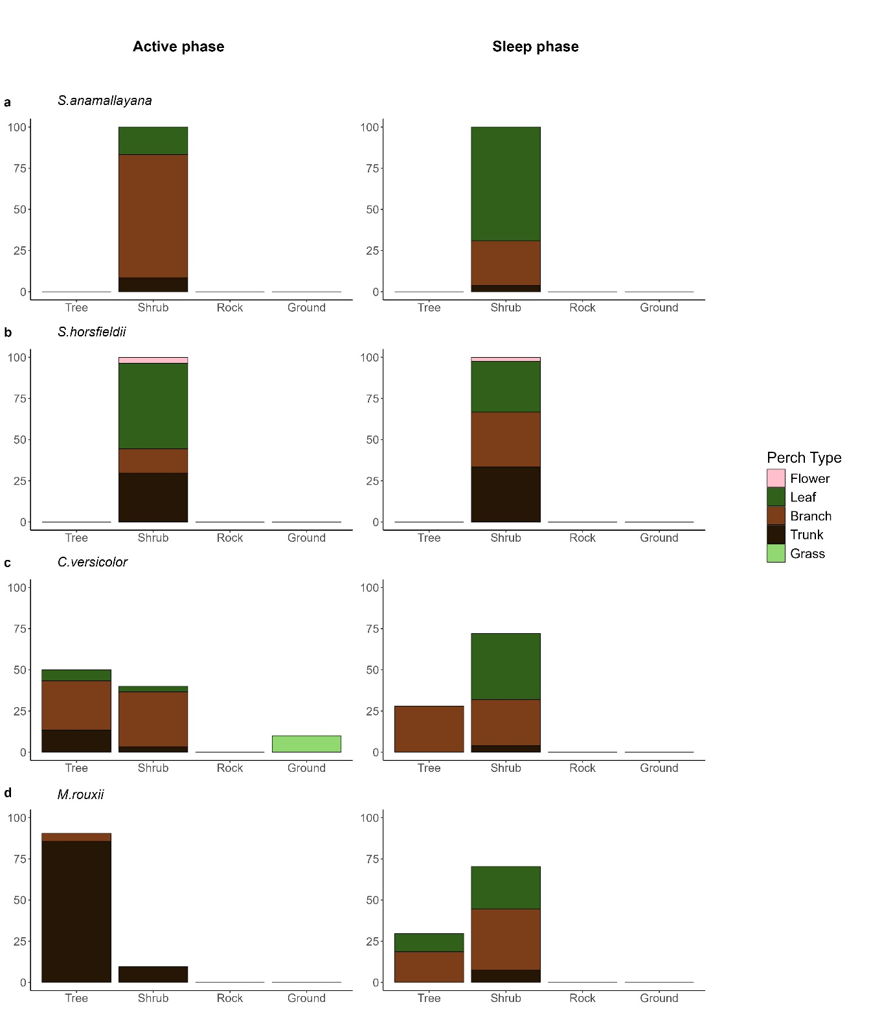

Fig. 2 Use of substrate types and perch types by rupiculous (Psammophilus dorsalis) and ground-dwelling (Sarada superba, Sitana marudhamneydhal, Sitana visiri) Agamid lizards during active (plots on left) and sleep phases (plots on right). Substrate types within each phase sum to 100% and perch types within each substrate type sum to 100%.

