Appendix A: Cross-plots of Archie-based Models
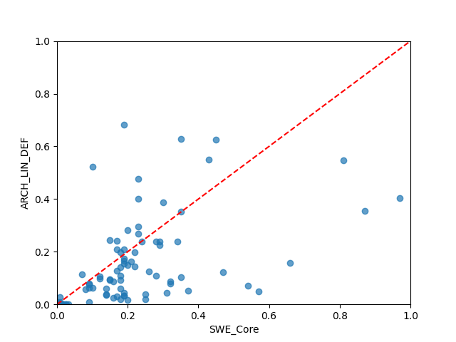  cross plot of SWE_Core versus ARCH_LIN_DEF (MSE=0.0227, CCC=0.6017, R²=0.2960, R=0.6325, Basic_Rank=31, Boot_Rank=30) | 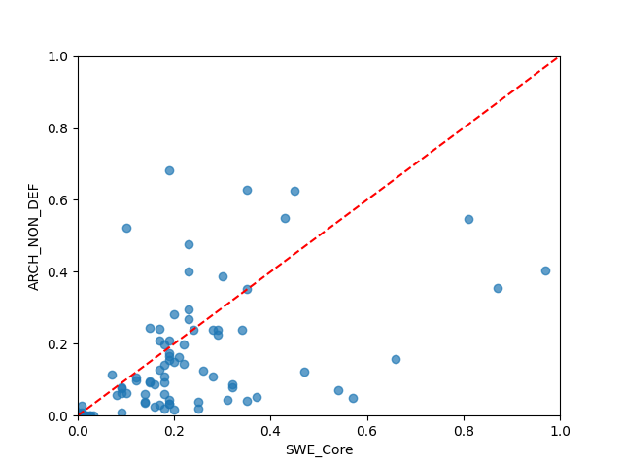  cross plot of SWE_Core versus ARCH_NON_DEF (MSE=0.0229, CCC=0.5975, R²=0.2878, R=0.6286, Basic_Rank=32, Boot_Rank=32)
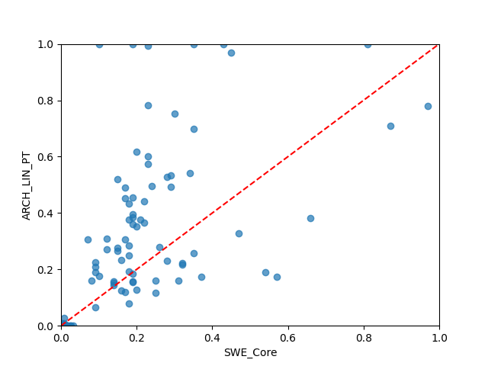  cross plot of SWE_Core versus ARCH_LIN_PT (MSE=0.0456, CCC=0.6005, R²=-0.4170, R=0.6904, Basic_Rank=52, Boot_Rank=52) | 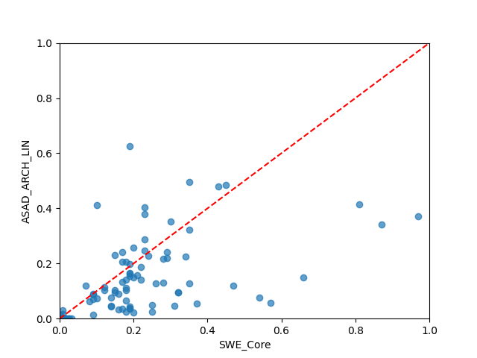  cross plot of SWE_Core versus ASAD_ARCH_LIN (MSE=0.0211, CCC=0.5919, R²=0.3438, R=0.6530, Basic_Rank=19, Boot_Rank=17)
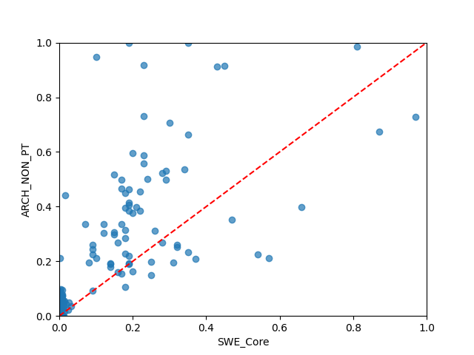  cross plot of SWE_Core versus ARCH_NON_PT (MSE=0.0454, CCC=0.5737, R²=-0.4108, R=0.6762, Basic_Rank=53, Boot_Rank=53) | 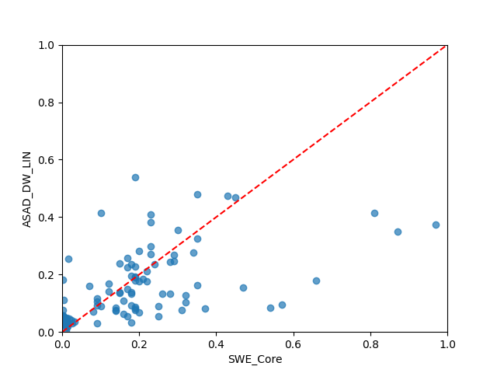  cross plot of SWE_Core versus ASAD_DW_LIN (MSE=0.0196, CCC=0.5794, R²=0.3923, R=0.6349, Basic_Rank=3, Boot_Rank=2)
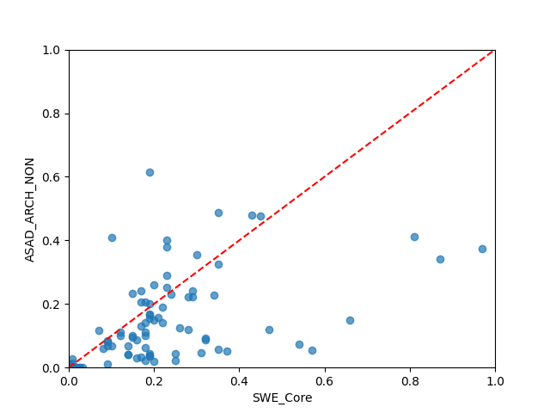  cross plot of SWE_Core versus ASAD_ARCH_NON (MSE=0.0215, CCC=0.5852, R²=0.3318, R=0.6477, Basic_Rank=25, Boot_Rank=25) | 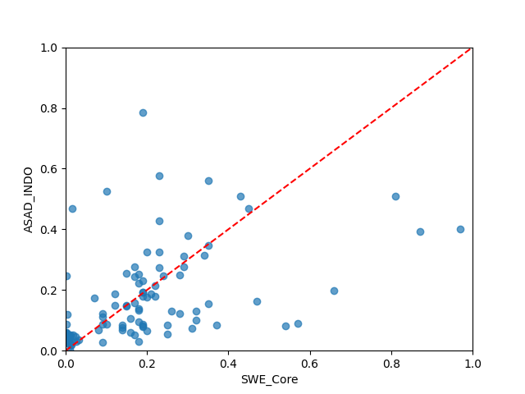  cross plot of SWE_Core versus ASAD_INDO (MSE=0.0235, CCC=0.5555, R²=0.2698, R=0.5696, Basic_Rank=40, Boot_Rank=40)
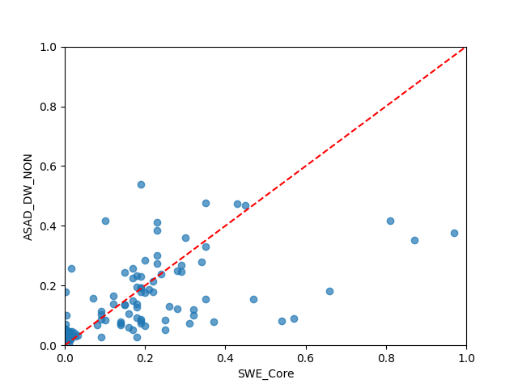  cross plot of SWE_Core versus ASAD_DW_NON (MSE=0.0197, CCC=0.5807, R²=0.3891, R=0.6340, Basic_Rank=6, Boot_Rank=3) | 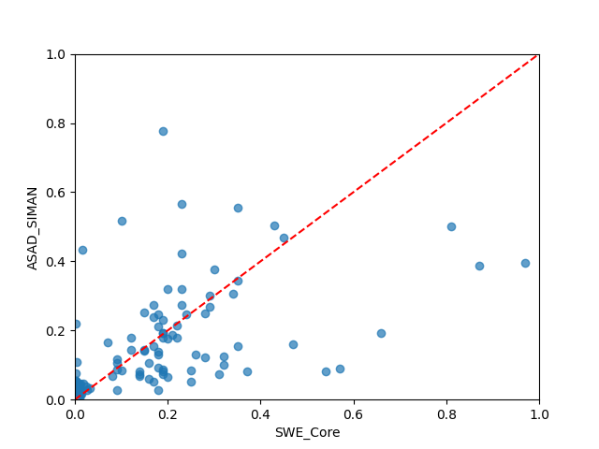  cross plot of SWE_Core versus ASAD_SIMAN (MSE=0.0230, CCC=0.5634, R²=0.2864, R=0.5794, Basic_Rank=35, Boot_Rank=35)
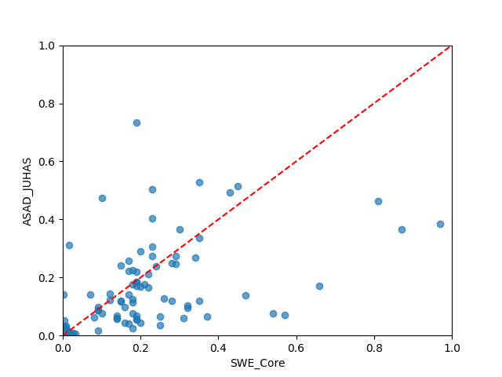  cross plot of SWE_Core versus ASAD_JUHAS (MSE=0.0221, CCC=0.5845, R²=0.3133, R=0.6121, Basic_Rank=29, Boot_Rank=29) | 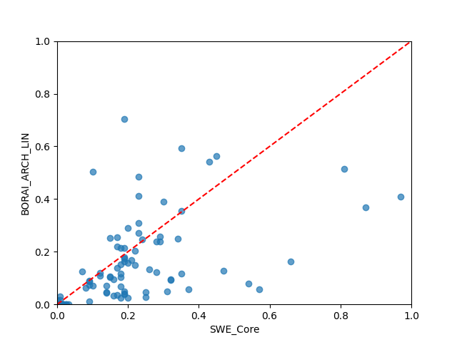  cross plot of SWE_Core versus BORAI_ARCH_LIN (MSE=0.0218, CCC=0.6111, R²=0.3228, R=0.6407, Basic_Rank=24, Boot_Rank=24)
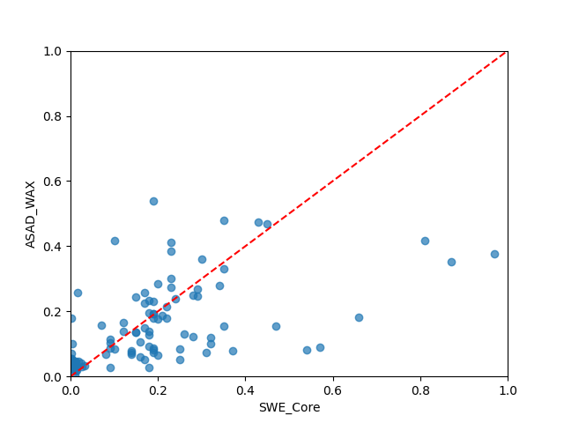  cross plot of SWE_Core versus ASAD_WAX (MSE=0.0197, CCC=0.5807, R²=0.3891, R=0.6340, Basic_Rank=7, Boot_Rank=4) | 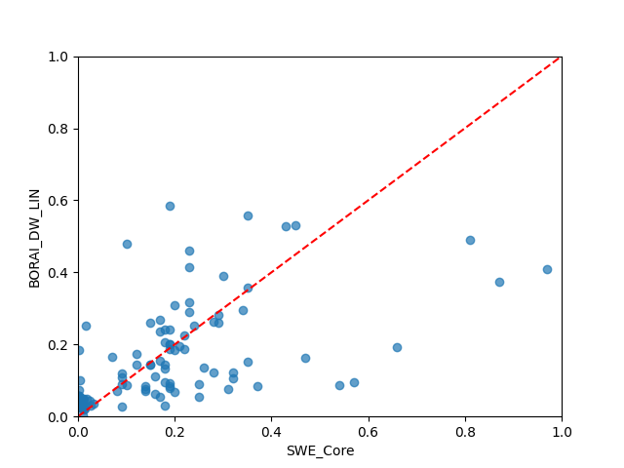  cross plot of SWE_Core versus BORAI_DW_LIN (MSE=0.0198, CCC=0.6011, R²=0.3833, R=0.6308, Basic_Rank=1, Boot_Rank=1)
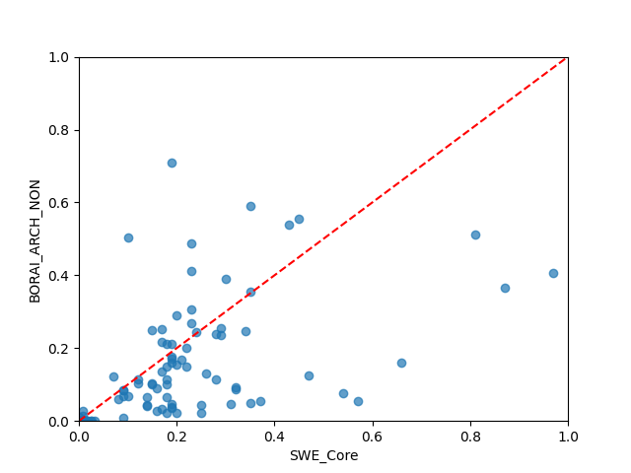  cross plot of SWE_Core versus BORAI_ARCH_NON (MSE=0.0224, CCC=0.6016, R²=0.3049, R=0.6329, Basic_Rank=28, Boot_Rank=28) | 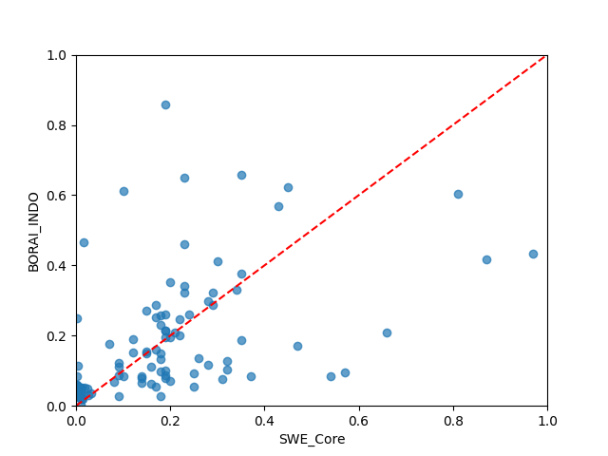  cross plot of SWE_Core versus BORAI_INDO (MSE=0.0252, CCC=0.5700, R²=0.2165, R=0.5730, Basic_Rank=42, Boot_Rank=42)
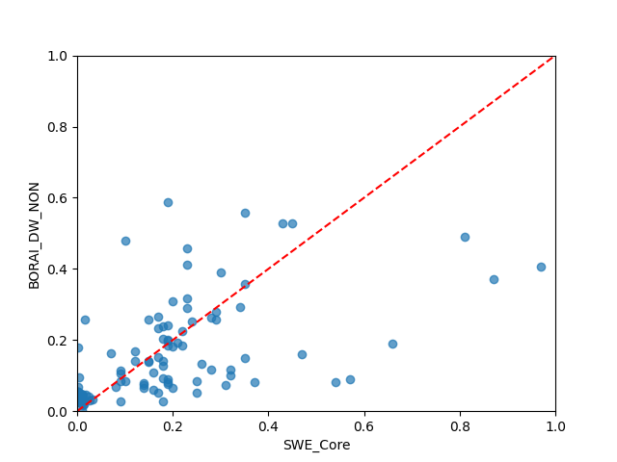  cross plot of SWE_Core versus BORAI_DW_NON (MSE=0.0200, CCC=0.5996, R²=0.3787, R=0.6293, Basic_Rank=5, Boot_Rank=7) | 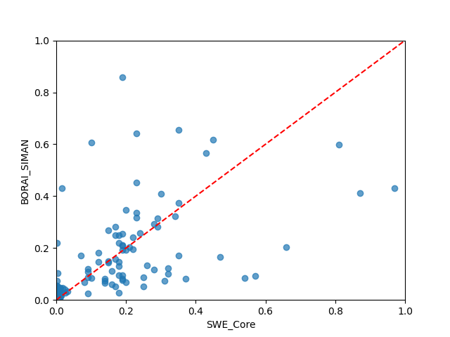  cross plot of SWE_Core versus BORAI_SIMAN (MSE=0.0248, CCC=0.5749, R²=0.2296, R=0.5780, Basic_Rank=41, Boot_Rank=41)
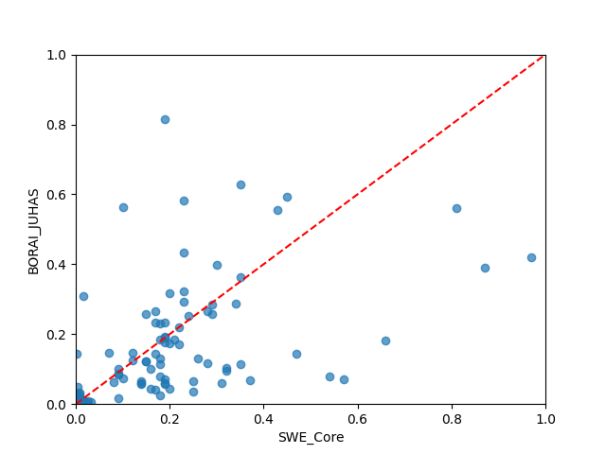  cross plot of SWE_Core versus BORAI_JUHAS (MSE=0.0235, CCC=0.5942, R²=0.2696, R=0.6042, Basic_Rank=33, Boot_Rank=34) | 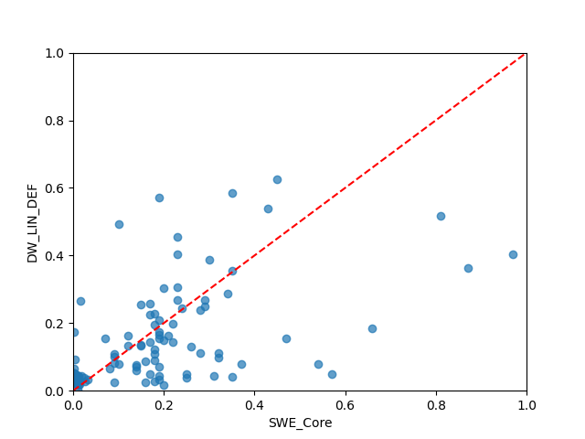  cross plot of SWE_Core versus DW_LIN_DEF (MSE=0.0218, CCC=0.5736, R²=0.3226, R=0.6003, Basic_Rank=30, Boot_Rank=31)
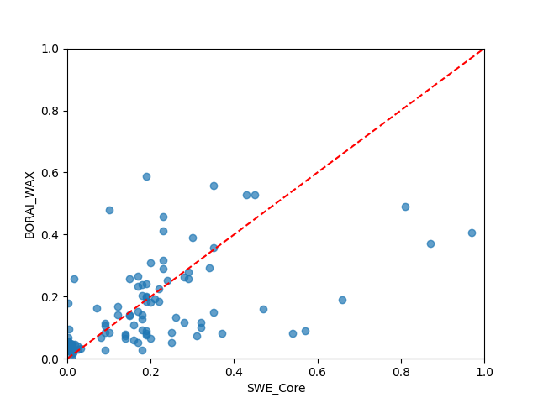  cross plot of SWE_Core versus BORAI_WAX (MSE=0.0200, CCC=0.5996, R²=0.3787, R=0.6293, Basic_Rank=4, Boot_Rank=6) | 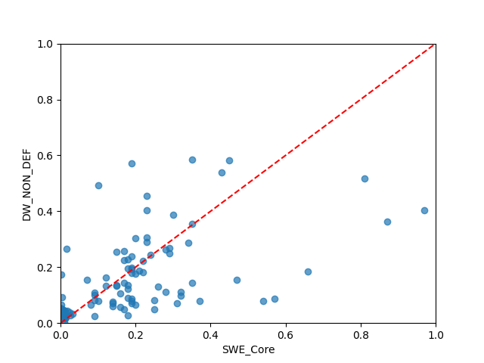  cross plot of SWE_Core versus DW_NON_DEF (MSE=0.0203, CCC=0.5982, R²=0.3688, R=0.6258, Basic_Rank=11, Boot_Rank=15)
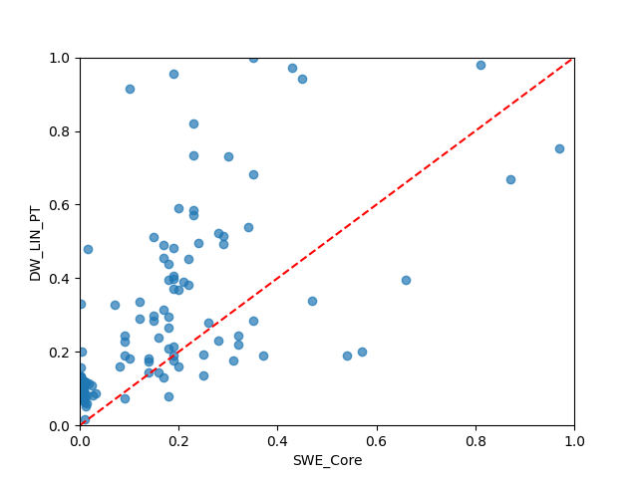  cross plot of SWE_Core versus DW_LIN_PT (MSE=0.0478, CCC=0.5311, R²=-0.4864, R=0.6461, Basic_Rank=54, Boot_Rank=54) | 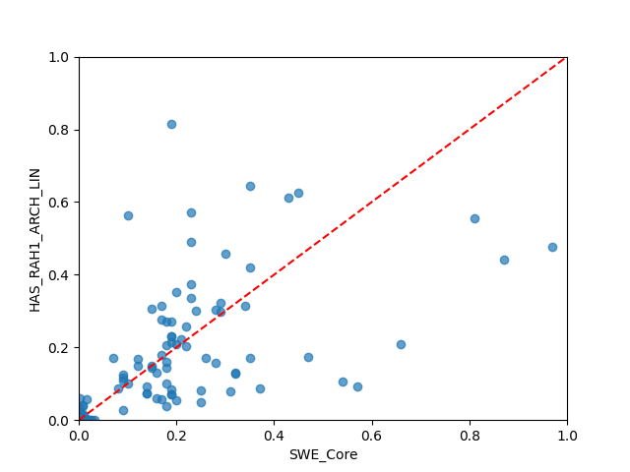  cross plot of SWE_Core versus HAS_RAH1_ARCH_LIN (MSE=0.0213, CCC=0.6536, R²=0.3378, R=0.6561, Basic_Rank=2, Boot_Rank=5)
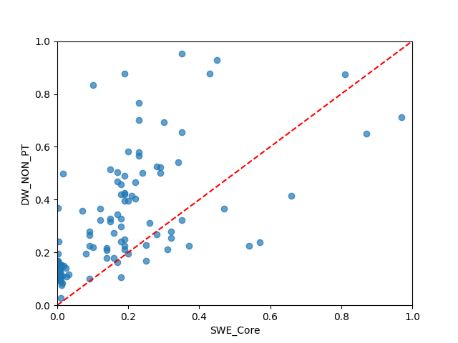  cross plot of SWE_Core versus DW_NON_PT (MSE=0.0481, CCC=0.5065, R²=-0.4937, R=0.6522, Basic_Rank=55, Boot_Rank=55) | 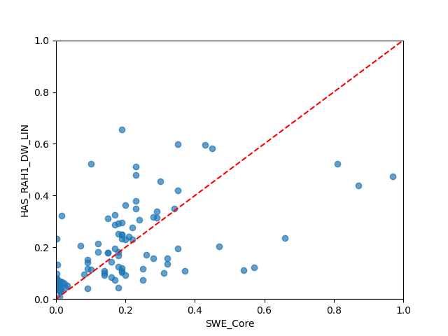  cross plot of SWE_Core versus HAS_RAH1_DW_LIN (MSE=0.0206, CCC=0.6195, R²=0.3603, R=0.6365, Basic_Rank=8, Boot_Rank=8)
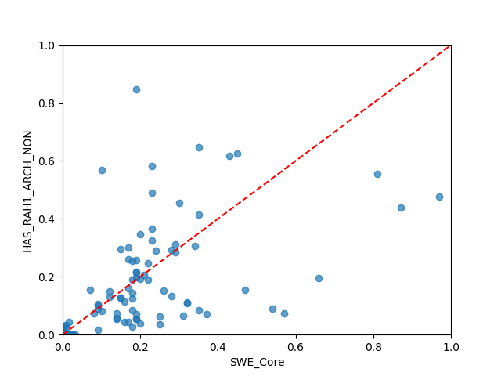  cross plot of SWE_Core versus HAS_RAH1_ARCH_NON (MSE=0.0229, CCC=0.6316, R²=0.2872, R=0.6370, Basic_Rank=27, Boot_Rank=27) | 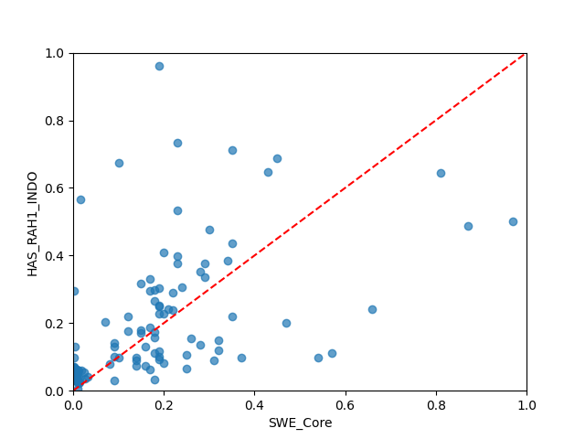  cross plot of SWE_Core versus HAS_RAH1_INDO (MSE=0.0288, CCC=0.5680, R²=0.1065, R=0.5746, Basic_Rank=49, Boot_Rank=49)
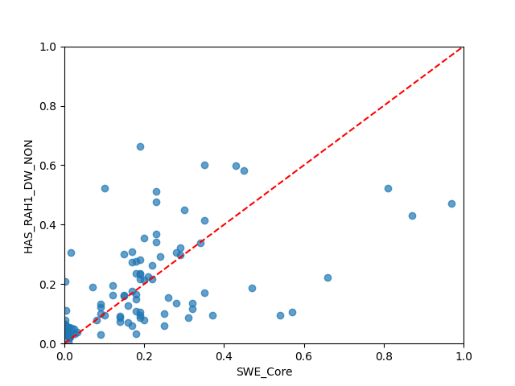  cross plot of SWE_Core versus HAS_RAH1_DW_NON (MSE=0.0207, CCC=0.6210, R²=0.3579, R=0.6320, Basic_Rank=10, Boot_Rank=10) | 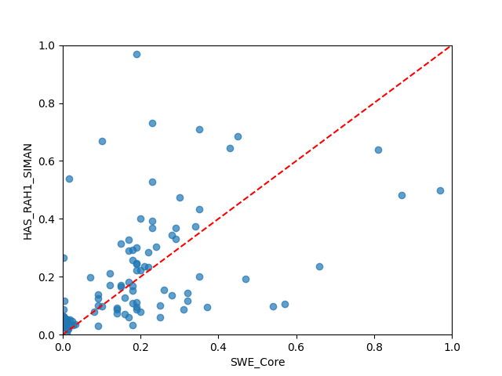  cross plot of SWE_Core versus HAS_RAH1_SIMAN (MSE=0.0283, CCC=0.5735, R²=0.1216, R=0.5779, Basic_Rank=48, Boot_Rank=47)
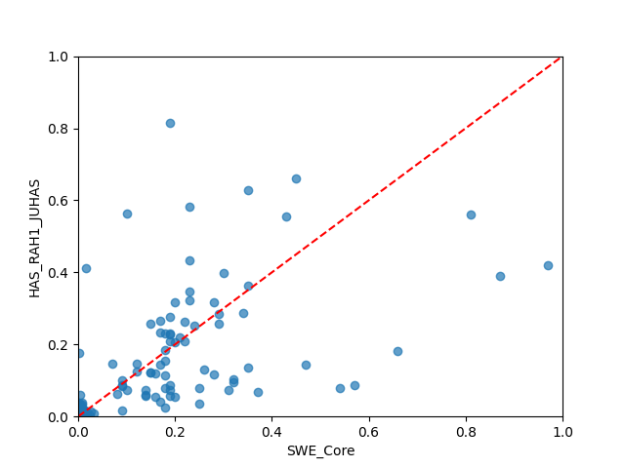  cross plot of SWE_Core versus HAS_RAH1_JUHAS (MSE=0.0241, CCC=0.5911, R²=0.2524, R=0.5965, Basic_Rank=38, Boot_Rank=38) | 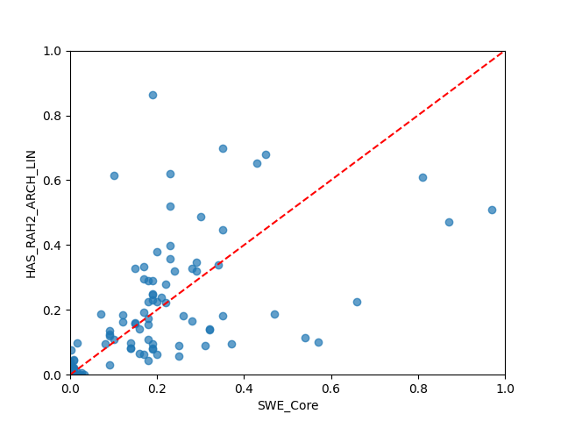  cross plot of SWE_Core versus HAS_RAH2_ARCH_LIN (MSE=0.0226, CCC=0.6552, R²=0.2982, R=0.6554, Basic_Rank=22, Boot_Rank=18)
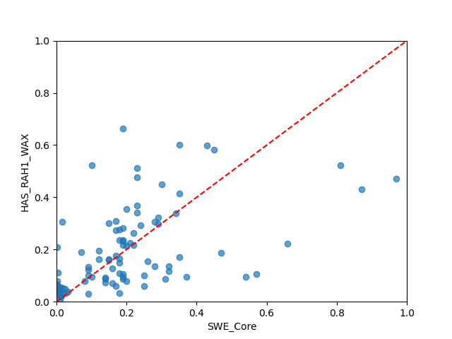  cross plot of SWE_Core versus HAS_RAH1_WAX (MSE=0.0207, CCC=0.6210, R²=0.3580, R=0.6321, Basic_Rank=9, Boot_Rank=9) | 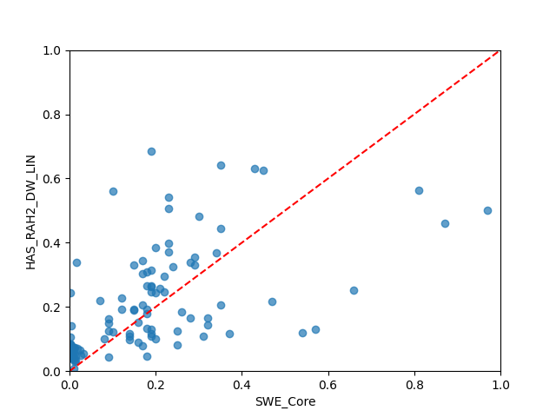  cross plot of SWE_Core versus HAS_RAH2_DW_LIN (MSE=0.0217, CCC=0.6213, R²=0.3260, R=0.6377, Basic_Rank=20, Boot_Rank=23)
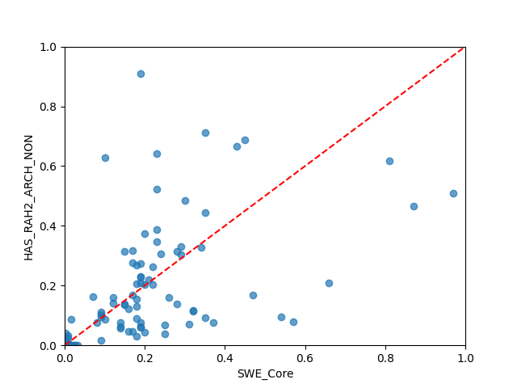  cross plot of SWE_Core versus HAS_RAH2_ARCH_NON (MSE=0.0246, CCC=0.6322, R²=0.2355, R=0.6340, Basic_Rank=34, Boot_Rank=33) | 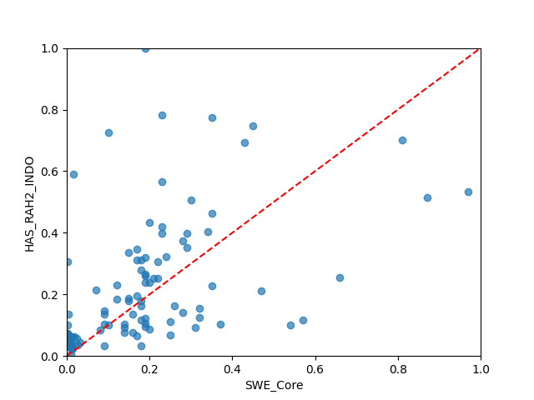  cross plot of SWE_Core versus HAS_RAH2_INDO (MSE=0.0313, CCC=0.5637, R²=0.0275, R=0.5765, Basic_Rank=51, Boot_Rank=51)
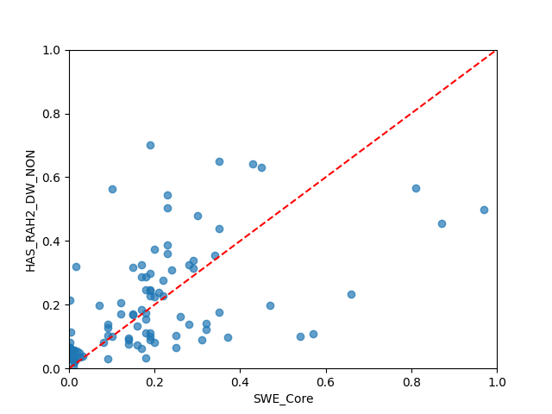  cross plot of SWE_Core versus HAS_RAH2_DW_NON (MSE=0.0217, CCC=0.6250, R²=0.3264, R=0.6317, Basic_Rank=18, Boot_Rank=21) | 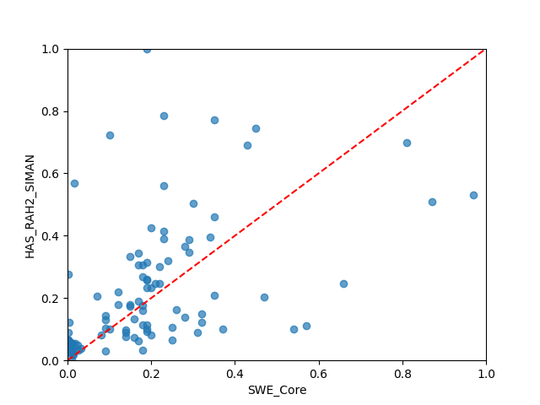  cross plot of SWE_Core versus HAS_RAH2_SIMAN (MSE=0.0307, CCC=0.5698, R²=0.0455, R=0.5798, Basic_Rank=50, Boot_Rank=50)
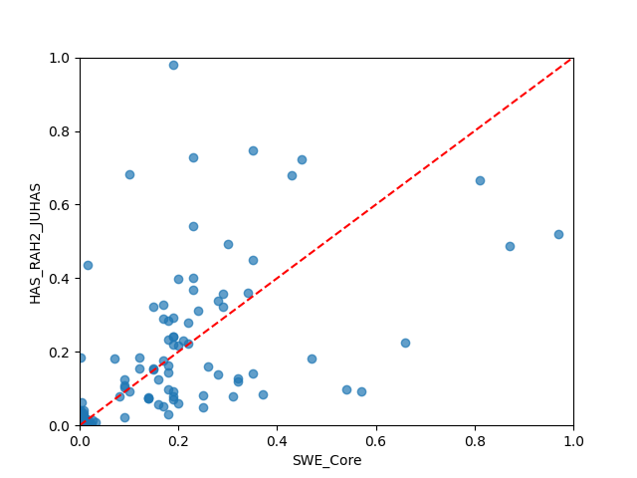  cross plot of SWE_Core versus HAS_RAH2_JUHAS (MSE=0.0279, CCC=0.6012, R²=0.1334, R=0.6035, Basic_Rank=45, Boot_Rank=45) | 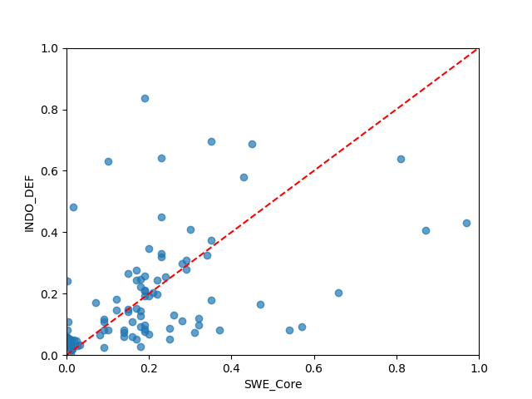  cross plot of SWE_Core versus INDO_DEF (MSE=0.0257, CCC=0.5687, R²=0.2030, R=0.5707, Basic_Rank=44, Boot_Rank=44)
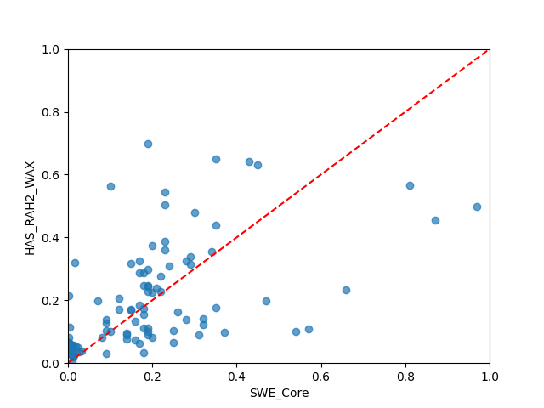  cross plot of SWE_Core versus HAS_RAH2_WAX (MSE=0.0217, CCC=0.6250, R²=0.3266, R=0.6318, Basic_Rank=17, Boot_Rank=20) | 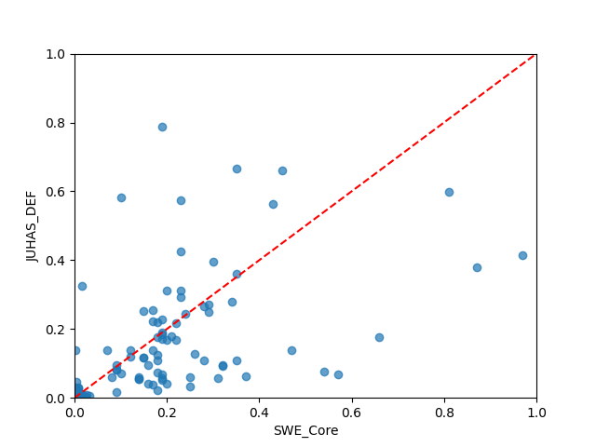  cross plot of SWE_Core versus JUHAS_DEF (MSE=0.0240, CCC=0.5913, R²=0.2538, R=0.6011, Basic_Rank=37, Boot_Rank=37)
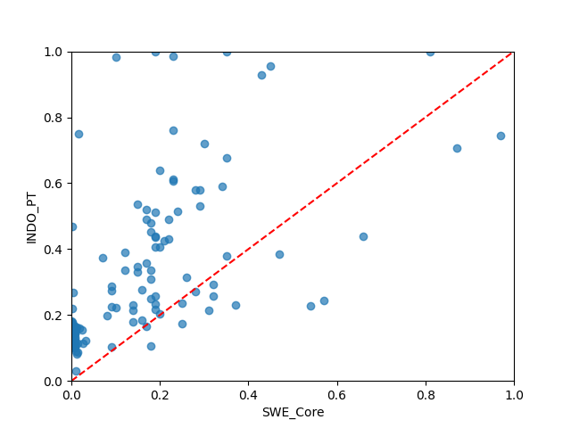  cross plot of SWE_Core versus INDO_PT (MSE=0.0619, CCC=0.4586, R²=-0.9233, R=0.6222, Basic_Rank=59, Boot_Rank=59) | 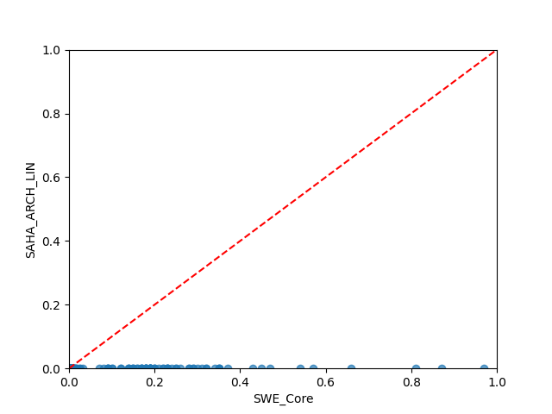  cross plot of SWE_Core versus SAHA_ARCH_LIN (MSE=0.0530, CCC=0.0000, R²=-0.6477, R=0.0912, Basic_Rank=68, Boot_Rank=68)
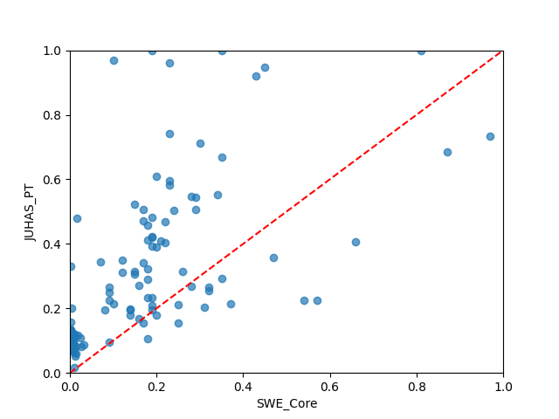  cross plot of SWE_Core versus JUHAS_PT (MSE=0.0515, CCC=0.5192, R²=-0.5999, R=0.6503, Basic_Rank=57, Boot_Rank=57) | 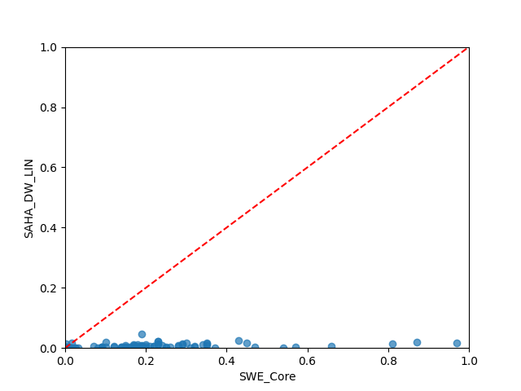  cross plot of SWE_Core versus SAHA_DW_LIN (MSE=0.0505, CCC=0.0236, R²=-0.5700, R=0.5029, Basic_Rank=65, Boot_Rank=65)
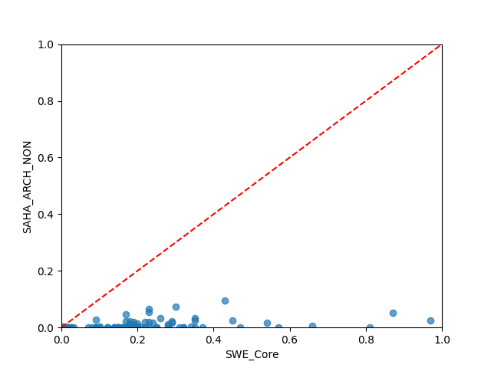  cross plot of SWE_Core versus SAHA_ARCH_NON (MSE=0.0490, CCC=0.0472, R²=-0.5238, R=0.4411, Basic_Rank=64, Boot_Rank=64) | 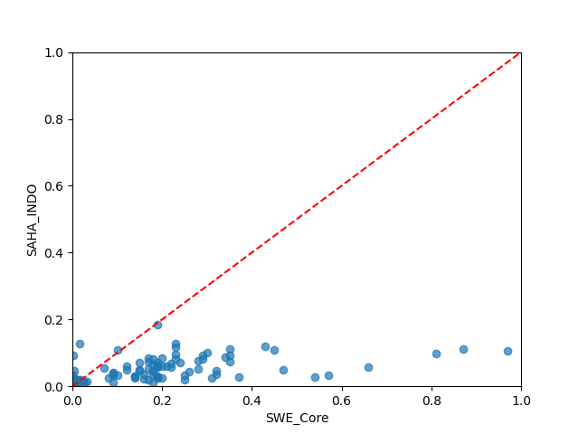  cross plot of SWE_Core versus SAHA_INDO (MSE=0.0367, CCC=0.1639, R²=-0.1414, R=0.5820, Basic_Rank=61, Boot_Rank=61)
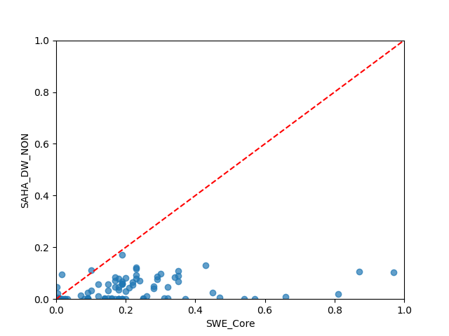  cross plot of SWE_Core versus SAHA_DW_NON (MSE=0.0416, CCC=0.1317, R²=-0.2918, R=0.4659, Basic_Rank=63, Boot_Rank=63) | 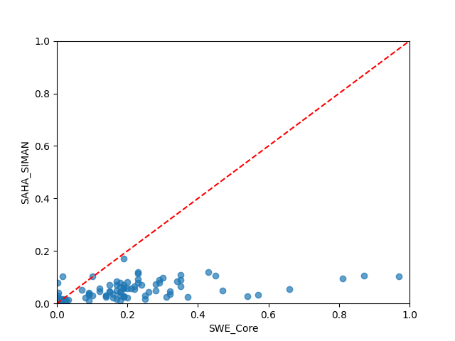  cross plot of SWE_Core versus SAHA_SIMAN (MSE=0.0371, CCC=0.1625, R²=-0.1512, R=0.6068, Basic_Rank=60, Boot_Rank=60)
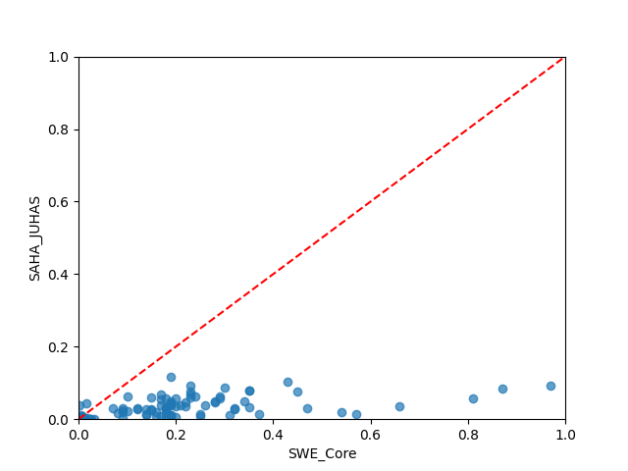  cross plot of SWE_Core versus SAHA_JUHAS (MSE=0.0411, CCC=0.1347, R²=-0.2771, R=0.6547, Basic_Rank=62, Boot_Rank=62) | 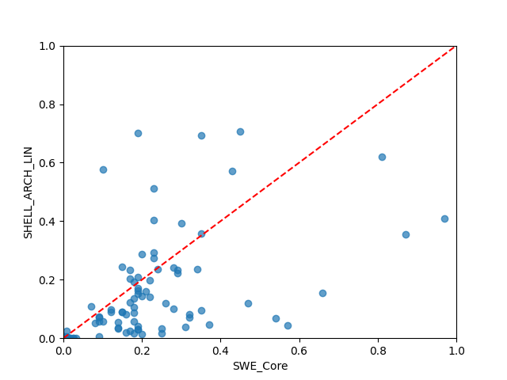  cross plot of SWE_Core versus SHELL_ARCH_LIN (MSE=0.0241, CCC=0.5958, R²=0.2511, R=0.6192, Basic_Rank=36, Boot_Rank=36)
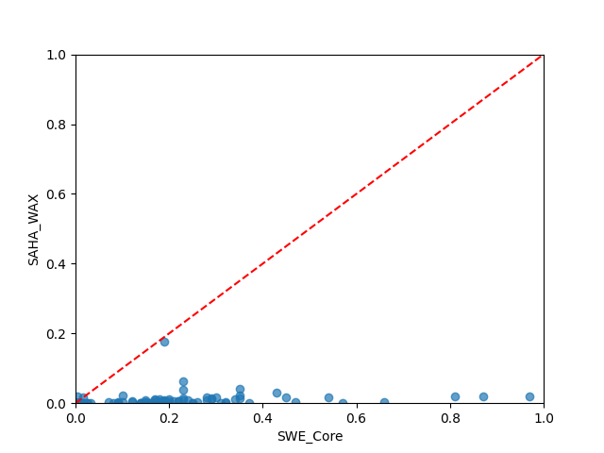  cross plot of SWE_Core versus SAHA_WAX (MSE=0.0499, CCC=0.0332, R²=-0.5499, R=0.2719, Basic_Rank=67, Boot_Rank=66) | 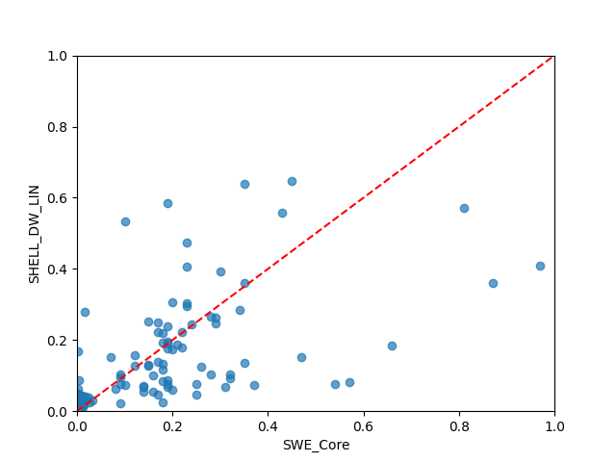  cross plot of SWE_Core versus SHELL_DW_LIN (MSE=0.0212, CCC=0.5983, R²=0.3428, R=0.6173, Basic_Rank=23, Boot_Rank=22)
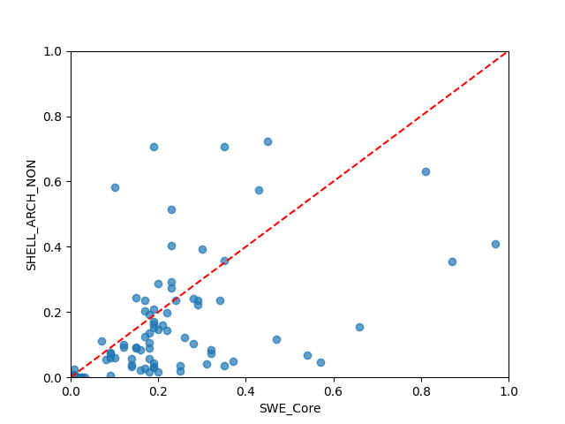  cross plot of SWE_Core versus SHELL_ARCH_NON (MSE=0.0244, CCC=0.5936, R²=0.2421, R=0.6156, Basic_Rank=39, Boot_Rank=39) | 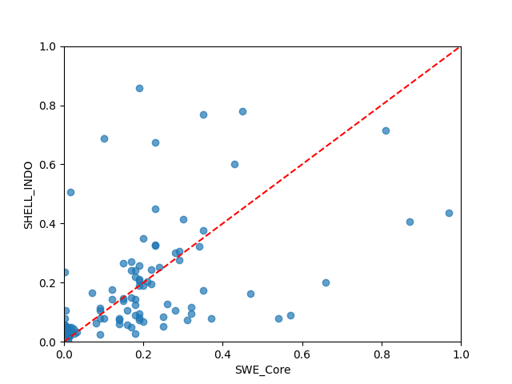  cross plot of SWE_Core versus SHELL_INDO (MSE=0.0275, CCC=0.5629, R²=0.1452, R=0.5632, Basic_Rank=47, Boot_Rank=48)
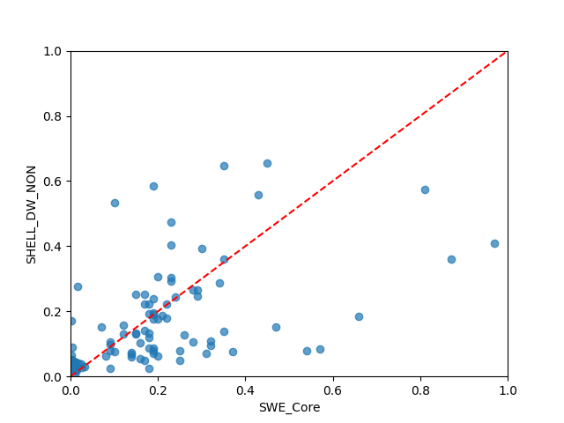  cross plot of SWE_Core versus SHELL_DW_NON (MSE=0.0211, CCC=0.5991, R²=0.3446, R=0.6177, Basic_Rank=21, Boot_Rank=19) | 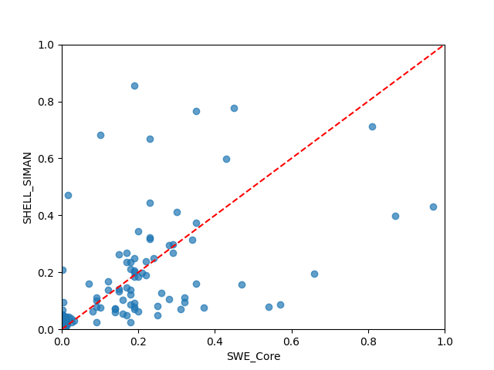  cross plot of SWE_Core versus SHELL_SIMAN (MSE=0.0272, CCC=0.5668, R²=0.1564, R=0.5670, Basic_Rank=46, Boot_Rank=46)
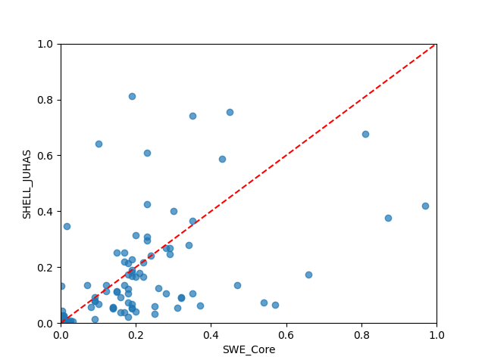  cross plot of SWE_Core versus SHELL_JUHAS (MSE=0.0258, CCC=0.5852, R²=0.1997, R=0.5908, Basic_Rank=43, Boot_Rank=43) | 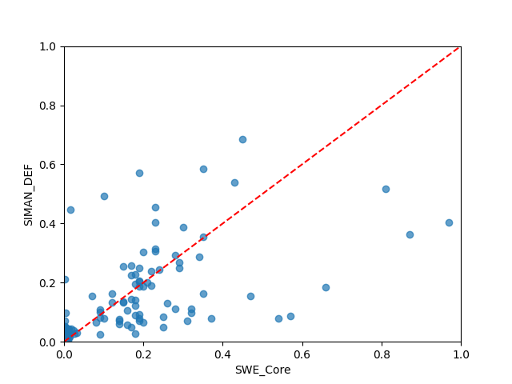  cross plot of SWE_Core versus SIMAN_DEF (MSE=0.0216, CCC=0.5866, R²=0.3291, R=0.6052, Basic_Rank=26, Boot_Rank=26)
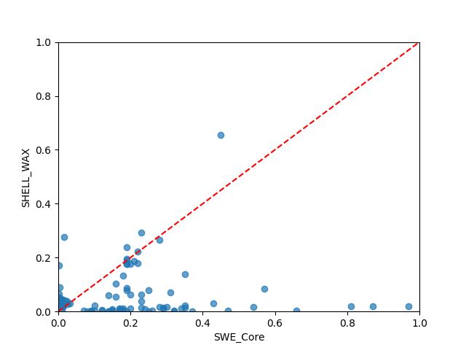  cross plot of SWE_Core versus SHELL_WAX (MSE=0.0440, CCC=0.0690, R²=-0.3657, R=0.1121, Basic_Rank=66, Boot_Rank=67) | 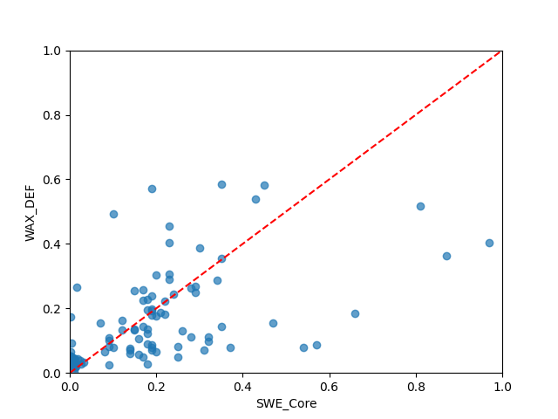  cross plot of SWE_Core versus WAX_DEF (MSE=0.0203, CCC=0.5982, R²=0.3688, R=0.6258, Basic_Rank=12, Boot_Rank=16)
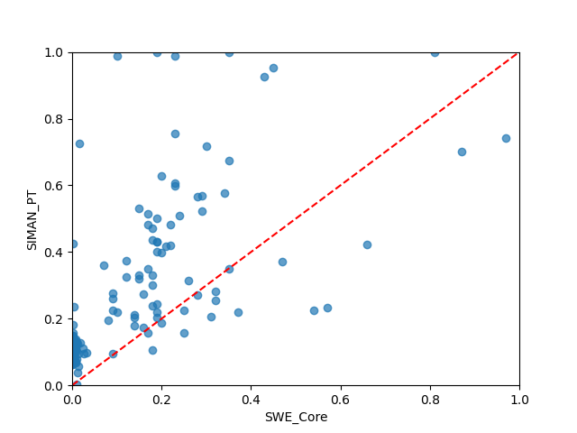
cross plot of SWE_Core versus SIMAN_PT (MSE=0.0575, CCC=0.4893, R²=-0.7865, R=0.6335, Basic_Rank=58, Boot_Rank=58)
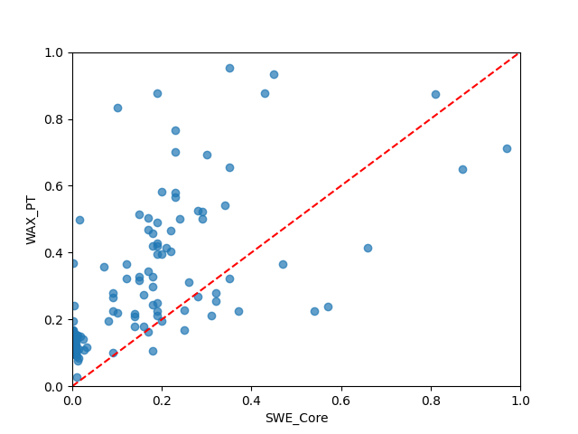  cross plot of SWE_Core versus WAX_PT (MSE=0.0481, CCC=0.5064, R²=-0.4951, R=0.6521, Basic_Rank=56, Boot_Rank=56) | 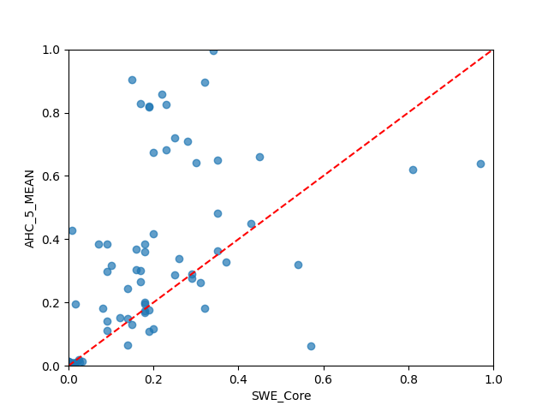  cross plot of SWE_Core versus AHC_5_MEAN (MSE=0.2991, CCC=0.2489, R²=-8.2940, R=0.5002, Basic_Rank=77, Boot_Rank=77)
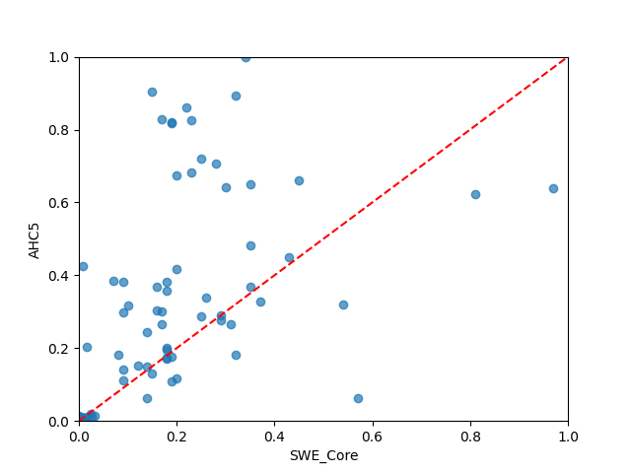  cross plot of SWE_Core versus AHC5 (MSE=0.2979, CCC=0.2496, R²=-8.2573, R=0.5008, Basic_Rank=73, Boot_Rank=73) | 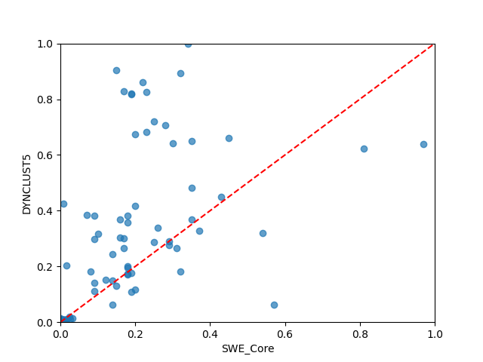  cross plot of SWE_Core versus DYNCLUST5 (MSE=0.2979, CCC=0.2496, R²=-8.2573, R=0.5008, Basic_Rank=74, Boot_Rank=74)
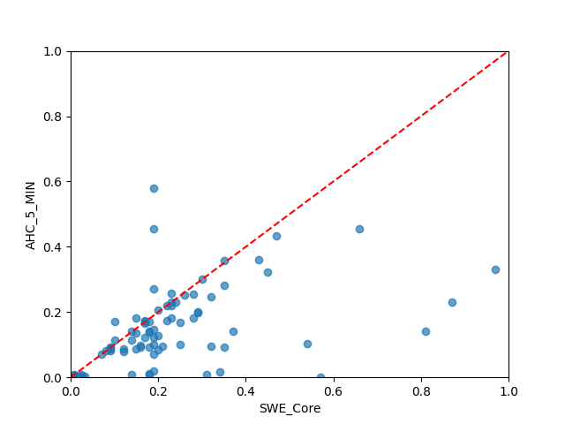  cross plot of SWE_Core versus AHC_5_MIN (MSE=0.0207, CCC=0.5747, R²=0.3560, R=0.6616, Basic_Rank=14, Boot_Rank=12) | 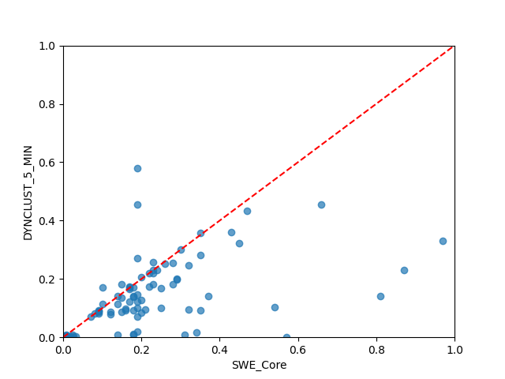  cross plot of SWE_Core versus DYNCLUST_5_MIN (MSE=0.0207, CCC=0.5747, R²=0.3560, R=0.6616, Basic_Rank=15, Boot_Rank=13)
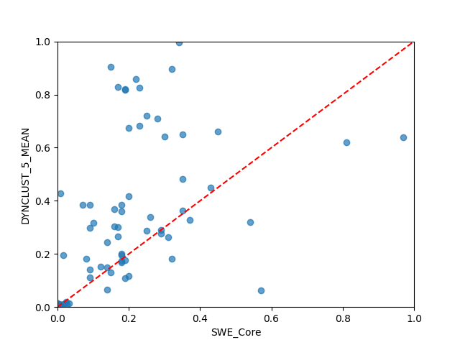  cross plot of SWE_Core versus DYNCLUST_5_MEAN (MSE=0.2991, CCC=0.2489, R²=-8.2940, R=0.5002, Basic_Rank=78, Boot_Rank=78) | 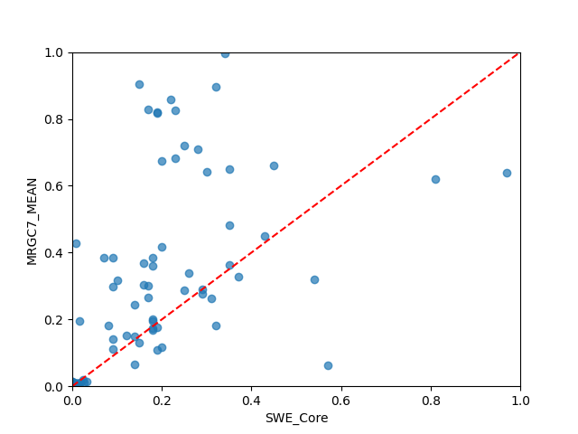  cross plot of SWE_Core versus MRGC7_MEAN (MSE=0.2991, CCC=0.2489, R²=-8.2940, R=0.5002, Basic_Rank=79, Boot_Rank=79)
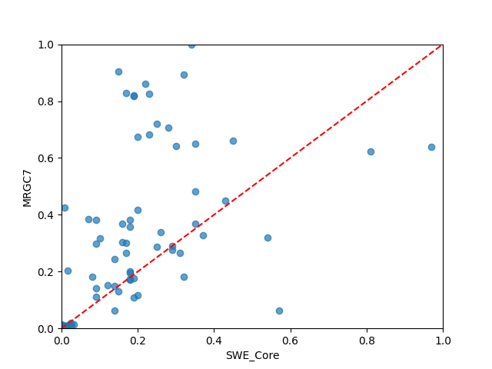  cross plot of SWE_Core versus MRGC7 (MSE=0.2979, CCC=0.2496, R²=-8.2573, R=0.5008, Basic_Rank=75, Boot_Rank=75) | 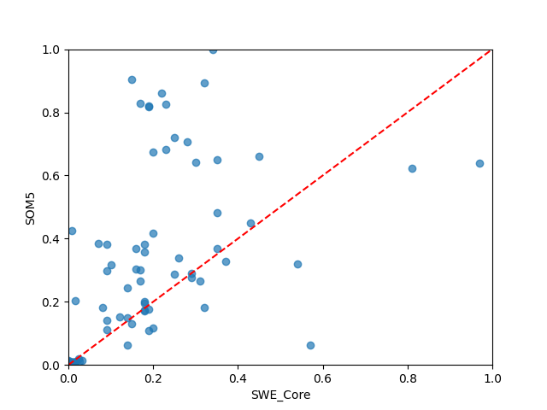  cross plot of SWE_Core versus SOM5 (MSE=0.2979, CCC=0.2496, R²=-8.2573, R=0.5008, Basic_Rank=76, Boot_Rank=76)
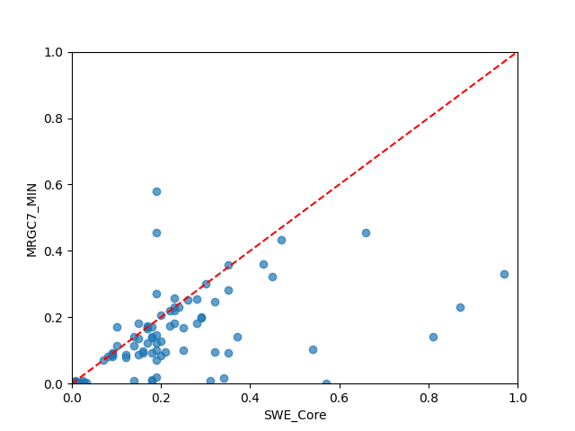  cross plot of SWE_Core versus MRGC7_MIN (MSE=0.0207, CCC=0.5747, R²=0.3560, R=0.6616, Basic_Rank=16, Boot_Rank=14) | 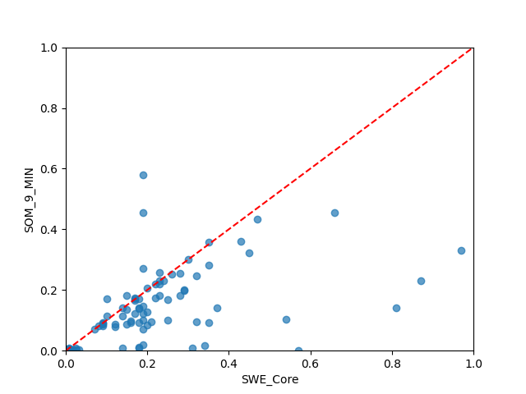  cross plot of SWE_Core versus SOM_9_MIN (MSE=0.0207, CCC=0.5747, R²=0.3560, R=0.6616, Basic_Rank=13, Boot_Rank=11)
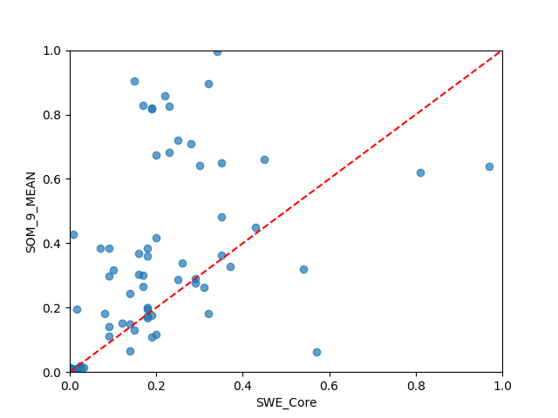  cross plot of SWE_Core versus SOM_9_MEAN (MSE=0.2991, CCC=0.2489, R²=-8.2940, R=0.5002, Basic_Rank=80, Boot_Rank=80) | 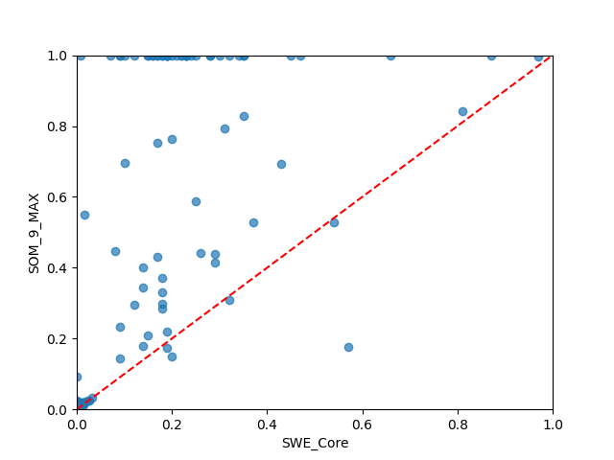  cross plot of SWE_Core versus SOM_9_MAX (MSE=0.2080, CCC=0.3196, R²=-5.4635, R=0.6239, Basic_Rank=69, Boot_Rank=69)
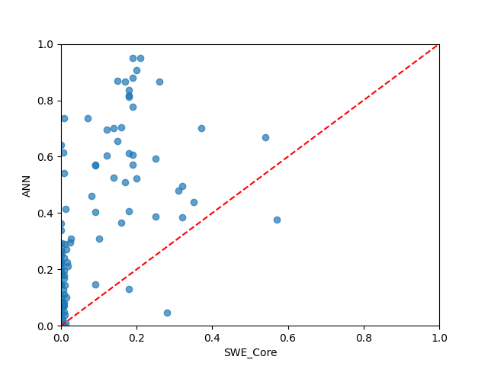  cross plot of SWE_Core versus ANN (MSE=0.5694, CCC=0.2238, R²=-16.6900, R=0.6748, Basic_Rank=81, Boot_Rank=81) | 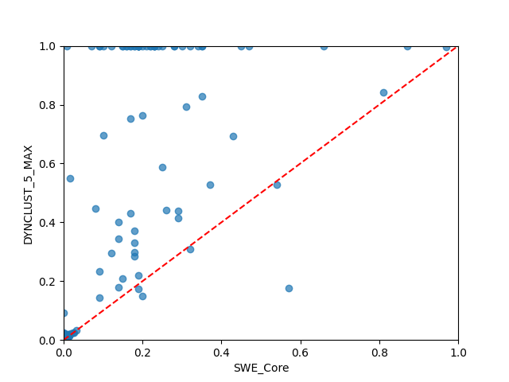  cross plot of SWE_Core versus DYNCLUST_5_MAX (MSE=0.2080, CCC=0.3196, R²=-5.4635, R=0.6239, Basic_Rank=71, Boot_Rank=71)
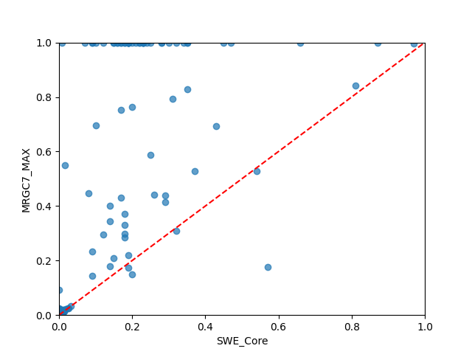
cross plot of SWE_Core versus MRGC7_MAX (MSE=0.2080, CCC=0.3196, R²=-5.4635, R=0.6239, Basic_Rank=70, Boot_Rank=70)
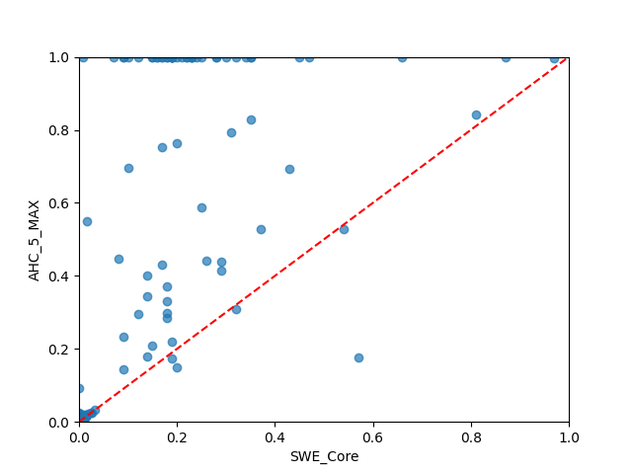
cross plot of SWE_Core versus AHC_5_MAX (MSE=0.2080, CCC=0.3196, R²=-5.4635, R=0.6239, Basic_Rank=72, Boot_Rank=72)

Appendix B: Cross-plots of Data-deriven Models
cross plot of SWE_Core versus AHC_5_MEAN (MSE=0.2991, CCC=0.2489, R²=-8.2940, R=0.5002, Basic_Rank=77, Boot_Rank=77) | cross plot of SWE_Core versus DYNCLUST5 (MSE=0.2979, CCC=0.2496, R²=-8.2573, R=0.5008, Basic_Rank=74, Boot_Rank=74)
cross plot of SWE_Core versus AHC5 (MSE=0.2979, CCC=0.2496, R²=-8.2573, R=0.5008, Basic_Rank=73, Boot_Rank=73) | cross plot of SWE_Core versus DYNCLUST_5_MIN (MSE=0.0207, CCC=0.5747, R²=0.3560, R=0.6616, Basic_Rank=15, Boot_Rank=13)
cross plot of SWE_Core versus AHC_5_MIN (MSE=0.0207, CCC=0.5747, R²=0.3560, R=0.6616, Basic_Rank=14, Boot_Rank=12) | cross plot of SWE_Core versus MRGC7_MEAN (MSE=0.2991, CCC=0.2489, R²=-8.2940, R=0.5002, Basic_Rank=79, Boot_Rank=79)
cross plot of SWE_Core versus DYNCLUST_5_MEAN (MSE=0.2991, CCC=0.2489, R²=-8.2940, R=0.5002, Basic_Rank=78, Boot_Rank=78) | cross plot of SWE_Core versus SOM5 (MSE=0.2979, CCC=0.2496, R²=-8.2573, R=0.5008, Basic_Rank=76, Boot_Rank=76)
cross plot of SWE_Core versus MRGC7 (MSE=0.2979, CCC=0.2496, R²=-8.2573, R=0.5008, Basic_Rank=75, Boot_Rank=75) | cross plot of SWE_Core versus SOM_9_MIN (MSE=0.0207, CCC=0.5747, R²=0.3560, R=0.6616, Basic_Rank=13, Boot_Rank=11)
cross plot of SWE_Core versus MRGC7_MIN (MSE=0.0207, CCC=0.5747, R²=0.3560, R=0.6616, Basic_Rank=16, Boot_Rank=14) | cross plot of SWE_Core versus SOM_9_MAX (MSE=0.2080, CCC=0.3196, R²=-5.4635, R=0.6239, Basic_Rank=69, Boot_Rank=69)
cross plot of SWE_Core versus SOM_9_MEAN (MSE=0.2991, CCC=0.2489, R²=-8.2940, R=0.5002, Basic_Rank=80, Boot_Rank=80) | cross plot of SWE_Core versus DYNCLUST_5_MAX (MSE=0.2080, CCC=0.3196, R²=-5.4635, R=0.6239, Basic_Rank=71, Boot_Rank=71)
cross plot of SWE_Core versus ANN (MSE=0.5694, CCC=0.2238, R²=-16.6900, R=0.6748, Basic_Rank=81, Boot_Rank=81) | cross plot of SWE_Core versus AHC_5_MAX (MSE=0.2080, CCC=0.3196, R²=-5.4635, R=0.6239, Basic_Rank=72, Boot_Rank=72)
cross plot of SWE_Core versus MRGC7_MAX (MSE=0.2080, CCC=0.3196, R²=-5.4635, R=0.6239, Basic_Rank=70, Boot_Rank=70)

