Supplementary Online Content
- Table S1 Self-Assessment Questionnaires
- Table S2 Eye Habits of Participants During One-Year Follow-Up
- Table S3 Subgroup Analysis in Adjusted Changes of AL and Cycloplegic SER Based on Ages and Daily Lens-Wearing Time
- Table S4 Adaptation and Visual Quality at Baseline and the 1-Month Visit
- Figure S1 Illustration of the Aberration-Enhanced Dual-Surface Lens
- Figure S2 The Sagittal Height Map of the Posterior Surface
- Figure S3 The Modulation Transfer Function of the Aberration-Enhanced Dual-Surface Lens and the Single-Surface Lens with Microlens Arrays
- Figure S4 Proportion of Participants with Different Degrees of AL Elongation (A) and SER Change (B) at the 12-Month Visit
- Figure S5 Relationship between the Changes in Cycloplegic SER and AL

Table S1 Self-Assessment Questionnaires
Questionnaire about lens-wearing time
- How many hours do you wear your spectacle lenses every workday (from Monday to Friday)?

- How many hours do you wear your spectacle lenses every day during the weekend (Saturday, Sunday) or holidays?

(Please note the special cases, e.g., spectacles are broken or forgotten)

Questionnaire about daily schedules

- How much time do you spend outdoors every workday (from Monday to Friday)?

- What time do you go to bed and get up every workday (from Monday to Friday)?

- How much time do you spend on your electronics every workday (from Monday to Friday)?

- How much time do you spend outdoors every day during the weekend (Saturday, Sunday) or holidays?

- What time do you go to bed and get up every day during the weekend (Saturday, Sunday) or holidays?

- How much time do you spend on your electronics every day during the weekend (Saturday, Sunday) or holidays?

Questionnaire about lens adaptation

- Do you feel uncomfortable wearing your spectacle lenses? (Such as vomiting, dizziness, headache, eye strain, etc.)
0 Very uncomfortable
1 A little uncomfortable
2 Mildly uncomfortable
3 Without any discomfort

- Do you see both far and near clearly with your spectacle lenses on?
0 very unclear 1 mildly clear 2 A little unclear 3 very clear

Table S2 Eye Habits of Participants During One-Year Follow-Up
Items | AEDS group  (n = 46) | SV group  (n = 46) | P value
Average time for outdoor activity, h/day | 1.57 [0.45] | 1.72 [0.50] | 0.12
Average time for sleep, h/day | 9.64 [0.84] | 9.43 [0.51] | 0.15
Average time for using electronics, h/day | 0.44 [0.32] | 0.55 [0.40] | 0.14
Average time for lens-wearing, h/day | 11.09 [1.07] | 10.97 [1.46] | 0.67
AEDS = aberration-enhanced dual-surface; SV = single vision; h/day, hour per day.
Data are presented as Mean [SD].

Table S3 Subgroup Analysis in Adjusted Changes of AL and Cycloplegic SER Based on Ages and Daily Lens-Wearing Time
Subgroup | AEDS group | SV group | P value
Change in AL (mm)
Age, years
6.0 - 8.0 | 0.30 ± 0.06 | 0.39 ± 0.07 | .28
8.1 - 12.0 | 0.17 ± 0.04 | 0.38 ± 0.04 | <.001
Lens-wearing time, h/day
< 11 | 0.27 ± 0.05 | 0.39 ± 0.05 | .09
≥ 11 | 0.20 ± 0.05 | 0.36 ± 0.05 | .007
Change in cycloplegic SER (D)
Age, years
6.0 - 8.0 | -0.36 ± 0.17 | -0.44 ± 0.20 | .73
8.1 - 12.0 | -0.23 ± 0.11 | -0.63 ± 0.10 | .007
Lens-wearing time, h/day
< 11 | -0.40 ± 0.12 | -0.57 ± 0.14 | .37
≥ 11 | -0.22 ± 0.14 | -0.47 ± 0.15 | .14
AEDS = aberration-enhanced dual-surface; SV = single vision; AL= axial length; SER = spherical equivalent refraction; D= diopter; h/day, hour per day.
Data are presented as Mean ± SE.

Table S4 Adaptation and Visual Quality at Baseline and the 1-Month Visit
 | AEDS group | SV group | P value
Discomfort while wearing the lenses at dispensing
A little uncomfortable | 3 (6) | 3 (6) | >0.99
Without any discomfort | 47 (94) | 47 (94) | >0.99
Discomfort while wearing the lenses at the 1-month visit
A little uncomfortable | 2 (4) | 0 (0) | 0.50
Without any discomfort | 46 (96) | 47 (100) | 0.50
Clarity of far and near vision with lenses at the 1-month visit
Very clear | 48 (100) | 47 (100) | > 0.99
AEDS = aberration-enhanced dual-surface; SV = single vision. Data are presented as number (%).

Figure S1 Illustration of the Aberration-Enhanced Dual-Surface Lens
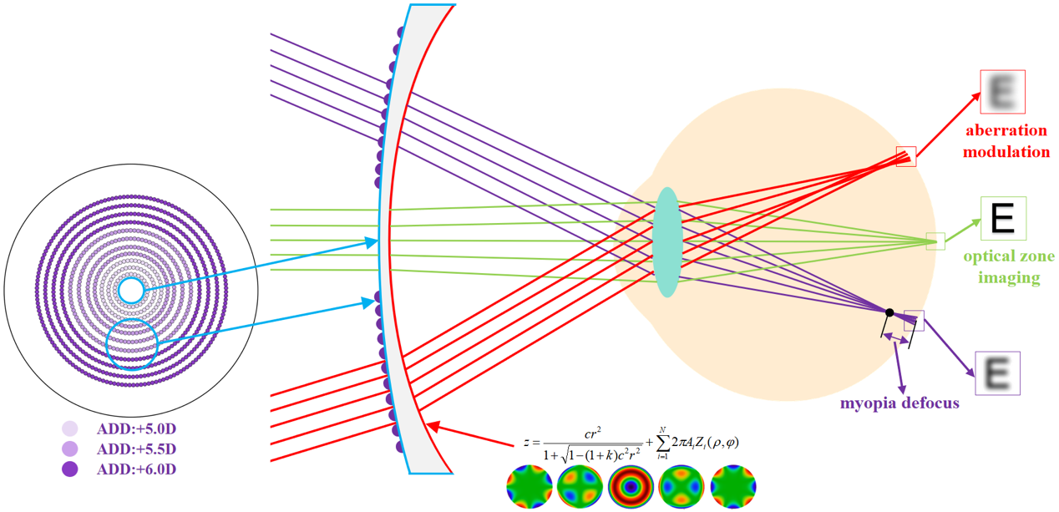
The front surface of the lens is presented on the left side of the figure. The eleven purple circles represent the concentric microlens array and the different shades of purple represent different refractive powers of lenslets (+5.00 D in the 3 inner rings, +5.50 D in the 4 intermediate rings, and +6.00 D in the 4 outer rings). The radius of the outermost ring is 57.39 mm. The purple lines depict the optical path if the light solely transmits through the front surface of the lens, generating myopic defocus signals in front of the peripheral retina. The green lines represent light transmitted through the central optic zone (8 mm), forming a clear image on the retina. In the side profile illustration of the lens, the posterior surface is depicted in red. It features a radial refractive gradient in the peripheral region, which enhances the ocular aberration. The formula represents the Zernike polynomial of aberration-enhanced modulation of the posterior surface, where z is the vector height, c is the vertex curvature, r represents the radial distance from the optical axis, k represents the conical coefficient of the surface, N is the number of Zernick coefficients in the series, i is the coefficient of the Zernick polynomial, ρ is the normalized radial ray coordinate, φ is the angular ray coordinate. Below the formula are some types of aberrations that are enhanced by the modulation effect of the posterior surface (e.g., spherical aberrations, 0° and 45° secondary astigmatism).

Below is the Zernike polynomial corresponding to a selected instance of the posterior surface:
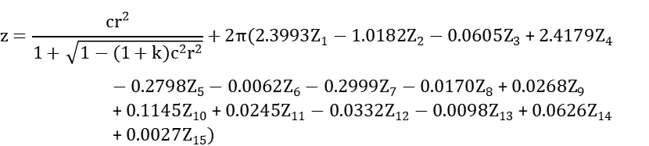

Figure S2 The Sagittal Height Map of the Posterior Surface
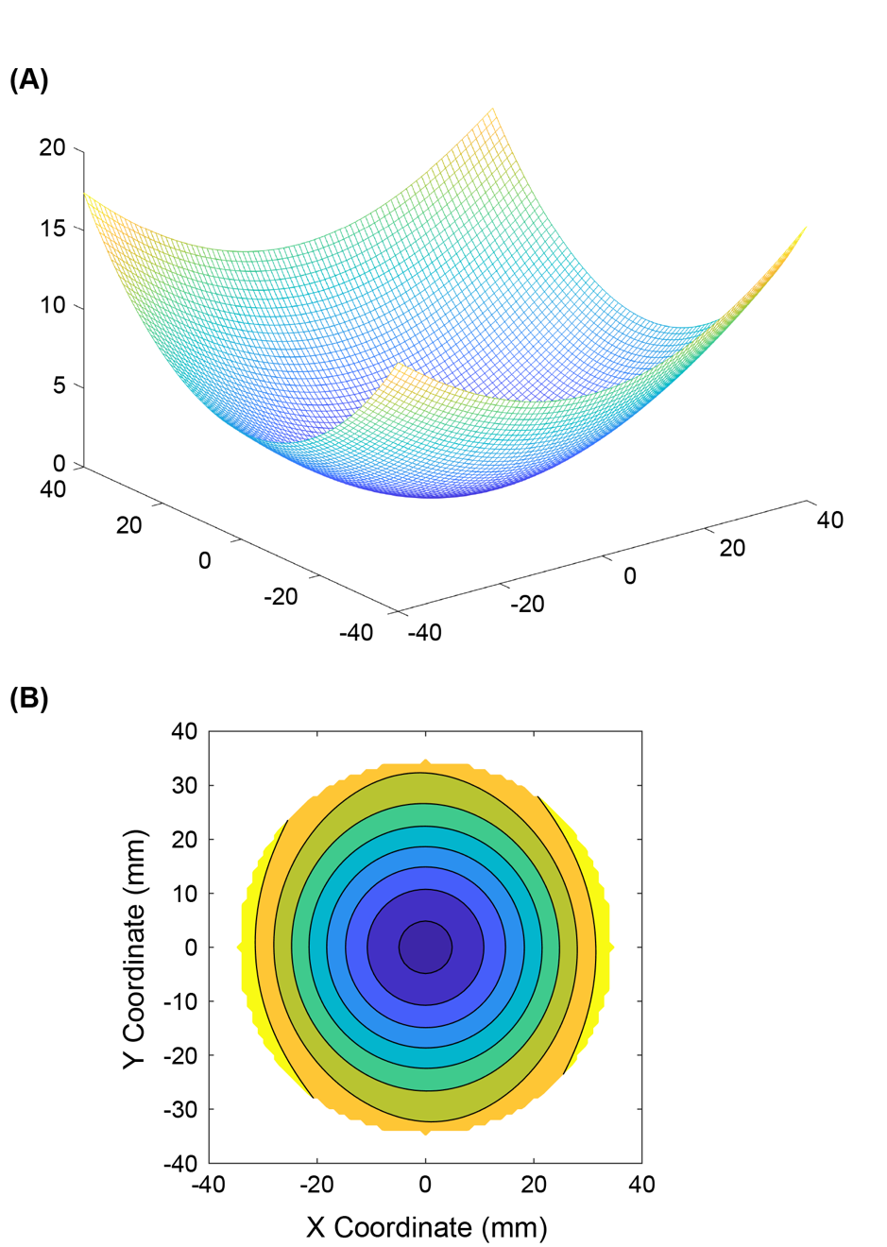
(A) illustrates the three-dimensional sagittal height map of the posterior surface. (B) illustrates the two-dimensional sagittal height projection of the posterior surface when viewed perpendicularly.
Figure S3 The Modulation Transfer Function of the Aberration-Enhanced Dual-Surface Lens and the Single-Surface Lens with Microlens Arrays
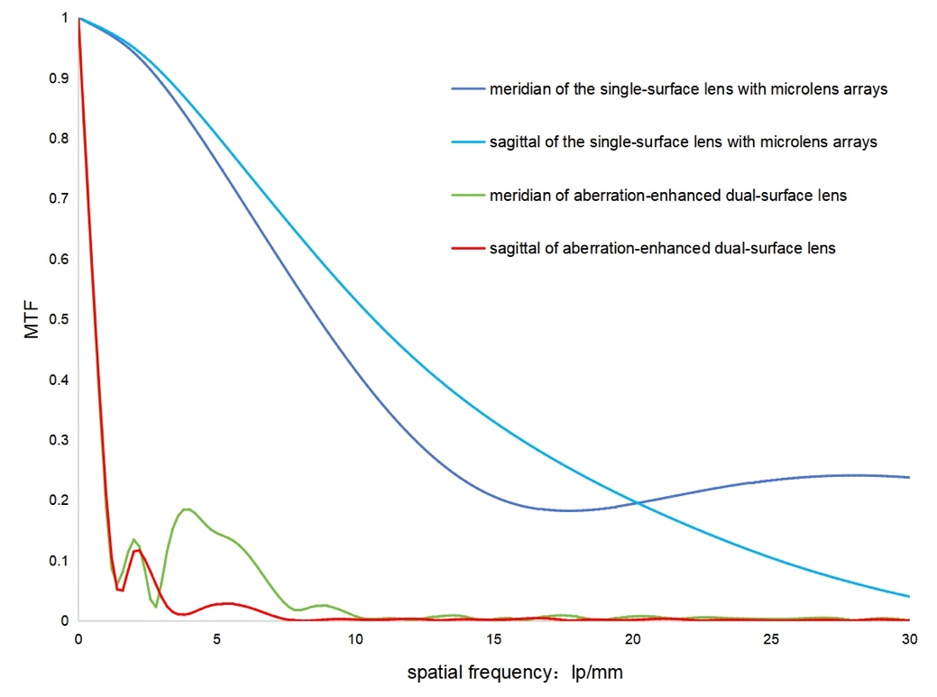
The modulation transfer function (MTF) of the fine beam that passes through the meridian and sagittal of the aberration-enhanced dual-surface lens and the single-surface lens with microlens arrays. The curves were calculated by the optical software ZEMAX.

Figure S4 Proportion of Participants with Different Degrees of AL Elongation (A) and SER Change (B) at the 12-Month Visit
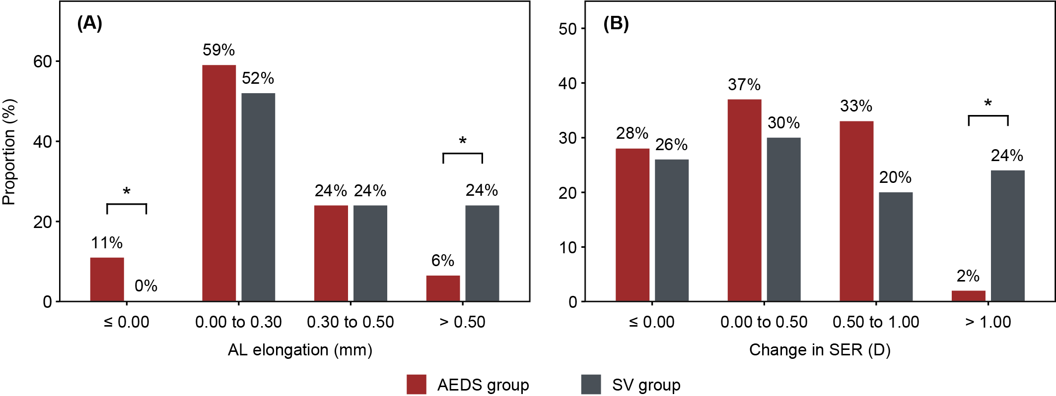
AEDS = aberration-enhanced dual-surface; SV= single vision; AL = axial length; SER = spherical equivalent refraction; D = diopter. * P < 0.05.
Figure S5 Relationship between the Changes in Cycloplegic SER and AL
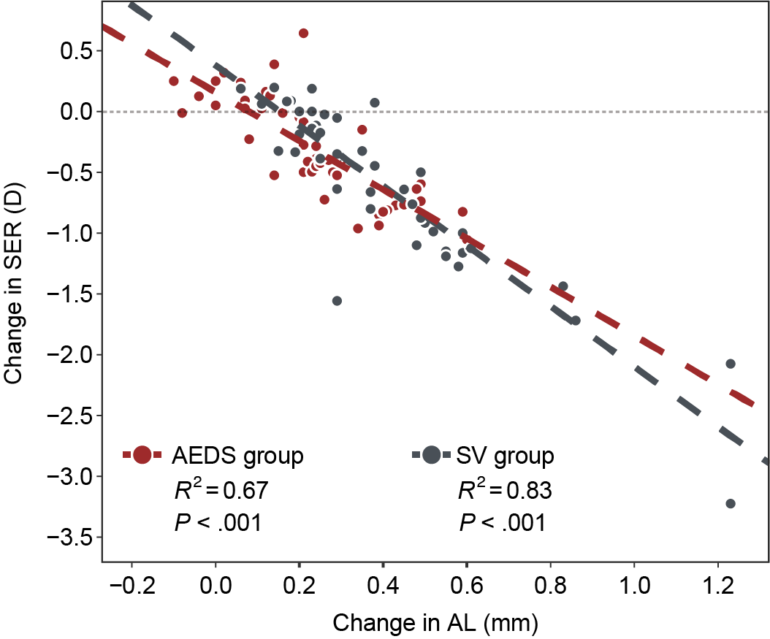
AEDS = aberration-enhanced dual-surface; SV = single vision; AL = axial length; SER = spherical equivalent refraction; D = diopter.

