Aberration-Enhanced Dual-Surface Lens vs Single-Vision Lens in Emmetropic/Mildly Hyperopic Children: A Randomized Clinical Trial
Protocol

Contents
1. Investigators
2. Study sites
3. Background
4. Hypothesis
5. Study objectives
6. Material and methods
6.1 Study design
6.2 Scheme
6.3 Enrollment and eligibility
6.4 Sample size
6.5 Randomization and masking
6.6 Interventions
6.7 Study outcomes
6.8 Study visit schedule
6.9 Outcome measurements
7. Data management
8. Statistical analysis
9. Ethics and governance
- Investigators
Principal Investigator:
Wanqing Jin, MMed, Chief physician, associate professor, Ophthalmologist and optometrist
Affiliation: School of Ophthalmology and Optometry and Eye Hospital, State Key Laboratory of Ophthalmology, Optometry and Vision Science, National Clinical Research Center for Ocular Diseases, Wenzhou Medical University
Address: 270 Xueyuan West Road, Lucheng District, Wenzhou, Zhejiang, China, 325027

Jiawei Zhou, PhD, Professor and Director of Zhejiang-Canada Translational Vision Research Center
Affiliation: School of Ophthalmology and Optometry and Eye Hospital, State Key Laboratory of Ophthalmology, Optometry and Vision Science, National Clinical Research Center for Ocular Diseases, Wenzhou Medical University
Address: 270 Xueyuan West Road, Lucheng District, Wenzhou, Zhejiang, China, 325027

Weiwei Lu, MMed, Ophthalmologist and optometrist
Affiliation: School of Ophthalmology and Optometry and Eye Hospital, State Key Laboratory of Ophthalmology, Optometry and Vision Science, National Clinical Research Center for Ocular Diseases, Wenzhou Medical University
Address: 270 Xueyuan West Road, Lucheng District, Wenzhou, Zhejiang, China, 325027

Shiqi Zhou, MMed
Affiliation: School of Ophthalmology and Optometry and Eye Hospital, State Key Laboratory of Ophthalmology, Optometry and Vision Science, National Clinical Research Center for Ocular Diseases, Wenzhou Medical University
Address: 270 Xueyuan West Road, Lucheng District, Wenzhou, Zhejiang China, 325027

Co-Investigators:
Fan Lu, PhD, Professor, Clinician Scientist
Affiliation: School of Ophthalmology and Optometry and Eye Hospital, State Key Laboratory of Ophthalmology, Optometry and Vision Science, National Clinical Research Center for Ocular Diseases, Wenzhou Medical University
Address: 270 Xueyuan West Road, Lucheng District, Wenzhou, Zhejiang China, 325027

Lihua Yu, MMed, Ophthalmologist and optometrist
Affiliation: School of Ophthalmology and Optometry and Eye Hospital, State Key Laboratory of Ophthalmology, Optometry and Vision Science, National Clinical Research Center for Ocular Diseases, Wenzhou Medical University
Address: 270 Xueyuan West Road, Lucheng District, Wenzhou, Zhejiang China, 325027

- Study sites
The study will be conducted in the Affiliated Eye Hospital of Wenzhou Medical University. The hospital is one of the top three eye hospitals in China, known for its comprehensive eye care, advanced ophthalmology and optometry technologies, and cutting-edge scientific research. As a leading eye hospital in China, it serves a large number of patients nationwide.

- Background
Myopia has become a global public health concern.¹ The World Health Organization (WHO) estimates that by 2050, nearly half of the global population could be affected by myopia, posing significant challenges to social healthcare.² Due to rapid lifestyle changes and increasing academic pressure, the prevalence of myopia and high myopia in China has been rising each year, with an increasing trend of earlier onset in younger children.³ Studies have shown that early-onset myopia is more likely to progress to high myopia,⁴ which is closely linked to serious ocular diseases, including macular degeneration, retinal detachment and so on.^{2,5–8,9} Therefore, early intervention to prevent myopia is crucial for improving individual well-being and relieving the burden on national healthcare systems.
Current interventions for myopia prevention remain limited. One of the most widely recognized preventative strategies is increasing outdoor activities.^{10–12} However, the growing reliance on electronic devices and increasing academic pressure have substantially diminished the time children and adolescents spend outdoors. Atropine, as a pharmacological intervention for myopia prevention^{13–15}, requires further research on its optimal dosage and suitable population. Recently, different kinds of functional lenses were designed for myopia management. These lenses involve a variety of myopic control mechanisms, such as inducing myopic defocus signals¹⁶ or higher-order aberrations.^{17,18} However, most of these studies have focused on children who are already myopic. Whether these technologies can prevent myopia in children who have not yet developed it warrants further investigation.
We developed an aberration-enhanced dual-surface (AEDS) lens by combining two techniques that have been proven effective for myopia control, peripheral myopic defocus and aberration enhancement, and incorporating them into the front and back surface design of the lens, respectively. We plan to conduct a randomized controlled trial involving emmetropic and mildly hyperopic children to verify its effect on myopia prevention.

- Hypothesis
Hypothesis 1: The aberration-enhanced dual-surface lenses can effectively prevent myopia in non-myopic children.
Hypothesis 2: The myopia prevention effectiveness of aberration-enhanced dual-surface lenses in emmetropic children will be more significant than in mildly hyperopic children.

- Study objectives
Primary objective: To evaluate the effectiveness of aberration-enhanced dual-surface spectacle lenses in preventing myopia in non-myopic children.
Second objective: To examine the impact of baseline characteristics and daily behaviors on the effectiveness of the aberration-enhanced dual-surface spectacle lenses.

- Material and methods
6.1 Study design
This study will be a 2-year, single-center, double-masked, randomized controlled trial starting from July 2023. Participants will be randomly assigned to the intervention group and the control group and further stratified into emmetropic (-0.50 D < cycloplegic spherical equivalent refraction [SER] < 0.50 D) and mildly hyperopic (0.50 D ≤ cycloplegic SER ≤ 3.00 D) children. Participants in the intervention group will wear the AEDS lenses in their daily lives, while those in the control group wear single-vision (SV) lenses.
  - Scheme
Figure 1. Study Flow Diagram
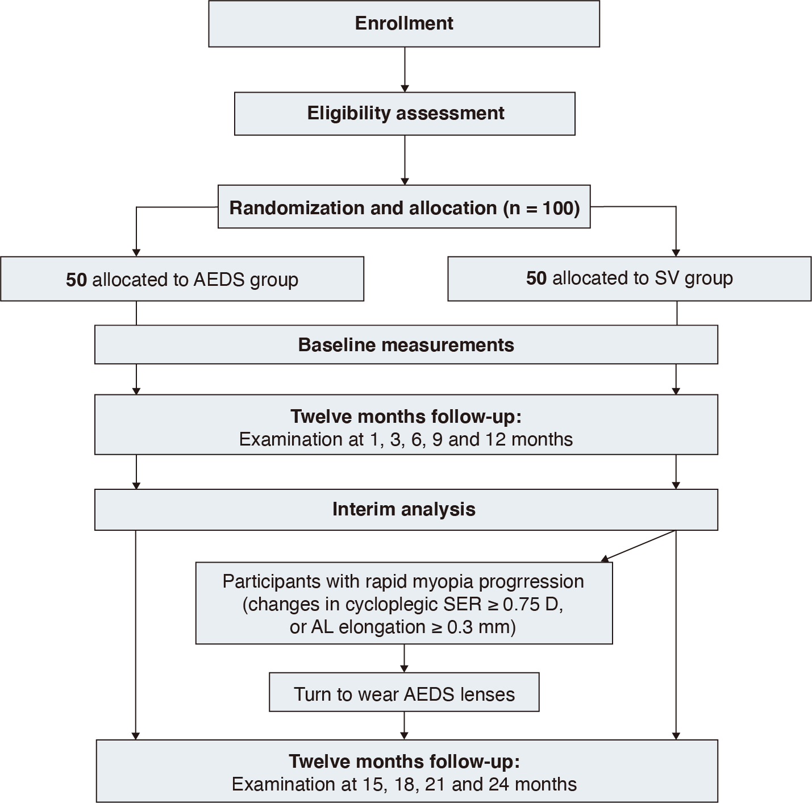

  - Enrollment and eligibility
Participants will be recruited in the hospital outpatient clinics. Advertisements will be placed in the hospital’s public areas and recommendations from clinical optometrists will be included in the recruitment strategy.
Inclusion criteria：(1) aged from 6 to 12 years old; (2) SER between -0.50 D and +3.00 D measured by an autorefractor under cycloplegia; (3) astigmatism of cycloplegic autorefraction ≤ 1.50 D; (4)distanct best-corrected visual acuity (BCVA) of 0.1 logMAR or better; (5) anisometropia ≤ 1.50 D; (6) willing to wear spectacle lens.
Exclusion criteria: (1) intraocular pressure ≥ 21 mmHg; (2) manifest strabismus; (3) ocular diseases or systemic diseases that affect visual development (excluding refractive errors); (4) history of ocular or systemic surgery that affects visual development; (5) use of defocus spectacle lenses or low-concentration atropine eye drops within the past 3 months; (6) use of orthokeratology lenses or other products that can prevent or control myopia within the past 6 months (e.g., red light-related treatment methods); (7) history of systemic medications that affect growth and development (e.g., growth hormone); (8) concurrent participation in any clinical research trials related to myopia control or prevention; (9) other conditions deemed unsuitable for the trial by the investigator.
  - Sample size
The sample size is calculated using two-sample t-tests assuming equal variance in SPSS (IBM Inc., Armonk, NY, United States). The mean (SD) annual axial elongation is assumed to be 0.36 (0.23) mm in the control group based on the previous studies for non-myopic children aged from 6 to 12 years.^{13–15,19} The intervention effect of the AEDS lens is assumed to be 40%. Considering a drop-out rate of 10%, a minimum sample size of 94 (47 per group) is needed to achieve 80% power at a significance level of 0.05.
  - Randomization and masking
Randomization will be conducted by a clinical research coordinator. Eligible participants will be randomly assigned to the intervention or control group (1:1) based on a computer-generated allocation sequence. The coordinator will notify the manufacturer of the appropriate lens type for each participant and check the lenses upon receipt. All spectacle lenses will be packaged in identical eyeglass cases and handed over by the coordinator to the dispensers, who will distribute them to the participants. The clinical research coordinator will not be involved in recruitment, clinical examinations, data collection, or data analysis. All other investigators (including examiners, dispensers and statisticians), participants, and their parents or guardians will remain masked throughout the study.
  - Interventions
Participants in the intervention group will wear AEDS spectacle lenses, whereas subjects in the control group wear SV spectacle lenses. The AEDS lens (Shanghai Baoli Lai Optical Lens Co. and Suzhou Mingshi Optical Technology Co., Ltd.) was designed by combining two technologies: a concentric microlens array on the anterior surface to generate peripheral myopic defocus signals, and a radial refractive gradient on the back surface to increase the total ocular aberration. The design is protected by the Patent Cooperation Treaty (202122046858X and 202221884655.6). Both the front and back surfaces of the lens have a central optical zone (8 mm) designed for correcting refractive error and providing a clear view at the center of the retina. The peripheral zone of the front surface has 11 concentric circular microlens arrays arranged with different refractive powers, and the radius of the outermost ring is 57.39 mm. The refractive power of the lenslets is +5.00 D in the 3 inner rings, +5.50 D in the intermediate 4 rings, and +6.00 D in the 4 outer rings. The peripheral zone of the back surface has a radial refractive gradient that can enhance aberrations (e.g., spheric aberration and secondary astigmatism).
The formula below is the Zernike polynomial of aberration-enhanced modulation on the posterior surface of the AEDS lens:
$$z=\frac{cr^{2}}{1+\sqrt{1−{(1+k)c}^{2}r^{2}}}+\sum_{i=1}^{N}{2πA_{i}Z_{i}(ρ,φ)}$$
where z is the vector height, c is the vertex curvature, r represents the radial distance from the optical axis, k represents the conical coefficient of the surface, N is the number of Zernick coefficients in the series, i is the coefficient of the Zernick polynomial, ρ is the normalized radial ray coordinate, φ is the angular ray coordinate. Normalized orthogonal polynomials represented in polar coordinates are shown in Table 1, where x = ρcosφ, y = ρsinφ, ρ² = x² + y², and n denotes the order of the polynomial.

Table1. Normalized Orthogonal Polynomials in Polar Coordinates
n | i | )
0 | 1 | 1
1 | 2
1 | 3 | 2
2 | 4 | 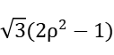
2 | 5 | 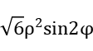
2 | 6 | 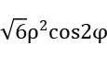
3 | 7 | 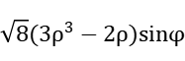
3 | 8 | 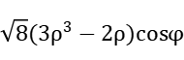
3 | 9 | 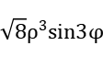
3 | 10 | 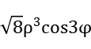
4 | 11 | 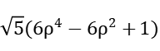
4 | 12 | 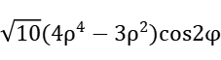
4 | 13 | 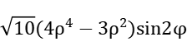
4 | 14 | 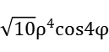
4 | 15 | 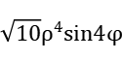
...... | ...... | ......

The formula below is the Zernike polynomial corresponding to a selected instance of the posterior surface. The amount of different aberrations at 10° and 15° field of view angle is shown in Table 2.
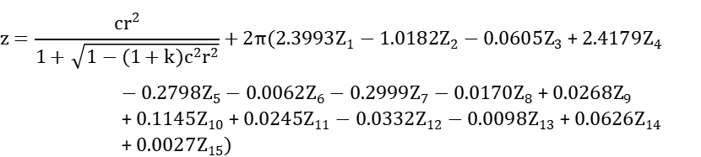

Table 2. The Amount of Different Aberration at 10° and 15° Field of View Angle
Aberration order number | Zi | 10°Field of view angle Zi | 15°Field of view angle Zi | Aberration meaning
Second order | Z4 | -17.50865552 | -29.70500871 | Defocus
Second order | Z5 | -0.15539903 | -9.36105801 | Coma-like distortion
Second order | Z6 | -3.3065078 | -0.78442698 | Horizontal astigmatism
Third order | Z7 | -0.0710118 | -0.13242021 | Vertical coma
Third order | Z8 | -0.03149834 | -0.5278612 | Horizontal coma aberration
Third order | Z9 | 0.01244168 | 0.26057668 | Tilted cloverleaf
Third order | Z10 | 0.03578069 | 0.14241967 | Level cloverleaf
Fourth order | Z11 | 0.12700155 | 0.15656005 | Spherical aberration
Fourth order | Z12 | 0.00157475 | 0.00321444 | Horizontal secondary astigmatism
Fourth order | Z13 | -0.0057844 | -0.01976174 | Tilted secondary astigmatism
Fourth order | Z14 | -0.00110142 | -0.00383473 | Horizontal four-leaf clover
Fourth order | Z15 | 0.00092039 | 0.09126318 | Tilted four-leaf clover
Fifth order | Z16 | -0.00012704 | 0.08969021 | Horizontal secondary coma
Fifth order | Z17 | -0.00325462 | 0.10228484 | Vertical secondary coma
...... | ...... | ...... | ...... | ......

  - Study outcomes
Primary outcomes: Changes in axial length (AL) and cycloplegic SER from baseline.
Secondary outcomes: The myopia incidence (cycloplegic SER ≤ -0.50 D will be determined as myopia) and average daily lens-wearing time.
Safety outcomes: Corneal astigmatism and total astigmatism, distance visual acuity; participants’ subjective feelings when wearing the lenses.

6.8 Study visit schedule
Participants will undergo 24 months of follow-up during the trial. Table 3 shows the follow-up schedule and the examinations that would be taken at each visit.

Table 3. Examinations at Baseline and Each Follow-up Visit
Items | Baseline | 1-month | 3-month | 6-month | 9-month | 12-month | 15-month | 18-month | 21-month | 24-month
Inclusion/exclusion criteria assessment | √
Informed consent | √
Slit lamp biomicroscopy | √ |  |  | √ |  | √ |  | √ |  | √
Subjective and objective refraction without cycloplegia | √ |  | √ | √ | √ | √ | √ | √ | √ | √
Subjective and objective refraction with cycloplegia | √ |  |  | √ |  | √ |  | √ |  | √
monocular pupil distance | √ |  | √ | √ | √ | √ | √ | √ | √ | √
Spectacle lenses dispensing | √
Frame adjustment, pupil height measurement | √ | √ | √ | √ | √ | √ | √ | √ | √ | √
Best-corrected visual acuity | √ |  | √ | √ | √ | √ | √ | √ | √ | √
Intraocular pressure | √ |  |  |  |  | √ |  |  |  | √
Strabismus at 33cm | √ |  |  |  |  | √ |  |  |  | √
Pupil size | √ |  |  |  |  | √ |  |  |  | √
Axial length | √ | √ | √ | √ | √ | √ | √ | √ | √ | √
Accommodative  amplitude | √ |  |  |  |  | √ |  |  |  | √
Accommodative facility | √ |  |  |  |  | √ |  |  |  | √
Contrast sensitivity | √ |  |  |  |  | √ |  |  |  | √
Lens-wearing time |  | √ | √ | √ | √ | √ | √ | √ | √ | √
Questionnaire about timetable |  | √ | √ | √ | √ | √ | √ | √ | √ | √
Questionnaire about lens adaptation | √ | √ | √

6.9 Outcome measurements
Distance visual acuity will be measured with and without spectacles by using an EDTRS chart at 5 meters. Best-corrected visual acuity will be measured after correcting the subjective refractive error.
Objective and subjective SER, both with and without cycloplegia, will be measured by a masked examiner. One drop of 0.5% proxymetacaine hydrochloride and 3 drops of 1% cyclopentolate will be used to induce cycloplegia, with a 5-minute interval between each dose. The refractive error will be measured at least half an hour after using eye drops to ensure complete cycloplegia. An autorefractor (Topcon KR-800, Topcon Corporation, Japan) will be used to measure objective SER, and its averaged value (including total astigmatism) will be obtained by calculating the mean of ten measurements. Subjective SER will be measured by using a photometer (Topcon Corporation, Japan). Lenses will be replaced when the subjective SER change is greater than 0.25 D or when there are scratches on the surface of the lens.
Mean AL and corneal astigmatism will be obtained by averaging five measurements taken by an Intraocular Lens Master (IOL-Master, Zeiss, Germany).
Participants’ daily schedule and their subjective feelings when wearing the lenses will be recorded by the self-assessment questionnaires (Table S1 in Additional file 2), which consists of the lens-wearing duration (items 1-2), daily schedule (items 3-8), and adaptation to the lens (items 9-10). The average daily lens-wearing time over 12 months and 24 months will be calculated by the formulas below:
T₁₂ = (a₁ × 30 + a₂× 60 + a₃ × 90 + a₄ × 90 + a₅ × 90)/360
T₂₄ =0.5× [T₁₂+(a₆ + a₇ + a₈ + a₉ ) × 90/360]
a₁ to a₉ represent the average daily lens-wearing time reported at each follow-up visit (from 1-month, to 24-month). T₁₂ represents the Average daily lens-wearing time over 12 months and T₂₄ represents the Average daily lens-wearing time over 24 months.
The average daily lens-wearing time at each visit will be calculated by the following formula:
Average daily lens-wearing time reported at each visit = (b × d₁ + c× d₂)/(d₁+d₂)
b is the average daily lens-wearing time on workdays, while c refers to the average daily wearing time on weekends (or holidays), both reported at each visit. d₁ and d₂ represent the total number of workdays and weekends (or holidays) between this follow-up and the previous one, respectively. The average hours spent on outdoor activities, electronics and sleeping per day will also be calculated using the similar formula provided above.

- Data management
The study will use paper-based documentation for data collection. Each participant will be assigned a unique screening identifier to ensure data retrieval. In compliance with national regulations, encryption or de-identification will be applied to all study documents and publications to safeguard participant confidentiality.
Data from each follow-up visit must be entered into the data collection system within seven days to ensure timely and accurate data management. After the 12-month follow-up visit, the outcome and group will be provided to data analysts for an interim analysis after identifiable information is removed to assess the preliminary efficacy and safety of the AEDS lens. Still, masking will be maintained for data collectors and participants. After finishing the 2-year follow-up, data managers will conduct comprehensive logical checks, with all identified discrepancies resolved prior to database locking. After the data collection system is locked, the final version of the data management report will be generated. All data will be reviewed by the principal investigator, sponsor, statisticians and monitors under a masked condition. The data will then be transferred to the statistical team for formal analysis in accordance with the pre-specified statistical analysis plan.

8. Statistical analysis
Statistical analysis will be performed using SPSS software (IBM Inc., Armonk, NY, United States). The distribution of continuous variables will be assessed with the Kolmogorov-Smirnov test. The intergroup and inter-subgroup differences of all the continuous variables will be analyzed using independent-sample t-tests. Categorical variables will be analyzed via the chi-square test. A univariate general linear model will be applied to determine the changes in AL and SER after adjusting for gender, age, lens-wearing time, initial AL, initial cycloplegic SER, photopic pupil size, daily durations of outdoor activities and using electronic and the number of parents with myopia. Both adjusted and non-adjusted values will be analyzed to ensure the robustness of intergroup differences assessment. Subgroup analyses will be conducted according to age, initial refractive states (emmetropia and mildly hyperopia) and daily lens-wearing time. The correlation between the axial elongation and the changes in refraction will also be analyzed by using Pearson correlation analysis. To reduce the risk of Type I error caused by multiple comparisons, p-values of <0.025 is considered statistically significant when analyzing 6-month follow-up data and subgroup data. Our study is exploratory in nature, therefore, we did not plan for multiple adjustments in subgroup analyses or imputation for missing data during the design phase.In other analyses, a p-value of < 0.05 is used to indicate statistical significance.

9. Ethics and governance
Written consent will be obtained from each participant and their parents or guardians after the objectives, procedures, possible risks and benefits of the study are informed. Signed consent copies will be distributed to participants and documented in study records. All the documents including this protocol, consent, enrollment advertisement and any amendments will be reviewed and approved by the Ethics Committee of the Eye Hospital of Wenzhou Medical University and Chinese Clinical Trial Registry. The study is designed in accordance with the WHO’s definition of a clinical trial and will be conducted following the tenets of the Declaration of Helsinki.

References
1. Sankaridurg P, Tahhan N, Kandel H, et al. IMI Impact of Myopia. Invest Ophthalmol Vis Sci. 2021;62(5):2. doi:10.1167/iovs.62.5.2
2. Holden BA, Fricke TR, Wilson DA, et al. Global Prevalence of Myopia and High Myopia and Temporal Trends from 2000 through 2050. Ophthalmology. 2016;123(5):1036-1042. doi:10.1016/j.ophtha.2016.01.006
3. Jb J, M A, P C, et al. IMI Prevention of Myopia and Its Progression. Investigative ophthalmology & visual science. 2021;62(5). doi:10.1167/iovs.62.5.6
4. Lai H, Gao K, Li M, et al. Handling missing data and measurement error for early-onset myopia risk prediction models. BMC Med Res Methodol. 2024;24(1):194. doi:10.1186/s12874-024-02319-x
5. Mu J, Zeng D, Fan J, et al. Epidemiological Characteristics and Influencing Factors of Myopia Among Primary School Students in Southern China: A Longitudinal Study. Int J Public Health. 2023;68:1605424. doi:10.3389/ijph.2023.1605424
6. Liu W, Gong L, Li Y, Zhu X, Stewart JM, Wang C. Peripapillary Atrophy in High Myopia. Curr Eye Res. 2017;42(9):1308-1312. doi:10.1080/02713683.2017.1307992
7. Lim DH, Lyu IJ, Choi SH, Chung ES, Chung TY. Risk factors associated with night vision disturbances after phakic intraocular lens implantation. Am J Ophthalmol. 2014;157(1):135-141.e1. doi:10.1016/j.ajo.2013.09.004
8. O P, M K. Risk factors for high myopia: a 22-year follow-up study from childhood to adulthood. Acta ophthalmologica. 2019;97(5). doi:10.1111/aos.13964
9. Oncel D, Minaker S, Shepherd EA, et al. Risk Factors for Proliferative Vitreoretinopathy in a Large Clinical Database. Retina. Published online December 31, 2024. doi:10.1097/IAE.0000000000004391
10. Rose KA, Morgan IG, Ip J, et al. Outdoor activity reduces the prevalence of myopia in children. Ophthalmology. 2008;115(8):1279-1285. doi:10.1016/j.ophtha.2007.12.019
11. Galvis V, Tello A, Gómez LM, Camacho PA, Ortiz RG. Re: Wu et al.: Myopia prevention and outdoor light intensity in a school-based cluster randomized trial (Ophthalmology. 2018;125:1239-1250). Ophthalmology. 2018;125(11):e77. doi:10.1016/j.ophtha.2018.06.003
12. Xiong S, Sankaridurg P, Naduvilath T, et al. Time spent in outdoor activities in relation to myopia prevention and control: a meta-analysis and systematic review. Acta Ophthalmol. 2017;95(6):551-566. doi:10.1111/aos.13403
13. Yam JC, Zhang XJ, Zhang Y, et al. Effect of Low-Concentration Atropine Eyedrops vs Placebo on Myopia Incidence in Children: The LAMP2 Randomized Clinical Trial. JAMA. 2023;329(6):472-481. doi:10.1001/jama.2022.24162
14. Jethani J. Efficacy of low-concentration atropine (0.01%) eye drops for prevention of axial myopic progression in premyopes. Indian J Ophthalmol. 2022;70(1):238-240. doi:10.4103/ijo.IJO_1462_21
15. Wang W, Zhang F, Yu S, et al. Prevention of myopia shift and myopia onset using 0.01% atropine in premyopic children - a prospective, randomized, double-masked, and crossover trial. Eur J Pediatr. 2023;182(6):2597-2606. doi:10.1007/s00431-023-04921-5
16. Su B, Cho P, Vincent SJ, et al. Novel Lenslet-ARray-Integrated Spectacle Lenses for Myopia Control: A 1-Year Randomized, Double-Masked, Controlled Trial. Ophthalmology. 2024;131(12):1389-1397. doi:10.1016/j.ophtha.2024.07.002
17. Liu X, Wang P, Xie Z, et al. One-year myopia control efficacy of cylindrical annular refractive element spectacle lenses. Acta Ophthalmol. 2023;101(6):651-657. doi:10.1111/aos.15649
18. Lau JK, Vincent SJ, Collins MJ, Cheung SW, Cho P. Ocular higher-order aberrations and axial eye growth in young Hong Kong children. Sci Rep. 2018;8(1):6726. doi:10.1038/s41598-018-24906-x
19. Li SM, Ran AR, Kang MT, et al. Effect of Text Messaging Parents of School-Aged Children on Outdoor Time to Control Myopia: A Randomized Clinical Trial. JAMA Pediatr. 2022;176(11):1077-1083. doi:10.1001/jamapediatrics.2022.3542

