Population-health analysis of the progress of chronic disease burden over a 10-year period in a regional cohort of 5.5 million adults living in Catalonia

  - Supplementary Appendix

Contents
Supplementary Methods 2
Risk estimates 2
Bonferroni threshold 2
Pairs classification according to transitions 2
Pairs directionality 3
Supplementary Tables 4
Table S1. Prevalence of ICD-10-CM codes. 4
Table S2. Predictive performance of the models 11
Table S3. Frequency of the most frequent diagnosis pairs at the end of the study period. 12
Table S4. Frequency of the most frequent diagnosis triads at the end of the study period 13
Supplementary figures 14
Figure S1· Overview of the study design 14
Figure S2· Sankey diagram for transitions across AMG risk groups 15
Figure S3· Conditions triggering the transition towards high/very-high risk· 16
Figure S4· Performance of the models for predicting transition to high/very-high clinical risk (Adjusted Morbidity Groups [AMG] index ≥P₈₀) 17
Figure S5· Distribution of diagnostic pairs (A) and triads (B) 18
Figure S6· Specific network diseases of the 20 most prevalent conditions at the end of the study period · 18

Supplementary Methods

Risk estimates
The risk ratio compares the observed frequency (O) of the triplet with the expected frequency (E).
Disease pairs:
$$RR_{\left\{AB\right\}}=\frac{O}{E} = \frac{N_{ABC}}{(N_{A}⋅N_{B})/N}=\frac{N_{AB}·N}{N_{A}⋅N_{B}}$$
where:
- N_{AB} (O): The observed number of patients with both diseases A and B.
- N: The total number of patients.
- N_{A}, N_{B}: The number of patients with disease A and disease B, respectively.

Disease triples:
$$RR_{\left\{ABC\right\}}=\frac{O}{E} = \frac{N_{ABC}}{(N_{A}⋅N_{B}⋅N_{C})/N^{2}}=\frac{N_{ABC}·N^{2}}{N_{A}⋅N_{B}⋅N_{C}}$$
where:
- N_{ABC} (O): The observed number of patients who have all three diseases A, B, and C.
- N: The total number of patients.
- N_{A}, N_{B}, N_{C}: The number of patients with disease A, disease B, and disease C, respectively.

Bonferroni threshold
Statistical significance for pairwise associations was assessed using a Bonferroni correction to account for multiple testing. For m tested pairs, the significance threshold was set at α/m, where α = 0·05 and m was the total number of evaluated pairs. Adjusted p-values were obtained using the Bonferroni method implemented in R, and only pairs with p < α/m and involving ≥50 individuals were retained for network construction.

Pairs classification according to transitions
Pairs of chronic conditions were assessed for temporal relationship between with transition from low/moderate clinical risk to high/very-high clinical risk according to the Adjusted Morbidity Groups stratification. For each individual in the study, all instances where two conditions occurred sequentially were examined and each sequential pair was categorized based on the individual's stratum status before and after the onset of both conditions in the pair.
Three categories were defined:
- Pre-transition (Pre): The individual remained in stratum low/moderate risk both before and after the onset of both conditions in the pair. This indicates that neither condition, in that specific instance, triggered a transition to high/very-high risk.
- Post-transition (Post): The individual was already in stratum high/very-high risk before the onset of the first condition in the pair and remained in this stratum after the onset of the second condition. This suggests the transition to stratum high/very-high risk had already occurred prior to both conditions.
- Mixed: All other possible scenarios. This primarily includes cases where the transition to high/very-high risk occurred between the onset of the first and second condition.
For each pair of conditions, we counted the number of times it was classified as "Pre," "Post," and "Mixed" across all individuals. The final classification of each condition pair was then determined as follows:
- Pre: If the "Pre" count was greater than both the "Post" and "Mixed" counts.
- Post: If the "Post" count was greater than both the "Pre" and "Mixed" counts.
- Mixed: If the "Mixed" count was greater than both the "Pre" and "Post" counts, or if the "Pre" and "Post" counts were equal.

Pairs directionality
All possible directed pairs of conditions were analysed separately, considering both A→B and B→A. Temporal ordering of diagnoses at the individual level was used to assign the direction of each pair, but both directions were evaluated independently. In the resulting networks, only those directed pairs that fulfilled the predefined relevance criteria (i.e., sufficient prevalence or high co-occurrence risk ratio) were retained. Therefore, both directions could appear simultaneously in the same network when each was independently relevant, resulting in the inclusion of both A→B and B→A.

Supplementary Tables

Table S1. Prevalence of ICD-10-CM codes.
Counts and percentages correspond to ICD-10-CM codes at the end of the investigation period. Only diagnoses with a prevalence ≥1% are shown.
CCS Code and description | ICD-10-CM Code and description | No. (%)
48 - Thyroid disorders | E02 - Subclinical iodine-deficiency hypothyroidism | 249,593 (29.2%)
48 - Thyroid disorders | E039 - Hypothyroidism, unspecified | 230,256 (27%)
48 - Thyroid disorders | E0590 - Thyrotoxicosis, unspecified without thyrotoxic crisis or storm | 81,512 (9.5%)
48 - Thyroid disorders | E041 - Nontoxic single thyroid nodule | 78,026 (9.1%)
48 - Thyroid disorders | E042 - Nontoxic multinodular goiter | 36,606 (4.3%)
48 - Thyroid disorders | E049 - Nontoxic goiter, unspecified | 36,409 (4.3%)
48 - Thyroid disorders | E069 - Thyroiditis, unspecified | 28,623 (3.4%)
48 - Thyroid disorders | E032 - Hypothyroidism due to medicaments and other exogenous substances | 21,282 (2.5%)
48 - Thyroid disorders | E031 - Congenital hypothyroidism without goiter | 20,404 (2.4%)
48 - Thyroid disorders | E063 - Autoimmune thyroiditis | 17,770 (2.1%)
48 - Thyroid disorders | E038 - Other specified hypothyroidism | 16,449 (1.9%)
49 - Diabetes mellitus without complication | E119 - Type 2 diabetes mellitus without complications | 594,132 (92.5%)
49 - Diabetes mellitus without complication | E109 - Type 1 diabetes mellitus without complications | 26,182 (4.1%)
49 - Diabetes mellitus without complication | E139 - Other specified diabetes mellitus without complications | 21,992 (3.4%)
53 - Disorders of lipid metabolism | E7800 - Pure hypercholesterolemia, unspecified | 652,134 (68.5%)
53 - Disorders of lipid metabolism | E781 - Pure hyperglyceridemia | 188,868 (19.8%)
53 - Disorders of lipid metabolism | E782 - Mixed hyperlipidemia | 65,355 (6.9%)
53 - Disorders of lipid metabolism | E785 - Hyperlipidemia, unspecified | 29,946 (3.1%)
53 - Disorders of lipid metabolism | E7801 - Familial hypercholesterolemia | 11,879 (1.2%)
58 - Other nutritional; endocrine; and metabolic disorders | E669 - Obesity, unspecified | 894,053 (50.4%)
58 - Other nutritional; endocrine; and metabolic disorders | E789 - Disorder of lipoprotein metabolism, unspecified | 662,356 (37.3%)
58 - Other nutritional; endocrine; and metabolic disorders | E668 - Other obesity | 60,485 (3.4%)
58 - Other nutritional; endocrine; and metabolic disorders | E739 - Lactose intolerance, unspecified | 48,811 (2.8%)
58 - Other nutritional; endocrine; and metabolic disorders | E804 - Gilbert syndrome | 24,503 (1.4%)
84 - Headache; including migraine | G43909 - Migraine, unspecified, not intractable, without status migrainosus | 256,559 (47%)
84 - Headache; including migraine | G44209 - Tension-type headache, unspecified, not intractable | 214,510 (39.3%)
84 - Headache; including migraine | G43109 - Migraine with aura, not intractable, without status migrainosus | 42,237 (7.7%)
84 - Headache; including migraine | G43009 - Migraine without aura, not intractable, without status migrainosus | 13,012 (2.4%)
86 - Cataract | H259 - Unspecified age-related cataract | 514,743 (91.8%)
86 - Cataract | H269 - Unspecified cataract | 33,382 (6%)
88 - Glaucoma | H409 - Unspecified glaucoma | 221,569 (82.3%)
88 - Glaucoma | H40009 - Preglaucoma, unspecified, unspecified eye | 23,930 (8.9%)
88 - Glaucoma | H40059 - Ocular hypertension, unspecified eye | 20,777 (7.7%)
89 - Blindness and vision defects | H547 - Unspecified visual loss | 502,382 (94.4%)
89 - Blindness and vision defects | H543 - Unqualified visual loss, both eyes | 10,275 (1.9%)
89 - Blindness and vision defects | H5440 - Blindness, one eye, unspecified eye | 7,015 (1.3%)
94 - Other ear and sense organ disorders | H6090 - Unspecified otitis externa, unspecified ear | 776,700 (56.4%)
94 - Other ear and sense organ disorders | H9190 - Unspecified hearing loss, unspecified ear | 453,675 (32.9%)
94 - Other ear and sense organ disorders | H905 - Unspecified sensorineural hearing loss | 45,074 (3.3%)
94 - Other ear and sense organ disorders | H6240 - Otitis externa in other diseases classified elsewhere, unspecified ear | 31,267 (2.3%)
94 - Other ear and sense organ disorders | H902 - Conductive hearing loss, unspecified | 25,926 (1.9%)
94 - Other ear and sense organ disorders | H908 - Mixed conductive and sensorineural hearing loss, unspecified | 19,649 (1.4%)
94 - Other ear and sense organ disorders | H608X9 - Other otitis externa, unspecified ear | 15,728 (1.1%)
95 - Other nervous system disorders | G5600 - Carpal tunnel syndrome, unspecified upper limb | 304,163 (51.7%)
95 - Other nervous system disorders | G8929 - Other chronic pain | 51,150 (8.7%)
95 - Other nervous system disorders | R262 - Difficulty in walking, not elsewhere classified | 41,095 (7%)
95 - Other nervous system disorders | G629 - Polyneuropathy, unspecified | 34,860 (5.9%)
95 - Other nervous system disorders | G5760 - Lesion of plantar nerve, unspecified lower limb | 22,562 (3.8%)
95 - Other nervous system disorders | G219 - Secondary parkinsonism, unspecified | 13,722 (2.3%)
95 - Other nervous system disorders | G5710 - Meralgia paresthetica, unspecified lower limb | 13,380 (2.3%)
95 - Other nervous system disorders | G919 - Hydrocephalus, unspecified | 12,092 (2.1%)
95 - Other nervous system disorders | G64 - Other disorders of peripheral nervous system | 8,780 (1.5%)
95 - Other nervous system disorders | G5601 - Carpal tunnel syndrome, right upper limb | 7,732 (1.3%)
95 - Other nervous system disorders | G729 - Myopathy, unspecified | 7,282 (1.2%)
98 - Essential hypertension | I10 - Essential (primary) hypertension | 1,494,457 (100%)
106 - Cardiac dysrhythmias | I4891 - Unspecified atrial fibrillation | 292,126 (52.9%)
106 - Cardiac dysrhythmias | I499 - Cardiac arrhythmia, unspecified | 103,964 (18.8%)
106 - Cardiac dysrhythmias | I4949 - Other premature depolarization | 32,073 (5.8%)
106 - Cardiac dysrhythmias | I4940 - Unspecified premature depolarization | 29,699 (5.4%)
106 - Cardiac dysrhythmias | I493 - Ventricular premature depolarization | 28,749 (5.2%)
106 - Cardiac dysrhythmias | I498 - Other specified cardiac arrhythmias | 18,530 (3.4%)
106 - Cardiac dysrhythmias | I480 - Paroxysmal atrial fibrillation | 15,958 (2.9%)
106 - Cardiac dysrhythmias | I4892 - Unspecified atrial flutter | 13,046 (2.4%)
106 - Cardiac dysrhythmias | I479 - Paroxysmal tachycardia, unspecified | 11,360 (2.1%)
127 - Chronic obstructive pulmonary disease and bronchiectasis | J449 - Chronic obstructive pulmonary disease, unspecified | 219,601 (54.1%)
127 - Chronic obstructive pulmonary disease and bronchiectasis | J42 - Unspecified chronic bronchitis | 63,004 (15.5%)
127 - Chronic obstructive pulmonary disease and bronchiectasis | J479 - Bronchiectasis, uncomplicated | 55,697 (13.7%)
127 - Chronic obstructive pulmonary disease and bronchiectasis | J439 - Emphysema, unspecified | 25,677 (6.3%)
127 - Chronic obstructive pulmonary disease and bronchiectasis | J441 - Chronic obstructive pulmonary disease with (acute) exacerbation | 25,523 (6.3%)
127 - Chronic obstructive pulmonary disease and bronchiectasis | J410 - Simple chronic bronchitis | 6,346 (1.6%)
127 - Chronic obstructive pulmonary disease and bronchiectasis | J418 - Mixed simple and mucopurulent chronic bronchitis | 4,911 (1.2%)
128 - Asthma | J45909 - Unspecified asthma, uncomplicated | 410,801 (97.3%)
128 - Asthma | J45902 - Unspecified asthma with status asthmaticus | 8,500 (2%)
134 - Other upper respiratory disease | J309 - Allergic rhinitis, unspecified | 705,773 (76.6%)
134 - Other upper respiratory disease | J300 - Vasomotor rhinitis | 68,169 (7.4%)
134 - Other upper respiratory disease | J3089 - Other allergic rhinitis | 54,259 (5.9%)
134 - Other upper respiratory disease | J312 - Chronic pharyngitis | 53,405 (5.8%)
134 - Other upper respiratory disease | J310 - Chronic rhinitis | 17,274 (1.9%)
134 - Other upper respiratory disease | J301 - Allergic rhinitis due to pollen | 10,706 (1.2%)
138 - Esophageal disorders | K219 - Gastro-esophageal reflux disease without esophagitis | 345,445 (90.8%)
138 - Esophageal disorders | K2270 - Barrett's esophagus without dysplasia | 14,180 (3.7%)
138 - Esophageal disorders | I8500 - Esophageal varices without bleeding | 10,982 (2.9%)
138 - Esophageal disorders | K224 - Dyskinesia of esophagus | 5,802 (1.5%)
151 - Other liver diseases | K760 - Fatty (change of) liver, not elsewhere classified | 210,227 (64.5%)
151 - Other liver diseases | K7689 - Other specified diseases of liver | 32,374 (9.9%)
151 - Other liver diseases | K769 - Liver disease, unspecified | 31,185 (9.6%)
151 - Other liver diseases | K7460 - Unspecified cirrhosis of liver | 22,397 (6.9%)
151 - Other liver diseases | K759 - Inflammatory liver disease, unspecified | 10,215 (3.1%)
151 - Other liver diseases | K7589 - Other specified inflammatory liver diseases | 5,650 (1.7%)
151 - Other liver diseases | K766 - Portal hypertension | 5,614 (1.7%)
163 - Genitourinary symptoms and ill-defined conditions | R32 - Unspecified urinary incontinence | 573,504 (78.5%)
163 - Genitourinary symptoms and ill-defined conditions | N39498 - Other specified urinary incontinence | 57,408 (7.9%)
163 - Genitourinary symptoms and ill-defined conditions | N393 - Stress incontinence (female) (male) | 53,359 (7.3%)
163 - Genitourinary symptoms and ill-defined conditions | N3941 - Urge incontinence | 33,002 (4.5%)
163 - Genitourinary symptoms and ill-defined conditions | N3946 - Mixed incontinence | 9,731 (1.3%)
164 - Hyperplasia of prostate | N400 - Benign prostatic hyperplasia without lower urinary tract symptoms | 399,488 (99.6%)
171 - Menstrual disorders | N921 - Excessive and frequent menstruation with irregular cycle | 187,005 (24.6%)
171 - Menstrual disorders | N912 - Amenorrhea, unspecified | 144,856 (19%)
171 - Menstrual disorders | N946 - Dysmenorrhea, unspecified | 139,013 (18.3%)
171 - Menstrual disorders | N920 - Excessive and frequent menstruation with regular cycle | 121,979 (16%)
171 - Menstrual disorders | N926 - Irregular menstruation, unspecified | 67,498 (8.9%)
171 - Menstrual disorders | N911 - Secondary amenorrhea | 66,380 (8.7%)
171 - Menstrual disorders | N944 - Primary dysmenorrhea | 14,155 (1.9%)
173 - Menopausal disorders | N951 - Menopausal and female climacteric states | 142,428 (42%)
173 - Menopausal disorders | N950 - Postmenopausal bleeding | 70,225 (20.7%)
173 - Menopausal disorders | N959 - Unspecified menopausal and perimenopausal disorder | 55,631 (16.4%)
173 - Menopausal disorders | N952 - Postmenopausal atrophic vaginitis | 37,312 (11%)
173 - Menopausal disorders | E28319 - Asymptomatic premature menopause | 13,552 (4%)
173 - Menopausal disorders | E2839 - Other primary ovarian failure | 12,621 (3.7%)
173 - Menopausal disorders | N924 - Excessive bleeding in the premenopausal period | 4,599 (1.4%)
198 - Other inflammatory condition of skin | L409 - Psoriasis, unspecified | 147,076 (43.4%)
198 - Other inflammatory condition of skin | L719 - Rosacea, unspecified | 59,973 (17.7%)
198 - Other inflammatory condition of skin | L42 - Pityriasis rosea | 59,745 (17.6%)
198 - Other inflammatory condition of skin | L305 - Pityriasis alba | 22,418 (6.6%)
198 - Other inflammatory condition of skin | L404 - Guttate psoriasis | 13,150 (3.9%)
198 - Other inflammatory condition of skin | L4059 - Other psoriatic arthropathy | 8,519 (2.5%)
198 - Other inflammatory condition of skin | L4050 - Arthropathic psoriasis, unspecified | 8,039 (2.4%)
203 - Osteoarthritis | M179 - Osteoarthritis of knee, unspecified | 424,129 (35.4%)
203 - Osteoarthritis | M1990 - Unspecified osteoarthritis, unspecified site | 256,086 (21.4%)
203 - Osteoarthritis | M169 - Osteoarthritis of hip, unspecified | 171,155 (14.3%)
203 - Osteoarthritis | M159 - Polyosteoarthritis, unspecified | 138,090 (11.5%)
203 - Osteoarthritis | M189 - Osteoarthritis of first carpometacarpal joint, unspecified | 73,849 (6.2%)
203 - Osteoarthritis | M1810 - Unilateral primary osteoarthritis of first carpometacarpal joint, unspecified hand | 49,524 (4.1%)
203 - Osteoarthritis | M19049 - Primary osteoarthritis, unspecified hand | 38,103 (3.2%)
205 - Spondylosis; intervertebral disc disorders; other back problems | M519 - Unspecified thoracic, thoracolumbar and lumbosacral intervertebral disc disorder | 258,658 (29.8%)
205 - Spondylosis; intervertebral disc disorders; other back problems | M47899 - Other spondylosis, site unspecified | 132,403 (15.2%)
205 - Spondylosis; intervertebral disc disorders; other back problems | M5126 - Other intervertebral disc displacement, lumbar region | 127,780 (14.7%)
205 - Spondylosis; intervertebral disc disorders; other back problems | M479 - Spondylosis, unspecified | 107,117 (12.3%)
205 - Spondylosis; intervertebral disc disorders; other back problems | M47892 - Other spondylosis, cervical region | 56,137 (6.5%)
205 - Spondylosis; intervertebral disc disorders; other back problems | M47896 - Other spondylosis, lumbar region | 55,198 (6.4%)
205 - Spondylosis; intervertebral disc disorders; other back problems | M5090 - Cervical disc disorder, unspecified, unspecified cervical region | 36,630 (4.2%)
205 - Spondylosis; intervertebral disc disorders; other back problems | M4726 - Other spondylosis with radiculopathy, lumbar region | 22,995 (2.6%)
205 - Spondylosis; intervertebral disc disorders; other back problems | M461 - Sacroiliitis, not elsewhere classified | 16,828 (1.9%)
205 - Spondylosis; intervertebral disc disorders; other back problems | M5020 - Other cervical disc displacement, unspecified cervical region | 16,685 (1.9%)
205 - Spondylosis; intervertebral disc disorders; other back problems | M47894 - Other spondylosis, thoracic region | 8,676 (1%)
206 - Osteoporosis | M810 - Age-related osteoporosis without current pathological fracture | 151,616 (53.5%)
206 - Osteoporosis | M818 - Other osteoporosis without current pathological fracture | 131,511 (46.4%)
208 - Acquired foot deformities | M2010 - Hallux valgus (acquired), unspecified foot | 174,297 (80.4%)
208 - Acquired foot deformities | M2040 - Other hammer toe(s) (acquired), unspecified foot | 38,938 (18%)
208 - Acquired foot deformities | M2030 - Hallux varus (acquired), unspecified foot | 2,318 (1.1%)
209 - Other acquired deformities | M419 - Scoliosis, unspecified | 239,324 (87.1%)
209 - Other acquired deformities | M4050 - Lordosis, unspecified, site unspecified | 9,858 (3.6%)
209 - Other acquired deformities | M4000 - Postural kyphosis, site unspecified | 8,627 (3.1%)
209 - Other acquired deformities | M40209 - Unspecified kyphosis, site unspecified | 8,250 (3%)
209 - Other acquired deformities | M40204 - Unspecified kyphosis, thoracic region | 5,345 (1.9%)
225 - Joint disorders and dislocations; trauma-related | M1250 - Traumatic arthropathy, unspecified site | 183,063 (40.6%)
225 - Joint disorders and dislocations; trauma-related | M23309 - Other meniscus derangements, unspecified meniscus, unspecified knee | 146,812 (32.5%)
225 - Joint disorders and dislocations; trauma-related | M2240 - Chondromalacia patellae, unspecified knee | 61,835 (13.7%)
225 - Joint disorders and dislocations; trauma-related | M2350 - Chronic instability of knee, unspecified knee | 25,293 (5.6%)
225 - Joint disorders and dislocations; trauma-related | M2390 - Unspecified internal derangement of unspecified knee | 11,129 (2.5%)
225 - Joint disorders and dislocations; trauma-related | M222X9 - Patellofemoral disorders, unspecified knee | 5,821 (1.3%)
225 - Joint disorders and dislocations; trauma-related | M238X9 - Other internal derangements of unspecified knee | 4,852 (1.1%)
253 - Allergic reactions | L209 - Atopic dermatitis, unspecified | 482,466 (96.9%)
253 - Allergic reactions | L2089 - Other atopic dermatitis | 7,377 (1.5%)
650 - Adjustment disorders | F4320 - Adjustment disorder, unspecified | 254,969 (86.8%)
650 - Adjustment disorders | F439 - Reaction to severe stress, unspecified | 16,453 (5.6%)
650 - Adjustment disorders | F4321 - Adjustment disorder with depressed mood | 11,407 (3.9%)
650 - Adjustment disorders | F4323 - Adjustment disorder with mixed anxiety and depressed mood | 6,187 (2.1%)
650 - Adjustment disorders | F4322 - Adjustment disorder with anxiety | 3,283 (1.1%)
651 - Anxiety disorders | F419 - Anxiety disorder, unspecified | 1,396,954 (68.9%)
651 - Anxiety disorders | F413 - Other mixed anxiety disorders | 285,065 (14.1%)
651 - Anxiety disorders | F411 - Generalized anxiety disorder | 141,292 (7%)
651 - Anxiety disorders | F410 - Panic disorder [episodic paroxysmal anxiety] | 72,812 (3.6%)
651 - Anxiety disorders | F409 - Phobic anxiety disorder, unspecified | 26,755 (1.3%)
651 - Anxiety disorders | F429 - Obsessive-compulsive disorder, unspecified | 21,288 (1.1%)
657 - Mood disorders | F329 - Major depressive disorder, single episode, unspecified | 547,076 (67.2%)
657 - Mood disorders | F341 - Dysthymic disorder | 80,277 (9.9%)
657 - Mood disorders | F322 - Major depressive disorder, single episode, severe without psychotic features | 42,479 (5.2%)
657 - Mood disorders | F339 - Major depressive disorder, recurrent, unspecified | 32,495 (4%)
657 - Mood disorders | F320 - Major depressive disorder, single episode, mild | 21,461 (2.6%)
657 - Mood disorders | F319 - Bipolar disorder, unspecified | 20,673 (2.5%)
657 - Mood disorders | F39 - Unspecified mood [affective] disorder | 14,239 (1.7%)
657 - Mood disorders | F321 - Major depressive disorder, single episode, moderate | 11,007 (1.4%)
657 - Mood disorders | F332 - Major depressive disorder, recurrent severe without psychotic features | 9,855 (1.2%)
657 - Mood disorders | F349 - Persistent mood [affective] disorder, unspecified | 8,305 (1%)
660 - Alcohol-related disorders | F1010 - Alcohol abuse, uncomplicated | 77,639 (36.8%)
660 - Alcohol-related disorders | F1020 - Alcohol dependence, uncomplicated | 65,966 (31.2%)
660 - Alcohol-related disorders | F1019 - Alcohol abuse with unspecified alcohol-induced disorder | 34,261 (16.2%)
660 - Alcohol-related disorders | K7010 - Alcoholic hepatitis without ascites | 8,310 (3.9%)
660 - Alcohol-related disorders | K709 - Alcoholic liver disease, unspecified | 6,548 (3.1%)
660 - Alcohol-related disorders | K7030 - Alcoholic cirrhosis of liver without ascites | 4,824 (2.3%)
660 - Alcohol-related disorders | G621 - Alcoholic polyneuropathy | 3,914 (1.9%)
660 - Alcohol-related disorders | F1021 - Alcohol dependence, in remission | 3,371 (1.6%)
660 - Alcohol-related disorders | F10239 - Alcohol dependence with withdrawal, unspecified | 2,127 (1%)
661 - Substance-related disorders | F17200 - Nicotine dependence, unspecified, uncomplicated | 851,228 (87.7%)
661 - Substance-related disorders | F1420 - Cocaine dependence, uncomplicated | 26,945 (2.8%)
661 - Substance-related disorders | F1219 - Cannabis abuse with unspecified cannabis-induced disorder | 15,124 (1.6%)
661 - Substance-related disorders | F1220 - Cannabis dependence, uncomplicated | 14,984 (1.5%)
661 - Substance-related disorders | F1920 - Other psychoactive substance dependence, uncomplicated | 11,385 (1.2%)
670 - Miscellaneous mental health disorders | F5109 - Other insomnia not due to a substance or known physiological condition | 609,111 (65.2%)
670 - Miscellaneous mental health disorders | F5221 - Male erectile disorder | 121,821 (13%)
670 - Miscellaneous mental health disorders | F458 - Other somatoform disorders | 38,588 (4.1%)
670 - Miscellaneous mental health disorders | F509 - Eating disorder, unspecified | 24,398 (2.6%)
670 - Miscellaneous mental health disorders | F529 - Unspecified sexual dysfunction not due to a substance or known physiological condition | 20,822 (2.2%)
670 - Miscellaneous mental health disorders | F524 - Premature ejaculation | 13,269 (1.4%)
670 - Miscellaneous mental health disorders | F502 - Bulimia nervosa | 11,561 (1.2%)
670 - Miscellaneous mental health disorders | F4520 - Hypochondriacal disorder, unspecified | 10,917 (1.2%)

CCS: Clinical Classification Software for chronic diseases. ICD-10-CM: International Classification of Diseases, version 10, Clinical Modification.

Table S2. Predictive performance of the models
Base models, including only age and sex; Complexity models, additionally incorporating AMG-based multimorbidity indicators and timing of diagnoses; and Full-disease models, which further include binary indicators for the presence of each chronic condition. Each specification was tested using logistic regression, random forest, neural networks, and extreme gradient boosting.
Model type | Algorithm | AUC-ROC | AUC-PR | Sensitivity | Specificity | Accuracy
Base | Logistic Regression | 0.8480 | 0.5964 | 0.5785 | 0.9415 | 0.6512
Base | Random Forest | 0.8138 | 0.4459 | 0.7399 | 0.8604 | 0.7640
Base | Neural Networks | 0.8799 | 0.6400 | 0.7782 | 0.8260 | 0.7878
Base | Extreme Gradient Boosting | 0.8800 | 0.6432 | 0.7782 | 0.8260 | 0.7878
Complexity | Logistic Regression | 0.9387 | 0.8372 | 0.8651 | 0.8558 | 0.8632
Complexity | Random Forest | 0.9282 | 0.8213 | 0.8471 | 0.8685 | 0.8514
Complexity | Neural Networks | 0.9388 | 0.8378 | 0.8588 | 0.8626 | 0.8595
Complexity | Extreme Gradient Boosting | 0.9395 | 0.8391 | 0.859 | 0.8644 | 0.8601
Full-disease | Logistic Regression | 0.9365 | 0.8335 | 0.8759 | 0.8387 | 0.8684
Full-disease | Random Forest | 0.9292 | 0.8191 | 0.8439 | 0.8716 | 0.8494
Full-disease | Neural Networks | 0.9294 | 0.7945 | 0.8952 | 0.7923 | 0.8746
Full-disease | Extreme Gradient Boosting | 0.9397 | 0.8396 | 0.8582 | 0.8661 | 0.8597

Table S3. Frequency of the most frequent diagnosis pairs at the end of the study period.
Disease 1 | Disease 2 | Frequency | Prevalence | Risk Ratio
Other nutritional; endocrine; and metabolic disorders | Essential hypertension | 686,161 | 12.4% | 2.08
Other nutritional; endocrine; and metabolic disorders | Anxiety disorders | 430,892 | 7.8% | 1.27
Essential hypertension | Osteoarthritis | 392,135 | 7.1% | 2.44
Essential hypertension | Anxiety disorders | 369,310 | 6.7% | 1.17
Other nutritional; endocrine; and metabolic disorders | Osteoarthritis | 357,420 | 6.5% | 2.07
Diabetes mellitus without complication | Essential hypertension | 344,076 | 6.2% | 2.85
Anxiety disorders | Substance-related disorders | 330,108 | 6.0% | 1.46
Diabetes mellitus without complication | Other nutritional; endocrine; and metabolic disorders | 309,825 | 5.6% | 2.38
Other nutritional; endocrine; and metabolic disorders | Substance-related disorders | 286,014 | 5.2% | 1.21
Anxiety disorders | Mood disorders | 280,705 | 5.1% | 2.00
Anxiety disorders | Miscellaneous mental health disorders | 246,878 | 4.5% | 1.78
Thyroid disorders | Other nutritional; endocrine; and metabolic disorders | 238,095 | 4.3% | 1.60
Essential hypertension | Substance-related disorders | 238,041 | 4.3% | 1.08
Other nutritional; endocrine; and metabolic disorders | Mood disorders | 237,057 | 4.3% | 1.62
Essential hypertension | Miscellaneous mental health disorders | 235,151 | 4.2% | 1.74

Table S4. Frequency of the most frequent diagnosis triads at the end of the study period
Disease 1 | Disease 2 | Disease 3 | Frequency | Prevalence | Risk Ratio*
Other nutritional; endocrine; and metabolic disorders | Essential hypertension | Osteoarthritis | 240,643 | 4.3% | 5.91
Diabetes mellitus without complication | Other nutritional; endocrine; and metabolic disorders | Essential hypertension | 225,953 | 4.1% | 7.39
Other nutritional; endocrine; and metabolic disorders | Essential hypertension | Anxiety disorders | 204,517 | 3.7% | 2.55
Other nutritional; endocrine; and metabolic disorders | Essential hypertension | Spondylosis; intervertebral disc disorders; other back problems | 134,277 | 2.4% | 4.14
Other nutritional; endocrine; and metabolic disorders | Essential hypertension | Miscellaneous mental health disorders | 133,760 | 2.4% | 3.92
Other nutritional; endocrine; and metabolic disorders | Essential hypertension | Mood disorders | 130,592 | 2.4% | 3.78
Other nutritional; endocrine; and metabolic disorders | Cataract | Essential hypertension | 129,728 | 2.3% | 6.02
Other nutritional; endocrine; and metabolic disorders | Essential hypertension | Substance-related disorders | 129,102 | 2.3% | 2.32
Essential hypertension | Osteoarthritis | Anxiety disorders | 127,455 | 2.3% | 3.27
Thyroid disorders | Other nutritional; endocrine; and metabolic disorders | Essential hypertension | 122,957 | 2.2% | 3.50
Other nutritional; endocrine; and metabolic disorders | Osteoarthritis | Anxiety disorders | 121,482 | 2.2% | 2.89
Diabetes mellitus without complication | Essential hypertension | Osteoarthritis | 117,456 | 2.1% | 7.88
Other nutritional; endocrine; and metabolic disorders | Essential hypertension | Genitourinary symptoms and ill-defined conditions | 114,850 | 2.1% | 5.79
Other nutritional; endocrine; and metabolic disorders | Anxiety disorders | Mood disorders | 113,210 | 2.0% | 3.18
Cataract | Essential hypertension | Osteoarthritis | 112,393 | 2.0% | 10.69
* The risk ratio (RR) for the combination of three conditions was estimated as follows:
RR = ​[No. of individuals with the triad] × [total population]^2​​ / (N1​×N2​×N3) , where N1, N2, and N3 correspond to the no. of individuals with each of the conditions within the triad.

Supplementary figures

Figure S1. Overview of the study design
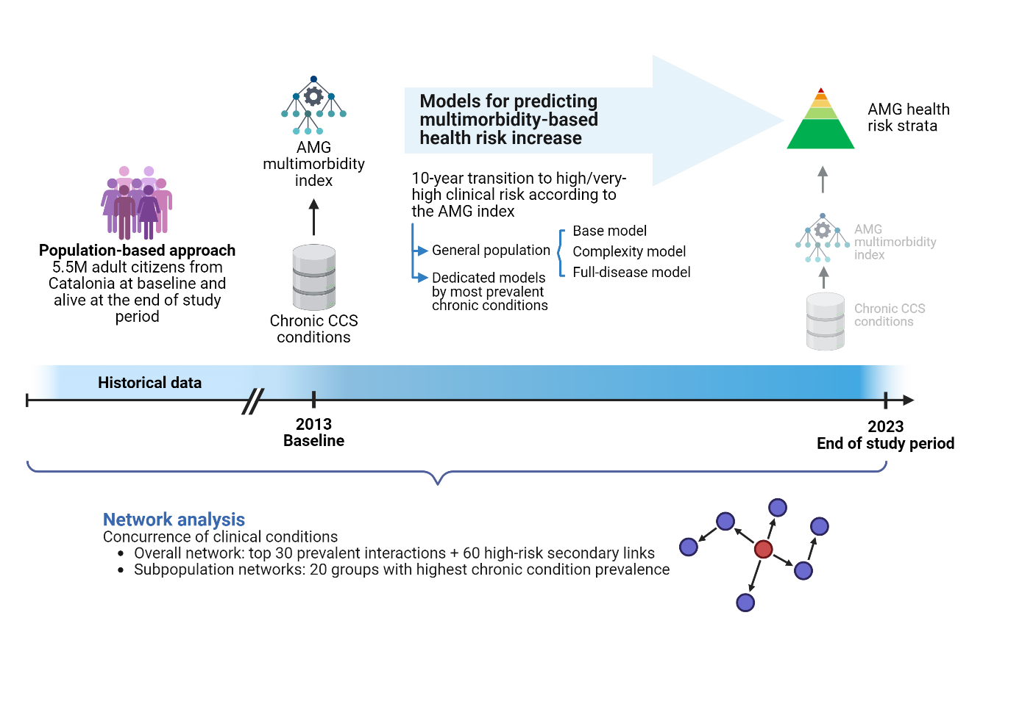

Figure S2. Sankey diagram for transitions across AMG risk groups
Flow of individuals across Adjusted Morbidity Groups (AMG) risk strata (Low <P50, Moderate P50–80, High P80–95, Very high ≥P95) from baseline to the end of the study period, showing the number of individuals in each group and their transitions over time.
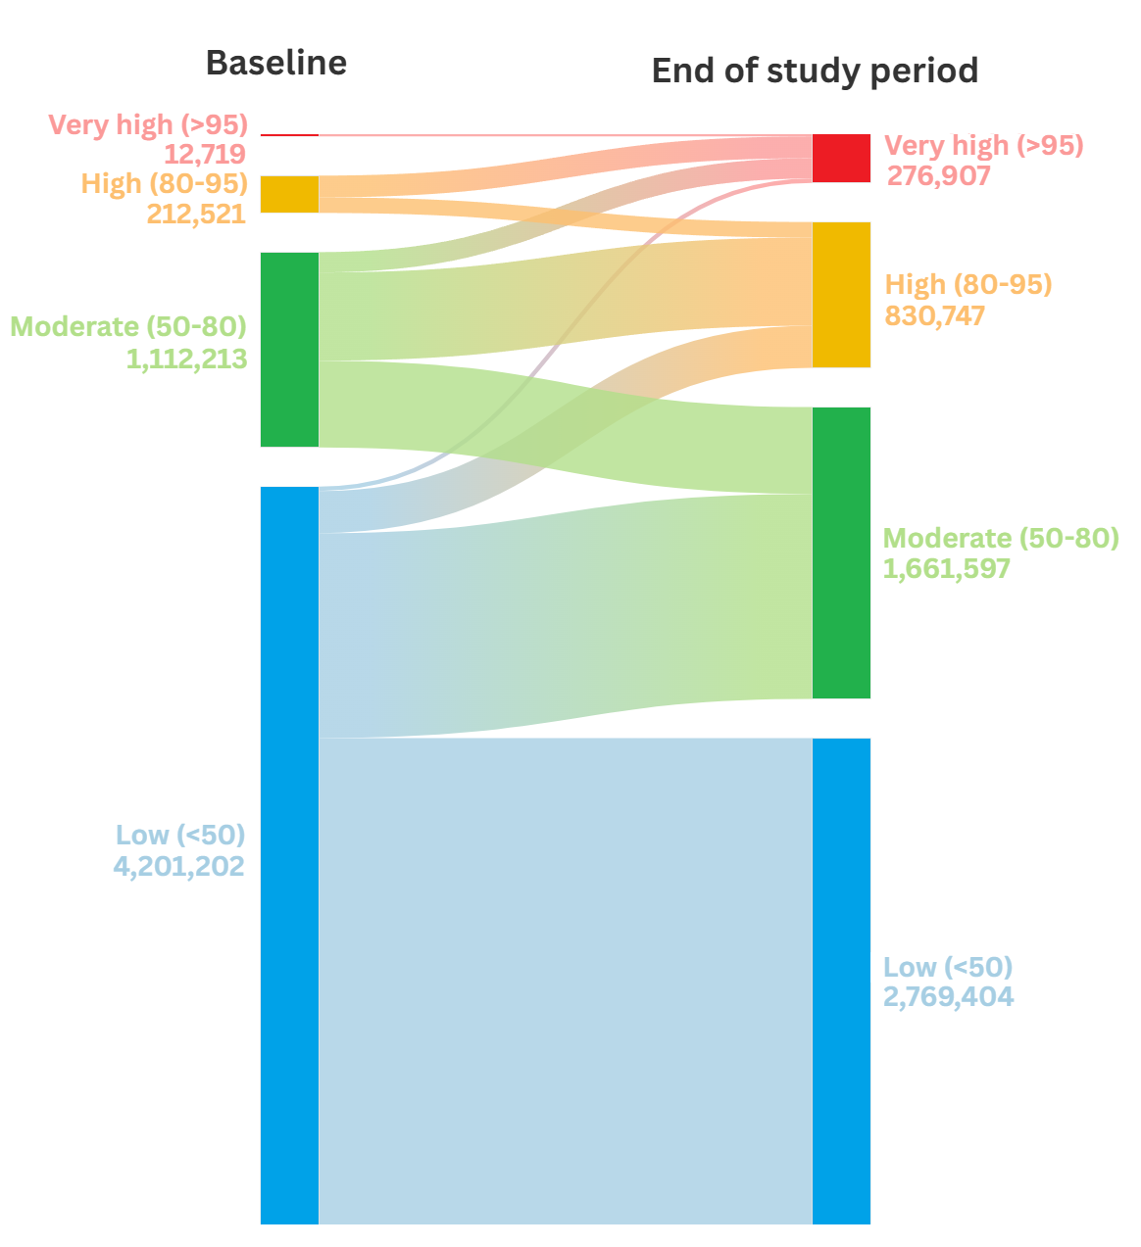

Figure S3. Conditions triggering the transition towards high/very-high risk.
Chronic kidney disease was the most frequent new diagnosis at the time of transition to a higher-risk group (n=59,628; 5.37% of those who progressed), followed by Essential hypertension (n=47,215; 4.25%) and Osteoarthritis (n=41,751; 3.76%).
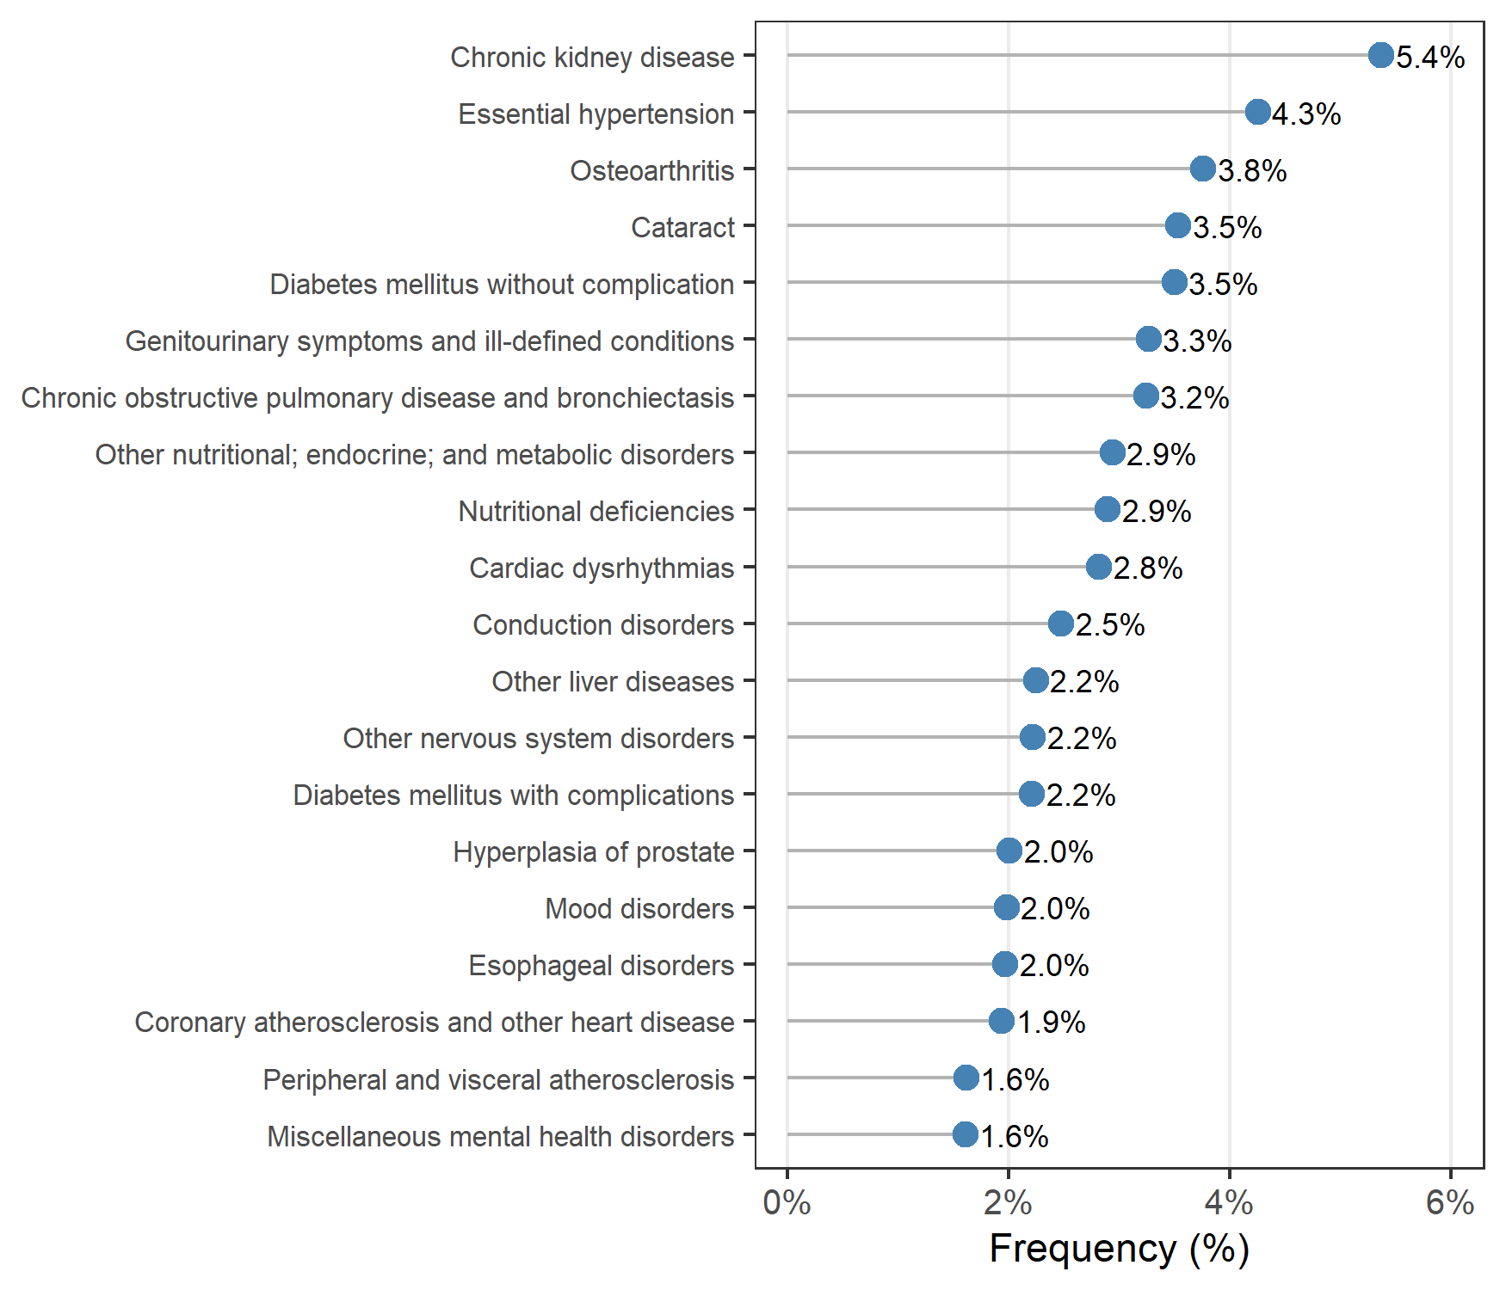

Figure S4. Performance of the models for predicting transition to high/very-high clinical risk (Adjusted Morbidity Groups [AMG] index ≥P₈₀)
Point estimates of the area under the precision-recall and ROC curves for the complexity model in the general (solid line) and dedicated (dotted line) forms for the populations used to produce the dedicated models (i.e., individuals with a given disease).
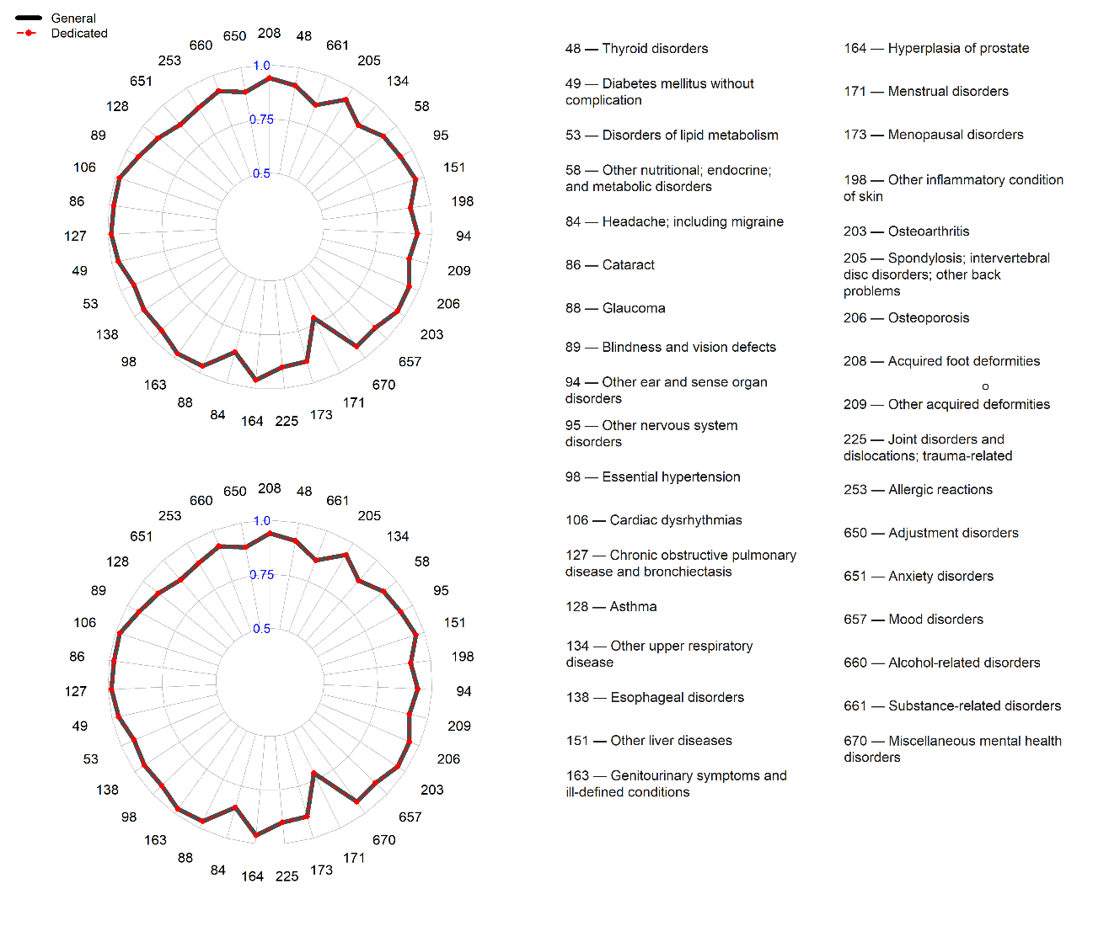

Figure S5. Distribution of diagnostic pairs (A) and triads (B)
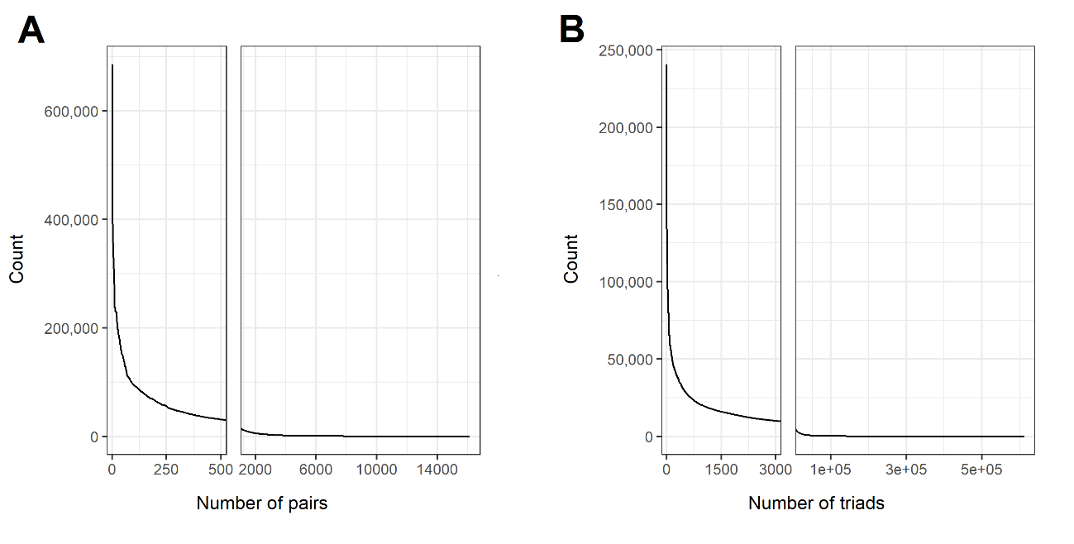

Figure S6. Specific network diseases of the 20 most prevalent conditions at the end of the study period .

Other nutritional; endocrine; and metabolic disorders
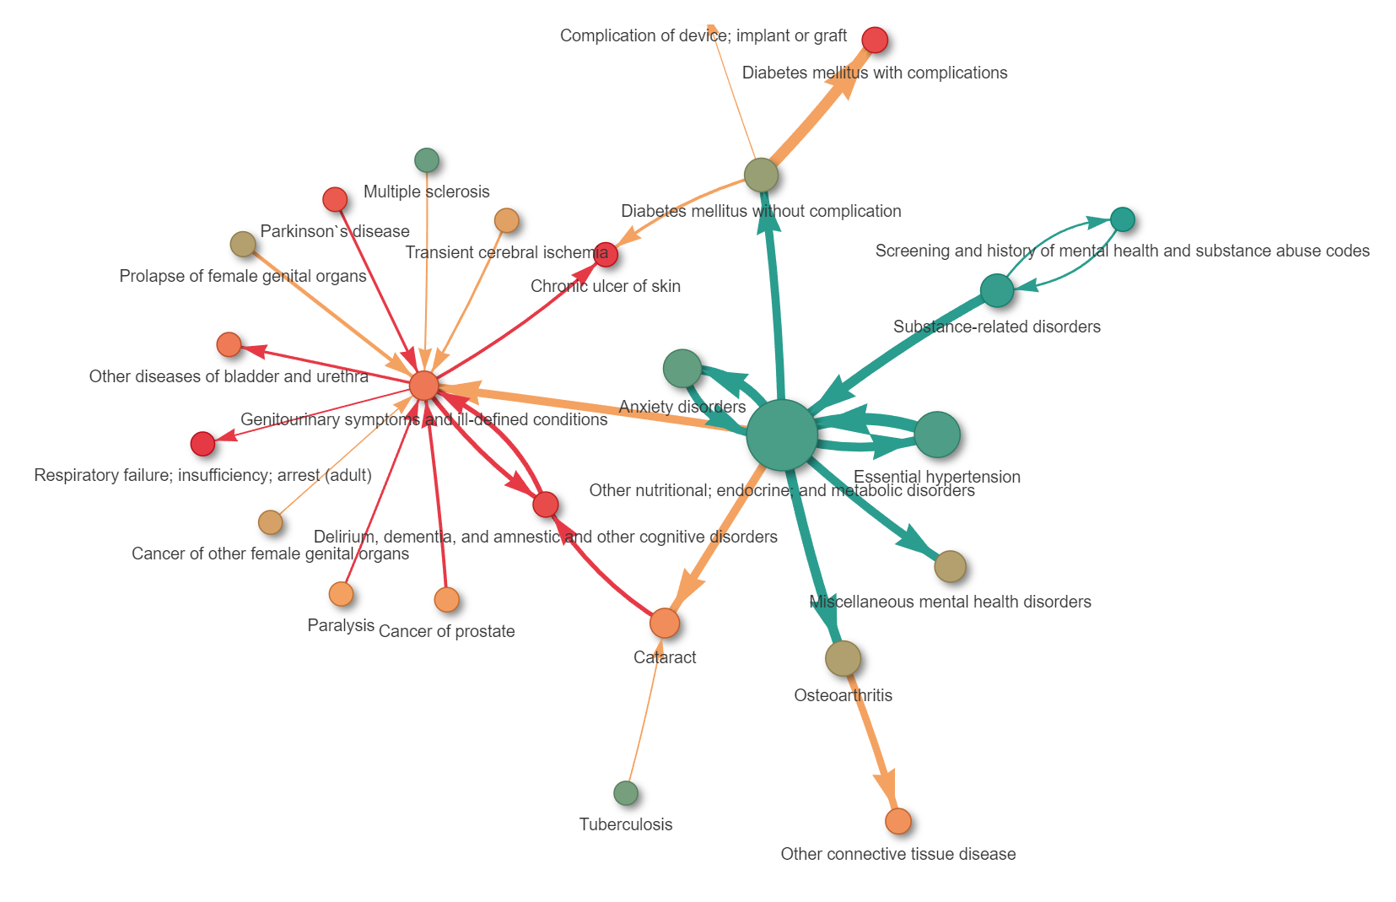

Anxiety disorders
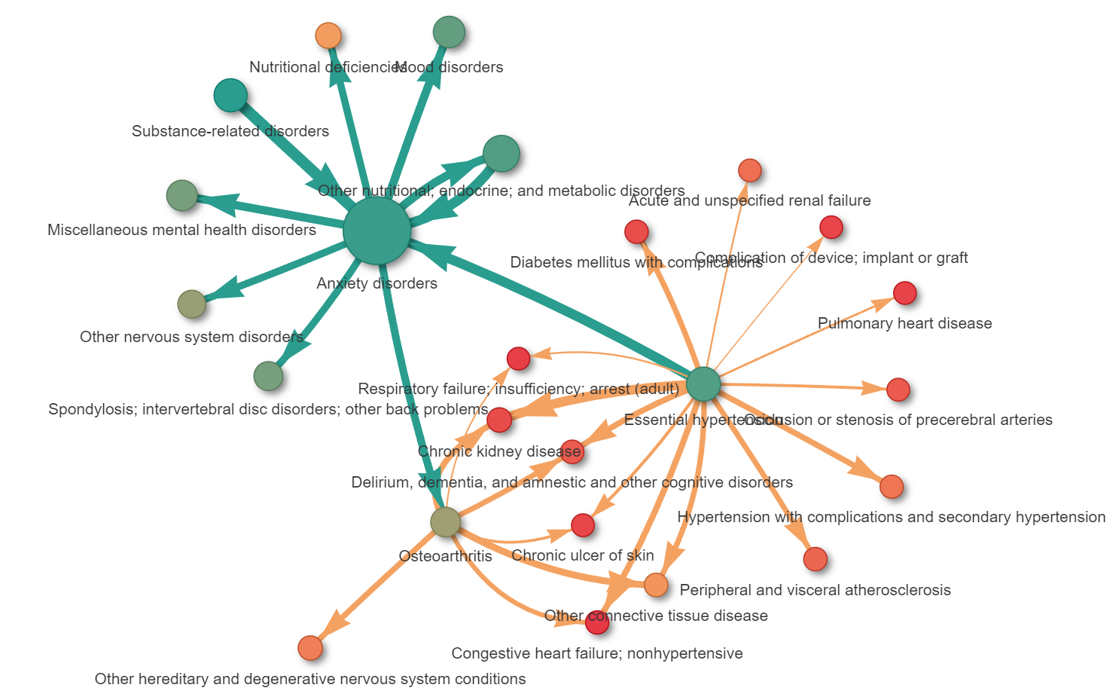

Essential hypertension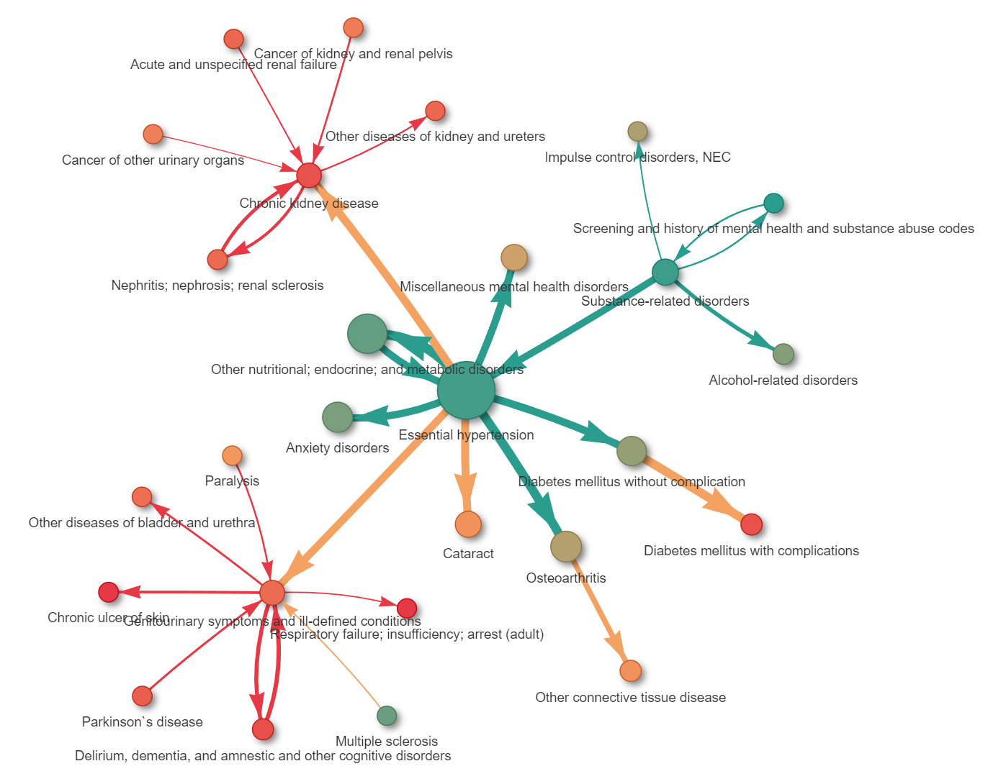

Substance-related disorders
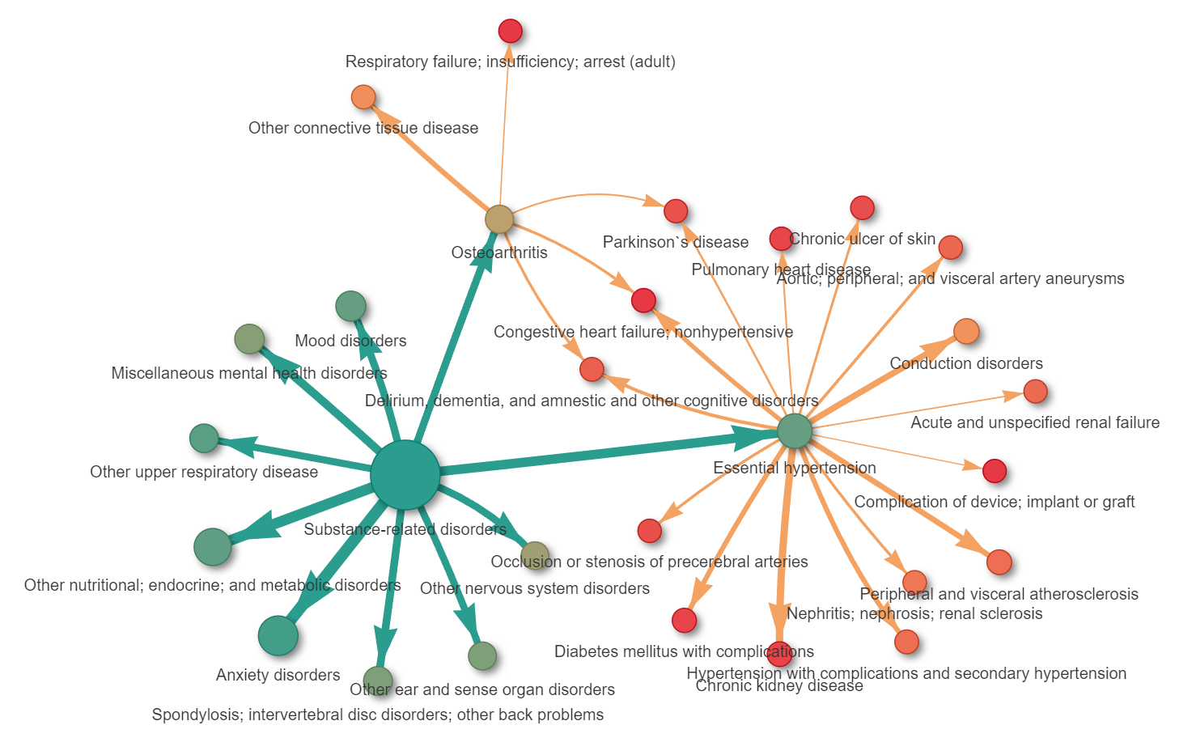

Other Upper respiratory disease
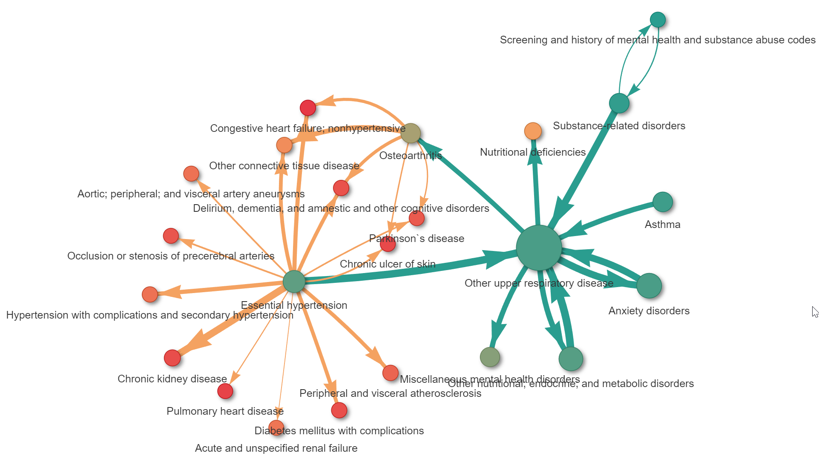

Osteoarthritis
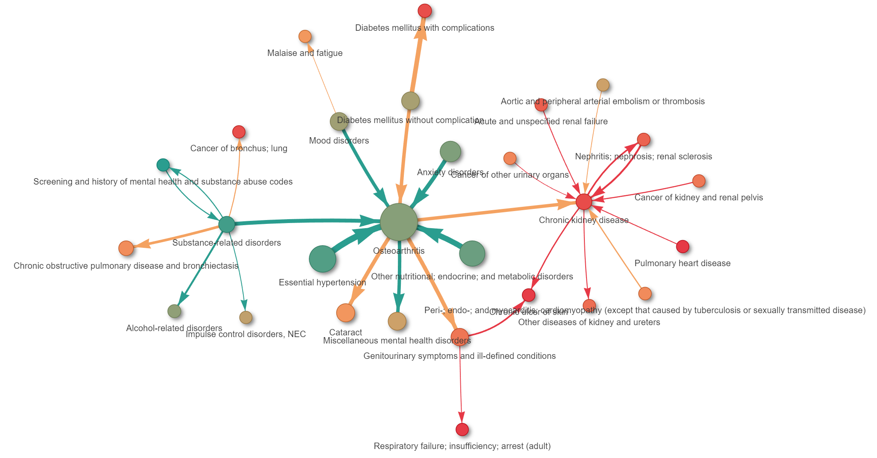

Thyroid disorders
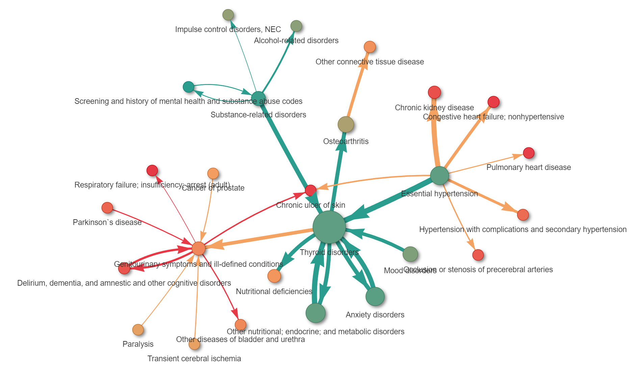

Miscellaneous mental health disorders
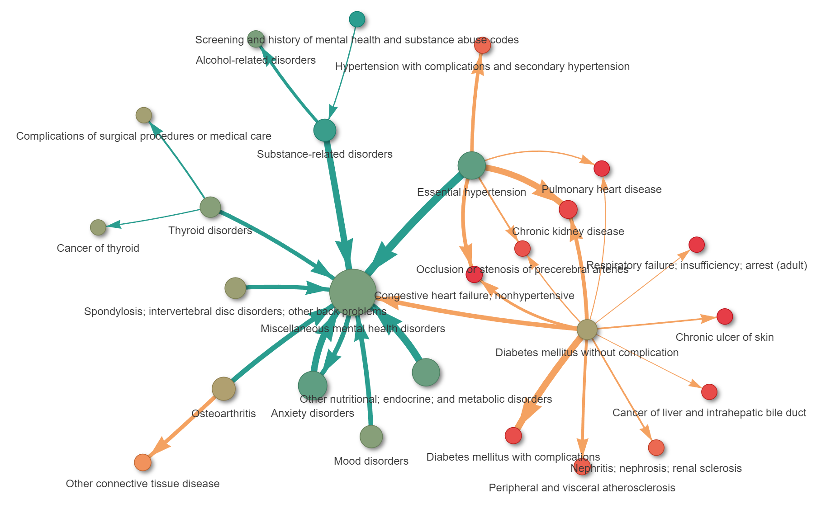

Mood disorders
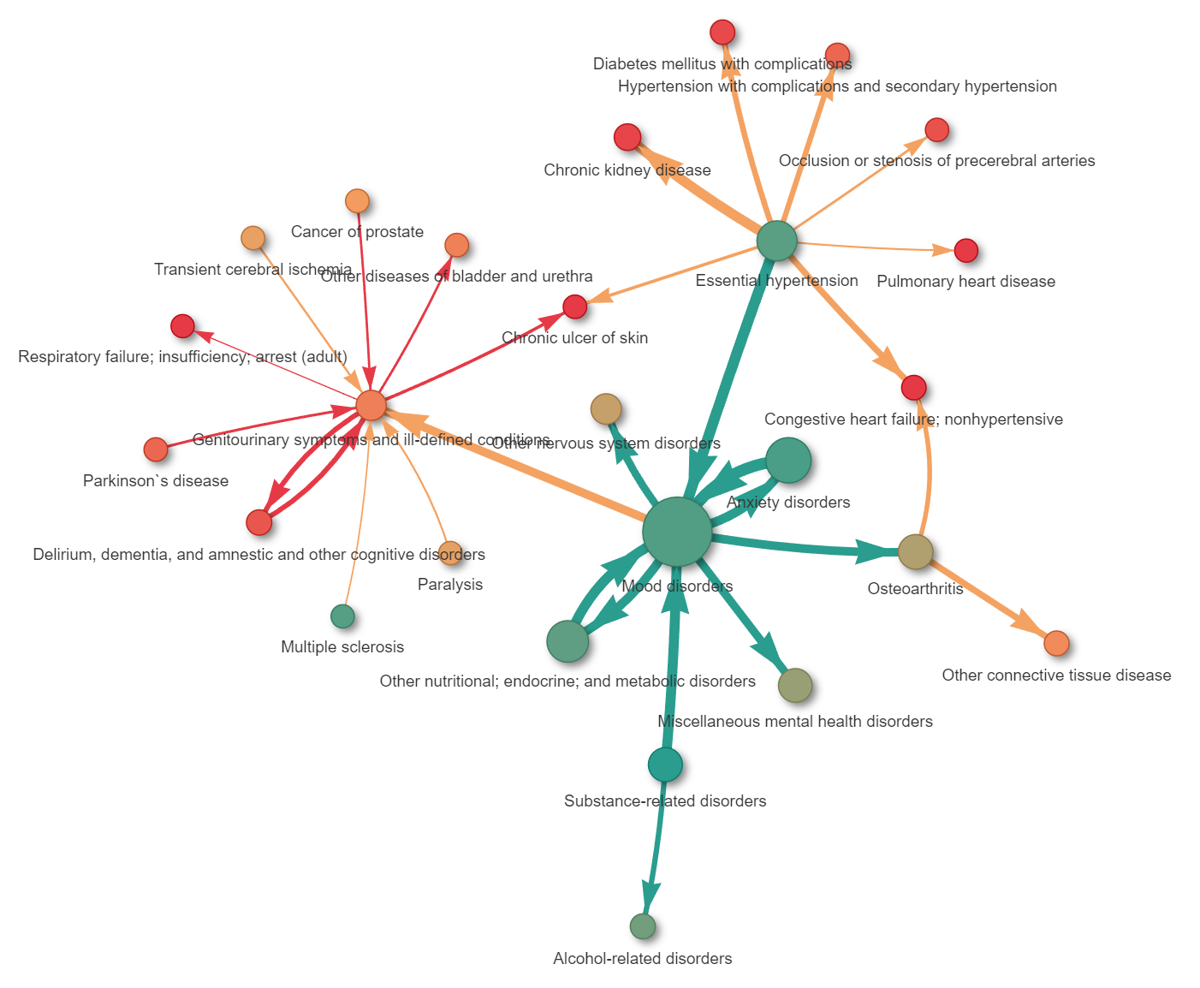

Spondylosis; intervertebral disc disorders; other back problems
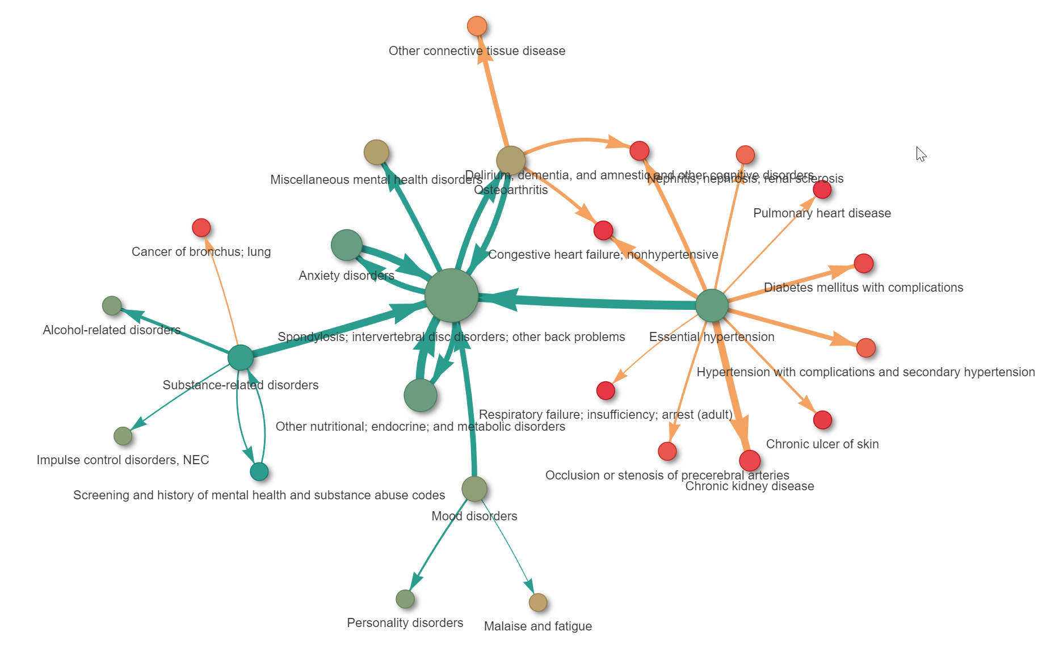

Diabetes mellitus without complication
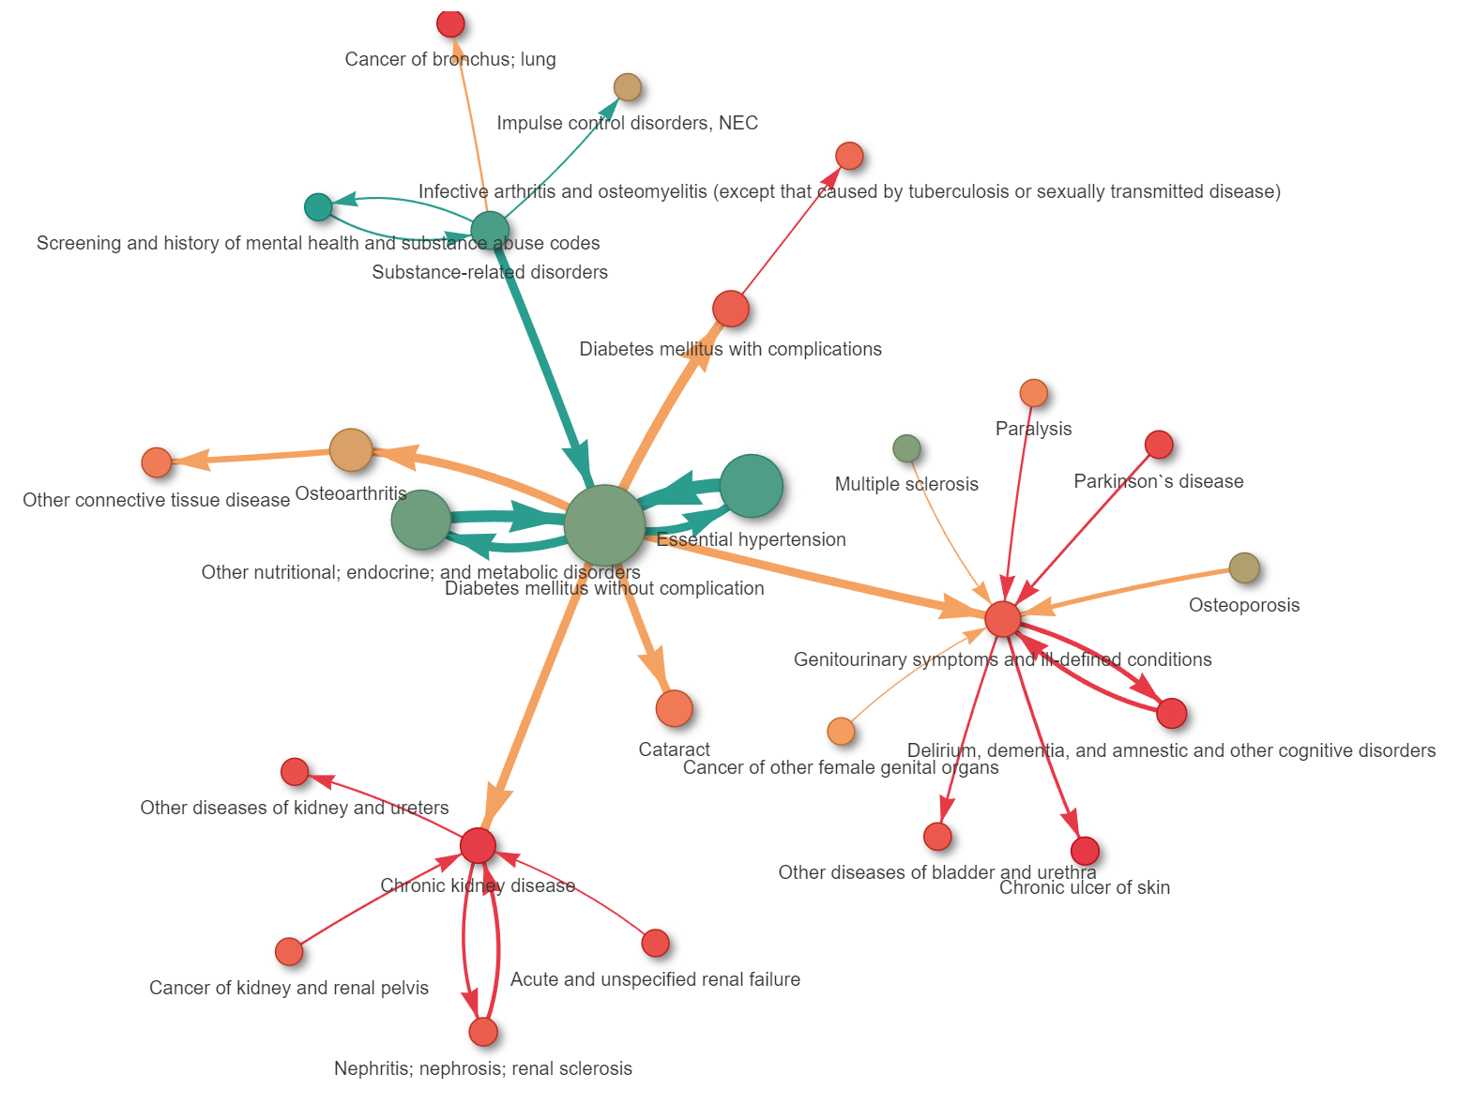

Other ear and sense organ disorders
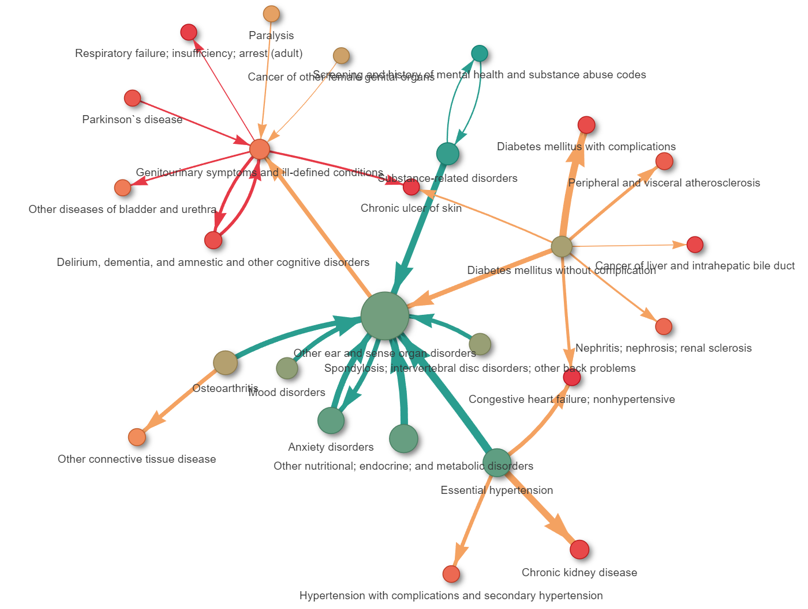
Cataract
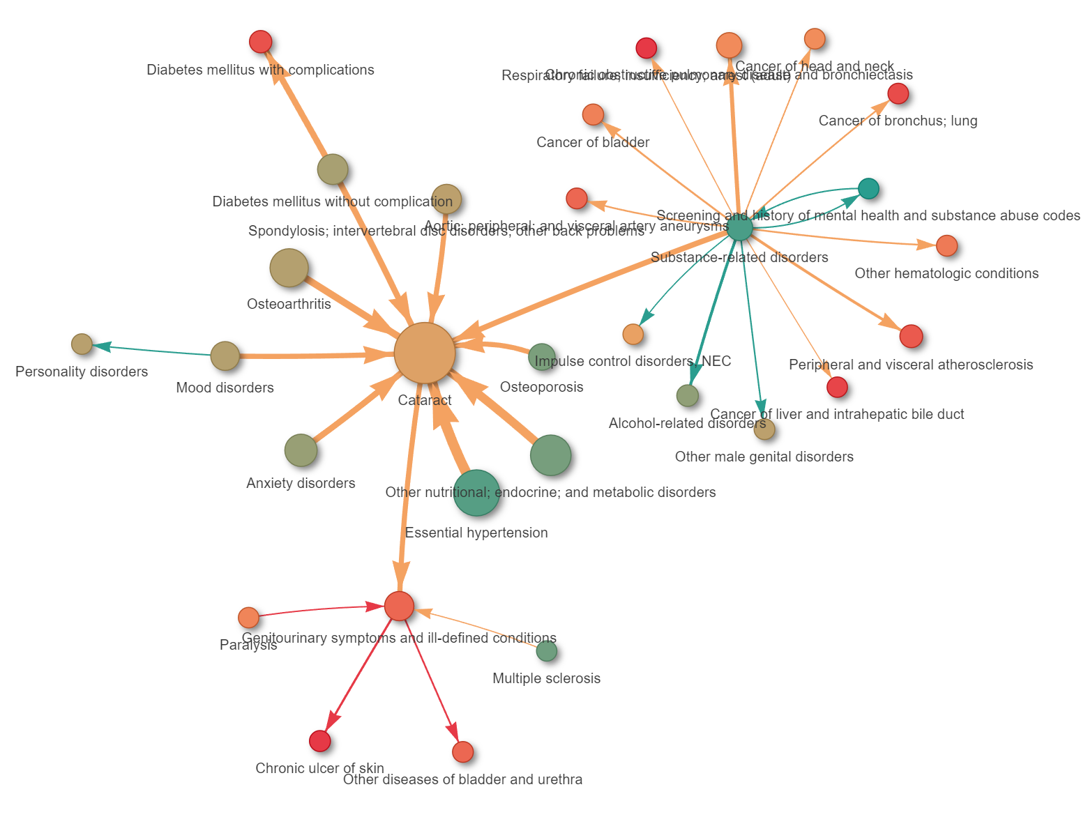

Esophageal disorders
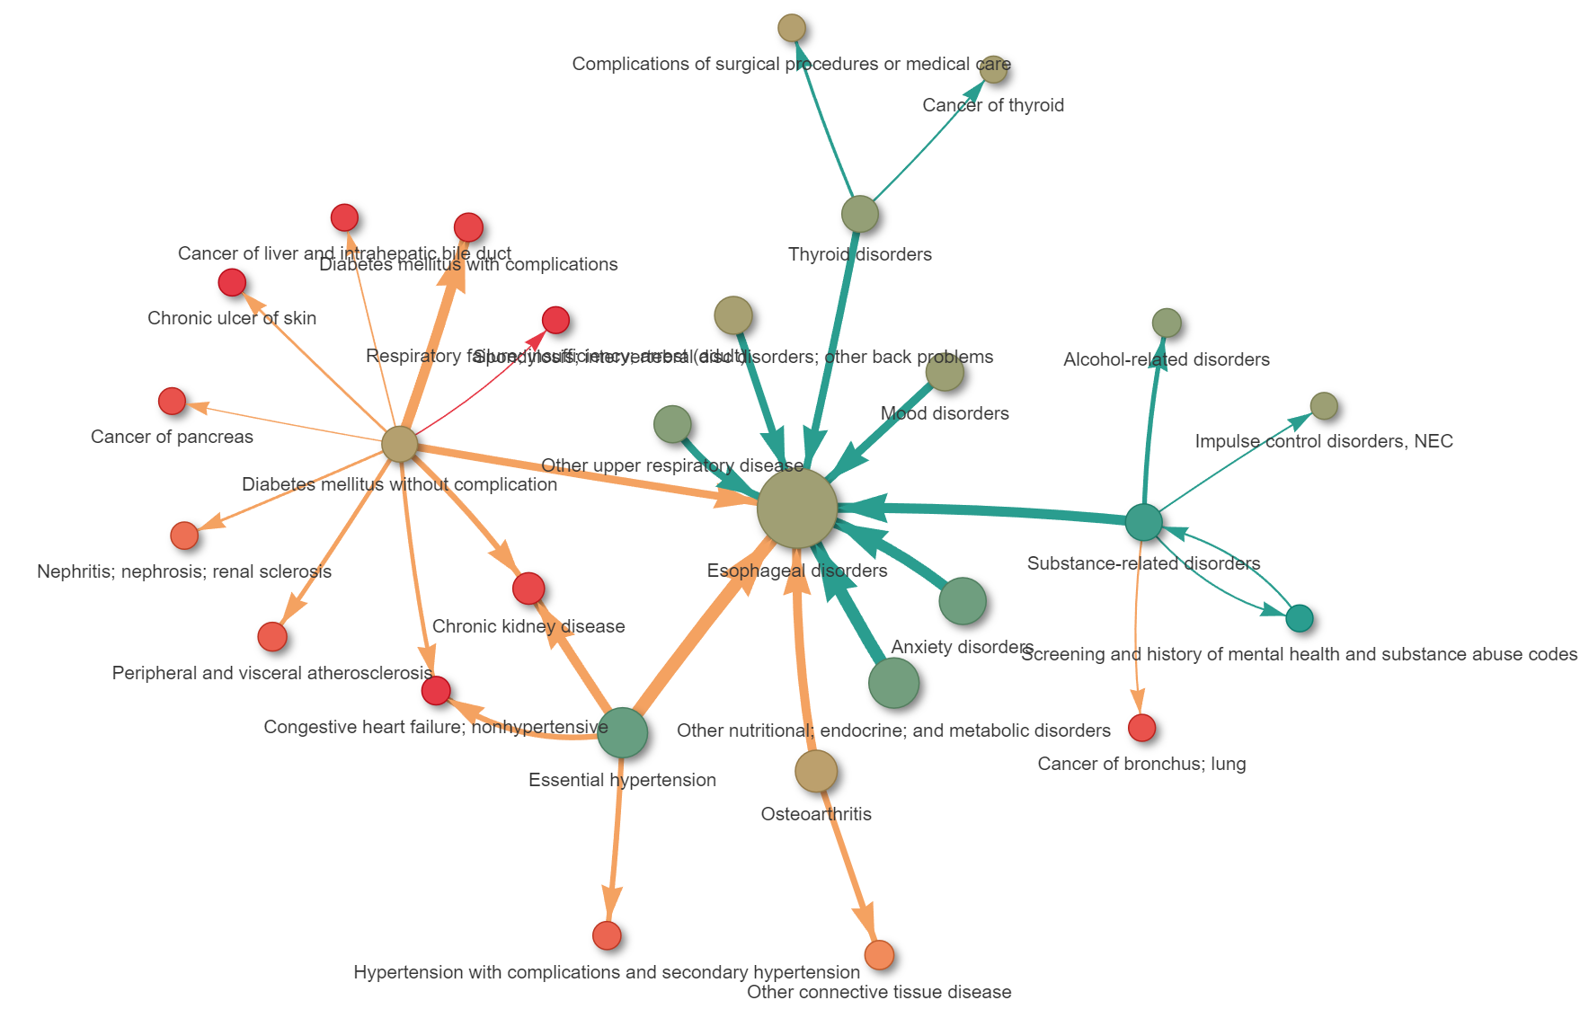
Asthma
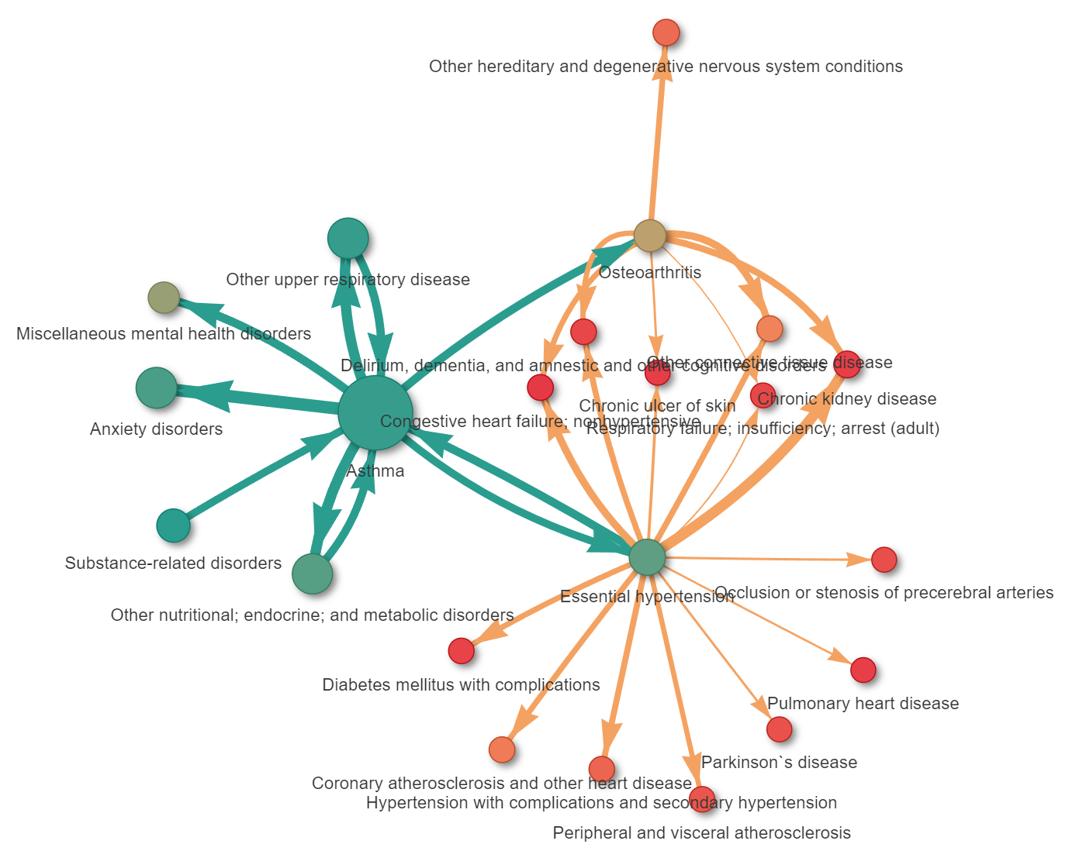

Disorders of lipid metabolism
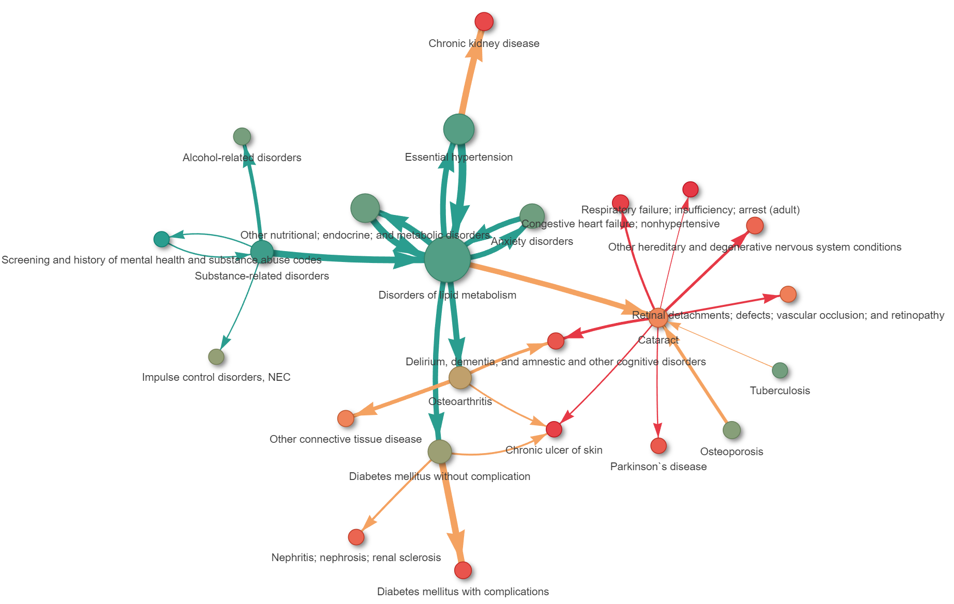
Genitourinary symptoms and ill-defined conditions
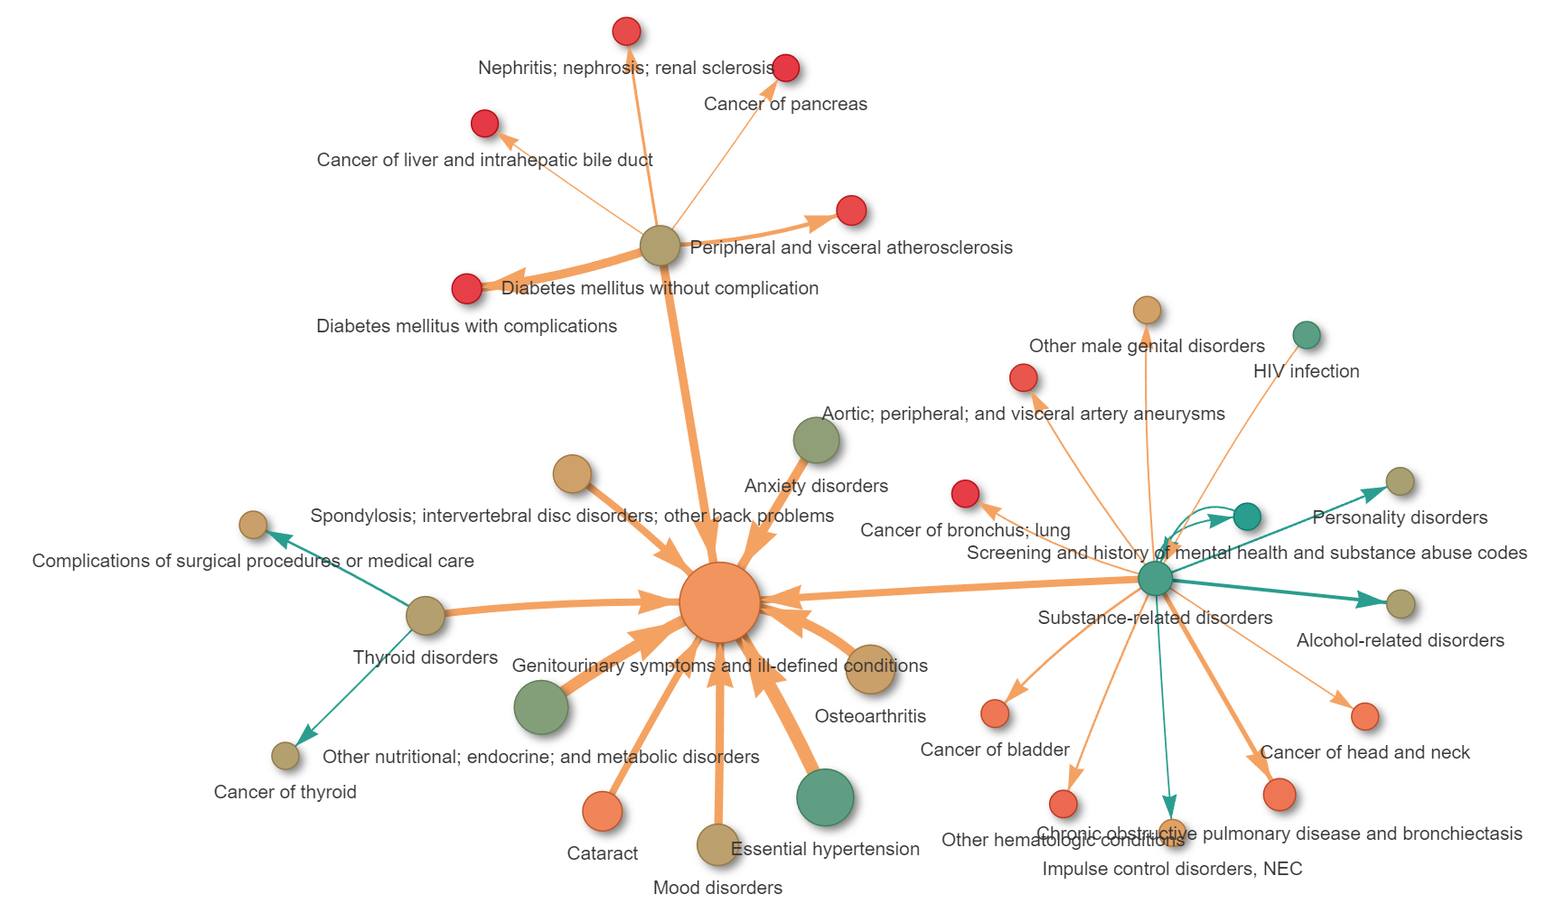

Hyperplasia of prostate
