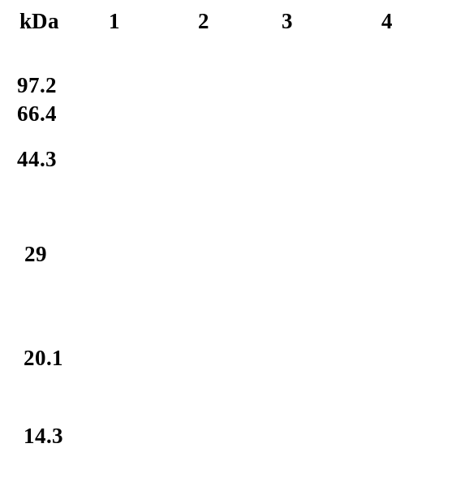
Fig. S1. SDS-PAGE (12%) of recombinant SaCsn46A expressed in E. coli Rosetta (DE3). Lanes 1, molecular weight marker; Lanes 2, supernatant of Rosetta (DE3); Lanes 3, supernatant of crude enzyme extraction; Lanes 4, purified enzyme of recombinant SaCsn46A.

Table S1. Summary of SaCsn46A purification
 | Total activity(U) | Total protein(mg) | Specific activity(U/mg) | Purification fold(times) | Recovery yield(%)
Crude enzyme | 30455.40 | 251 | 121.2 | 1 | 100
Purified enzyme | 23755.20 | 56 | 424.2 | 3.5 | 78

