Supplementary Figure 1. Leave-one-out sensitivity analysis for mortality. Results obtained when each study is left out of each analysis: A) Lin et al; B) Orandi et al; C) Sahi et al.
A
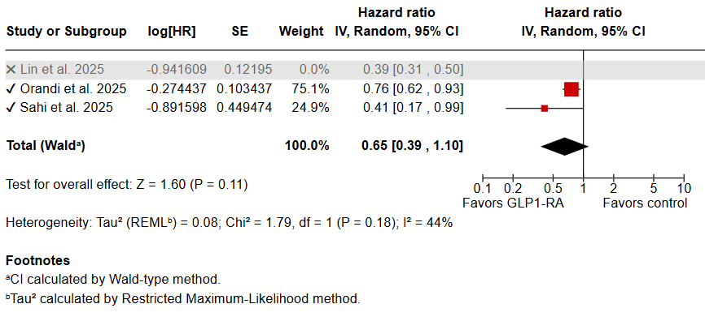
B
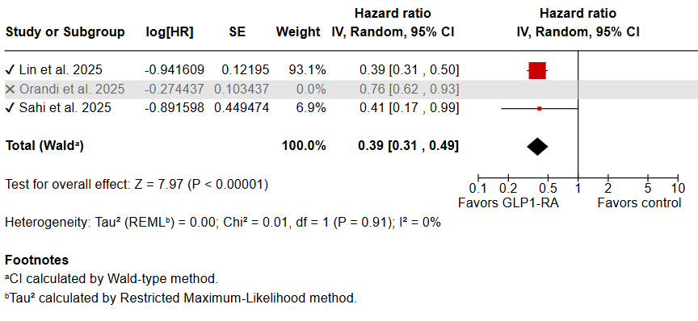

C
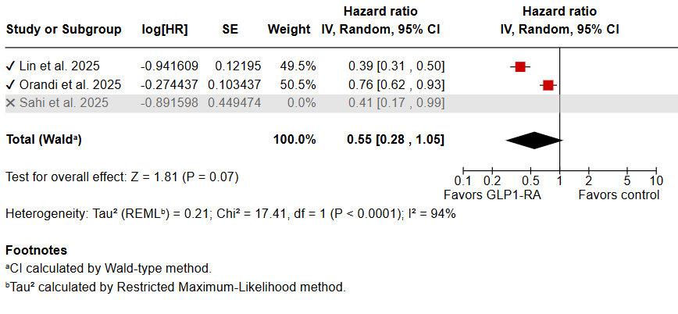

Supplementary Figure 2. Leave-one-out sensitivity analysis for MAKE. Results obtained when each study is left out of each analysis: (A) Cohen et al., (B) Lin et al., (C) Orandi et al.
A
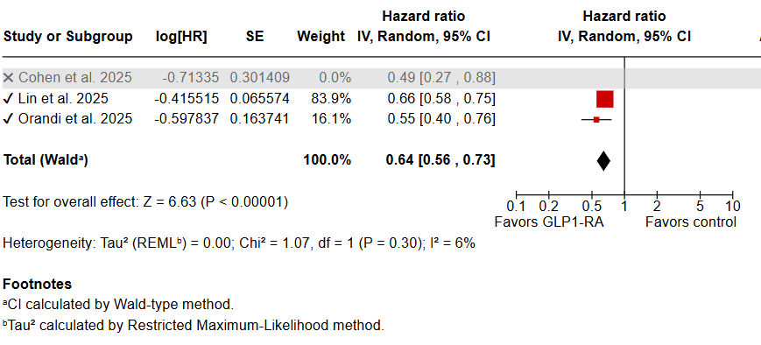

B
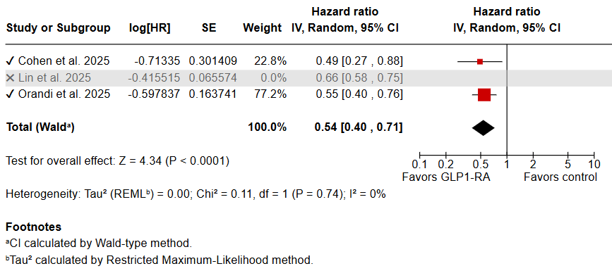

C
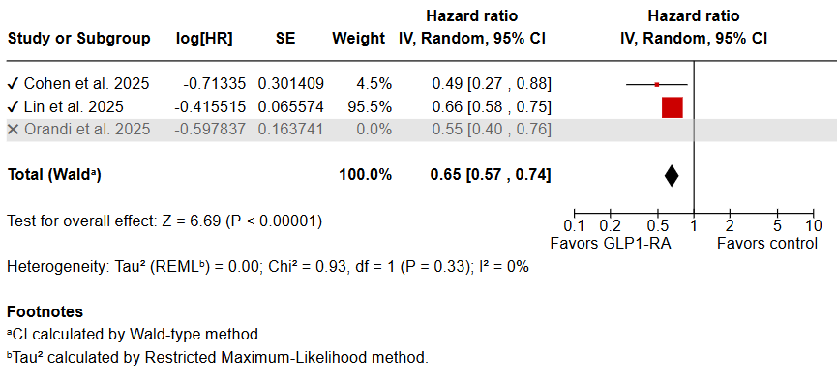

Supplementary Figure 3. Funnel plot for A) mortality and B) MAKEs.
A
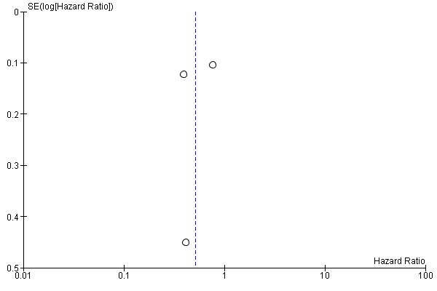

B
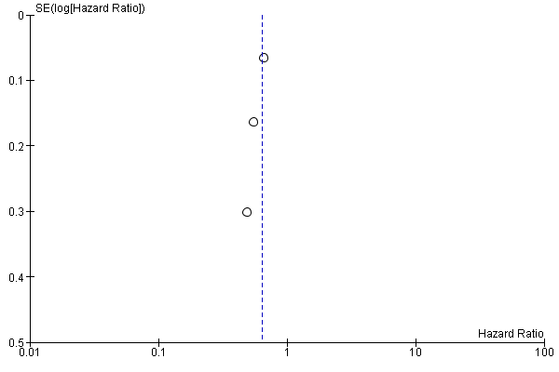

Supplementary Figure 4. Risk of bias summary for observational studies (ROBINS-I).

