Supplementary Information for
Deep Neural Network Inference on an Integrated, Reconfigurable Photonic Tensor Processor
Lennart Meyer¹, Jelle Dijkstra¹, Simon Tebeck¹, Liam McRae¹, Niklas Bahr^{1,2}, Daniel Steinmeyer², Sergey Koptyaev³, Johana Bernasconi³, Nikolay G. Pavlov³, Maxim Karpov³, John D. Jost³, Wolfram Pernice¹, Frank Brückerhoff-Plückelmann¹
¹University of Heidelberg, Kirchhoff-Institut für Physik, 69120 Heidelberg, Germany
²Volkswagen AG, Berliner Ring 2, 38440 Wolfsburg, Germany
³Enlightra, Rue de Lausanne 64, 1020 Renens, Switzerland
Self-injection locking microcombs (SIL)
The traditional scheme for microcomb generation requires the use of tunable narrow-linewidth lasers as pump sources [1]. Such lasers are bulky and prevent the compact integration of soliton microcombs. Another way to generate frequency combs in chip-scale optical microresonators has recently been demonstrated using compact semiconductor lasers and the self-injection locking (SIL) effect [2-6]. The self-injection locking effect is based on light, which is reflected from surface inhomogeneities of the microresonator (Rayleigh back-scattering) [7-9] and directed back to the semiconductor laser diode. This forces the laser to be locked close to the microresonator resonance frequency, suppressing the laser noise while at the same time stabilizing the generation of microcombs.
Optical packaging:
The challenge in terms of optical packaging is the precise alignment of the laser diode to the Si₃N₄ chip (with <0.5µm accuracy), satisfying at the same time the optimal phase for SIL. The Fig.1 illustrates the photos of a proof-of-concept assembly (left) as well as the packaged microcomb source (right).
The Si₃N₄ microresonator with a 485 GHz free spectral range (FSR) was pumped with a hybrid integrated distributed feedback (DFB) semiconductor diode laser to generate the microcombs in SIL. The detailed SIL theory, early experiments are presented in the papers[5-9]. The optical subsystem consists of a ~100 mW DFB laser diode butt-coupled to the Si₃N₄ photonic chip input facet and a single-mode PM fiber pigtail at the opposite facet (Fig.1). This subsystem allows the generation of a low noise soliton microcomb in the SIL. The precise integration between the DFB diode, Si₃N₄ chip, and output optical fiber was done with the precision alignment of all elements satisfying the stringent conditions for SIL [7], such as low loss and optical feedback phase control [8,9]. The single-mode PM FC/APC fiber array was glued to the chip facet for coupling output light from the photonic chip. A custom package (66 x 32 x 15 mm) featuring a thermoelectric cooler (TEC) element as well as a thermistor for temperature control is used to further isolate the optical subsystem and interface the laser diode and TEC, and thermistor with the electronic subsystem.
The performance of the packaged device is shown in Fig.2(a)-(b). Fig.2(a) represents the low noise single soliton microcomb spectrum with ~485 GHz spacing. Fig.2(b) shows the frequency noise performance for the laser diode self-injection-locked to a high-Q Si₃N₄ microresonator. The blue curve is the free-running DFB laser diode, the red curve is the SIL laser diode (central line). The SIL LD achieves two orders of magnitude linewidth suppression at high frequency offsets (>10kHz) and is limited by thermal-refractive noise in the microresonator (represented by the black dashed line [10]). The Lorentzian linewidth for the comb's teeth is around 2 kHz. The spikes on the trace are artefacts originating from the measurement setup.

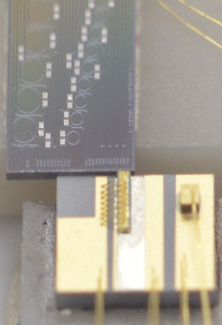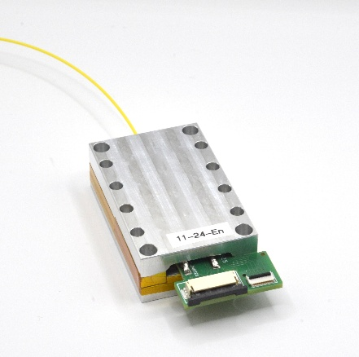
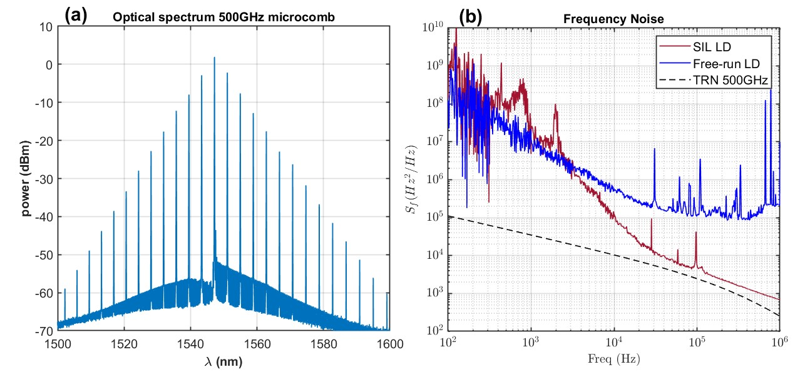
Fig 1: Optical packaging of the microcomb. Left: LD is butt-coupled to the Si3N4 chip from one side and output pigtailed fiber from another side. Right: Generic packaged with SIL microcombs features TEC element and thermistor.
Fig 2: Characterisation of the microcomb. (a), Optical spectrum of 500 GHz SIL microcomb. (b), Frequency noise suppression of SIL laser: blue curve – free run DFB laser, red curve – SIL, black dashed curve is thermorefractive noise for 500 GHz Si₃N₄.

PCB Design
A carrier PCB was designed to establish an electrical connection to the chip. The chip is glued to the bare copper area in the center and connected to the PCB via bond wires. The input modulation voltages from the RF-DACs enter the board differentially via Samtec ARC6 connectors and are transitioned to single-ended signals using local baluns (Mini-Circuits’ TCM2-43X+). All input modulators share a common connection to the bias voltage, which is decoupled with capacitors located directly underneath. The photodiode output currents are routed to SMA connectors at the left edge to be connected to external TIAs. The TIA inputs provide a 50R path to ground, while the other end of the photodiodes shares a common, locally decoupled bias voltage like the input EAMs. The TIA outputs are connected to a second set of SMA connectors, transitioned to differential signals using the same baluns as for the inputs and then routed to ARC6 connectors to be connected to the RF-ADCs. Although not high-speed, the bias and weight voltages use the same type of connector. All traces are impedance-matched to 50R (single-ended) or 100R (differential) and groupwise length-matched.
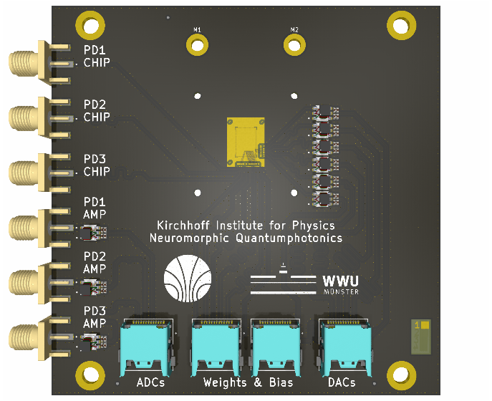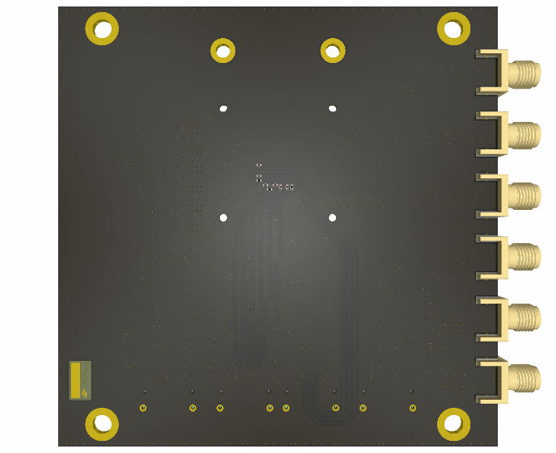
Fig. 3: Printed Circuit Board for electronic interfacing
Input Encoding
We are using a zero-mean, four-sample, return-to-zero, alternating encoding, such that the TIA’s see only changes around the optical bias. That lets us represent signed values even though the modulator only attenuates power.
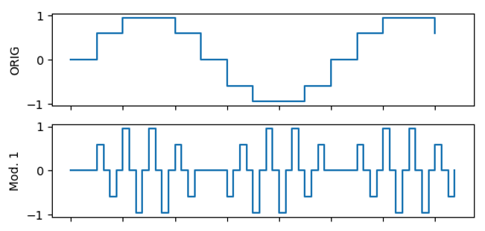
Fig. 4: Modulation Schemes. A single symbol is encoded into four samples. We send 4 samples per symbol, two samples with the value of the symbol but with flipped signs and insert zeros in between
Our desired input symbol is
$$k_{n}∈\left[-1,1\right]$$
We encode it into 4 DAC samples without a DC part:
$$s_{n}=\left[s_{4n+1},s_{4n+2},s_{4n+3},s_{4n+4}\right]=\left[k_{n},0,-k_{n},0\right]$$
We bias the EAM at $V_{b}$ and scale the DAC swing by $V_{p}$, applying the voltage $v_{m}$ at the modulator
$$v_{m}=V_{b}+V_{p}*s_{m}$$
Assuming linear transmission around the bias point
$$T\left(v_{m}\right)≈T_{b}+αV_{p}s_{m}$$
With $α=\frac{dT}{dV}|V_{B}$.
The photocurrent is
$$i_{m}=RP_{in}T\left(v_{m}\right)$$
With the photodiode responsivity R and the input optical power $P_{in}$.
The output after the AC-coupled TIA is
$$y_{m}=GRP_{in}αV_{p}s_{m}=C*s_{m}$$
With the gain of the TIA G.
We drive the ADC at half the speed of the DAC and sample at the non-zero time slots:
$${\tilde{k}}_{n}=\left(y_{4n+1}-y_{4n+3}\right)=C\left(s_{4n+1}-s_{4n+3}\right)$$
The two nonzero samples produce opposite-signed fluctuations around the bias, so the AC-coupled output carries a signed value even though the optical power itself is non-negative.
Normalizing with $\frac{1}{2C}$recovers the encoded symbol
$\frac{1}{2C} * {\tilde{k}}_{n}$= $\frac{1}{2C} * C\left(s_{4n+1}-s_{4n+3}\right)=\frac{1}{2C} * C\left(k_{n}-\left(-k_{n}\right)\right)=k_{n}$
Balanced Weight Encoding
Balanced encoding uses one row as a reference. The FPGA subtracts the reference transmission from the main transmission, so the difference is a signed value. Let w_{p}^{max} and w_{p}^{min} be the physical weights at maximum and minimum transmission. Define the neutral level
$$w_{p}^{ref}=\left(w_{p}^{max}+w_{p}^{min}\right)/2$$
and the span
$$Δw_{p}=w_{p}^{max}-w_{p}^{min}$$
two physical weights $w_{p1}$, $w_{p2}$ encode a target weight w in [−1, 1]
$$w=\left(w_{p1}-w_{p2}\right)/Δw_{p}, \\ w_{p1}=w_{p}^{ref}+\left(Δw_{p}/2\right)*w,$$
$$w_{p2}=w_{p}^{ref}-\left(Δw_{p}/2\right)*w$$We symmetrically offset the reference row around w_{p}^{ref}, so the main minus reference photocurrent spans $\left[-Δw_{p},Δw_{p}\right]$
Weight and Crosstalk Calibration
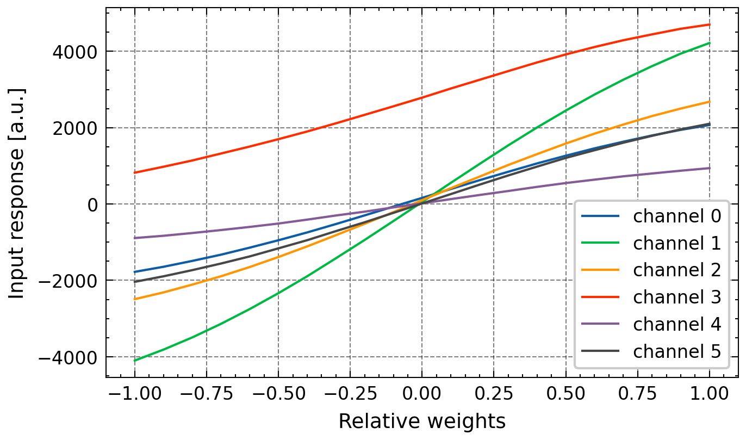
Fig. 5: Typical weight map. The measurement captures the input responses of each channel for the whole range of relative weights. The nonlinear scaling becomes obvious, resembling the EAM transmission curve as well as the strongly inhomogeneous behaviour between different channels. The red curve indicates a channel where the reference row in the crossbar array is not working; therefore, only positive weights can be set with that specific channel.
Weight-map calibration:
For each channel c, we sweep the relative drive r ∈ [−1,1] while holding other channels at zero and record the input response y.
$$\vec{X}*\vec{w}=1*{\vec{e}}_{ctest}*\sum_{i}{w_{i}}*{\vec{e}}_{i}=w_{ctest}$$
This yields a per-channel calibration curve f_{c}: r ↦ y, sampled on a fixed grid r_{j} and stored as a matrix m_{c,j}=f_{c}(r_{j}). The common realizable target range is the intersection of per-channel ranges [min_{j} m_{c,j},max_{j} m_{c,j}].
Weight setting:
Given desired w, we linearly map w into target units t inside the common feasible range, then obtain the required drives by inverting each channel’s calibration curve via interpolation, ρ_{c}=f_{c}⁻¹(t_{c}). When available, a measured linear crosstalk matrix C is applied in a single pass as t_{c}←t_{c}−∑_{k}C_{c,k}ρ_{k}​ before reinversion.
Crosstalk analysis and correction:
Full multidimensional mapping is infeasible, so correlations are measured pairwise. For each test channel, its map is remeasured while stepping one reference channel through 11 values with all others at zero, and this is repeated so every channel serves once as the reference. Linear fits without intercept provide a slope for each test–reference pair, which is then used as a linear correction when choosing target weights. The strongest couplings are between physically adjacent connectors. For larger arrays, it is efficient to measure only neighboring pairs.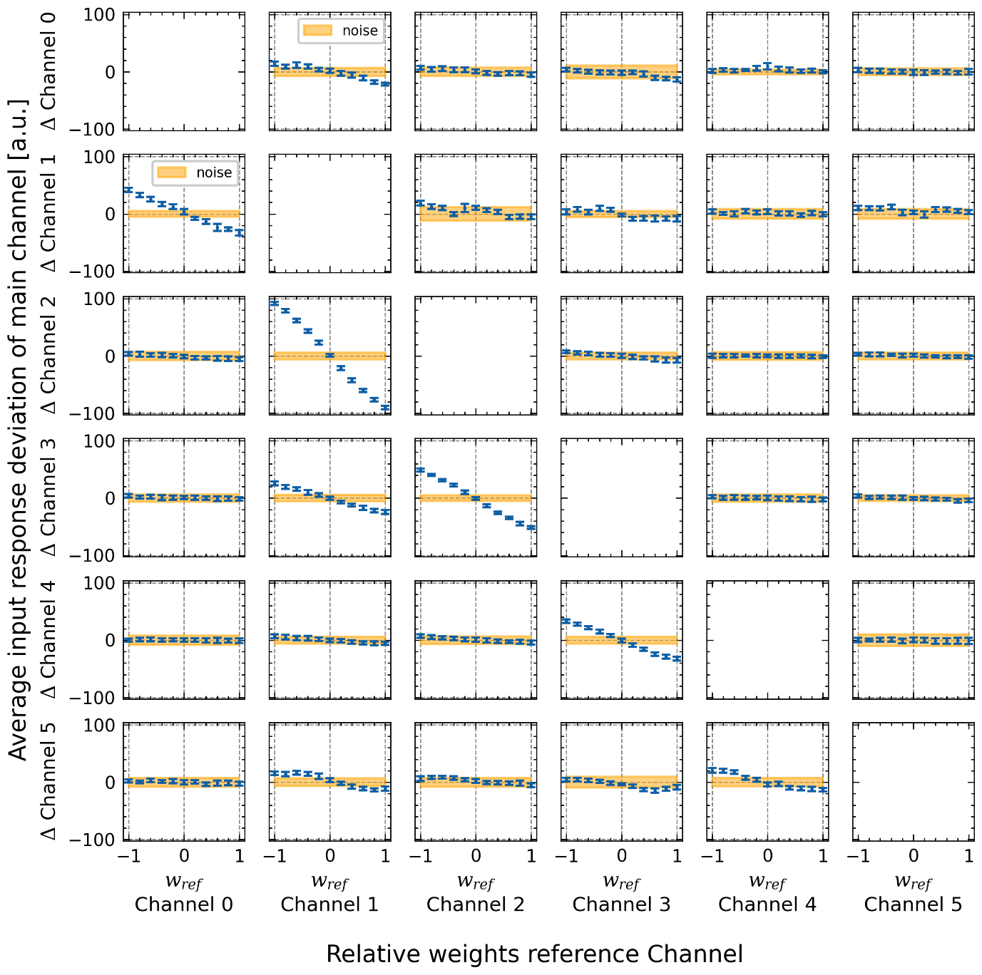
Fig. 6: Typical crosstalk measurement. The x-axis shows the relative weights of the respective reference channel, and the y-axis depicts the average deviation of the weight map in units of the output response for the respective main channels. The orange region indicates deviations within the weight mapping that can be explained just by the ground noise of the system.
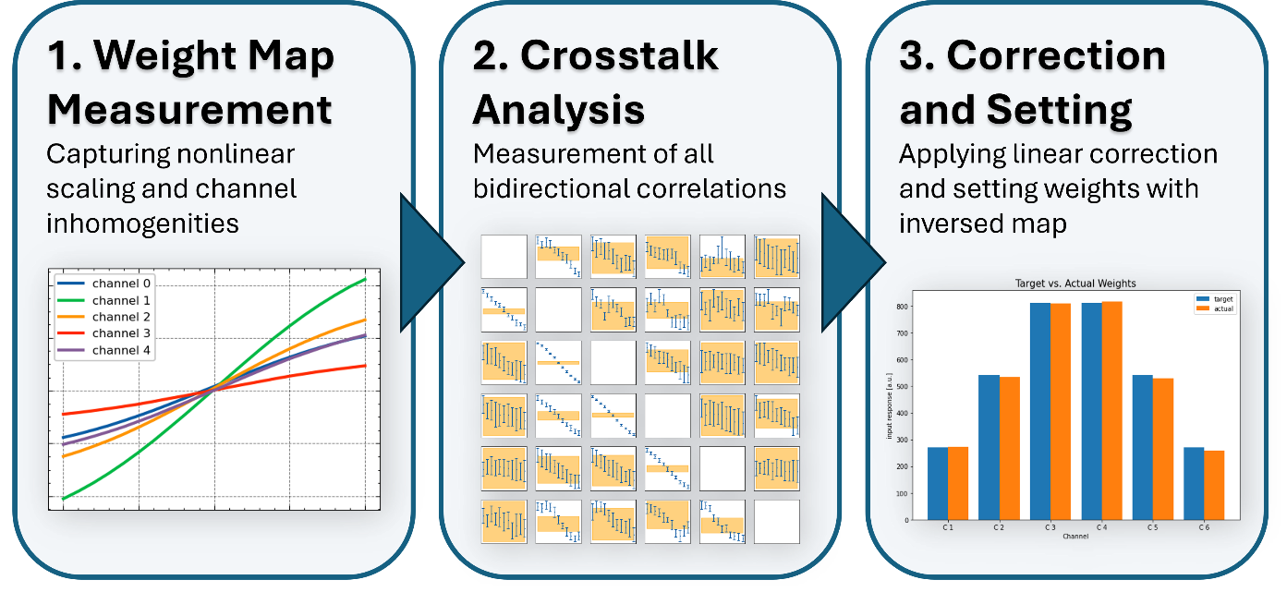
Fig. 7: Flowchart of the weight mapping

References
- T. J. Kippenberg et al.,Dissipative Kerr solitons in optical microresonators. Science 361,(2018).
- Stern, B., Ji, X., Okawachi, Y. et al. Battery-operated integrated frequency comb generator. Nature 562, 401–405 (2018)
- Raja, A.S., Voloshin, A.S., Guo, H. et al. Electrically pumped photonic integrated soliton microcomb. Nat Commun 10, 680 (2019).
- Shen, B., Chang, L., Liu, J. et al. Integrated turnkey soliton microcombs. Nature 582, 365–369 (2020).
- Voloshin, A.S., Kondratiev, N.M., Lihachev, G.V. et al. Dynamics of soliton self-injection locking in optical microresonators. Nat Commun 12, 235 (2021).
- Chao Xiang et al., Laser soliton microcombs heterogeneously integrated on silicon. Science 373, 99-103(2021).
- Oraevsky A N, Yarovitsky A V and Velichansky V L 2001 Quant. El. 31 897
- N. M. Kondratiev, V. E. Lobanov, A. V. Cherenkov, A. S. Voloshin, N. G. Pavlov, S. Koptyaev, and M. L. Gorodetsky, "Self-injection locking of a laser diode to a high-Q WGM microresonator," Opt. Express 25, 28167-28178 (2017)
- N. M. Kondratiev, V. E. Lobanov, E. A. Lonshakov, N. Yu. Dmitriev, A. S. Voloshin, and I. A. Bilenko, "Numerical study of solitonic pulse generation in the self-injection locking regime at normal and anomalous group velocity dispersion," Opt. Express 28, 38892-38906 (2020)
- G. Huang, E. Lucas, J. Liu, A. S. Raja, G. Lihachev, M. L. Gorodetsky, N. J. Engelsen, and T. J. Kippenberg, "Thermorefractive noise in silicon-nitride microresonators. " Physical Review A, 99(6), 061801, (2019).

