Supplementary Information

Survival in the GLY experiment
Table S1A. Statistical analysis of survival in the GLY experiment. Number of bees (N), observed and expected deaths, and contribution to the log-rank test statistic ((O−E)²/V) for each treatment in the GLY experiment. The treatment groups consisted of honey bees exposed to one of three different concentrations of GLY (0 mg/l, 1.25 mg/l, 2.5 mg/l) combined with one of two combinations of pollen types (B-D series and S-D series). The log-rank test indicated significant differences in survival among groups (Chisq = 20.3, p = 0.001). Pairwise comparisons between concentrations within each pollen series are also shown.

Log-rank test | survdiff(Surv(time, status) ~ group, data)
Group | N | Observed | Expected | (O−E)^2/V
0 mg/l * B-D series | 481 | 49 | 40.70 | 2.05
1.25 mg/l * B-D series | 483 | 30 | 42.80 | 4.72
2.5 mg/l * B-D series | 495 | 32 | 43.70 | 3.90
0 mg/l * S-D series | 378 | 52 | 33.00 | 13.01
1.25 mg/l * S-D series | 487 | 39 | 42.30 | 0.31
2.5 mg/l * S-D series | 472 | 41 | 40.60 | 0.01
 |  |  | Chisq | 20.30
 |  |  | p | 0.001
Comparisons | pairwise_survdiff(Surv(time, status) ~ concentration, data = subset(data, serie =="B-D series"), p.adjust.method = "holm")
 |  |  |  | p-value
0 mg/l - 1.25 mg/l |  |  |  | 0.058
0 mg/l - 2.5 mg/l |  |  |  | 0.058
1.25 mg/l - 2.5 mg/l |  |  |  | 0.861
Comparisons | pairwise_survdiff(Surv(time, status) ~ concentration, data = subset(data, serie =="S-D series"), p.adjust.method = "holm")
 |  |  |  | p-value
0 mg/l - 1.25 mg/l |  |  |  | 0.027
0 mg/l - 2.5 mg/l |  |  |  | 0.057
1.25 mg/l - 2.5 mg/l |  |  |  | 0.689

Survival in IMI experiment
Table S1B. Statistical analysis of survival the IMI experiment. Number of bees (N), observed and expected deaths, and contribution to the log-rank test statistic ((O−E)²/V) for each treatment in IMI experiment. The treatment groups consisted of honey bees exposed to one of three different concentrations of IMI (0 µg/l, 1 µg/l, 10 µg/l) combined with one of two combinations of two pollen types (B-D series and S-D series). The log-rank test indicated significant differences in survival among groups (Chisq = 84.7, p < 0.001). Pairwise comparisons between concentrations within each pollen series are also shown in the table.

Log-rank test | survdiff(Surv(time, status) ~ group, data)
Group | N | Observed | Expected | (O−E)^2/V
0 µg/l * B-D series | 538 | 69 | 80.40 | 2.12
1 µg/l * B-D series | 575 | 129 | 80.10 | 39.26
10 µg/l * B-D series | 432 | 91 | 59.40 | 20.64
0 µg/l * S-D series | 304 | 16 | 45.30 | 22.27
1 µg/l * S-D series | 363 | 35 | 53.20 | 7.49
10 µg/l * S-D series | 373 | 33 | 54.60 | 10.36
 |  |  | Chisq | 84.70
 |  |  | p | < 0.001
Comparisons | pairwise_survdiff(Surv(time, status) ~ concentration, data = subset(data, serie == "B-D series"), p.adjust.method = "holm")
 |  |  |  | p-value
0 µg/l - 1 µg/l |  |  |  | < 0.001
0 µg/l - 10 µg/l |  |  |  | < 0.001
1 µg/l - 10 µg/l |  |  |  | 0.710
Comparisons | pairwise_survdiff(Surv(time, status) ~ concentration, data = subset(data, serie == "S-D series"), p.adjust.method = "holm")
 |  |  |  | p-value
0 µg/l - 1 µg/l |  |  |  | 0.110
0 µg/l - 10 µg/l |  |  |  | 0.150
1 µg/l - 10 µg/l |  |  |  | 0.720

Standardized consumption (SC) of pollen in the GLY and IMI experiment
Table S2. Standardized consumption (mean ± SE) of pollen during the initial (Days 1-2), training (Days 3–4), and testing (Days 5–6) phases. Bee-cages contained 80 individuals of known age and were provided with either B. napus (B-D series) or S. lorentzii (S-D series) pollen with different concentrations of glyphosate (GLY: 0, 1.25, 2.5 mg/l) or imidacloprid (IMI: 0, 1, 10 µg/l) during the training phase.

 |  | N | Standardized Consumption (SC)
 |  | N | Initial phase |  | Training phase |  | Testing phase
 |  | N | Day 1 | Day 2 | Day 3 | Day 4 | Day 5 | Day 6
GLY experiment | B-D series
GLY experiment | 0 mg/l | 6 | 0.562±0.064 | 0.582±0.031 | 0.599±0.048 | 0.552±0.028 | 0.556±0.020 | 0.631±0.046
GLY experiment | 1.25 mg/l | 6 | 0.523±0.056 | 0.698±0.048 | 0.526±0.012 | 0.607±0.040 | 0.447±0.073 | 0.725±0.089
GLY experiment | 2.5 mg/l | 6 | 0.488±0.038 | 0.543±0.043 | 0.348±0.046 | 0.325±0.046 | 0.475±0.064 | 0.625±0.047
GLY experiment | S-D series
GLY experiment | 0 mg/l | 6 | 0.545±0.060 | 0.514±0.090 | 0.486±0.043 | 0.629±0.077 | 0.455±0.021 | 0.625±0.105
GLY experiment | 1.25 mg/l | 6 | 0.539±0.059 | 0.740±0.068 | 0.524±0.024 | 0.457±0.033 | 0.512±0.012 | 0.477±0.060
GLY experiment | 2.5 mg/l | 6 | 0.569±0.059 | 0.661±0.055 | 0.512±0.034 | 0.435±0.033 | 0.504±0.044 | 0.561±0.107
IMI experiment | B-D series
IMI experiment | 0 µg/l | 7 | 0.509±0.059 | 0.607±0.024 | 0.543±0.025 | 0.595±0.049 | 0.579±0.046 | 0.495±0.037
IMI experiment | 1 µg/l | 8 | 0.526±0.047 | 0.538±0.029 | 0.569±0.057 | 0.528±0.046 | 0.455±0.051 | 0.570±0.035
IMI experiment | 10 µg/l | 6 | 0.572±0.055 | 0.581±0.038 | 0.525±0.033 | 0.615±0.038 | 0.455±0.065 | 0.596±0.026
IMI experiment | S-D series
IMI experiment | 0 µg/l | 4 | 0.457±0.025 | 0.673±0.060 | 0.557±0.021 | 0.524±0.085 | 0.493±0.046 | 0.471±0.072
IMI experiment | 1 µg/l | 5 | 0.511±0.032 | 0.553±0.063 | 0.474±0.071 | 0.683±0.028 | 0.357±0.030 | 0.412±0.027
IMI experiment | 10 µg/l | 5 | 0.448±0.048 | 0.670±0.024 | 0.573±0.032 | 0.341±0.041 | 0.355±0.019 | 0.648±0.033

Consumption preferences in the GLY experiment
Table S3A. Statistical analysis of the consumption preferences in the GLY experiment. Analysis of variance and Post hoc comparisons among concentrations for the linear mixed model proposed for testing the effect of GLY compound on young bees' consumption preferences. Values in bold represent p-values < 0.05.

ANOVA | SC ~ phase*concentration*pollen_identity + SC_initial_phase + total_consumption, random = ~ 1|cage
 |  | numDF | denDF | F-value | p-value
 | phase | 1 | 29 | 0.037 | 0.848
 | concentration | 2 | 29 | 6.590 | 0.004
 | pollen_identity | 1 | 29 | 0.112 | 0.741
 | SC_initial_phase | 1 | 29 | 0.004 | 0.950
 | total_consumption | 1 | 29 | 5.783 | 0.023
 | phase*concentration | 2 | 29 | 2.785 | 0.078
 | phase*pollen_identity | 1 | 29 | 0.004 | 0.948
 | concentration*pollen_identity | 2 | 29 | 1.999 | 0.154
 | phase*concentration*pollen_identity | 2 | 29 | 3.301 | 0.051
Comparisons | model, pairwise ~ concentration
 |  | t-ratio |  |  | p-value
 | 0 mg/l - 1.25 mg/l | 1.690 |  |  | 0.226
 | 0 mg/l - 2.5 mg/l | 3.722 |  |  | 0.002
 | 1.25 mg/l - 2.5 mg/l | 2.010 |  |  | 0.128

Consumption preferences in the IMI experiment
Table S3B. Statistical analysis of consumption preferences in the IMI experiment. Analysis of variance and Post hoc comparisons among concentrations for the linear mixed model proposed for testing the effect of IMI compound on young bees' consumption preferences. Values in bold represent p-values < 0.05.

ANOVA | SC ~ phase*doses*pollen_identity + SC_initial_phase + w, random = ~ 1|cage
 |  | numDF | denDF | F-value | p-value
 | phase | 1 | 27 | 11.449 | 0.002
 | concentration | 2 | 27 | 3.644 | 0.040
 | pollen_identity | 1 | 27 | 8.366 | 0.007
 | SC_initial_phase | 1 | 27 | 0.352 | 0.558
 | total_consumption | 1 | 27 | 0.108 | 0.745
 | phase*concentration | 2 | 27 | 2.079 | 0.145
 | phase*pollen_identity | 1 | 27 | 0.036 | 0.851
 | concentration*pollen_identity | 2 | 27 | 1.862 | 0.175
 | phase*concentration*pollen_identity | 2 | 27 | 3.339 | 0.051
Comparisons | model, pairwise ~ concentration
 |  | t-ratio |  |  | p-value
 | 0 µg/l - 1 µg/l | 1.573 |  |  | 0.274
 | 0 µg/l - 10 µg/l | 2.553 |  |  | 0.043
 | 1 µg/l - 10 µg/l | 1.017 |  |  | 0.573
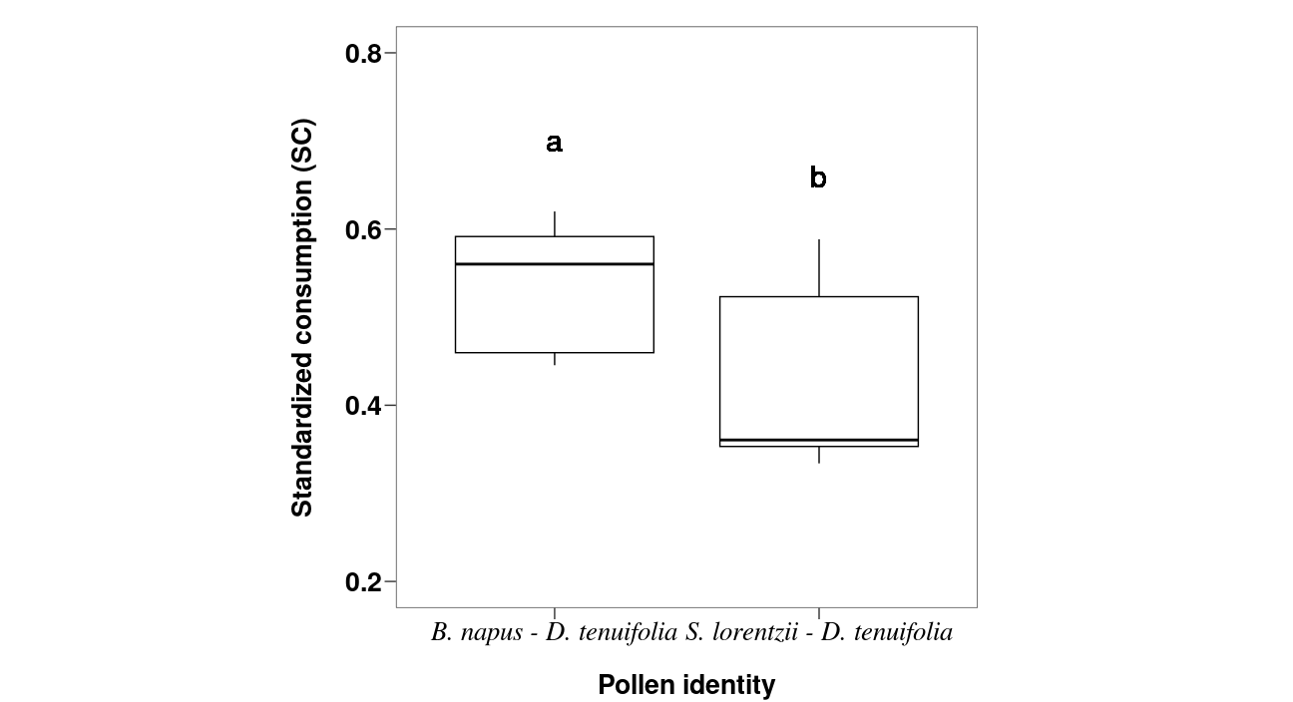
Figure S1A. Effects of pollen identity on consumption preferences of young honey bee workers in IMI experiment. Standardized consumption was obtained in caged bees that experienced either B. napus and D. tenuifolia pollen combination (B-D series) or S. lorentzii - D. tenuifolia (S-D series). The box plots show medians, quartiles, and 5th and 95th percentiles of the data predicted by LMM. Different letters indicate significant differences among doses (P < 0.05).

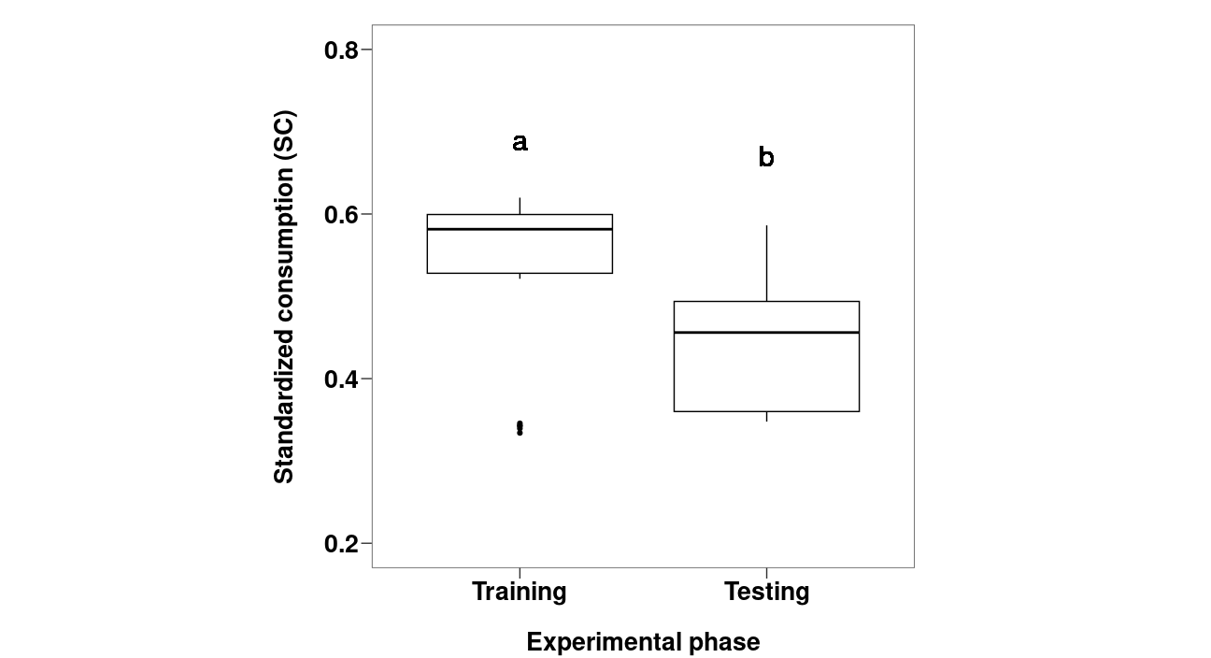
Figure S1B. Effects of the experimental phase on pollen consumption preferences of young honey bee workers in the IMI experiment. Standardized consumption (SC) was obtained during (training phase) or after (testing phase) caged bees experienced pollens contaminated with IMI. The box plots show medians, quartiles, and 5th and 95th percentiles of the data predicted by LMM. Different letters indicate significant differences among doses (P < 0.05).

Total pollen consumption in the GLY experiment
Table S4A. Statistical analysis of total pollen consumption in the GLY experiment. Analysis of variance and Post hoc comparisons among concentrations for the general linear model proposed for testing the effect of GLY compound on young bees' total pollen consumption. Values in bold represent p-values < 0.05.

ANOVA | Total_pollen_consumption ~ concentration*pollen_identity
 |  | numDF | F-value | p-value
 | concentration | 2 | 1.631 | 0.213
 | pollen_identity | 1 | 2.174 | 0.151
 | concentration*pollen_identity | 2 | 4.895 | 0.014
Comparisons | model, pairwise ~ concentration*pollen_identity
 | B-D series | t-ratio |  | p-value
 | 0 mg/l - 1.25 mg/l | 3.257 |  | 0.008
 | 0 mg/l- 2.5 mg/l | 2.652 |  | 0.033
 | 1.25 mg/l - 2.5 mg/l | -0.605 |  | 0.818
 | S-D series
 | 0 mg/l - 1.25 mg/l | -0.749 |  | 0.736
 | 0 mg/l - 2.5 mg/l | -0.979 |  | 0.595
 | 1.25 mg/l - 2.5 mg/l | -0.230 |  | 0.971

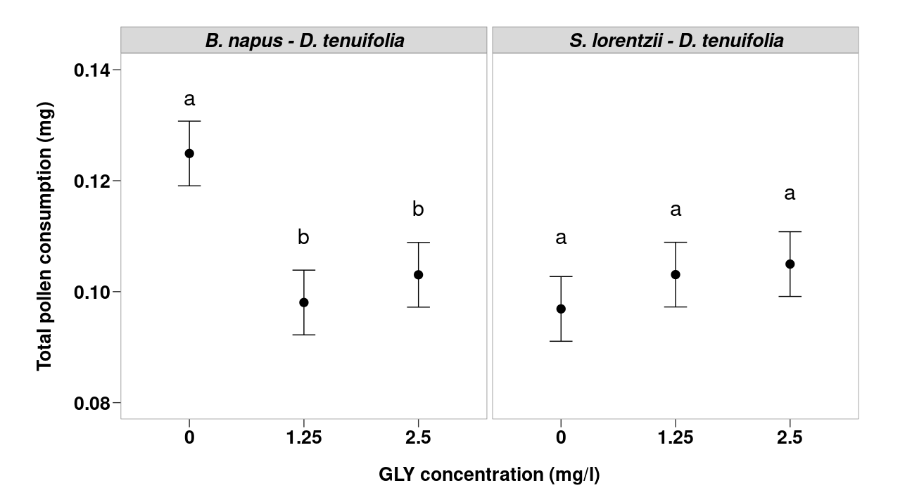
Figure S2. Effects of GLY-contaminated pollen on the total pollen consumption of young worker bees. Total pollen consumption is shown as a function of the GLY concentrations (in mg/l) according to the pollen identity (B. napus and D. tenuifolia in B-D series and S. lorentzii and D. tenuifolia pollens in the S-D series). Circles indicate mean value, bars show the 95% confidence intervals of the data predicted by the general linear model. Different letters indicate significant differences (P<0.05).

Total pollen consumption in the IMI experiment
Table S4B. Statistical analysis of total pollen consumption in the IMI experiment. Analysis of variance and Post hoc comparisons among concentration for the general linear model proposed for testing the effect of IMI compound on young bees' total pollen consumption.

ANOVA | Total_pollen_consumption ~ concentration*pollen_identity
 |  | numDF | F-value | p-value
 | concentration | 2 | 1.088 | 0.351
 | pollen_identity | 1 | 3.314 | 0.079
 | concentration*pollen_identity | 2 | 0.941 | 0.402
Comparisons | model, pairwise ~ concentration*pollen_identity
 | B-D series | t-ratio |  | p-value
 | 0 µg/l - 1 µg/l | -0.479 |  | 0.882
 | 0 µg/l - 10 µg/l | -0.163 |  | 0.985
 | 1 µg/l - 10 µg/l | -0.310 |  | 0.949
 | S-D series
 | 0 µg/l - 1 µg/l | -0.541 |  | 0.852
 | 0 µg/l - 10 µg/l | 1.302 |  | 0.406
 | 1 µg/l - 10 µg/l | -1.987 |  | 0.134

