Supplementary Material
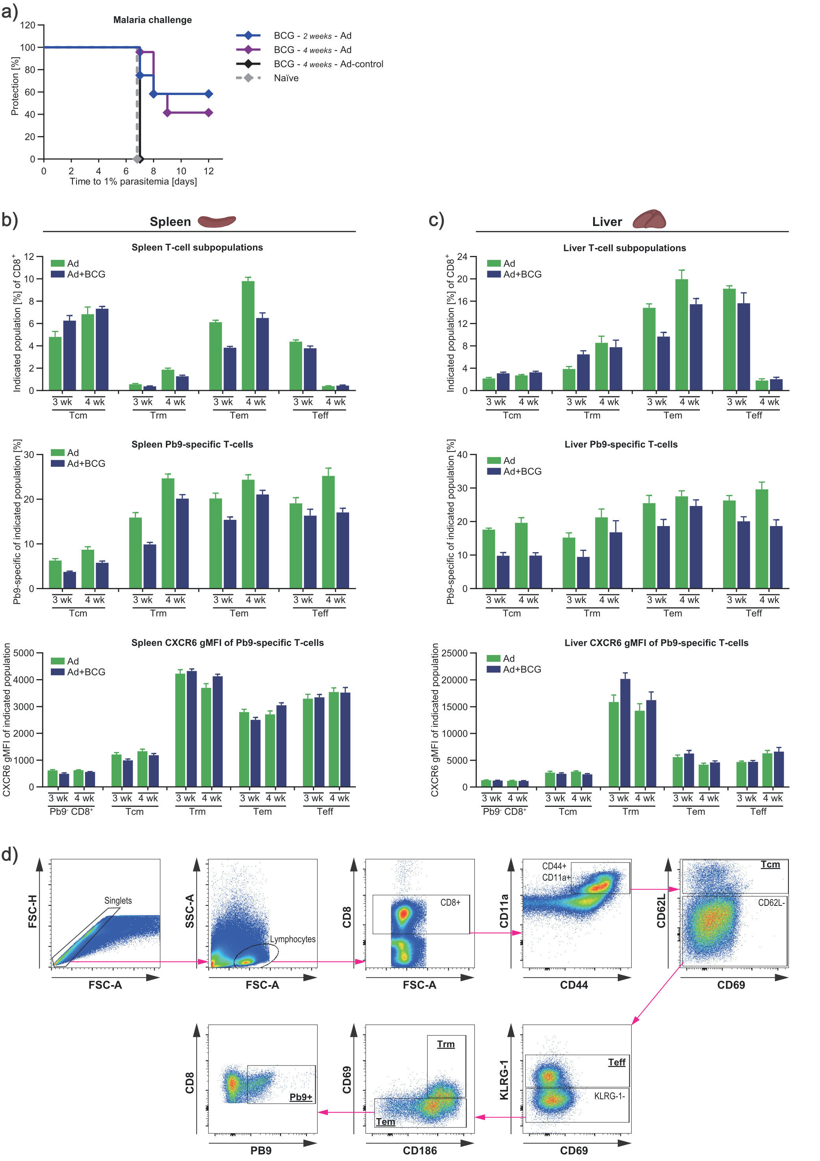
Figure S1. Staggered immunisation with BCG and Ad enables partial protection against malaria in mice.
(a) Survival post-malaria challenge: BALB/c mice were vaccinated with a BCG prime Ad boost regimen at indicated intervals and challenged with malaria 2 weeks post Ad immunisation. Parasitaemia was assessed by daily blood smears, with 1% parasitaemia taken as irreversible malaria infection (n ≥ 8).
(b and c) T cell phenotyping of splenic and hepatic cells by FACS after vaccination and harvest as described in 1a) (n = 6). Top panels show the distribution of T cell subpopulations within the CD8⁺ T cell compartment. Middle panels show relative numbers of Pb9-specific cells within T cell subpopulations. Bottom panels show the gMFI of the liver homing marker CXCR6 for Pb9-specific T cells and Pb9⁻ CD8⁺ T cells.
(d) Gating strategy for T cell FACS data shown in figure 1 and S1.

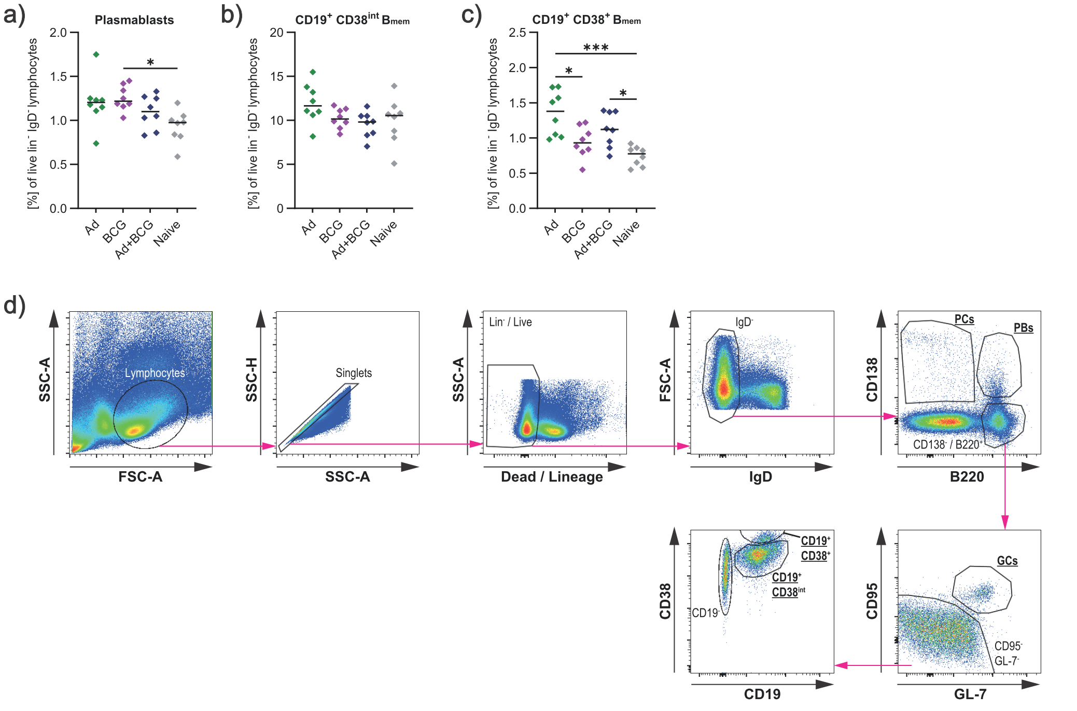
Figure S2. Ad and BCG co-administration enhances the memory B cell compartment.
(a - c) Total B cell phenotyping of splenic cells by FACS after vaccination and harvest as in Figure 1a). The specific cell populations are indicated. Gating strategy as in figure S2d. Median + replicates) (n = 8); One-way ANOVA with Bonferroni’s correction for multiple comparisons; *p < 0.05; **p < 0.01; ****p < 0.0001.
(d) Gating strategy for B cell FACS data shown in Figure 1 and S2.

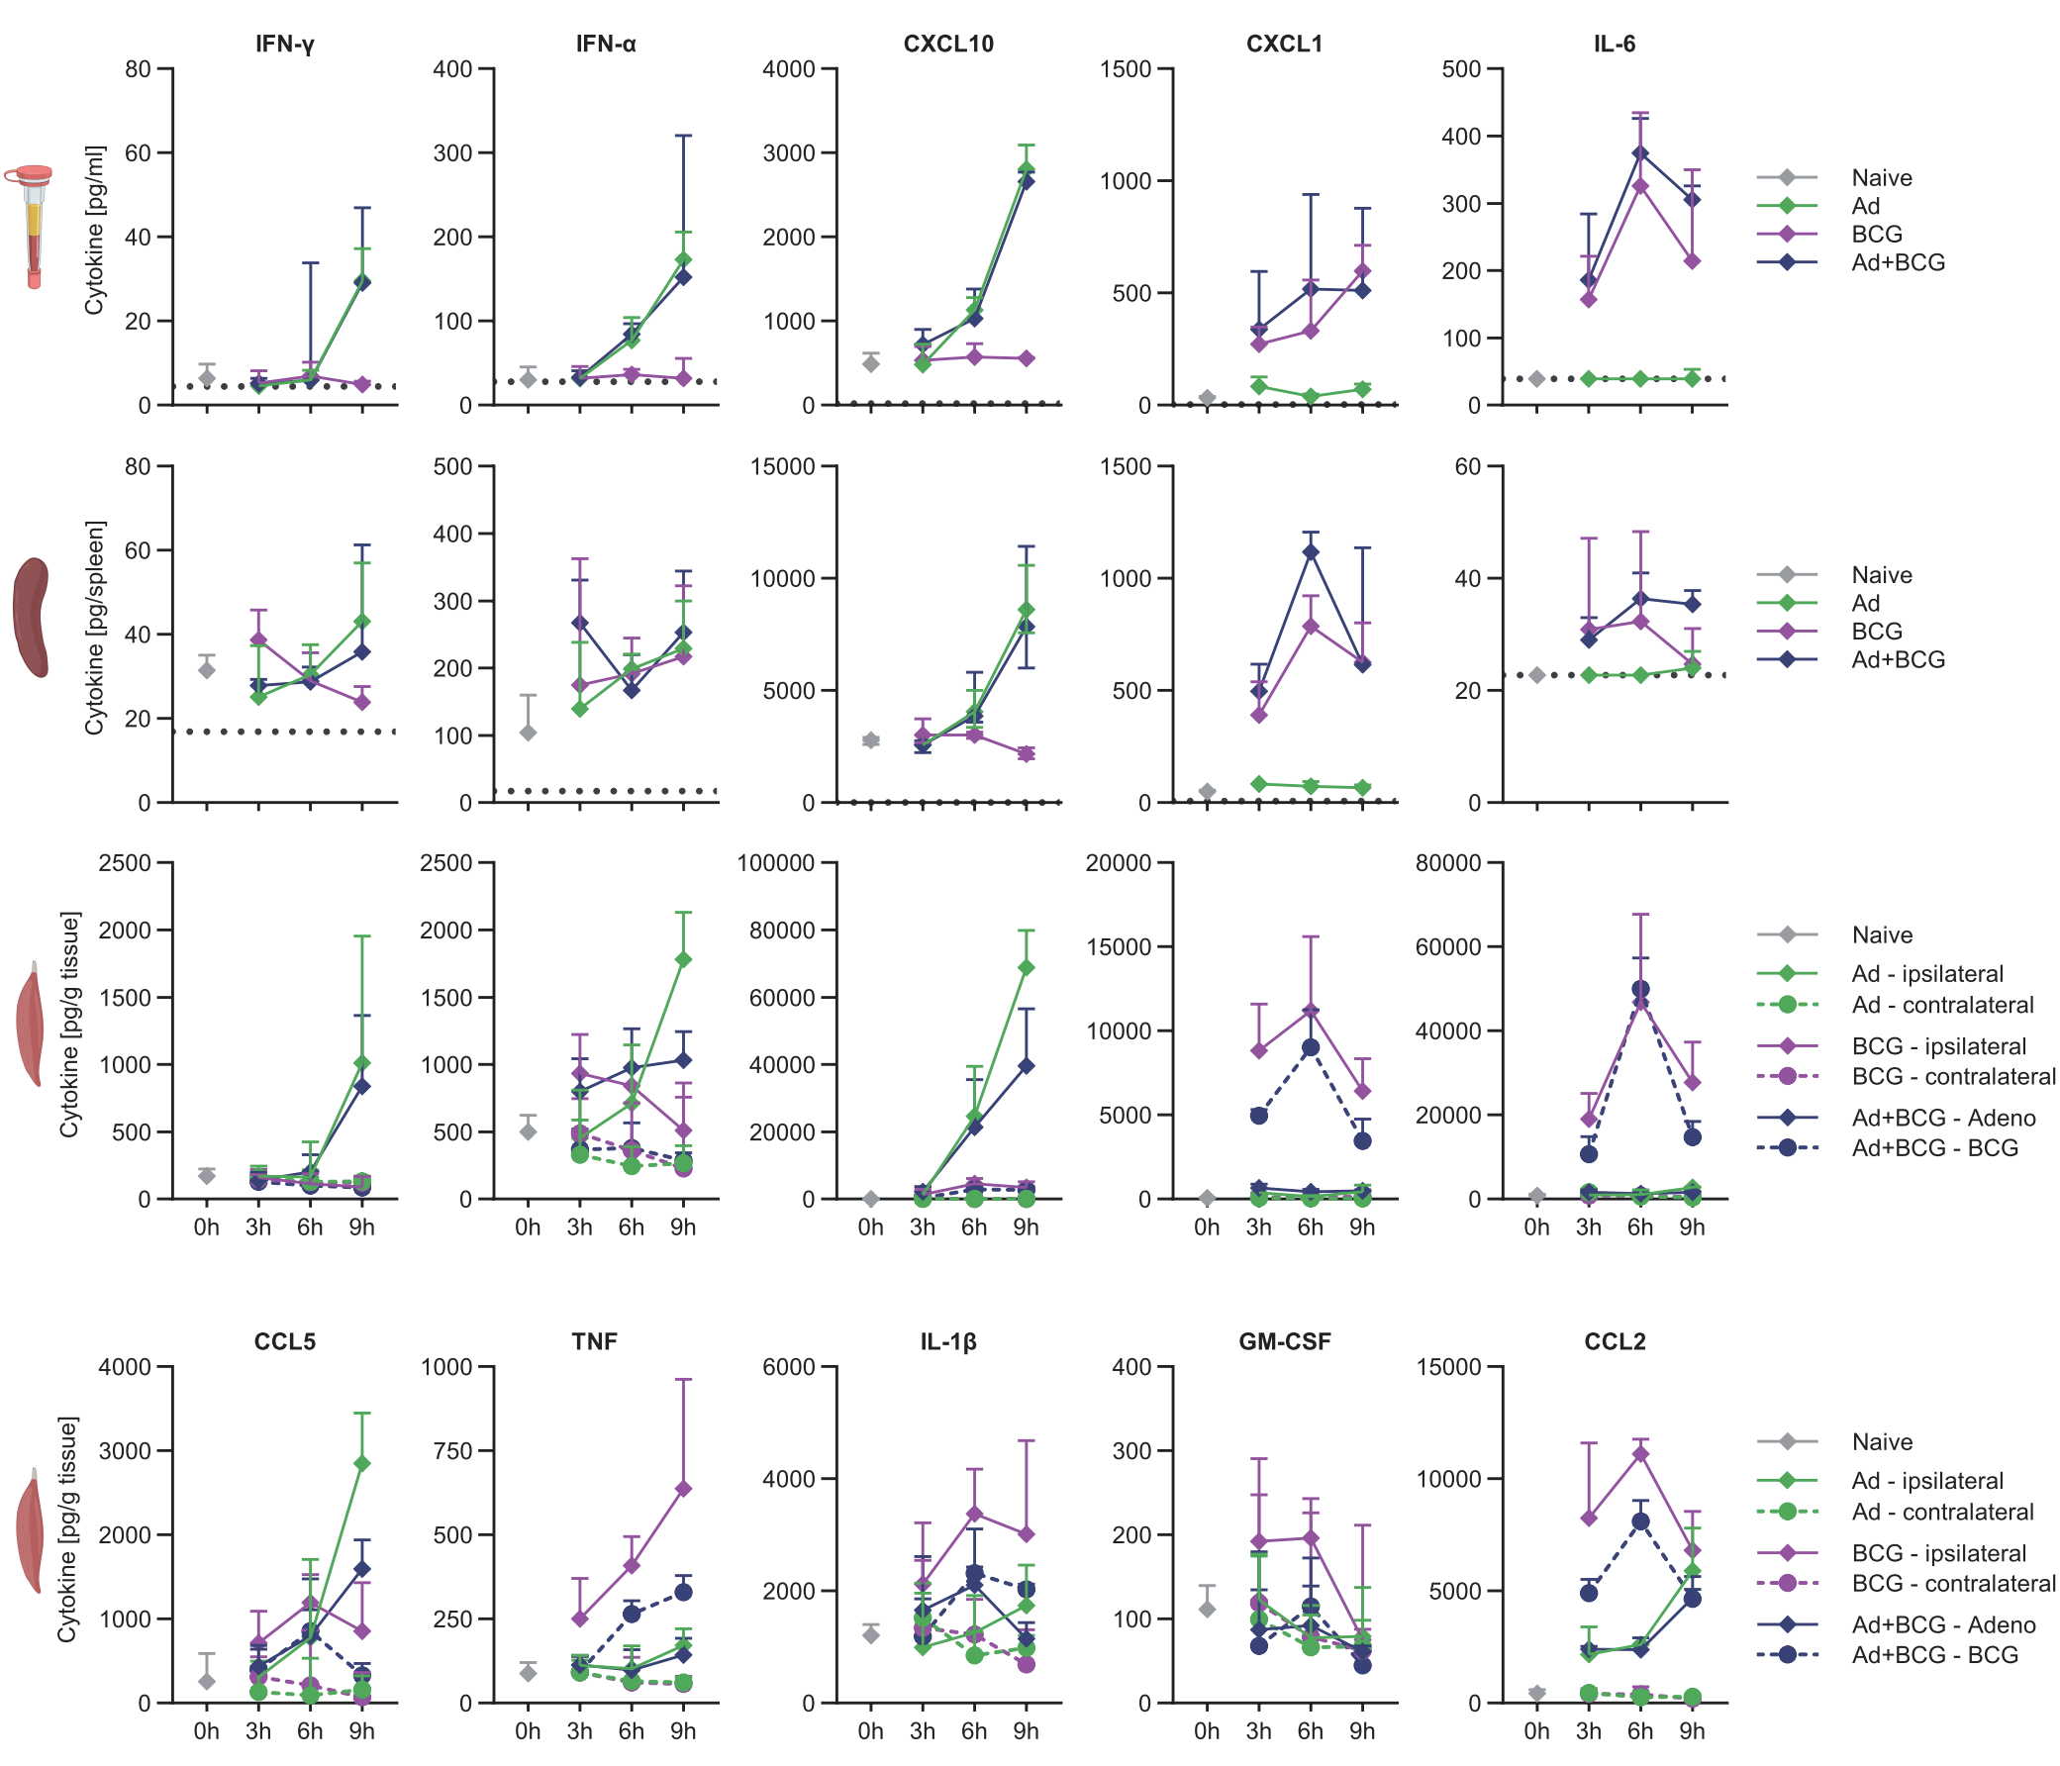
Figure S3. Innate cytokine kinetics post Ad and BCG immunisation
Detailed representation of data shown in Figure 2b – d. Vaccine dose per mouse: 0.5x10⁵ CFU for BCG and 5x10⁷ i.u. for AdHu5-TIPeGFP ) (n = 6). In the Ad+BCG group, Ad was injected into the right leg and BCG into the left leg. Indicated cytokines were measured using LEGENDplexTM MU Anti-Virus Response Panel. Graphs show the cytokine levels detected in the serum, spleen, and the site of immunisation (SOI) in the ipsi- and contra-lateral muscles for each vaccine (Ad alone and BCG alone: contralateral leg received no vaccine, Ad+BCG: each leg received one of the vaccines).

