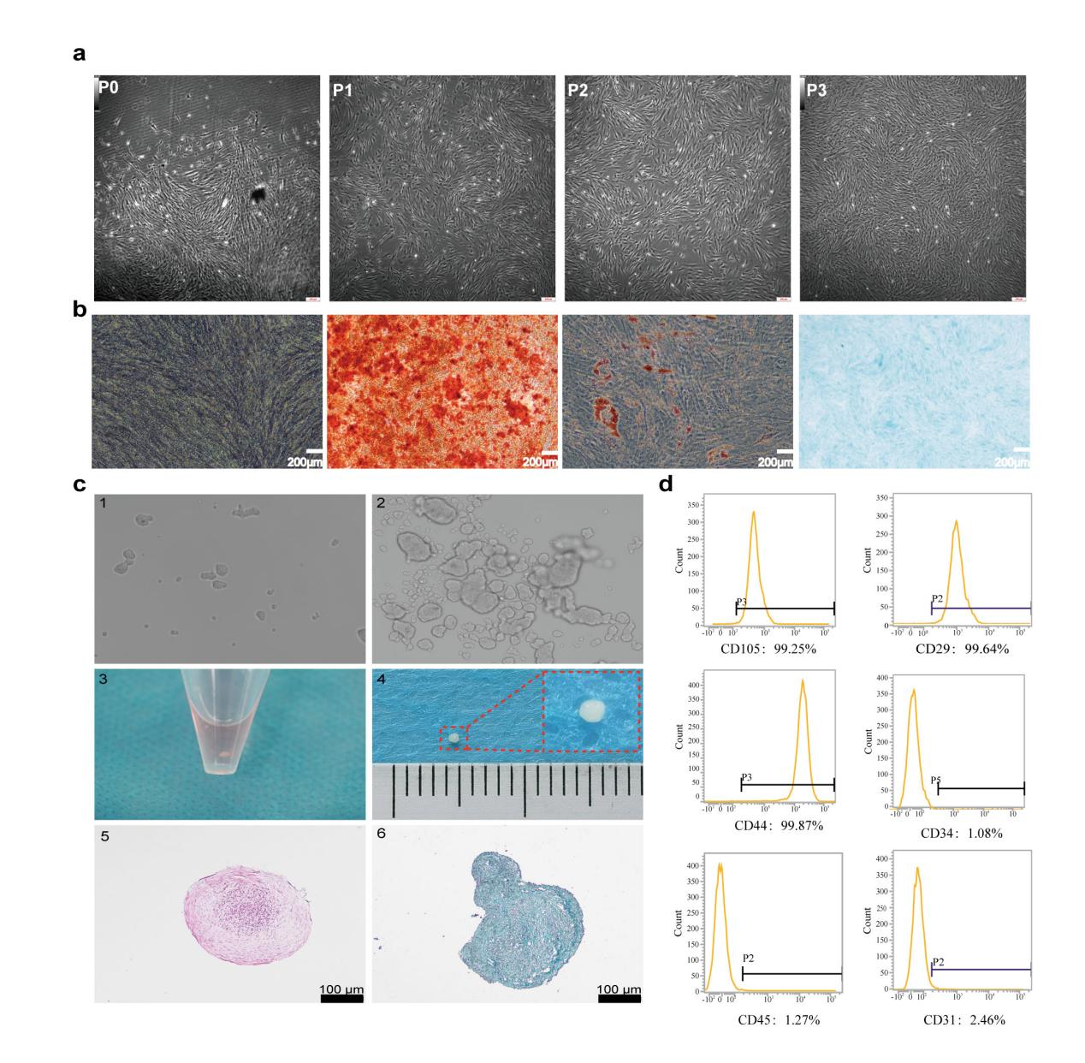
FIGURE S1. Primary culture and 3D chondrogenic induction of hPDLSCs.
a Primary culture and subculture of hPDLSCs, showing uniform long spindle-shaped morphology. (Scale bar = 200 µm). b Multidirectional differentiation potential of hPDLSCs: osteogenesis (Alizarin Red S and ALP staining), chondrogenesis (Alcian Blue staining), and adipogenesis (Oil Red O staining). (Scale bar = 200 µm). c 3D chondrogenic induction in a centrifuge tube system with Matrigel® as a natural extracellular matrix scaffold.(Scale bar = 100 µm) d Flow cytometric analysis of hPDLSCs surface marker expression: CD29, CD44, CD105, CD34, CD45, and CD31.

Table 1 The oligonucleotide sequences
Genes | Sequence 5’-3’
siRNA-YTHDC1-NC-F | UUCUCCGAACGUGUCACGUTT
siRNA-YTHDC1-NC-R | ACGUGACACGUUCGGAGAATT
siRNA-YTHDC1-1-F | GAAGCAAGAUACAGAGAUATT
siRNA-YTHDC1-1-R | UAUCUCUGUAUCUUGCUUCTT
siRNA-YTHDC1-2-F | GGAAGAUGAAGAAGUAGAATT
siRNA-YTHDC1-2-R | UUCUACUUCUUCAUCUUCCTT
siRNAYTHDC1-3-F | GCAAGGAGUGUUAUCUUAATT
siRNAYTHDC1-3-R | UUAAGAUAACACUCCUUGCTT

Table 2 Details of constructs and viral vectors used in this study
Vector type | Control Type | Construct/Virus Name
Lentivirus | OE NC | pcSLenti-EF1-EGFP-P2A-Puro-CMV-MCS-3×Flag-WPRE
Lentivirus | OE YTHDC1 | pcSLenti-EF1-EGFP-P2A-Puro-CMV-YTHDC1-3×Flag-WPRE
Plasmid | WT | psiCHECK-2-GADD45B-mRNA (1867bp)
Plasmid | Mut757 | psiCHECK-2-GADD45B-mRNA (1867bp, A757T)
Plasmid | Mut1086 | psiCHECK-2-GADD45B-mRNA (1867bp, A1086T)
Plasmid | Mut1110&1137 | psiCHECK-2-GADD45B-mRNA (1867bp, A1110T; A1137T)
Plasmid | Mut1193 | psiCHECK-2-GADD45B-mRNA(1867bp, A1193T)
Lentivirus | OE NC | pcSLenti-EF1-EGFP-P2A-Puro-CMV-MCS-3xFLAG-WPRE
Lentivirus | OE WT | pcSLenti-EF1-EGFP-P2A-Puro-CMV-3xFLAG-GADD45B+3UTR-WPRE
Lentivirus | OE MUT | pcSLenti-EF1-EGFP-P2A-Puro-CMV-3xFLAG-GADD45B (Mut1193)+3UTR-WPRE

Table 3 Primer sequences for qPCR
Genes | Primer sequence 5’-3’
GAPDH-F | GGAGCGAGATCCCTCCAAAAT
GAPDH-R | GGCTGTTGTCATACTTCTCATGG
YTHDC1-F | AACTGGTTTCTAAGCCACTGAGC
YTHDC1-R | GGAGGCACTACTTGATAGACGA
SOX9-F | GGAAGTCGGTGAAGAACGGG
SOX9-R | CAAGGTCGAGTGAGCTGTGT
COL2A1-F | GCTCCTGCCGTTTCGCTG
COL2A1-R | TGAGGCAGTCTTTCACGTCT
CDKN2A/p16-F | GAAGGTCCCTCAGACATCC
CDKN2A/p16-R | GTAGGACCTTCGGTGACTG
CDKN1A/p21-F | TCTTGTACCCTTGTGCCTC
CDKN1A/p21-R | GGTAGAAATCTGTCATGCTGG
TP53/p53-F | CTCAGATAGCGATGGTCTGG
TP53/p53-R | CTGTCATCCAAATACTCCACAC
GADD45B-F | ATTGACGAGGAGGAGGAGGATGAC
GADD45B-R | CCGACACCCGCACGATGTTG

Table 4 Antibodies applied in this paper
Antibodies | Company | Application | Dilution fold | Catalog Number
m⁶A antibody | Synaptic System | Dot blot | 1:1000 | 202-003
YTHDC1 | Abcam | WB; IF; IHC | WB(1:1000); IF(1:200); IHC(1:500) | ab122340
SOX9 | Abcam | WB; IF; IHC | WB(1:1000); IF(1:200); IHC(1:200) | ab196450
COL2A1 | Abcam | WB; IF; IHC | WB(1:1000); IF(1:200); IHC(1:200) | ab307674
p21 | Abcam | WB | 1:1000 | ab188224
p16 | Abcam | WB; IF | WB：1:1000；IF：1：200 | ab51243
p53 | Abcam | WB | 1:1000 | ab26
GAPDH | Proteintech | WB | 1:10000 | 60004-1-ig‌

Table 5 Primer sequences for MeRIP-qPCR
Genes | Primer sequence 5’-3’
Site 757-F | ACCAGTGGGTCCCCTACATC
Site 757-R | GTTTGTGGCAGCAACTCAACA
Site 1086-F | GAAGCTGAGGCCTTGGGATG
Site 1086-R | TCAGTCTCACTCCACCCCC
Site 1110&1137-F | ACCCTCCTTGAGACTGGAGC
Site 1110&1137-R | GTGCAGACAAGGACCAACCA
Site 1193-F | CCACACTTTGGGACTTGGGA
Site 1193-R | CCATCTCGCTCTCAGTGGTT

