Supplementary content
Statistical procedure: We extracted India-specific estimates for chronic kidney disease (CKD) from the Global Burden of Disease (GBD) 2021 Results Tool on 1 September 2025. The dataset provides annual estimates from 1990 to 2021 for cause-specific mortality, disability-adjusted life years (DALYs), prevalence, and incidence, disaggregated by sex, age group, and etiology (type 1 diabetes, type 2 diabetes, hypertension, glomerulonephritis, and other/unspecified causes). All measures were age-standardized to the GBD reference population, and 95% uncertainty intervals (UIs) were calculated from 1,000 draws within the GBD modeling framework.
To evaluate long-term changes, we analyzed trends in CKD mortality and DALYs between 1990 and 2021. We estimated the average annual percent change (AAPC) in age-standardized rates over both the full 1990–2021 period and the more recent 2010–2021 decade.
A log-linear regression model of the form $\ln\left(ASR_{t}\right)= α + β × t$ was fitted, where t is calendar year, and AAPC was derived as
$$AAPC = \left(e^{β}– 1\right)× 100$$
Separate AAPC estimates were obtained for overall CKD and for each etiology. We then projected the CKD burden in India from 2022 to 2040 using three scenarios. In the flat-rate scenario, age-specific CKD rates were held constant at 2021 levels, and future counts were obtained by multiplying these rates by projected age- and sex-specific population counts. In the trend scenario, recent AAPCs (2010–2021) in age-standardized mortality and DALY rates were extrapolated to 2040 using the equation
$$ASR_{y}= ASR_{\left\{2021\right\}}×{\left(1 + AAPC\right)}^{\left\{\left(y - 2021\right)\right\}}$$
, with similar approaches applied to prevalence and incidence. In the policy scenario, we modelled partial attainment of improved risk factor control, assuming a gradual reduction in uncontrolled hypertension and diabetes by 2030, resulting in lower projected mortality and DALY rates compared with the trend. The difference between trend and policy projections was interpreted as the potentially avoidable CKD burden.
Population forecasts by age and sex were drawn from the Institute for Health Metrics and Evaluation (IHME) reference scenario, which extends demographic trends to 2040 and harmonizes with United Nations population estimates. For the flat-rate scenario, UIs were propagated by applying the 2021 lower and upper bounds to projected populations. For the trend and policy scenarios, we assessed uncertainty by varying the AAPC by ±1% annually, producing approximate sensitivity ranges consistent with GBD methodology.
All analyses followed the Guidelines for Accurate and Transparent Health Estimates Reporting (GATHER). Data cleaning, processing, and visualization were performed in R version 4.2 and Python version 3.9, using standard epidemiological and statistical libraries. Regression modeling of AAPC was undertaken in R using the Epi and segmented packages, while figures were produced with ggplot2 and Python’s matplotlib.

Figure legend:

Supple Figure 1: Trends in age-standardised incidence and prevalence of chronic kidney disease (CKD) in India, 1990–2021. Panel A: Age-standardised incidence of CKD per 100,000 population with 95% uncertainty intervals (UIs). Panel B: Age-standardised prevalence of CKD per 100,000 population with 95% UIs. Sex-specific trends in CKD incidence (Panel C) and prevalence (Panel D) with 95% UIs, showing consistently higher incidence among males, while prevalence trends converge between sexes in recent years.
Supple Figure 2. Age group distribution of CKD mortality and DALYs in India, 2021 and projections to 2040. Mortality and DALYs increase steeply with age, with >80% of deaths in those aged ≥50 years and 43% in those ≥70 years. Projections to 2040 show the steepest absolute increases in older age groups, reflecting population aging.
Supple Figure 3. Etiological contributions to CKD burden in India, 1990–2040. CKD deaths and DALYs are shown by etiology. Type 2 diabetes is the leading cause, responsible for 32% of CKD deaths in 2021, followed by hypertension (19%) and glomerulonephritis (14%). Projections indicate that diabetes- and hypertension-related CKD will continue to expand through 2040, while glomerulonephritis will remain stable or decline proportionally.
Supple Figure 4: Percentage change in age-standardised mortality and disability-adjusted life years (DALYs) for major non-communicable diseases in India, 1990–2021. Panel A: Percentage change in age-standardised death rates. Panel B: Percentage change in age-standardised DALY rates.
Error bars represent 95% uncertainty intervals. CKD ranks among the leading causes with substantial increases in both mortality and DALYs, in contrast to declining rates for stroke and chronic obstructive pulmonary disease

S1:
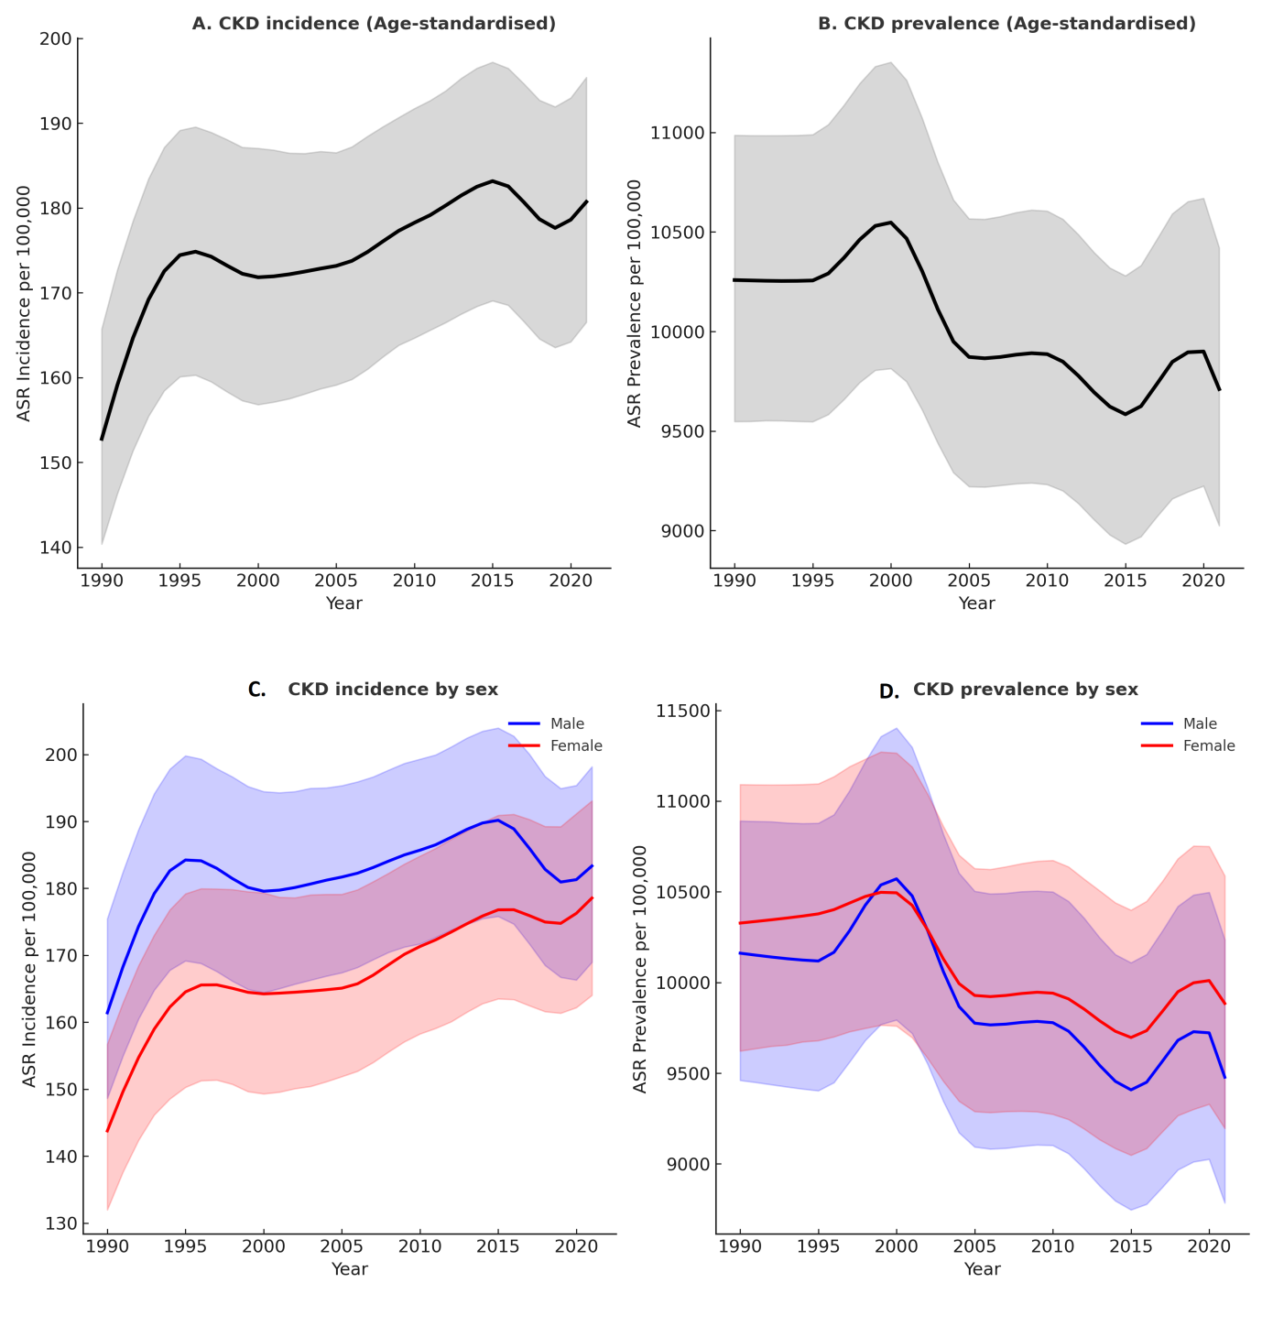

S2: Age group wise mortality and DALY historical and projected
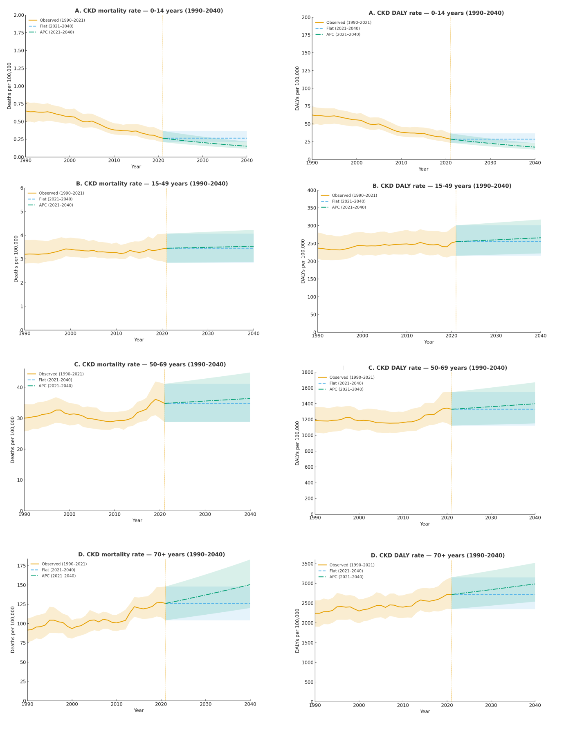

S3: Etiology wise historical and projection data for mortality and DALY\
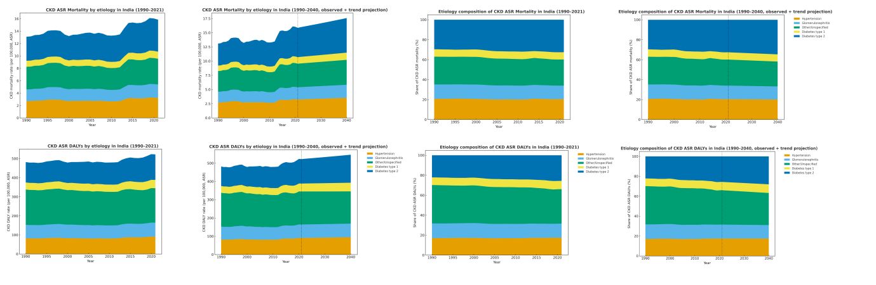

S4: % change ASR mortality and DALY in CKD
