Supplementary Figures

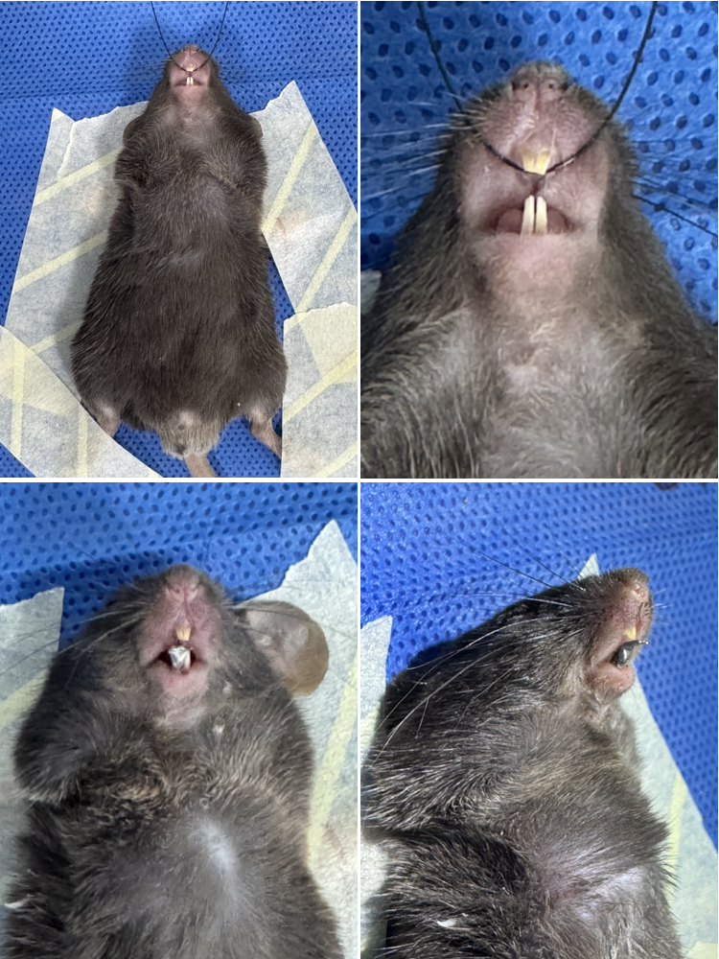
Fig. S1: Establishment of UAC model.

Fig. S2: Weights of mice at BL, day 7, and 10. Data were expressed as means ± SD. (ns, P > 0.05; two-tailed unpaired Student’s t-test).

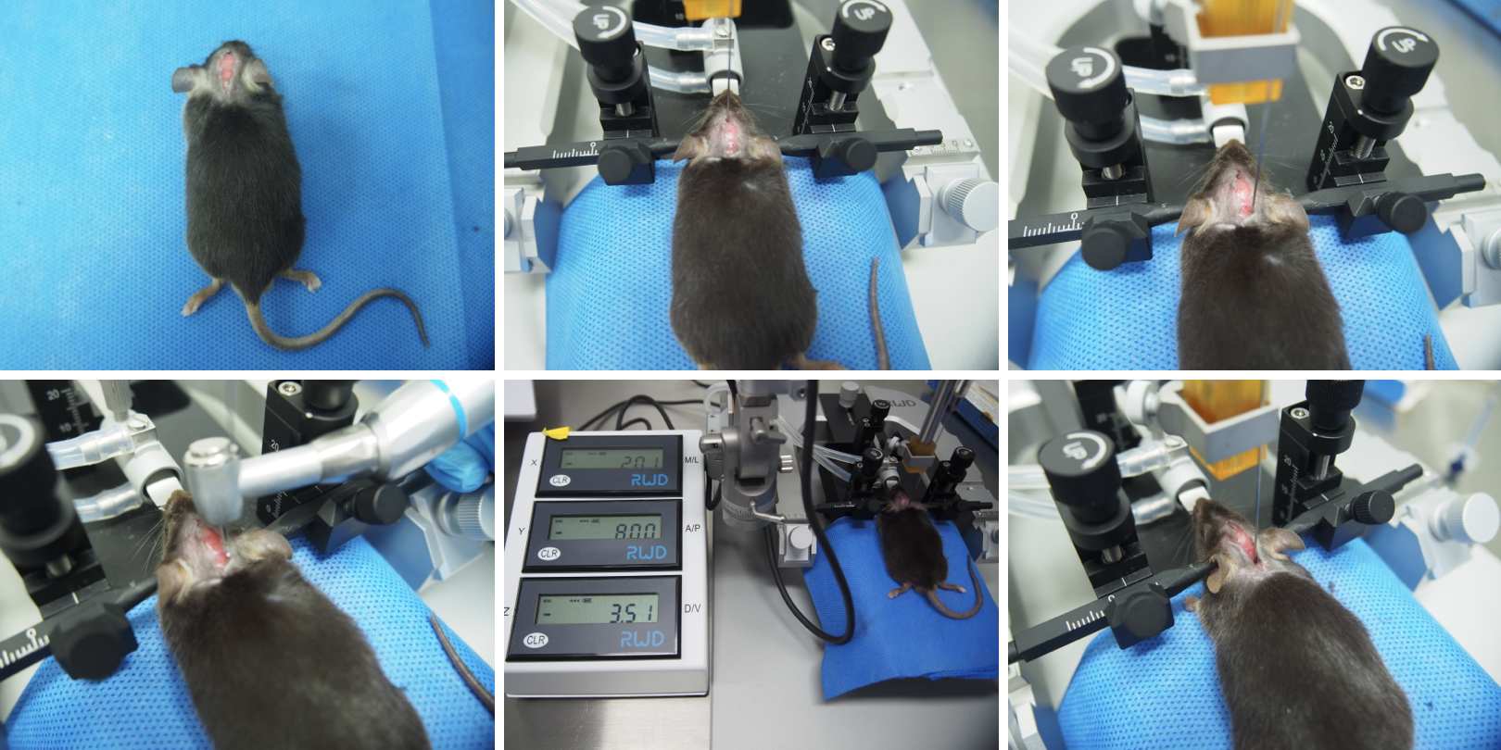
Fig. S3: Stereotaxic viral delivery into the SpVc of mice.

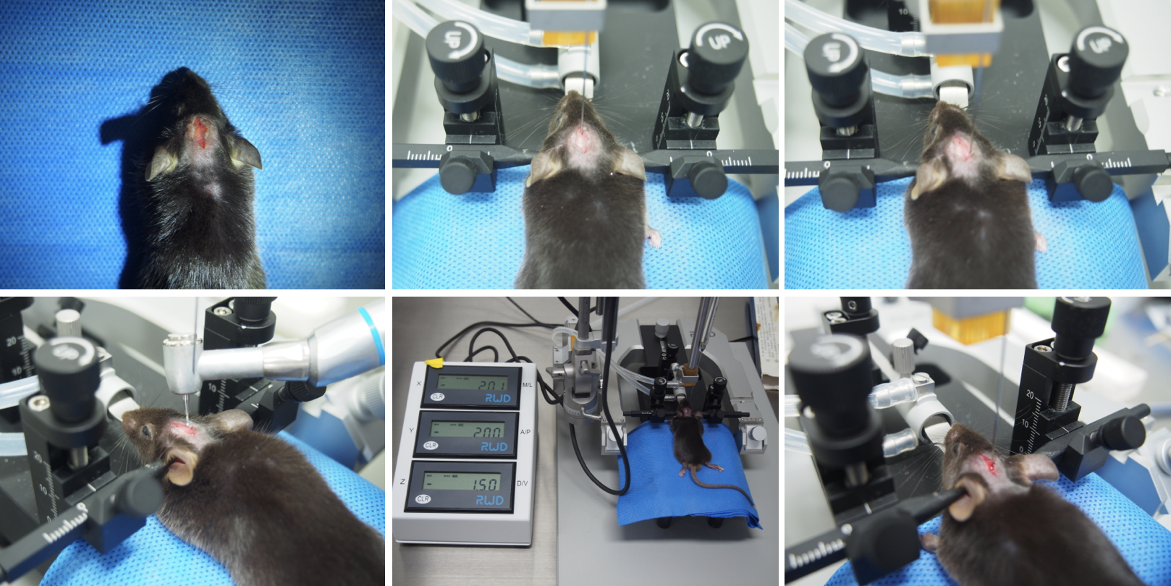
Fig. S4: Stereotaxic viral delivery into the HPC of mice.

Fig. S5: Immobile time of female mice in CTL and UAC groups at BL, day 7, and 10 in FST. Data were expressed as means ± SD. (ns, P > 0.05 at BL; *P < 0.05 at day 7 and 10; two-tailed unpaired Student’s t-test).

Fig. S6: Sucrose preference index of female mice in CTL and UAC groups at BL, day 7, and 10 in SPT. Data were expressed as means ± SD. (ns, P > 0.05 at BL; **P < 0.01 at day 7; *P < 0.05 at day 10; two-tailed unpaired Student’s t-test).

Fig. S7: Center cumulative duration of female mice in CTL and UAC groups at BL, day 7, and 10 in OFT. Data were expressed as means ± SD. (ns, P > 0.05 at BL; **P < 0.01 at day 7 and 10; two-tailed unpaired Student’s t-test).

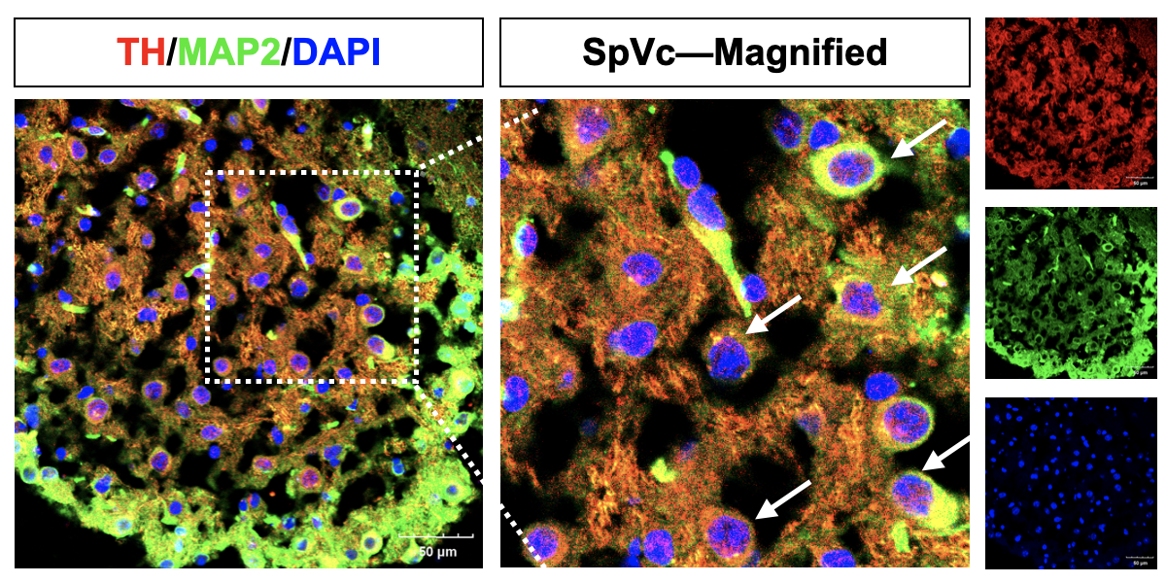
Fig. S8: TH and MAP2 co-localized on SpVc neurons. (red: TH; green: MAP2; blue: DAPI). Scale bars: 50 μm.

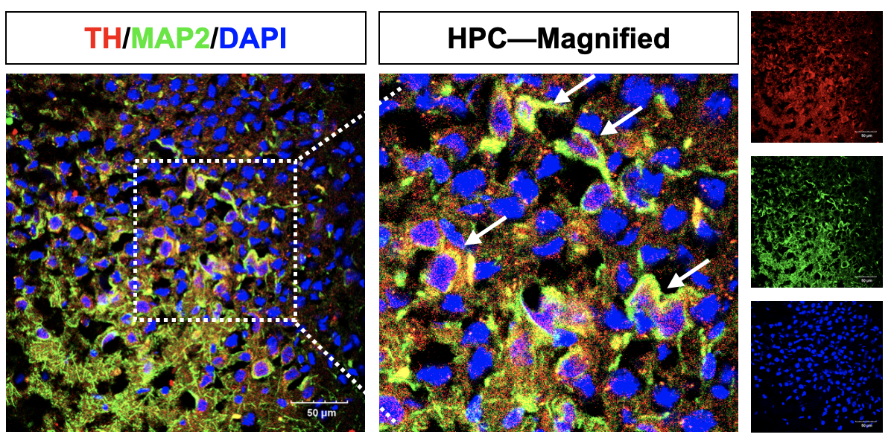
Fig. S9: TH and MAP2 co-localized on HPC neurons. (red: TH; green: MAP2; blue: DAPI). Scale bars: 50 μm.

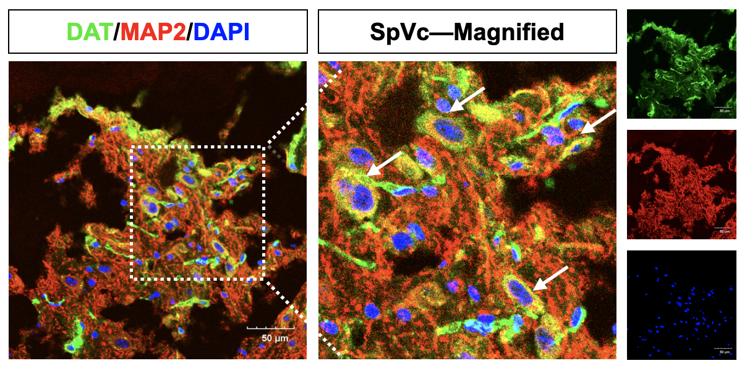
Fig. S10: DAT and MAP2 co-localized on SpVc neurons. (green: DAT; red: MAP2; blue: DAPI). Scale bars: 50 μm.

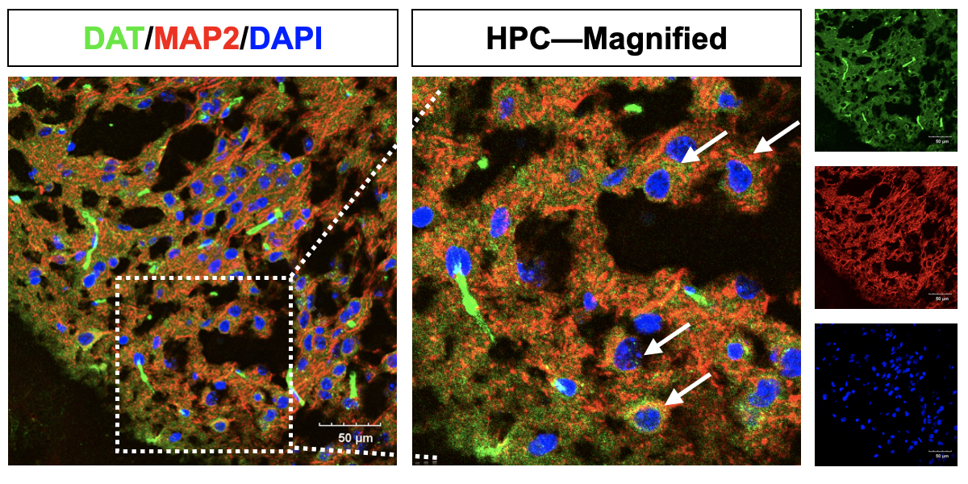
Fig. S11: DAT and MAP2 co-localized on HPC neurons. (green: DAT; red: MAP2; blue: DAPI). Scale bars: 50 μm.

Fig. S12: Female mice in CTL and UAC groups showed a significant difference in DRD2 mRNA. Data were expressed as means ± SD. (***P < 0.001; two-tailed unpaired Student’s t-test).

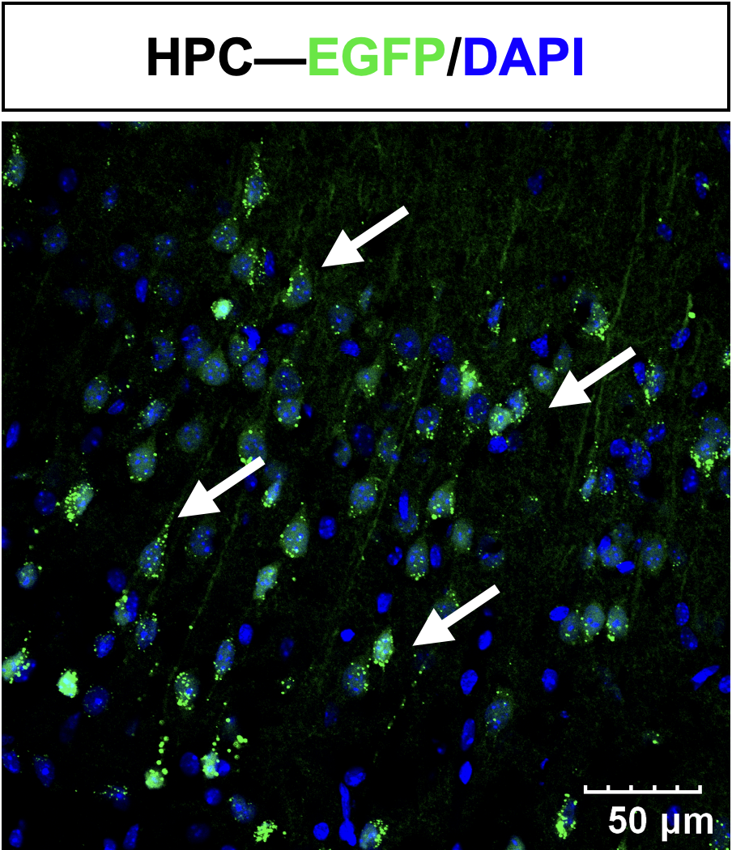
Fig. S13: EGFP and DAPI fluorescence in the HPC confirmed successful AAV2/9 transduction. (Green: EGFP; blue: DAPI). Scale bars: 50 μm.

Fig. S14: Female mice in CTL and UAC groups presented a significant difference in LEPR mRNA. Data were expressed as means ± SD. (***P < 0.001; two-tailed unpaired Student’s t-test).

Fig. S15: CCK-8 viability assays identified an optimal LV-DRD2 MOI of 5.

Fig. S16: RT-qPCR showed LEPR mRNA levels following pathway-specific inhibitors administration.

