Characteristic | n=28
Age (years), median(range) | 67 (55-80)
<75,n (%) | 19(67.9%)
≥75,n(%) | 9(32.1%)
Gender, n(%)
Male | 16(57.1%)
Female | 12(42.9%)
ECOG PS, n(%)
0 | 11(39.3%)
1 | 17(60.7%)
Clinical stage, n(%)
II | 4(14.3%)
III | 19(67.9%)
IV | 5(17.9%)
Tumor location, n(%)
Cervical | 1(3.6%)
Upper thoracic | 3(10.7%)
Middle thoracic | 14(50.0%)
Lower thoracic | 10(35.7%)
Table 1. Baseline characteristics of the patients

Best overall response | Efficacy analysis set(n=28)
PD,n(%) | 0(%)
SD,n(%) | 5(17.9%)
PR,n(%) | 20(71.4%)
CR,n(%) | 3(10.7%)
pCR,n (%) | 18(64.3%)
non-pCR,n (%) | 10(35.7%)
ORR,n (%) | 23(82.1%)
DCR,n(%) | 28(100%)
Median PFS,months [95%Cl] | 23.5 months [18.2–not reached]
Median OS,months [95%Cl] | Not Reached
Table 2 Response data of the efficacy analysis set

Adverse Events | Grade 1 |  | Grade 2 |  | Grade 3 |  | Grade 4 |  | Grade 5
 | n | % | n | % | n | % | n | % | n | %
Esophagitis | 5 | 17.86% | 15 | 53.57%
Checkpoint inhibitor pneumonitis |  |  | 3 | 10.71%
Radiation pneumonitis |  |  | 3 | 10.71%
Lung infection |  |  |  |  | 2 | 7.14% |  |  | 1 | 3.57%
Radiation dermatitis | 2 | 7.14% | 1 | 3.57%
Hypokalemia | 2 | 7.14%
Hyperkalemia | 1 | 3.57%
Hyponatremia | 13 | 46.43% | 1 | 3.57%
Hypocalcemia | 10 | 35.71% | 1 | 3.57%
Hypomagnesemia | 7 | 25.00%
Hypermagnesemia | 2 | 7.14% |  |  | 1 | 3.57%
Hyperglycemia | 5 | 17.86% | 1 | 3.57%
Hyperlipidemia | 1 | 3.57%
Hypertriglyceridemia | 2 | 7.14%
Hypercholesterolemia | 6 | 21.43%
Hypoalbuminemia | 6 | 21.43% | 5 | 17.86%
Hyperuricemia | 3 | 10.71%
Hyperthyroidism | 1 | 3.57%
Hypothyroidism | 1 | 3.57% | 4 | 14.29%
Thyroid stimulating hormone increased / decreased | 1 | 3.57%
Adrenal insufficiency | 1 | 3.57% | 1 | 3.57%
GGT increased | 1 | 3.57%
Fibrinogen decreased | 1 | 3.57%
Blood lactate dehydrogenase increased | 5 | 17.86%
Leukopenia | 9 | 32.14% | 5 | 17.86%
Anemia | 4 | 14.29% | 3 | 10.71%
Eosinophilia | 1 | 3.57%
Neutropenia | 10 | 35.71%
Lymphopenia |  |  | 7 | 25.00% | 15 | 53.57%
Pain |  |  | 1 | 3.57%
Weight loss | 10 | 35.71% | 2 | 7.14%
Weight gain | 1 | 3.57% | 1 | 3.57% | 1 | 3.57%
Constipation | 3 | 10.71%
Diarrhea | 1 | 3.57%
Anorexia | 2 | 7.14% | 5 | 17.86%
Vomiting |  |  | 2 | 7.14%
Flu-like syndrome | 5 | 17.86%
Cough | 3 | 10.71%
Skin and subcutaneous tissue disorders (Other) |  |  | 3 | 10.71%
Urethral infection |  |  |  |  | 1 | 3.57%
Esophageal stenosis |  |  | 1 | 3.57% | 1 | 3.57%
Esophageal ulcer | 1 | 3.57%
Hiccups |  |  | 1 | 3.57%
Pleural effusion |  |  | 1 | 3.57%
Atrial fibrillation |  |  | 1 | 3.57%
Esophageal fistula |  |  |  |  | 1 | 3.57%
immune checkpoint inhibitor-related myocarditis |  |  | 1 | 3.57%
Immune-related hepatotoxicity |  |  |  |  | 1 | 3.57%
myocardial infarction |  |  |  |  |  |  |  |  | 1 | 3.57%
Vascular access complication |  |  |  |  |  |  |  |  | 1 | 3.57%
Peripheral neuropathy | 1 | 3.57%
Alanine aminotransferase increased |  |  |  |  | 1 | 3.57%
Aspartate aminotransferase increased |  |  |  |  | 1 | 3.57%
Table 3 Adverse Events
(小数点后一位

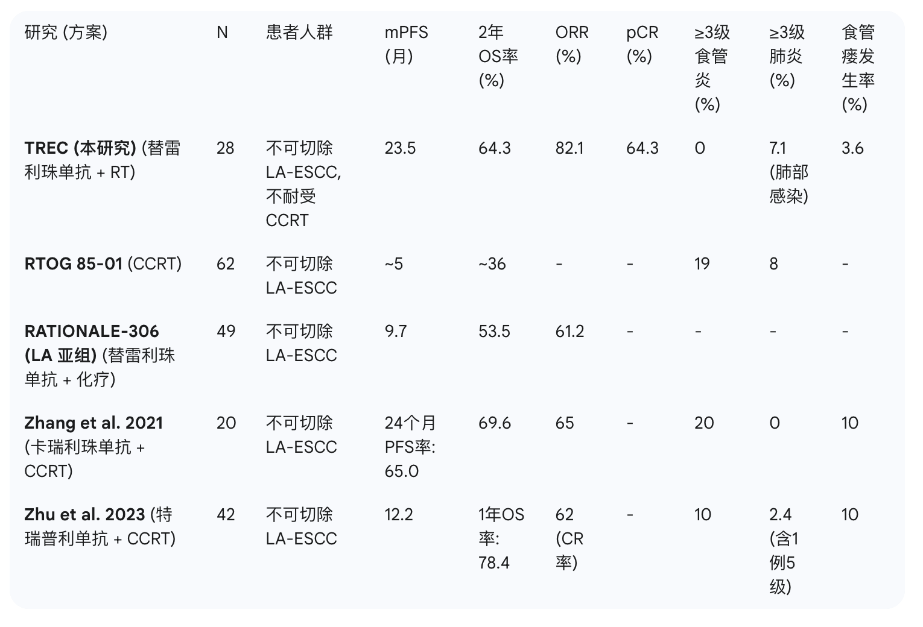

Study(Regimen) | N | Patient Population | mPFS (months) | - year rate  OS(months) | ORR(%) | pCR(%) | ≥G3 Esophagitis (%) | ≥G3 Pneumonitis (%) | Esophageal Fistula (%)
TREC(Tislelizumab + RT) | 28 | Unresectable LA-ESCC, CCRT-intolerant | 23.5 | 64.3% | 82.1 | 64.3 | 0 | 7.1 | 3.6
RTOG 85-01(CCRT) | 62 | Unresectable LA-ESCC | 5 | 36% | N/A | N/A | 19 | 8 | N/A
RATIONALE-306 (Tislelizumab + Chemo) | 49 | Unresectable LA-ESCC | 9.7 | 53.5% | 61.2 | N/A | N/A | N/A | N/A
Zhang et al. 2021 (Camrelizumab + CCRT) | 20 | Unresectable LA-ESCC | N/Aᵇ | 69.6% | 65 | N/A | 20 | 0 | 10
Zhu et al. 2023 (Toripalimab + CCRT) | 42 | Unresectable LA-ESCC | 12.2 | 78.4%ᶜ | 62ᵈ | N/A | 10 | 2.4ᵉ | 10

footnotes：
ᵃ Reported as Grade ≥3 lung infection.
ᵇ The 24-month PFS rate was reported as 65.0%.
ᶜ The 1-year OS rate is shown.
ᵈ This value represents the CR rate, not the ORR.
ᵉ Includes one Grade 5 event.

