Supporting Information
Eco-Friendly Synthesis of Hierarchical Heterostructured CsV₃O₈/V₂O₅ Composite Cathode: Lattice Stabilization and Vanadium Dissolution Resistance for Long-Life Aqueous Zinc-Ion Batteries
1. Chemicals and materials
The cesium chloride (CsCl, 99%), vanadium pentaoxide (V₂O₅, 99%), metallic Zn (0.1 cm thickness), and zinc trifluoromethane sulfonate (Zn(CF₃SO₃)₂, 98%) were purchased from Sigma Aldrich Co., South Korea. The carbon cloth fiber was received from the Nara Cell-Tech Corp., South Korea. Polyvinylidene fluoride (PVDF, -(C₂H₂F₂)_{n}-), Super P carbon black (C65, TIMCAL), and N-methyl-2-pyrrolidone (NMP, C₅H₉NO) were obtained from Daejung Chemicals Ltd., South Korea. Deionized water received from a Milli-Q water purification system was used during experiments (resistivity ~18.0 MΩ cm). All of the chemicals were of analytical quality and used directly without any additional purification.
2. Material characterizations
The crystallographic phase and composition of the materials were obtained by X-ray diffraction (XRD, M18XHF-SRA, Mac Science) using Cu Kα (λ=1.54056 Å). X-ray photoelectron spectroscopy (XPS) and ultraviolet photoelectron spectroscopy (UPS) were performed using a ThermoFisher Scientific Nexsa instrument under a base pressure of 2.0 × 10⁻⁸ mBar. For XPS, a monochromated Al Kα source (1486.6 eV, 72 W, 12 kV) with a 400 × 400 μm² beam spot was used. Instrumental broadening was 0.9 eV (Au 4f7/2, FWHM), and energy calibration was referenced to clean Au 4f7/2 at 84.0 eV. Survey and high-resolution scans were acquired at pass energies of 200 and 50 eV, respectively. For UPS, He I excitation (21.22 eV, 1 × 1 mm² spot) was used. Pass energies of 3.0 eV (work function, with –10 V bias) and 5.0 eV (valence band, 0 V bias) were employed. The instrumental broadening was 0.09 eV (Fermi edge onset, clean Au reference). All the spectra were acquired at normal emission (0°) with the charge neutralizer and external light turned off. The specific surface area and pore distribution of all the samples were evaluated by Brunauer-Emmett-Teller (BET) and Barrett-Joyner-Halenda (BJH) adsorption methods, respectively. Raman spectroscopy was employed to further study the various vibrational and bending modes of the prepared materials. Functional groups on the surfaces of the materials were investigated using Fourier-transform infrared spectroscopy (FTIR, Spectrum One System (Perkin-Elmer)). The surface morphology of the materials was analyzed by field-emission scanning electron microscopy (FE-SEM, Carl Zeiss, LEO SUPRA 55, GENESIS 2000). The transition electron microscopy (TEM, JEM-2100F) was equipped with an energy-dispersive X-ray spectroscopy (EDS) and elemental mapping. High-resolution TEM (HRTEM) and scanning TEM (S-TEM) analyses were performed using a JEOL Cs-corrected TEM operated at 200 kV. The instrument was equipped with a spherical aberration (Cs) corrector for the objective lens, enabling atomic-resolution imaging. High-angle annular dark-field S-TEM (HAADF-S-TEM), bright-field TEM (BF-TEM), and selected area electron diffraction (SAED) were conducted as required. Samples were prepared on carbon-coated copper grids. Elemental analysis was performed using a direct reading echelle inductively coupled plasma optical emission spectrometer (ICP-OES, Leeman Labs). The experiments were conducted using a 600 MHz solid-state nuclear magnetic resonance (NMR) with a MAS spinning rate of 12 kHz to find the V multiple environments (Agilent Technologies (DD2 600 MHz FT NMR)).
3. Electrochemical measurements
All the electrochemical properties were measured by using a WonTech battery workstation. The electrochemical properties of the as-prepared samples were measured using CR2032 coin-type half-cell. The working electrode was prepared in the following manner. First, the active materials (VO and CsVO/VO), super-P carbon, and polyvinylidene fluoride (PVDF) were well mixed in a weight ratio of 7:2:1 using N-methyl-2-pyrrolidone (NMP) solvent. The slurry was coated on a carbon cloth current collector substrate using a brush coating technique and dried in a vacuum oven at 120 ºC for 12 h. After drying, the active material-coated carbon cloth was punched into a circular shape. The active material mass loading on the carbon cloth was around 1.5 to 2.3±0.2 mg cm⁻². The coin cells were assembled in an open atmosphere using Whatman glass fiber membrane (GF/D, diameter 47 mm) as a separator and Zn foil as a reference and counter electrode in 3 M zinc trifluoromethane sulfonate (3 M ZCF) aqueous electrolyte. The coin cells were cycled under different current densities within the potential window of 0.2-1.8 V by using the WonTech battery workstation. The electrochemical measurements including cyclic voltammetry (CV), galvanostatic charge-discharge (GCD), and electrochemical impedance spectroscopy (EIS, at a frequency range of 0.01 Hz to 100 kHz with 5 mV amplitude) studies were performed at room temperature.
4. Crystal structure properties and stability analysis
The crystalline structures of pure VO and HH–CsVO/VO composite were analyzed using Rietveld refinement, shedding light on their structural configurations and stability. The structural features of the composite, particularly the interplay between the CsVO and VO phases, contribute to its superior stability compared to the pure VO.
Pure VO
Pure VO crystallizes in an orthorhombic structure with the space group P m n m (No. 59). The lattice parameters are a = 11.510 Å, b = 4.372 Å, c = 3.564 Å, and the unit cell volume is 179.37 Å³. This structure consists of layered VO₆ octahedra connected via edge-sharing and corner-sharing. While the layered structure facilitates ion intercalation and diffusion, it is prone to structural degradation under repeated electrochemical cycling, primarily due to stress and volume changes [1].
CsVO phase in composite
The CsVO phase in the composite adopts a monoclinic structure with the space group P 21/m (No. 11), lattice parameters a = 8.206 Å, b = 8.546 Å, c = 5.005 Å, and β = 95.57°, with a unit cell volume of 349.32 Å³. This phase is characterized by a three-dimensional (3D) framework of VO₄ tetrahedra and VO₆ octahedra interconnected by cesium ions. Cesium plays a crucial role in stabilizing the structure by neutralizing the negative charge of the vanadate framework and reducing lattice strain [2]. The open-channel structure of CsVO, facilitated by Cs⁺ ions, enhances ion mobility and provides additional diffusion pathways. The thermal displacement parameters for oxygen atoms in CsVO, especially O5 (B = 10.693 Å²), suggest the presence of oxygen vacancies. These vacancies improve ionic conductivity and electrochemical activity. Importantly, the 3D framework of CsVO resists structural collapse, maintaining its integrity during cycling. This stability is a significant improvement compared to the layered structure of pure VO, which is more susceptible to stress-induced degradation.
VO phase in composite
The VO phase in the composite retains its orthorhombic structure (space group P m n m) with slightly altered lattice parameters (a = 11.516 Å, b = 4.372 Å, c = 3.565 Å, unit cell volume 179.49 Å³). The minor changes in lattice parameters reflect strain induced by the CsVO phase, which is beneficial for enhancing the composite’s mechanical stability. The oxygen atoms in the VO phase of the composite exhibit lower thermal displacement parameters than those in the pure VO, indicating reduced structural distortions. This suggests that the presence of CsVO mitigates the structural instabilities commonly observed in VO.
Stability enhancement in CsVO/VO composite
The superior stability of the HH–CsVO/VO composite compared to the pure VO arises from the complementary structural features of its two phases. The 3D framework of CsVO acts as a stabilizing matrix, reducing the susceptibility of the VO phase to volume changes and structural degradation during cycling. Additionally, the Cs⁺ ions in CsVO enhance the composite ability to accommodate strain and maintain structural coherence. The presence of oxygen vacancies in CsVO improves ionic mobility and active site availability without compromising the lattice stability. Together, these factors contribute to the composite enhanced stability and performance. In contrast, pure VO, despite its layered structure and high theoretical capacity, is prone to delamination and structural collapse under prolonged cycling due to its limited ability to manage strain. The incorporation of CsVO not only improves the mechanical stability of the composite but also creates a synergistic interaction between the two phases, leading to superior electrochemical performance and structural resilience.

5. GCD polarization analysis
To further understand the charge transport kinetics and polarization behavior of the VO and HH–CsVO/VO cathodes, the first charge–discharge profiles at each current density (from 0.3 to 1.8 A g⁻¹) were extracted and analyzed (Figure S7(a,b)). The polarization was estimated by measuring the voltage gap between the charge and discharge plateaus at each current. These values were then plotted against the corresponding current densities to obtain linear fits (Figure S7(c)).
The pristine VO electrode displayed a polarization slope of 0.211 V A⁻¹ g, reflecting high internal resistance and slower Zn²⁺ transport kinetics under elevated rates. In contrast, the HH–CsVO/VO composite exhibited a much lower polarization slope of 0.107 V A⁻¹ g, suggesting enhanced charge-transfer properties and reduced kinetic hindrance. The lower overpotential in CsVO/VO is attributed to multiple synergistic factors, including 1) improved electronic conductivity induced by Cs incorporation and formation of heterostructure, which leads to high surface area, 2) hierarchical porous structure promoting faster Zn²⁺ diffusion, and 3) stabilized vanadium oxidation states facilitating multivalent redox processes [3–5]. These polarization results are in excellent agreement with the rate performance data (Figure 4d, main text), where CsVO/VO showed superior capacity retention at higher current densities. The lower polarization confirms that CsVO/VO enables more efficient electrochemical reactions and preserves structural and redox reversibility even under fast charge/discharge conditions.

6. GITT analysis
For measuring diffusion coefficient and overpotential, we employed the galvanostatic intermittent titration technique (GITT). During the GITT experiment, it was alternated between discharging and charging the cell at a controlled rate of 0.1 A g⁻¹ for 10 min. Subsequently, we allowed the cell to rest for 5 h to allow the voltage to reach equilibrium. This discharge/charge cycle was repeated throughout the entire charge/discharge process. By employing this method, we calculated the ionic diffusivity of Zn²⁺ using the following equation [6]:
$D=\frac{4}{πτ} {\left(\frac{m V_{m}}{M s}\right)}^{2} {\left(\frac{ΔE_{s}}{ΔE_{τ}}\right)}^{2}$ (1)
where D is the diffusion coefficient of the Zn²⁺ ions, $τ$ is the rest time; m is the active mass loaded, V_{M} is the molar volume of electrode material, M is the molar mass, and S is the electrochemically active surface area of the electrode. And, ΔE_{s} is the steady-state voltage change (V) by the current pulse and ΔE_{t} is the voltage change (V) during the constant current pulse after eliminating the iR drop.
7. EIS analysis
Equivalent circuit fitting and parameters:
EIS data were fitted using the equivalent circuit shown in Figure S14. The circuit comprises R₁, R₂, CPE₁ and Warburg element corresponding to solution resistance, charge transfer resistance at the electrode–electrolyte interface, constant phase element representing the non-ideal double-layer capacitance, and Warburg impedance representing ion diffusion. The fitting was carried out using IVIUMSTAT software, and the extracted fitted parameters are tabulated below (Table S2). The CsVO/VO composite exhibits a significantly lower R₂ value (121.3 Ω) compared to the pristine VO (499.5 Ω), confirming faster charge transfer kinetics due to the dual-phase structure. Moreover, the lower Warburg impedance of CsVO/VO (0.015 Ω·s^{-1/2}) compared to VO (0.018 Ω·s^{-1/2}) further confirms improved ion diffusion, likely facilitated by the composite’s hierarchical porosity and charge redistribution at the CsVO/VO interface.
Conductivity calculation:
The bulk resistances (R) obtained from the equivalent circuit fitting were used to calculate the electrical conductivity ($σ$) of the electrodes using the relation [3]:
$σ$ = L / (R $×$ A) (2)
where L is the electrode thickness (0.033 cm), A is the electrode area (1.13 cm²), and R is the total resistance, taken as the sum of R₁ and R₂. Based on this, the calculated conductivities are 2.3 × 10⁻⁴ S cm⁻¹ for the CsVO/VO composite and 5.7 × 10⁻⁵ S cm⁻¹ for the pristine VO. These results clearly demonstrate that the CsVO/VO composite exhibits nearly five times higher conductivity than the pristine VO, which aligns well with its lower charge transfer resistance and enhanced electrochemical kinetics.
Capacitance calculations from the EIS data:
Relationship Between Impedance and Complex Capacitance
Complex capacitance (C) is derived from impedance (Z) using:
C∗ = C′−jC′′ = 1/jωZ
Where, ω = 2πf (angular frequency) and Z = Z′+jZ′′ (complex impedance)
Formulas for C′ and C′′
C ′= −Z′′/ω∣Z∣², C′′ = Z′/ω∣Z∣²
Here, ∣Z∣ = $√$(Z′)²+(Z′′)² is the impedance magnitude [7]

Table S1. Summary of electrochemical performance metrics for HH–CsVO/VO and literature-reported V-based ZIB cathodes.
Cathode Material | Electrolyte | Capacity (mAh g⁻¹) | Synthesis | Key Features | Ref.
Mg²⁺ doped NH₄V₄O₁₀ | 3 M Zn (CF₃SO₃)₂ | 296 @ 0.5 A g⁻¹ | Hydrothermal | Mg-stabilized layered structure | [8]
Zn_{0.36}V₂O₅·nH₂O | 3 M Zn(CF₃SO₃)₂ | 457@ 0.5 A g⁻¹ | Hydrothermal | In-situ electrochemical oxidation | [9]
Na₂V₆O₁₆·nH₂O | 2 M ZnSO₄ + 0.3 M Na₂SO₄ | 371@ 0.5 A g⁻¹ | Hydrothermal | Na⁺ intercalation-stabilized | [10]
δ-Ni_{0.25}V₂O₅·nH₂O | 3 M ZnSO₄ | 402@0.2 A g⁻¹ | Hydrothermal | Ni²⁺ intercalation-stabilized | [11]
VO₂(B) | 1 M ZnSO₄ | 456@0.1 A g⁻¹ | Hydrothermal | 1D tunnel structure | [12]
Cs_{0.24}V₂O₅·0.19H₂O | 2 M Zn(CF₃SO₃)₂ | 347@0.2 A g⁻¹ | Hydrothermal | Cs⁺ Pillar effect | [13]
Cs_{0.3}V₂O₅ | 3 M Zn(CF₃SO₃)₂ | 453@0.5 A g⁻¹ | Hydrothermal | Cs-Induced Phase Transformation | [14]
Cs⁺ intercalated V₂O₅ | 3 M Zn(CF₃SO₃)₂ | 269@0.5 A g⁻¹ | Hydrothermal | Cs⁺ intercalation-stabilized | [15]
Na_{0.33}Cs_{0.03}V₂O₅ | 3 M Zn(CF₃SO₃)₂ | 376@0.2 A g⁻¹ | Hydrothermal | Dual ion intercalation | [16]
CsV₃O₈/V₂O₅ | 3 M Zn (CF₃SO₃)₂ | 483 @ 0.3 A g⁻¹ | Eco-friendly | Cs⁺-induced strain, mixed valence, NMR structure | This work

Table S2. Fitted EIS parameters from equivalent circuit model
Electrode | R₁ (Ω) | R₂ (Ω) | CPE₁ (F·s^{n-1}) | Warburg (W, Ω·s^{-1/2})
CsVO/VO | 5.573 | 121.3 | 5.61 $×$ 10⁻⁵ | 0.015
Pristine VO | 9.139 | 499.5 | 6.87 $×$ 10⁻⁵ | 0.018

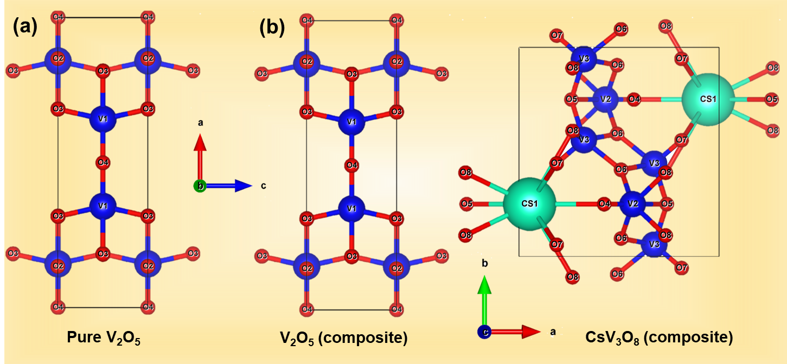
Figure S1. Refined crystallographic structures. (a) Rietveld-refined orthorhombic structure of VO indexed to Pmnm space group. (b) Dual-phase structure of HH–CsVO/VO composite showing coexistence of monoclinic CsVO (P2₁/m) and VO phases, confirming heterostructure formation.

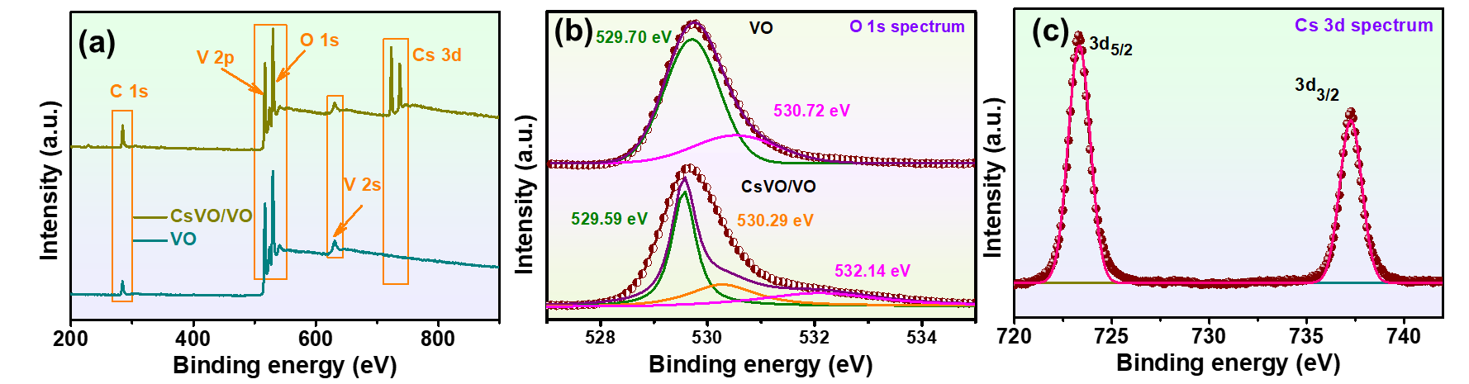
Figure S2. XPS analysis of VO and HH–CsVO/VO. (a) Total XPS survey scan spectra indicating elemental composition. (b) High-resolution O 1s spectra highlighting shifts in oxygen coordination. (c) Cs 3d core-level spectrum confirming successful Cs incorporation in the composite.

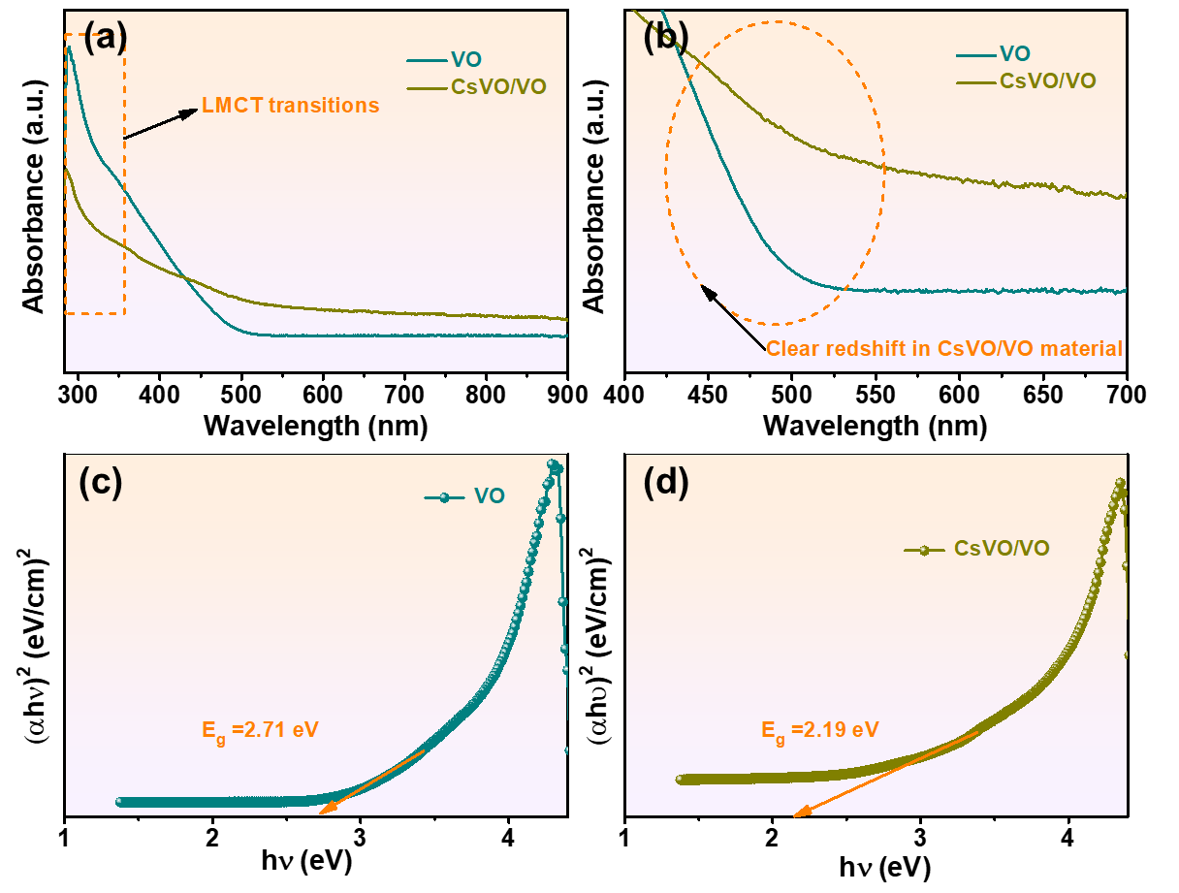
Figure S3. Optical and band structure analysis. (a) UV–Vis absorption spectra of VO and HH–CsVO/VO. (b) Magnified region highlighting redshift in the composite. (c) Tauc plot for VO showing a wider band gap. (d) Tauc plot for CsVO/VO revealing bandgap narrowing due to heterostructure-induced electronic modulation.

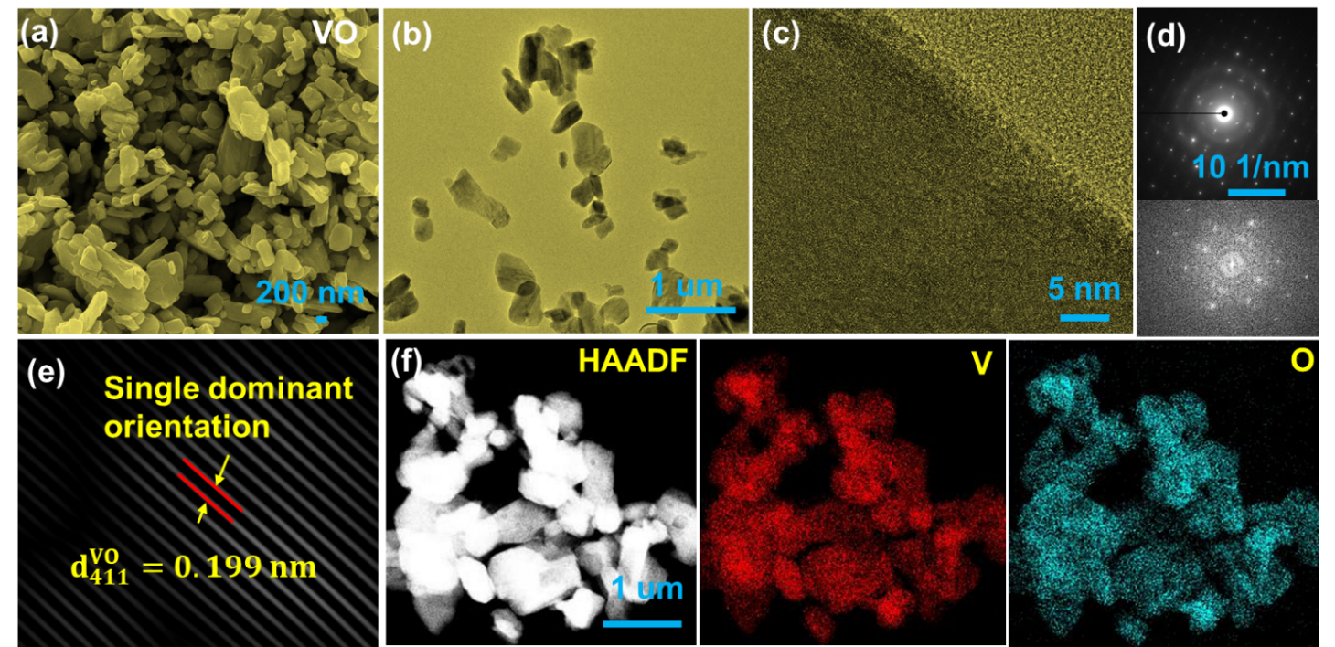
Figure S4. Morphological and structural analysis of pristine VO. (a) FE-SEM image illustrating surface morphology. (b-e) TEM, HRTEM, SAED pattern, FFT, and IFFT images depicting the crystallinity and lattice spacing. (f) HAADF-S-TEM image and corresponding EDS elemental mapping confirming uniform distribution of V and O.

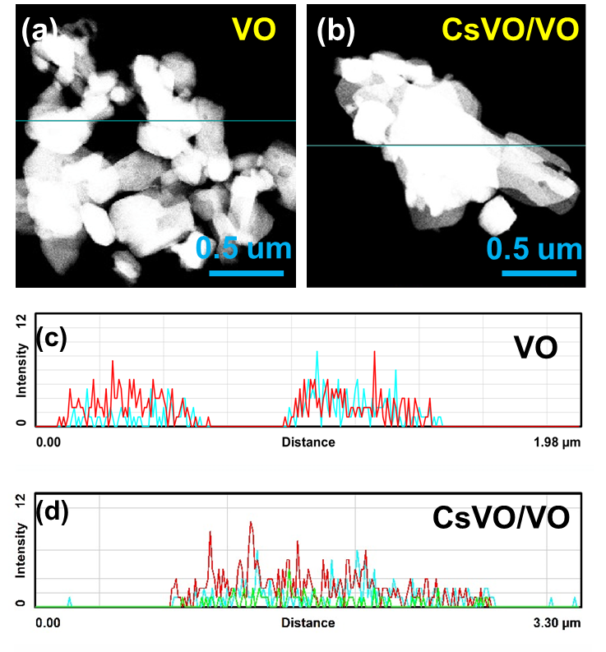
Figure S5. S-TEM-EDS line scan analysis of VO and HH–CsVO/VO composite. (a,b) Dark-field S-TEM images showing the selected region for elemental line scan. (c,d) Corresponding EDS line profiles highlighting a distinct and abrupt variation in V intensity, suggesting a clear phase boundary and confirming the heterointerface within the composite.

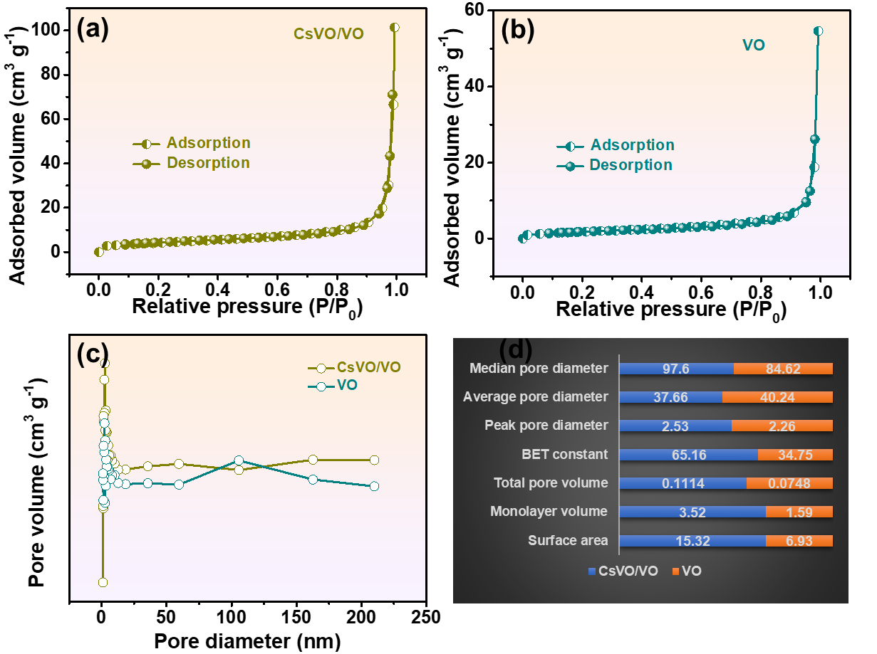
Figure S6. Surface area and porosity characterization. (a,b) N₂ adsorption–desorption isotherms of VO and HH–CsVO/VO, exhibiting type-IV curves with H₃-type hysteresis loops characteristic of mesoporous structures. (c) BJH pore size distribution profiles confirming hierarchical porosity. (d) Summary of BET surface area, total pore volume, and average pore diameter, showing significantly enhanced surface area and porosity in HH–CsVO/VO composite.
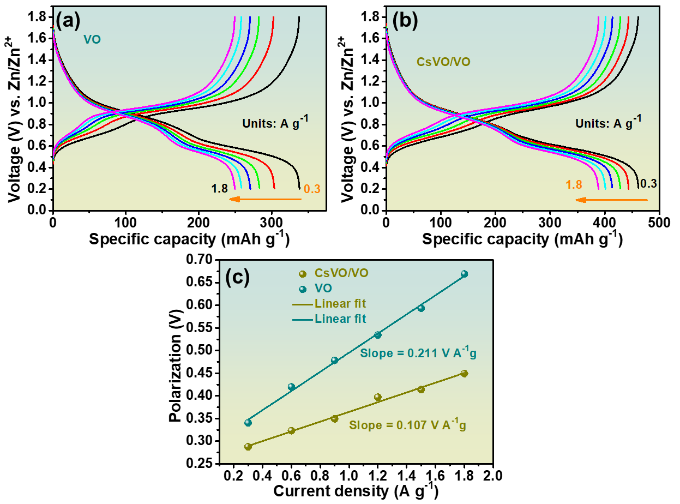
Figure S7. GCD profiles of (a) VO and (b) CsVO/VO at various current densities (0.3–1.8 A g⁻¹), and (c) linear fitting of polarization (ΔV) vs. current density. CsVO/VO shows a lower polarization slope (0.107 V A⁻¹ g) compared to VO (0.211 V A⁻¹ g), indicating improved reaction kinetics and lower internal resistance.

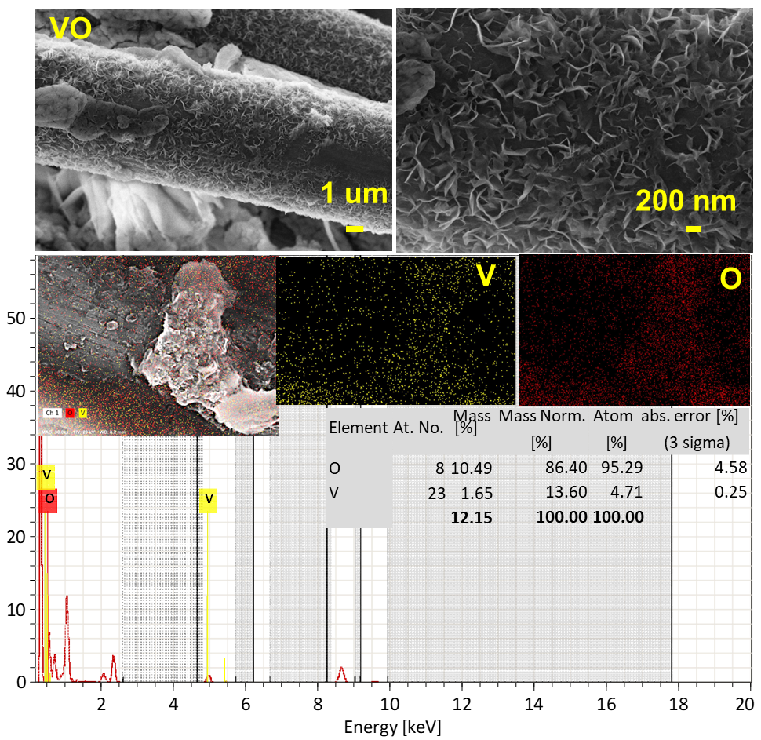
Figure S8. Ex-situ FE-SEM image and corresponding EDS mapping of the VO electrode after 200 cycles at 0.3 A g⁻¹. Surface exhibits noticeable degradation and irregular morphology, indicative of structural instability. Elemental mapping shows significant loss of vanadium, suggesting uncontrolled Zn²⁺ intercalation and V dissolution during prolonged cycling.

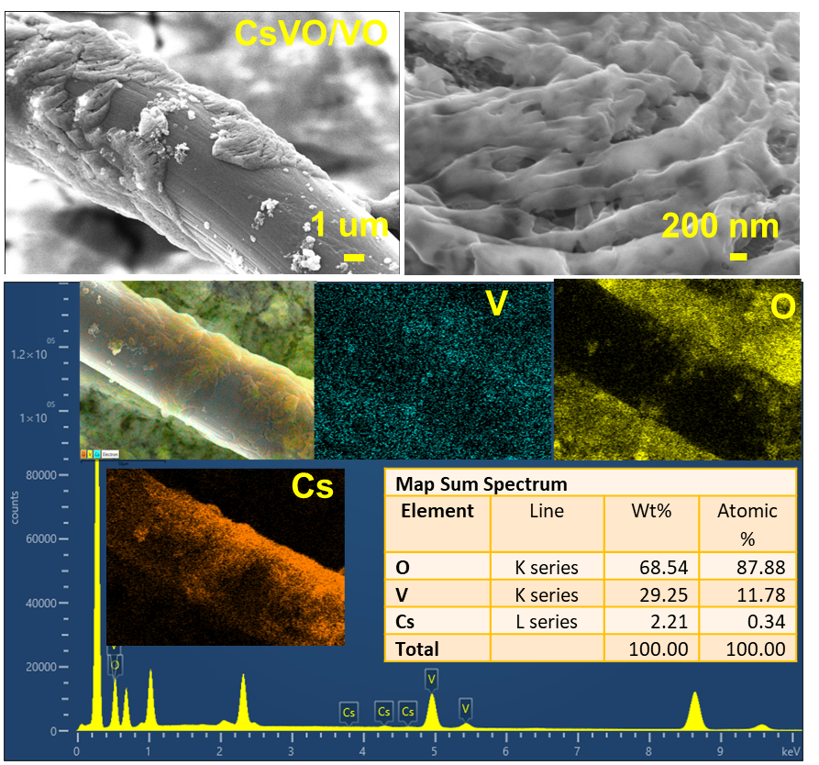
Figure S9. Ex-situ FE-SEM image and EDS mapping of the CsVO/VO composite after 200 cycles at 0.3 A g⁻¹. The electrode retains a relatively uniform and stable surface morphology. Elemental maps show well-distributed Cs, V, and O, confirming reversible Zn²⁺ intercalation and suppressed vanadium dissolution, consistent with improved structural robustness and long-term cycling stability.

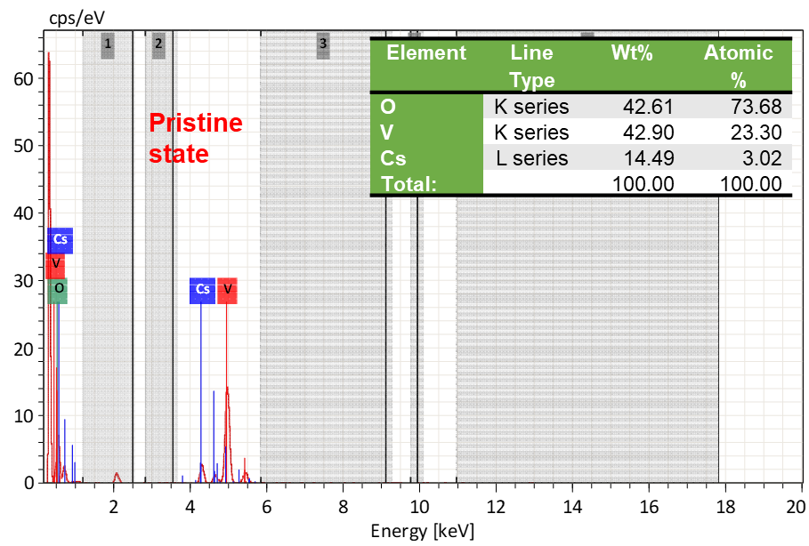
Figure S10. FE-SEM-EDS mapping of HH–CsVO/VO cathode in pristine state.

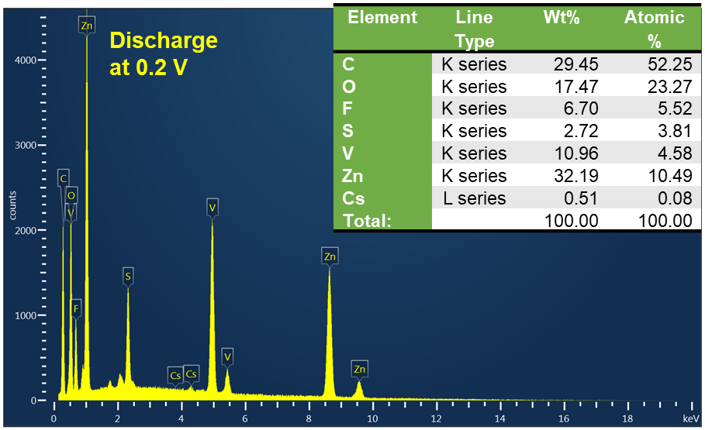
Figure 11. Ex-situ FE-SEM-EDS mapping of HH–CsVO/VO cathode at full discharge (0.2 V) state.

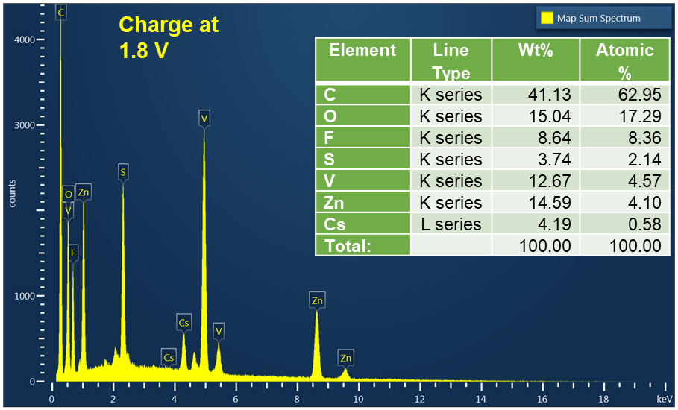
Figure 12. Ex-situ FE-SEM-EDS mapping of HH–CsVO/VO cathode at full charge (1.8 V) state.
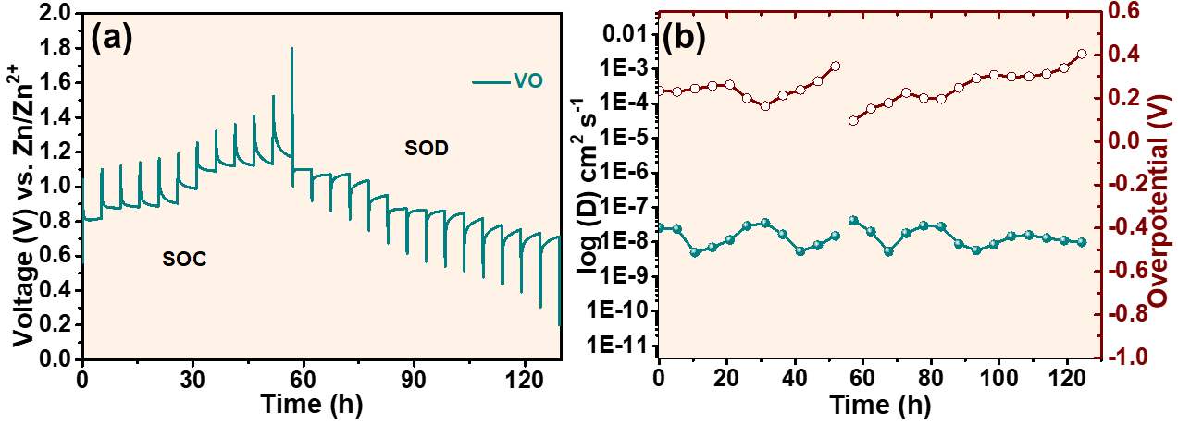
Figure S13. (a) GITT profile of the pristine VO. (b) Corresponding Zn²⁺ diffusion coefficient (D_{Zn2+}) and overpotential (η) plots derived from GITT data, reflecting sluggish ion transport and higher polarization compared to the CsVO/VO composite. These results highlight the kinetic limitations of pristine VO during Zn²⁺ intercalation/extraction.

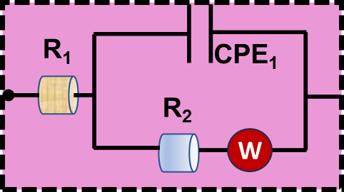
Figure S14. Equivalent circuit model used for fitting the EIS data of the electrodes.

References
[1] K. Zhu, W. Yang, Vanadium-Based Cathodes for Aqueous Zinc-Ion Batteries: Mechanisms, Challenges, and Strategies, Acc. Chem. Res. (2024). https://doi.org/10.1021/acs.accounts.4c00484.
[2] L. Mi, Y. Huang, C. Qin, L. Qin, H.J. Seo, Hydrothermal synthesis and optical properties of CsV3O8 microplates, J. Lumin. 194 (2018) 414–419. https://doi.org/10.1016/j.jlumin.2017.10.044.
[3] H. Bandi, R. Dahule, A.K. Kakarla, R. Maezono, D. Narsimulu, S.W. Akram, R. Shanthappa, J.S. Yu, Green synthesis and interface engineering of CoMoO4–Ag heterostructures: Enhanced electrochemical performance for lithium-ion batteries, Chem. Eng. J. 508 (2025). https://doi.org/10.1016/j.cej.2025.160748.
[4] A. Koklu, A. Mansoorifar, A. Beskok, Effects of electrode size and surface morphology on electrode polarization in physiological buffers, Electrophoresis 40 (2019) 766–775. https://doi.org/10.1002/elps.201800303.
[5] G.Y. Han Zhang, Yang Liu, Ting Wang, Yang Yang, Shaojun Shi, Li2ZrO3-coated Li4Ti5O12 with nanoscale interface for high performance lithium-ion batteries, (2016) 368 56–62. https://doi.org/https://doi.org/10.1016/j.apsusc.2016.01.244.
[6] W. Liang, D. Rao, T. Chen, R. Tang, J. Li, H. Jin, Zn0.52V2O5−a⋅1.8 H2O Cathode Stabilized by In Situ Phase Transformation for Aqueous Zinc-Ion Batteries with Ultra-Long Cyclability, Angew. Chemie - Int. Ed. 61 (2022) 1–11. https://doi.org/10.1002/anie.202207779.
[7] T. Zhou, X. Du, G. Gao, Revealing the role of calcium ion intercalation of hydrated vanadium oxides for aqueous zinc-ion batteries, J. Energy Chem. 95 (2024) 9–19. https://doi.org/10.1016/j.jechem.2024.03.022.
[8] X. Wang, Y. Wang, A. Naveed, G. Li, H. Zhang, Y. Zhou, A. Dou, M. Su, Y. Liu, R. Guo, C.C. Li, Magnesium Ion Doping and Micro-Structural Engineering Assist NH4V4O10 as a High-Performance Aqueous Zinc Ion Battery Cathode, Adv. Funct. Mater. 33 (2023) 1–10. https://doi.org/10.1002/adfm.202306205.
[9] X. Zhang, F. Xue, X. Sun, T. Hou, Z. Xu, Y. Na, Q. An, Z. Chen, S. Cai, C. Zheng, High-capacity zinc vanadium oxides with long-term cyclability enabled by in-situ electrochemical oxidation as zinc-ion battery cathode, Chem. Eng. J. 445 (2022). https://doi.org/10.1016/j.cej.2022.136714.
[10] L. Qin, S. Li, L. Li, G. Fang, H. Cheng, Q. Zhu, H. Gao, S. Chen, Improved working voltage and high rate performance of sodium vanadate cathode materials for aqueous zinc ion batteries by altering synthetic solution pH guiding the structure change, Mater. Today Commun. 31 (2022) 2–11. https://doi.org/10.1016/j.mtcomm.2022.103460.
[11] J. Li, K. McColl, X. Lu, S. Sathasivam, H. Dong, L. Kang, Z. Li, S. Zhao, A.G. Kafizas, R. Wang, D.J.L. Brett, P.R. Shearing, F. Corà, G. He, C.J. Carmalt, I.P. Parkin, Multi-Scale Investigations of δ-Ni0.25V2O5·nH2O Cathode Materials in Aqueous Zinc-Ion Batteries, Adv. Energy Mater. 10 (2020) 1–14. https://doi.org/10.1002/aenm.202000058.
[12] F. Cui, J. Zhao, D. Zhang, Y. Fang, F. Hu, K. Zhu, VO2(B) nanobelts and reduced graphene oxides composites as cathode materials for low-cost rechargeable aqueous zinc ion batteries, Chem. Eng. J. 390 (2020) 124118. https://doi.org/10.1016/j.cej.2020.124118.
[13] H. Liu, X. Hou, T. Fang, Q. Zhang, N. Gong, W. Peng, Y. Li, F. Zhang, X. Fan, Boosting zinc-ion storage in hydrated vanadium oxides via migration regulation, Energy Storage Mater. 55 (2023) 279–288. https://doi.org/10.1016/j.ensm.2022.11.035.
[14] G. Qu, K. Guo, W. Chen, Y. Du, Y. Wang, B. Tian, J. Zhang, Cs-Induced Phase Transformation of Vanadium Oxide for High-Performance Zinc-Ion Batteries, Energy Environ. Mater. 6 (2023). https://doi.org/10.1002/eem2.12502.
[15] Y. Qi, J. Huang, L. Yan, Y. Cao, J. Xu, D. Bin, M. Liao, Y. Xia, Towards high-performance aqueous zinc-ion battery via cesium ion intercalated vanadium oxide nanorods, Chem. Eng. J. 442 (2022) 136349. https://doi.org/10.1016/j.cej.2022.136349.
[16] H. Tian, Y. He, L. Wang, Y. Lai, J. Wang, H. Xiang, W. Zhao, L. Zhang, Simultaneous pre-intercalation of caesium and sodium ions into vanadium oxide bronze nanowires for high-performance aqueous zinc-ion batteries, Mater. Chem. Front. 6 (2022) 1920–1928. https://doi.org/10.1039/d2qm00420h.

