Synthesis of new phosphonylated bis-1,3,4-oxadiazoles and study of their antimicrobial and antiviral activity
_____________________________________________________________________________
Elizaveta A. Gerasimova^{1,2}, Dmitry M. Egorov^{1,2*}, Aleksandr S. Krylov^{1,2}, Ekaterina N. Chernova¹, Dar`ya V. Spiridonova⁴, Irina L. Kuzikova¹, Tatyana B. Zaytsev¹, Zoya A. Zhakovskaya¹, Alexandrina S. Volobueva³ Maria A. Niukalova ³, Vladimir V. Zarubaev ³
¹ St. Petersburg Federal Research Center of the Russian Academy of Sciences (SPC RAS),
39, 14th Line V.O., St. Petersburg, 199178, Russia

² St. Petersburg State Institute of Technology (Technical University), 26, Moskovski ave., St. Petersburg, 190013, Russia

³ Saint Petersburg Pasteur Research Institute, 14 Mira Street, 197101 St. Petersburg, Russia

⁴ Saint-Petersburg State University, 7-9, Universitetskaya Embankment, St. Petersburg, 199034, Russia

* Correspondence: diavoly@mail.ru

Figure S1. ¹H, ¹³C and ³¹P spectra of compound 3aa | 2-3
Figure S2. ESI-MS spectra of compound 3aa | 3
Figure S3. ¹H, ¹³C and ³¹P spectra of compound 3ab | 4-5
Figure S4. ESI-MS spectra of compound 3ab | 5
Figure S5. ¹H, ¹³C and ³¹P spectra of compound 3ac | 6-7
Figure S6. ESI-MS spectra of compound 3ac | 7
Figure S7. ¹H, ¹³C and ³¹P spectra of compound 3bc | 8-9
Figure S8. ESI-MS spectra of compound 3bc | 9
Figure S9. ¹H, ¹³C and ³¹P spectra of compound 3cc | 10-11
Figure S10. ESI-MS spectra of compound 3cc | 11
Figure S11. ¹H, ¹³C and ³¹P spectra of compound 3ad | 12-13
Figure S12. ESI-MS spectra of compound 3ad | 13
Figure S13. ¹H, ¹³C and ³¹P spectra of compound 3ae | 14-15
Figure S14. ESI-MS spectra of compound 3ae | 15
X-ray diffraction experiments | 16-20

Figure S1. ¹H,¹³C, ³¹P spectra of compound 3aa
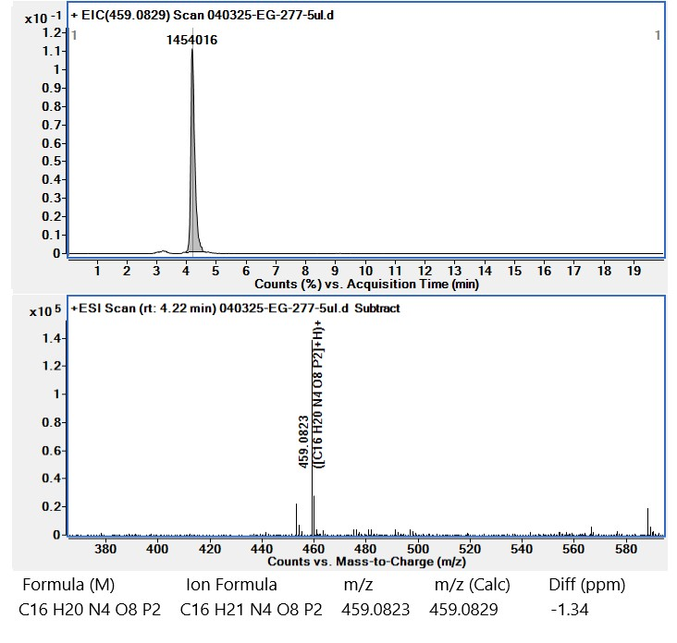
Figure S2. ESI-MS spectra of compound 3aa

Figure S3. ¹H,¹³C, ³¹P spectra of compound 3ab
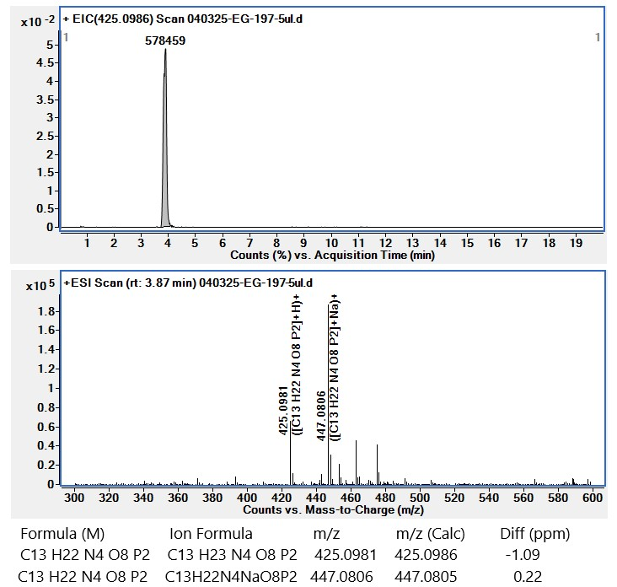
Figure S4. ESI-MS spectra of compound 3ab

Figure S5. ¹H,¹³C, ³¹P spectra of compound 3ac
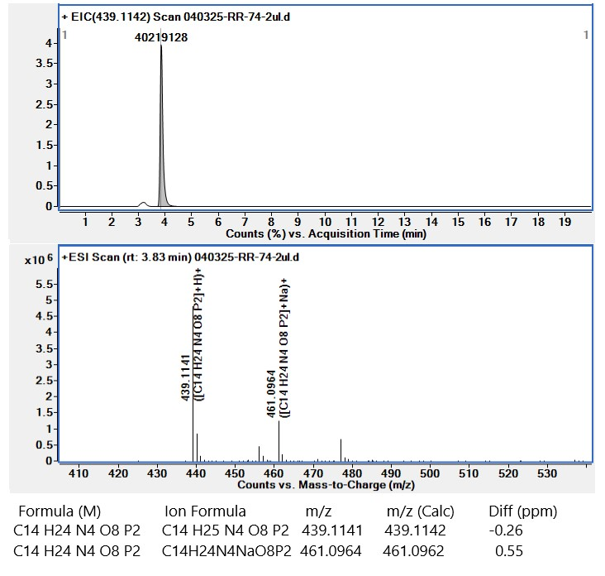
Figure S6. ESI-MS spectra of compound 3ac
Figure S7. ¹H,¹³C, ³¹P spectra of compound 3bc
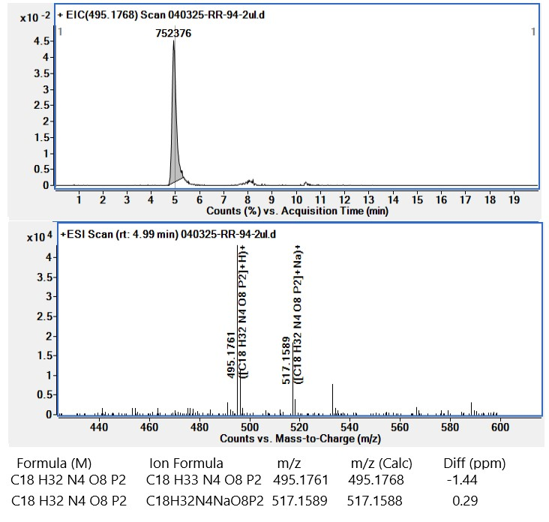
Figure S8. ESI-MS spectra of compound 3bc
Figure S9. ¹H,¹³C, ³¹P spectra of compound 3cc
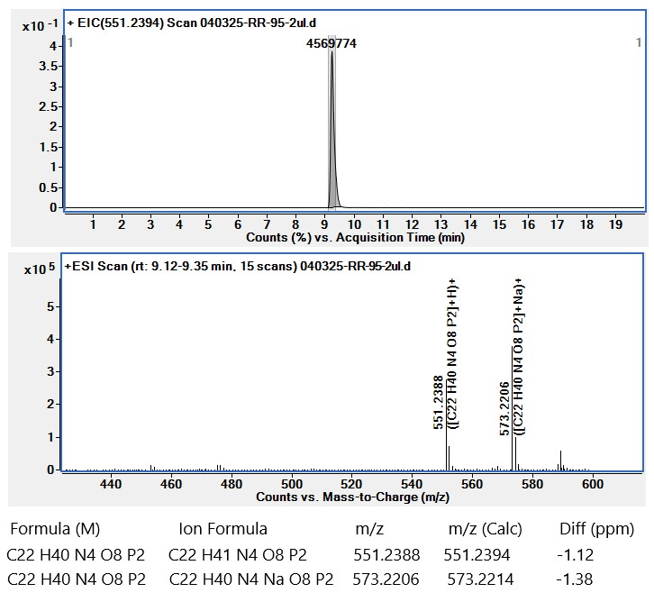
Figure S10. ESI-MS spectra of compound 3cc

Figure S11. ¹H,¹³C, ³¹P spectra of compound 3ad
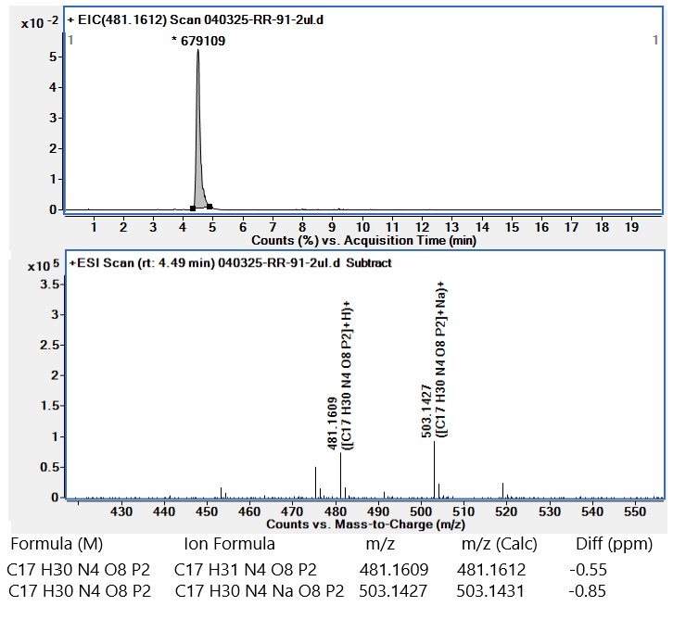
Figure S12. ESI-MS spectra of compound 3ad
Figure S13. ¹H,¹³C, ³¹P spectra of compound 3ae
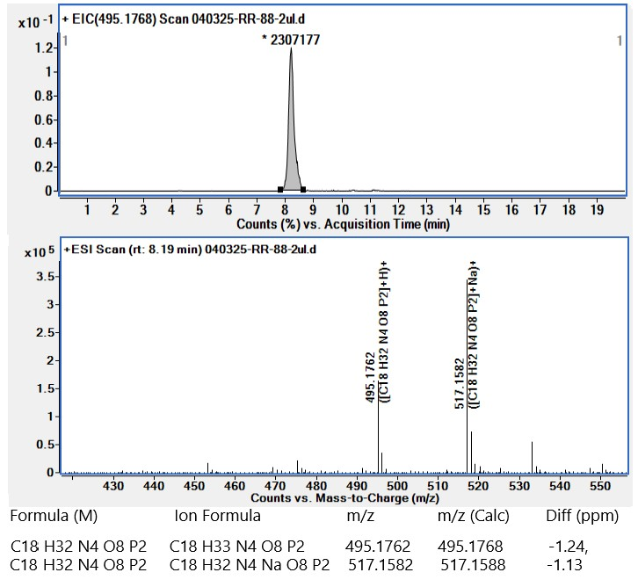
Figure S14. ESI-MS spectra of compound 3ae

X-ray diffraction experiments
The X-ray diffraction study of 3cc (EG-126) was performed at 100(2) K on Rigaku Oxford Diffraction «XtaLAB Supernova» diffractometer (HyPix-3000 type detector) using CuKα (λ = 1.54184 Å) radiation. The structure was solved with the ShelXT [1] structure solution program using Intrinsic Phasing and refined with the ShelXL [2] refinement package incorporated in the OLEX2 program package [3] using Least Squares minimization. The hydrogen atom positions were fixed geometrically at calculated distances and allowed to ride on the parent atoms.

[1] Sheldrick, G., SHELXT - Integrated space-group and crystal-structure determination. Acta Crystallographica Section A 2015, 71, 3-8.

[2] Sheldrick GM. Crystal structure refinement with SHELXL. Acta Crystallographica Section C 2015; 71, 3-8.

[3] Dolomanov, O. V.; Bourhis, L. J.; Gildea, R. J.; Howard, J. A. K.; Puschmann, H., OLEX2: a complete structure solution, refinement and analysis program. Journal of Applied Crystallography 2009, 42, 339-341.

CCDC for 3cc (EG-126) is 2493467
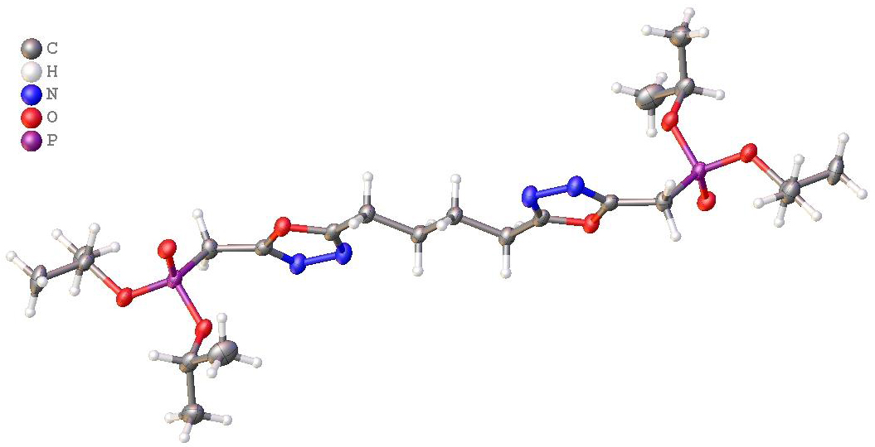
Crystal Data for C₂₂H₄₀N₄O₈P₂ (M = 550.52 g/mol): triclinic, space group P-1 (no. 2), a = 5.7654(9) Å, b = 8.4737(8) Å, c = 14.8122(13) Å, V = 691.72(14) Å³, Z = 1, T = 100(2) K, μ(CuKα) = 1.863 mm⁻¹, D_{calc} = 1.322 g/cm³, 4825 reflections measured (6.204° ≤ 2Θ ≤ 139.946°), 2499 unique (R_{int} = 0.0346, R_{sigma} = 0.0370) which were used in all calculations. The final R₁ was 0.0685 (I ≥ 2σ(I)) and wR₂ was 0.1921 (I ≥ 2σ(I)).

Table 1 Crystal data and structure refinement for 3cc (EG-126).

Identification code | EG-126
Empirical formula | C₂₂H₄₀N₄O₈P₂
Formula weight | 550.52
Temperature/K | 100(2)
Crystal system | triclinic
Space group | P-1
a/Å | 5.7654(9)
b/Å | 8.4737(8)
c/Å | 14.8122(13)
α/° | 105.713(8)
β/° | 90.338(11)
γ/° | 96.430(10)
Volume/Å³ | 691.72(14)
Z | 1
ρ_{calc}g/cm³ | 1.322
μ/mm⁻¹ | 1.863
F(000) | 294.0
Crystal size/mm³ | 0.1 × 0.08 × 0.02
Radiation | Cu Kα (λ = 1.54184)
2Θ range for data collection/° | 6.204 to 139.946
Index ranges | -6 ≤ h ≤ 7, -9 ≤ k ≤ 10, -17 ≤ l ≤ 16
Reflections collected | 4825
Independent reflections | 2499 [R_{int} = 0.0346, R_{sigma} = 0.0370]
Data/restraints/parameters | 2499/0/167
Goodness-of-fit on F² | 1.144
Final R indexes [I>=2σ (I)] | R₁ = 0.0685, wR₂ = 0.1921
Final R indexes [all data] | R₁ = 0.0805, wR₂ = 0.2000
Largest diff. peak/hole / e Å⁻³ | 0.51/-0.51

Table 2 Fractional Atomic Coordinates (×10⁴) and Equivalent Isotropic Displacement Parameters (Å²×10³) for 3cc (EG-126). U_{eq} is defined as 1/3 of the trace of the orthogonalised U_{IJ} tensor.
Atom | x | y | z | U(eq)
C1 | 4405(7) | 4695(5) | 8704(3) | 25.3(8)
C2 | 2549(7) | 2949(4) | 9331(3) | 24.3(8)
C3 | 607(7) | 2167(5) | 9771(3) | 26.5(8)
C4 | 993(7) | 406(5) | 9775(3) | 26.6(8)
C5 | 4859(7) | 6168(5) | 8354(3) | 27.0(8)
C6 | 4571(7) | 9184(5) | 7280(3) | 30.1(9)
C7 | 7163(8) | 9636(5) | 7472(3) | 36.9(10)
C8 | 3626(8) | 9983(5) | 6582(4) | 40.9(11)
C9 | 978(8) | 4012(5) | 5950(3) | 34.1(10)
C10 | -1143(9) | 3040(7) | 6214(4) | 53.5(14)
C11 | 2168(9) | 3038(6) | 5126(3) | 44.8(12)
N1 | 5799(6) | 3625(4) | 8725(2) | 29.2(8)
N2 | 4576(6) | 2464(4) | 9138(2) | 28.4(7)
O1 | 2292(5) | 4358(3) | 9078.7(19) | 26.5(6)
O2 | 559(5) | 6787(3) | 7805(2) | 29.3(6)
O3 | 4131(5) | 7382(3) | 6874(2) | 30.3(7)
O4 | 2681(5) | 4485(3) | 6745.2(19) | 27.4(6)
P1 | 2786.7(17) | 6258.0(11) | 7446.6(7) | 24.6(3)
Table 3 Anisotropic Displacement Parameters (Å²×10³) for 3cc (EG-126). The Anisotropic displacement factor exponent takes the form: -2π²[h²a*²U₁₁+2hka*b*U₁₂+…].
Atom | U₁₁ | U₂₂ | U₃₃ | U₂₃ | U₁₃ | U₁₂
C1 | 27.5(19) | 22.4(18) | 23.6(18) | 2.1(15) | -3.0(15) | 3.7(15)
C2 | 27.6(19) | 18.2(17) | 25.0(18) | 2.1(15) | -9.2(15) | 3.2(14)
C3 | 26.2(19) | 22.5(19) | 31(2) | 7.6(16) | -2.3(15) | 3.5(15)
C4 | 29(2) | 21.7(19) | 30(2) | 6.8(16) | -1.4(16) | 5.8(15)
C5 | 25.3(19) | 26.1(19) | 30(2) | 11.0(16) | -3.4(15) | -0.8(15)
C6 | 34(2) | 19.3(18) | 37(2) | 6.8(17) | 6.4(17) | 4.0(16)
C7 | 36(2) | 25(2) | 47(3) | 8.4(19) | -9.9(19) | 1.3(17)
C8 | 36(2) | 26(2) | 66(3) | 21(2) | -9(2) | 1.9(18)
C9 | 38(2) | 26(2) | 36(2) | 3.5(18) | -13.8(18) | 6.0(17)
C10 | 36(3) | 48(3) | 65(3) | -2(3) | -7(2) | -3(2)
C11 | 59(3) | 39(3) | 35(2) | 6(2) | -6(2) | 10(2)
N1 | 28.6(18) | 24.1(17) | 36.3(19) | 10.1(15) | -0.4(14) | 4.5(13)
N2 | 25.1(17) | 25.2(17) | 37.7(19) | 12.8(14) | -1.1(14) | 3.8(13)
O1 | 26.8(14) | 22.4(13) | 31.7(14) | 8.8(11) | -1.2(11) | 5.3(10)
O2 | 29.3(14) | 25.8(14) | 33.5(15) | 6.7(12) | -0.7(11) | 9.1(11)
O3 | 37.8(16) | 19.9(13) | 32.3(15) | 5.4(12) | -1.2(12) | 4.3(11)
O4 | 29.5(14) | 19.4(13) | 32.4(15) | 5.6(11) | -7.2(11) | 3.8(11)
P1 | 27.7(5) | 18.7(5) | 27.8(5) | 6.5(4) | -2.9(4) | 3.8(4)
Table 4 Bond Lengths for 3cc (EG-126).
Atom | Length/Å | Atom | Length/Å
C1-C5 | 1.475(5) | C6-C8 | 1.509(6)
C1-N1 | 1.283(5) | C6-O3 | 1.473(5)
C1-O1 | 1.375(5) | C9-C10 | 1.510(7)
C2-C3 | 1.481(6) | C9-C11 | 1.495(7)
C2-N2 | 1.290(5) | C9-O4 | 1.468(5)
C2-O1 | 1.367(5) | N1-N2 | 1.420(5)
C3-C4 | 1.535(5) | O2-P1 | 1.463(3)
C4-C4¹ | 1.521(8) | O3-P1 | 1.584(3)
C5-P1 | 1.815(4) | O4-P1 | 1.573(3)
C6-C7 | 1.506(6)
¹-X,-Y,2-Z

Table 5 Bond Angles for 3cc (EG-126).
Atom-Atom-Atom | Angle/˚ | Atom-Atom-Atom | Angle/˚
N1-C1-C5 | 127.7(4) | O4-C9-C10 | 108.4(4)
N1-C1-O1 | 112.1(3) | O4-C9-C11 | 106.9(4)
O1-C1-C5 | 120.1(3) | C1-N1-N2 | 106.5(3)
N2-C2-C3 | 127.9(3) | C2-N2-N1 | 106.3(3)
N2-C2-O1 | 112.2(3) | C2-O1-C1 | 102.9(3)
O1-C2-C3 | 119.9(3) | C6-O3-P1 | 120.2(3)
C2-C3-C4 | 111.6(3) | C9-O4-P1 | 119.0(2)
C4¹-C4-C3 | 111.9(4) | O2-P1-C5 | 113.82(18)
C1-C5-P1 | 114.4(3) | O2-P1-O3 | 114.57(16)
C7-C6-C8 | 112.6(4) | O2-P1-O4 | 116.47(16)
O3-C6-C7 | 107.9(3) | O3-P1-C5 | 105.56(17)
O3-C6-C8 | 107.5(3) | O4-P1-C5 | 102.55(16)
C11-C9-C10 | 113.0(4) | O4-P1-O3 | 102.34(15)
¹-X,-Y,2-Z

Table 6 Torsion Angles for 3cc (EG-126).
A-B-C-D | Angle/˚ | A-B-C-D | Angle/˚
C1-C5-P1-O2 | 78.2(3) | C9-O4-P1-C5 | 173.8(3)
C1-C5-P1-O3 | -155.3(3) | C9-O4-P1-O2 | 48.8(3)
C1-C5-P1-O4 | -48.5(3) | C9-O4-P1-O3 | -76.9(3)
C1-N1-N2-C2 | -0.1(4) | C10-C9-O4-P1 | -97.3(4)
C2-C3-C4-C4¹ | 180.0(4) | C11-C9-O4-P1 | 140.6(3)
C3-C2-N2-N1 | 180.0(3) | N1-C1-C5-P1 | 123.8(4)
C3-C2-O1-C1 | -179.9(3) | N1-C1-O1-C2 | -0.1(4)
C5-C1-N1-N2 | 179.0(4) | N2-C2-C3-C4 | -14.1(5)
C5-C1-O1-C2 | -179.1(3) | N2-C2-O1-C1 | 0.0(4)
C6-O3-P1-C5 | -74.2(3) | O1-C1-C5-P1 | -57.5(4)
C6-O3-P1-O2 | 51.8(3) | O1-C1-N1-N2 | 0.2(4)
C6-O3-P1-O4 | 178.8(3) | O1-C2-C3-C4 | 165.8(3)
C7-C6-O3-P1 | 112.2(3) | O1-C2-N2-N1 | 0.1(4)
C8-C6-O3-P1 | -126.1(3)
¹-X,-Y,2-Z

Table 7 Hydrogen Atom Coordinates (Å×10⁴) and Isotropic Displacement Parameters (Å²×10³) for 3cc (EG-126).
Atom | x | y | z | U(eq)
H_{3A} | -876 | 2134.78 | 9422.43 | 32
H_{3B} | 472 | 2840.9 | 10424.06 | 32
H_{4A} | 1129.17 | -266.27 | 9120.96 | 32
H_{4B} | 2478.03 | 439.74 | 10122.04 | 32
H_{5A} | 6446.19 | 6196.94 | 8102.39 | 32
H_{5B} | 4837.79 | 7164.71 | 8888.01 | 32
H₆ | 3738.3 | 9506.64 | 7880.72 | 36
H_{7A} | 7698.76 | 9063.16 | 7912.53 | 55
H_{7B} | 7499.91 | 10831.84 | 7744.7 | 55
H_{7C} | 7977.07 | 9308.92 | 6883.21 | 55
H_{8A} | 4430.99 | 9654.27 | 5991.67 | 61
H_{8B} | 3885.55 | 11186.17 | 6834.61 | 61
H_{8C} | 1948.2 | 9627.32 | 6468.2 | 61
H₉ | 512.62 | 5027.85 | 5812.88 | 41
H_{10A} | -709.9 | 2003.32 | 6300.33 | 80
H_{10B} | -2354.5 | 2798.19 | 5712.73 | 80
H_{10C} | -1739.72 | 3688.36 | 6799.37 | 80
H_{11A} | 3512.16 | 3731.33 | 4980.54 | 67
H_{11B} | 1069.61 | 2668.35 | 4581.93 | 67
H_{11C} | 2701.84 | 2075.46 | 5273.65 | 67

CCDC for 3cc (EG-126) is 2493467

