Supplementary Information

Curcumae Radix extract reduces beta-amyloid (Αβ) and tau protein through increased mitochondrial respiration

Seong Lae Jo^{1#}, Hyun Yang^{2#}, Jun H. Heo¹, Sang R. Lee¹, Hye Won Lee ^{2*}, and Eui-Ju Hong^{1*}

¹ College of Veterinary Medicine, Chungnam National University, Daejeon 34134, Korea

² KM Convergence Research Division, Korea Institute of Oriental Medicine, Daejeon 34054, Korea;

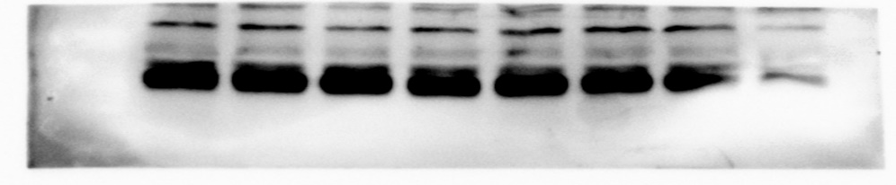
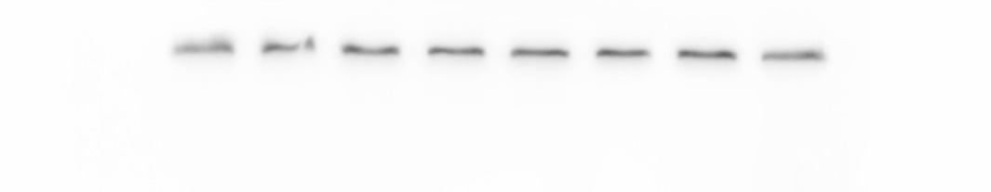
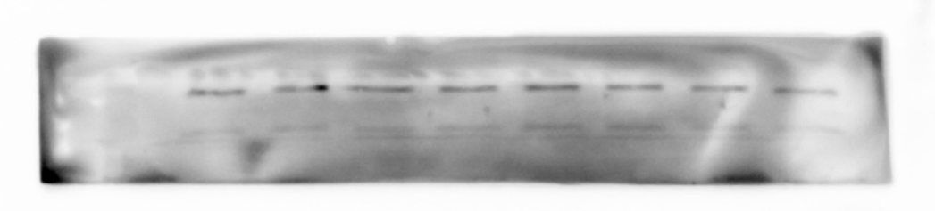
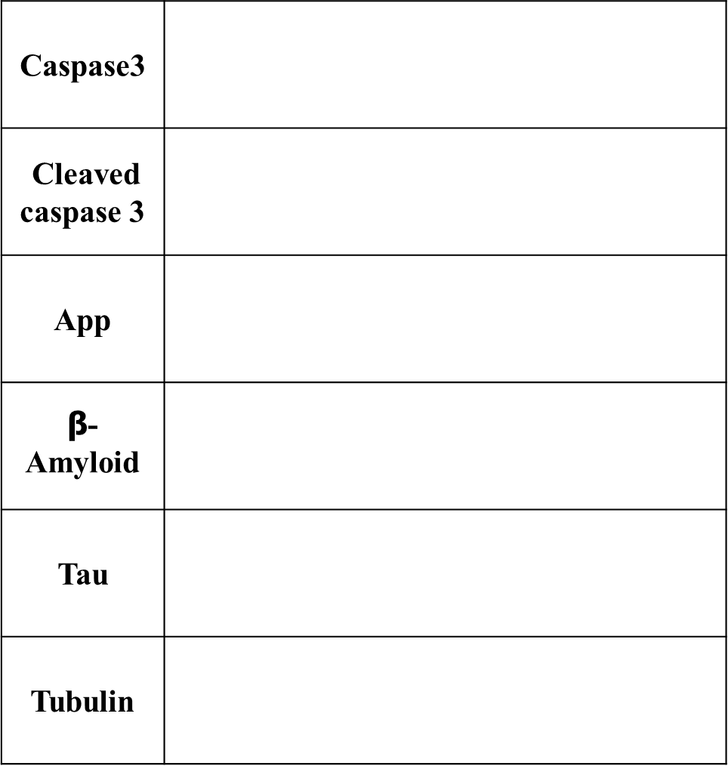
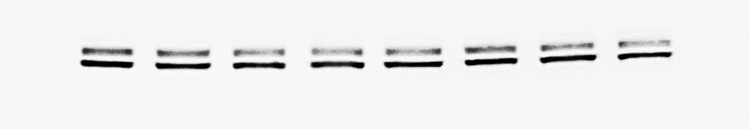
Figure S1. Quantitative Analysis of major ingredients in Curcumae Radix Extract. (A) The structures of three reference standards (curcumin, demethoxycurcumin, and bisdemethoxycurcumin), (B) Curcumae radix 70% ethanol extraction.
Fig. 1B

Fig. 1C
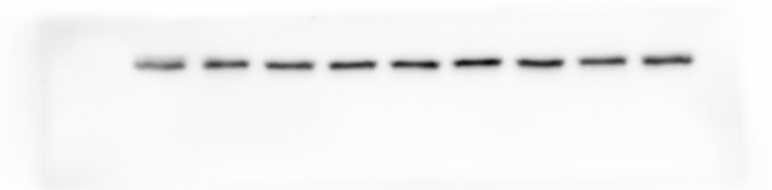
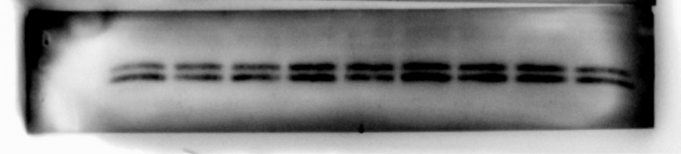
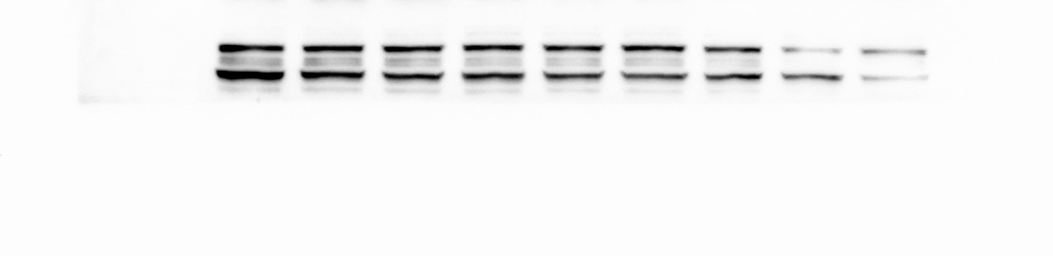
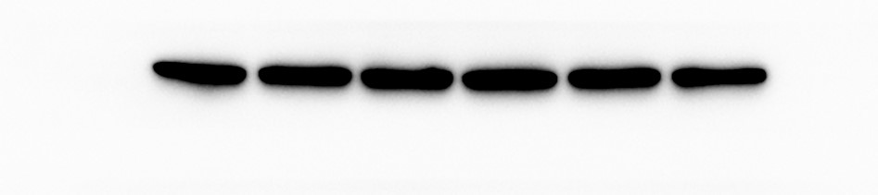
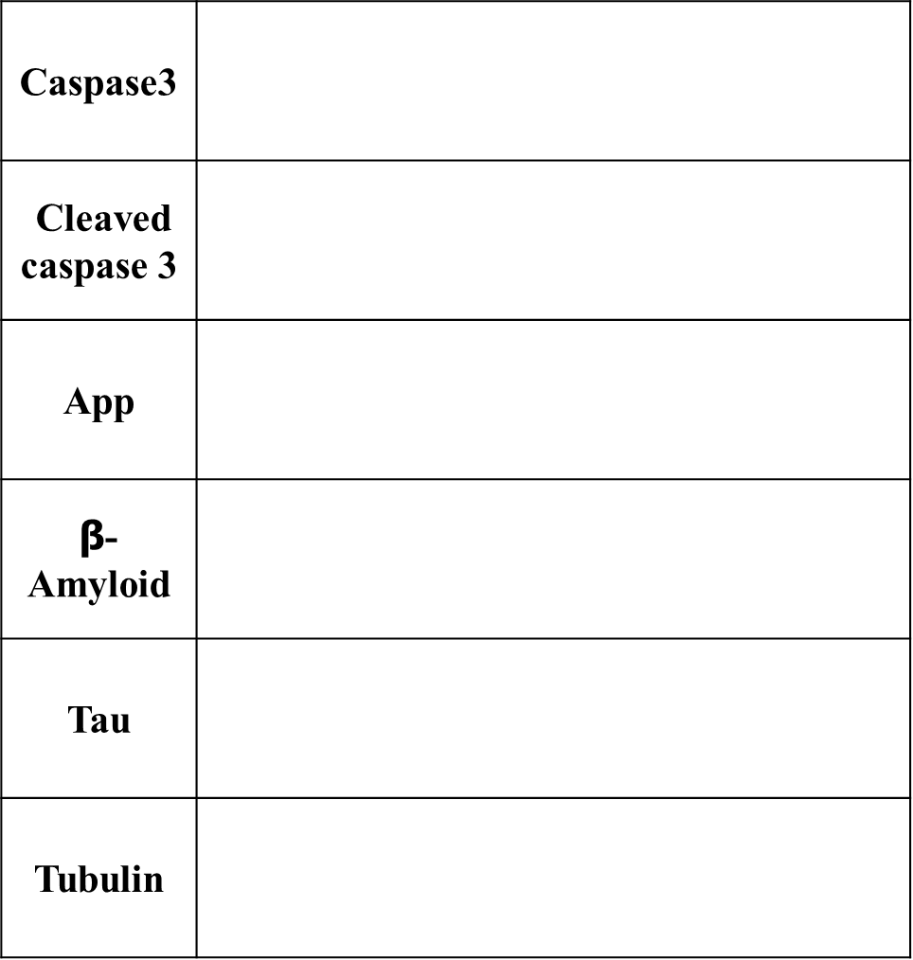
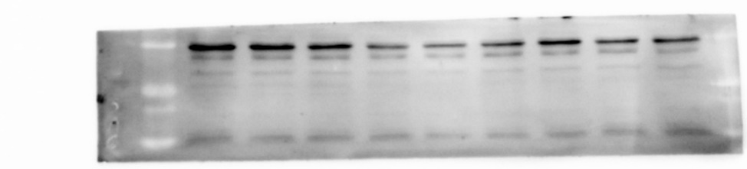
Fig. 2A
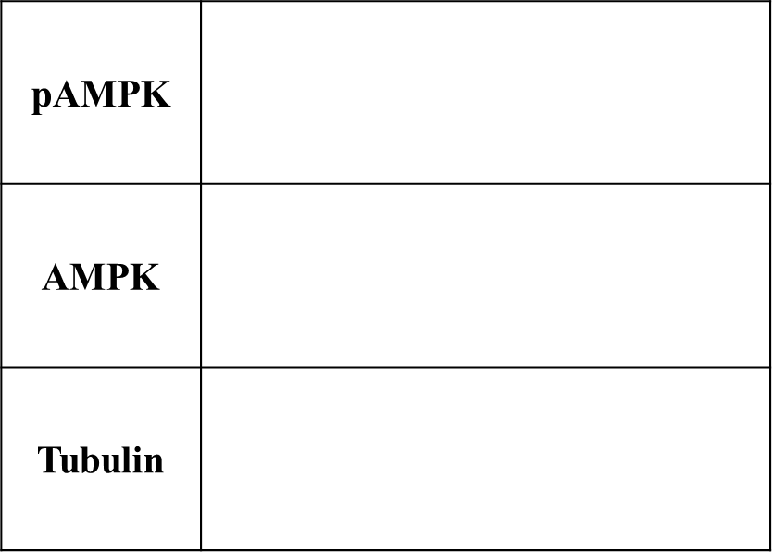
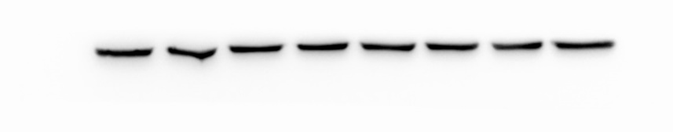

Fig. 2B
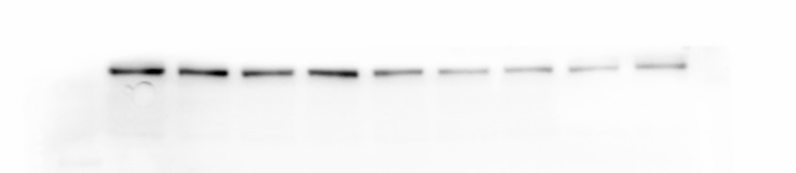
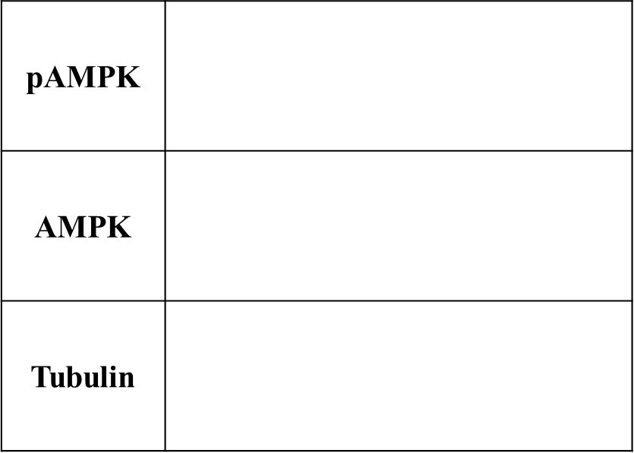

Fig. 3A
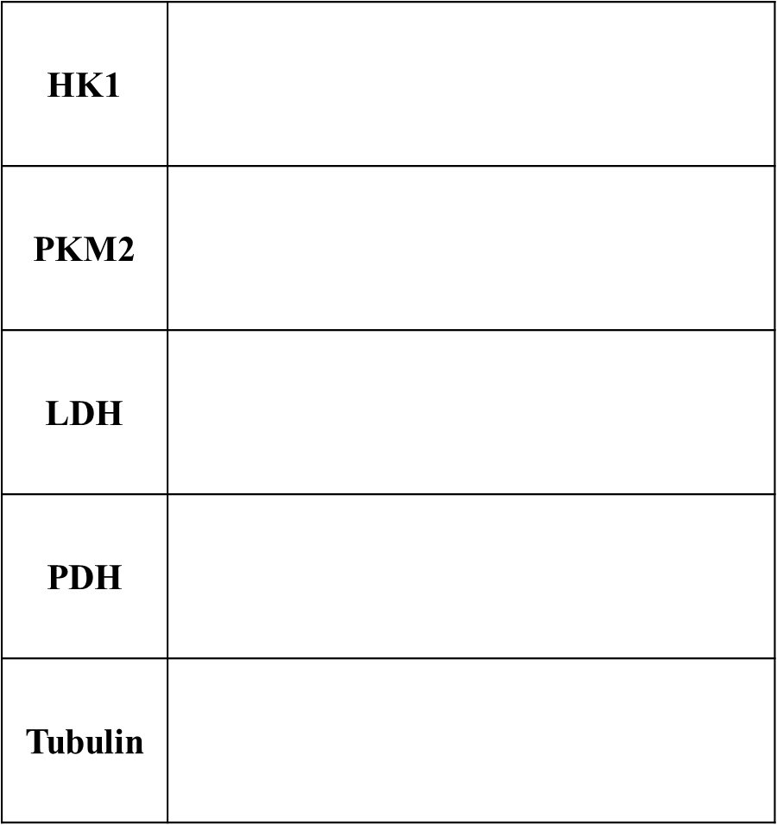
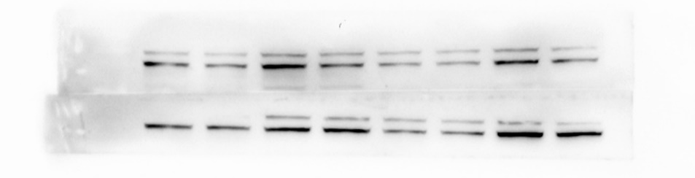
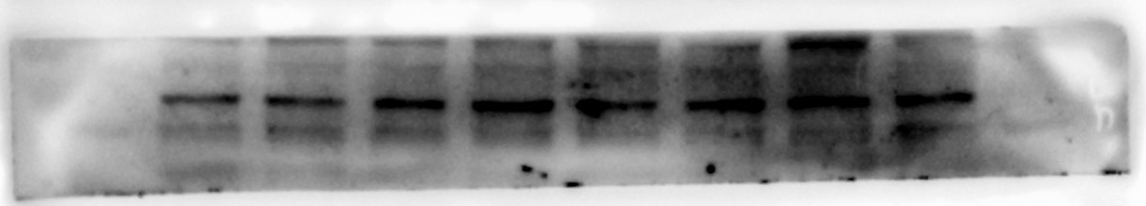
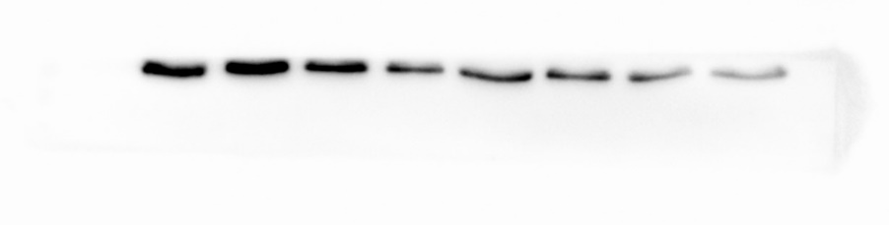
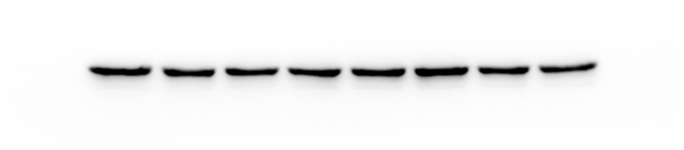

Fig. 3B
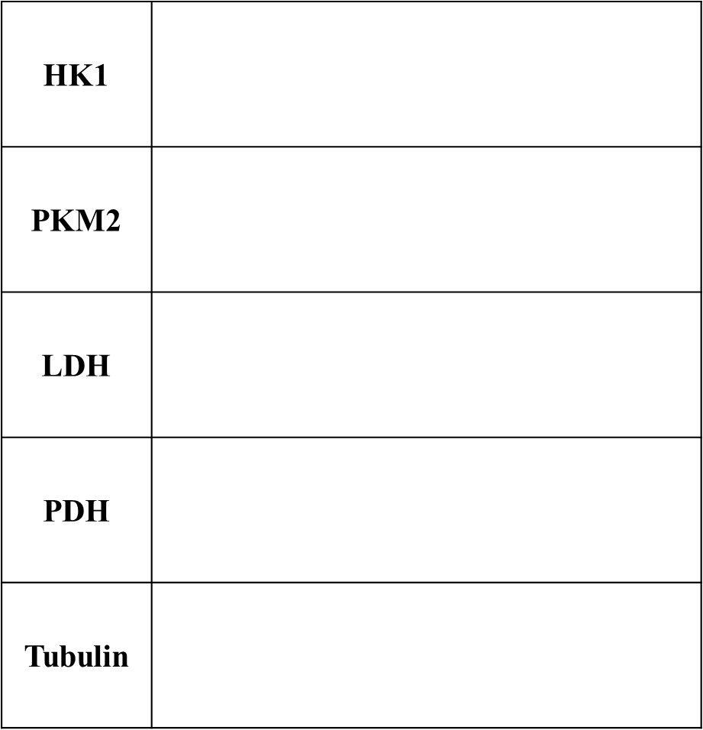
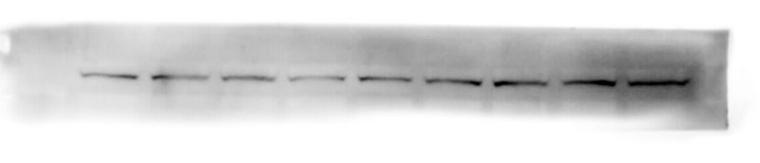
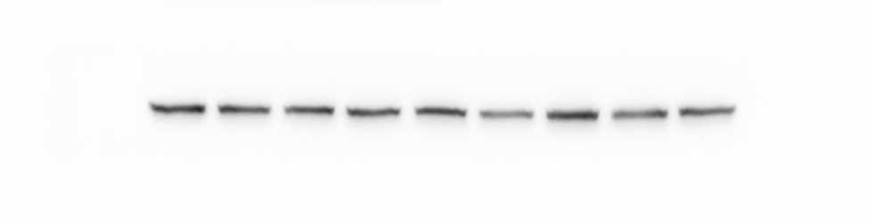
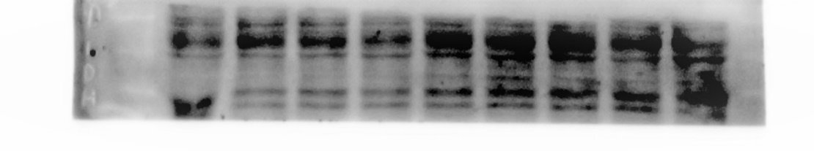
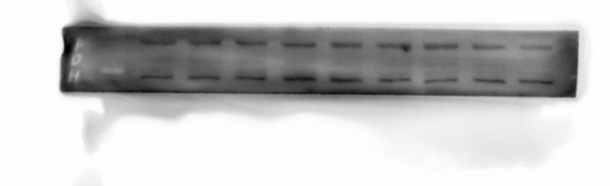
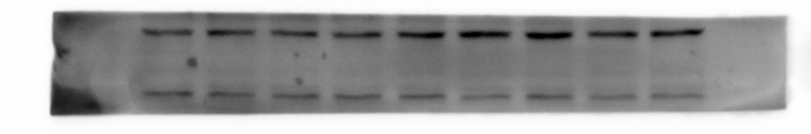

Fig. 5B
