Supplementary Material
A zebrafish stable model of Galectin-3 to elucidate its role in Arrhythmogenic Cardiomyopathy
Giovanni Risato^{1,2}†, Rudy Celeghin¹†, Marco Cason¹, Maria Bueno Marinas¹, Serena Pinci¹, Raquel Brañas Casas², Monica de Gaspari¹, Mila Della Barbera¹, Nicola Facchinello^{3,4}, Stefania Rizzo¹, Francesco Argenton², Gaetano Thiene¹, Barbara Bauce¹, Cristina Basso¹, Natascia Tiso ^{2*}, Kalliopi Pilichou^{1*}
¹Department of Cardiac-Thoracic-Vascular Sciences and Public Health, University of Padova, Padova, 35128, Italy.
²Department of Biology, University of Padova, Padova, 35131, Italy.
³Department of Pharmacy and Biotechnology, University of Bologna, Bologna, 40126, Italy.

⁴Neuroscience Institute, Italian Research Council (CNR), Padova, 35131, Italy

† These authors contributed equally to this work
* Corresponding authors

Natascia Tiso, PhD
Associate Professor of Biology
Dept. of Biology
University of Padua
via Ugo Bassi 58/b
35131 Padova, Italy
Phone n. +39 049 8276302
Email natascia.tiso@unipd.it
http://zfin.org/ZDB-PERS-020116-8
Kalliopi Pilichou, PhD
Associate Professor of Genetics
Head of Cardiovascular Genetics Lab
Dept. of Cardiac-Thoracic-Vascular Sciences and Public Health
University of Padua
Via A. Gabelli 61
35121 Padova, Italy
Phone n. +39 049 8272293 Email kalliopi.pilichou@unipd.it

Supplementary Table 1: List of oligonucleotides for lgals3 mutant generation and analysis.
The table lists the sgRNA oligos for lgals3a and lgals3b mutant lines generation (A), the primers for PCR-based genotyping (B), and for gene expression analysis by quantitative Real-Time (RT-PCR) (C).
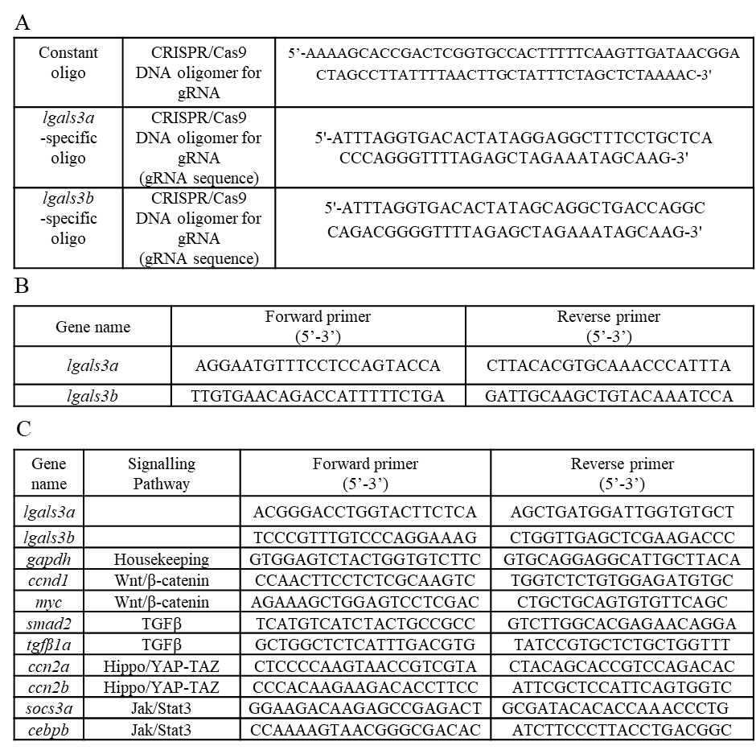
Supplementary Figure 1: Genotyping of lgals3a and lgals3b zebrafish mutants. A-B-D-E: sequence-based identification of the lgals3a 4-nt and lgals3b 114-nt deletions (red boxes) in case of homozygous control (B-D) and homozygous mutant (A-E). C- F: gel-based identification of the lgals3a (C) and lgals3b (F) genotypes; from left to right: size marker, WT control, and homozygous mutant. The C and F panels are photo-compositions of non-adjacent lanes.

Supplementary Figure 2: Graphical representation of fertility analysis of lgals3b homozygous male and female adult zebrafish. Left: lgals3b homozygous male fish fertilize 72% of the total eggs. Right: lgals3b homozygous female fish may exhibit abnormal ovulation, releasing already degrading eggs; 67% of the obtained eggs resulted unfertilized (n = 100).

Supplementary Figure 3: Decreased survival of zebrafish lgals3a (-aa) mutants at juvenile stages. One-month survival analysis of mutant lines showed a significant decrease in the survival rate of mutant larvae (p<0.0001), compared to WT. Sample size: n = 100. Test: Log-rank (Mantel-Cox) test.

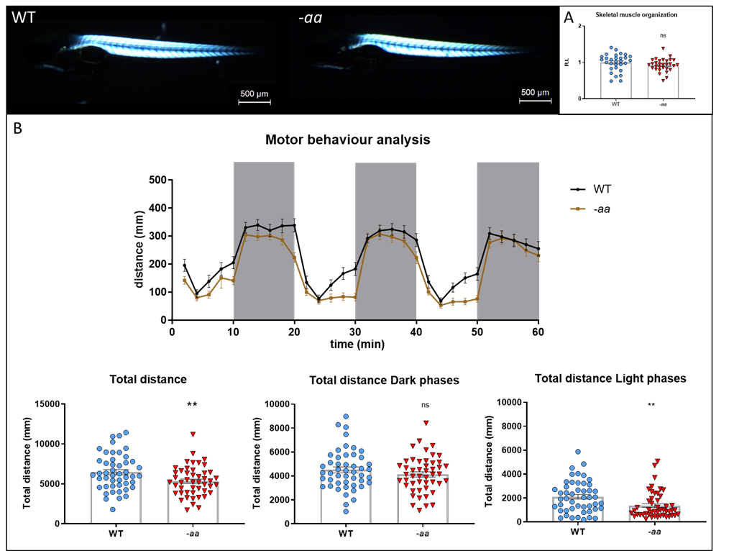

Supplementary Figure 4: Impaired motor behaviour and exercise-induced mortality in zebrafish lgals3a (-aa) mutant larvae. A-A’-A’’: Birefringence analysis on WT and -aa larvae at 5 dpf fails to detect any significant difference in the skeletal muscle structure. Embryos are displayed at 5 dpf, in lateral view, anterior to the left. Sample size: n = 30. R.I.: Relative Intensity. ns = not significant. Test: Unpaired t-test. B-B’: WT and -aa larvae at 5 dpf display normal response to light (white areas) and dark (grey areas) stimuli, but with reduced motor performances in the mutants, evaluated as total distance swum. Sample size: n = 47. ** = p<0.01. Test: Unpaired t-test.

Supplementary Figure 5: Signalling pathways dysregulation in lgals3a mutants. qPCR analysis detected dysregulation in all the pathways analysed in lgals3a mutant larvae. Wnt/β-catenin, Hippo/YAP-TAZ and TGFβ signalling pathway target genes showed a significant downregulation. Each point on the graph corresponds to a pool of 30 embryos of the same genotype. Sample size: n ≈ 15. Log2 FC: Log2 Fold Change. * = p<0.05; ** = p<0.01; *** = p<0.001; **** = p<0.0001. Test: Unpaired t-test.

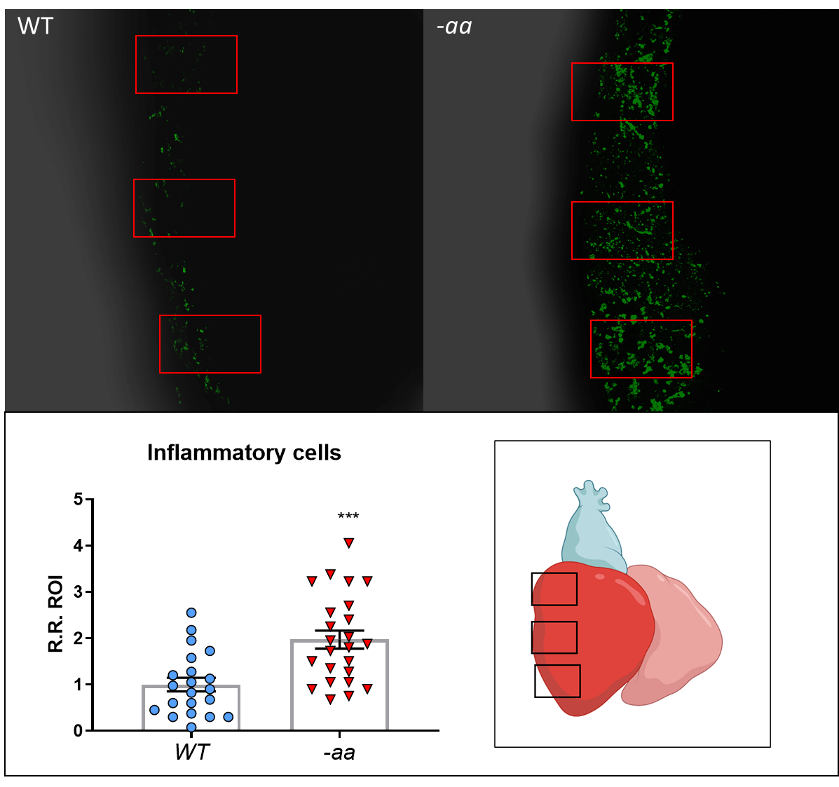

Supplementary figure 6: Inflammatory response in lgals3a (-aa) mutants. Cells expressing the inflammatory marker L-plastin are significantly more abundant in the epicardial layer of -aa mutants (B) compared to WT (A), as shown in the statistical analysis. Sample size: n ≈ 20. *** = p<0.001. Test: Unpaired t-test. Red rectangular boxes indicate ROI. R.R. ROI: Relative Ratio ROI.

