Supplemental Information for “Non-lithifying microbial ecosystem dissolves peritidal lime sand,” by T. M. Present, M. L. Gomes, E. J. Trower, N. T. Stein, U. F. Lingappa, J. Naviaux, M. Thorpe, M. D. Cantine, W. W. Fischer, A. H. Knoll, and J. P Grotzinger

Supplemental Table 1: Coring locations and recovery results
Core | Date | Latitude (°N) | Longitude (°W) | Barrel length (cm) | Distance to sediment top (cm) | Distance to core top (cm) | Length Recovered (cm) | Compaction (%) | Recovery (%) | Site Description
VC-01 | 8/3/17 | 21.28868 | 71.69667 | 305 | 94 | 120 | 148 | 14 | 80 | polygonal mats
VC-02 | 8/3/17 | 21.28910 | 71.69632 | 305 | 113 | 199 | 106 | 81 | 100 | blister mats near grainstone berm
VC-03 | 8/4/17 | 21.29822 | 71.70177 | 305 | 60 | 85 | 223 | 11 | 101 | polygonal mats at edge of mangroves
VC-04 | 8/5/17 | 21.29055 | 71.70635 | 305 | 32 | 70 | 240 | 16 | 102 | muddy algal patch behind tidal bar, in about 30 cm water
VC-05 | 8/8/17 | 21.30400 | 71.68665 | 305 | 107 | 137 | 168 | 18 | 100 | blister mats on tidal bar
VC-06 | 8/8/17 | 21.29833 | 71.68725 | 305 | 185 | 205 | 86 | 20 | 86 | polygonal mats in middle of tidal bay
VC-07 | 8/8/17 | 21.29465 | 71.68778 | 200 | 100 | 105 | 93 | 5 | 98 | polygonal mats in tidal creek behind grainstone berm
VC-08 | 8/8/17 | 21.29825 | 71.68423 | 305 | 132 | 166 | 138 | 24 | 99 | smooth mats on small sand lobe in tidal bay

Supplemental Data
Geochemical data from porewater and sinkhole water is provided in the attached spreadsheet, “Supplemental Data Table.xslx”. Graphic logs of vibracore sedimentology are shown in Supplemental Figure 1 and 2. Sediment texture and allochems are indicative of deposition by reworking of shoreface sand to gravel in a restricted interior basin (Supplemental Figure 3).

Supplemental Figure 1: Graphic logs of vibracores VC-01, VC-02, VC-03, and VC-04
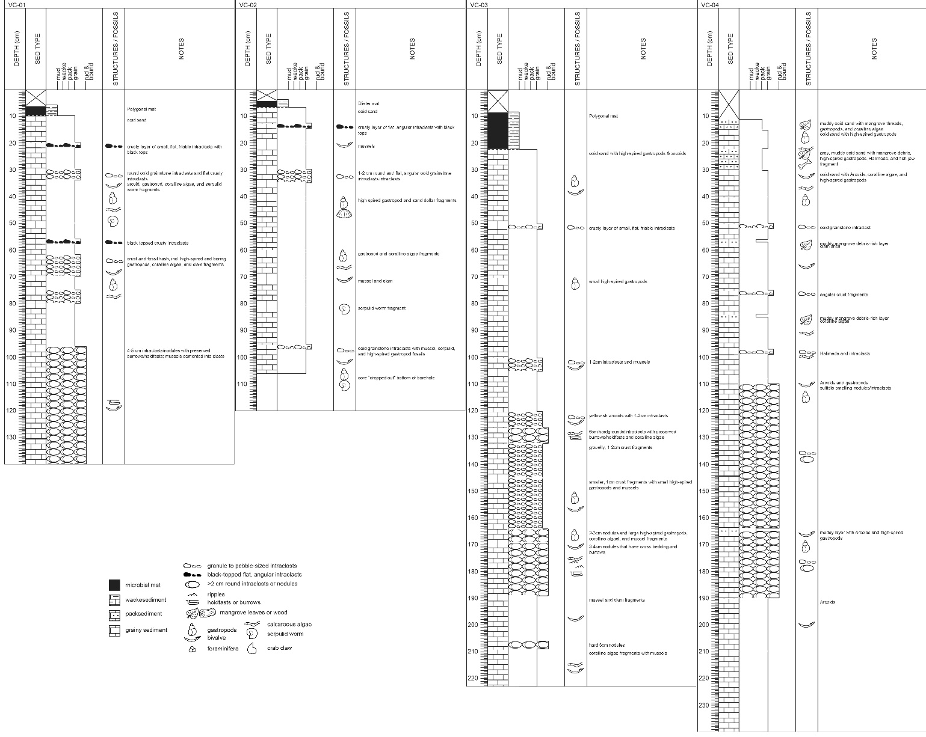

Supplemental Figure 2: Graphic logs of vibracores VC-05, VC-06, VC-07, and VC-08.
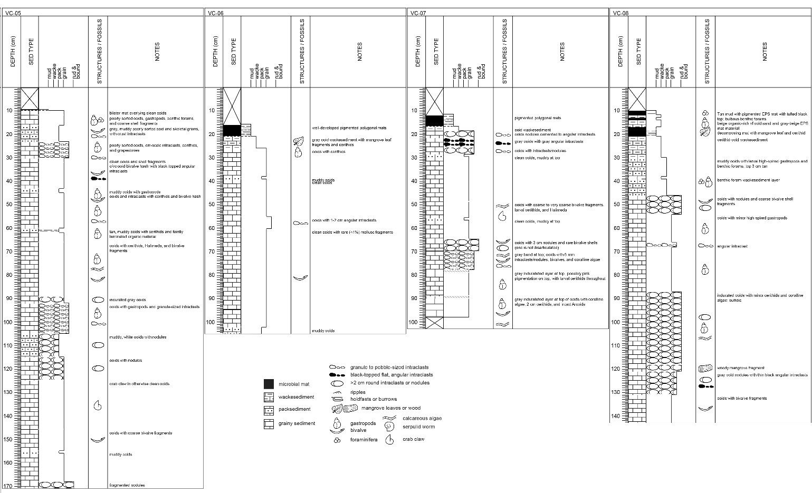

Supplemental Figure 3: Photos of core sediments. Scales are marked in millimeters. (a) Ooid-bioclast sand, VC-03 at 190 cm. (b) Muddy, ooid-bioclast sand, VC-04 at 165 cm. (c) Black-topped, micro-karsted angular ooid grainstone intraclast interpreted as fragment of crusts forming in interior basin, VC-01 at 20 cm. (d) Rounded ooid-skeletal grainstone intraclast or nodule of partially-indurated sediment, VC-01 at 40 cm. (e) Well-sorted cerithid gastropod-arcoid gravel interpreted as reworked skeletal lag, VC-05 at 35 cm. (f) Large, bleached cerithid gastropod, VC-04 at 160 cm. (g) Olive snail shell, VC-03 at 190 cm. (h) Coralline algae fragments, in skeletal-intraclast gravel, VC-01 at 38-46 cm. (i) Serpulid worm tube with a foraminifera (arrow) in skeletal-intraclast gravel, VC-01 at 38-46 cm. (j) Disarticulated arcoid bivalve in skeletal-intraclast gravel, VC-01 at 38-46 cm. (k) Fragmented bivalve and coralline algae gravel, VC-07 at 80 cm.
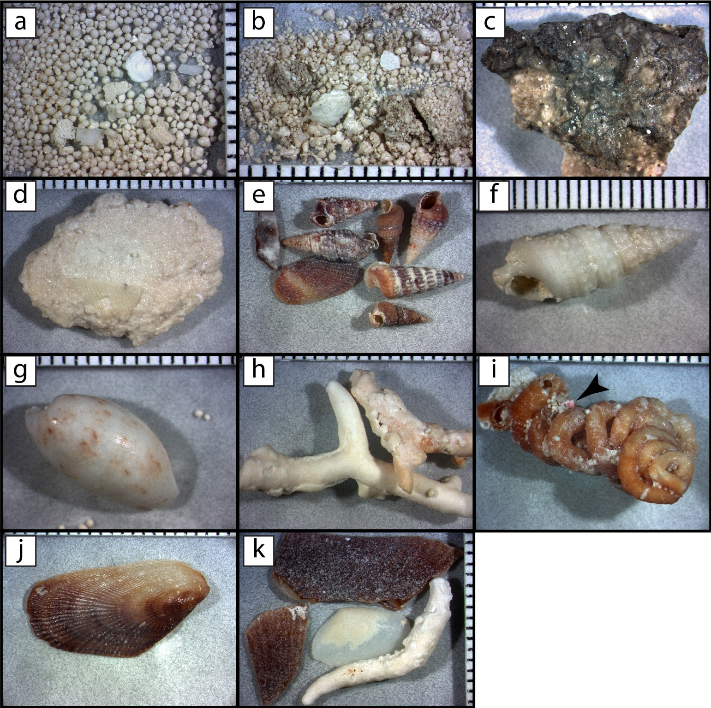

Supplemental Figure 4: Plane-polarized light photomicrographs of ooid-skeletal sand from VC-03. (a) Solution-enlarged microbores in sand at 60 cm depth. (b) Fabric-selective dissolution of micrite envelope and cement in grapestone grain at 80 cm depth. (c) Solution-enlarged microbores and irregular grain boundaries of grapestone grain at 190 cm depth. (d) Dissolution of algal grain at 200 cm depth.
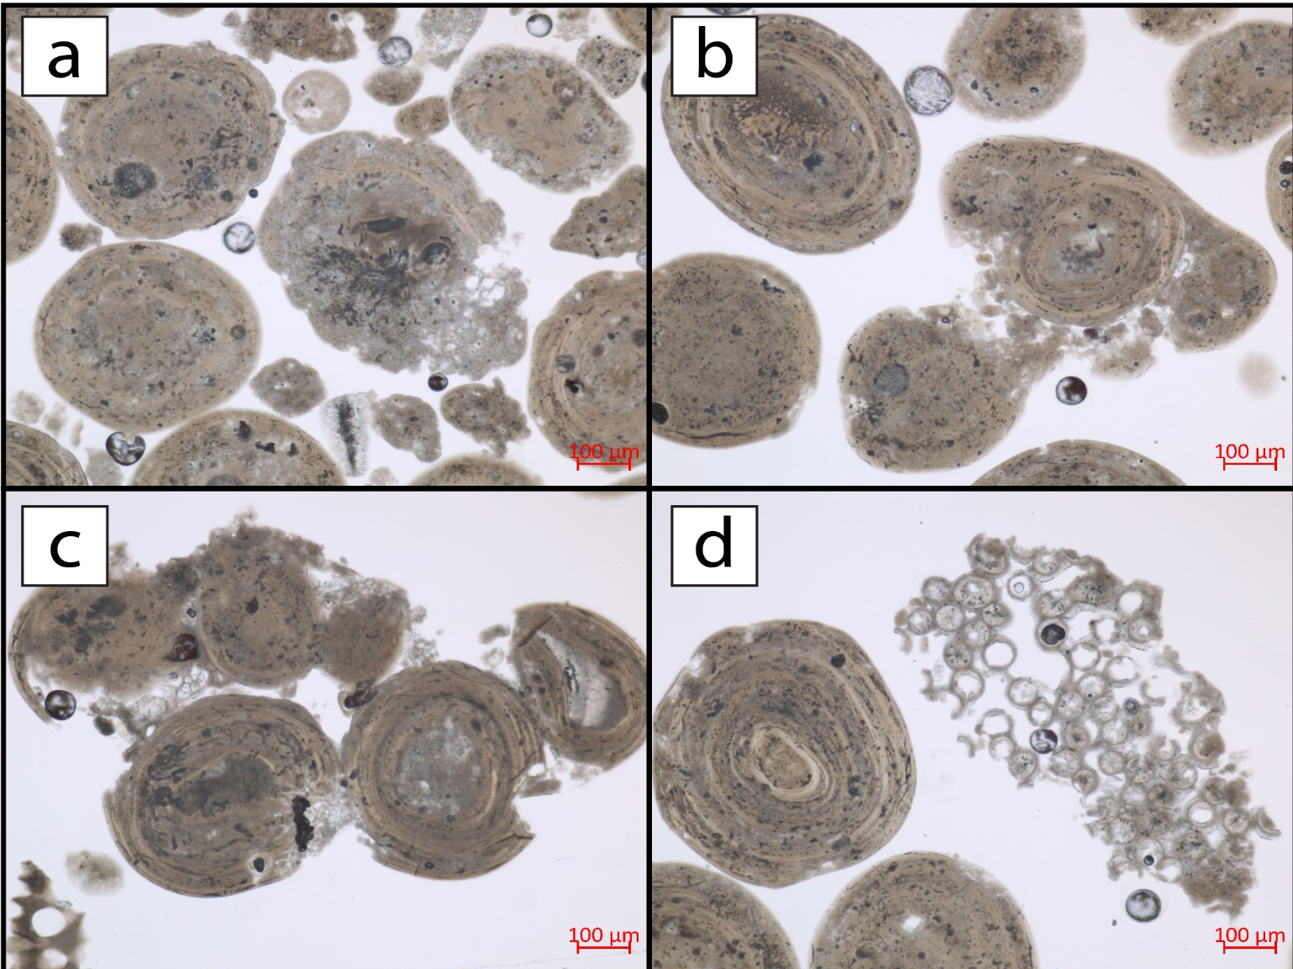

Supplemental Figure 5: Aerial photograph taken in September 2017 of a tidal channel at the western end of Little Ambergris Cay showing brown, tannic groundwater escaping in plumes during ebb tide (arrows). Image acquired with a DJI Phantom 4 drone.
